Untitled

# Exp 1

## Test1

### Accuracy

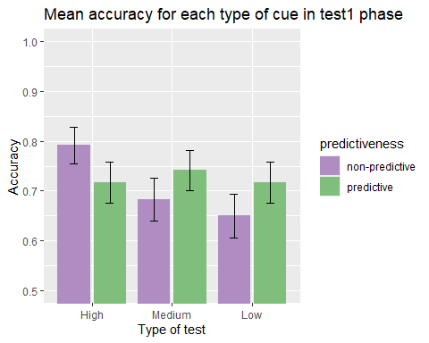

Except for those that did the very subtle test, all subjects had lower accuracy for the non predictive vs the predictive targets. However, there are no significant effects: *similarity* : *F*(2, 87) = 0.87, *p* = .425, = .02, BF10 = 0.17 ± 0.75%; *predictiveness*: *F*(1, 87) = 0.23, *p* = .635, < .01, BF10 = 0.18 ± 1.12%; *similarity x predictiveness*: *F*(2, 87) = 1.72, *p* = .185, = .04, BF10 = 0.17 ± 0.75%.

###Just correct ratings

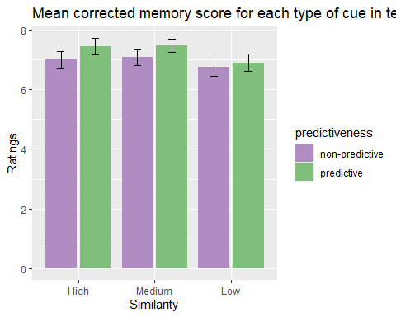

In this first test, there was a significant effect of the predictiveness, *F*(1, 82) = 4.70, *p* = .033, = .05, BF10 = 1.15 ± 0.86%, but not of the *similarity*, *F*(2, 82) = 0.86, *p* = .428, = .02, BF10 = 0.25 ± 0.52%, nor of the *similarity x predictiveness* interaction, *F*(2, 82) = 0.43, *p* = .653, = .01, BF10 = 0.25 ± 0.52%.

##Test2 ### Accuracy

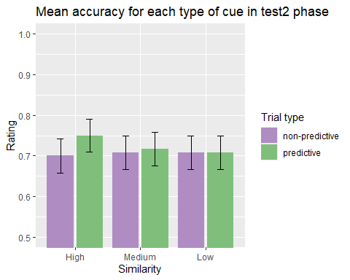

There are no significant differences due to any effect or interaction in accuracy in the second test, *similarity* : *F*(2, 87) = 0.05, *p* = .952, < .01, BF10 = 0.09 ± 1.14%; *predictiveness*: *F*(1, 87) = 0.26, *p* = .613, < .01, BF10 = 0.2 ± 5.79%; **similarity x predictiveness*:* F*(2, 87) = 0.16,* p* = .850, < .01, BF10 = 0.12 ± 3.89%.

###Just correct ratings

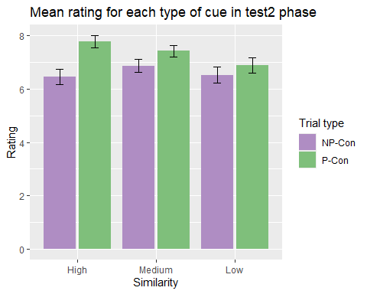

When the confidence ratings for the correct options were analysed, there was a clear effect of predictiveness, *predictiveness*: *F*(1, 83) = 13.67, *p* < .001, = .14, BF10 = 54.12 ± 1.66%. The rest of the main effects and interactions were not significant: *similarity* : *F*(2, 83) = 0.62, *p* = .538, = .01, BF10 = 0.19 ± 0.52%; *similarity x predictiveness*: *F*(2, 83) = 1.37, *p* = .259, = .03, BF10 = 0.36 ± 14.13%.

#### Group Low

T test showed no differences in predictiveness in group Low, *t*(28) = -1.01, *p* = .320, *d* = -0.19, BF10 = 0.31 ± 0.03%.

#### Group Medium

For group Medium, there was also no effect of *predictiveness*, *t*(28) = -1.59, *p* = .122, *d* = -0.30, BF10 = 0.61 ± 0.03%.

#### Group High

For group High there was a significant effect of *predictiveness*, *t*(28) = -4.12, *p* < .001, *d* = -0.76, BF10 = 95.78 ± 0%.

# Exp 2

## Accuracy

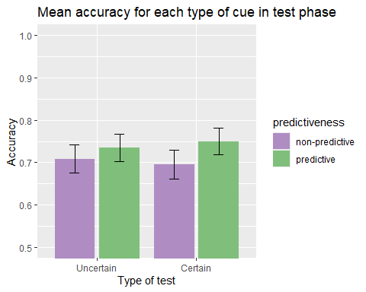

There were no significant differences due to the main effect of *group*, *F*(1, 92) = 0.00, *p* = .970, < .01, BF10 = 0.2 ± 0.93%, nor of *predictiveness*: *F*(1, 92) = 1.77, *p* = .187, = .02, BF10 = 0.37 ± 1.45%, but there was a significant *group x predictiveness* interaction, *F*(1, 92) = 0.22, *p* = .641, < .01, BF10 = 0.23 ± 3.18%.

## Just correct ratings

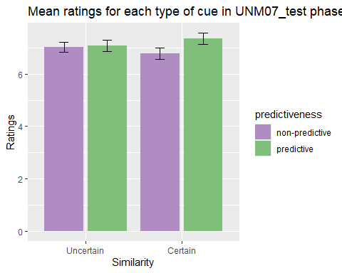

There was no significant effect of the *group*, *F*(1, 91) = 0.02, *p* = .892, < .01, BF10 = 0.27 ± 0.59%, nor *predictiveness*, *F*(1, 91) = 0.01, *p* = .911, < .01, BF10 = 0.16 ± 1.12%, neither of the *group x predictiveness* interaction, *F*(1, 91) = 1.05, *p* = .308, = .01, BF10 = 0.27 ± 0.59%. It is worth mentioning that the effect of predictiveness is very close to significance and that the bayesian evidence is anecdotal.

# Exp 3

## Accuracy

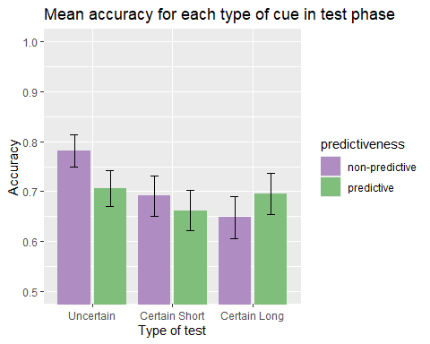

There were no significant differences, *group*: *F*(2, 103) = 1.44, *p* = .241, = .03, BF10 = 0.3 ± 1.12%, *predictiveness*: *F*(1, 103) = 0.50, *p* = .480, < .01, BF10 = 0.22 ± 1.92%, *group x predictiveness*: *F*(2, 103) = 1.73, *p* = .183, = .03, BF10 = 0.3 ± 1.12%.

## Just correct ratings

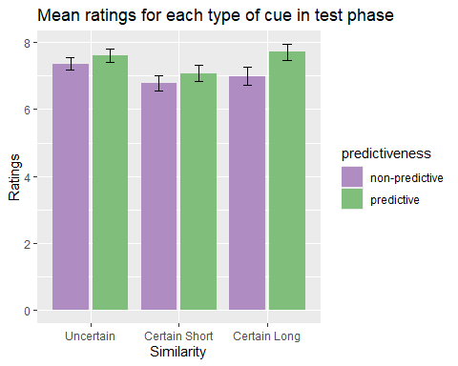

There was a significant effect *predictiveness*, *F*(1, 101) = 8.27, *p* = .005, = .08, BF10 = 7.11 ± 1.59%, but not of the *group*, *F*(2, 101) = 1.34, *p* = .265, = .03, BF10 = 0.25 ± 0.46%, nor of the *group x predictiveness* interaction, *F*(2, 101) = 0.81, *p* = .449, = .02, BF10 = 0.19 ± 1.83%.