Important links

NSIS link: <https://www.youtube.com/watch?v=bgQGFVJrLHM>

+ Purchases Addition sophisticated 6M

Sel Trinity@12345

Eduardo 10603

SEL service password Pass#123

[12:44 PM] Rhett Smith

again so sorry it is a weird time to start a new job, please know we are very excited to have you here and both Eduardo and I are happy to help get you going so keep asking questions and contacting us when you need us.  Eduardo will be providing tasks for you in June so please look to him for direction.  Then in July you'll get a full project in critical infrastructure networking (smile)

[9:39 AM] Rhett Smith

The controller is in .NET Core

​

[9:39 AM] Rhett Smith

so we can port it to Linux easy

​

[9:39 AM] Rhett Smith

right now it is only tested and supported on Windows but we will have a project soon to support it on a Linux distribution

​

[9:40 AM] Munja Dnyanoba Solanke

okay great to know.

​

[9:40 AM] Rhett Smith

We are thinking to have a containerized Linux distribution so we make it easy for any customer to spin it up on any version

----------------------------------------------6/2/2020-----------------------------------------------------------------------------

**Introduction to SEL Relays**

**SELogic Control Equations**

The equations are combinations of relay word bits and logical operators.

* Relay word bits(1/0)–outputs of protection & control element logic – can see instruction manual
* Logic operators -
* Timers and latches- timers allows to delay the output & latches used to retain O/P even after I/O has dropped out.
* Convert logic diagram to SELogic control equations
* Program SELogic control equation

**Data Capture and Event Reports**

* Event reporting feature in SEL relays
* Retrieve event reports using Quickset
* View event reports using synchroWAVe event software – allows to open, visualize, and analyze data from relay event reports

**Relay Testing Basics**

* Identify test types and test tools –
* - **Types** -static tests / Multistate / end-to-end / system fault / fault playbacks
* - **Tools** – relay word bits / sequential event recorder SER reports / event reports
* Utilize SEL-4000 relay test system
* Create pickup and timing test
* Design multistate test
* Retrieve relay word bits via front panel / Terminal window through QuickSet – sec 5.2 / HMI
* Pickup test –
* Timing test -Sec 5.6

------------------------------------------------6/3/2020------------------------------------------------------------------------------

**SEL-5230**

**acSELerator Database API**

The acSELerator Database API is a representational state transfer (RESTful) web service that provides access to device data collected by acSELerator Team SEL-5045 Software. Once acSELerator Team archives data in the acSELerator Database, third-party software tools can use the acSELerator Database API to send standard HTTP GET requests as well as “strongly typed” request objects.

In University project, I created ASP.NET Web API service that returns data from a SQL Server database.

Videos need to watch on youtube

* <https://synchrocenter.ad.selinc.com/sites/RD/RD_Techinars/Recently%20Recorded%20Techinars/20180302_AcSELerator%20Database%20API%20Training?d=wba88f35a7a0b4ad58458d365af190141>
* <https://selinc.com/events/on-demand-webinar/126686/>
* ACSELERATOR TEAM® Global Options Overview
* ACSELERATOR QuickSet® Device Manager Overview
* How to Set the SEL Secure Communications System, Part 1: Overview & part 2,3,4,5,6
* SEL RTAC — Basic Software (1 of 9)

**webinar on Introduction to SEL RELAYS**

SEL-751 Feeder Protection Relay

* How reclosing works?
* Enhanced SELogic control equations and operators
* SER variables
* Relay generates event reports
* Programmable default display
* Local control switches – operate via front panel display
* Remote control switches – operates via serial port
* Computer connections -eg windows hyper terminal
* Front panel HMI menus
* PC communications required equipment
* **AcSELerator QuickSet features**
* Targets
* New relay settings
* Z number – version number followed by Z(3 digits) and found in relay FID
* Setting tree + sign to expand tree
* Use powerful analysis tools – impedence plots, al[ha plane
* Database manager – copy and move settings from database A to B

------------------------------------------------6/4/2020------------------------------------------------------------------------------

* <https://confluence.metro.ad.selinc.com/display/SDNRC>
* Nice, this is where we put all our project planning details. all the specs, builds and tests are in other linked tools, but this is the starting point
* Under this heading, <https://confluence.metro.ad.selinc.com/display/SDNRC/Research>, I'd like you to start a new page and record any fun details you learn as you spin up on the SEL products.
* Feel free to think of it as your "notes" and this way we all benefit from your research
* write them for yourself and don't feel like you need to polish them, just a good way to make sure we capture all your good work. and a good way for you to centrally manage your own notes for yourself 🙂
* yes, document in Confluence rather than outside tool, this keeps all the info together for the team (SDNRC = Software Defined Network Responsibility Center)  The SDNRC is the full team of all R&D engineers working on SDN
* DDC- Device Data Collection
* SEL-3355: This is rugged computer in which we are hosting the software AcSELerator TEAM and AcSELerator quickset.
* **AcSELerator TEAM** is going to be an integral tool to the system providing us real time acquisition of our asila graphic event reports. **AcSELerator quick** **set** is providing us the configuration tool for the rest of the system.
* SEL-3620 is a security gateway providing us the proxy services user management and password management in order to comply with standards. It also allows VPN dead-ending.
* **SEL RTAC – Real Time Automation** Controller. This device is used for configuration baselining as well as data collection and logic processing.
* **Protective relays SEL- 351S and SEL-451**: these are used as protective relay connection that our technicians
* **I** added SEL-3620 security gateway device in AcSELerator QuickSet tool. There if I go to Device Tab under SEL-3620, and click on the Global Device ID, it gives popup text about the Global Device ID and warning message. I suggest we can give small description for each variable in QuickSet tool.

------------------------------Week-2------------------6/8/2020-------------------------------------------------------------------

**AcSELerator Database API (SEL-5230) Integration Training**

**Getting Started with the ACSELERATOR Database API**

5230-001 Single Database with single client connection

5230-002 Multiple database connection with multiple clients

Database PING 10.42.96.254

uniqueDeviceId is the dbHost and deviceId.

------------------------------Week-2------------------6/10/2020------------------------------------------------------------------

|  |  |
| --- | --- |
| **File name** | **ORM function** |
| appsettings.json | Connection string |
| EF_Models.cs | Entity definitions |
| ApplicationDbContext.cs | Entity framework context |
| DatabaseExampleController.cs | Business application |
| Startup.cs | Database connection |

**API Workflow**

**Read data from SEL database file (SEL Database server-Read only)**

**Display data on Web Browser**

**Add search and filter logic on web pages (like filter data by device type SEL-351)**

**Can deploy the data on SEL database server/ Microsoft Azure cloud database**

**Can save the data to local database file**

**How to show the web browser data to customers/third party?**

**Make an Executable file to run on third part or any PC**

**Add-Migration InitialCreate**

**Update-Database**

Categories for the website (How many = List all in the website)

**Primary Search**

Inventory Query: **API-SEL-5230**

1. How many IEDs (intelligent electronic devices) are in the Database - Display
2. How many Substations are there?
3. How many RTACs are in the Database? (these are of Device Type SEL-3530/3530-4/3555/3505/3505-3/3630)
4. How many Security Gateways are in the Database? (these are of Device Type SEL-3620/3622)
5. How many SEL-2730M Managed Ethernet Switch are in the Database?
6. How many Regions are there?
7. How many IEDs of Device Type “xyz” are there in “xyz” Region?
8. How many IEDs of Device Type “xyz” have Firmware Version “xyz”?
9. How many IEDs are IN Service?

**Advanced Search**

Protection Query: (<https://selinc.com/products/comparisons/product-features/> ) **Need to implement**

1. How many IEDs are Transformer Protection? (this query compares the DeviceType string versus the list of devices that fall under this category, for example the SEL-487E is of category Transformer Protection and cannot be associated with any other category like Motor Protection)
2. How many IEDs are Motor Protection?
3. How many IEDs are Feeder Protection?
4. How many IEDs are Generator Protection?
5. How many IEDs are Breaker Failure and Capacitor Bank Protection?
6. How many IEDs are Bus Bar Protection?
7. How many IEDs are Transmission Line Protection?

Communications/Connection Query: **API-SEL-5231**

1. How many relays are connected via Serial Port? – Query with Connection Type
2. How many relays use “xyz” baud rate on their Serial Ports?
3. How many relays are connected via Ethernet Port? – Query with Connection Type
4. How many relays are connected with a SEL-RTAC as its Master?- – Query with Access Script
5. How many relays are connected with a SEL-3620 as its Security Gateway?
6. How many Host IP addresses are duplicates?

IED Settings Query: **API-SEL-5231**

1. How many IEDs have been created by “admin”?
2. How many Users are authorized to login to the Database to access these IEDs?
3. How many settings have been created during “start date” to “end date”?
4. Who was the last user to change any settings in the Database?

TEAM settings Query:

1. How many IEDs have automatically Event Report Collection?

 

1. How many IEDs are Transformer Protection Relay?

* SEL-487E
* SEL-787
* SEL-387E
* SEL-400G
* SEL-387A
* SEL-387

1. How many IEDs are Motor Protection Relay?

* SEL-710
* SEL-701
* SEL-749
* SEL-849

1. How many IEDs are Feeder Protection?

* SEL-751
* SEL-351
* SEL-351S
* SEL-451
* SEL-551C
* SEL-551
* SEL-501
* SEL-352

1. How many IEDs are Generator Protection?

* SEL-400G
* SEL-700G
* SEL-300G
* SEL-547
* SEL-2664S

1. How many IEDs are Capacitor Bank Protection Relay?

* SEL-487V

1. How many IEDs are Bus Bar Protection Relay?

* SEL-487B
* SEL-587Z
* SEL-487E

1. How many IEDs are Transmission Line Protection Relay?

* SEL-421
* SEL-311C
* SEL-321
* SEL-321-5
* Display total number of devices on home page
* Search text should be visible after pressing submit button
* Add product url as per device type entered in search box
* Information Icon for view example questions
* Make an exe file for this to open from any place on earth
* Advanced search for device category
* Advanced search query for API-5231-look for manual & API handling requests

**Abbreviations**:

**RID** – Relay Identifier- Relay Identifier is typically used to identify the relay or the type of protection scheme.

**TID** – Terminal Identifier-Typical terminal identifiers include an abbreviation of the substation name and line terminal.

**SID** – Substation Identifier-

**GID** -

**FID** –

**CID** –

**The SEL Lab setup Procedure steps:**

1. **Powerup** all the devices connected in setup.
2. Connect **serial cables** from each relay/ any other devices to RTAC for each rack. Remember the serial port numbers connected to RTAC that is required when you add new SEL devices to AcSELerator RTAC (asks for com port connection)
3. Connect **Ethernet cables** from each relay/any other devices to RTAC through Ethernet switch for each rack.
4. Make **Network connection loop** of all the devices and RTACs from each rack by connecting through Ethernet cables.
5. Connect the **IRIG-B cable for time synchronization**. Make the connection loop by connecting each RTAC with IRIG-B cable.
6. Note down the IP addresses for each RTACs, Ethernet switch and devices connected through ethernet cables. Make sure there is no duplicate IP address.
7. Now this is the time where we can check that all setup is ready to go or not. We can check this by pinging each device through CMD Command Prompt window. Each device response is expected.
8. Firstly, go to each **ETHERNET SWITCH’s webpage 192.168.10.131** (this is what I configured for my setup) Username – admin ; Password – P@ssw0rd (for my case, you can have what you configured).

* Go to Switch Management -> Port Settings: Check all ports are enabled or not.
* Network Settings -> IP Configuration:
* Default Gateway -> 192.168.10.20
* Under Mgmt Settings: Give Alias name and IP address as 192.168.10.131/24 (24 gives you the number of port connections available, for more details you can check **CIDR**) and enable the services HTTPS & SNMP.
* System -> Global Settings: As per the requirement insert maximum sessions and session timeout values.
* System -> Date/Time: Select the **TIME ZONE** and **Network Time Protocol (NTP)** settings. Enable NTP Client and put NTP server IP address same as RTAC IP address (192.168.10.61 – for my case) connected to that switch in that Rack.

1. Now go to RTAC webpage (192.168.10.61). Go to Dashboard and check the firmware version. If it’s not the latest version, update the Firmware version (System->Device Management).
2. Above same step applies to Ethernet switch. Go to System -> File Management -> Firmware Upgrade.
3. Till this step we have checked all the devices connected and communicating properly and firmware versions are updated to the latest versions.

* 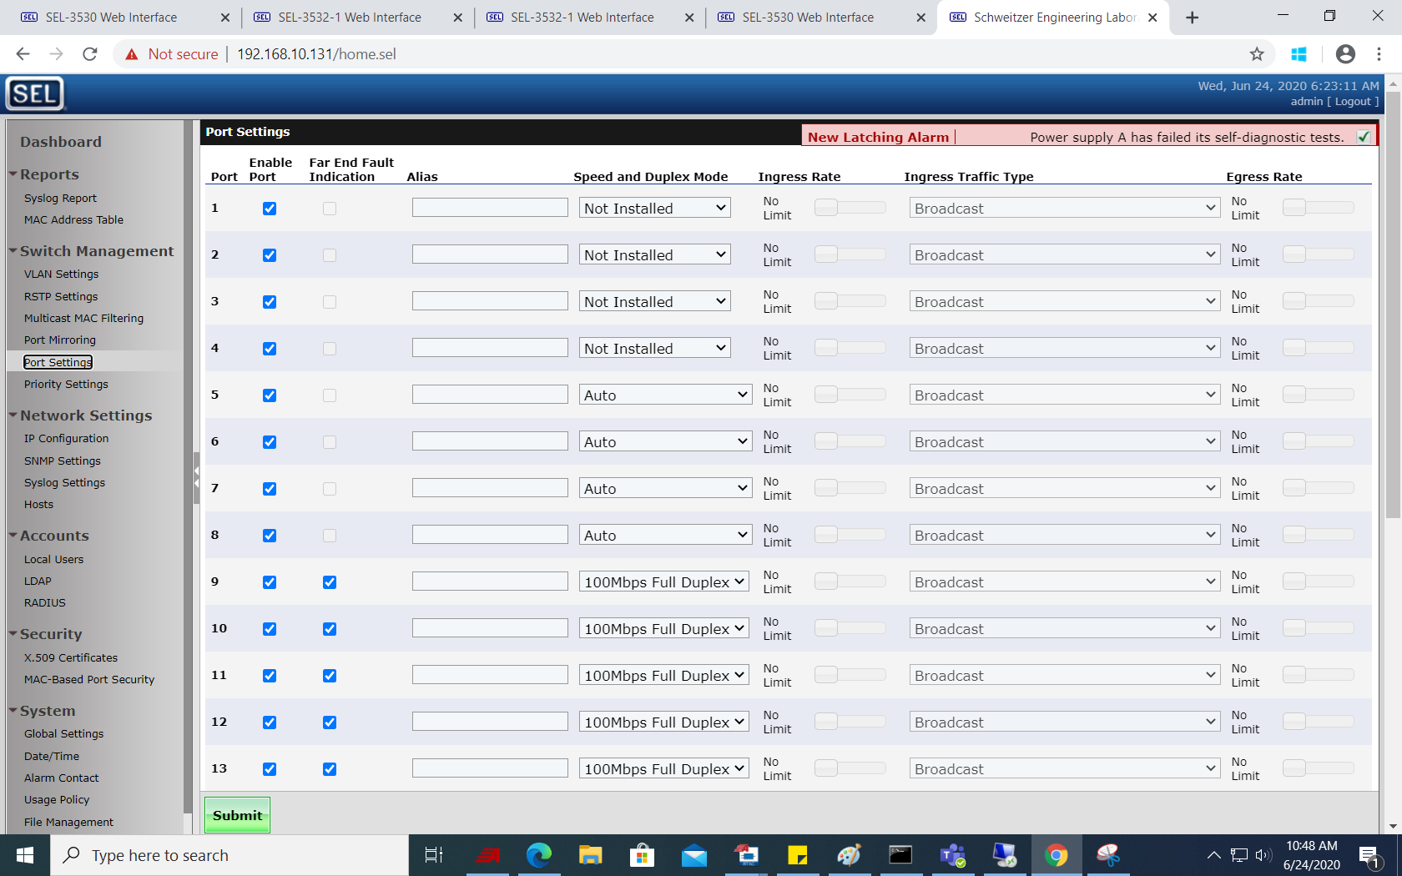
* 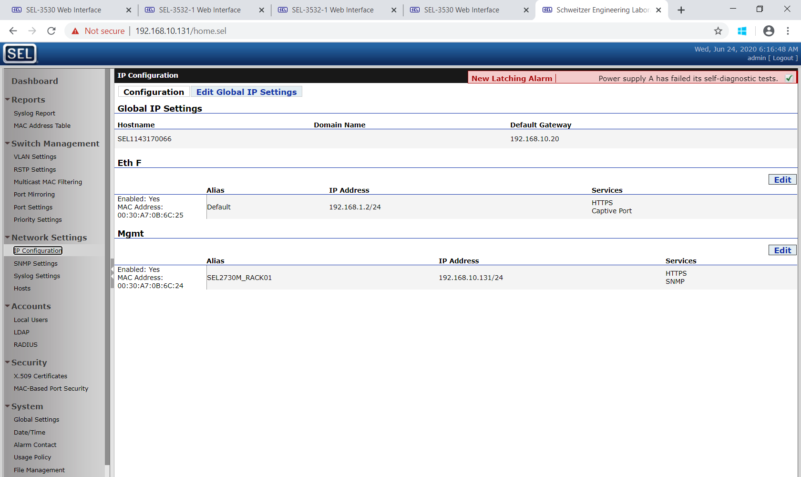
* 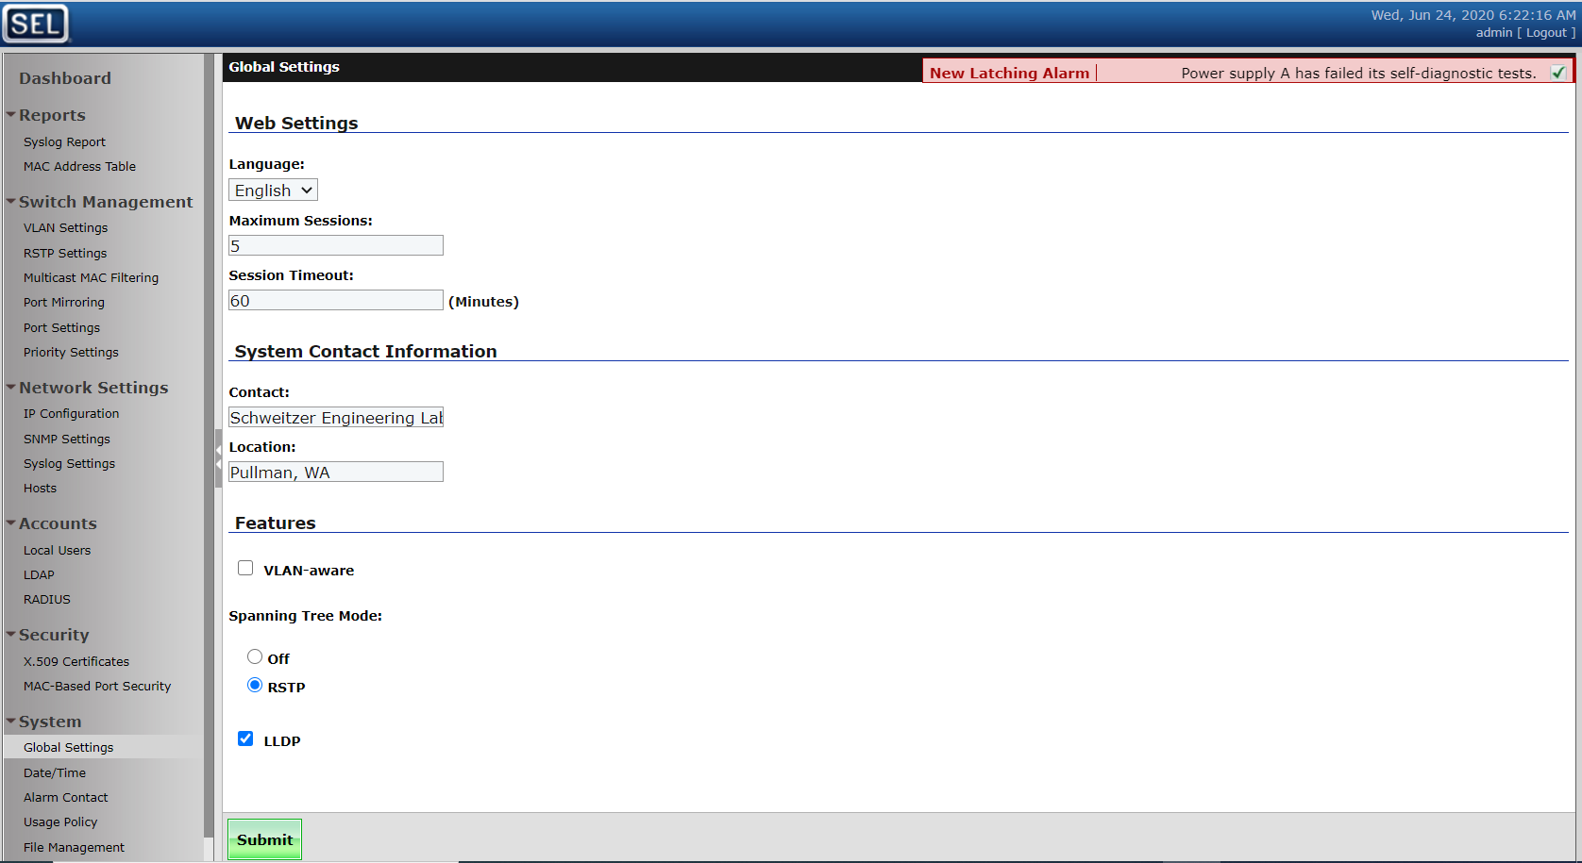
* 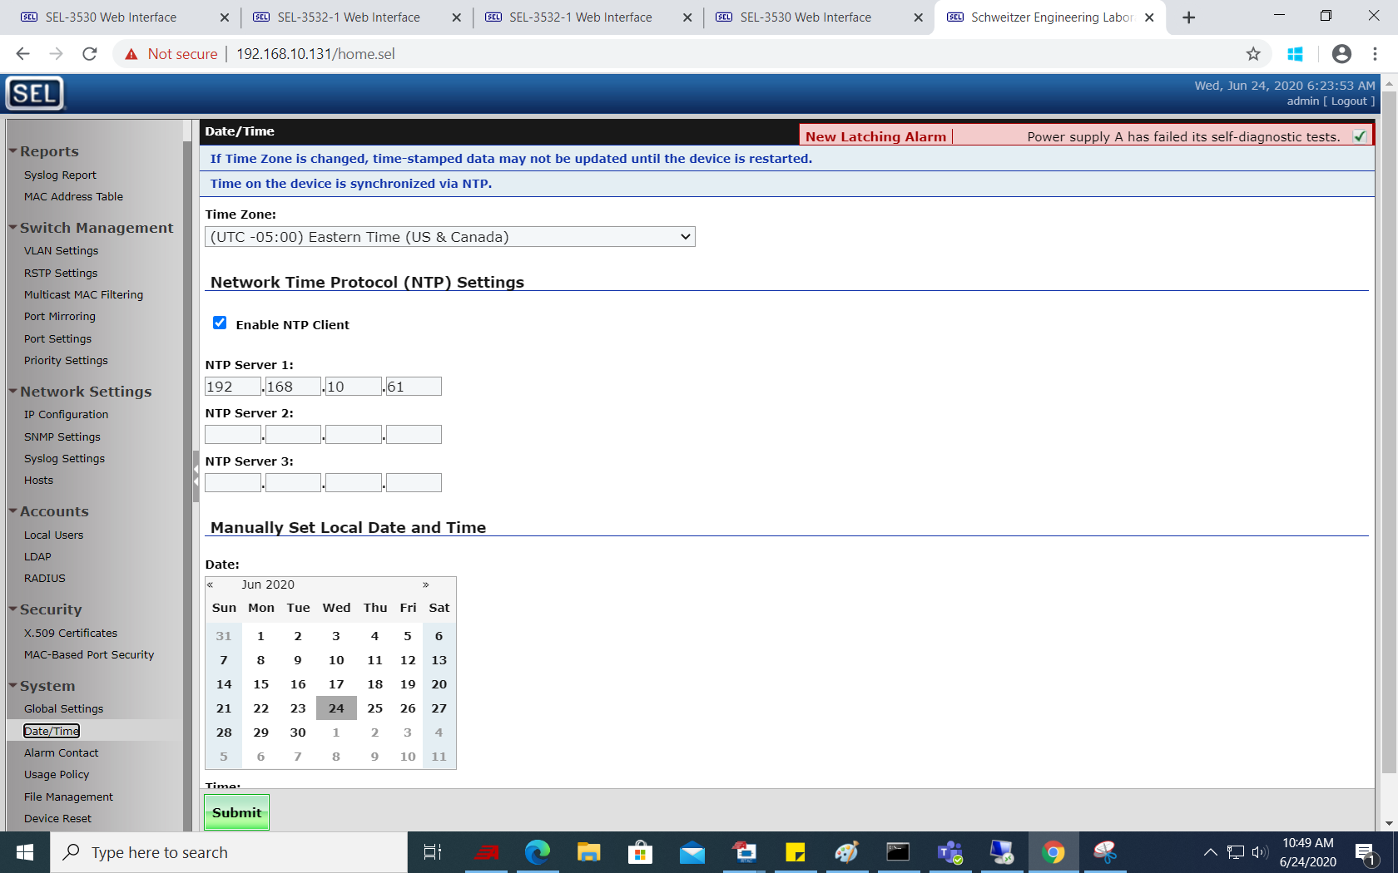

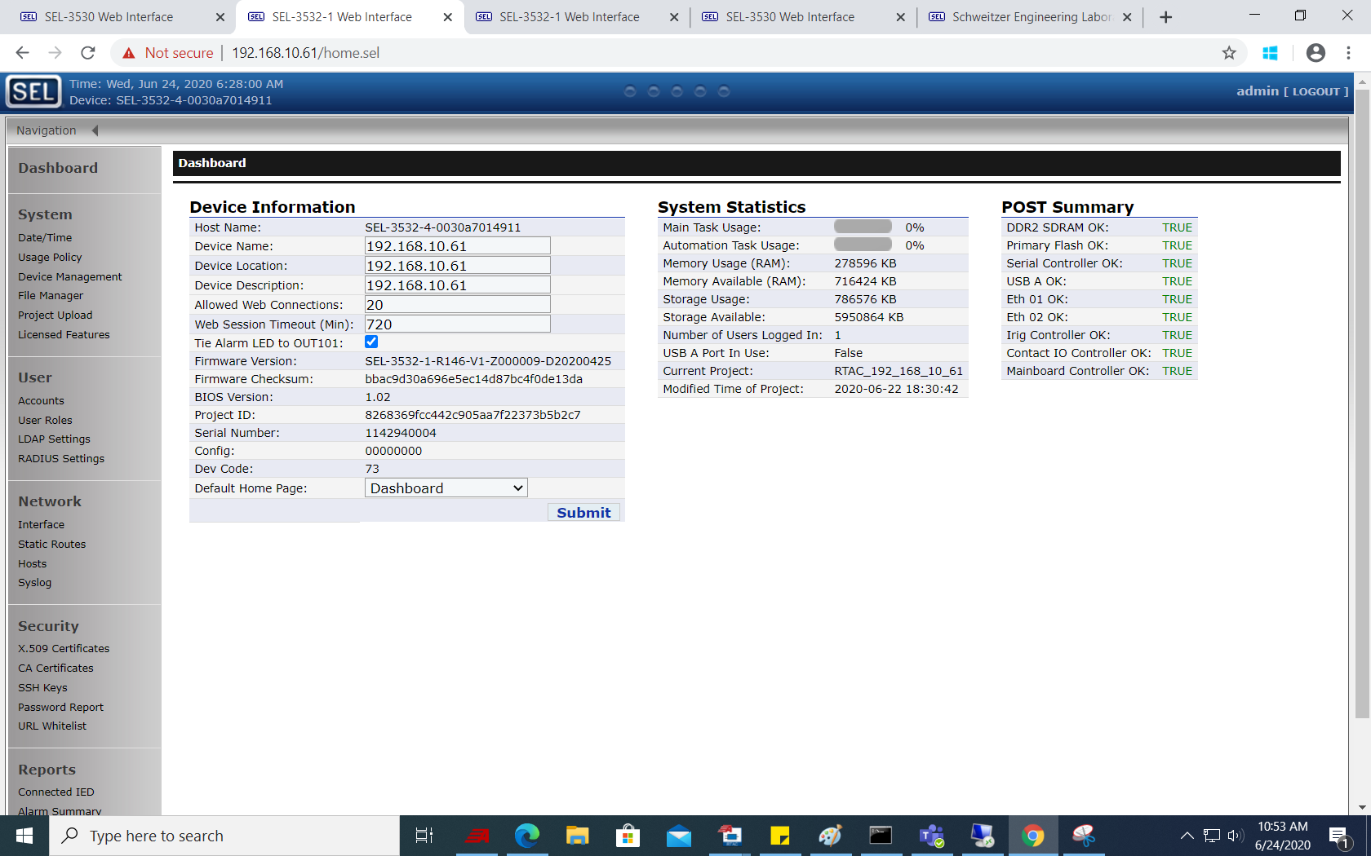

1. Now Open the AcSELerator RTAC software and create new projects (Separate project for each RTAC). Add devices connected to the RTAC in the software as shown in below pictures. Make sure Serial communication port and Baud rate is correct. When all the settings done after adding all the devices. Go online and check RTAC and Relays are communicating properly, check the status of Offline (Initial status is TRUE) and Auto_Configuration_Pending (Initial status is TRUE) is FALSE and Message_Sent_Count and Message_Received_Count is good enough for communication going to Controller tab.

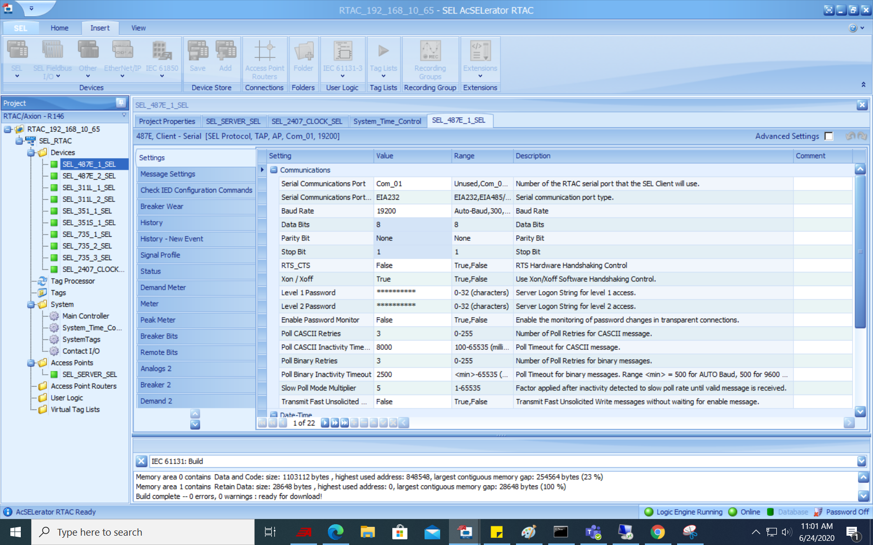

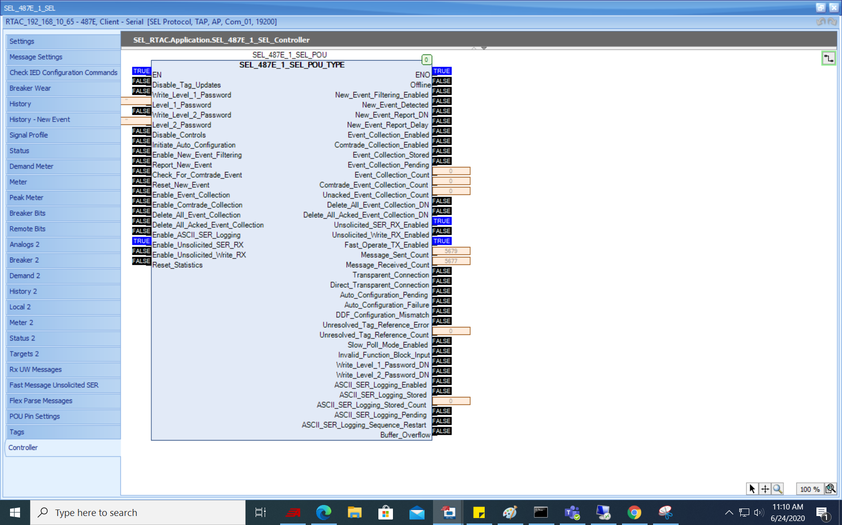

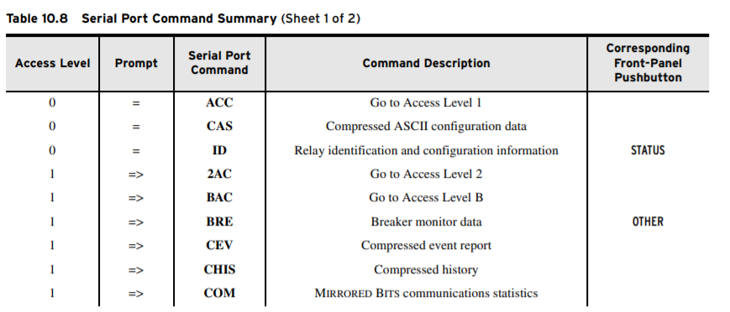

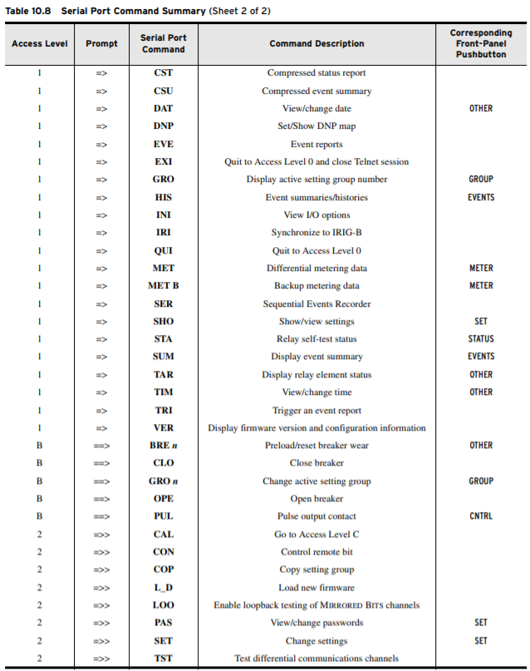

SO now The Major step we need to carry out are listed below:

1. RTAC and Relay connections and all settings need to be set as mentioned in above all steps.
2. Create ACCESS POINT server inside RTAC as mentioned below picture. Select connection Type as Server-Ethernet and give device name as SEL_SERVER. Allow Anonymous SEL IP Clients as True
3. Check the Time Synchronization of all the IEDs (Intelligent Electronics Devices)

* Open SEL Communication Terminal window to check connection status of the devices and to set the time
* **WHO** to get all the devices connected?
* **STA** to get the data of Satellite Synchronized Clock
* **TIME** command to set the time =>>TIME 2020-06-24T09:43:22
* Set Local Time to 2020-06-24T09:43:22 (Y,N)? Y
* User Time Setting Applied.
* **ID** command to get device data
* ACC (password if asked OTTER)
* 2AC (Password if asked TAIL)
* FTQ 0
* Y
* FTQ 1
* Y
* Ctrl + D to terminate the connection.

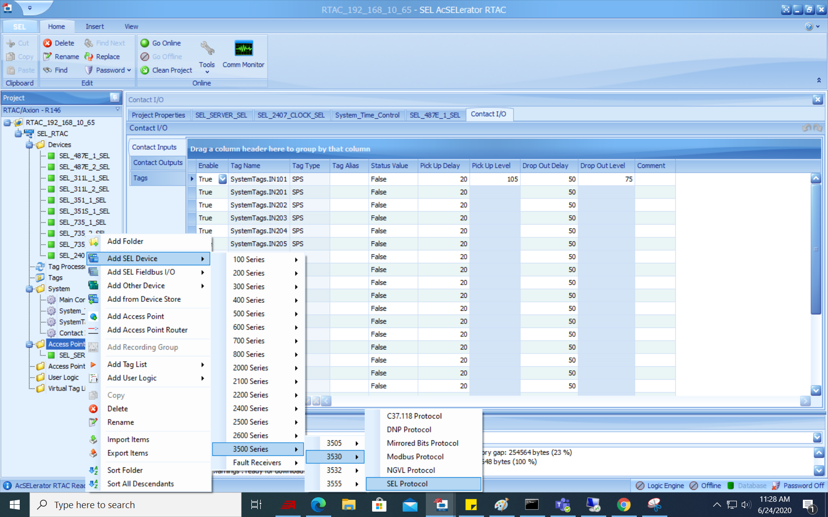

- RID in the relay

- then the device name in the RTAC project

- then the GUID for each device in the RTAC project

- then the Device Name and Global Device ID of the device in Device manager of Quickset

1. Make all the connections in the Quickset and check whether all devices are going online or not means are they talking to RTAC
2. HIS C -Clear Event Summaries/Histories

SER CA -Sequential event recorder

TRIG -to make a new oscillography report

[Monday 9:57 AM] Eduardo Palma

so that the AcDatabase (PostgreSQL) can have the data that we need to show via the API into the webpage that you made

(1 liked)

​

[Monday 9:57 AM] Eduardo Palma

do you know how to set up SEL-5045 software (TEAM)?

​

[Monday 9:57 AM] Munja Solanke

No, but I will see its manual and try to do setup

​

[Monday 9:58 AM] Eduardo Palma

great, let me know if you get stuck or if you want me to set up the first rack so that you can set up all the rest

​

[Monday 9:59 AM] Munja Solanke

yup.

thanks(smile)

​

[Monday 10:13 AM] Munja Solanke

I have a question ,

Do I need to read relay setting through Quickset only or I can read it from SEL-5045 TEAM software too ?

As SEL-5045 TEAM software helps for automated data collection.

[Monday 10:21 AM] Eduardo Palma

so, the TEAM DDC is a Windows service that runs unattended and retrievesdevice data from SEL intelligent electronic devices (IEDs) and othersupported devices.  The licensing of TEAM is what really tells us what are we allowed to "collect"

(1 liked)

​

[Monday 10:21 AM] Eduardo Palma

Using the features of TEAM Event, automate the collection of CEV and COMTRADE files from supported SEL devices and other supported vendors. Collect Sequence of Events (SOE) records from SEL relays, SEL meters, and the SEL Real-Time Automation Controller (RTAC) family of IEDs.

(1 liked)

​

[Monday 10:21 AM] Eduardo Palma

so that's only TEAM.  Now let's talk about Quickset

​

[Monday 10:21 AM] Eduardo Palma

Quickset is not automatic collection, it is manual collection

(1 liked)

​

[Monday 10:22 AM] Eduardo Palma

Quickset reads relay's settings when you click on the menu/buttons "manually" and direct it to do so

(1 liked)

​

[Monday 10:23 AM] Eduardo Palma

but Quickset and TEAM both have something in common, the AcSELerator Database as storage

(1 liked)

​

[Monday 10:23 AM] Eduardo Palma

TEAM always stores in the AcSELerator Database

​

[Monday 10:24 AM] Eduardo Palma

Quickset not always stores in the AcSELerator Database.  Only if you start the "Device Manager" to login to the AcSELerator Database is that you are purposely choosing to store into the AcSELerator Databse whatever you "manually" collect with Quickset

(1 liked)

​

[Monday 10:26 AM] Eduardo Palma

let me know if you need further clarification?

yes so we'll concentrate on:  1.  SOE and CEV data that's automatically "collected by TEAM's DDC.  2. identification data (Part number, serial number, firmware ID, etc) that's manually collected by Quickset

**Date – 08/03/2020**

**Ref links:**

* <https://support.microsoft.com/en-us/help/164015/understanding-tcp-ip-addressing-and-subnetting-basics>

**Started working on Software Defined Network Switch (SDN) with Rhett**

**SEL-2740S**

* The SEL-2740S is the industry’s first field-hardened software-defined networking (SDN)-enabled switch and is designed to improve Ethernet cybersecurity and performance for operational technology (OT) applications.
* Create stronger Network Security
* Improve Failover Performance
* Streamline NERC () CIP Data Collection
* Manage Network Scalability and Change Management
* Programmatically Test and Validate Your Network
* Synchronize Time Over the LAN with Accuracy

------------------------------------------------------------------------------------------------------------------------------------------

**Task 1: Install SEL-5056, commission it, firmware upgrades the SEL-2740S to R105, and adopt the switch**

**Easy to do:**

* Installing SEL-5056 and commissioning it was easy to do. The instruction manuals “[SEL-5056 SDN Flow Controller](https://selinc.com/api/download/131730/)” made easy to understand as stepwise instructions mentioned in the manual.
* The firmware upgrade of SEL-2740S to version R105 and adoption was also easily understandable from the instruction manual.

**Challenges to do:**

* The ports status of switch SEL-2740S was adopted but after hitting the Firmware Upload Submit button, I was unable to communicate to Node Flow i.e. failed to connect to device.
* But the problem was resolved later as there was an issue with the settings of IP Subnet mask and default gateway.

**Task 2: Grab two hosts and get them configured to be on the same subnet and plug one into each switch and program a logical connection to allow PING between them.  You can use a computer and a relay.**

**Easy to do:**

* Configuring the hosts on the same subnet and programming a logical connection to allow PING between them was easy to understand from the instruction manuals “[SEL-5056 SDN Flow Controller](https://selinc.com/api/download/131730/)”. The images of configuration settings from SEL-5056 web interface application made sure that we are on right track of configurations steps.
* Video description also helped to understand the steps for tasks.

**Challenges to do:**

* The challenge faced was that initially I could not establish a logical connection to allow PING between hosts. This was the problem facing because there was conflict with Npcap installation. As I had installed Wireshark (which consist of Npcap installation) on my host PC and SEL-5056 software application also have Npcap installation. So, I felt, this might be the problem.
* So, I uninstalled the both the software (SEL-5056 and wireshark). Reinstalled both and this time avoided the Npcap installation twice. This resolved the problem facing to establish a a logical connection.
* I think this Npcap installation conflict was not mentioned in the instruction manual.
* Second challenge: I took one of host as relay SEL-351A, for this host IP address did not come on its own in SEL-5056 Web Interface application under Configuration -> Topology. I had to manually configure the IP address for the relay host SEL-351A to establish a communication. But the problem was resolved with the solution provided in above.

**Task 3: Use to learn & lock to perform adoption and logical connection learning. You can use ping and telnet to the relays. If you have both relays connected to the network and set the relays in failover mode so each relay has 2 connections to the network that would be great**

**Easy to do:**

* Completed

**Task 4: Try to read SEL_5056 API and get/post settings, configurations, create a node, read nodes configured. Use and get in touch with SEL-5056 Web Interface and understand different features.**

**Task 5: VISIO Plugins for configuration creation. Entering configuration information into visio. Prepare Architectural Flow Diagram and Data Flow Diagrams-DFD.**

**There are two different drawing that need to be created to represent all the configuration files.**

* Architectural Flow Diagram
  + Represents the physical devices and the how they are connected
  + Specifies the details of their network configurations (IP addresses for example)
  + Hosts and Topology files are created from this diagram
* Data Flow Diagram (DFD)
  + Represents the logical communication on the network
  + Details which devices are talking to which other devices and with which protocols
  + Host Profile, Applications, Protocols files are created from this diagram

Many of the configuration files that must be configured to use the Network Builder tools can be configured by using special templates and plugins for Visio.  These make the process of stitching together these files much easier and it also means that you have accurate drawings that completely represent your network configuration.  This means that if you want to make changes to your network you can update the drawings to represent what you want, export the config files, and rerun the NB tools to push that new configuration.

[https://confluence.metro.ad.selinc.com/display/KBSDN/Visio+Plugins+for+Configuration+Creation](https://confluence.metro.ad.selinc.com/display/KBSDN/Visio+Plugins+for+Configuration+Creation%20)

**Task 6: Use the Raspberry Pi for Network Commissioning Assistant tool, configure and build the network and execute testing, debugging and monitoring the NCA.**

References:

* <https://confluence.metro.ad.selinc.com/pages/viewpage.action?spaceKey=SysEngr&title=Using+Raspberry+Pi+For+Network+Commissioning>
* <https://confluence.metro.ad.selinc.com/display/SysEngr/Image+Flashing+Guide>
* <https://confluence.metro.ad.selinc.com/display/SysEngr/Development+and+Release+Procedure+%28NCA%29+OLD>

[**Using Raspberry Pi for Network Commissioning**](https://confluence.metro.ad.selinc.com/display/SysEngr/Using+Raspberry+Pi+For+Network+Commissioning)

* The Network Commissioning Assistant (NCA) is a tool suite for testing, monitoring and debugging Software Defined Networks (SDN). It is an inexpensive solution consisting of two Raspberry Pi's running a pre-existing Rasbian Lite version.
* **Features**:
* Pcap Capturer:
* PTP Info:
* IP Connections:
* Auto FAT/SAT:

Protocols and port numbers for that:

* HTTP – 80
* HTTPS – 443
* Modbus –
* NTP – 123
* Secure Fox –
* IP->IP:
* Syslog: 514
* Telnet: 23
* PING:
* BACnet:
* Niagara TLS Platform:

**Task 7: Write a program that will firmware upgrade all the adopted switches in the controller. Use SEL-5056 API document.**

* we need to have a program get a list of all the adopted switches in the controller, we have 2740S and 2742S now.
* then do a firmware upgrade on the 2740S or 2742S based on the user choice.
* I envision a program where the user initiates a firmware upgrade, selects if its 2740S or 2742S, and passing in the firmware file and the program takes it and does them all from there.

from selsdn.interfaces.rest import RESTInterface

with RESTInterface("munja", "Pass@12345",verbose=True) as i:

i.firmware_upload_from_file_name(file_name="install_SEL-2740S-R105_release_prod.tar.gz", switch_name="SEL2740_357")

import requests

import urllib.request

token="7303eb05f85093f8c87e6b24d9715599b4887fa832131921f1f2bc9352ea0199"

##r3 = requests.get('https://localhost/api/default/operational/nodes(‘aec12012d452a4e5d972f168361beefc’)',

## headers = {"Authorization": 'Bearer ' + token},verify=False)

url = "https://localhost/api/default/operational/nodes('aec12012d452a4e5d972f168361beefc')/FirmwareUpgrade"

##req = urllib.request.Request(url)

##resp = urllib.request.urlopen(req)

##

##r3 = urllib.request.urlopen(url)

##r3 = request.urlopen(url, headers = {"Authorization": 'Bearer ' + token},verify=False)

##r3 = requests.url('https://localhost/api/default/operational/nodes(‘aec12012d452a4e5d972f168361beefc’)',

## headers = {"Authorization": 'Bearer ' + token},verify=False)

response = requests.post(url,

headers = {"Authorization": 'Bearer ' + token},

files={"fileName": open("install_SEL-2740S-R105_release_prod.tar.gz", "rb").read()}, verify=False)

##

##response2 = requests.get('https://localhost/api/default/operational/nodes',

## headers = {"Authorization": 'Bearer ' + token}, verify=False)

##

print(response)

**Firmware Upload Status**

1. 21% Uploaded –0.01 – 1
2. 34% Uploaded---0.03 - 3
3. 47% Uploaded---0.04 - 4
4. 62% Uploaded---0.06 - 6
5. 72% Uploaded---0.08 - 8
6. 80% Uploaded---0.09 - 9
7. 88% Uploaded---0.12 - 12
8. 97% Uploaded---0.14 - 14
9. Step 3 of 6: Verifying signature ---0.18 -18
10. Step 4 of 6: Preparing upgrade---0.26 - 26
11. Step 5of 6: Running upgrade ---0.43 - 43
12. Step 6 of 6: Cleaning up ---3.50 - 230
13. Firmware upgrade succeeded ---3.52 – 232

Need to solve

1. Main thread is not in main loop
2. Threads can only be started once
3. When there is no device in the list, thread should not start, give some message and abort the further steps.
4. Progress bar should be updated with the last device into consideration not the first or all devices. It should be stable progress bar.

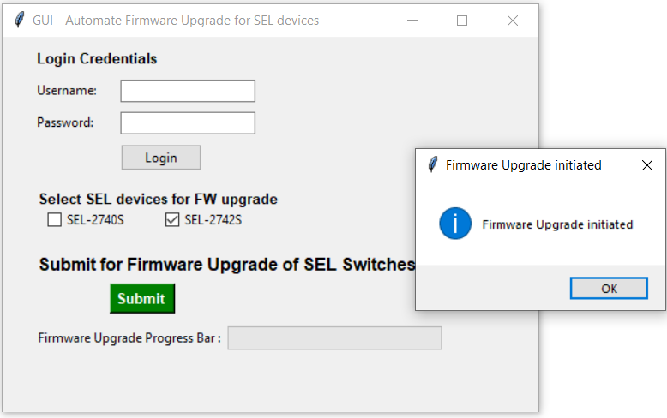

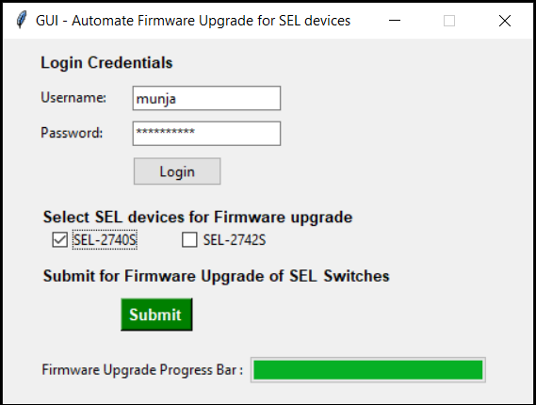

* Creating exe from python script

pyinstaller --onefile -w ‘SEL2740S_SEL2742S_Firmware_Upgrade_GUI.py’

pyinstaller --onefile SEL2740S_SEL2742S_Firmware_Upgrade_GUI.py

.\pyinstaller --onefile -w ‘SEL2740S_SEL2742S_Firmware_Upgrade_GUI.py’

pyinstaller --onefile -w ‘Automate Switch Firmware Upgrader.py’

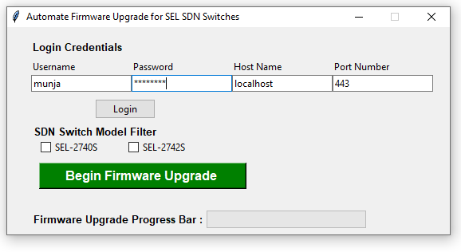

**Task 8: Improve and implement a freeze the graph option in the visNetowrk visualization graph.**

**Task 8: IO Test Report examples with OpenFlow.**

* How Allied Telesis fared in the testing process?
* Where can I find the test procedures derived from reference (b) and (c) and cybersecurity test results in references (d)?
* How can I access? System Tracking Program (STP). STP is accessible by .mil/.gov users at <https://stp.fhu.disa.mil/>.
* Also could not open Test reports, lessons learned, and related testing documents and references are on the JITC Joint Interoperability Tool (JIT) at <https://jit.fhu.disa.mil/>.
* The LANs are designed to meet traffic engineering and redundancy requirements, as required by applicable mission needs. The ASLANs may be designed to use any combination of the layers

and functional capabilities. ASLANs support assured services and provide enhanced availability

and backup power. Non-ASLAN need not meet assured services requirements.

* *The Unified Capabilities (UC) LAN components for ASLAN are Core, Distribution, and Access switches? How can we explain it?*
* The core layer is a high-speed switching backbone designed to switch packets as quickly as

possible. The distribution layer is the demarcation point between the access and core layers.

The distribution layer helps to define and differentiate the core, provides boundary definition,

and is the place at which packet manipulation can take place. The access layer is the point at

which local end users are allowed into the network. This layer may use access lists or filters to

optimize further the needs of a particular set of users.

* The UC architecture is a two-level network hierarchy consisting of Defense Information Systems Network backbone switches and Service/Agency installation switches.
* How can we decide which operational UC architecture in which the SUT may be used?
* Depending upon vendor maturity, testing is either conducted using homogenous and heterogeneous test configurations or just heterogeneous test configurations. What are the parameters we need to consider deciding which configuration to use?
* What is all Core, Distribution and Access products?
* How to identify the ASLAN products? based on table requirements ?

The points attached on the LinkedIn related to Internship

Technologies: Python, UI/UX design, RESTful API, ASP.Net, C#, SDN, vis.js, JavaScript, CSS, HTML5, Git, Visio plugins

• Designed and developed the Python windows application script to automate the firmware upgrade of all the Software Defined Networking (SDN)-enabled Switches and flow controller. Switches and Software-Defined-Network Flow Controller gives path- and packet-level control of communications flows, which eliminates common cybersecurity vulnerabilities in traditional LAN and improves fail-over performance to less than 100 μs.

• Developed Full stack ASP.Net Core web Application using RESTful API and web supporting technologies (JavaScript, CSS, HTML5, Razor) to answer all the sales customer queries on database and inventory details.

• Developed an interactive, dynamic, automatically organized Network visualization Graph to handle large amounts of network dataset modules consisting of nodes, edges and graphs using vis.js library

• Created and designed VISIO plugins and templates for network configuration creation and developed Architectural Flow Diagram and Data Flow Diagrams which will represent the physical and logical communication on the network respectively.

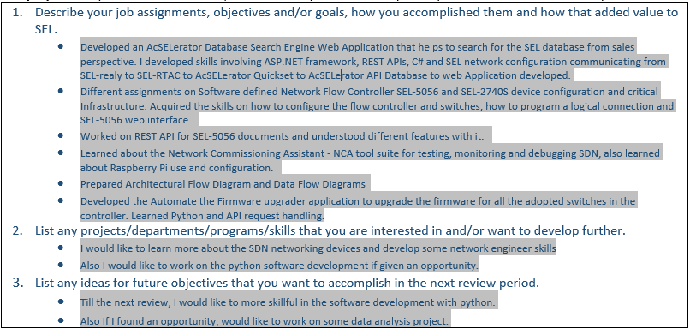

**SEL Configuration API SEL-5231**

* The SEL Configuration API is an application programming interface (API) that provides access to protection, security, and communications device configuration stored in the AcSELerator® Database and managed by Device Manager in AcSELerator QuickSet SEL-5030 Software.
* The API is deployed as a representational state transfer (RESTful) web service running as a Windows service. The RESTful web service is a de facto standard that can be accessed by client applications by using most programming languages.
* This manual describes the programming model and operations provided by the API. The target audience is the application programmer writing a custom application that accesses device configuration information.
* The resource model of the API closely follows the business object model presented in the Device Manager user interface. For example, both Device Manager and the API support creating, viewing, and updating devices. Device properties, displayed in their respective tabs in Device Manager, are accessed as properties of the device API resource. Composite resources of a device such as connection, settings working copy, and settings versions, are modeled as sub-objects of the device resource. Devices and folders are generalized as 'assets' in the API, and the hierarchy displayed and managed in the Connection Explorer is exposed in the asset node resource of the API.

Interview related

* **JavaScript** is a text-based programming language used both on the client-side and **server**-side that allows you to make web pages interactive. Where HTML and **CSS** are languages that give structure and style to web pages, JavaScript gives web pages interactive elements that engage a user
* Automated Unit Testing NUnit, MSTest <https://anarsolutions.com/automated-unit-testing-tools-comparison/>
* Below is Meshing Network Protocols (MQTT, CoAP)
* <https://www.researchgate.net/publication/342943599_MQTT-SN_CoAP_and_RTP_in_wireless_IoT_real-time_communications>
* Database Design: <https://www.datanamic.com/support/lt-dez005-introduction-db-modeling.html>
* .Net Core, Angular JS, TypeScript
* AngularJS
* <https://www.w3schools.com/angular/angular_intro.asp>
* TypeScript
* <https://www.tutorialspoint.com/typescript/typescript_basic_syntax.htm>
* After 31 min, token gets expired

Interview experiences online:

* C, C++, data structures, --- embedded programming, debugging and errors, --- system design, bit manipulation, C programming --- operating systems, mutexes, semaphores, some C coding
* Class, object, polymorphism, inheritance, encapsulation, interrupts, multi threading, try-throw-catch concepts, call by value, reference, pointers, **semaphore**, mutex, SRS, SDLC, stack, linkedlists, trees, OSI stack, TCP/IP, networking protocols. Go through job description and prepare accordingly.
* Personal questions, why SEL, dealing with hard people, struggles in school, small questions about threading and software design principals
* More technical questions about C++, threading, OO design, databases, network layers, and more
* Questions about presentation, data structures, file systems, interests, expect anything
* .
* They asked questions regarding algorithms, embedded systems,OS,networking and few coding interview questions.
* -
* 1) What is a semaphore? 2) Where union is used ? . Then I was given a programming assignment which I had to complete in half an hour . It was to reverse a string .
* -
* Reverse linked list, C multithreading, String manipulation, Software engineering process
* standard C++ competency questions, multithreading in C++
* What are the general requirements/criteria to be achieved in the software design?
* Describe the software development cycle?
* Replacing substrings within a string with a string without using temporary storage.
* The interview covered various aspects of software engineering, OOP concepts.
* Some questions are
* Tell me about SDLC and each stage.
* Explain OOP concepts in detail
* What are the features of .NET framework
* Garabage collection in .NET, use of dispose() method
* Boxing and Unboxing
* Function of CLR, CTS in .NET framework
* Managed vs Unmanaged code in .NET
* UML Diagrams, use of class, sequence, usecase diagram
* How do you write a design document
* What are design patterns and various types of design patterns
* -
* what is the use of keyword virtual? what are OOPs concepts, explain polymorphism with example
* difference between IPv4 and IPv6 , difference between tcp and udp, where they are used and why specifically , what is ARP and how it works
* -
* Onsite Interview starts with a tour of the company and continues with three rounds of interviews and one presentation. I was interviewed for C# position in Pullman, WA. Technical questions were majorly conceptual questions from C, C#, SQL Queries, OO Design Class Diagrams, SDLC
* -
* Can you describe what an index is?
* What are the forms of database normalization?
* -
* OOP concepts, Exception Handling, Recursion, String Manipulation, arrays, lists. Some memory-related questions like heap and stack. Call by value, call by reference, overloading etc
* Agile Methodologies, Object-Oriented Programming, Unit and Integration testing, C, C++ and C# and Software Design questions
* Type casting, Unions, Software requirement specifications, etc.

***OOPs C# Concepts:***

**Polymorphism and Overriding Methods**

* Polymorphism means "many forms", and it occurs when we have many classes that are related to each other by inheritance.
* Inheritance lets us inherit fields and methods from another class. Polymorphism uses those methods to perform different tasks. This allows us to perform a single action in different ways.
* the base class method overrides the derived class method, when they share the same name.
* However, C# provides an option to override the base class method, by adding the virtual keyword to the method inside the base class, and by using the override keyword for each derived class methods.

**Abstraction**:

* Data abstraction is the process of hiding certain information and showing only essential information to the user. Abstraction can be achieved by either **abstract classes** or **interfaces**.
* The **abstract** **keywork** is used for classes and methods.
* **Abstract class**: is a restricted class that cannot be used to create objects (to access it, it must be inherited from another class).
* **Abstract method**: can only be used in an abstract class, and it does not have a body. The body is provided by the derived class (inherited from).
* Why And When To Use Abstract Classes and Methods?
* To achieve security - hide certain details and only show the important details of an object.
* Note: Abstraction can also be achieved with Interfaces

**Interfaces**

* Another way to achieve abstraction in C#, is with interfaces.
* An interface is a completely "abstract class", which can only contain abstract methods and properties (with empty bodies)
* It is considered good practice to start with the letter "I" at the beginning of an interface, as it makes it easier for yourself and others to remember that it is an interface and not a class.
* By default, members of an interface are abstract and public.
* Note: Interfaces can contain properties and methods, but not fields.