**How to Introduce Yourself in English | Self Introduction**

What do you say when you meet someone new? Introduce yourself of course!

Introducing yourself is much more than saying your name. You need to tell some more information about you in English.

In this lesson, you will learn how to confidently introduce yourself in English.

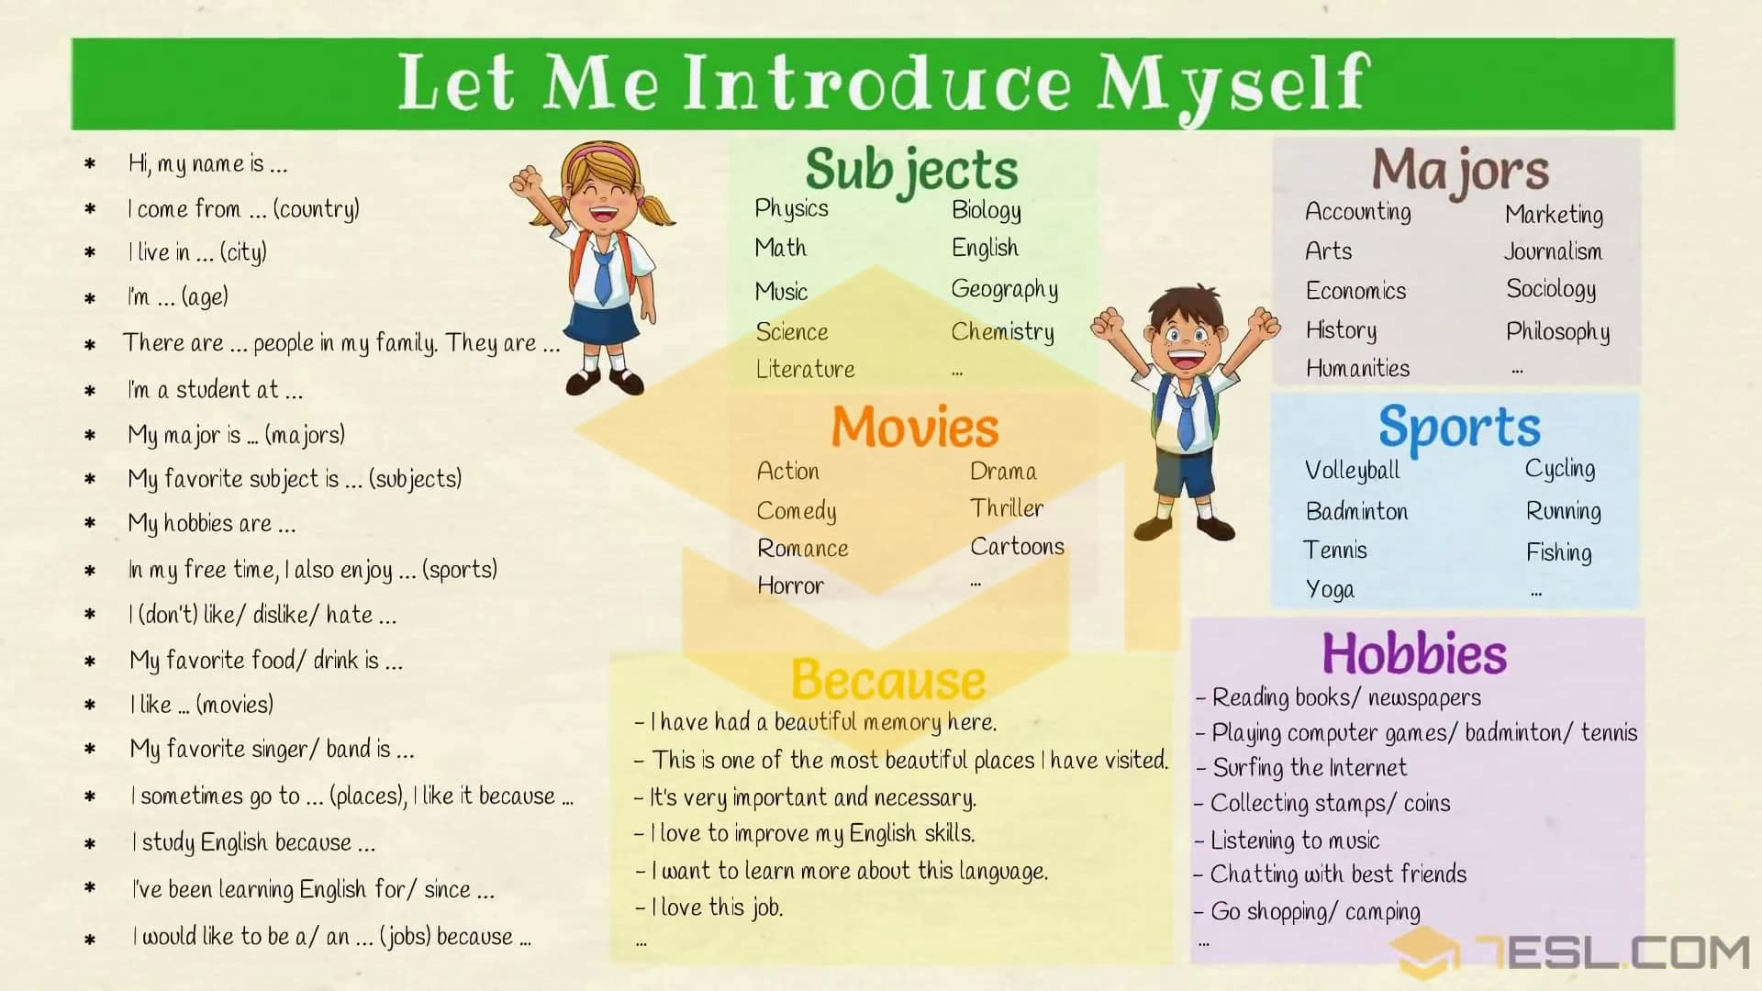

**Introduce Yourself: Name**

**Question: What’s your name?**

**Answers:**

* My name is …/ I’m …
* My full/ first/ last name is …
* You can call me …/ They call me …/ Please call me …/ Everyone calls me …
* My nick name is …

**Self Introduction: Country**

**Questions:**

**Where are you from?/ Where do you come from?**

**Where were you born?**

**Answers:**

* I’m from …/ I hail from …/ I come from …/ My hometown is …/ I’m originally from … ([country](https://7esl.com/countries-nationalities-and-languages/))
* I’m … ([nationality](https://7esl.com/countries-nationalities-and-languages/))
* I was born in …

**Introduce Yourself: Address**

**Question: Where do you live?/ What’s your address?**

**Answers:**

* I live in … / My address is … (city)
* I live on … (name) street.
* I live at …
* I spent most of my life in …
* I have lived in … for/ since …
* I grew up in …

**Self Introduction: Age**

**Question: How old are you?**

**Answers:**

* I’m … years old.
* I’m …
* I’m over/ almost/ nearly
* I am around your age.
* I’m in my early twenties/ late thirties.

**Introduce Yourself: Family**

**Questions:**

**How many people are there in your**[**family**](https://7esl.com/members-of-the-family/)**?**

**Who do you live with?/ With whom do you live?**

**Do you have any sibling?**

**Answers:**

* There are … (number) people in [my family](https://7esl.com/family-members-vocabulary-tree/). They are …
* There are … (number) of us in my family.
* My family has … (number) people.
* I live with my …
* I am the only child.
* I don’t have any siblings.
* I have … brothers and … (number) sister.

**Self Introduction: Birthday/ Phone number**

**Questions:**

**What is your date of birth?/ When is your birthday?**

**What is your phone number?**

**Answers:**

* My birthday is on …
* My phone number is …

**Introduce Yourself: Jobs**

**Questions:**

**What do you do?/ What do you do for living?/ What’s your**[**job**](https://7esl.com/jobs-and-occupations-vocabulary/)**?/ What sort of work do you do?/ What line of work are you in?**

**What did you want to be when you grew up?**

**Answers:**

* I am a/ an …
* I work as a/ an …
* I work for (company) … as a/ an …
* I’m unemployed./ I am out of work./ I have been made redundant./ I am between jobs.
* I earn my living as a/ an …
* I am looking for a job. / I am looking for work.
* I’m retired.
* I would like to be a/ an …/ I want to be a/ an …
* I used to work as a/ an … at … (places)
* I just started as … in the … department.
* I work in/at a … (places)
* I have been working in … (city) for … years.

[**Useful jobs**](https://7esl.com/jobs-and-occupations-vocabulary/)**for self introduction**: teacher, nurse, secretary, manager, cleaner, policeman, builder, engineer, businessman, fire fighter, postman, doctor, architect, farmer, …

**Useful places**: bank, factory, supermarket, museum, hospital, shop, gallery, …

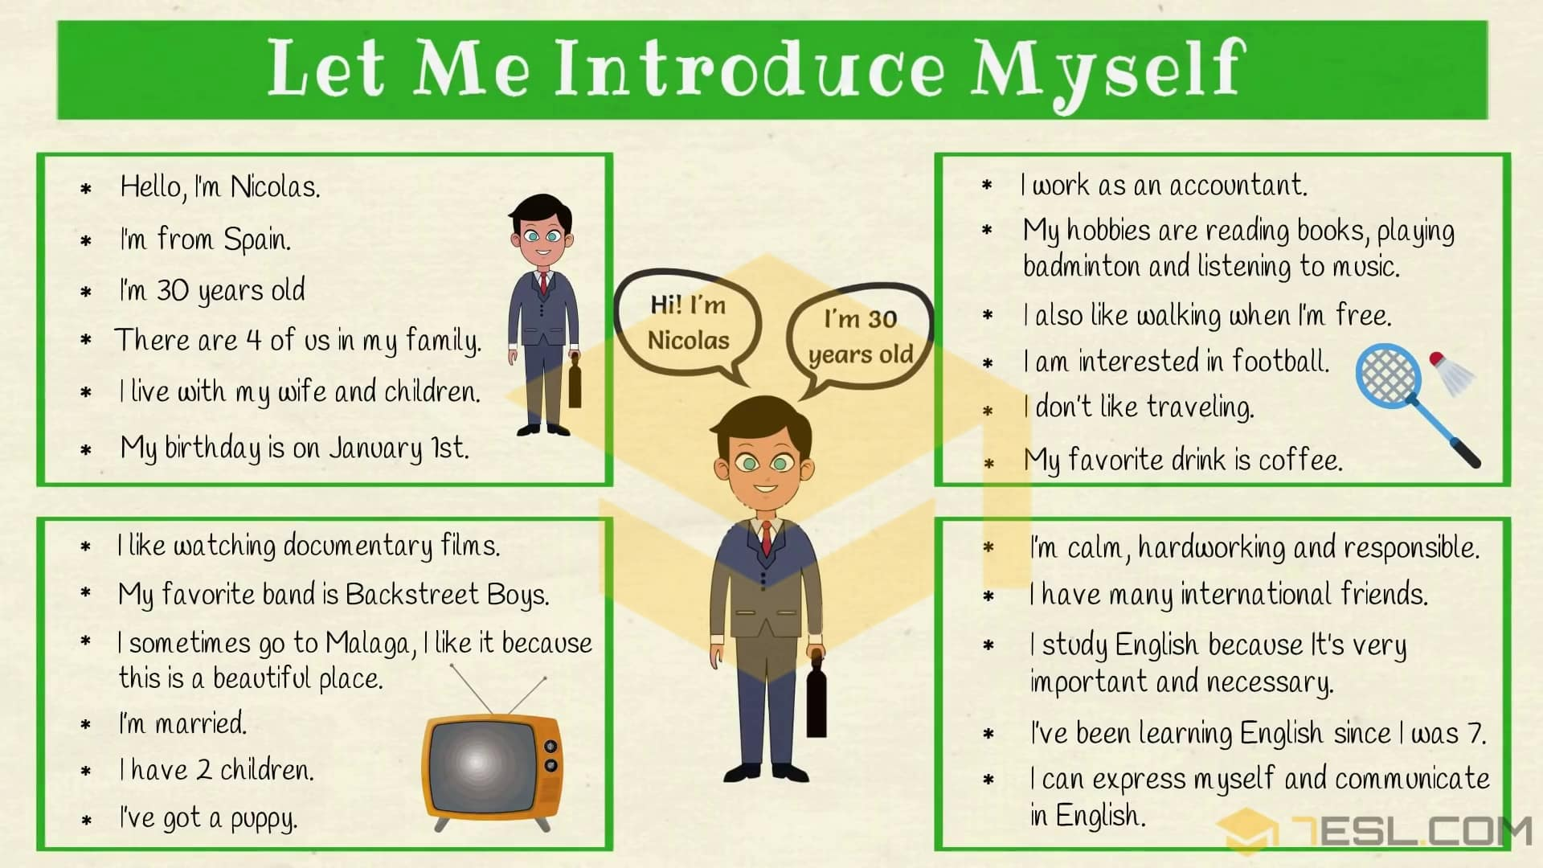

**Self Introduction: Hobbies**

**Questions:**

**What’s your hobby?/ What do you like?/ What do you like to do?/ What’s your favorite … ?**

**Answers:**

* I like/ love/ enjoy/ … (sports/ movies/ …/)
* I am interested in …
* I am good at …
* My hobby is …/ I am interesting in …
* My hobbies are …/ My hobby is …
* My favorite sport is …
* My favorite [color](https://7esl.com/colour-vocabulary/) is …
* My favorite place is …
* I sometimes go to … (places), I like it because …
* I don’t like/ dislike/ hate …
* My favorite [food/ drink](https://7esl.com/food-and-drinks-vocabulary/) is …
* My favorite singer/ band is …
* My favorite day of the week is … because …

**Because:**(self introduction sample)

* there are many things to see and do
* This is one of the most beautiful places I have been visited.
* I can relax there
* it’s relaxing/ popular/ nice/ …

**Hobbies**– Free time [activities](https://7esl.com/outdoor-games-activities-vocabulary/) for self introduction.

* Reading, painting, drawing
* Playing computer games
* Surfing the Internet
* Collecting stamps/ coins/ …
* Going to the cinema
* Playing with friends
* Chatting with best friends
* Going to the park/ beach/ zoo/ museum/ …
* Listening to music
* Shopping, singing, dancing, travelling, camping, hiking, …

**Movies**: action movie, comedy, romance, horror, document, thriller, cartoons, …

[**Sports**](https://7esl.com/sports-vocabulary/)**:** volleyball, badminton, tennis, yoga, cycling, running, fishing, …

**Questions:** **What do you like doing your free time?/ What do you do in your spare time?**

**Answers:**

* In my free time, I like …
* I like … when I’m free.
* At weekends I sometimes go to … (places)

**Introduce Yourself: Education**

**Questions:**

**Where do you study?**

**What do you study? / What is your major?**

**Answers:**

* I’m a student at MUST… ([school](https://7esl.com/school-vocabulary-english/))
* I study at …/ I am at …/ I go to … (school)
* I study … (majors)
* My major is …

**Majors in English:** accounting, advertising, arts, biology, economics, history, humanities, marketing, journalism, sociology, philosophy, …

**Questions:**

**Why do you study English?**

**Do you speak English?**

**How long have you been learning English?/ How long have you learned English?**

**Answers:**

* I study English because …
* I can speak English very well.
* I’ve been learning English for 6 years/ since 2008
* I can express myself and communicate in English.

**Because:**(self introduction sample)

* I like it a lot
* I love it.
* I think it’s important
* I have to
* It’s very important and necessary.
* I want to learn more about this language.
* I love to improve my English skills.

**Questions:**

**Which grade are you in?**

**Which year are you in?**

* I’m in … grade.
* I’m in my first/ second/ third/ final year.
* I am a freshman.
* I graduated from …/ My previous school was …

**Question: What’s your favorite subject?**

**Answers:**

* My favorite subject is …
* I am good at … (subjects)

**Subjects:**Maths, English, Physics, Physical Education, Science, Music, …

**Self Introduction: Marital status**

**Questions: What is your marital status?**

**Are you married?**

**Do you have a boyfriend/ girlfriend?**

**Answers:**

* I’m married/ single/ engaged/ divorced.
* I’m not seeing/ dating anyone.
* I’m not ready for a serious relationship.
* I’m going out with a … (someone)
* I’m in a relationship./ I’m in an open relationship.
* It’s complicated.
* I have a boyfriend/ girlfriend/ lover/ …
* I’m in love with … (someone)
* I’m going through a divorce.
* I have a husband/ wife.
* I’m a happily married man/ woman.
* I have a happy/ unhappy marriage.
* My wife/ husband and I, we’re separated.
* I am available.
* I haven’t found what I’m looking for.
* I’m ready for a [rebound](https://en.wikipedia.org/wiki/Rebound_(dating)) relationship.
* I’m a widow/ widower.
* I’m still looking for the one.
* I (don’t) have … (number) children.

**Introduce Yourself: Others**

* I’ve got a … (pet)
* I am a … person/ I’m … (character & personality)
* My best quality is … (character & personality)
* My best friend’s name is …
* I (don’t) have … (number) international friends.
* My dream is …

[**Character & Personality**](https://7esl.com/adjectives-that-describe-personality/)**for self introduction:**brave, calm, gentle, courteous, creative, hard-working, rude, unfriendly, unreliable, lazy, stingy, insensitive, …

[**Pets**](https://7esl.com/pets-vocabulary-english/)**:**dog, puppy, mouse, rabbit, cat, goldfish, …

Let Me Introduce Myself! Learn how to give self introduction in an English class.

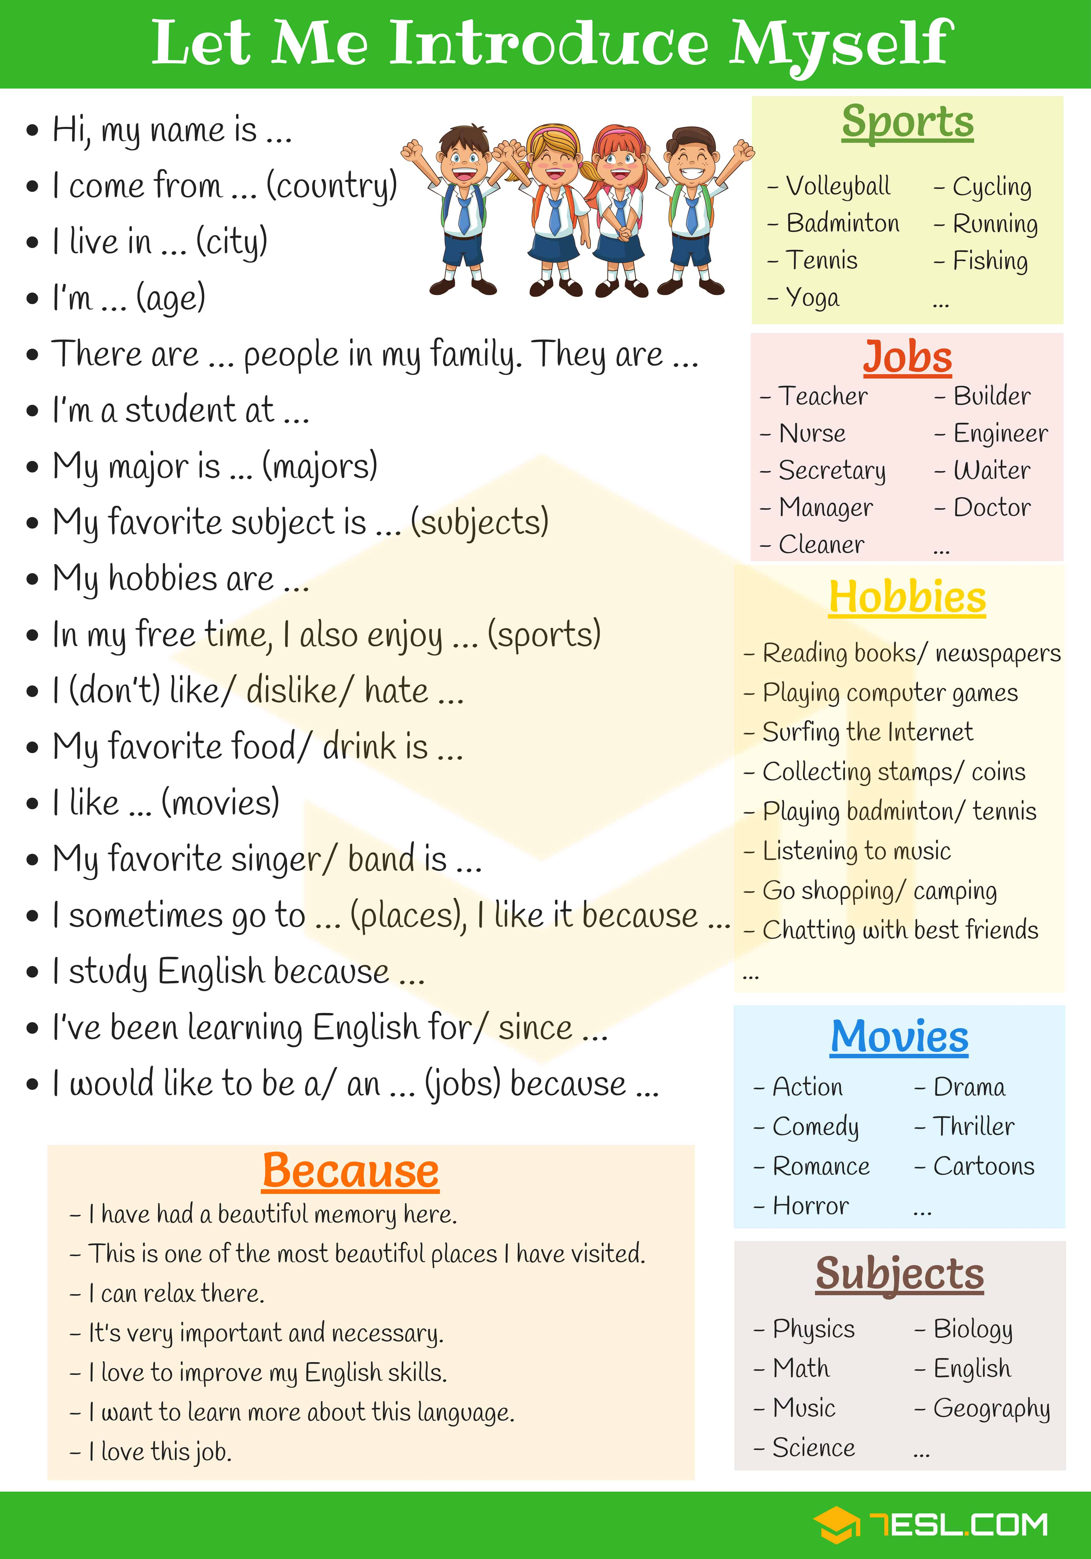

**How to Introduce Yourself in English | Self Introduction**

