Thaw-Induced Structural Degradation of Highway Pavements Under Sustained Warm-Air Events:
A 1D Enthalpy-Method Thermal Model with a Conceptual Bearing Capacity Index
Munkhtuvshin Mungunkhuu
University / Institution Name
munkhtuvshineast@gmail.com
June 2026 (revised October 2026)

Abstract
Extended warm-air intrusions in spring can thaw seasonally frozen pavement foundations faster than ordinary diurnal freeze–thaw cycling. This paper presents a one-dimensional enthalpy-method thermal model of a four-layer highway pavement (asphalt, granular base, subbase, subgrade) that includes the latent heat of fusion of pore water, and links the computed thaw-front depth to a conceptual Bearing Capacity Index (BCI). The model is verified against the Neumann (Stefan) analytical solution (front-depth error 1.0%) and is grid-converged to within 0.1% for dz ≤ 1.25 cm. Three 120-hour surface-temperature scenarios are compared. A Chinook-type event whose nights stay above freezing advances the thaw front by 25.6 cm (0.30 → 0.56 m), which is 3.4 times the advance under a standard thaw with freezing nights (7.5 cm) and 1.6 times the advance under a scenario with similar daytime peaks but freezing nights (15.5 cm). With the assumed water contents, the front does not reach the subgrade within 120 h; omitting latent heat would have predicted a front 0.47 m deeper (1.02 m versus 0.56 m) and a spurious loss of bearing capacity. Under sustained forcing (mean +8 °C), the front entered the subgrade after about 10.0 days and the BCI fell below 80% after about 16.1 days. A sweep of nightly minimum and daily maximum temperature shows that 120-hour thaw advance is governed by the mean temperature (closely tracked by the thawing index) rather than by the minimum or the maximum alone. Water contents and the BCI are assumed rather than site-calibrated, so results are qualitative and are intended to support, not replace, field validation.
Keywords: spring thaw, pavement, enthalpy method, latent heat, finite difference, bearing capacity, thawing index

1. Introduction
Highway pavements in cold regions experience repeated freeze–thaw cycling that degrades structural capacity. During spring thaw, ice in the foundation melts from the top down while the soil below is still frozen and nearly impermeable. Meltwater then cannot drain, pore pressures rise, effective stress falls, and the bearing capacity of the pavement structure drops sharply (Andersland & Ladanyi, 2004; Simonsen & Isacsson, 1999). This thaw weakening is the reason many northern jurisdictions impose seasonal load restrictions.
Warm-air intrusions such as Chinook winds in North America and Foehn winds in Europe can raise surface temperatures well above seasonal norms for several days at a time. Unlike a conventional spring thaw, where freezing nights partly refreeze the upper layers each day, such events can keep nighttime temperatures above 0 °C. Mechanistic pavement design tools include one-dimensional climatic modules (for example the Enhanced Integrated Climatic Model in the AASHTO Mechanistic-Empirical Pavement Design Guide; AASHTO, 2008), but it is not obvious how much sustained warm forcing matters compared with ordinary diurnal forcing, nor how strongly the answer depends on the latent heat of the pore water.
This paper makes three contributions: (1) a one-dimensional enthalpy-method thermal model of a four-layer pavement that includes latent heat, verified against an analytical solution and checked for grid convergence; (2) an explicit, reproducible, but conceptual BCI function that converts thaw-front depth to a bearing-capacity measure; and (3) a quantitative comparison of how surface-forcing type, pore-water content, and event duration control thaw advance and the time to load-restriction thresholds. The model is not validated against field measurements; the water contents and the BCI are assumptions, and the results should be read as a process study.

1.1 Research Objectives
- Develop and verify a computationally efficient 1D model of pavement thermal response that includes the latent heat of fusion.
- Compare thaw-front advance under an extreme warm-night event, a standard thaw, and a freezing-night scenario with matched daytime peaks.
- Quantify the sensitivity of the thaw front to latent heat, water content, initial ground temperature and numerical resolution, and estimate how long sustained warm forcing must last before the subgrade begins to thaw.
- Identify which feature of the surface temperature series (nightly minimum, daily maximum, or mean) best explains thaw advance.

2. Background

2.1 Freeze–Thaw Mechanics in Pavement Subgrades
The advance of a freezing or thawing front in soil is classically described by the Stefan problem and its extensions (Aldrich & Paynter, 1953; Carslaw & Jaeger, 1959; Lunardini, 1991). The latent heat of fusion of pore water is large relative to the sensible heat of warming the soil by a few degrees. Consequently, in wet soils the front moves much more slowly than a pure diffusion calculation suggests. Frost action also draws water toward the freezing front and forms ice lenses; on thawing, these lenses release water into soil that cannot drain quickly (Andersland & Ladanyi, 2004).

2.2 Thermal Models of Pavement Systems
Analytical frost-penetration solutions date back to Berggren (1943). Numerical finite difference and finite element models extend them to layered systems, variable boundary conditions and phase change, typically through an apparent heat capacity or enthalpy formulation (Lunardini, 1991). The enthalpy method used here conserves energy across the phase-change zone and is simple to implement on a fixed grid.

2.3 Bearing Capacity Degradation During Thaw
Bearing capacity loss during thaw is non-linear in thaw depth and depends on drainage conditions. Strength loss is greatest while thaw is confined to the upper part of the frozen subgrade and meltwater cannot escape downward (Simonsen & Isacsson, 1999). Load restriction programs in cold jurisdictions commonly rely on air-temperature or thaw-index triggers rather than on the depth or duration of the warm event. Whether a duration-aware trigger would perform better is an open question that this paper can only inform, not settle.

3. Methodology

3.1 Model Domain and Pavement Structure
The pavement is a 0.10 m asphalt surface, a 0.25 m granular base, a 0.30 m subbase, and a subgrade whose uppermost 0.50 m (0.65–1.15 m depth) is treated as the active layer for bearing capacity. The model domain extends to 2.0 m so that the lower boundary does not control the thaw front within the simulated period. Thermal conductivity, density and specific heat are representative values of the magnitude given in standard heat-transfer references (e.g. Cengel, 2003); they are assumed, not measured. Volumetric water contents θ, which set the latent heat available, are also assumptions (Table 1) and are varied in Section 4.4.
Table 1. Pavement layer properties used in the simulation.
Layer | Thickness (m) | k (W/m·K) | ρ (kg/m³) | cp (J/kg·K) | θ (vol. water)
Asphalt | 0.10 | 1.05 | 2300 | 920 | 0.00
Granular base | 0.25 | 1.30 | 2000 | 840 | 0.05
Subbase | 0.30 | 0.90 | 1800 | 800 | 0.10
Subgrade | 0.50 active (domain to 2.0 m) | 0.50 | 1600 | 1200 | 0.25

3.2 Governing Equations
Heat conduction with phase change is solved in enthalpy form, which conserves energy through the freezing zone:
∂H/∂t = ∂/∂z ( k(z) ∂T/∂z ) (1)
The volumetric enthalpy is H(T) = C·T + L_{θ}·g(T), with C = ρ·c_{p} the volumetric heat capacity of the layer and L_{θ} = θ·ρ_{w}·L_{f} the latent heat per unit volume (L_{f} = 334 kJ/kg, ρ_{w} = 1000 kg/m³). The liquid fraction g rises linearly from 0 at T = −ΔT to 1 at T = 0 °C, with ΔT = 0.5 °C representing the gradual melting of pore water:
g(T) = 0 for T ≤ −ΔT; (T + ΔT)/ΔT for −ΔT < T < 0; 1 for T ≥ 0 (2)
Within the freezing band, the effective heat capacity is C + L_{θ}/ΔT. For the subgrade, L_{θ} = 0.25 × 334 × 10⁶ = 8.4 × 10⁷ J/m³, which equals the sensible heat of warming that soil by about 43 °C. Latent heat therefore dominates the energy budget of a barely frozen subgrade.

3.3 Numerical Scheme
Equation (1) is discretized with an explicit forward-in-time, centered-in-space scheme on a uniform grid with dz = 0.01 m (201 nodes). Interface conductivities are harmonic means of the adjacent nodal values, which preserves flux continuity across layer boundaries:
H_{i}^{n+1} = H_{i}^{n} + (Δt/Δz²) [ k_{i+½}(T_{i+1} − T_{i}) − k_{i−½}(T_{i} − T_{i−1}) ] (3)
Temperature is recovered from H by inverting H(T) analytically. The time step is set to Δt = 0.25·min(C·Δz²/k), which is 32.3 s at dz = 0.01 m, so that the explicit stability number based on sensible heat capacity does not exceed 0.25 (the limit is 0.5). The upper boundary is a Dirichlet condition equal to the surface temperature of the scenario (Section 3.4); the lower boundary at 2.0 m is a Dirichlet condition of −2 °C. The surface condition treats pavement surface temperature as equal to air temperature and ignores solar radiation, convection and snow cover.

3.4 Initial Conditions and Surface-Temperature Scenarios
Initial temperatures are piecewise-linear in depth through (0, +2.0 °C), (0.10 m, +2.0 °C), (0.35 m, −0.5 °C), (0.65 m, −1.0 °C) and (2.0 m, −2.0 °C). This places the initial 0 °C isotherm at 0.30 m, in the upper part of the granular base, and represents a pavement at the onset of spring thaw. All scenarios start from this state. Time t is in hours.
Table 2. Surface-temperature scenarios (120 h unless noted).
Scenario | Surface temperature T(t) (°C) | Range (°C)
Extreme (Chinook-type) | 8 + 7·sin(2πt/24 − π/2) + 3·exp(−(t − 60)²/800) | +1.0 to +18.0
Peak-matched | 4.5 + 10.5·sin(2πt/24 − π/2) | −6.0 to +15.0
Standard | 2 + 7·sin(2πt/24 − π/2) | −5.0 to +9.0
Sustained (duration study, 504 h) | 8 + 7·sin(2πt/24 − π/2) | +1.0 to +15.0

The Extreme scenario has nighttime lows of about +1 °C at the start and end of the event and about +3.5 °C near its middle, because of the Gaussian pulse. The Peak-matched scenario has similar daytime peaks (15 °C) but freezing nights, so it tests whether warm nights, rather than warm days, drive the response. The Sustained scenario removes the pulse and is run for 21 days to estimate the duration needed to thaw the subgrade.

3.5 Thaw Front and Bearing Capacity Index
The thaw front is the deepest 0 °C crossing, located by linear interpolation between nodes; the reported thaw depth is its running maximum, so night-time refreezing of the near-surface layers does not reduce it. The thawed fraction of the active subgrade is f = clip((d − 0.65)/0.50, 0, 1), where d is the thaw depth. The BCI (0–100%) is a piecewise-linear function of f through the anchor points in Table 3. These anchors encode the qualitative regimes described in the literature (little loss while the subgrade is almost entirely frozen, rapid loss early in thaw, slower decline later). They are an assumption and have not been calibrated against site measurements; recovery through drainage is not modeled. The 80% (load restriction) and 60% (road closure) thresholds are illustrative.
Table 3. BCI anchor points (linear interpolation between them).
Thawed fraction f of active subgrade | BCI (%) | Regime
0.00 | 100 | Fully frozen subgrade
0.05 | 95 | Little loss
0.30 | 45 | Rapid loss (undrained meltwater)
0.70 | 20 | Slower decline
1.00 | 10 | Near-total loss

4. Results

4.1 Model Verification and Grid Convergence
The model was checked against the Neumann solution for a homogeneous half-space (k = 0.5 W/m·K, C = 1.92 MJ/m³·K, θ = 0.25, constant surface temperature 5 °C, initially frozen at the freezing point, dz = 5 mm). After 120 h the analytical front depth is 0.1579 m and the numerical value is 0.1594 m, a difference of 0.96%. For the layered pavement under the Extreme scenario, the front depth after 120 h changes by less than 0.1% when dz is reduced from 1.25 cm to 0.5 cm (Table 4). A 5 cm grid underestimates the depth by 1.9% and, more importantly, can only move the front in discrete 5 cm increments, which produces stair-step artefacts in thaw depth and any quantity derived from it.
Table 4. Grid convergence, Extreme scenario (front depth at 120 h).
dz (m) | Δt (s) | Front depth (m) | Difference from finest
0.0500 | 807.5 | 0.5452 | -1.91%
0.0250 | 201.9 | 0.5491 | -1.20%
0.0125 | 50.5 | 0.5557 | -0.01%
0.0100 | 32.3 | 0.5556 | -0.04%
0.0050 | 8.1 | 0.5558 | —

4.2 Temperature Field Under the Extreme Event
Figures 1 and 2 show the response to the Extreme scenario. The thaw front advances from 0.30 m to 0.56 m over 120 h, crossing 0.35 m (the base/subbase interface) after about 17 h and 0.45 m after about 63 h. It does not reach the subgrade at 0.65 m: at t = 120 h the temperature at 0.65 m is −0.5 °C and at 1.0 m it is −1.1 °C. The diurnal temperature wave attenuates quickly with depth: over the last day, the daily temperature range is 5.7 °C at 0.1 m, 2.8 °C at 0.2 m, 1.6 °C at 0.3 m and 0.6 °C at 0.5 m. Below about 0.3 m the temperature is controlled mainly by the multi-day trend.
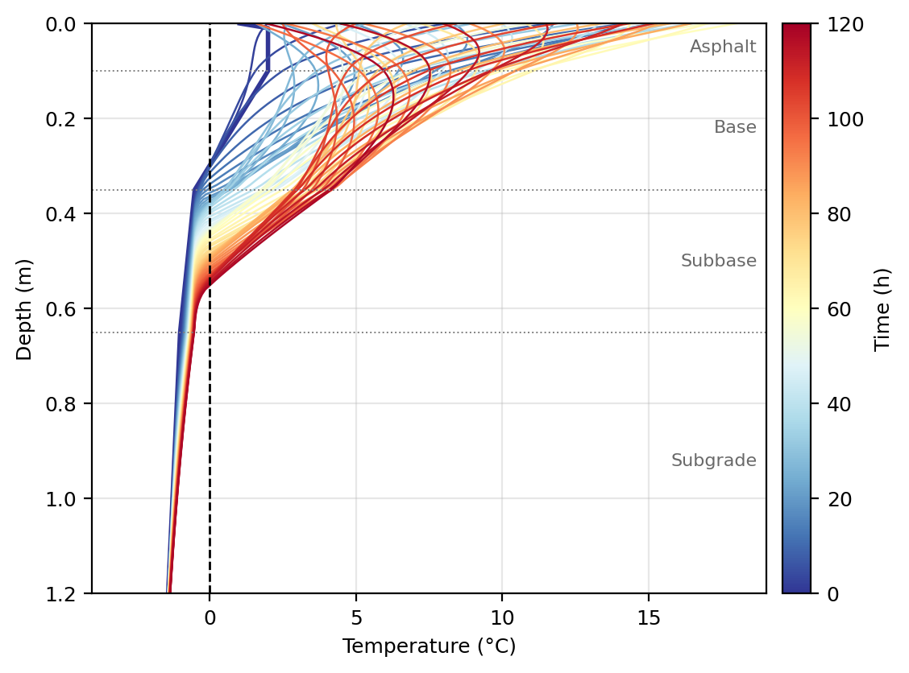
Figure 1. Temperature profiles at 2-h intervals during the 120-h Extreme scenario. Colour indicates time; bold lines show t = 0, 60 and 120 h. The dashed vertical line is 0 °C and dotted horizontal lines mark layer interfaces.
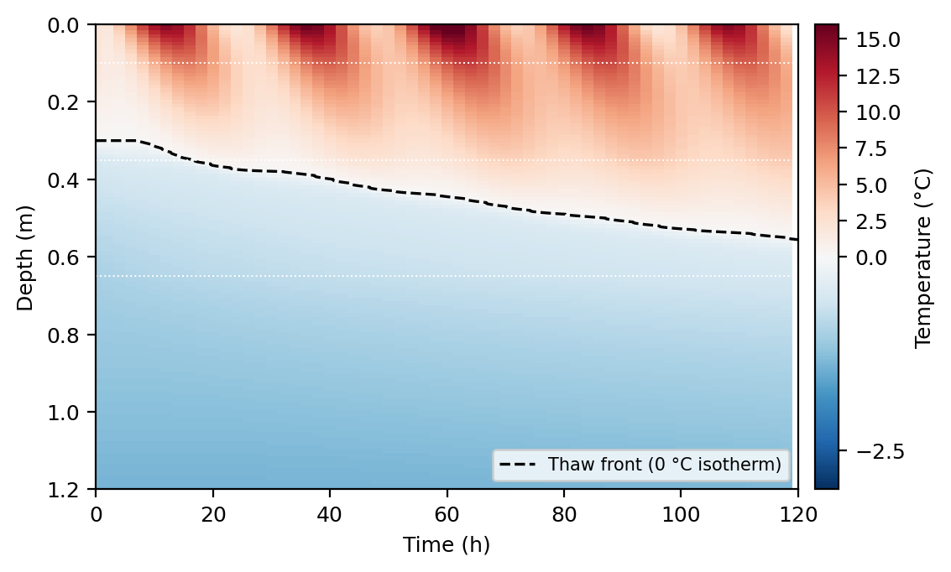
Figure 2. Subsurface temperature field for the Extreme scenario. The dashed line is the thaw front (0 °C isotherm); dotted white lines mark layer interfaces.

4.3 Comparison of Surface-Temperature Scenarios
Table 5 and Figure 3 compare the three scenarios. The Extreme scenario advances the front by 25.6 cm, the Peak-matched scenario by 15.5 cm, and the Standard scenario by 7.5 cm. Warm nights therefore multiply the advance by about 1.6 relative to freezing nights at similar daytime peaks. The thawing index (degree-hours above 0 °C of surface temperature) ranks the scenarios in the same order, and the advance per unit thawing index is similar across them (0.023, 0.022 and 0.019 cm per °C·h), so the thawing index tracks the thaw advance reasonably well here.
Table 5. Scenario comparison over 120 h.
Scenario | Surface range (°C) | Thawing index (°C·h) | Max thaw depth (m) | Advance from 0.30 m (cm)
Extreme | +1 to +18 | 1110 | 0.556 | 25.6
Peak-matched | −6 to +15 | 709 | 0.455 | 15.5
Standard | −5 to +9 | 398 | 0.375 | 7.5

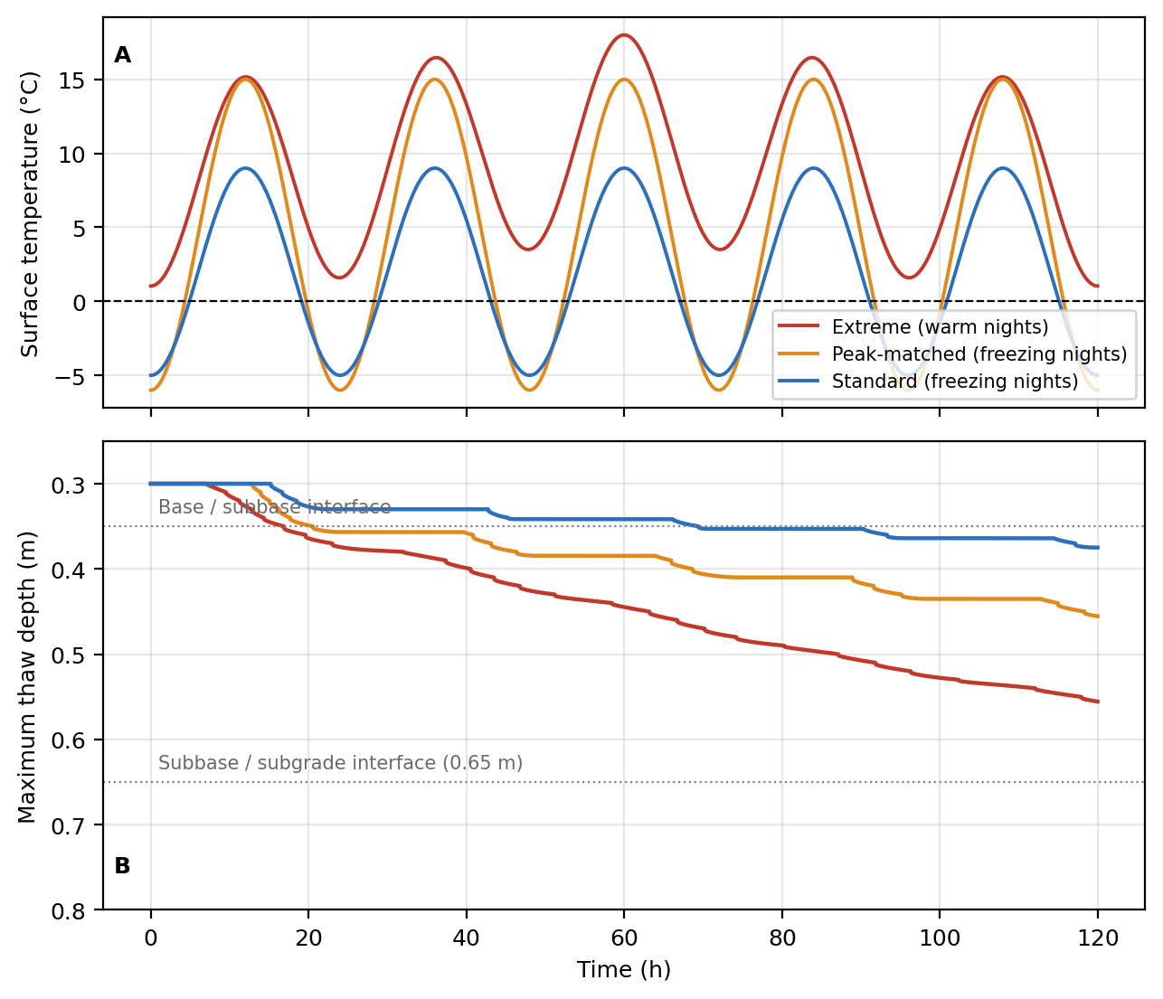
Figure 3. (A) Surface-temperature forcing for the three 120-h scenarios. (B) Maximum thaw depth (running maximum of the deepest 0 °C crossing). None of the scenarios reaches the subgrade at 0.65 m within 120 h, so the BCI remains at 100% throughout.

4.4 Role of Latent Heat and Sensitivity
Table 6 shows how the 120-hour Extreme-scenario result depends on the assumptions. Removing latent heat changes the outcome qualitatively: the front enters the subgrade after 26 h, reaches 1.02 m, and the BCI falls to 19%, spending 82 h below 80% and 71 h below 60%. The same no-latent-heat model on the original 1.15 m domain with a −4 °C lower boundary gives a front at 0.84 m and a minimum BCI of 40%. This is the type of rapid bearing-capacity collapse that a pure diffusion model suggests, and it is an artefact of neglecting the energy needed to melt pore ice. With latent heat, only the case with half the baseline water content reaches the subgrade (at 119 h, with negligible BCI loss). Initial subgrade-top temperature (−2.0 to −0.3 °C) and the width of the freezing band change the 120-h depth by only a few centimetres (0.55 to 0.61 m), much less than the effect of latent heat itself.
Table 6. Sensitivity of the Extreme-scenario result at 120 h. “—” means the front did not reach the subgrade.
Case | Time to subgrade (h) | Max depth (m) | Min BCI (%) | h < 80% | h < 60%
Baseline (water x1.0, subgrade-top -1.0, deep -2.0 at 2 m) | — | 0.556 | 100 | 0 | 0
No latent heat (original assumption) | 26 | 1.022 | 19 | 82 | 71
Water content x0.5 | 119 | 0.653 | 99 | 0 | 0
Water content x1.5 | — | 0.500 | 100 | 0 | 0
Warmer initial subgrade top (-0.3 C) | — | 0.607 | 100 | 0 | 0
Colder initial subgrade top (-2.0 C) | — | 0.545 | 100 | 0 | 0
Narrow freezing band (0.25 C) | — | 0.557 | 100 | 0 | 0
Wide freezing band (1.0 C) | — | 0.586 | 100 | 0 | 0
Original geometry (1.15 m, -4 C bottom), no latent heat | 29 | 0.839 | 40 | 70 | 48

4.5 Duration of Warm Forcing Needed to Thaw the Subgrade
Because 120 h is not long enough for the subgrade to thaw with latent heat included, the Sustained scenario (mean +8 °C, no pulse) was run for 21 days (Figure 4, Table 7). At baseline water content the front reached the top of the subgrade after 10.0 days, the BCI fell below 80% after 16.1 days, and it was still 64% at day 21 (it never fell below 60%). Halving the water content brought these times forward to 5.8, 9.1 and 12.4 days for subgrade arrival, 80% and 60%, with a BCI of 36% at day 21. Increasing it by 50% delayed subgrade arrival to 14.1 days and the BCI stayed above 85% throughout. In this model, therefore, the BCI declines over days, not hours. In the half-water case it took 78 h (3.2 days) to go from the load-restriction to the road-closure threshold.
Table 7. Sustained forcing (mean +8 °C): times to key events.
Water content | Subgrade reached (days) | BCI < 80% (days) | BCI < 60% (days) | BCI at day 21 (%)
×0.5 | 5.8 | 9.1 | 12.4 | 36
×1.0 (baseline) | 10.0 | 16.1 | — | 64
×1.5 | 14.1 | — | — | 86

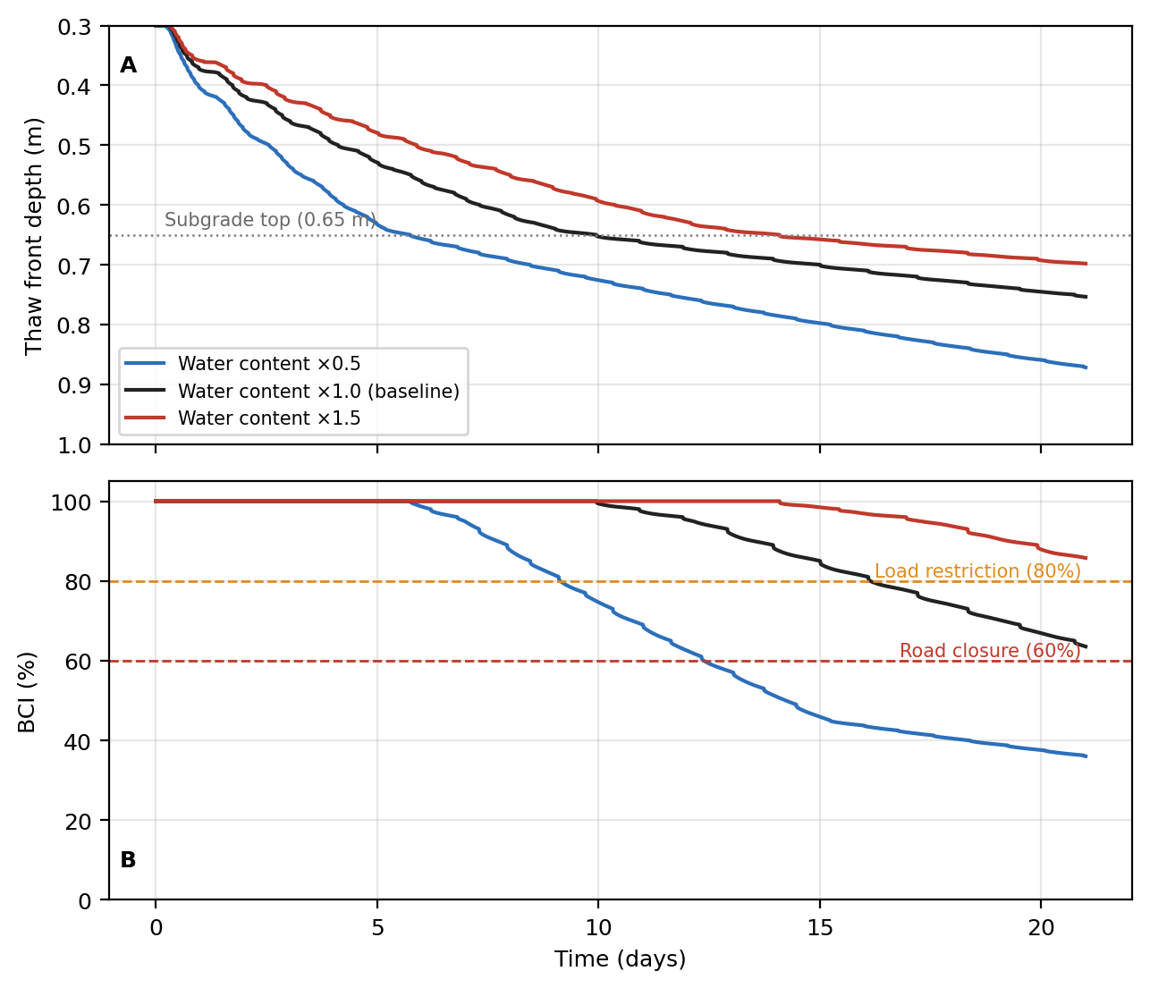
Figure 4. Sustained forcing (mean +8 °C, ±7 °C diurnal, no pulse) over 21 days, with subsurface water content scaled by 0.5, 1.0 and 1.5. (A) Maximum thaw depth. (B) BCI with the illustrative load-restriction (80%) and road-closure (60%) thresholds.

4.6 What Controls Thaw Advance?
To test which feature of the surface temperature matters, 63 simulations were run with sinusoidal forcing over a grid of nightly minimum (−8 to +4 °C) and daily maximum (8 to 20 °C) temperatures (Figure 5). The contours of thaw advance in 120 h run parallel to lines of constant mean temperature. Near the middle of the grid, raising the daily maximum by 2 °C adds 2.09 cm of advance and raising the nightly minimum by 2 °C adds 2.06 cm, which is effectively the same. Thaw advance therefore depends on the mean temperature, not on the nightly minimum or the daily maximum separately.
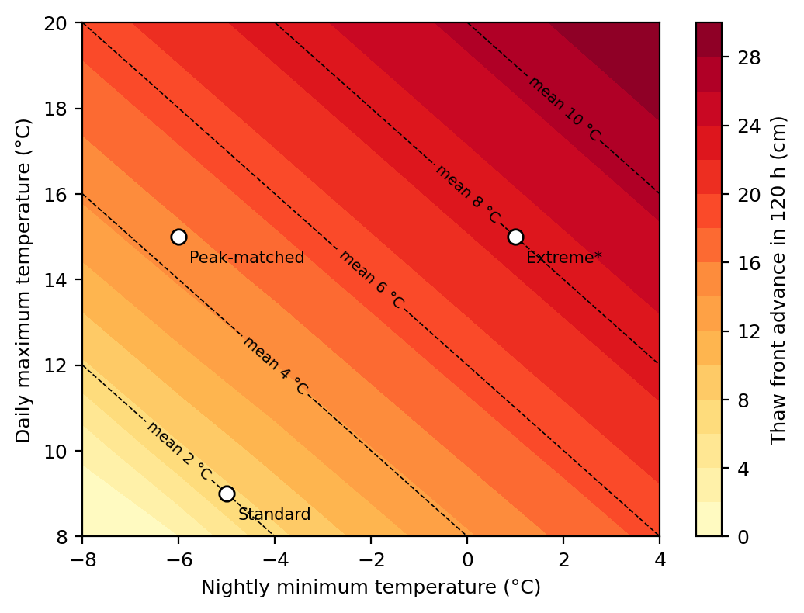
Figure 5. Thaw-front advance over 120 h for sinusoidal surface forcing as a function of nightly minimum and daily maximum temperature. Dashed lines are contours of mean temperature. *The Extreme marker shows the sinusoid without the +3 °C pulse (+1/+15 °C); the full Extreme scenario advances somewhat further.

5. Discussion

5.1 Latent Heat Controls the Timing of Subgrade Thaw
The main lesson of the simulations is that the neglect of latent heat can change the conclusion. A conduction-only model sends the front into the subgrade within about a day (26 h in Table 6) and predicts a large bearing capacity loss from a five-day warm spell. When latent heat is included, the same event thaws the base and subbase but leaves the subgrade frozen, and the subgrade begins to thaw only after roughly 10.0 days of sustained warmth at baseline. The result depends strongly on pore-water content (Table 7), which is poorly constrained here and should be measured at a real site before any quantitative use.

5.2 Persistence Acts Through the Mean Temperature
Warm nights matter in these simulations because they raise the mean surface temperature and prevent the upper layers from refreezing. They have no separate effect: a 2 °C rise in nightly minimum and a 2 °C rise in daily maximum produce the same additional thaw. The practical implication is that a multi-day forecast of mean temperature, or of the cumulative thawing index, is a more appropriate indicator of foundation thaw than either the peak daytime temperature or a single night's minimum. Thawing-index approaches are already used in practice; what this study adds is a simple mechanistic illustration of why a persistent warm spell is much more damaging than a series of warm days with cold nights.

5.3 Implications for Load Restriction Protocols
Under the assumed properties, the model suggests that a restriction triggered at the first above-freezing surface temperature precedes the thaw of the subgrade by many days, and that the BCI then declines over days rather than hours. This does not by itself justify delaying restrictions. The BCI used here depends only on subgrade thaw and ignores weakening of the already-thawed base and subbase, infiltration of rain and meltwater, and traffic. One hypothesis that could be tested in the field is a two-part approach: an advisory based on a forecast thawing index, confirmed by a subsurface temperature sensor near the subbase/subgrade interface. Trigger values would have to be calibrated against measured deflection or strength data, which this study does not provide.

5.4 Limitations
- Water contents, thermal properties and the BCI function are assumed. Results are qualitative and no field validation was performed.
- Conductivity does not change between frozen and thawed states and does not depend on moisture; frozen soil is usually more conductive, which would speed the front somewhat.
- The surface boundary uses air temperature directly, with no radiation, convection, snow or rain, and no meltwater movement. Real pavements may be warmer than the air by several degrees in sunshine.
- The model is one-dimensional, uses a single initial state, and does not model drainage or the recovery of strength after thaw.
- Only the front depth is used to compute the BCI; weakening of the base, subbase and asphalt is not represented.

6. Conclusion
A 1D enthalpy-method model of a four-layer pavement with latent heat was verified against an analytical solution (error 1.0%) and converged on the grid to within 0.1%. The main findings are:
- Under a 120-h Chinook-type event with warm nights, the thaw front advanced 25.6 cm (to 0.56 m), 3.4 times the advance under a standard thaw and 1.6 times the advance under freezing nights with similar daytime peaks. It did not reach the subgrade, and the BCI stayed at 100%.
- Neglecting latent heat overestimates the 120-h front depth (1.02 m versus 0.56 m) and produces a spurious bearing-capacity collapse. Water content is the most influential assumption.
- Under sustained warm forcing (mean +8 °C), the subgrade began to thaw after about 10.0 days (5.8 to 14.1 days for water content ×0.5 to ×1.5), and the BCI fell below 80% after about 16.1 days at baseline. The decline takes days, not hours.
- Thaw advance depends on the mean surface temperature (closely tracked by the thawing index), not on the nightly minimum or the daily maximum separately. Warm nights matter because they raise the mean and suppress refreezing.
Future work should calibrate water content, conductivity and the BCI with field data from instrumented pavements, add frozen/thawed conductivity and a surface energy balance, represent drainage and weakening of the base layers, and test candidate restriction triggers against measured strength.

References
AASHTO. (2008). Mechanistic-Empirical Pavement Design Guide: A Manual of Practice (Interim ed.). American Association of State Highway and Transportation Officials.
Aldrich, H. P., & Paynter, H. M. (1953). Analytical studies of freezing and thawing of soils (Technical Report 42). U.S. Army Corps of Engineers, Arctic Construction and Frost Effects Laboratory.
Andersland, O. B., & Ladanyi, B. (2004). Frozen ground engineering (2nd ed.). John Wiley & Sons.
Berggren, W. P. (1943). Prediction of temperature distribution in frozen soils. Eos, Transactions American Geophysical Union, 24, 71–77.
Carslaw, H. S., & Jaeger, J. C. (1959). Conduction of heat in solids (2nd ed.). Oxford University Press.
Cengel, Y. A. (2003). Heat transfer: A practical approach (2nd ed.). McGraw-Hill.
Lunardini, V. J. (1991). Heat transfer with freezing and thawing. Elsevier.
Simonsen, E., & Isacsson, U. (1999). Thaw weakening of pavement structures in cold regions. Cold Regions Science and Technology, 29(2), 135–151.

Appendix A: Simulation Source Code
The core model is listed below (Python 3, NumPy only). The accompanying files study.py (verification, convergence, scenarios, sensitivity, duration and sweep studies, producing results.json) and make_figures.py (Matplotlib; Figures 1–5) reproduce every number and figure in this paper. Run with: python study.py && python make_figures.py
"""1D enthalpy-method thaw model for a four-layer highway pavement (core model)."""
import numpy as np

LATENT = 334e3 * 1000.0 # J/m3 of water (L_f * rho_w)
# name, top depth (m), k (W/m.K), rho (kg/m3), cp (J/kg.K), volumetric water content
LAYERS = [("Asphalt", 0.00, 1.05, 2300, 920, 0.00),
("Granular base", 0.10, 1.30, 2000, 840, 0.05),
("Subbase", 0.35, 0.90, 1800, 800, 0.10),
("Subgrade", 0.65, 0.50, 1600, 1200, 0.25)]
SG_TOP, SG_ACTIVE = 0.65, 0.50 # subgrade top depth and "active" thickness used for BCI (m)
BCI_F = [0.00, 0.05, 0.30, 0.70, 1.00] # thawed fraction of active subgrade
BCI_VAL = [100.0, 95.0, 45.0, 20.0, 10.0] # Bearing Capacity Index (%)

def forcing(kind):
"""Surface temperature (degC) as a function of time in hours."""
if kind == "extreme": # Chinook-type: mean +8, +/-7 diurnal, +3 pulse centred at 60 h
return lambda h: 8 + 7*np.sin(2*np.pi*h/24 - np.pi/2) + 3*np.exp(-(h-60)**2/800)
if kind == "sustained": # extreme mean/diurnal range without the pulse (used for duration studies)
return lambda h: 8 + 7*np.sin(2*np.pi*h/24 - np.pi/2)
if kind == "standard": # warm days, freezing nights: -5 .. +9
return lambda h: 2 + 7*np.sin(2*np.pi*h/24 - np.pi/2)
if kind == "peakmatched": # same daytime peak as the extreme case, freezing nights: -6 .. +15
return lambda h: 4.5 + 10.5*np.sin(2*np.pi*h/24 - np.pi/2)
raise ValueError(kind)

def initial_profile(z, t_sg0=-1.0, t_deep=-2.0):
return np.interp(z, [0, 0.10, 0.35, 0.65, 2.0], [2.0, 2.0, -0.5, t_sg0, t_deep])

def bci(f):
return np.interp(f, BCI_F, BCI_VAL)

def thaw_depth(T, z):
"""Depth (m) of the deepest 0 degC crossing (linear interpolation); 0 if nothing is thawed."""
pos = np.nonzero(T > 0)[0]
if len(pos) == 0: return 0.0
i = pos[-1]
if i == len(T) - 1: return z[-1]
return z[i] + (z[i+1]-z[i]) * T[i] / (T[i] - T[i+1])

def simulate(kind="extreme", dz=0.01, hours=120, depth=2.0, dt=None, band=0.5, latent=True,
water_scale=1.0, t_sg0=-1.0, t_deep=-2.0, snap_every_h=2, rec_every_s=60,
layers=None, forcing_fn=None, init_fn=None):
layers = LAYERS if layers is None else layers
z = np.arange(0, depth + dz/2, dz); n = len(z)
k = np.zeros(n); C = np.zeros(n); Lt = np.zeros(n)
for name, top, kk, rho, cp, th in layers:
m = z >= top - 1e-9
k[m], C[m], Lt[m] = kk, rho*cp, (LATENT*th*water_scale if latent else 0.0)
kh = 2*k[:-1]*k[1:]/(k[:-1]+k[1:]) # harmonic-mean interface conductivity
dt_max = 0.25*np.min(C*dz**2/k) # explicit stability (r <= 0.25 on sensible capacity)
dt = dt_max if dt is None else min(dt, dt_max)
dt = hours*3600/np.ceil(hours*3600/dt) # make steps divide the run exactly
Ca = C + Lt/band # slope of H(T) inside the freezing band
def H_of_T(T):
return np.where(T <= -band, C*T, np.where(T >= 0, C*T + Lt, -C*band + Ca*(T+band)))
def T_of_H(H):
return np.where(H <= -C*band, H/C, np.where(H >= Lt, (H-Lt)/C, -band + (H + C*band)/Ca))
Ts = forcing_fn if forcing_fn is not None else forcing(kind)
T = init_fn(z) if init_fn is not None else initial_profile(z, t_sg0, t_deep)
T = np.array(T, float); T[-1] = t_deep
H = H_of_T(T)
nsteps = int(round(hours*3600/dt)); rec = max(1, int(round(rec_every_s/dt))); snap = int(round(snap_every_h*3600/dt))
ts, depths, snaps, snap_t = [], [], [], []
for s in range(nsteps + 1):
h = s*dt/3600
T[0] = Ts(h); H[0] = H_of_T(T[:1])[0]
if s % rec == 0: ts.append(h); depths.append(thaw_depth(T, z))
if s % snap == 0: snaps.append(T.copy()); snap_t.append(h)
if s == nsteps: break
q = kh*(T[1:] - T[:-1])/dz
H[1:-1] += dt*(q[1:] - q[:-1])/dz
T = T_of_H(H); T[0] = Ts((s+1)*dt/3600); T[-1] = t_deep
ts, depths = np.array(ts), np.maximum.accumulate(np.array(depths)) # running maximum of the 0 degC front
f = np.clip((depths - SG_TOP)/SG_ACTIVE, 0, 1)
return dict(z=z, t=ts, depth=depths, f=f, bci=bci(f), snaps=np.array(snaps), snap_t=np.array(snap_t), dt=dt, dz=dz)

def metrics(r):
t, d, b = r["t"], r["depth"], r["bci"]; step = t[1]-t[0]
hit = np.nonzero(d >= SG_TOP)[0]
return dict(t_subgrade=(t[hit[0]] if len(hit) else np.nan), d_final=d[-1], d_max=d.max(),
bci_min=b.min(), h_below80=(b < 80).sum()*step, h_below60=(b < 60).sum()*step)

