Research Agenda
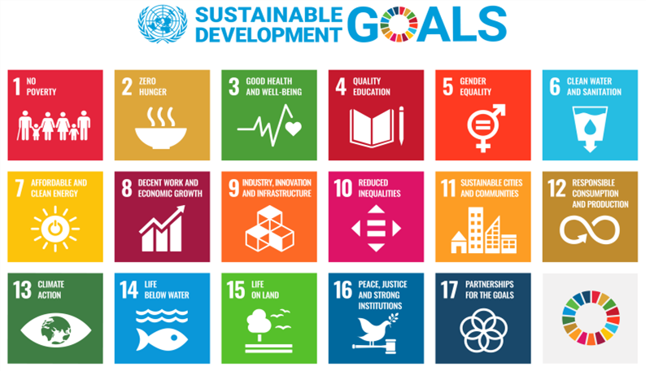
SDGs 1, 2, 3, 4, 5, 8, 9, 11, 13 & 16

Capstone Projects

A capstone project is the culminating requirement for the completion of BSIT program.


It deals with the analysis, design and implementation of the proposed software project
Students are required to present a working implementation of the system.
A software project shall be developed individually and shall be evaluated through an oral defense and skill test.

General Objectives
▪ Gain practical experience in the software development by completing a software project.
▪ Learn technical skills for analysis, design and programming of software systems.

Track Concentrations
Web Applications Development - use of web technologies to design and develop aesthetically looking and functional web applications and web services
Mobile Application Development - design & develop cutting edge mobile applications.
Multimedia Applications Development - Develop innovative and creative applications that combines audio, video, graphics, sounds and animation.
Intelligent Systems Development – development of a system that has the capacity to gather and analyze data and use them to assist in decision making.

Actors in the Project

Student
identifies, approaches and solves a problem



Adviser
provides guidance to help you achieve success in your project; critically point out strengths and weaknesses



Panel
critically evaluates your work, and recommends or decides the outcome of the defense

Process
Capstone Capstone
Project Concept
Capstone
Defense
ProposalDevelopment

Developing your proposal
Capstone Capstone
Project Concept
Capstone
Defense
ProposalDevelopment
A project proposal is a brief description of what you intend to do. You need to introduce the:
Subject area. What is the topic and scope of your project?
Aim. What is the goal of your project?
Arguments. Why is it important to investigate the chosen topic?
Objectives. Preliminary ideas for how you intend to achieve the aim.

Choosing the project
Capstone Capstone
Project Concept
Capstone
Defense
ProposalDevelopment
The project must have a clear outcome (in terms of deliverables) that focuses on a direction.
The project links suitably with your degree course
The project is of sufficient scope and quality to fit the requirements of your course.
The project idea is something that interests you
The resources required for the project are available or can be obtained

Choosing the project
Capstone Capstone
Project Concept
Capstone
Defense
ProposalDevelopment
The project must have a clear outcome (in terms of deliverables) that focuses on a direction.
The project links suitably with your degree course
The project is of sufficient scope and quality to fit the requirements of your course.
The project idea is something that interests you
The resources required for the project are available or can be obtained

Proposal Capstone
Project Concept
Capstone
Defense
HearingDevelopment
Adviser endorses for proposal hearing to the ETEEAP office.
The purpose of the session is for the panel members to evaluate the feasibility of the proposed project with consideration on the tools/technology used and time frame.
The proponent and the panel members agree on the specification of the project which includes list of MUST-HAVES and NICE-TO-HAVES.
Capstone Capstone ProposalDevelopment
Information
Session
Capstone
Defense
Capstone Capstone ProposalDevelopment
Information
Session
Capstone
Defense

