**Distance Learning Scheduling App**

**Senior Project**

**Fall 2019**

**Users’ Manual**

**Requirements**

* PHP
* MySQL
* Angular
* Windows, Mac or Linux OS
* Browser

**Installation**

***Download and Install Locally***

Download PHP from <https://www.php.net/manual/en/install.php> and follow the instruction on <https://www.sitepoint.com/how-to-install-php-on-windows/> to install it.

Download MySQL community server from <https://dev.mysql.com/downloads/mysql/> and follow the instruction on <https://www.sitepoint.com/how-to-install-mysql/>.

Angular requires Node.js version 10.9.0 or later which can be downloaded from <https://nodejs.org/en/>

After downloading all the requirements, follow the following steps:

1. Get the App
2. Get Distance Learning Scheduling App on your device by either cloning or downloading the git repository *https://github.com/sthamun/DLSchedulingApp.git*.
3. Set up Angular
4. Open a terminal/command prompt and go to the file path *DLSchedulingApp/DL_Scheduling_Client*
5. Run the command- *npm install -g @angular/cli* to install Angular CLI which will generate application and library code.
6. Run *npm start* or *npm serve* to launch the server and build the application.
7. Connect to Database
8. Go to the file path [*DLSchedulingApp*](https://github.com/sthamun/DLSchedulingApp)*/DL_Scheduling_Client/backend/api* and change the database credentials on *database.php* file.
9. Start the MySQL server which will be available in system preferences.
10. On a terminal/ command prompt, login to your MySQL account with the command

*mysql -u <username> -p <password>*.

1. After successful login, create a new database named *DLScheduling* and use the database with commands:

*CREATE DATABASE dbname;*

*Use DLScheduling*

1. Execute all the SQL files present on DLSchedulingApp folder. These files will create the required tables and enter required data.
2. Run PHP server
3. Open a new terminal/command prompt and go to the file path [*DLSchedulingApp*](https://github.com/sthamun/DLSchedulingApp)*/DL_Scheduling_Client/backend*
4. Run the command *php -S 127.0.0.1:8080* to run the built-in php server.
5. Run the app in a browser
6. Openany browser and go to *localhost:4200* this will load the login page of the app.

***Deployment:*** In Progress

For now all the files have to be manually deleted to uninstall this web application.

**Use**

There are two types of users for this application- student workers and admin (manager of Distance Learning). The landing page is login page. After successful login, both admin and student workers will be directed to the homepage where they can view work schedule. It shows Distance learning(DL) classes schedules for all the DL classrooms. There are different tabs for different days of the week on top of the schedule. A click on the desired day tab will display the schedule of that particular day.

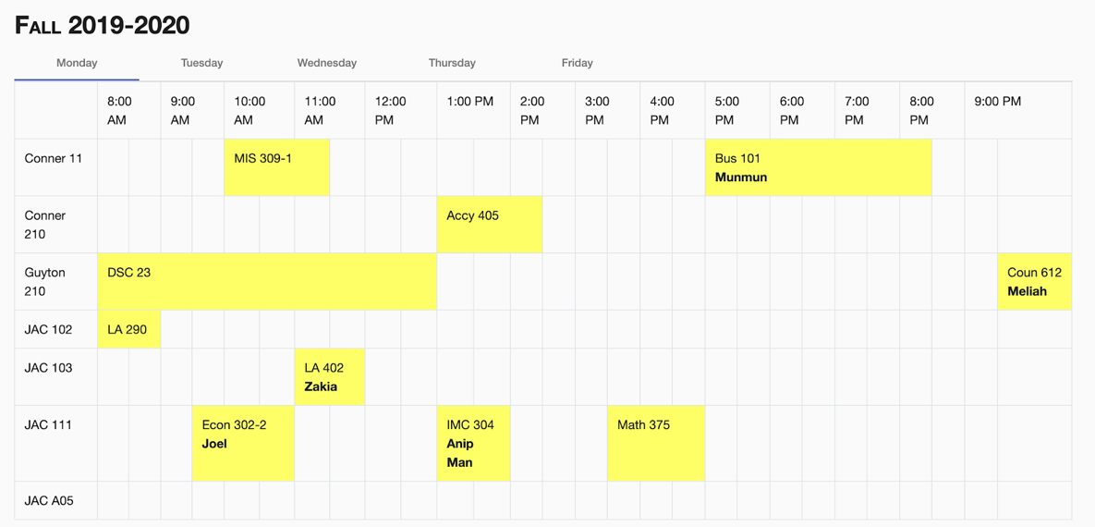

Fig: Work Schedule view on homepage

There is a menu button on the top left corner of the screen. A click on the button will list all the available pages which are different for different types of users.

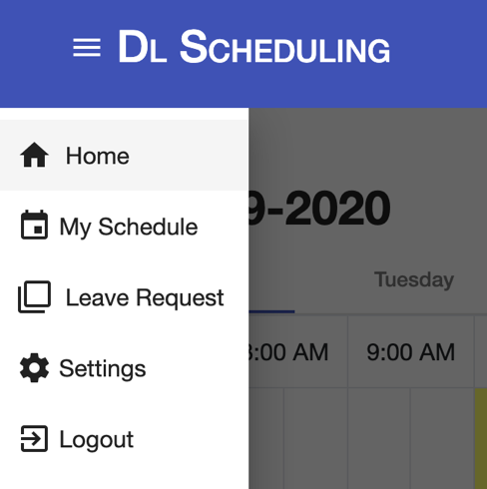 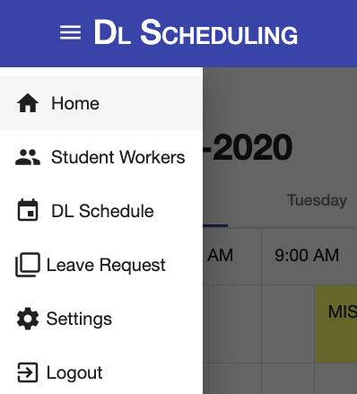

Fig: Menu for student workers Fig: Menu for admin

***Student Workers Interface***

There are 4 pages for public interfaces.

1. Home

Student workers can view overall work schedule on this page as described above.

1. My Schedule

Student workers can view their personal schedule on this page.It displays their schedule for the whole week on the same page. This schedule is color coded. Their class schedule and unavailable times to work are displayed in grey and their assigned work hours are displayed in yellow.

Student workers can also add their schedule from this page by clicking on the ‘Add Schedule’ button at the bottom left of the schedule. A click on this button will display a form shown below:

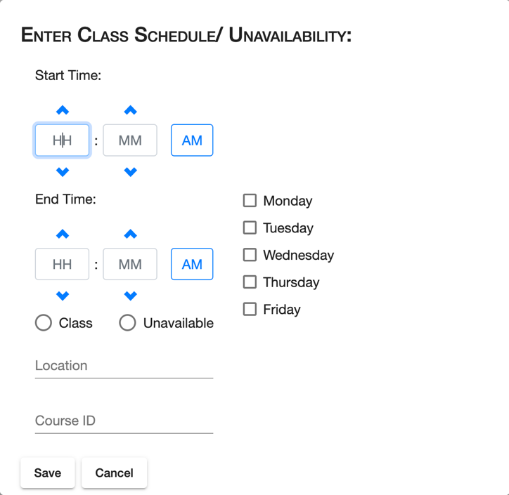

Fig: Form to add new student schedule

The inputs, ‘Location’ and ‘Course ID’ are enabled only if ‘Class’ is selected in the radio button. Multiple days of the week can be selected to add the same schedule to multiple days. Once all the input fields are filled out, they can click on ‘Save’ button to close the form and view the new schedule in ‘My Schedule’ page. They can click on ‘Cancel’ button if they want to close the form without saving.

1. Leave Request

The ‘Request Leave’ page has a date-time picker from where student workers can choose the date for requesting a leave. If the student worker does not have any assigned work hours on the selected date, it will display that they do not have work on that day. If they have work hours on the selected date, all their assigned work hours (DL classes) will be listed as a checkbox. They can request a leave for one or more DL classes assigned to him by checking the checkbox and hitting the ‘Request’ button. This will send an email to the admin informing about the new leave request.

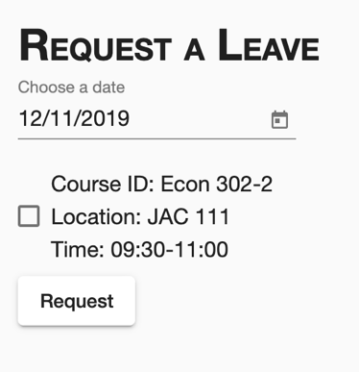 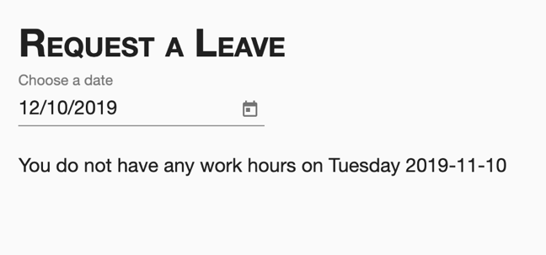

Fig: Leave Request page

1. Settings

Student workers can change their account information from ‘Settings’ page. They can edit their name, email, password and preferred number of hours by clicking the edit button on the right of each information field.

***Admin Interface***

There are 4 pages for public interfaces.

1. Home

Admin can view overall work schedule or all the DL class schedule on this page as described above.

1. Student Workers

This page includes a list of all the student workers information. Admin can edit or delete each student worker by clicking on the edit or delete button on the rightmost column. The admin can also add new student workers by clicking on the ‘Add Student Workers’ button at the bottom left end of the table. This will display a dialog box with a form to enter student worker’s information. On clicking the ‘Save’ button, the new student worker will be added to the table and an email will be sent to the new student worker stating that his account has been created in the DL Scheduling App. The admin can click on the ‘Cancel’ button on the form to close the form without saving.

1. DL Schedule

This page shows the same work/DL schedule as shown in homepage. The admin can add new DL class and assign student workers to existing DL classes through the buttons ‘Add DL Class’ and ‘Assign Student Workers’ at the bottom left end below the schedule.

The ‘Add DL Class’ will display a dialog box with a form to enter DL class information. This form is similar to the form to enter student worker’s schedule in ‘My Schedule’ page. The admin has to enter the course ID, location, start time, end time and days of the week. On clicking the ‘Save’ button, the new DL class will be saved in the database and it will be displayed on the schedule.

The ‘Assign Student Workers’ button will direct to a different page with a drop down list of weekdays. Select the day to display a list of all the DL classes on that day. Click on the row of the table with the desired course to display the course detail of that particular course below the table. The course details also includes a drop down list of all the student workers available to work in that class. Select a student and click ‘Assign’ button which is at the bottom left to assign the DL class to the selected student worker.

The admin can view course details of different course by simply clicking on a different row on the table with the desired course.

1. Leave Request

This page displays a list of all the leave requests which require action. Admin can accept the request by clicking the check marked button and reject it by clicking the cross button in the action column as shown in the figure.

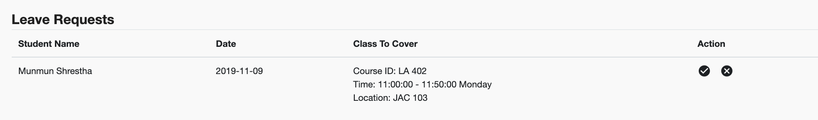

Fig: List of leave request which can be accepted/rejected

1. Settings

Admin can change their account information from ‘Settings’ page. They can edit their name, email and password by clicking the edit button on the right of each information field.

**Maintenance and Possible Enhancement**

1. Currently, the app can only enter schedule of one semester so the data in student schedule and DL schedule table needs to be reset to enter schedules for the new semester. This can be enhanced by letting the admin set the current semester which will archive the data from older semesters to a different table. The app will display data from only the current semester.
2. The users cannot change the schedule once they save it. The data has to be manually changed in the database. This can be enhanced by including a functionality to edit the schedule on the same page which displays the schedule.
3. The admin can view the available student workers to assign them DL classes to work. In future, this app can be enhanced to automatically assign DL classes to available student workers once all the DL classes are entered.