A COMPUTATIONAL AND ANALYTICAL APPROACH FOR CLOUD COMPUTING SECURITY WITH USER DATA MANAGEMENT
ABSTRACT:
Cloud computing is emerging trend in today’s research world. The main benefits of cloud computing are the adaptability, domain compatibility and better service use. So, the applicability of cloud computing in different domain is the main strength with the ease of resource sharing. As the increasing demand of cloud computing make a broader span in the direction of user-data security. In this paper empirical meta-analysis has been provided in the direction of cloud computing security. It also includes complete discussion based on the results achieved in the same. This paper provides the analytical and empirical view of cloud computing security. The major aspect covered in this paper is data security, data management and efficient resource sharing mechanism. It also covers the computational aspect their applicability and the analytical view for the study and analysis. It explores the wider view and the area of applicability in different domain with the ease of data management and secure data sharing mechanism.
Keywords: cloud computing security , Data Management , Resource Sharing Mechanism
PROBLEM STATEMENT:
The main aim of our project is covered data security, data management and efficient resource sharing mechanism. Here we are providing Prevention Mechanism to handle internal and external threats. It is also suggested that it should covered data loss handling and data retention mechanism to avoid data violation and loss in any way, and here we are using Homomorphic encryption to provide the security.

MOTIVATION
Cloud computing represents a transformative paradigm in research, offering adaptability, domain compatibility, and enhanced service delivery. This paper explores its diverse applicability across domains, emphasizing robust resource sharing. Addressing escalating security concerns, it presents an empirical meta-analysis on cloud computing security, focusing on data security, efficient data management, and computational aspects. This study provides analytical insights into enhancing secure data sharing mechanisms amidst evolving technological landscapes.
OBJECTIVE OF THE PROJECT
The objective of this paper is to conduct an empirical meta-analysis focusing on cloud computing security. It aims to explore and analyze the adaptability, domain compatibility, and service utilization benefits of cloud computing. The study emphasizes data security, efficient data management, and resource sharing mechanisms across various domains. Through analytical and empirical insights, it seeks to enhance understanding and implementation of secure and effective cloud computing practices.
SCOPE
The objective of this paper is to conduct an empirical meta-analysis focusing on cloud computing security. It aims to explore and analyze the adaptability, domain compatibility, and service utilization benefits of cloud computing. The study emphasizes data security, efficient data management, and resource sharing mechanisms across various domains. Through analytical and empirical insights, it seeks to enhance understanding and implementation of secure and effective cloud computing practices.
EXISTING SYSTEM:
The problems identified based on the recent survey and analyses are as follows: There is the need of data sensitivity calculation to apply security in terms of data sensitivity and the size of the data. There is the need of specific hierarchical or level-based orientation. There is the need of data prevention mechanism in terms of security leak or identification of such leak in the timely manner. There is the need of holomorphic encryption as the chances and the substitution are completely different so that the security may enhance. There is the need of deterrent controls so that the warning system can be maintained.

DIS ADVANTAGES:
- Providing less Security to the Data.
- Less efficiency.
- There is no external and inter threats

PROPOSED SYSTEM:
They have suggested the maximum approaches uses for the data integrity are RSA based which has higher computational overhead. So, they have proposed a data integrity approach. This approach is based on the short signature algorithm. It has been used for the verification purpose. It supports security. It reduces the computational overhead. It has been found to be efficient and safe. It shows the current requirement of the todays cloud computing environment. It shows the need of data handling mechanism and resource sharing with the protective view from internal and external threats. It also shows that it may be helpful in the data retention and maintain the required integrity for the security.

ADVANTAGES:
- Improving Data Privacy.
- Providing more Security to the Data.
- High efficiency.
- Anonymity of data sharing.
- Confidentiality of outsourced data.

PROJECT FLOW
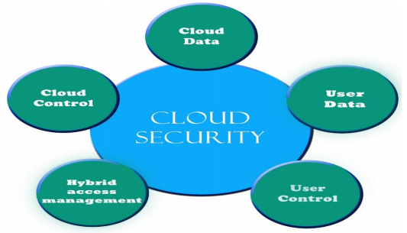

HARDWARE & SOFTWARE REQUIREMENTS
SYSTEM REQUIREMENTS

H/W System Configuration:-

Processor - I3/Intel Processor
- RAM - 4GB (min)
- Hard Disk - 160GB
- Key Board - Standard Windows Keyboard
- Mouse - Two or Three Button Mouse
- Monitor - SVGA
S/W System Configuration:-
- Operating System : Windows 7/8/10
- Application Server : Tomcat 9.0
- Front End : HTML, JSP
- Scripts : JavaScript.
- Server side Script : Java Server Pages.
- Database : My SQL 6.0
- Database Connectivity : JDBC

MODULES:
Data Maintainer
Data Maintainer can login with his entities and them View Users, View Files, Check Threats, View Solved Threats, and Logout
User:
Here User can register and login with OTP with his entities and they have View Users, upload Data, View Data, Share Data, View Shared Data and then user can logout

