

# Training Management Software (TMS) for Electoral Training Institute

Features of the Software:

1. Interactive, dynamic and multimedia oriented homepage
2. Responsive design and Compatible to all browsers
3. Bilingual information in Bengali and English
4. Multi-user Controlled by Admin
5. Reporting and Import/Export data
6. SSL

Scope of the works:

1. User ID creation [3 types: *Admin, * Officials of ETI, Others]
2. Create,Edit,Delete, Active/Inactive users, centres, faculty
3. Designation, department setup
4. Profile of Each employees
5. Trainers profile
6. Auto-generated invitation letter
7. Auto-generated List
8. Auto-generated Acquittance
9. Auto-generated Attendance
10. Auto-generated Release Order
11. Crystal Report to check data within date range [for easy export]
12. Dormitory allocation
13. Notices with automated google translation feature

**Menu Architecture**

* Dashboard (with search program schedules)
* Human Resources
  + Setup
    - Centre & Faculties
    - Departments
  + Employees
    - Officers & Stuffs
    - Trainers
  + Attendance
    - Upload Data [will do later]
    - Edit Attendance
    - Attendance history
* Training Programs
  + Setup
    - Training Categories
    - Training Programs
    - Restore Program
    - Letter Templates
  + Dormitory
    - Dormitory Setup
    - Rooms Setup
  + Participants
    - Upload Participants
    - Manage Participants (Biodata with Pictures)
    - Assign to Training Program
    - Print Invitation Letter
    - Participant Attendance
* Reports (10 crystal reports after Forms complete)
  + Employees
    - List by Branches
  + Training Programs
    - Programs by Participants
    - Room Allotment By Programs (Report)
* Maintenance (Keep everything from existing software)

**Forms Layouts**

* + 1. Login Form

[Place EC logo Everywhere, Replace Extreme Solutions by Optimum Soft]

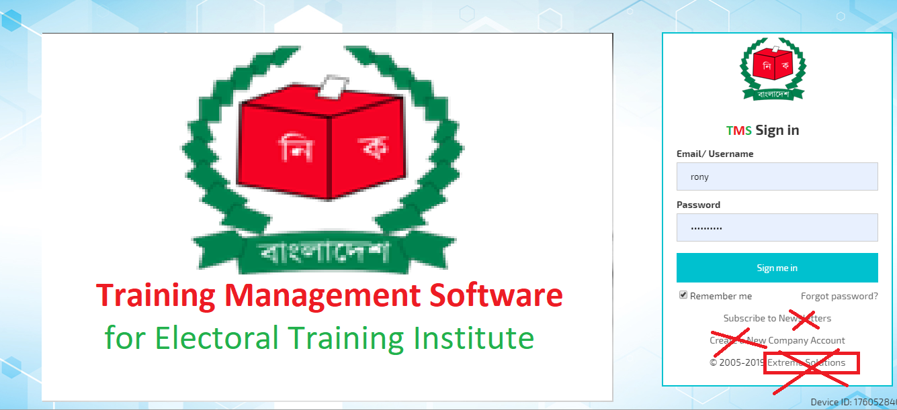

* + 1. Dashboard

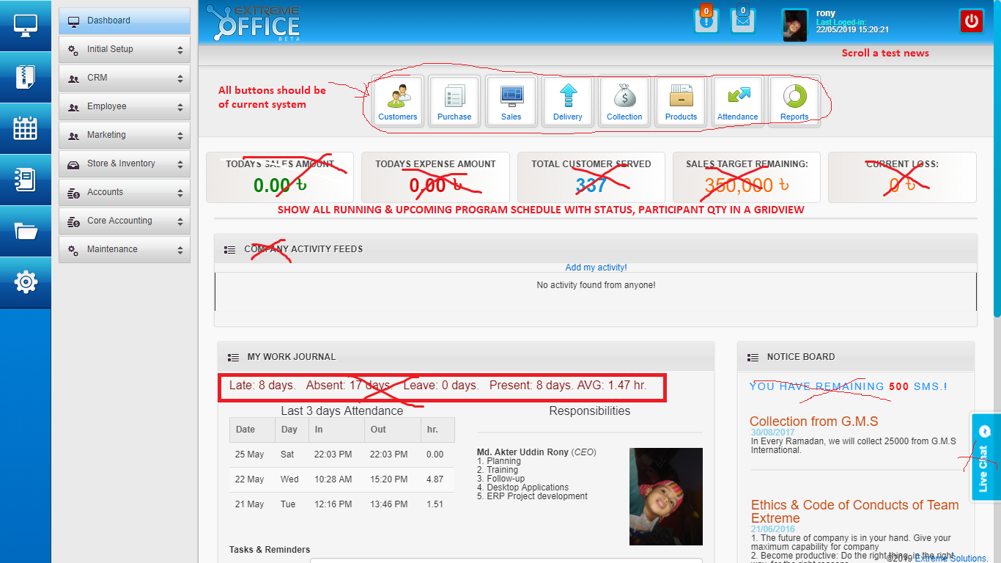

* + 1. Faculty/ Offices ()

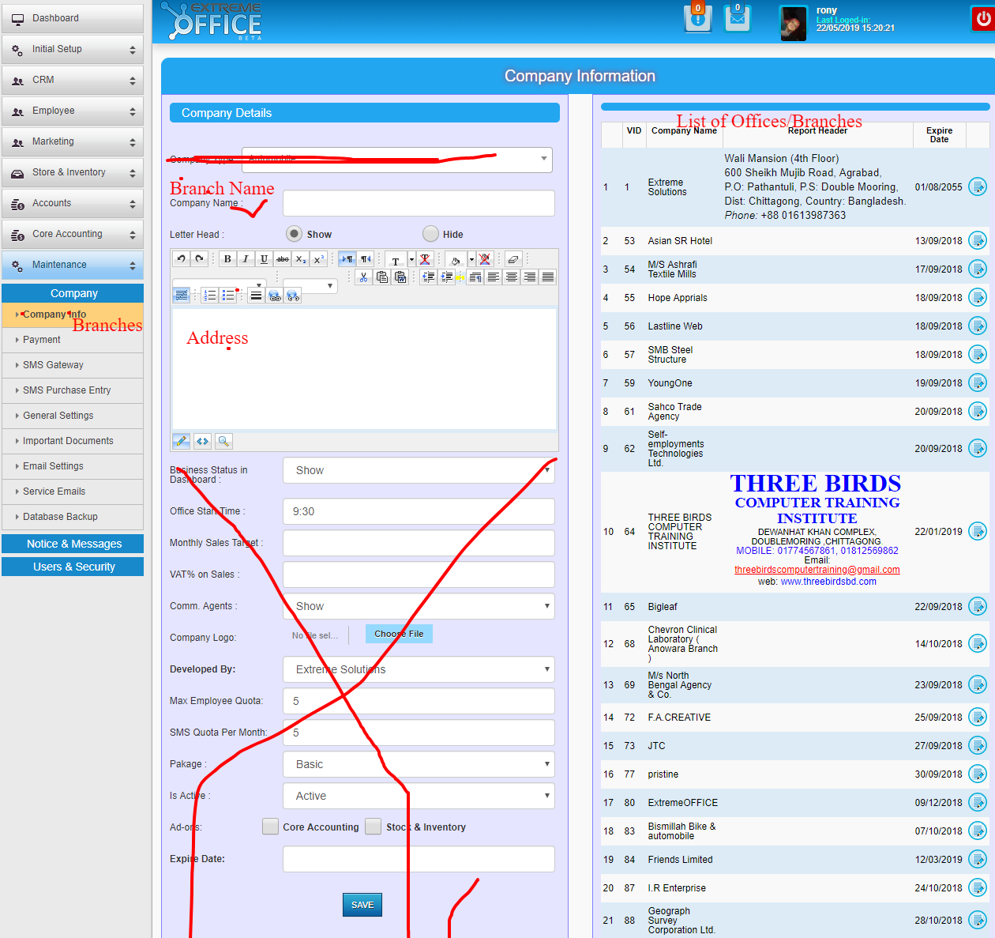

* + 1. Departments

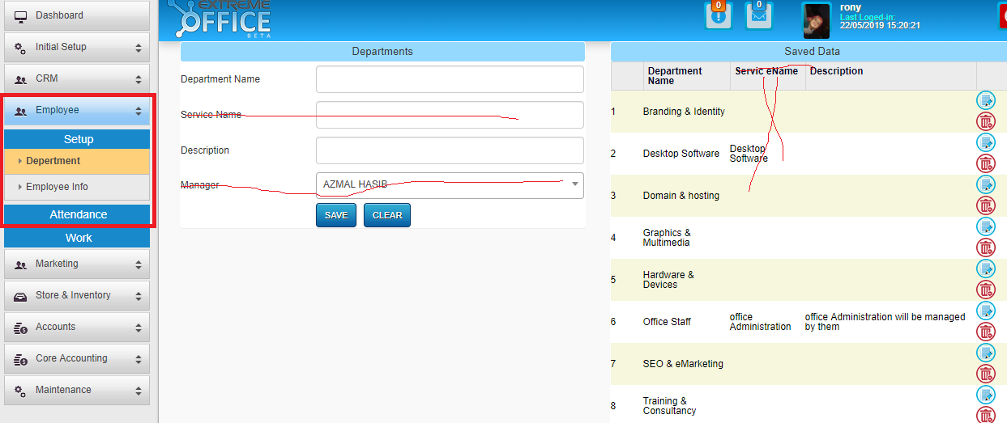

* + 1. Officers & Stuffs

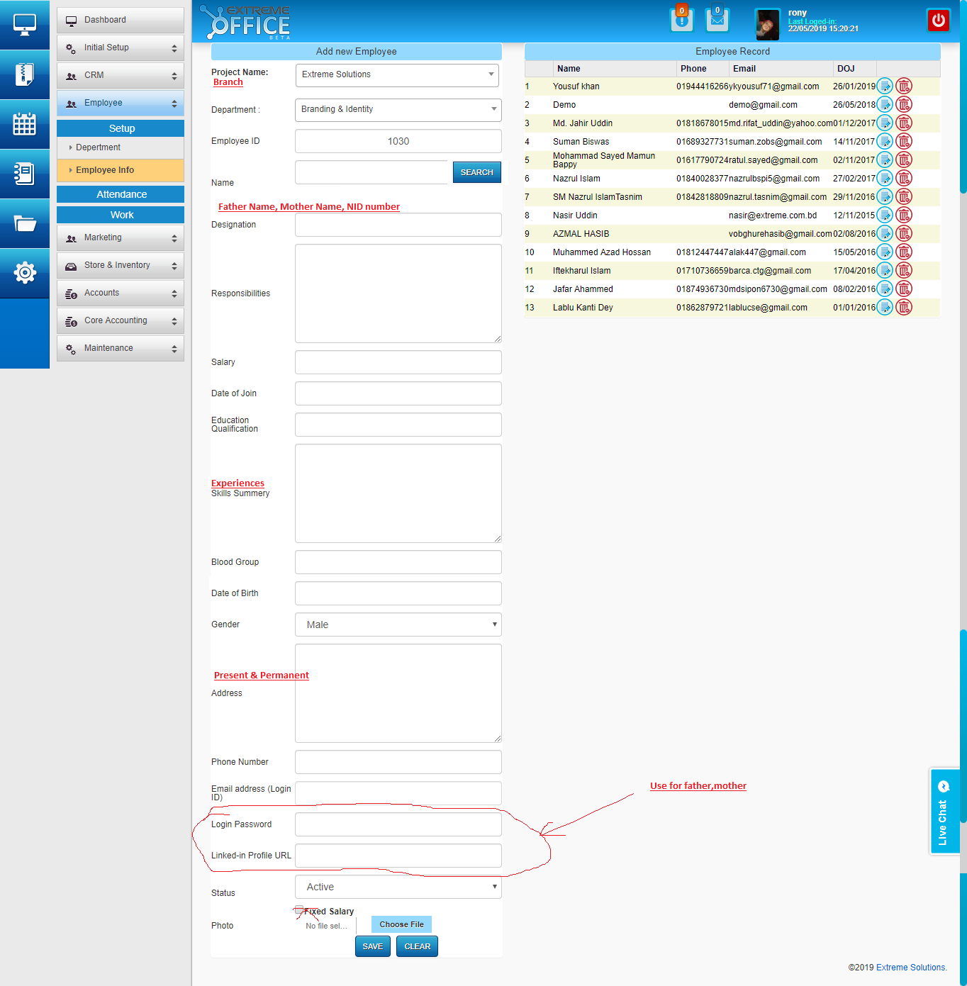

* + 1. Trainers [Same as Stuffs info. Remove Department & designation only]
    2. Upload Data [do later]
    3. Edit Attendance

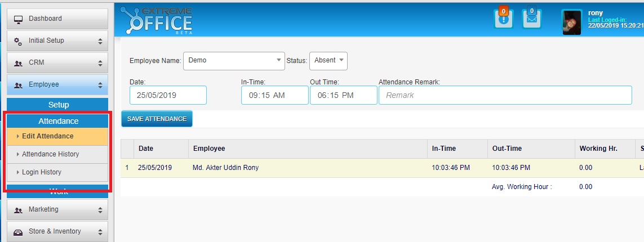

* + 1. Attendance History

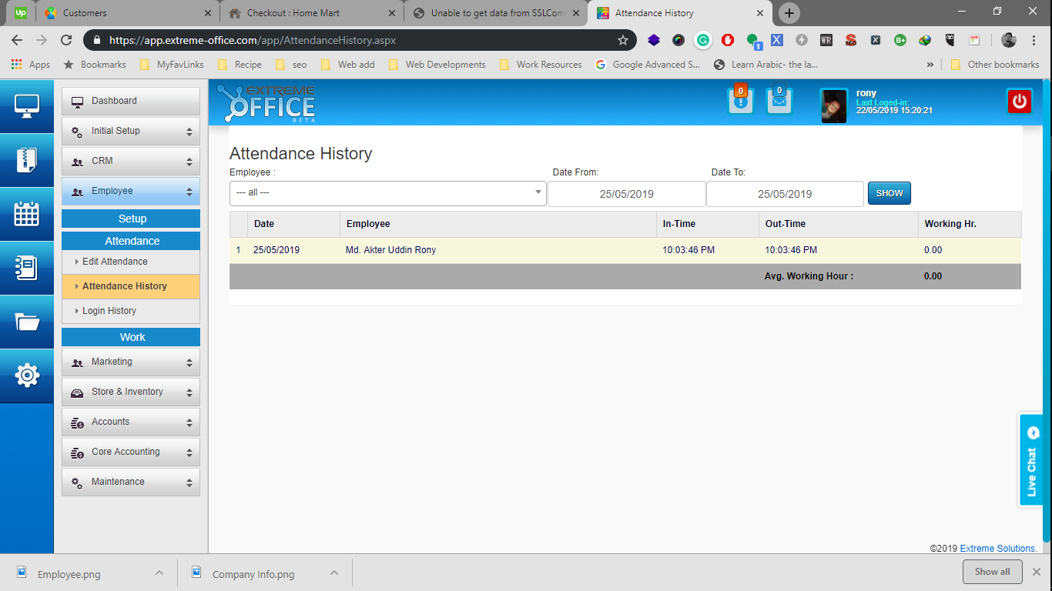

* + 1. Training Categories

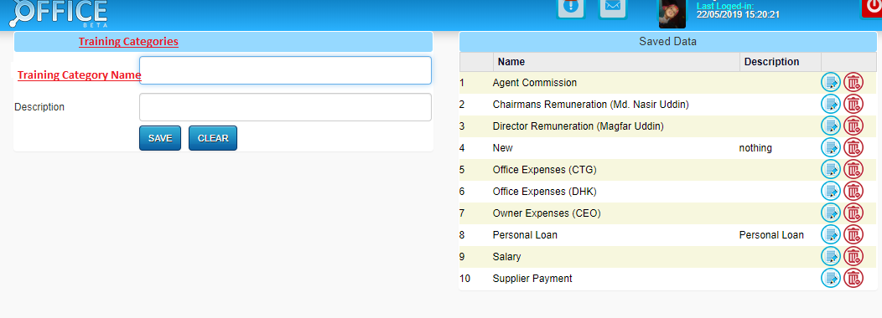

* + 1. Training Programs

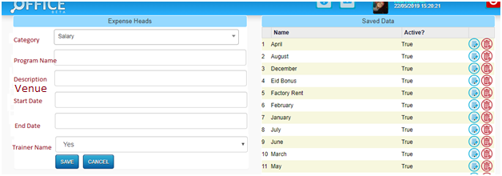

* + 1. Dormitory Setup

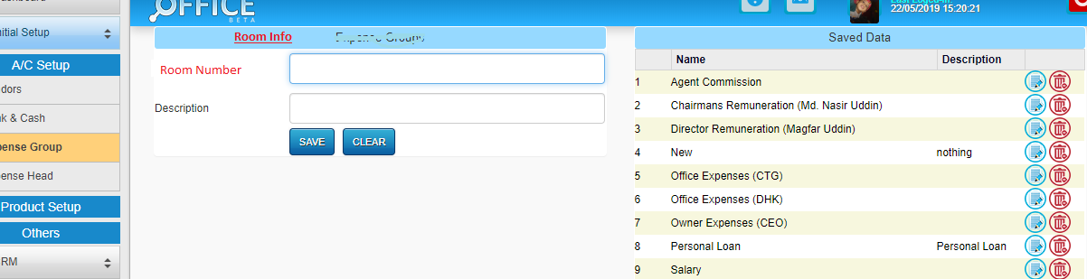

* + 1. Rooms Setup (Under dormitory)



* + 1. Letter Templates

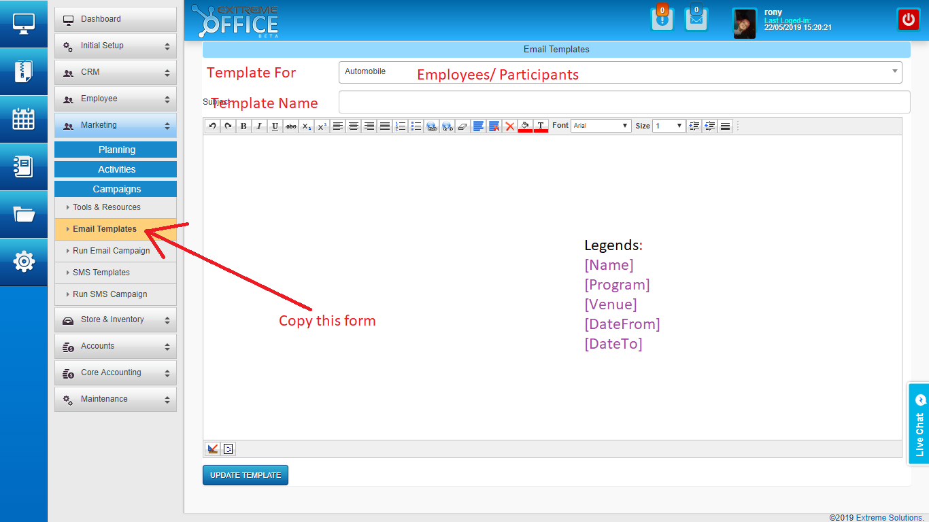

* + 1. Manage Participants (Biodata with Pictures)

Copy same as Trainers (4) form

* + 1. Assign to training programs

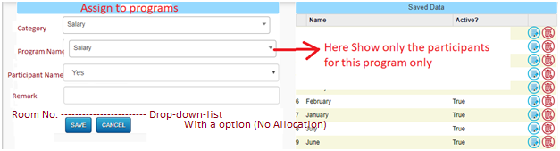

* + 1. Print Invitation Letter

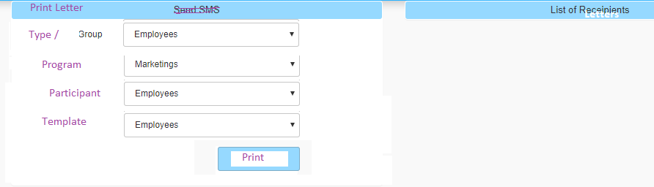

* + 1. Attendance of Participants
    2. Room Allotments

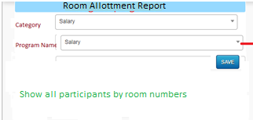

* + 1. Upload Participants
    2. Restore Program