ProtoSpace
www.givingspace.org/protospace

Concept Paper
Tom Munnecke
January 29, 2003
Visiting Scholar
Stanford University
Digital Visions Program
munnecke@stanford.edu

Table of Contents
Introduction 2
ProtoSpace 2
The Ontology of the Void 4
A Tour through a ProtoSpace Viewer 5
ProtoSpace Browser Functions 10
AngelTalk 12
Addressability 13
Primordium 14
Activation Energy 14
Intrinsics of ProtoSpaces 15

Table of Figures

Figure 1 Looking into the future void from the primordium 5
Figure 3 Protospace Receding into Blob 8
Figure 4 Blob becoming stuff in larger ProtoSpace 9
Figure 5 Zooming out from Embedded ProtoSpace 10

Introduction
“We create our tools, and they create us”
someone…

As we move towards more linked and sophisticated interactions between divergent sources, we need stronger tools with which to use and think. The electronic spreadsheet, for example, allowed people to visualize and model data and decisions which were unthinkable to those used to getting their reports in thick stacks of computer printouts. Once the spreadsheet was introduced, it became a tool for many new forms of thinking, and people are naturally inclined to lay out information in terms of rows and columns, and the ability to use formulas into to express relationships.
Certain kinds of problems fit well into the cells of a spreadsheet. However, there are many issues which do not fit. It is not possible to assign a predefined “cell” to the following:

- The name of the species of an ape which evolves into humans.
- The name of a disease called consumption which later becomes tuberculosis.
- The genetic “footprint” of a cancer which changes over time.
- The notion of “here” in a cosmos which is expanding in an ever-increasing rate.
- A social network which starts with just a few people but rapidly expands.
- Things which start simply, but “ignite” over time
- Things which modify their own environment, which in turn shapes their behavior.
- Things which organize themselves, often in surprising ways.
- Things which change continuously over time, such as a language or a culture.

This paper describes a vision of a concept called the ProtoSpace, which can be thought of as a kind of spreadsheet for “spaces” which start simply and evolve over time. The ProtoSpace browser is a tool, not unlike today’s web browser, which allows a user to zoom about these spaces, watching the evolution of what happens in the space. It provides a framework and a metaphor for discussing other spaces, such as GivingSpace. (www.givingspace.org)
The source code to the current mockup of ProtoSpace is available for download at www.givingspace.org/protospace it is written in Visual Python, and runs as a client software package on most computers.

ProtoSpace
ProtoSpace is a software-based environment which can be used to model autocatalytic spaces. Autocatalytic spaces have the property that they start out with very simple initial conditions, a primordium containing very little stuff and very little void. The stuff and the void co-evolve over time, and the space expands. The creation of new stuff has the effect of cocreating a more void, subject to the constraints of the space. The space pulls itself into existence by the energy of the vacuum. The designer of a ProtoSpace is largely focused on the autocatalytic effects of this energy of the vacuum. Rather than focusing on what is, the designer is focused on the latent energy of the vacuum pulling the space into existence. The ProtoSpace can thus be described as spaces which discover themselves.
ProtoSpaces can nested, in the sense that a space can appear as just a blob within a larger space. This allows scale-free representations of the intrinsics that apply across spaces of vastly different scales. For example, if we were to create a ProtoSpace for health called HealthSpace, it may have many embedded spaces, from the human species, to global population, to nations, to communities, to families, to a person, to an immune system, to an organ, to a cell, to the gene. Each of these characteristic scales has its own space, but they are also connected by patterns which span two or more characteristic scales. For example, the pattern of IDENTITY applies to all of the above mentioned, in the sense of the identity of an immune system, the identity of a cell, or of a gene. This could lead to the discovery of another pattern, DISIDENTITY, which may have influence over multiple characteristic scales. ProtoSpaces may be ouroboric, in which the smallest scale loops back to the largest, for example, the gene is connected to evolution of the species, and the quark is connected to the evolution of the cosmos.
Cascades are triggered by intrinsics operating over multiple scales, over spaces and their evolutionary time. Thus, one could refer to the cascading effect DISIDENTITY of over the immune system (autoimmune disease), community (loss of sense of community), and cancer (loss of a cell’s sense of self). A link between stuff in ProtoSpaces of different scale is called a Fractalink, which can be viewed as a scale-free notion of the hyperlink developed by Ted Nelson in Xanadu, Douglas Engelbart in NLS, and Tim Berners-Lee in the World Wide Web.
ProtoSpace is a kind of extension of hypertext thinking (now nearly 60 years old) by applying notions of scale-free networks, fractals, recursion, autocatalysis, self-organization, computer simulation, visualization, experimental philosophy, and many other innovations.
The ProtoSpace starts with a primordium, which are the simple initial conditions, and evolves according to the activation energy of the stuff within it and the energy of the vacuum of the void surrounding it. The ProtoSpace “discovers” its self in an evolutionary process of expanding ontologies, which are the ways of assigning meaning to the stuff in the space. As the space expands, these ontologies also evolve in a succession of eras. Visually, we can envision ontologies to reside in the “cage” surrounding a region of ProtoSpace. We can zoom back in time to see earlier ontologies either in the context of their contemporaneous ontology or a previous one.
ProtoSpaces may have agents known as Angels which are able to fly about the space and communicate with others via a language called AngelTalk. AngelTalk can communicate within a given ProtoSpace, or it may communicate with remote ProtoSpaces via communication protocols. AngelTalk is capable of making expressions between ontologies and eras and either resolving the differences or noting “failures of expectations” between topic maps.

The Ontology of the Void
Since a prototype coevolves with the stuff in it, the properties of the void which pull it into existence are critical. Since there is initially no stuff in the void, it is difficult to discuss it using words from the language of things. The energy of the vacuum is a driving force in the mechanism by which a space discovers itself.
We define two terms to describe this way of knowing and creating:

- Benegnosis is a way of knowing based on what is positive or successful.
- Malgnosis is a way of knowing based on what is wrong or failing.

Imagine a team of Martians trying to understand how a television set works. They pull out a tube, and discover a squealing sound, so they categorize that as the “anti-squeal” tube. They work around to other components, discovering what goes wrong when they disable the component, discovering all the modes of failure of the television set. But how the TV works escapes them, because they are only looking at how it fails. If, however, they were to discover a circuit diagram, they would eventually be able to discover the patterns of components, and how they work. Their way of understanding based on failure is the malgnostic view. Their way of understanding based on interpreting the schematic is the benegnostic view. The basic pattern they use: “what is the problem and how do we fix it” drives the malgnostic energy of the vacuum, and their knowledge space fills with how the TV fails. If they use a different pattern, based on patterns of operation of the components, the energy of the vacuum creates the benegnostic space. Thus, the choice of patterns by which we understand the evolutionary space becomes a major factor in understanding that space.
This is evident in our current health care system. The UMLS system from NIH lists about 1.2 million terms for how to be sick. A primary tool for genetic researchers is to knock out a gene and see what happens, leading to such conclusions as, “The loss of this gene causes a loss of speech ability.” The encyclopedia of world problems lists 30,000 world problems. Brain researchers study what happens when certain parts of the brain are damaged.
These are all malgnostic perspectives, and they have their place. If I have a broken TV set, I want the repairman to know how to fix it and not try to reengineer the whole TV set from a holistic perspective. Similarly, if I have a disease, I want my physician to know everything possible about the treatment of that disease.
However, these malgnostic perspectives apply to a limited number of cases, and they are easily carried by fear of the pathological extreme. Someone with a headache worries about the one in a million chance of having a serious problem, and this fear then drives the need for an MRI instead of “take two aspirins and call me in the morning.” The very long, unlikely tail of the probability of failure ability wags the dog of very likely, simple circumstances. As we discover more and more extreme modes of failure, their sensationalistic value drives the “normal” far out of proportion to their risk.

A Tour through a ProtoSpace Viewer
Analogous to the way that a web browser allows a user to browse cyberspace, the the ProtoSpace viewer allows a user to browse a ProtoSpace, zooming through time and space to see the evolution of the space from various locations, evolutionary time, and scale. This particular mock up shows cubic “cages,” illustrating the different eras of the evolution of the ProtoSpace. We can imagine each cage holding an ontology, or a topic map which describes the object inside the cage. As these topic maps evolve, then we have an evolution of ever larger cages, containing objects which themselves emerge over time. The browser allows viewers to relate to different

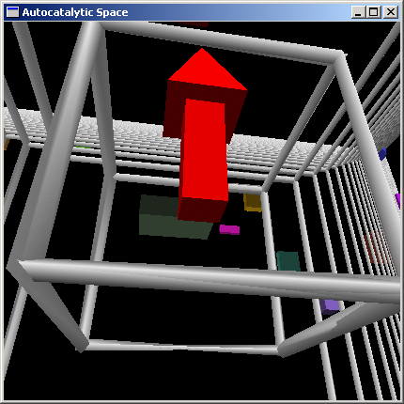
Figure 1 Looking into the future void from the primordium
We can begin by viewing the space and its void from its initial conditions, called the primordium. The arrow is symbolic of an initial condition, and the bars are simply markers to indicate the progress of the void over time.

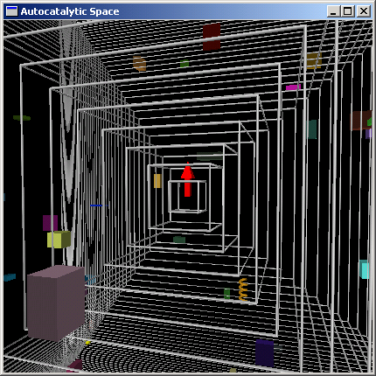
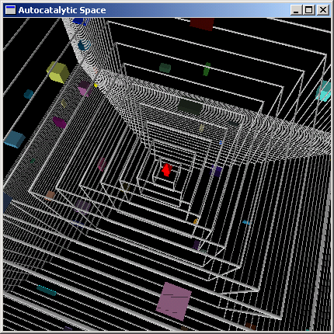
Or, we can zoom into the future and look back into the space. Note the appearance of new stuff which is created during the evolution of the space. In this case, there is little stuff evolving (i.e., the energy of the vacuum is relatively strong) and we can see all the way back to the initial conditions of the ProtoSpace. If this space represented the web after its first decade, for example, there would be so much stuff that the initial conditions would have been obscured and the initial conditions would fade into the “dust” of past stuff. If the ProtoSpace represented the evolutionary attribution of an idea this view would show an original expression of an idea and the cloud of follow on ideas which evolved from it. A social network could be represented in this manner, as the original members of the network are represented in the primordium and the expansion of the network is shown as objects in the space. A gift economy could also be illustrated, showing the expansion of generosity into an ever-increasing space. For example, the thankyou transactions generated in GivingSpace the complementary currency of “Ts” could represented by an expanding cloud of people’s expression of gratitude over time into an ever-increasing community.
Figure 2 Looking back to initial conditions from their future

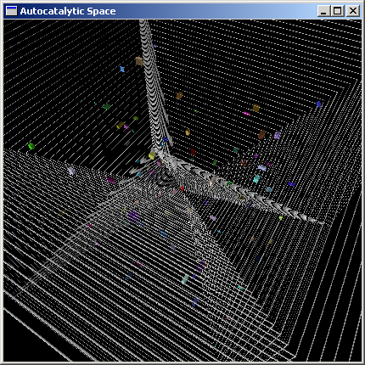
As we zoom out further, the stuff in the space becomes smaller, and merges into dust. The edge of the space is shown in the bottom left, beyond the limits of this space. The entire evolutionary history of the space can be viewed from and zoomed about from this perspective.

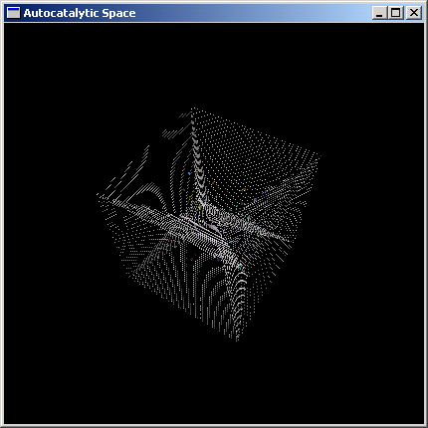
Figure 3 Protospace Receding into Blob

If we zoom out further, the stuff in the ProtoSpace looses its identity, and the entire space becomes a “blob” with only its aggregate characteristics visible. The initial conditions of the ProtoSpace are barely visible at this scale as a tiny red pixel at the center of the space.

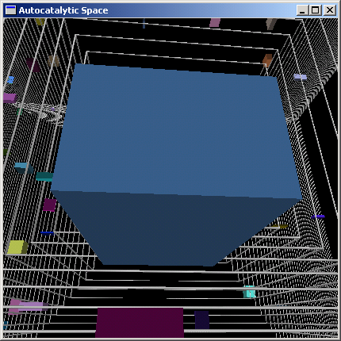
Figure 4 Blob becoming stuff in larger ProtoSpace
Zooming even further out, we discover that this blob is embedded as stuff in a larger ProtoSpace. This new space can be browsed, just as before.

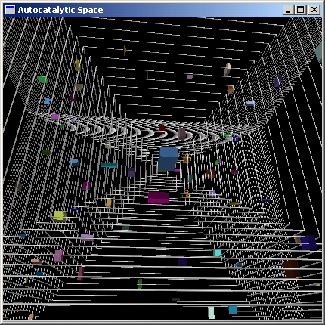
Figure 5 Zooming out from Embedded ProtoSpace
We can then zoom even further out, finding new blobs, zooming in to see the primordium of this new space, zooming in to other stuff, etc.

ProtoSpace Browser Functions
The browser would have many of the same features of a standard web browser, only having more capabilities for dealing with scale and point of view:

- Spacemarks – the equivalent of bookmarks in cyberspace browsers, allowing viewers to return to a browser scale and point of view or send a viewpoint to another via email as a URL.
- Ontologies – as the user zooms in and out of a ProtoSpace, different ontologies will be evident, reflecting the evolution of the ways of attributing meaning to objects over time. An ontology side window will be available, showing the topic map display of the ontology in effect at the time of the evolution of the protospace. Zooming into the primordium of the ProtoSpace will show the initial ontology of the space. Zooming out from the space, the user may discover the evolution of meaning of a term over time, for example. The ontologies can be imagined to be are “contained” in the grid surrounding the space.
- Merged Ontologies. A browser may jump via a Fractalink from one ProtoSpace to another. These spaces may or may not share the same ontologies. The browser would merge the topic map from one “cage” to another, allowing the user to understand the shared meaning between the two. If there is a “expectation failure” of the merge…there is no or inconsistent mappings, then this is pointed out and can be resolved via questioning or other process.

- Save: viewers may pickle a space, freezing its state for later viewing. Depending on permissions, users may edit only their pickled version, or the “live” one.

- Fractalinks. Stuff may be linked to other stuff at a variety of scales, evolutionary states, and points of view. A fractalink would allow a user to link from one point to another, not unlike an HTML link works on the web.

- Annotation. A user could put a flag on a point or object to serve as a sign post for others.

- Paths. The path a viewer has taken through a space could be saved and recorded, either for public viewing or for personal backtracking. Note that path dependencies become more interesting when moving through evolutionary spaces. It might be that the browser can only look backward in time, or that a space must be pickled before fully browsing.

- Angels. Angels are agents which “float” freely around the space, which may operate according to different constraints than the active browser. They can contain state, or may influence object. Angels could be organized into hierarchies, reporting within or between spaces or at different scales. Angels communicate in a language called AngelTalk which is capable of expressing the ontologies between two points in ProtoSpaces.

- Syndication. Events and activities may be announced to other spaces through a syndication mechanism, perhaps using RSS. For example, a ProtoSpace model of a big bang could announce via RSS that it has created a black hole, and syndicate its nature to an aggregator. Some other waiting ProtoSpace could use that nature, perhaps mutating some of the constants, feeding it into a big bang. A biological ProtoSpace might announce the emergence of a new species or genera. A social network may announce the emergence of new clusters of interest. Angels may communicate via syndication, also, opening up channels to communicate with other angels.

- Intrinsics discovery, display. Scale-independent properties of a ProtoSpace may be indicated by shading of the grid. For example, a ProtoSpace of the universe in which physical constants have varied may show the earlier universe shaded in a different color, indicating the changing value of the constant. Other software would discover intrinsics or patterns over a wide variety of ProtoSpaces.

- View-by-Intrinsic. This view would look at a ProtoSpace or spaces from the perspective of a given intrinsic. For example, given that “identity” is an intrinsic of health (we can speak of the identity of a cell, and immune system, a person, a family, a population), what are the cross-scale characteristics for which identity is a “glue?” What are the effects of loss of identity (disidentity) at different scales? Is it possible that loss of personal identity has an effect on loss of identity of the immune system? The ProtoSpace fractalink and ontology mechanism provides a framework within which these concepts may be explored. This is a highly novel viewpoint, viewable only after building the ontological framework for it.

- View-by-identity. What does the ProtoSpace look like from the perspective of an individual object?. This inverts the perspective from the outside-in to the inside-out. Jonas Salk imagined himself a polio virus, Albert Einstein imagined himself riding a light beam. The browser could “lock on” to the perspective and ontology of an individual, and then view (merge ontologies) with arbitrary other spaces, eras, or individuals. For example, what does the world look like from Joe’s perspective? This would involve merging ontologies, and resolving topic map expectation failure between the two points of view.

- View-by-ontology. View the evolution of an ontology over time. One display might be to show the cages between ontology eras (or other ProtoSpaces) with threads between them, showing how topics have emerged over time. A user could drag a cage from one space into another and see the merge process visually. Or, they could take an older cage and “drag” it forward to see what today’s meaning would look like in yesterday’s ontology. Views themselves could be merged, for example, a “view-by-intrinsic” perspective of the “view-by-ontology” could show only the intrinsic changes between Victorian and Modern Era ontologies.

- Interactive editing. A user may “drag and drop” various stuff into the space, for example, seeding a primordium with a big bang or primordial soup. Users may link ProtoSpaces with others through fractalinks, allowing one space to link to others. The user might vary the constraints on the space over time, or as the result of certain evolutionary achievements.

- Cascade mapping. Much of our current thinking about causality is based on the implicit restriction of the characteristic scale to that within which causality can be proven. For example, physicists do not study the effects of people when studying the atom. However, there is a broad class of problems which are multi-scale, which can not be “proven” using mono-scale causality thinking. The ProtoSpace viewer would model cascades of interaction, which are triggered by intrinsics happening at multiple scales simultaneously.

- Eras. A ProtoSpace may evolve through eras, which might be visualized by cages radiating from the primordium. This would allow the user to jump from one era to another, rather than zoom continuously. Eras are also a part of the addressing function, indicating the era in which an ontology was active. This would allow understanding of objects in the “current” era and the contemporaneous era. For example, “leg” in modern English has less meaning than “leg” in the Victorian era, in which people covered up table legs out of modestly.

AngelTalk
The AngelTalk language is designed to support communications angels scattered throughout ProtoSpaces. It can address any object from any viewpoint due to the strength of the addressing scheme. It is an interpretive language, allowing the expression of verbs as well as nouns. An initial implementation would be written over RSS and syndicated over a system such as Internet Topic Exchange. AngelTalk is integrated into the topic maps of the spaces, allowing the exchange of meaning across widely diverse spaces. Angels may be pickled along with a space, or they may continue to operate, allowing archival and historical activities.
An example of an angel agent can be found in the Guardian Angle proposal from MIT. AngelTalk is designed to be diachronic, allowing the expression of meaning over time, as well as updating itself with new versions gracefully within the speech community.
An AngelTalk expression has at least the following parameters:

- Expression: the expression to be evaluated
- Source Ontology(era): the ontology of the sender, and the era used.
- Destination Ontology(era) the ontology of the receiver, and the era used.
- Flow of time… ability to describe time in the context of one or more ProtoSpace. Times would be contained in the ProtoSpace ontology, and subject to various interpretations, and vary between eras.

Addressability
The ProtoSpace mechanism will require a more powerful identity mechanism to handle the diachronic and autocatalytic mechanisms of ProtoSpace. This includes:
- Scale, addressing the granularity of the point of view, from a “crude look at the whole” to very fine resolution. For example, the same addressing scheme could address an individual quark at the sub atomic level as well as an entire galaxy at the cosmic level, allowing fractalinks between the two.
- Parallel spaces: A given ProtoSpace may split into parallel spaces, either in a pickled state or with continuing evolution. The addressing scheme must address this fact. For example, a pickled version of the GivingSpace thankyou network may refer to stuff in the “real” one which continues to grow.
- Evolutionary identity. A given blob may evolve over time, for example, a species of ape may split into humans and other apes. The addressing scheme must be able to preserve this identity relationship. For example, GivingSpace may evolve from the thankyou currency to something new, but the thankyou was a critical contributor to the energy of the vacuum which pulled the original GivingSpace primordium. When future ProtoSpace browsers look at GivingSpace, they will be able to see the evolutionary effects of the original choice of currency.
- Diachronic Ontology. When linking between two spaces, or the same space at different stages of its evolution, there may be different ontologies. Each end of the link therefore has an ontology and and era parameter. The era may be thought of as the “cage” in the protospace which expands with the evolution of the space. The ontology may be thought of as a residing in the “cage,” defining the meaning of the objects within the cage. The user can zoom in to smaller cages, backward in the evolution of the space, and see objects in their earlier contexts. Fractalinks between protospaces can be understood by merging the topic maps between the spaces.

Primordium
The simple initial conditions of the ProtoSpace. This includes the initial ontology, which may be the “minimum ontological commitment” to provide the initial connectivity to drive the evolution of the space. Users may “drag and drop” initial conditions for either operational or modeling use. For example, the user may drop in a big bang into an empty ProtoSpace, and watch a cosmological model unfold, or a primordial soup and watch a simulation of life emerge. They may also drop in the seed of a social network, and watch the network emerge.
They may drop in multiple objects simultaneous, to watch the interaction. Perhaps a user would drop in a big bang and a primordial soup. The big bang may clobber the primordial soup, so the user would have to wait for a time in the evolutionary growth for the primordial soup to appear. He could write an AngelTalk script to observe the evolution of the big bang and then activate the primordial soup object, however. Similarly, a social network could be dropped into a primordium with just a couple of initial people. An AngelTalk script could watch the network, expanding the space as necessary, introducing more formal ontologies as the network expanded, or generally guide the network’s growth.

Activation Energy
The activation energy of a ProtoSpace describes that which drives the space forward in its evolution. It is based on both the stuff in the space, as well as the energy of the vacuum which expands the void for expansion. Thus, the ProtoSpace “discovers” itself into existence. The activation energy can thus be seen as the “vitality” of the space. This relates to Christopher Alexander’s “Quality without a name” in architectural patterns, as well as Stuart Kauffman’s “Investigations” work.
Not all ProtoSpaces will have sufficient activation energy to sustain their growth. Some may start out (The Hula Hoop fad of the 1950’s, for example) with a bang but rapidly fad away. Others will thrive for a while, to be replaced by another one (the transistor, replaced by the Integrated circuit).
In order for a ProtoSpace to scale up successfully, it must have a scale-free activation energy, capable of working at multiple scales simultaneously. GivingSpace uses uplift as the activation energy of its space, because it is scale free. We can speak of uplift at the personal, family, community, nation, and species level.

Intrinsics of ProtoSpaces
We will define intrinsics to be the scale-free properties of ProtoSpaces. Some are common to all spaces, others are unique. Some intrinsics are:

Primordium: The simple initial conditions which are at the core of the ProtoSpace. This relates to the minimum ontological commitment from which to derive an evolutionary ontology, some stuff, and a void.

Stuff. The material which is created in the ProtoSpace.

Void. The space within which stuff accumulates. In an autocatalytic space, stuff increases the void within which more stuff may accumulate. For example, adding a new node to a social network creates the potential for even more nodes.

Activation energy. The energy which drives the ProtoSpace in its evolution, based on the stuff in the space. Think of this as the “push” energy from the past “cage.”

Energy of the void. The energy which pulls the ProtoSpace based on the ontology of the void. (think of this energy being contained in the next cage outside the current one, pulling in new stuff). It is the coevolution of these two energies which drives the evolution of the space…

Acknowledgements
Ideas for this paper have emerged over time. Jan Hauser has been an intellectual sparing partner for many of these topics, as well as a connector to help find other to participate. Jack Park has contributed many ideas, particularly relating to Topic Maps..
(and many others, to be listed.)

From the Greek and Egyptian mythological representations of an animal eating its own tail – the ouroborous… see Rees, Martin Just Six Numbers
Murray Gell-Mann pointed out to me that these terms were mixing Latin and Greek, however, he couldn’t suggest a better alternative, so I’ve stuck with them.
See Douglas Engelbart’s work on evolutionary attribution. http://www.bootstrap.org/colloquium/session_06/session_06.jsp
Term from Jack Park
Szolovits, Peter et al., Guardian Angel: Patient-Centered Health Information Systems, May 1994 http://www.ga.org/ga/manifesto/GAtr.html
A candidate technology would be Linear Topic Maps (LTM) http://www.ontopia.net/download/ltm.html
This is in response to Murray Gell-Mann’s advice to me to figure out a way of looking at a crude look at the whole.
The term diachronic comes from linguistics. The diachronic study of language is the study of language across time. The synchronic study of language is at a fixed point in its evolution. Nearly all information systems and accounting systems today are based on synchronic perspective, while protospaces offer a metaphor to consider graceful diachronic expression.

