SIT725- 1.4P

Kalp Prajapati - s224834542

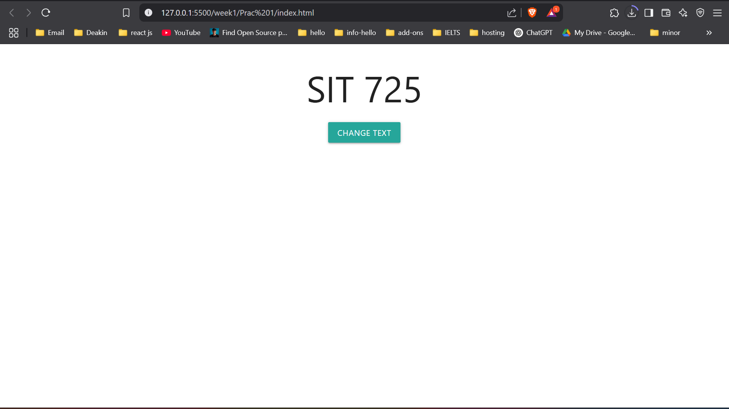 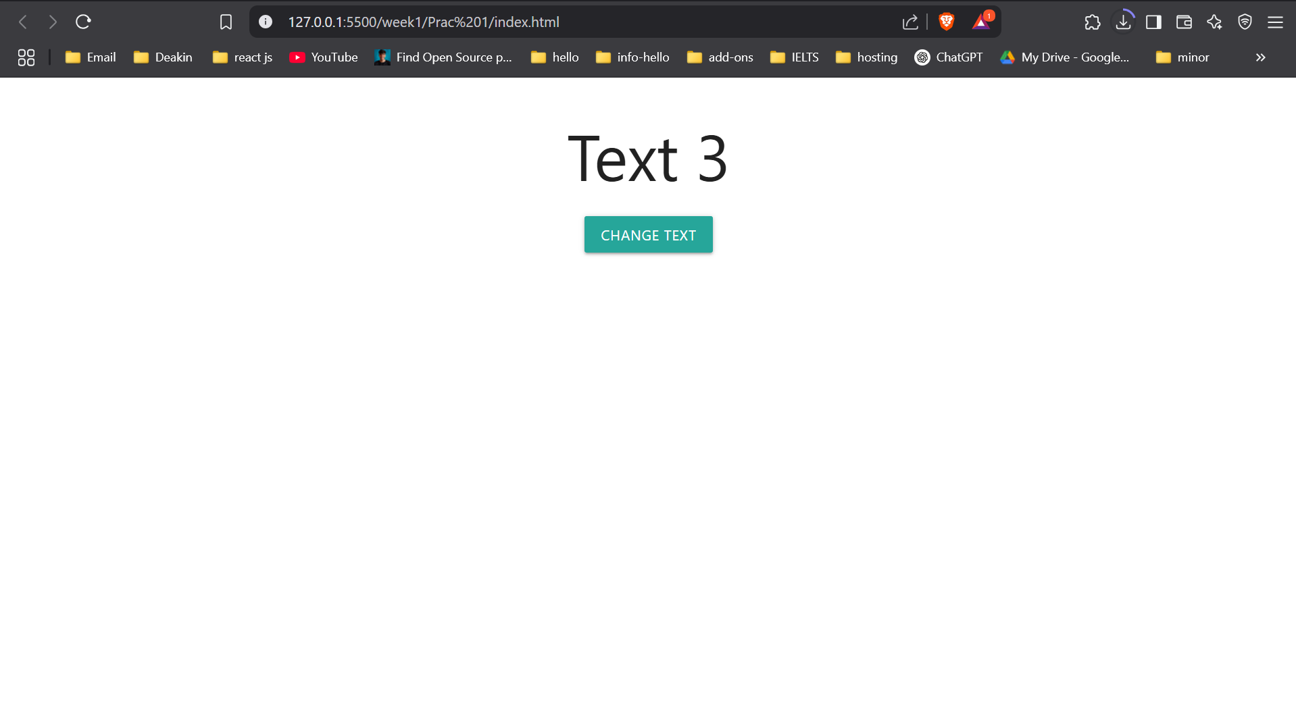

Repo Link: https://github.com/munnokd/SIT725