Aasiya mahmoud hamza
ID : C6240447

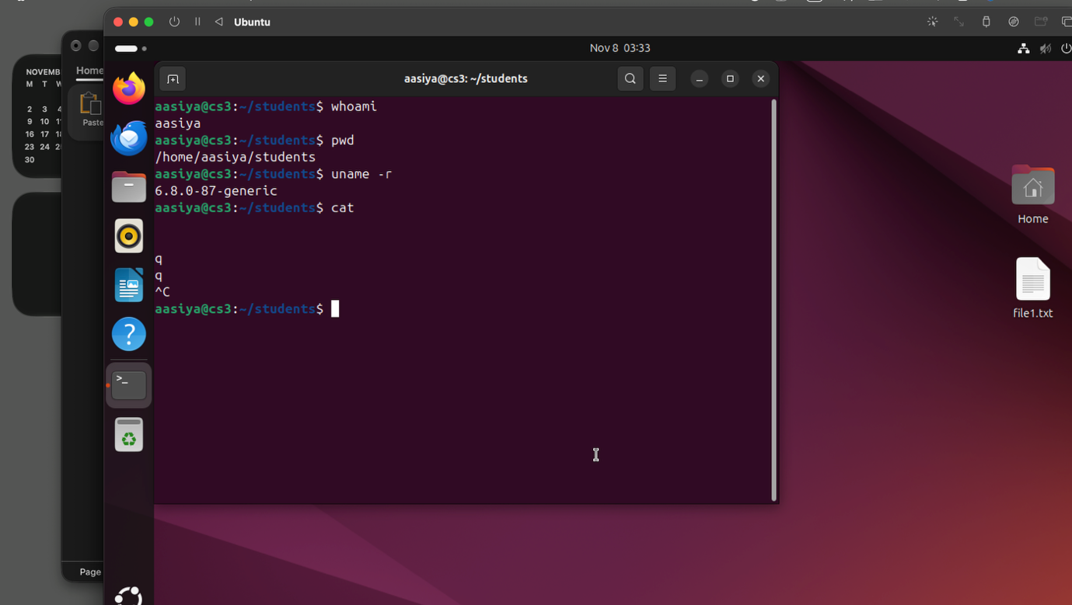

Whoami
= Displays the current username.
pwd
= pwd Prints the current working directory.
Uname -r
=Displays the Linux kernel
release/varsion
cat
= cat Displays the contents of a file

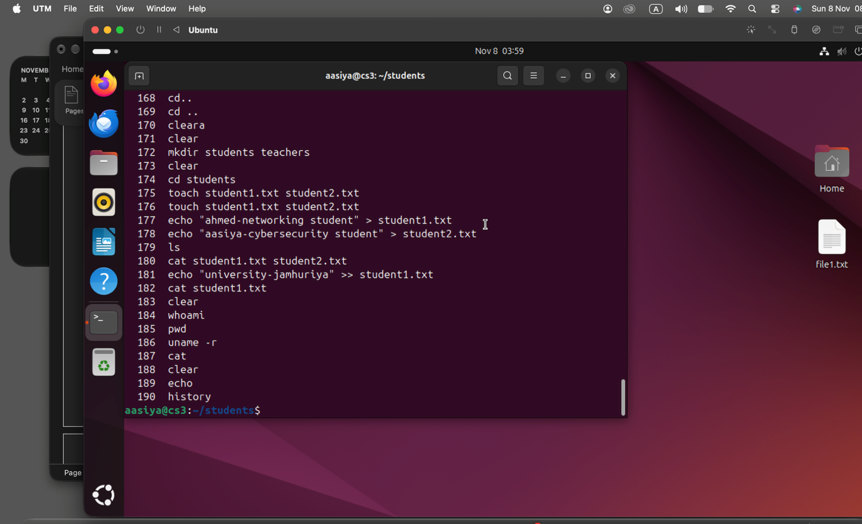

Echo
= Displays text or variable values
History
= displays previously used
commands.

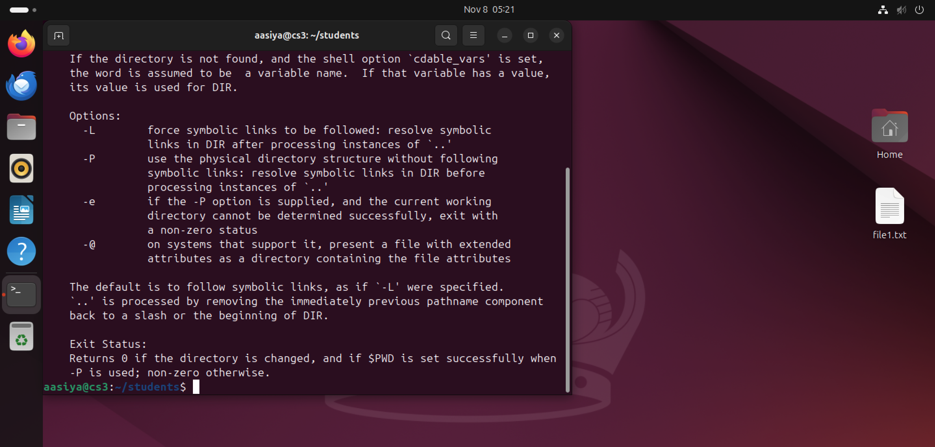

Help
= Shows help for Bash built-in
commands
help cd

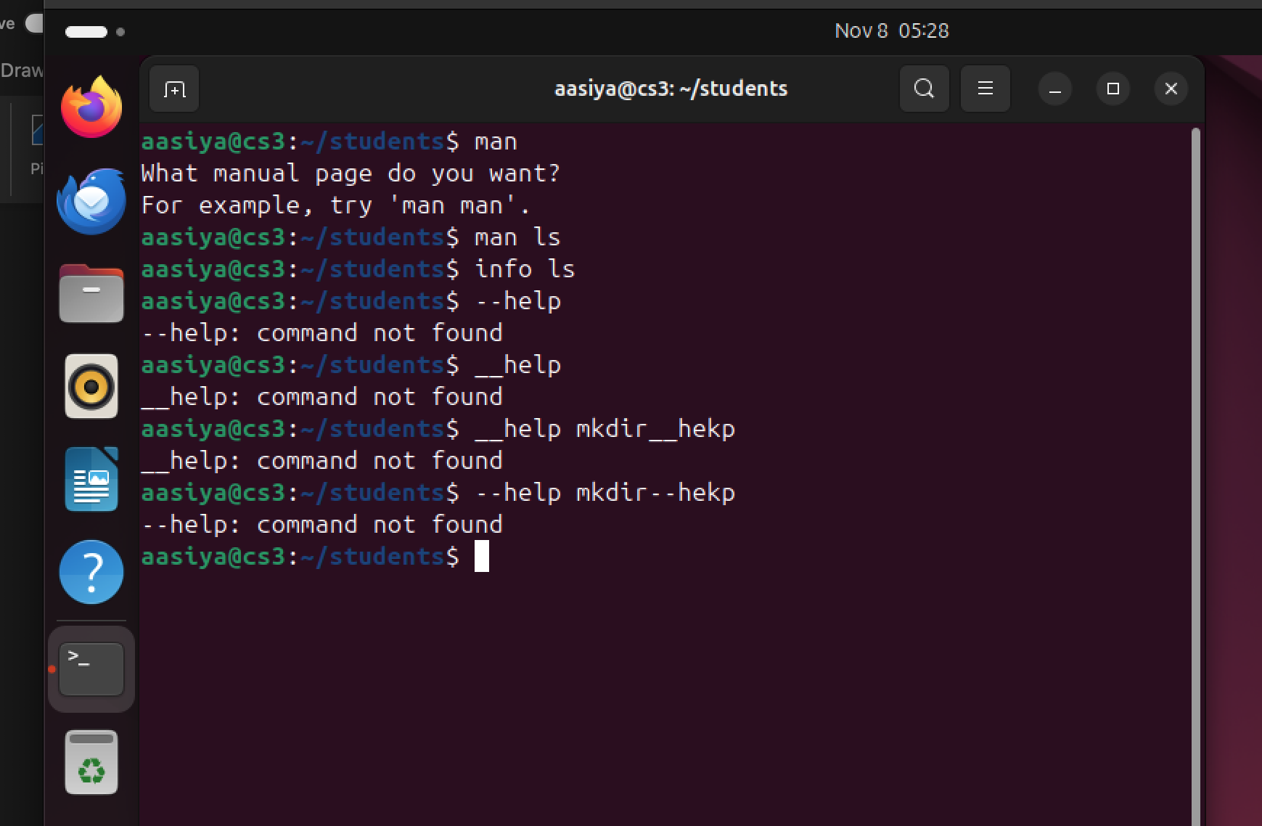

Man
= Opens the manual page for a
command.
Info
= opens detailed command
documentation.
--help
= Displays a short help summary for a
command.

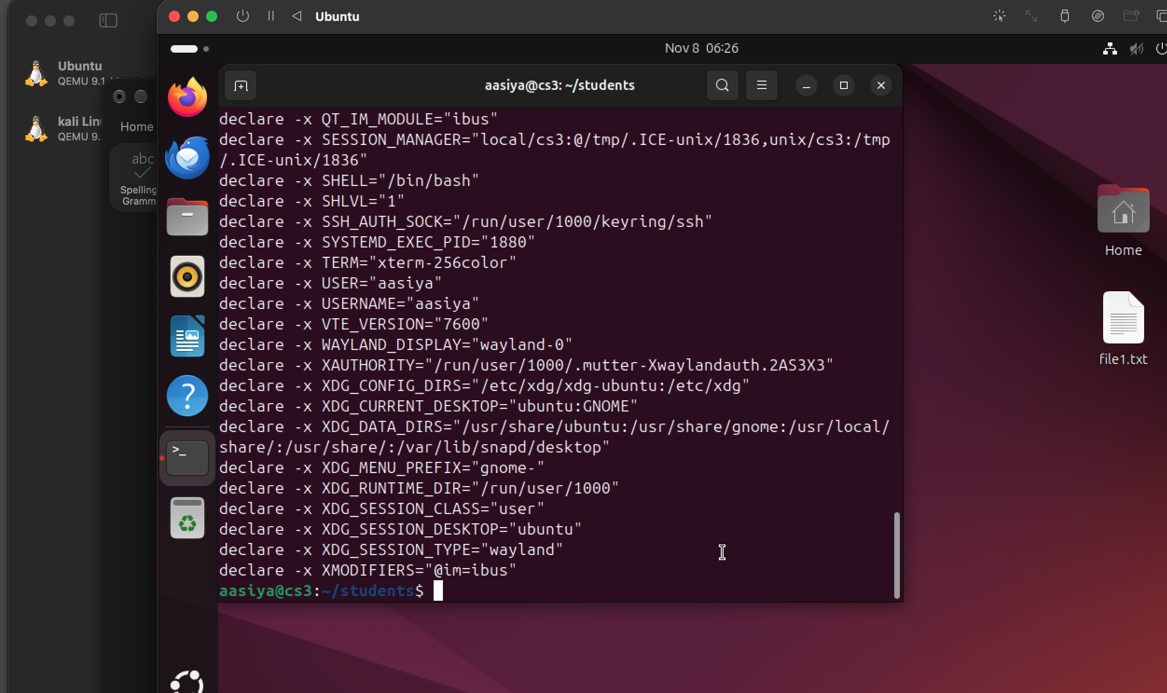

Name=value
= assigns a value to a shell variable.
Echo$name
= displays the value stored in a
variable
export name
= Exports a variable to child
processes

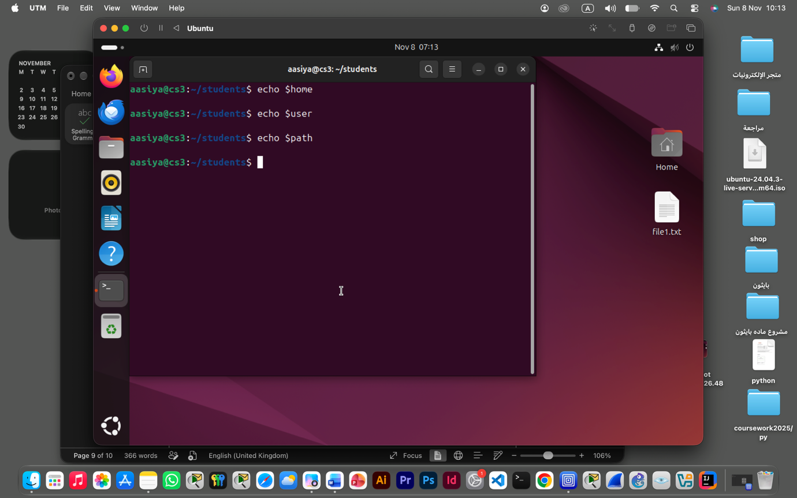

Echo $home
= Variable containing the user's home
Directory.
$USER
= variable containing the current
username.
$path
= Directories searched for executable
commands.
Ls -a ~
= lists all home-directory entries,
including hidden ones.

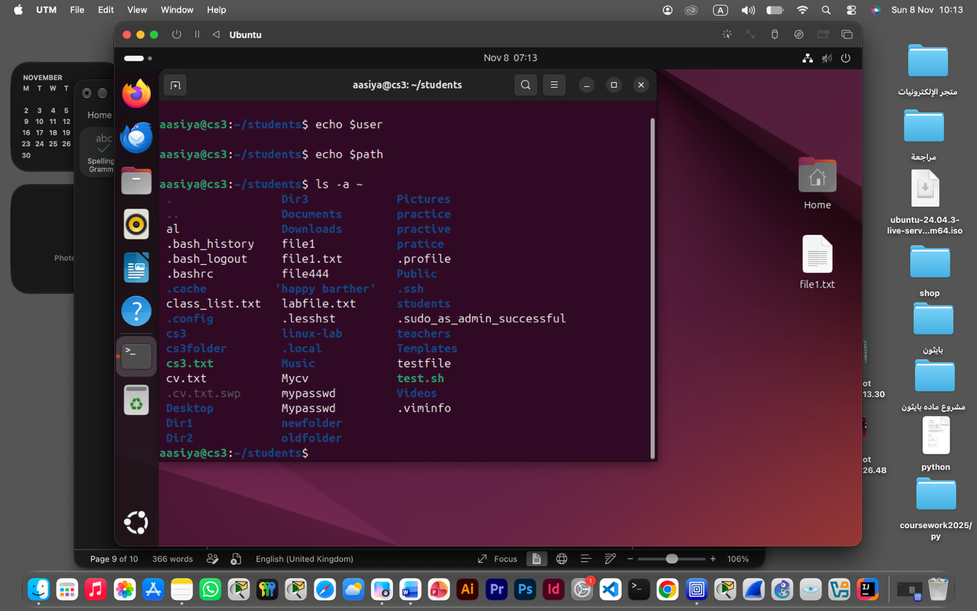

$USER
= variable containing the current
username.
$path
= Directories searched for executable
commands.
Ls -a ~
= lists all home-directory entries,

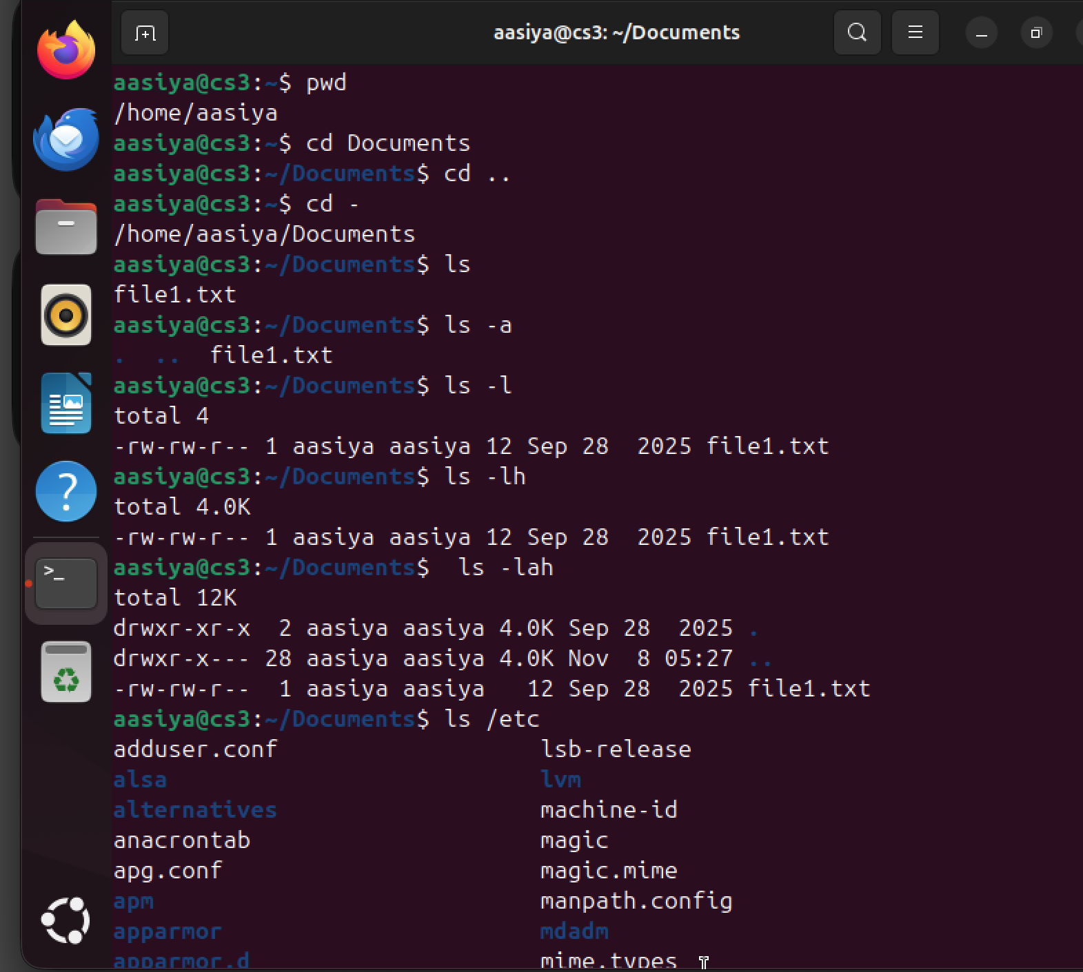

Pwd
= Prints the current working directory.
Cd dir emple cd document
= Changes to another directory.
cd ..
=Moves to the parent directory.
cd ~
= Changes to the home directory.
cd –
= Returns to the previous directory
cd /
= Changes to the root directory.
Ls
= Lists files and directories.
ls -a
= Lists all entries, including hidden
files.
ls -l
= Displays a long, detailed listing.
ls -h Displays file sizes in human-readable units when used
with -l.
ls -lah
= Combines long, all andhuman-readable listing.
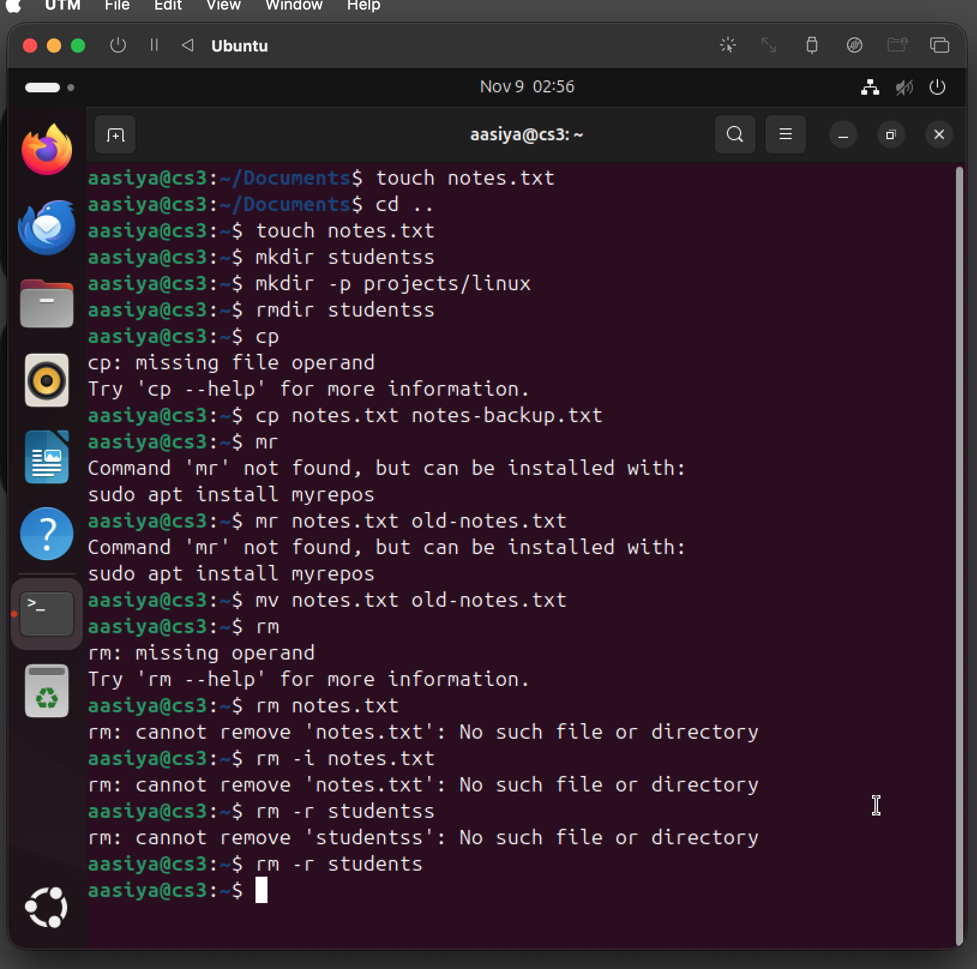

touch FILE
= Creates an empty file or updates its
timestamp.example touch notes.txt.
mkdir DIR
= Creates a directory. Example mkdir students
mkdir -p A/B
= Creates missing parent directories
as needed. Example mkdir -p projects/linux
rmdir DIR
= Removes an empty directory.example rmdir students
cp SOURCE DEST
= Copies a file or directory (with
suitable options).example cp notes.txt backup.txt
mv SOURCE DEST
= Moves or renames a file/directory. Example mv notes.txt old.txt
rm FILE
= Removes a file. Example rm notes.txt
rm -i FILE
= Prompts before removing a file example rm -i notes.txt
rm -r DIR
= Removes a directory and its contents recursively. Example rm -r students

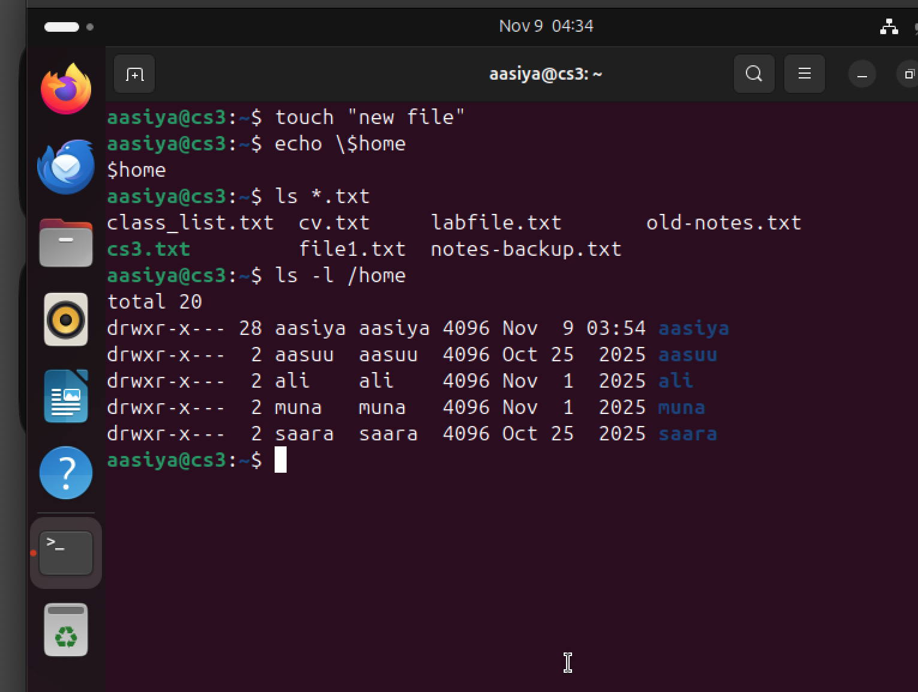
"..."
= Double quotes preserve spaces but
allow variable expansion.
Double quotes waxay isku hayaan
qoraalka, laakiin $ variable wuu
shaqaynayaa.example echo "$HOME".
'...'
= Single quotes preserve the text
literally.
Single quotes waxay qoraalka u
ilaalinayaan sida uu yahay.example echo '$HOME'.
\\
=Backslash escapes the next
character.
Backslash wuxuu character-ka xiga
ka dhigaa mid literal ah.example echo \\$HOME
*
= Wildcard matching zero or more
characters.
Wuxuu matalaa characters badan. Example ls *.txt.
?
=Wildcard matching exactly one
character.
Wuxuu matalaa hal character. Example ls file?.txt
[ ]
Matches one character from a
specified set or range.
Wuxuu matalaa hal xaraf oo ka mid
ah kuwa la doortay.examplels file[1-3].txt

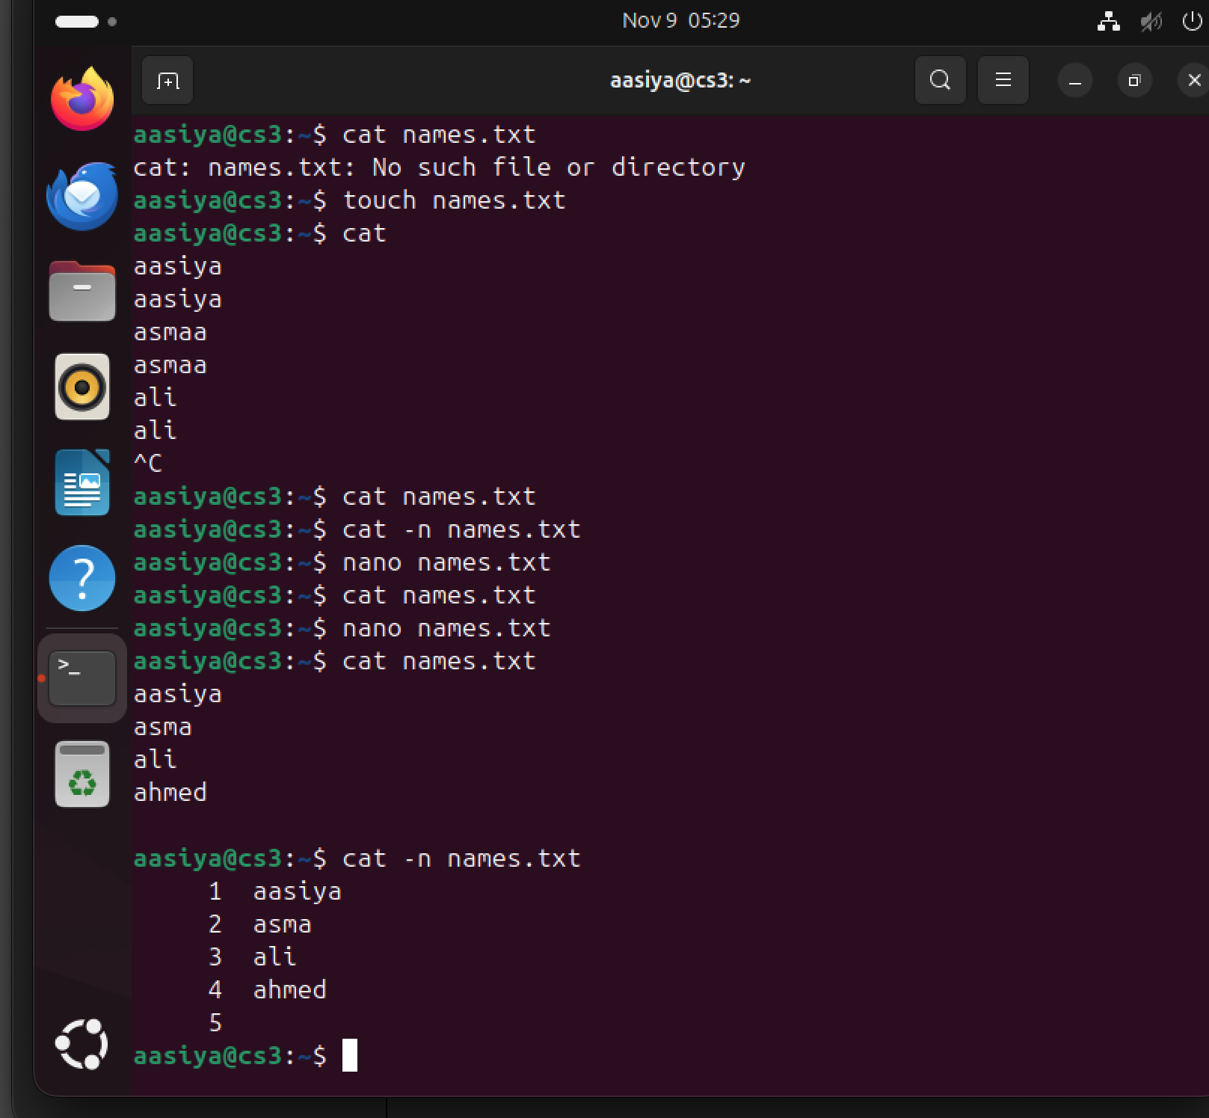

cat
=Displays file contents. Example cat names.txt
cat -n
=Numbers all output lines example . cat -n names.txt

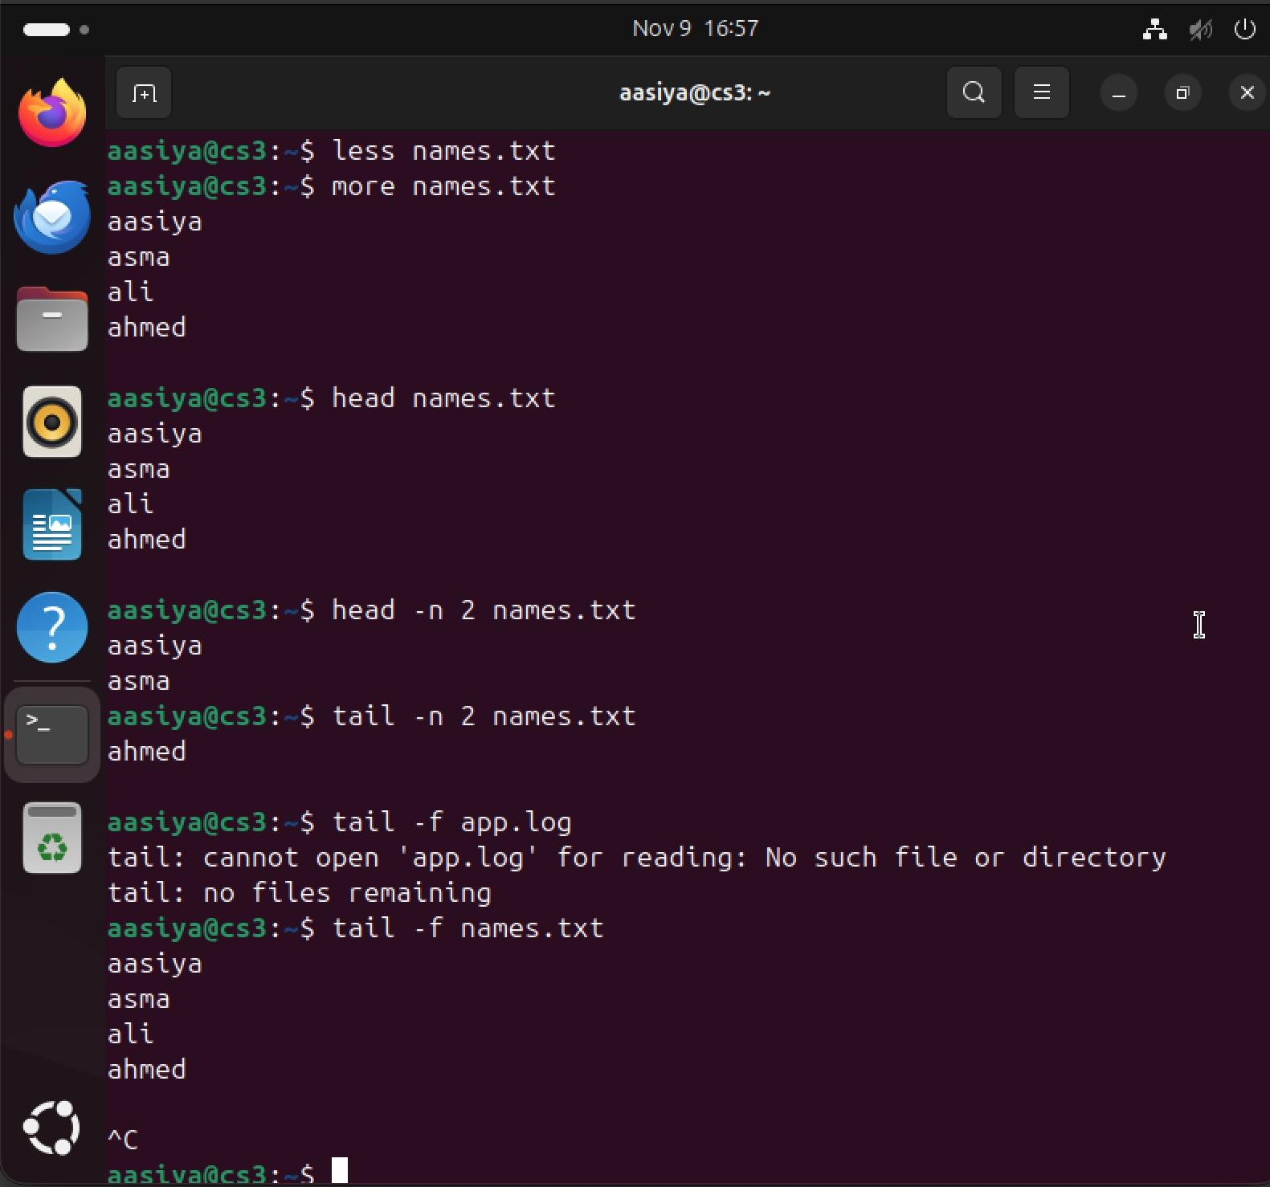

Less
= views a text file page by page support backword/forwad movent example less log.txt
more
=Views a text file one screen at atime. Example more long.txt
head
=Displays the beginning of a file default is 10 lines.example head names.txt
head -n N
= Displays the first N lines. Example head -n 2 names.txt
tail
Displays the end of a file default is 10 lines. Example tail names.txt
tail -n N
= Displays the last N lines. Example tail -n 2 names.txt
tail -f
=Follows a file as new lines areadded. Example tail -f app.log

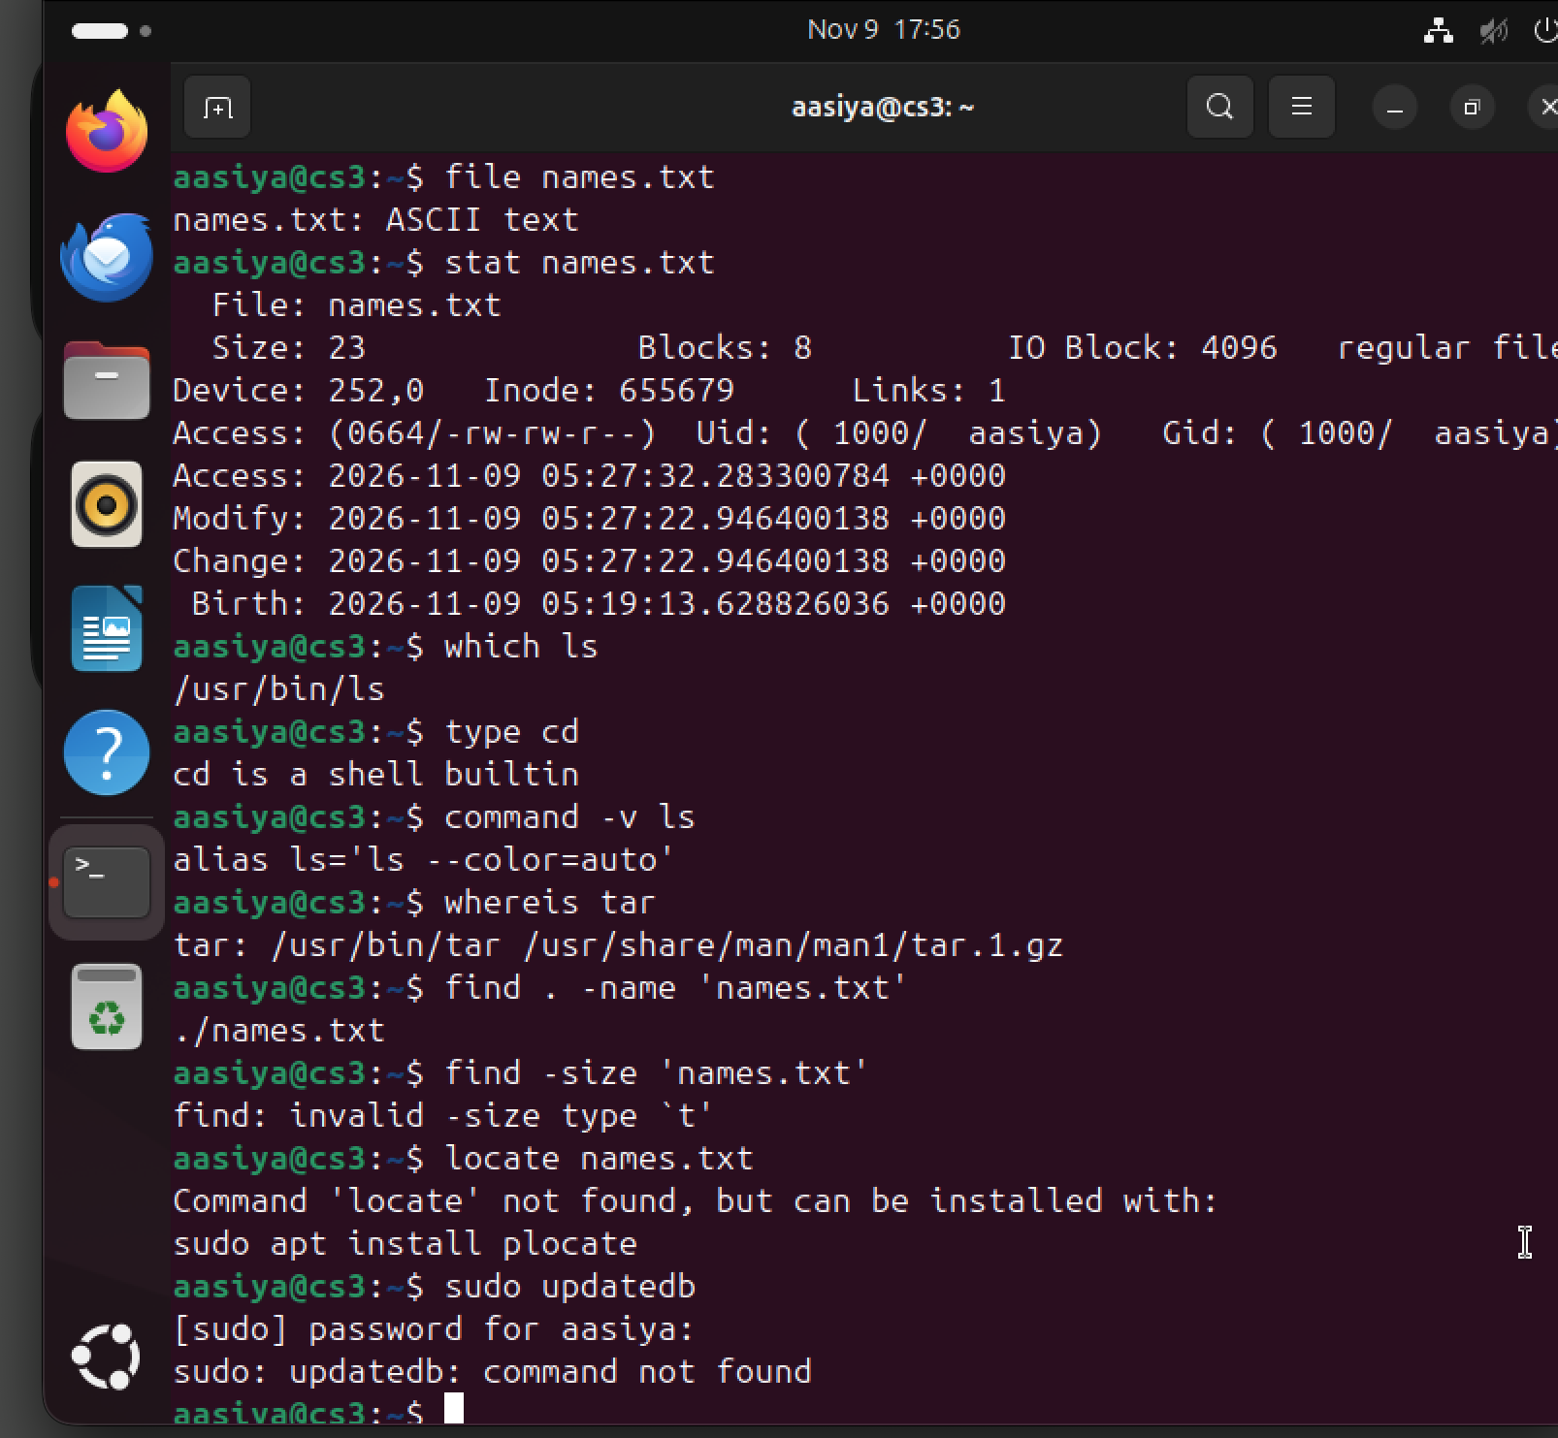

File
= Identifies the type of a file.example. file notes.txt
Stat
= Displays detailed file metadata,such as size, permissions andtimestamps. Example stat notes.txt
Which
= Shows the path of an executable command. Example which ls
type
= Identifies how the shell interprets a command.example.type cd
command -v
=Displays how the shell resolves a command name. example command -v ls
Whereis
= Locates a program, its source and manual files.example whereis tar
find
= Searches for files and directories.example. find . -name 'names.txt'
-name
= Searches by a case-sensitive namepattern.example find . -name '*.log'
-iname
=Searches by name without case sensitivity.example find . -iname 'names.txt'
-type f
= Matches regular files. Example find . -type f
-type d
=Matches directories. Example find . -type d

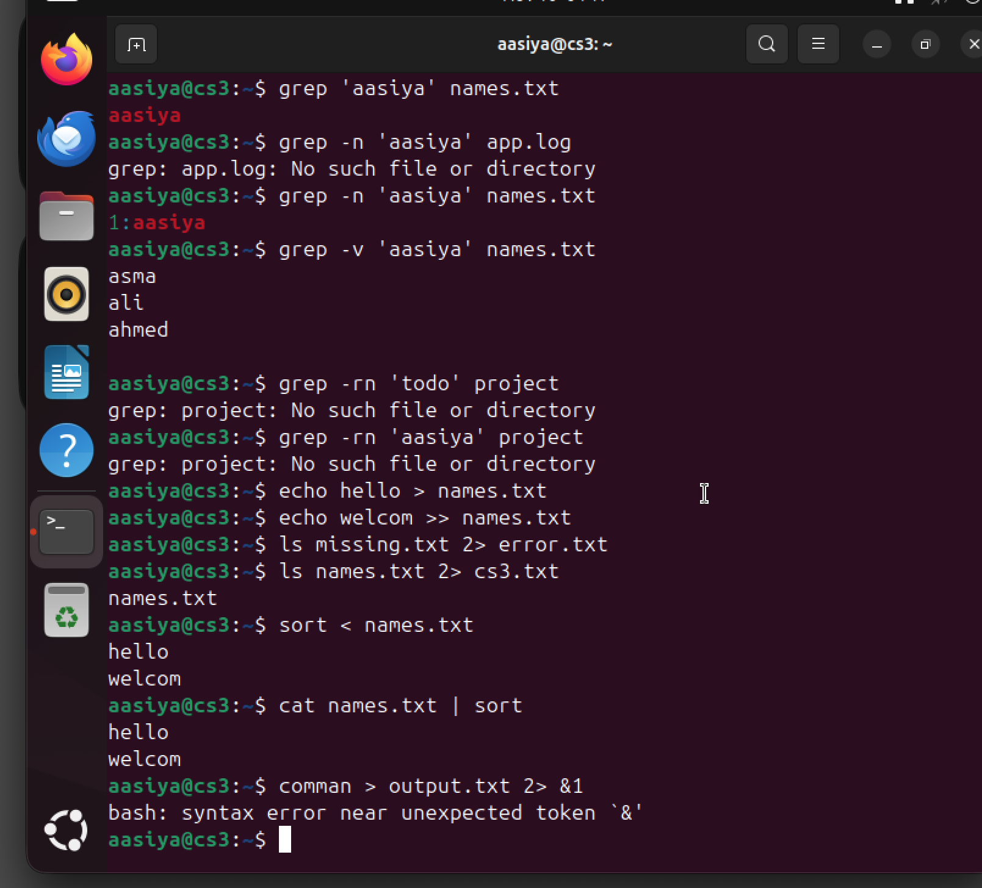

grep
= Searches text for lines matching a pattern.example.grep ‘ali’ names.txt
grep -n
=Displays matching lines with line numbers.example.grep-n ‘error’app.log
grep -i
=Ignores uppercase/lowercase differences.exaple.grep-i ‘error.app.log
grep -v
Displays lines that do not match the pattern.
grep -r
Searches recursively through directories.
grep -l
=Displays names of files containing a match.

.
Matches any single character.
grep b..h' file.txt
.
Repeats the preceding item zero or
more times.
grep to"g' flle.txt
^
Matches the beginning of a line.
grep "^All" names.txt
$
Matches the end of a line.
grep bashs' names.txt
[ ]
Matches one character trom the
listed set.
Grep 'gr[aejy' words.txt
stdin (0)
Standard input: data supplied to a command.
command < input. bxt
stdout (1)
Standard output: normal command oulput.
command > outputtxt
stderr (2)
Standard error: eror messages
from a command.
command 2 errors.txt
>
Redirects output to a file, replacing existing content.
echo Hello > notes.txt
>>
Appends output to the end of a file.
echo Welcome >> notes.txt
<
Uses a file as command input.
sort < names.txt
|
Sends one command's output as the
next command's input.
cat names.bxt | sort
2>&1
Redirects standard error to the
same destination as standard output.
command > output.bxt 2&1

sort
=Sorts lines of text. sort names.txt
sort -r
=Sorts in reverse order. sort -r names.txt
sort -n
=Sorts numerically. sort -n scores.txt
sort -u
=Sorts and outputs unique lines. sort -u names.txt

uniq
=Filters adjacent repeated lines. uniq cities.txt
uniq -c
=Counts repeated adjacent lines. uniq -c cities.txt
cut
=Extracts selected fields or columns from each line. cut -d: -f1 users.txt
-d
=Specifies the delimiter. cut -d: users.txt
-f
=Selects the first field. cut -f1 users.txt
paste
=Merges corresponding lines from files. paste names.txt cities.txt
wc
=Counts lines, words and bytes. wc names.txt
wc -l
=Counts lines. wc -l names.txt
wc -w
= Counts words. wc -w names.
wc -c
= Counts bytes. wc -c names.txt
tr
=Translates, deletes or squeezes characters. tr 'a-z' 'A-Z' < names.txt
tr -d Deletes selected characters. tr -d '0-9' < file.txt
tr -s Squeezes repeated characters into one. tr -s ' ' < file.txt
tr -c
= Uses the complement of the selected character set. tr -c 'a-z' ' ' < file.txt
tar -c
=Creates a new archive. tar -cf notes.tar notes.txt

tar -x
=Extracts files from an archive. tar -xf notes.tar
tar -t
=Lists the contents of an archive. tar -tf notes.tar
tar -f
=Specifies the archive file name. tar -cf project.tar project/
tar -v
=Displays files being processed. tar -cvf project.tar project/
tar -z
=Uses gzip compression with tar. tar -czf project.tar.gz project/
tar -j
=Uses bzip2 compression with tar. tar -cjf project.tar.bz2 project/
tar -J
=Uses xz compression with tar. tar -cJf project.tar.xz project/
tar -C
=Changes directory before extracting or operating. tar -xf project.tar -C restored/
gzip
=Compresses a file using gzip. gzip notes.txt
gzip -k
= Keeps the original file after compression. gzip -k notes.txt
gzip -9
=Uses the highest gzip compression level. gzip -9 notes.txt
Gunzip
= Decompresses a gzip file. gunzip notes.txt.gz
gunzip -c
=Writes decompressed data to standard output. gunzip -c notes.txt.gz
bzip2
=Compresses a file using bzip2. bzip2 app.log
bunzip2
=Decompresses a bzip2 file. bunzip2 app.log.bz2
bzcat
=Displays the contents of a bzip2 file. bzcat app.log.bz2

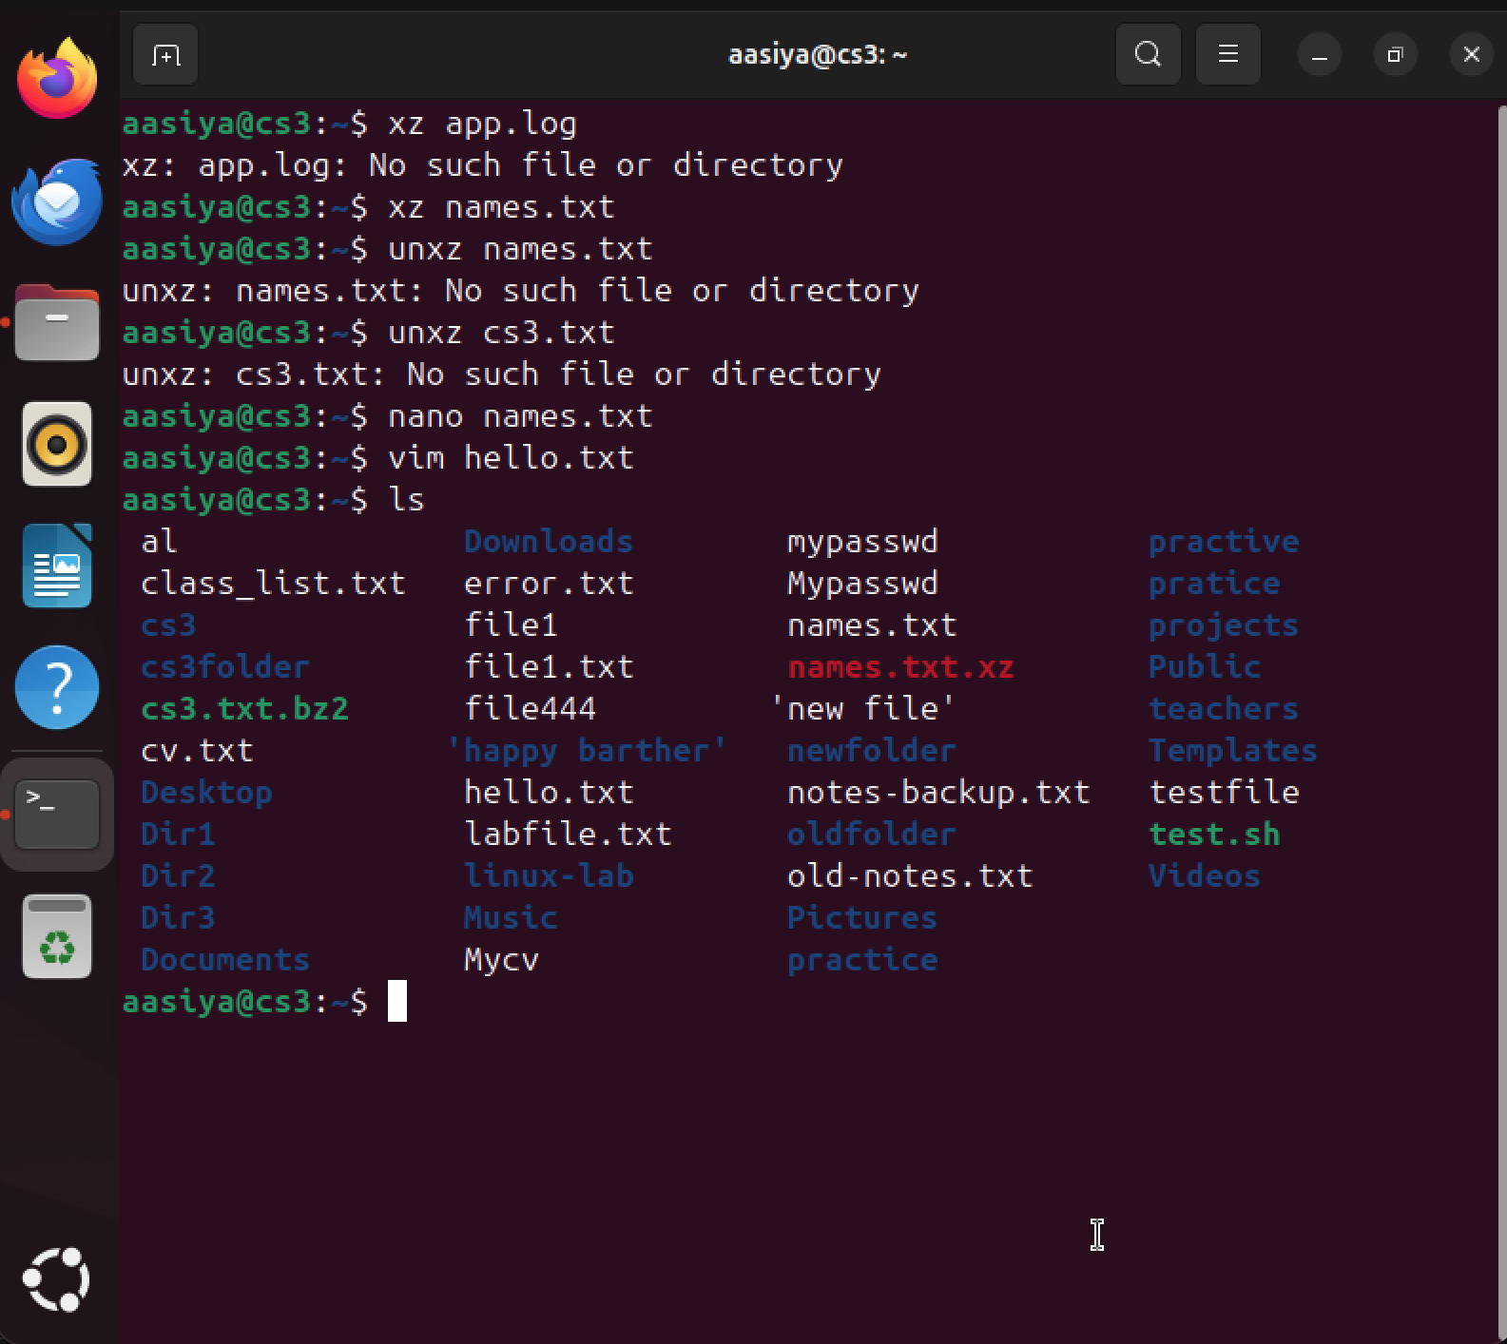

xz
=Compresses a file using xz. xz app.log
unxz
=Decompresses an xz file. unxz app.log.xz
xzcat
=Displays the contents of an xz file. xzcat app.log.xz
zip -r
= Creates a ZIP archive recursively. zip -r project.zip project/
Unzip
= Extracts a ZIP archive. unzip project.zip
unzip -l
=Lists ZIP archive contents without extracting. unzip -l project.zip
unzip -d
=Extracts to a specified directory. unzip project.zip -d restored/
nano
=Opens a simple text editor. nano notes.txt
Ctrl + O
= Writes or saves the file in Nano. Ctrl + O
Enter
=Confirms the file name when saving. Enter
Ctrl + X
=Exits Nano. Ctrl + X
Ctrl + W
= Searches for text in Nano. Ctrl + W
vim / vi
= Opens the Vim text editor. vim hello.txt
i
الحمد الله

