# Technical Design Document: example docstring

# Name: Angelica C. Munoz
# Date: February 15, 2026
# Program Description: Scan a user-entered email for 30 common spam/phishing trigger words/phrases, calculate a spam score based on occurrences, and display the score, likelihood rating, and the triggers that contributed to the score.

## Function: display_total_sales
Calls the function that reads and totals sales, then displays the result.

Parameters:
None

Variables:
total_sales (float): The total sales amount returned from
the read_sales_and_total function.

Logic:
1. Call the read_sales_and_total function.
2. Store the returned value in total_sales.
3. Display the total sales to the user.

Return:
None

## Function: read_sales_and_total
Reads sales amounts from a file and calculates the total sales.

Parameters:
filename (str): The name of the file containing sales data.

Variables:
file (TextIO): File object used to read data from the file.
total (float): Accumulator used to store the total sales amount.
line (str): Each line read from the file representing a sale.

Logic:
1. Open the file in read mode.
2. Initialize total to 0.0.
3. Loop through each line in the file.
4. Convert the line to a float and add it to total.
5. Return the total sales amount.

Return:
float: The total of all sales read from the file.

## Function: write_sales_to_file
Writes a list of sales amounts to a text file.

Parameters:
sales (list of float): A list containing individual sales amounts.
filename (str): The name of the file where sales will be written.

Variables:
file (TextIO): File object used to write data to the file.
sale (float): Individual sales amount from the sales list.

Logic:
1. Open the file in write mode.
2. Loop through the sales list.
3. Write each sale amount to the file on a new line.
4. Close the file automatically using a context manager.

Return:
None
https://github.com/munoza-scf/COP2373
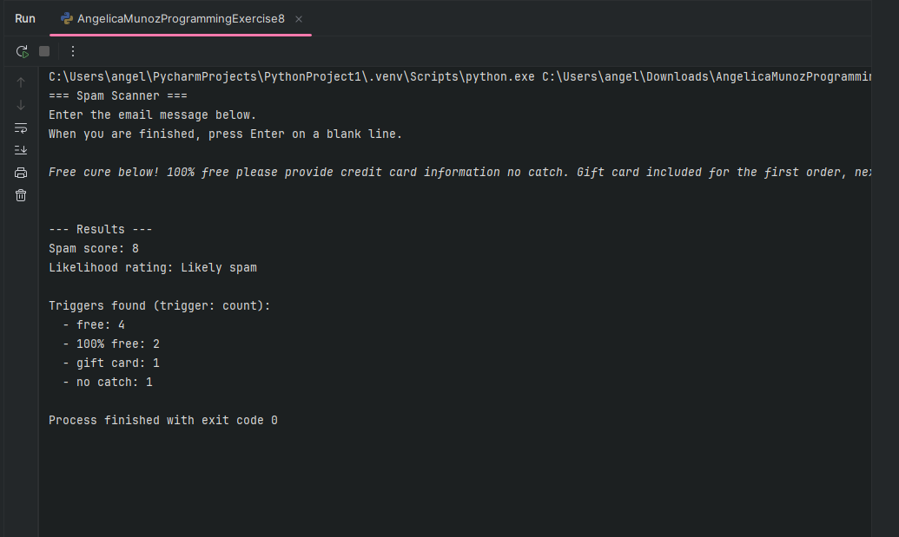

Functions (Docstring-Based Technical Design):

Function: run_spam_scanner
Orchestrates the program: collects input, scans, rates likelihood, and displays results.

Function: get_email_message_from_user
Reads a multi-line email message from the user until a blank line is entered.

Function: get_spam_triggers
Returns the list of 30 spam trigger words/phrases.

Function: normalize
Normalizes text (lowercase, hyphens to spaces, collapse whitespace) for consistent matching.

Function: count_trigger_occurrences
Counts occurrences of a specific trigger using whole-word/phrase matching.

Function: scan_message_for_spam
Scans the email for all triggers and produces score + trigger counts.

Function: rate_spam_likelihood
Maps the spam score to a rating string using thresholds.

Function: display_results
Displays score, rating, and trigger counts to the user.

Link to your repository:
https://github.com/munoza-scf/COP2373
Output Screenshot:

