
American International University-Bangladesh (AIUB)
Faculty of Engineering

Department of CSE, EEE, and CoE
EEE4103 MICROPROCESSOR AND EMBEDDED SYSTEM

COURSE CAPSTONE PROJECT PROPOSAL FORM

SEMESTER: Spring 2025-26
PROJECT TITLE: (must be an embedded system designed using Arduino/STM32/Raspberry Pi with other necessary sensors, actuators, components, etc. Both hardware implementation and simulation must be shown by the end of the semester. However, the proposal form should be submitted within the
next two weeks from now on) 2 MARKS
SURVEY: (to develop a process for complex engineering problems considering cultural and societal factors (use Google or Microsoft Forms to design questions, show the outcomes in the form of a pie/bar chart, show the links of questions, minimum 10 questions, and 40 respondents), present survey link 7
MARKS
AIMS AND OBJECTIVES OF THE PROJECT: (there must be a minimum of three aims and objectives of your work using measurable action verbs of Bloom’s Taxonomy, for example, design, simulate, implement, analyze, etc.) 4 MARKS
LITERATURE REVIEW: (must be related to embedded system design with other necessary citations
from the most recently published papers. At least 5 most recent publications must be collected, studied, identified the problems, and then discussed in this section) 5 MARKS
EXPERIMENTAL BLOCK DIAGRAM: (demonstrate how this project is interconnected with various components and how various signals flow among them using text boxes and arrows) 5 MARKS
POSSIBLE OUTCOMES OF THE PROJECT: (describe how this project can help society and improve the culture of society) 4 MARKS
PROJECT TIMELINE (GANTT CHART): describe how this project will progress with time by breaking the whole task into several components concerning some specific time using a horizontal or
vertical bar graph) 5 MARKS
REFERENCES: (only published paper-based references are allowed with the IEEE format, don’t use YouTube links, Wikipedia, or any random websites for references; however, datasheets, databases, can be used as references with the appropriate formats, links, and access dates): 3 MARKS
Sample for the conference paper:
[1] M. H. Bhuyan and Q. D. M. Khosru, “Linear Asymmetric Pocket Profile Based Pinch Off Voltage Model for Nano Scale n-MOSFET,” Proceedings of the IEEE sponsored International Conference on Electrical, Computer and Communication Engineering (ICECCE2017), organized by the Chittagong University of Engineering and Technology (CUET), Cox’s Bazar, Bangladesh, 16-18 February 2017, pp. 28-32.
Sample for the journal paper:
[1] M. H. Bhuyan and Q. D. M. Khosru, “Effects of Temperature on Reverse Short Channel Effect in Pocket
Implanted Sub-100 nm n-MOSFET,” Journal of Materials Science and Engineering, USA, 1934-8959, vol. 4, no 7, July
2010, pp. 18-23, DOI:10.17265/2161-6213/2010.07.004.

Instructions:
- There is no definite format for writing the course project proposal, but students must follow the instructions mentioned above properly.
- Fill in the form accurately with all necessary information.
- Make a color print on this form.
- Figures, tables, charts, circuit diagrams, block diagrams, and wave shapes must be color printed.
- The survey form links with the answers that must be provided in the proposal form.

FOR FACULTY USE ONLY
COMMENTS BY COURSE TEACHER:

COURSE TEACHER’S NAME COURSE TEACHER’S SIGNATURE DATE

GROUP MEMBERS
(Maximum 6 students are permitted to carry out a single Project. However, depending on the capability of the students, 4 students may be allowed, but not fewer than that.

NAME: Najiat Islam Rishad
ID: 23-55218-3 PROGRAM: CSE
EMAIL: 23-55218-3 @student.aiub.edu
REMARKS (for OFFICE use only)

Course Name: |  | Microprocessor and Embedded System | Course Code: | EEE 4103
Semester: |  | Spring 2025-26 | Sec:
Faculty Member:
Capstone Project Title: |  | Gas Leakage and Flame Detection System Using Arduino for Real-Time Hazard Monitoring and Alert Automation.
Project Group No. |  | 07
Sl # | Student ID # | Student Name | Obtained Marks
1. | 23-55218-3 | Najiat Islam Rishad
2.
3.
4.
5.
Assessment Materials and Marks Allocation:

COs | Assessment Materials | POIs | Marks
CO3 | Course Capstone Proposal Form | P.c.2.C6 | 35
Assessment Rubrics:

KPIs | Excellent [2] | Proficient [1.5] | Good [1] | Acceptable [0.5] | Unacceptable [0] | No Response [0] | Secured Marks
Project Title | The title reflects an issue related to complex engineering problems, showing targets and methods with possible  outcomes. | The title reflects an issue related to complex engineering problems, showing targets and methods, but some missing  issues. | The title reflects an issue related to the course capstone project, but there may be some missing issues. | The title reflects an issue related to the course capstone project, but it is not complete or specific. | The title does not reflect any issues related to the course capstone project. | No Response at all/ copied from others /identical submissions with gross errors/ image  file printed
Comments |  |  |  |  |  | Total Marks (2)

KPIs | Excellent [6-7] | Proficient [4-5] | Good [3] | Acceptable [2] | Unacceptable [1] | No Response [0] | Secured Marks
Survey | The survey developed as a process for complex engineering problems, considering cultural and societal factors, has superior variables, targets, measures, and  the implementation process is clear and challenging for future project implementation, with several possible outcomes having good impacts. | The survey, developed as a process for complex engineering problems, considering cultural and societal factors, has good variables, targets, measures, and  The implementation process is clear and challenging for future project implementation, with some possible outcomes and little impact. | The survey developed as a process for complex engineering problems, considering cultural and societal factors, has moderate variables, targets, measures, and  The implementation process is clear and challenging for future project implementation, with a few possible outcomes and impacts. | The survey, developed as a process for complex engineering problems, considering cultural and societal factors, has good variables, targets, measures, and  The implementation process is somewhat clear for future project implementation, with very few possible  outcomes and little impact. | The survey developed as a process for complex engineering problems, considering cultural and societal factors, has poor variables, targets, measures, and  the implementation process is very unclear for future project implementation, with a few possible outcomes but no impacts. | No Response at all/ copied from others  /identical submissio ns with gross errors/ image file printed

Comments |  |  |  |  |  | Total Marks (7)
KPIs | Excellent [4] | Proficient [3] | Good [2] | Acceptable [1] | Unacceptable [0.5] | No  Response [0] | Secured Marks
Aims and Objectives | Aims and objectives are written to solve complex engineering problems, considering cultural and societal factors with specific targets, measurements, and implementation processes that are clear and challenging, and have several possible outcomes having very good impacts. | Aims and objectives are written to solve complex engineering problems, considering cultural and societal factors with general targets, measurement, and implementation processes that are not clear and challenging, and have some possible outcomes that have a good impact. | Aims and objectives are written to solve complex engineering problems considering a few cultural and societal factors with narrow targets; measurement, and implementation processes are clear and challenging and have a few possible  outcomes, having some impacts. | Aims and objectives are written to solve complex engineering problems considering cultural or societal factors with a very specific target; measurement and implementation processes are not clear or challenging, and have little  possible outcome, having no impact. | Aims and objectives are written to solve complex engineering problems, but do not consider cultural and societal factors with any targets; measurement and implementation processes are not clear and challenging, and no possible outcomes that have an impact. | No Response at all/ copied from others  /identical submissio ns with gross errors/ image file printed
Comments |  |  |  |  |  | Total  Marks (4)

KPIs | Excellent [5] | Proficient [4] | Good [3] | Acceptable [2] | Unacceptable [1] | No Response [0] | Secured Marks
Literature Review | Specific formats are maintained to review and cite the literature with recent publications.  Identified and analyzed the problem correctly. | Specific formats are maintained to review and cite the literature with recent publications.  Identified and analyzed the problem correctly, but not all issues were addressed with relevant or  intended work. | Specific formats are maintained to review and cite the literature with recent and past publications.  Identified and analyzed the problem correctly, but not all issues were addressed with relevant or  intended work. | Specific formats are maintained to review and cite the literature with recent and past publications. Identified but could not analyze all the problems correctly, and all issues were not addressed with  relevant or intended work. | No specific formats are maintained to review and cite the literature with recent publications.  Could not identify and analyze all the problems correctly, and all issues are not addressed with relevant or intended work at all. | No Response at all/ copied from others/ identical submissions with gross errors/ image file printed
Comment s |  |  |  |  |  | Total Marks (5)

KPIs | Excellent [5] | Proficient [4] | Good [3] | Acceptable [2] | Unacceptable [1] | No Response [0] | Secured Marks
Experime ntal Block Diagram | The block diagram is drawn to show the connections of all the possible components or subsystems to show their interdependence with all possible flows of signals from inputs to outputs. | The block diagram is drawn to show the connections of all of the possible components or sub- systems to show their interdependence, with a few missing flows of signals from inputs to outputs. | The block diagram is drawn to show the connections of most of the possible components or sub- systems to show their interdependence, with a few missing flows of signals from inputs to outputs. | The block diagram is drawn to show the connections of a few possible components or sub-systems to show their interdependence, with some missing flow of signals from inputs to outputs. | The block diagram is not drawn to show the connections of all possible components or sub- systems, to show their interdependence and flow of signals from  inputs to outputs. | No Response at all/ copied from others  /identical submissions with gross errors/ image file printed
Comment s |  |  |  |  |  | Total Marks (5)

KPIs | Excellent [4] | Proficient [3] | Good [2] | Acceptable [1] | Unacceptable [0.5] | No Response [0] | Secured Marks
Possible Outcomes | Outcomes are written to achieve complex engineering problems’ solutions, considering cultural and societal factors and showing measurement and implementation processes to attain the outcomes with all possible impacts. | Outcomes are written to achieve complex engineering problems’ solutions, considering cultural and societal factors and showing measurement and implementation processes to attain the outcomes with some impacts. | Outcomes are written to achieve complex engineering problems’ solutions, considering cultural and societal factors, and do not show measurement and implementation processes to attain the outcomes without showing any impacts. | Outcomes are written to achieve complex engineering problems’ solutions, but do not consider cultural and societal factors, and do not show measurement and implementation processes to attain the outcomes without showing any impacts. | Outcomes are not written to achieve complex engineering problems’ solutions, do not consider cultural and societal factors, and do not show measurement and implementation processes to attain the outcomes without showing any impacts. | No Response at all/ copied from others  /identical submissions with gross errors/ image file printed
Comment s |  |  |  |  |  | Total Marks (4)

KPIs | Excellent [5] | Proficient [4] | Good [3] | Acceptable [2] | Unacceptable [1] | No Response [0] | Secured Marks
Gantt Chart | Specific formats are maintained to draw the Gantt chart, and there is an order of  workflow with all work to be done. | Specific formats are maintained to draw the Gantt chart, and there is an order of  workflow with a few tasks missing. | Specific formats are maintained to draw the Gantt chart, and there is an order of workflow with some work missing. | No specific formats are maintained to draw the Gantt chart, and there is little order to the  workflow, with some work missing. | No specific formats are maintained to draw the Gantt chart, and there is no order of workflow, with the  most important tasks missing. | No Response at all/ copied from others/ identical submissions with gross errors/ image file printed
Comment s |  |  |  |  |  | Total Marks (5)

KPIs | Excellent [3] | Proficient [2.5] | Good [2] | Acceptable [1] | Unacceptable [0.5] | No Response [0] | Secured Marks
References | Specific formats are maintained to write references, and all are recently published journal and conference papers having no missing information. | Specific formats are maintained to write the references, and all are journal and conference papers, but some old papers have missing information. | No specific formats are maintained to write the references, and many are internet sources with several missing information and very old references. | No specific formats are maintained to write the references, and most of them are internet sources with missing  information. | No specific formats are maintained to write the references, and all are internet sources with missing information. | No Response at all/ copied from others /identical submissions with gross errors/ image file printed
Comments |  |  |  |  |  | Total Marks (3)

PROJECT TITLE

“Gas Leakage and Flame Detection System Using Arduino for Real-Time Hazard Monitoring and Alert
Automation”

SURVEY
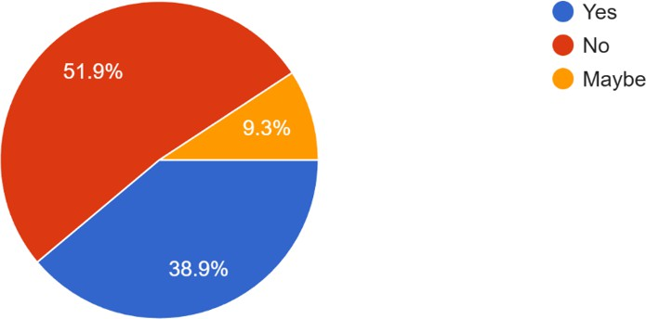

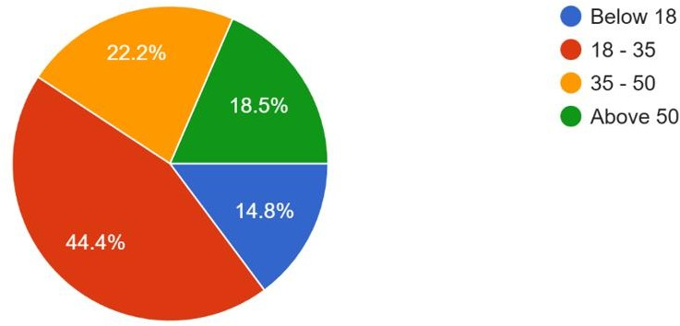
Figure 1: Age Group Distribution
The survey begins by analyzing the age demographics of the 54 respondents. The data indicates that the largest group, comprising 44.4%, falls within the 18–35 age range, suggesting that the primary respondents are young adults or students. This is followed by those below 18 at 22.2%, and those above 50 at 18.5%. The smallest group is the 35–50 demographic, representing 14.8% of the total.

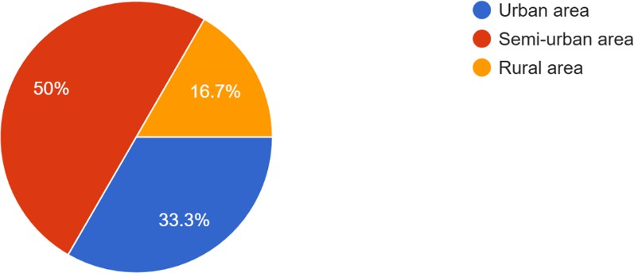
Figure 2: Residential Location Analysis
Regarding living arrangements, exactly 50% of the respondents currently reside in Urban areas, which is significant because urban households are more likely to utilize piped gas connections that require leakage detection. The remaining respondents are divided between Rural areas (33.3%) and Semi-urban areas (16.7%), indicating a diverse geographic spread for the potential user base.
Figure 3: Awareness of Gas Accident Causes
This chart measures public knowledge regarding safety hazards. A slight majority of 51.9% confirmed they are fully aware that gas leakages are a major cause of accidents in Bangladesh. However, a significant portion (38.9%) answered "Maybe," and 9.3% said "No," highlighting a gap in safety education that this project aims to address.

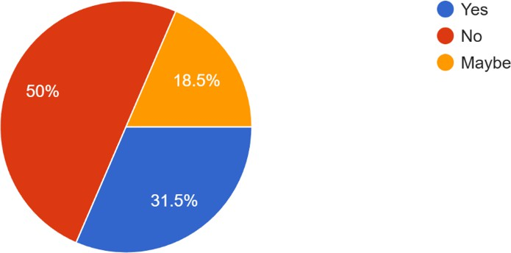
Figure 4: Personal Experience with Accidents
When asked about personal experiences with fire or gas incidents, 50% of respondents stated they have never experienced one. However, nearly one-third (31.5%) responded "Yes," confirming that they have personally witnessed or heard of such accidents in their community. The remaining 18.5% were unsure, answering "Maybe."

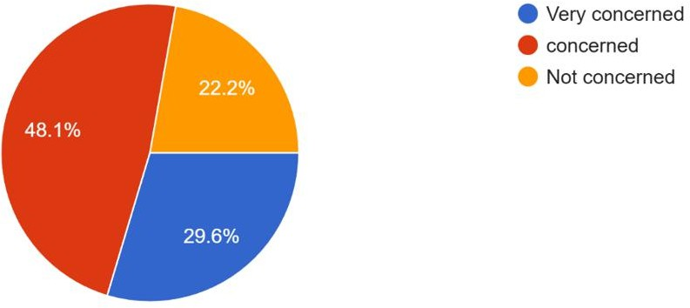
Figure 5: Level of Hazard Concern
The data shows a high level of anxiety regarding potential accidents. 48.1% of people are "Very concerned" about gas leakage risks in their kitchens, while another 29.6% are "Concerned." Only 22.2% stated they are "Not concerned," proving that the psychological demand for a safety solution is high.

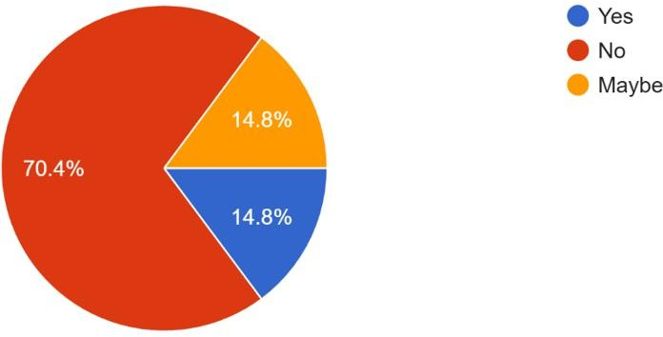
Figure 6: Utilization of Existing Detection Devices
This figure highlights a major market opportunity. An overwhelming 70.4% of respondents stated they do not currently use any gas leakage or fire detection device at home. Only 14.8% confirmed using one, with the remaining 14.8% answering "Maybe," which likely implies they are unsure if their building has central safety measures.

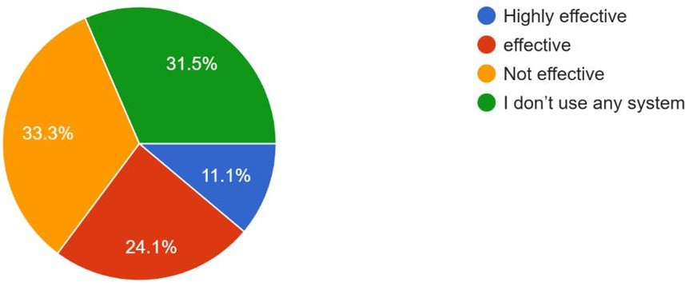
Figure 7: Perceived Effectiveness of Current Systems
Among the few who do have systems or have an opinion on them, the results are mixed. While 33.3% believe their system is "Effective," a significant 24.1% deem
existing solutions "Not effective." Notably, 31.5% reiterated that they do not use any system, validating the consistency of the data from the previous question.

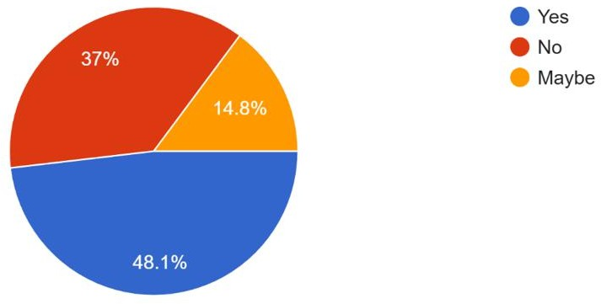
Figure 8: Interest in Automated Detection Systems
Public interest in the proposed IoT solution is strong but cautious. The largest group (48.1%) answered "Maybe," suggesting they need to see the device work before committing. 37% responded with a definite "Yes," showing immediate interest, while only 14.8% were not interested.

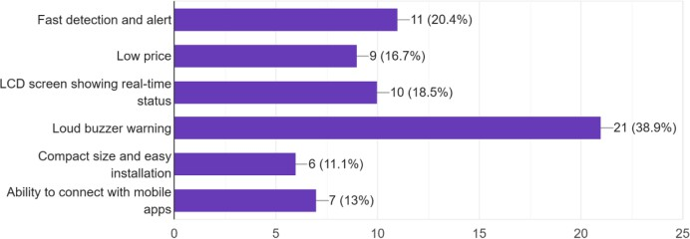
Figure 9: Preferred Device Features
This bar chart reveals that users prioritize basic safety over advanced tech. The most requested feature is a "Loud buzzer warning" (38.9%), followed by "Fast detection and alert" (20.4%). Interestingly, connectivity features like "Mobile apps" were the lowest priority (13%), indicating that users value immediate local alarms over remote monitoring.

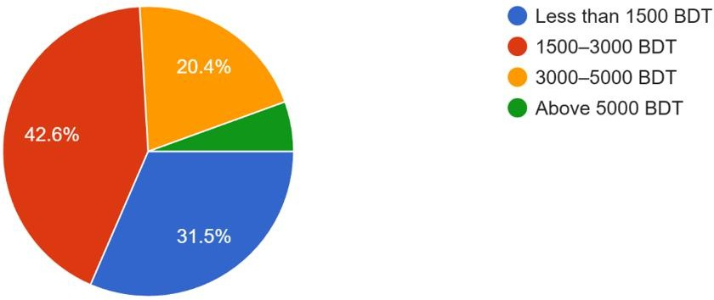

Figure 10: Pricing Tolerance

The survey indicates a price-sensitive market. The majority of respondents (42.6%) are willing to pay Less than 1500 BDT for such a device. 31.5% are willing to pay between 1500–3000 BDT, while only 20.4% would pay above 5000 BDT. This sets a clear budget constraint for the project's component selection.

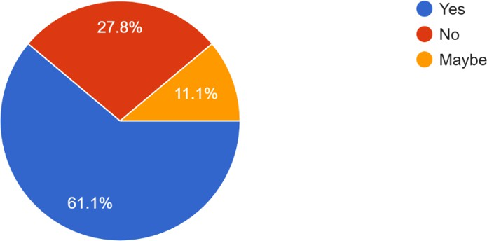

Figure 11: Opinion on Mandatory Installation
There is strong public support for government regulation. 61.1% of respondents believe that installing gas-fire detection devices should be mandatory in homes, shops, and restaurants. 27.8% were unsure ("Maybe"), and only 11.1% opposed the idea.

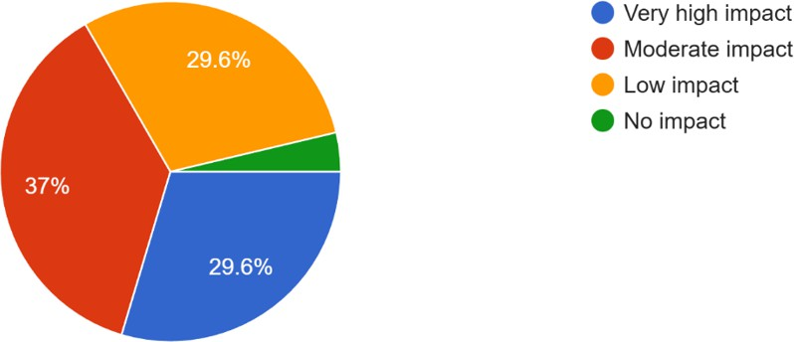
Figure 12: Estimated Accident Prevention Impact
Respondents are optimistic about the device's potential. 37% believe the device will have a "Moderate impact" on preventing accidents, while 29.6% believe it will have a "Very high impact." Only a minority felt it would have low or no impact.

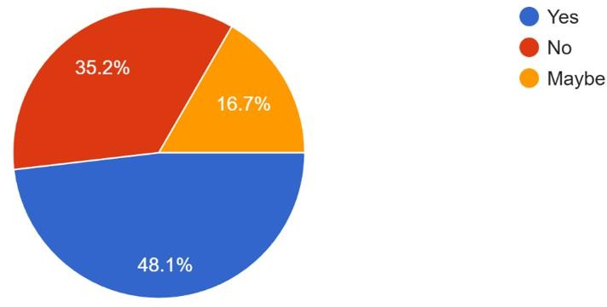
Figure 13: Recommendation to Community

Finally, the survey concludes with high promoter potential. 48.1% of respondents said "Yes," they would recommend a low-cost, reliable system to their community. 35.2% said "Maybe," contingent on the device's reliability, while only 16.7% said they would not recommend it.

The "Gas Leakage and Flame Detection System" project. The data decisively establishes two critical factors: a high level of public concern and risk validation (with 77.7% of respondents concerned about gas hazards and 31.5% having personal experience with accidents), and a profound market opportunity (with an overwhelming 70.4% of households lacking any form of detection device). To successfully enter this gap, the device must be designed as a low-cost, immediate-alert system, prioritizing a loud buzzer warning (most requested feature, 38.9%) and adhering to a price ceiling below 1500 BDT (desired by 42.6% of the market). The strong public support for mandatory installation (61.1%) and high recommendation potential (48.1%) underscores the project's societal relevance and commercial viability, confirming that a reliable, affordable solution is critically needed and highly anticipated by the community.

Metric | Survey Result | Implication
Problem Demand (High  Concern) | 77.7%  (Concerned/Very Concerned) | Confirms strong psychological and safety need  for the device.
Market Gap (No Device Used) | 70.4% (Do Not  Use a Device) | Confirms a massive, untapped  market for a new solution.
Price Constraint (Max Willingness) | 42.6% (Willing to pay < 1500 BDT) | Sets a strict design requirement for component cost and final  pricing.
Key Feature Priority | 38.9% (Loud Buzzer Warning) | Directs the  design focus toward immediate,  local hazard notification.

Survey Link: https://forms.gle/NYwwGzDz9NvoC4X2A

AIMS AND OBJECTIVES

The main aim of this project is to design and implement an embedded safety monitoring system capable of detecting gas leakage and flames and generating automated alerts.

Objectives
- Design an Arduino-based embedded system using MQ-2 gas sensor, flame sensor, and buzzer for real-time hazard detection.
- Simulate the entire system in Proteus to validate component interactions and verify sensor thresholds before hardware implementation.
- Implement a working prototype capable of detecting gas leakage or flame and triggering alerts through buzzer, LED indicators.
- Analyze system performance by comparing real-time sensor data with simulation data to determine accuracy and response time.

Circuit Diagram & Simulation:

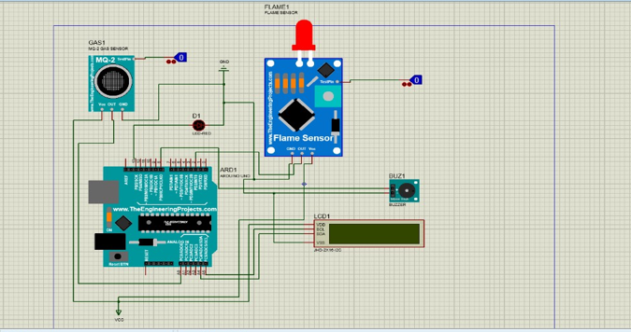

Figure 14: Circuit Diagram

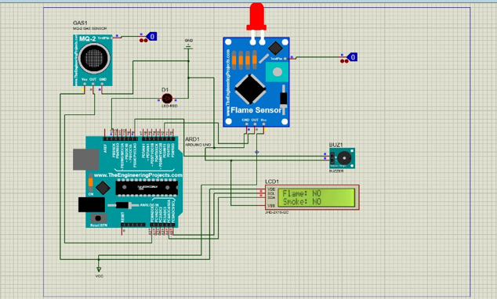

Figure 15: Finding any gas and flame LED blink and LCD display show the fire instruction.

Literature Review

Embedded System Design for Hazard Monitoring
This literature review focuses on the current state of embedded system design for Gas Leakage and Flame Detection, drawing on recent research (2022-2025) to identify key advancements, common implementations, and critical challenges that your project aims to address.

The following papers represent the most recent research in this domain, providing a snapshot of contemporary practices and problems in IoT-enabled hazard monitoring systems:

Citation & Year | Embedded/IoT Focus | Key Contribution
[1] Mustofa, (2025). Design an Internet of Things-Based LPG Gas Leak Detection System. | NodeMCU, MQ-6 Sensor, Blynk (IoT) | Developed an IoT system using MQ-6 and NodeMCU, achieving an error value of 9.52% in gas detection and 500m  distance for smartphone alerts.
[2] Ghasemi, S. M. et al. (2025). Reliability and Performance Evaluation of IoT-Based Gas Leakage Detection Systems for Residential Environments. | Dual-Sensor (VOC/Pellistor), BLE, LoRa, Reliability Testing | Focuses on reliability validation under stress and the use of dual-sensor strategy to optimize power consumption in power-intensive pellistor sensors.
[3] Baballe, M. A. et al. (2022). A Comparative Study on Gas Alarm Detection System. | ESP Controller, MQ-5 Sensor, Notification via Email/App | Comprehensive review of gas alarm systems, emphasizing the need for fast messaging and reliable notification to the user's mobile device.
[4] Alao, P. O. et al. (2024). Integrated Gas Leakage Detection and Automatic  Shutoff System for Safety and Emergency Response. | ESP32, MQ-2, Flame  Sensor, Servo Motor (Automatic Shutoff) | Integrated gas, fire, and temperature sensors with a servo motor for  automatic gas line shutoff, showing a trend toward automated mitigation.
[5] Arfianto, R. et al. (2025). Gas Leakage Detection Using Tiny Machine Learning (TinyML). | Arduino Nano 33 BLE, Edge-based Processing (TinyML) | Proposed a TinyML solution to move data processing to the edge, significantly reducing latency and power consumption for real-time response.

Based on the synthesis of these recent publications, the following critical problems and trends in embedded system design for hazard monitoring are identified:

Sensor Reliability and Environmental Noise (Latency/Accuracy)
While most studies utilize common Metal-Oxide-Semiconductor (MOS) sensors like the MQ-2, MQ-5, or MQ-6 [1, 3, 4], achieving high accuracy remains a challenge.
  - Problem: Systems often struggle with false alarms or detection delays due to sensor noise, especially in semi-open environments where gas can quickly dilute [3]. For instance, one system reported a 9.52% error rate in gas detection [1].
  - Discussion: Newer research is addressing this by implementing filtering algorithms (like the Kalman filter, as found in some studies) or advanced edge computing techniques like TinyML [5] to process and filter noisy sensor data locally and in real-time. This is a vital trend for ensuring the reliability of a mass-market domestic device.

Power Consumption vs. Performance in Advanced Systems
There's a growing need for highly reliable and continuous monitoring, but this conflicts with power demands.
  - Problem: High-performance systems using power-intensive sensors (like professional-grade pellistor sensors) or complex algorithms (like image processing for flame detection) are unsuitable for battery-operated domestic use due to excessive power drain [2].

  - Discussion: Solutions involve a dual-sensor strategy where a low-power sensor (VOC) acts as a trigger for the high-power sensor (pellistor) [2], or using highly optimized algorithms (e.g., quantized deep learning models) on resource-constrained microcontrollers like ESP32 [5]. Your project, being low-cost, must find the right balance between the energy-efficient Arduino platform and necessary detection speed.

Over-reliance on Cloud/Remote Communication for Critical Alerts
Current IoT systems are highly dependent on Wi-Fi connectivity and cloud platforms (Blynk, ThingSpeak, etc.) for alerting.
  - Problem: If the Wi-Fi network fails or cloud servers are down, the primary notification system is compromised. Crucially, the survey results indicate users prioritize an immediate local alarm (loud buzzer) over remote mobile app notifications, which had a low priority (Figure 9).
  - Discussion: The embedded system design must adopt a multi-layered alerting protocol: the local alert (buzzer, LED) must be the primary, failsafe response triggered directly by the microcontroller, with IoT (Wi-Fi/Mobile App) alerts serving only as a secondary, value-added feature.

Lack of Integrated, Automated Mitigation
Most basic low-cost systems only detect and alert, requiring human intervention to shut off the gas supply.
  - Problem: The time taken for a human to respond to a remote alert is often too slow to prevent an explosion, especially for high concentrations of gas.
  - Discussion: Recent research demonstrates the trend toward automated mitigation by integrating servo motors or solenoid valves to physically cut off the gas supply immediately upon detection [4]. Incorporating this active safety feature, while adding cost, represents the future of effective hazard prevention and is a strong differentiator for an advanced capstone project.

Experimental Block Diagram
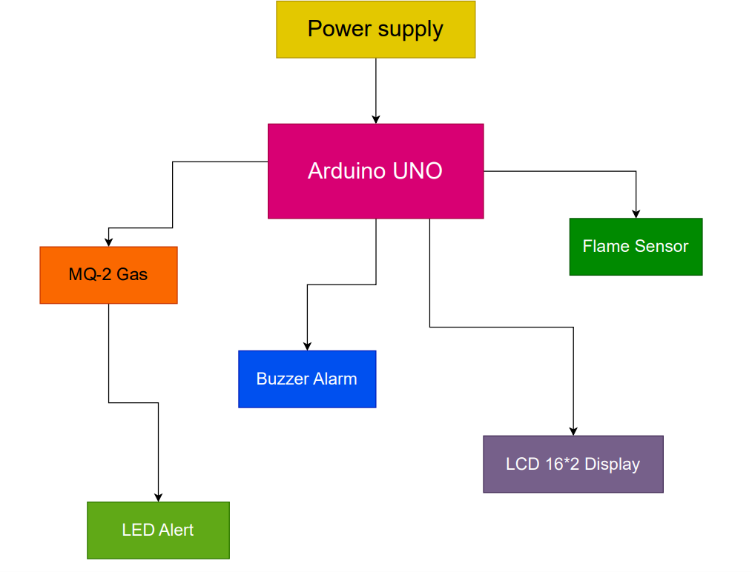
Figure 16: Block Diagram

The circuit is designed around an Arduino Uno microcontroller which serves as the central processing unit. An MQ-2 Gas Sensor and a Flame Sensor are connected to the analog and digital input pins of the Arduino to continuously monitor the environment for potential hazards. The MQ-2 sensor outputs an analog voltage proportional to the concentration of LPG/methane gas detected, while the flame sensor provides a digital HIGH/LOW signal based on flame presence.
A buzzer and LED indicators (Red and Green) are connected to the Arduino’s digital output pins. When gas leakage or flame is detected, the microcontroller immediately activates the buzzer and turns on the red LED as a warning signal. Under normal conditions, the green LED remains ON to indicate safe operation.
A 5V regulated supply from the Arduino powers all sensors and actuators. The system is first simulated in Proteus to validate sensor behavior, wiring correctness, and alert responses before deploying the hardware.

Equipment List:

- Arduino Uno R3 (1 pc)
- MQ-2 Gas Sensor (1 pc)
- Flame Sensor Module (1 pc)
- Active Buzzer (1 pc)
- Red LED (1 pc)
- 220Ω Resistors – 2 pcs
- Breadboard (1 pc)
- Jumper Wires (20–30 pcs)
- USB Power Cable (1 pc)

POSSIBLE OUTCOMES
  - The system will help reduce fire accidents in households and small businesses.
  - Early hazard detection will protect families, especially in apartment cultures where shared kitchens increase risks.
  - The project can be expanded to IoT home automation for future smart-city applications.
  - The system will encourage public awareness about safety technologies and modernize domestic safety culture in Bangladesh.

The proposed gas leakage and flame detection system is expected to provide significant safety improvements for households and small businesses by minimizing the risk of fire-related accidents. Through early detection of hazardous gas concentrations and flame presence, the system can alert users immediately, enabling rapid response and potentially preventing large-scale damage. This early warning capability is especially beneficial in apartment-based living environments, where shared kitchens and close proximity between units increase the chances of widespread accidents. Beyond its immediate safety benefits, the system serves as a foundational technology that can be later expanded into a complete IoT-based home automation framework, contributing to the development of smart home and smart-city initiatives.
Furthermore, the implementation of this project promotes awareness about the importance of adopting safety technologies in Bangladesh, ultimately encouraging a safer domestic culture and motivating communities to invest in preventive solutions rather than reacting after accidents occur

PROJECT TIMELINE (GANTT CHART)

Task | Week 1 | Week 2 | Week 3 | Week 4 | Week 5 | Week 6 | Week 7 | Week 8
Survey + Requirements Analysis | ████ | ████ | Mid Term Exam
Literature Review |  | ████ |  | ████
Simulation (Proteus) |  |  |  | ████ | ████
Hardware Implementation |  |  |  |  | ████ | ████
Testing & Calibration |  |  |  |  |  | ████ | ████
Report + Final Submission |  |  |  |  |  |  | ████ | ████

The project timeline is divided into structured weekly tasks to ensure steady progress from planning to implementation.
Weeks 1–2 focus on survey development, requirement identification, and midterm exam activities. Week 3–4 are allocated for completing the literature review and analyzing previous research.
Weeks 5–6 involve the Proteus simulation phase, where the circuit is designed, wired, and tested virtually. Weeks 7–8 are dedicated to hardware implementation, calibration, sensor threshold adjustments, and final testing.
The final two weeks focus on preparing the report, documentation, and completing the project submission. The workflow follows a sequential approach where each stage logically depends on the successful completion of the previous one.

References:
  - S. Kumar and V. Patel,
“Low-Cost Fire Detection Using Microcontroller and Flame Sensor Network,”
IEEE Access, vol. 10, pp. 115230–115240, 2022.

  - M. Uddin, R. Chowdhury, and K. Hossain,
“Smart Home Safety Monitoring System Using Arduino and IoT,”
in Proc. IEEE Int. Conf. Computing, Electronics and Communications Engineering (ICCECE), 2024, pp. 556–561.

  - H. Tanvir and N. Chowdhury,
“Embedded LPG and Methane Leakage Alert System for Domestic Applications,”
in IEEE Region 10 Symposium (TENSYMP), 2023, pp. 102–107.

  - R. Singh, M. Das, and P. Roy,
“Design of a Multi-Sensor Fire and Gas Detection System for Smart Buildings,”
in IEEE Int. Conf. Intelligent Systems (IS), 2022, pp. 844–850.

  - J. Park and J. Lee,
“Real-Time Fire Detection Using Flame Sensors and Edge Computing,”
IEEE Internet of Things Journal, vol. 9, no. 12, pp. 9510–9521, 2022.

  - K. Shukla and B. Mishra,
“Development of an Arduino-Based Early Warning System for LPG Leakage,”
in IEEE Int. Conf. Electronics, Communication and Aerospace Technology (ICECA), 2023, pp. 398–402.

  - F. Rahman, T. Mostafa, and S. Yousuf,
“A GSM-Based Fire and Gas Alert System for Low-Income Urban Households,”
in Proc. IEEE Int. Conf. Sustainable Technologies (ICST), 2023, pp. 334–339.

  - K. L. Benjamin and T. Ansari,
“Design and Implementation of a Real-Time Domestic Safety Monitoring System Using Arduino and
NodeMCU,”
IEEE Sensors Journal, vol. 22, no. 9, pp. 8724–8732, 2022.

  - S. Das and P. Nath,
“Hybrid IoT-Based Hazard Detection System Using Gas and Flame Sensors,”
in IEEE Int. Conf. Smart Electronics and Communication (ICOSEC), 2022, pp. 1269–1274.

