Milestone 7

* Title: Homework Underground
* Team: Area 51
  + Matthew Donovan
  + Josh Brown
  + Chris Hill
  + Muntadher AlZayer
* Project Tracker: Trello
  + We stopped using this at a certain point when we began changing our original goals and found other ways to manage progress.
  + <https://trello.com/b/Eg3C2sLK/area-51-project>
  + <https://trello.com/b/GAa3omnq/sprint-1>

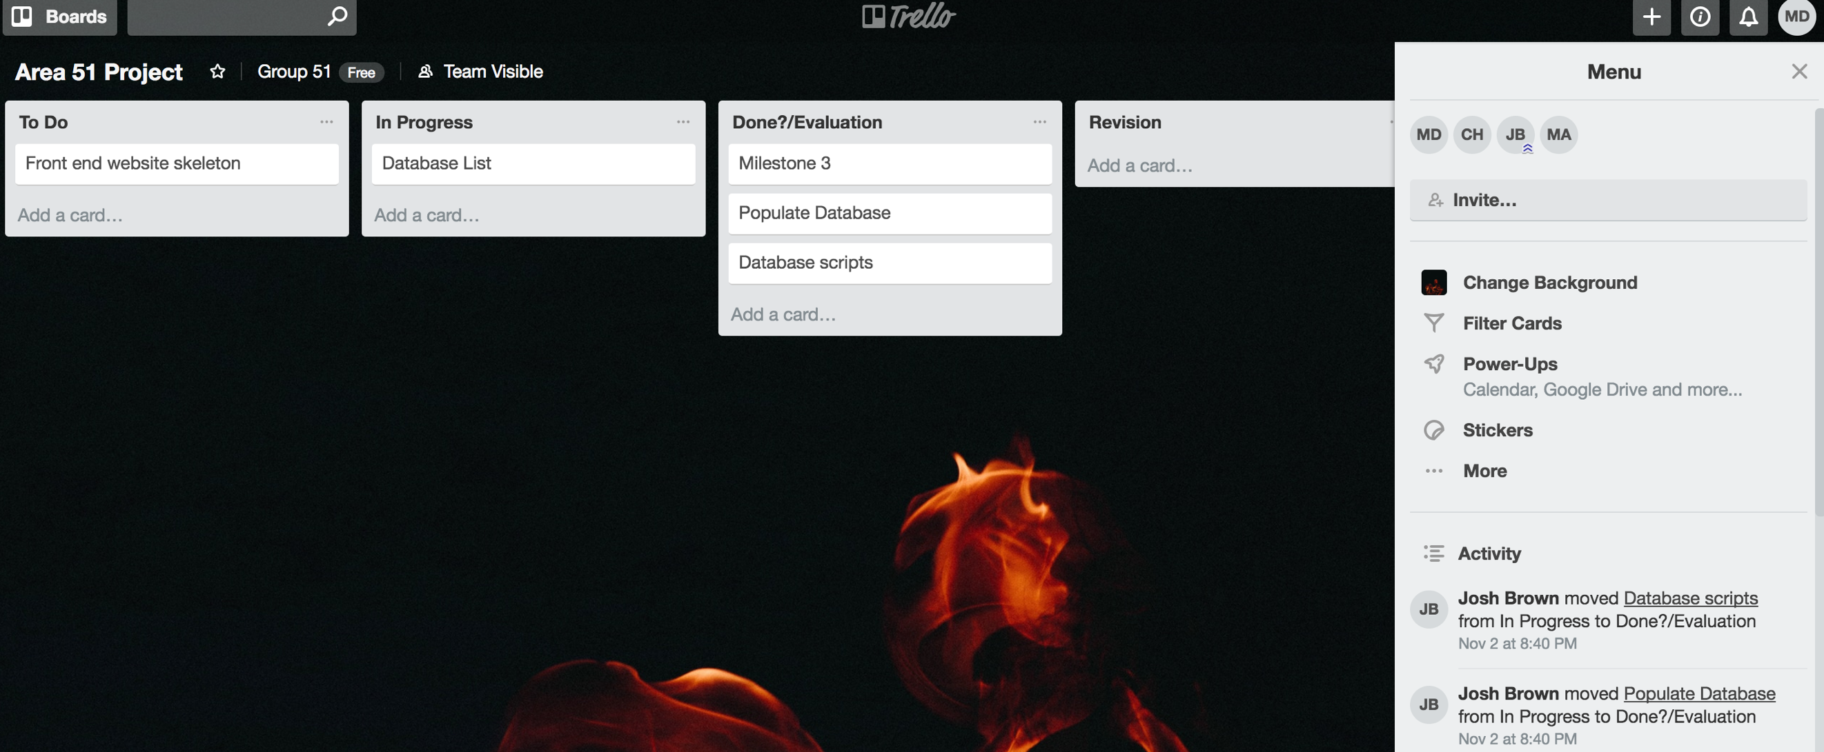

* VCS
  + <https://github.com/ChristianNHill/Group_Fifty_Fun>

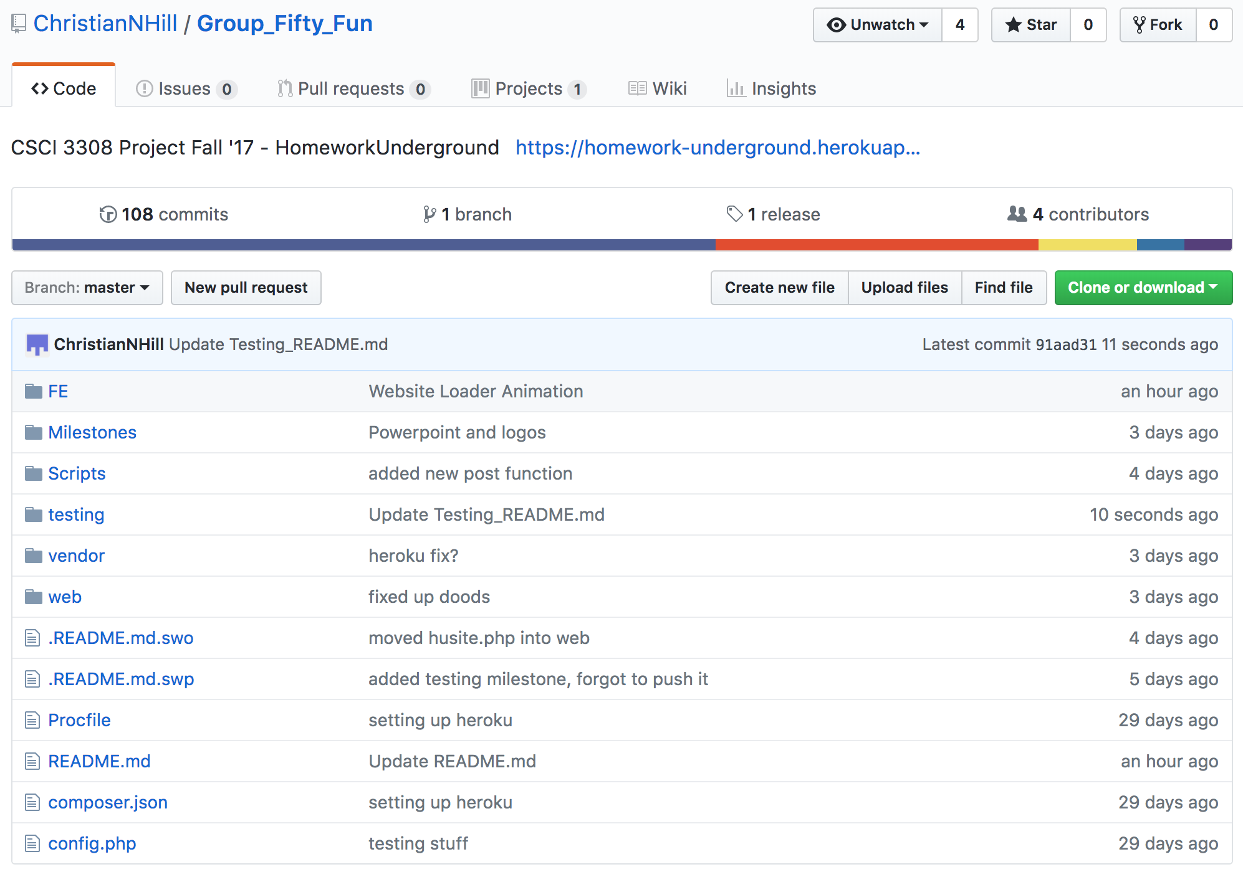

* Contributions

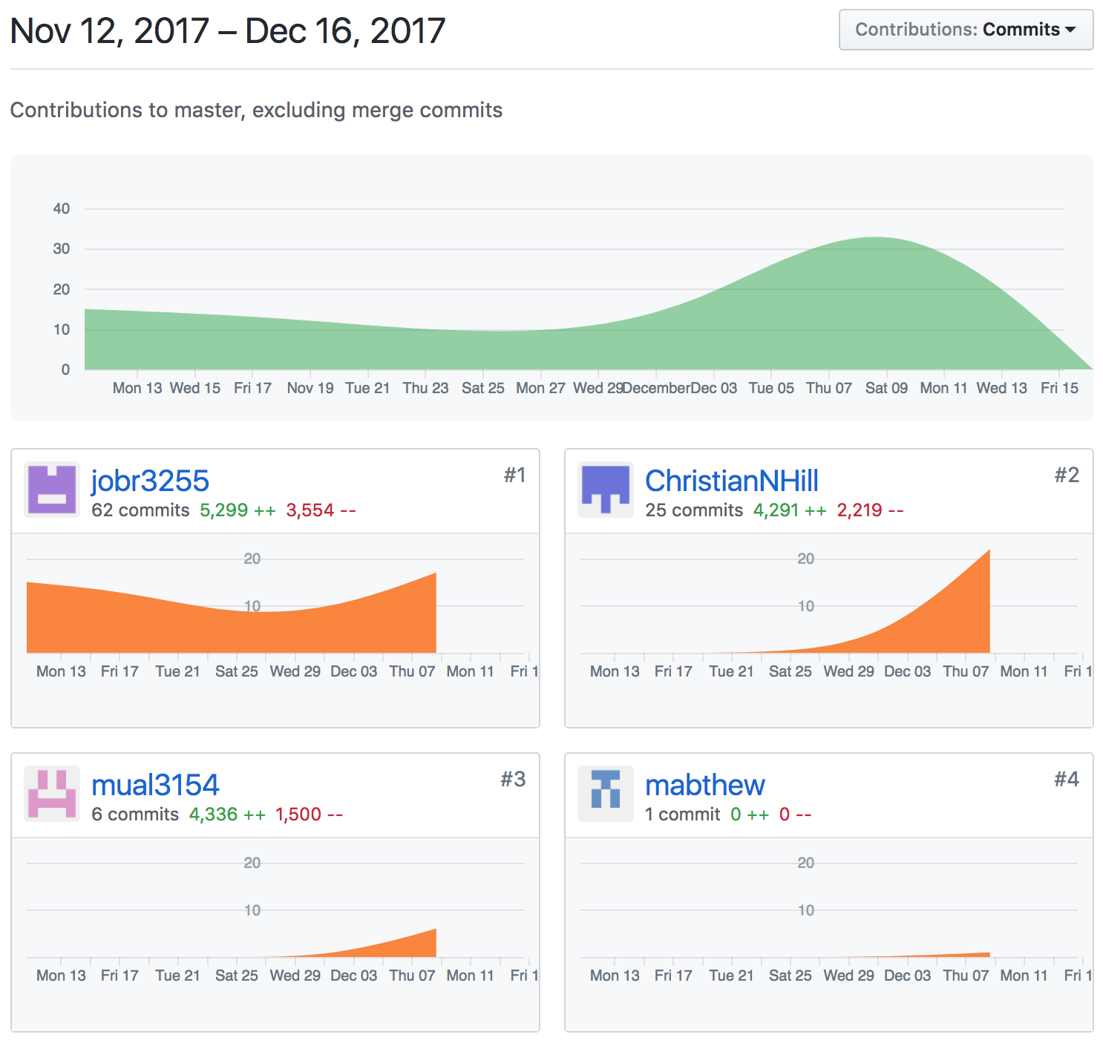

Deployment

* + <https://homework-underground.herokuapp.com/home.php>
  + From the home page, select “Sign up” to register, then you have the ability to
    - log out and log in (with email validation and password encryption/verification)
    - search for and link to schools
    - unlink from classes
    - search for and follow classes
    - unfollow classes
    - post to forums
    - comment on posts
    - vote on posts.