
Porter’s five force model is known as the parameter to evaluate startups whether it is good for invest or not. So, let’s dig into Muntajar details to find out where it is standing now days

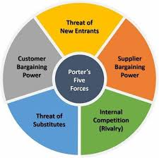

- Entry Barrier: theoretically there are no entry barriers for others to start similar business like Muntajar. But practically it requires some features which is inadequate in market for others to acquire such as –a) international affiliation, b) technical expertise with vision, c) international Licensed partners, d) franchise mode to cover country wise and e) long term sustainability model
- Threat of Substitutions: In Bangladesh, Muntajar does not have any direct substitution as it’s a an end to end service provider online based and apps based and we focused on making an independent Bangladesh and transforming undocumented and scattered manpower sector into digitally structured platform
- Competitive Rivalry: Currently there is no competition in Bangladesh market
- Bargaining Power of Buyers: Our candidates/subscribed members our buyers. And Muntajar is the first service provider in Bangladesh who are operating to fulfill candidates interests and give them the best possible opportunity. That’s why our members/candidates happily enrolling with Muntajar as there is no other such platform with reasonable and logical pricing which satisfies this point of buyer negotiation point as well
- Bargaining Power of Suppliers: Yes we do have some issues still now on supplier’s negotiation point. We are depending on international affiliation such as RCIC, Immigration Attorney, MLO, etc. In future we have plan to cover those areas with our own platform trained stuffs and local support offices with tie-up with local authorities directly. To do this, we need funds to run on full-fledged operation and we are working on it continuously
But still we are working without any fish market negotiation as we are not interfering our affiliated partners own pricings such as lawyer consultation fees, RCIC session charges etc.

