clc;
clear all;
close all;
% Hardcoded input to avoid 'input' error
x = [0 1 2];
y = [1 6 17];
n = 4;
x = x';
y = y';
len = length(x);
lt = n;
store_x = zeros(1, 2*lt + 1);
for i = 1 : 2*lt
sum_x = 0;
for j = 1 : len
sum_x = sum_x + (x(j))^i;
end
store_x(i+1) = sum_x;
end
str_x = zeros(1, lt + 1);
for k = 1 : lt+1
sumx = 0;
for s = 1 : len
sumx = sumx + (x(s)^(k-1)) * y(s);
end
str_x(k) = sumx;
end
am = zeros(n+1, n+1);
for i = 1 : n+1
store_x(1) = len;
for j = 1 : n+1
am(i,j) = store_x(j+i-1);
end
end
am(1,1) = len;
dm = zeros(n+1, 1);
for r = 1 : n+1
dm(r,1) = str_x(r);
end
aug_mt = [am dm];
aug_mt = rref(aug_mt);
sol_m = zeros(1, n+1);
for m = 1 : n+1
sol_m(m) = aug_mt(m, n+2);
end
X = x(1):0.1:x(len);
len_x = length(X);
w = zeros(1, len_x);
for d = 1 : len_x
sum_f = 0;
for t = 1 : n+1
sum_f = sum_f + sol_m(t) * (X(d))^(t-1);
end
w(d) = sum_f;
end
Y = w;
figure;
plot(X, Y, 'g-', 'LineWidth', 2);
hold on;
plot(x, y, 'ro', 'MarkerSize', 8, 'MarkerFaceColor', 'r');
xlabel('X values');
ylabel('Fitted Polynomial Y values');
title(['Polynomial Curve Fitting of order ', num2str(n)]);
grid on;
legend('Fitted Curve', 'Data Points');
fprintf("\nStep 05: The Coefficient Matrix (from highest to lowest power):\n");
disp(sol_m');
filename = 'poly_curve_fitting_output.doc';
fid = fopen(filename, 'w');
fprintf(fid, 'Polynomial Curve Fitting Report\n');
fprintf(fid, '================================\n\n');
fprintf(fid, 'X values:\n');
fprintf(fid, '%g ', x');
fprintf(fid, '\n\n');
fprintf(fid, 'Y values:\n');
fprintf(fid, '%g ', y');
fprintf(fid, '\n\n');
fprintf(fid, 'Polynomial order (n): %d\n\n', n);
fprintf(fid, 'Coefficient Matrix:\n');
for i = 1:length(sol_m)
fprintf(fid, 'a%d = %.6f\n', i-1, sol_m(i));
end
fprintf(fid, '\nPolynomial equation:\ny = ');
for i = 1:length(sol_m)
if i == 1
fprintf(fid, '%.6f', sol_m(i));
else
fprintf(fid, ' + %.6f*x^%d', sol_m(i), i-1);
end
end
fprintf(fid, '\n');
fclose(fid);
fprintf('\nPolynomial fitting report exported as "%s"\n', filename);
Step 05: The Coefficient Matrix (from highest to lowest power):
1
2
3
0
0
Polynomial fitting report exported as "poly_curve_fitting_output.doc"
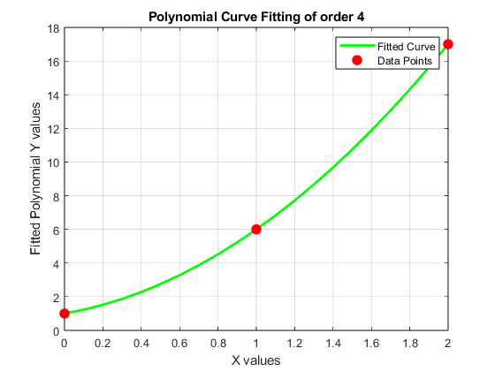
Published with MATLAB® R2023b

