clc;
clear all;
close all;
%PDF, CDF, MGF of Rayleigh Channel Gain
% First Parameters
sigma = 1; % Scale parameter for Rayleigh distribution
h = linspace(0, 5, 1000); % Channel gain values (non-negative)
% PDF of Rayleigh distribution
pdf_h = (h./(sigma^2)) .* exp(-h.^2 ./(2*sigma^2));
% CDF of Rayleigh distribution
cdf_h = 1 - exp(-h.^2 ./ (2*sigma^2));
% MGF of Rayleigh distribution does not have a simple closed form,
% Here MGF of h^2 (which is exponential) can be used.
% For h, approximate MGF numerically:
t = linspace(-1, 1, 500); % MGF variable t
mgf_h = zeros(size(t));
for k = 1:length(t)
mgf_h(k) = trapz(h, exp(t(k)*h) .* pdf_h);
end
% Plotting PDF, CDF, MGF of Rayleigh Channel Gain
figure;
subplot(3,1,1)
plot(h, pdf_h, 'LineWidth', 2.5);
title('PDF of Rayleigh Channel Gain');
xlabel('h');
ylabel('f_H(h)');
grid on;
% Plotting CDF
subplot(3,1,2)
plot(h, cdf_h, 'LineWidth', 2.5);
title('CDF of Rayleigh Channel Gain');
xlabel('h');
ylabel('F_H(h)');
grid on;
% Plotting MGF
subplot(3,1,3)
plot(t, mgf_h, 'LineWidth', 2.5);
title('MGF of Rayleigh Channel Gain ');
xlabel('t');
ylabel('M_H(t)');
grid on;
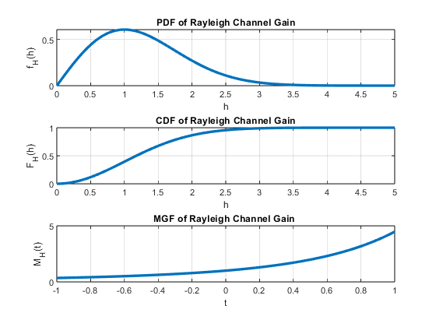
Published with MATLAB® R2023b

