clc;
clear all;
close all;
x = [1 2 3 4 5];
y = [2 4 5 4 5];
p = polyfit(x, y, 2); % 2 means linear fit
slope = p(2);
intercept = p(3);
fprintf("Slope = %.4f\n", slope);
fprintf("Intercept = %.4f\n", intercept);
y_pred = polyval(p, x);
plot(x, y, 'r');
hold on;
plot(x, y_pred, 'LineWidth', 2.5);
title('Linear Regression using polyfit in MATLAB');
xlabel('x');
ylabel('y');
grid on;
Slope = 2.3143
Intercept = 0.2000
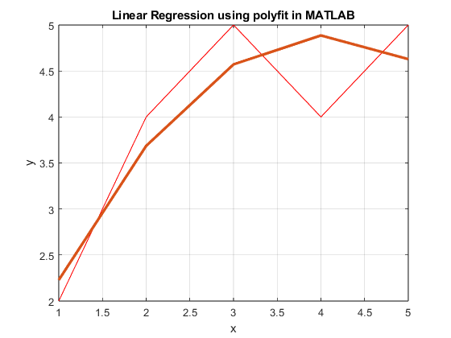
Published with MATLAB® R2023b

