clc;
clear all;
close all;
% Input Data (Multiple Features)
X1 = [1 2 3 4 5 6]'; % First independent variable
X2 = [2 1 3 5 4 5]'; % Second independent variable
y = [5 7 10 11 12 14]'; % Dependent variable
% Combine Features into One Matrix
X = [X1 X2]; % Create input matrix containing both features
% Fit Multiple Linear Regression Model
model = fitlm(X, y); % Perform multiple linear regression
% Display Model Summary
disp(model); % Show regression coefficients and statistics
% Plotting
figure; % Create an output and a new figure
plot(model); % Plot model diagnostics (residuals, etc.)
% Title
title('Multiple Linear Regression using MATLAB'); % Add plot title
Linear regression model:
y ~ 1 + x1 + x2
Estimated Coefficients:
Estimate SE tStat pValue
________ _______ _______ ________
(Intercept) 3.5984 0.72386 4.9712 0.015638
x1 1.6062 0.32742 4.9056 0.016216
x2 0.18394 0.37511 0.49036 0.65751
Number of observations: 6, Error degrees of freedom: 3
Root Mean Squared Error: 0.719
R-squared: 0.972, Adjusted R-Squared: 0.953
F-statistic vs. constant model: 51.5, p-value = 0.00476
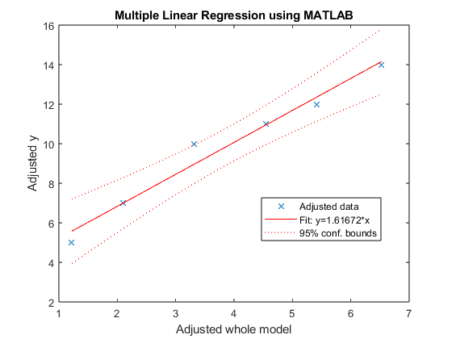
Published with MATLAB® R2023b

