clc;
clear all;
close all;
x = [1 2 3 4 5]';
y = [2 4 5 4 5]';
degree = 2; % ← set degree here
% Prepare polynomial terms
X = []; % Start with an empty matrix to store polynomial features
for i = 1:degree
X = [X x.^i]; % Add x^1, x^2, ..., x^degree as columns for polynomial regression
end
% Fit model
model = fitlm(X, y) % Fit polynomial regression model using linear regression
% Plot the fit
figure; % Create an output figure in a new window
plot(model); % Plot the regression model
%Polynomial Regression using MATLAB
title(['Polynomial Regression using fitlm (Degree = ', num2str(degree), ') using MATLAB']);
model =
Linear regression model:
y ~ 1 + x1 + x2
Estimated Coefficients:
Estimate SE tStat pValue
________ _______ _______ _______
(Intercept) 0.2 1.7004 0.11762 0.91712
x1 2.3143 1.2958 1.7859 0.21603
x2 -0.28571 0.21189 -1.3484 0.30993
Number of observations: 5, Error degrees of freedom: 2
Root Mean Squared Error: 0.793
R-squared: 0.79, Adjusted R-Squared: 0.581
F-statistic vs. constant model: 3.77, p-value = 0.21
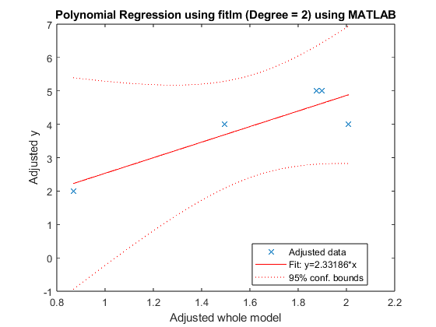
Published with MATLAB® R2023b

