clc;
clear all;
close all;
% Input Data Side
x = [1 2 3 4 5]'; % Independent variable
y = [2.7 7.4 20.1 54.6 148.4]'; % Nonlinear data (exponential) it means that the data does not form a straight line
%Define Nonlinear Model Function
modelFun = @(b, x) b(1) * exp(b(2) * x);
% b(1) = a and b(2) = b in y = a*exp(bx)
% Initial Guess for Parameters
beta0 = [1; 0.5]; % Starting values for parameters (helps fitting)
% Fit Nonlinear Regression Model
model = fitnlm(x, y, modelFun, beta0);
% fitnlm fits nonlinear models using the defined function
disp(model); % Display the fitted model and parameters
% Generate Smooth Curve for Plot
x_fit = linspace(min(x), max(x), 200); % Smooth x-values
y_fit = modelFun(model.Coefficients.Estimate, x_fit);
% Compute predicted y using fitted parameters
% Plot Data and Fitted Curve
figure; % Create figure
plot(x, y, 'g', 'LineWidth', 2.5);
hold on; % Plot real data points
plot(x_fit, y_fit, 'LineWidth', 2); % Plot nonlinear fitted curve
title('Nonlinear Regression using MATLAB'); % Add final title
xlabel('x'); ylabel('y'); % Label axes
grid on; % Add grid for clarity
legend('Data Points','Nonlinear Fit'); % Add legend
Nonlinear regression model:
y ~ b1*exp(b2*x)
Estimated Coefficients:
Estimate SE tStat pValue
________ _________ ______ __________
b1 1.001 0.0009685 1033.5 1.9976e-09
b2 0.99979 0.000199 5024.2 1.7389e-11
Number of observations: 5, Error degrees of freedom: 3
Root Mean Squared Error: 0.0135
R-Squared: 1, Adjusted R-Squared 1
F-statistic vs. zero model: 7.02e+07, p-value = 3.13e-12
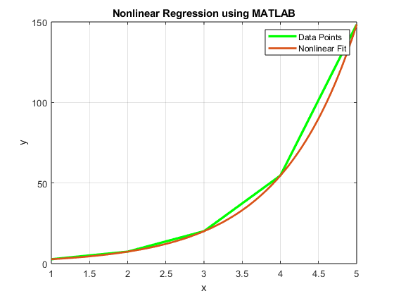
Published with MATLAB® R2023b

