clc;
clear all;
close all;
% Original signal parameters
f = 1000; % Analog signal frequency (1 kHz)
t = 0:1e-6:1e-2; % Very high resolution time (for original signal)
x = sin(2*pi*f*t); % Original analog-like signal
% Case 1: High sampling frequency (fs >= 2*f)
fs1 = 10000; % 10 kHz sampling frequency
ts1 = 0:1/fs1:1e-2;
x1 = sin(2*pi*f*ts1);
% Case 2: Low sampling frequency (fs < 2*f)
fs2 = 1200; % Only 1.2 kHz (Aliasing)
ts2 = 0:1/fs2:1e-2;
x2 = sin(2*pi*f*ts2);
% Plotting the signal
figure;
subplot(3,1,1);
plot(t, x, 'LineWidth', 1.5);
title('Original (Analog) Signal (1 kHz)');
xlabel('Time (s)');
ylabel('Amplitude');
subplot(3,1,2);
stem(ts1, x1, 'filled');
hold on;
plot(t, x, 'r--');
title('High Sampling (fs = 10 kHz) – Correct Sampling');
xlabel('Time (s)');
ylabel('Amplitude');
subplot(3,1,3);
stem(ts2, x2, 'filled');
hold on;
plot(t, x, 'g--');
title('Low Sampling (fs = 1.2 kHz) – Aliasing Occurs');
xlabel('Time (s)');
ylabel('Amplitude');
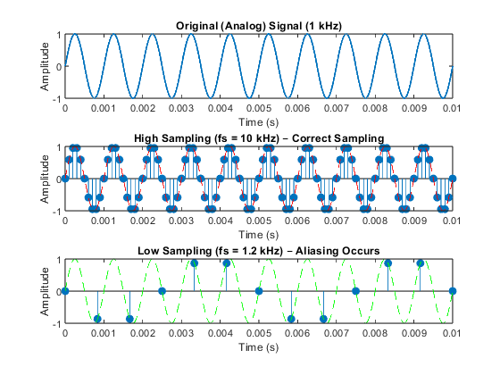
Published with MATLAB® R2023b

