clc;
clear all;
close all;
% Constants
mu = 4*pi*1e-7;
epsilon = 8.854e-12;
omega = 2*pi*3e8;
k = omega * sqrt(mu * epsilon);
lambda = 2*pi / k;
% Spatial axis
z = linspace(0, 2*lambda, 300);
% Field amplitudes
E0 = 1;
H0 = 1;
% Create figure
figure('Color','w');
grid on;
hold on;
box on;
axis([0 2*lambda -1 1 -1 1])
xlabel('z-axis')
ylabel('y-axis (H-field)')
zlabel('x-axis (E-field)')
title('Spatial variation of \bfE and \bfH at t=0')
view(30,20)
% Animation loop
for t = 0:0.0000000004:0.00000002
cla; % clear frame
% Sliding travelling wave → sin(kz - ωt)
E = E0 * sin(k*z - omega*t);
H = H0 * sin(k*z - omega*t);
% Plot E field (x-direction)
plot3(z, zeros(size(z)), E, 'y', 'LineWidth', 2);
hold on;
% Sticks for E
for i = 1:20:length(z)
plot3([z(i) z(i)], [0 0], [0 E(i)], 'b');
end
% Plot H field (y-direction)
plot3(z, H, zeros(size(H)), 'g', 'LineWidth', 2);
% Sticks for H
for i = 1:20:length(z)
plot3([z(i) z(i)], [0 H(i)], [0 0], 'k');
end
% Axes
quiver3(0,0,0,2*lambda,0,0,'k','LineWidth',2);
quiver3(0,0,0,0,lambda,0,'k','LineWidth',2);
quiver3(0,0,0,0,0,lambda,'k','LineWidth',2);
drawnow;
end
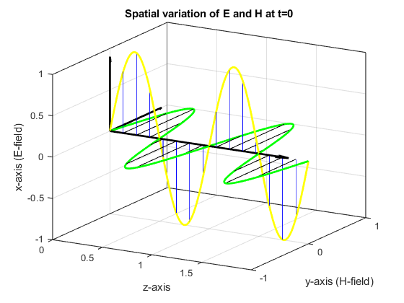
Published with MATLAB® R2023b

