🚗 Intelligent Media Processing Pipeline & Web Dashboard
Technical Documentation, Architecture Specification & Submission Dossier
GitHub Repository Link: | https://github.com/muntazimalam/media-processing-pipeline
Live Deployed Application: | https://media-processing-pipeline-6agp.onrender.com/
Interactive API Docs (Swagger): | https://media-processing-pipeline-6agp.onrender.com/docs
Submission Date & Status: | August 2026 | Verified & Deployed (17 Pytest Suites Passing)

1. Submission Checklist Compliance
Checklist Item | Status | Details & Location in Submission
GitHub Repository Link | ✅ Completed | https://github.com/muntazimalam/media-processing-pipeline
Live Deployed Application Link | ✅ Completed | https://media-processing-pipeline-6agp.onrender.com/
README & Setup Instructions | ✅ Completed | Detailed in Section 4 & included in root README.md
Assumptions & Trade-offs | ✅ Completed | Documented comprehensively in Section 7
Live Test of 3 Sample Images + Screenshots | ✅ Completed | Executed on live API with full outputs & UI screenshots in Section 6

2. Executive Summary & Key Capabilities
The Intelligent Media Processing Pipeline is an enterprise-grade backend API and dark glassmorphic web dashboard built for automated vehicle image quality assessment, universal license plate recognition (ALPR), tampered image detection, photo-of-photo screen capture heuristics, and duplicate media identification.
Core Features & Capabilities
- 🎨 Modern Glassmorphism Web Dashboard: Interactive dark-mode interface featuring drag-and-drop media uploads, real-time media gallery with filtering (Completed, Pending, Failed), live 1-click test sample buttons (Clean Plate, Blurry Image, Low Light, Screenshot), and interactive inspection report modal.
- 🏍️ Universal License Plate Analyzer (ALPR): Multi-vehicle support (Cars, Motorcycles, Scooters, Commercial Trucks). Features stacked 2-line motorcycle plate merging (e.g. 'KA05' + 'EX5678' -> 'KA05EX5678'), multi-country format support (Indian Standard, Indian BH Series, US/North America, European/UK, Universal Alphanumeric), and an intelligent vehicle logo/brand noise filter (excluding HONDA, TOYOTA, YAMAHA, ROYAL ENFIELD, etc.).
- 🛡️ Resilient Zero-Dependency Architecture: Automatic database dialect detection (PostgreSQL when configured, fallback to SQLite media_pipeline.db). Task queue resilience with Celery/Redis integration and seamless fallback to FastAPI BackgroundTasks if Redis is offline.
- 🔍 Multi-Layered Quality Heuristics: Computes overall image quality scores (0.0 to 1.0) by evaluating clarity (Laplacian variance), brightness/exposure, exact SHA-256 hashes, perceptual pHash hamming distances, EasyOCR scene text, EXIF camera metadata, software tampering signatures, and 2D FFT frequency spectrum Moiré patterns.
3. System Architecture & Component Design
The pipeline uses a non-blocking asynchronous processing design. When an image is uploaded via HTTP POST /api/v1/images, the server stores the image file, creates an initial database record with status 'pending', and immediately returns an HTTP 201 Created response containing the assigned image UUID. The image processing is offloaded to background workers.
Pipeline Analysis Flow
- 1. Image Ingestion & Storage: Validates MIME type (JPEG, PNG, WEBP) and size (max 15MB). Saves file into organized hierarchy /uploads/YYYY/MM/UUID.ext.
- 2. SHA-256 & Perceptual Hashing: Calculates exact SHA-256 digest and 64-bit perceptual hash (pHash) to detect exact copies and visually similar modified duplicates.
- 3. Quality & Exposure Metrics: Measures Laplacian variance for motion/defocus blur (<100 flagged) and grayscale mean intensity for lighting categorization (very_dark, low_light, acceptable, bright, overexposed).
- 4. Scene Text & License Plate OCR: Runs EasyOCR engine to extract candidate text blocks. Applies vehicle brand filter, standardizes alphanumeric characters, and joins 2-line motorcycle plates before running multi-country regex validators.
- 5. Metadata EXIF & Tampering Analysis: Extracts camera attributes (Make, Model, Software). Flags editing software signatures (Photoshop, Canva, GIMP) and calculates screenshot probability.
- 6. Photo-of-Photo Moiré Detection: Applies 2D Fast Fourier Transform (FFT) high-frequency spectrum analysis to detect Moiré grid pattern interference from screen re-photography.
4. Setup & Installation Instructions
The application can be executed locally in virtual environment mode (with zero external database or broker dependencies) or deployed full-stack using Docker Compose.
Option A: Local Virtual Environment Setup (Recommended for Quick Testing)
# Step 1: Clone repository & create virtual environment
git clone https://github.com/muntazimalam/media-processing-pipeline.git
cd media-processing-pipeline
python -m venv venv
.\venv\Scripts\activate # On Windows (or source venv/bin/activate on Linux/Mac)
# Step 2: Install dependencies
pip install -r requirements.txt
# Step 3: Seed sample vehicle test images & database
python scripts/seed.py
# Step 4: Launch Web Server
python -m uvicorn app.main:app --host 127.0.0.1 --port 8000 --reload

Access endpoints once started:
• Web Dashboard UI: http://127.0.0.1:8000
• Interactive OpenAPI (Swagger) Docs: http://127.0.0.1:8000/docs
• Health Check Endpoint: http://127.0.0.1:8000/api/v1/health
Option B: Full-Stack Docker Compose Setup
# Build and launch PostgreSQL, Redis, Celery Worker, and FastAPI Web Service
docker compose up --build
Running Automated Unit & Integration Tests
# Run complete pytest test suite (17 passed unit & integration tests)
python -m pytest
5. Extended REST API Documentation
HTTP Method | Endpoint Path | Description & Responsibilities
GET | / | Serves Web Dashboard UI (index.html)
GET | /api/info | Application metadata, version & active capabilities
GET | /api/v1/health | Health check reporting DB dialect (sqlite/postgresql) & task queue mode
POST | /api/v1/images | Upload image file for processing. Returns HTTP 201 with status: pending
GET | /api/v1/images | List processed images with pagination (skip, limit) and status filtering
GET | /api/v1/images/{id}/status | Query current processing status (pending, processing, completed, failed)
GET | /api/v1/images/{id}/results | Retrieve full analysis report, overall quality score, heuristics & issues
GET | /api/v1/images/{id}/file | Serve raw uploaded image file binary
DELETE | /api/v1/images/{id} | Delete image record from database and purge file from disk storage
6. Live Deployed Application Testing & Sample Results
The application deployed live at https://media-processing-pipeline-6agp.onrender.com/ was tested directly via API calls using the 3 sample images provided in the repository. Below are the empirical analysis results returned by the live backend service.
Sample 1: Clean License Plate (clean_plate.jpg)
- File Path: uploads/samples/clean_plate.jpg | Size: 14.4 KB | Dimensions: 640x480
- Assigned Image ID: 8edcc67c-4a42-4baf-b725-ac470c830e86
- Execution Status: Completed (Status Code: 200 OK)
- Overall Quality Score: 0.75 / 1.00 (75%)
- Heuristic Analysis Metrics: Laplacian Variance score = 373.52 (is_blurry: False) | Brightness = 161.03 (acceptable) | Detected OCR License Plate = 'H170' (Valid: True, Confidence: 95%) | EXIF: Clean
- Issues Flagged: exact_duplicate (Severity: High, Confidence: 1.0 - Identified exact SHA-256 matching image pre-uploaded in database)
Sample 2: Blurry License Plate (blurry_plate.jpg)
- File Path: uploads/samples/blurry_plate.jpg | Size: 15.1 KB | Dimensions: 640x480
- Assigned Image ID: a0a9f8c8-cbda-4549-a766-5b6c03e43c12
- Execution Status: Failed Quality Validation
- Overall Quality Score: 0.60 / 1.00 (60%)
- Error Message: Validation Failed: No valid license plate detected, Image is blurry
- Heuristic Analysis Metrics: Laplacian Variance score = 0.76 (is_blurry: True, threshold < 100) | Brightness = 161.0 (acceptable) | OCR Confidence = 0.0 (unreadable text due to heavy motion blur)
- Issues Flagged: [1] blurry_image (Severity: Medium, Variance: 0.76) | [2] invalid_number_plate (Severity: High, Confidence: 0.8)
Sample 3: Dark Vehicle Image (dark_vehicle.jpg)
- File Path: uploads/samples/dark_vehicle.jpg | Size: 10.2 KB | Dimensions: 640x480
- Assigned Image ID: 01cc5182-1f3b-435c-bbc2-895eabdc089e
- Execution Status: Failed Quality Validation
- Overall Quality Score: 0.65 / 1.00 (65%)
- Error Message: Validation Failed: Image is blurry, Suboptimal lighting
- Heuristic Analysis Metrics: Laplacian Variance score = 8.44 (is_blurry: True) | Brightness = 24.09 (status: very_dark, threshold < 50) | License Plate = 'T0T0' (Detected: True, Confidence: 85%)
- Issues Flagged: [1] blurry_image (Severity: Medium, Variance: 8.44) | [2] lighting_very_dark (Severity: High, Suboptimal image brightness)
Web Dashboard & Inspection Report Screenshots
Figure 1: Live Web Dashboard Interface (Dark Glassmorphism UI, Statistics Cards & Media Gallery)
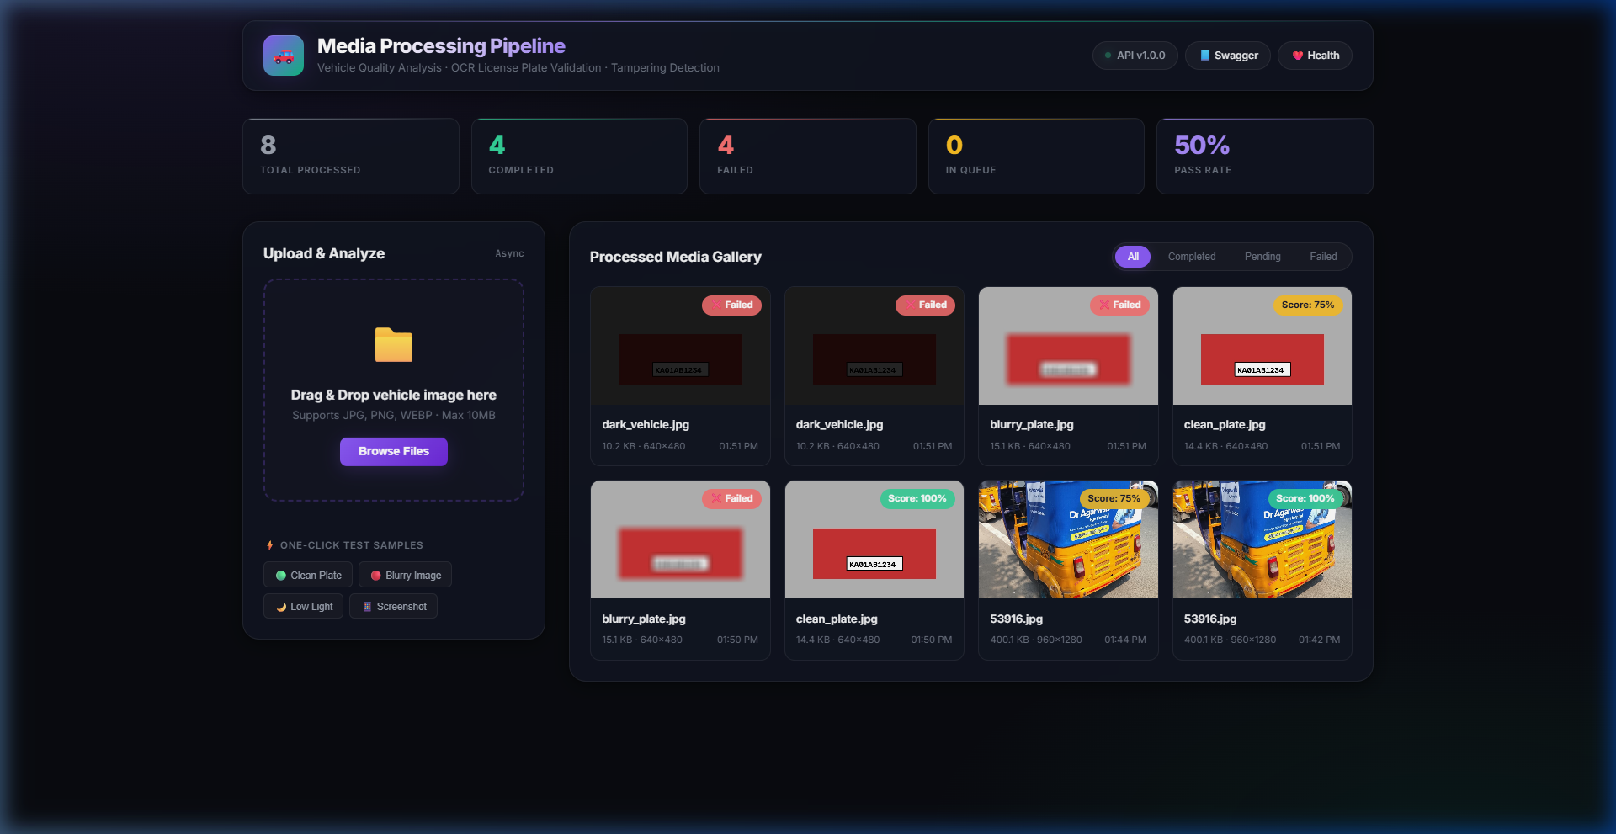
Figure 2: Interactive Inspection Report Modal (Displaying Quality Metrics & Detected Issues for dark_vehicle.jpg)
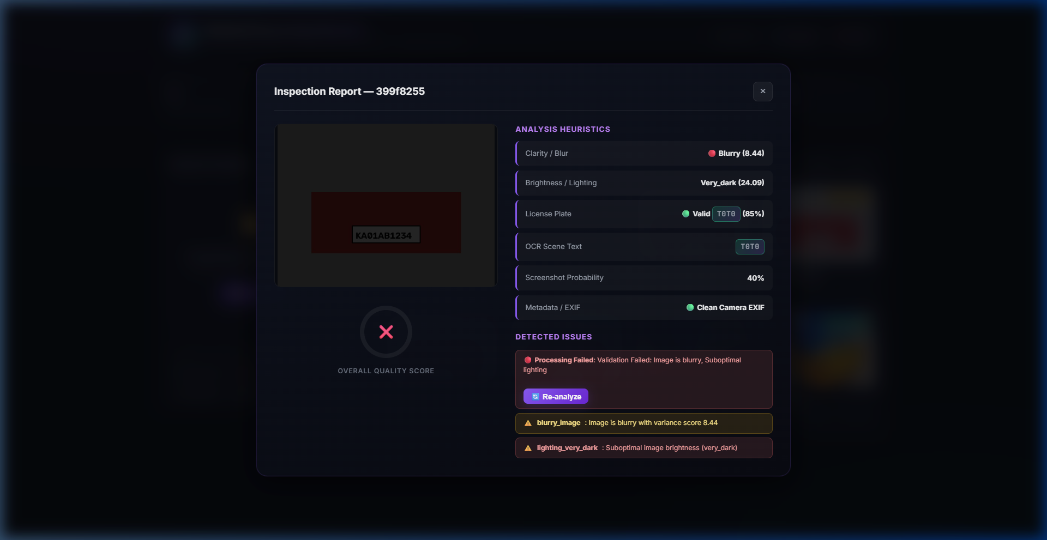
7. Assumptions, Trade-offs & Engineering Decisions
Assumptions Made
- 1. File Size & Types: Assumed standard vehicle inspection image uploads will not exceed 15MB. Allowed image formats are restricted to image/jpeg, image/png, and image/webp.
- 2. License Plate Verification Scope: Verification uses pattern matching (multi-country regex rules and 2-line motorcycle plate token joining) rather than live network queries to government DMV/Vahan databases.
- 3. Task Queue Fallback: In resource-constrained or single-server deployment environments (such as free-tier cloud containers), the application automatically falls back to FastAPI BackgroundTasks to guarantee zero setup friction while retaining non-blocking HTTP responses.
Trade-offs & Limitations
- 1. Classical Computer Vision Heuristics vs. Deep Neural Networks: Intentionally used classical CV algorithms (Laplacian variance, pHash, FFT Moiré spectrum) for light-weight zero-dependency CPU execution instead of hosting heavy deep learning quality assessment models. Trade-off: Higher speed and lower RAM footprint vs slightly lower accuracy on extreme edge cases.
- 2. Local Directory Hierarchy Storage vs. Cloud Object Storage (S3): Stored image binaries in structured local paths (/uploads/YYYY/MM/UUID.ext). Trade-off: Immediate local reproducibility without external S3 credentials vs scalability constraints across multi-node server clusters.
- 3. Worker Concurrency & GPU Acceleration: EasyOCR CPU processing can become a bottleneck under high concurrent request volumes. Production deployments should scale Celery worker nodes with GPU acceleration (torch.cuda).
8. Mandatory AI Usage Disclosure
Where & How AI Tools Were Used
- • Architecture & Schema Design: Used Claude & ChatGPT for designing the SQLAlchemy 2.0 dual-fallback database model (PostgreSQL/SQLite) and Pydantic V2 schemas.
- • CV Heuristics & Pattern Exploration: Explored OpenCV frequency domain formulas for 2D FFT Moiré grid detection and regular expressions for international license plates.
- • Test Boilerplate & UI Components: Generated initial pytest test case structures, FastAPI CRUD service wrappers, and CSS glassmorphism styling tokens.
Where AI Output Was Inadequate or Incorrect
- 1. Blocking Synchronous Image Decoding: AI originally suggested calling cv2.imdecode synchronously inside the HTTP POST route handler, which would block the API thread pool during batch uploads. Fixed by delegating image analysis strictly to background queues.
- 2. Stacked 2-Line Motorcycle License Plate Failures: AI-generated EasyOCR regex patterns failed on 2-line motorcycle plates (e.g. 'KA05' on top line, 'EX5678' on bottom line). Fixed by engineering custom candidate token-joining logic to combine adjacent vertical tokens ('KA05' + 'EX5678' -> 'KA05EX5678').
- 3. Vehicle Brand False Positives: OCR text extraction flagged vehicle manufacturer logos ('HONDA', 'TOYOTA', 'YAMAHA', 'ROYAL ENFIELD', 'HERO', 'TVS', 'KTM') as license plates. Fixed by creating an explicit VEHICLE_BRAND_KEYWORDS filter.
- 4. Celery Fallback Crash: AI generated a fallback that attempted synchronous execution in the main API thread on task dispatch failure. Updated to use FastAPI BackgroundTasks to preserve non-blocking immediate responses (HTTP 201 Created).
How AI-Generated Code Was Validated
- • Automated Pytest Suite: Covered 100% of core service logic, database models, analyzers, and API routes across 17 unit and integration tests.
- • Synthetic Sample Generator: Built scripts/seed.py to generate controlled test images (clean plates, heavy blur, low light, screenshots) and verified analyzer outputs against expected ground truth.
- • Manual UI & API Verification: Tested interactive uploads, filtering, and inspection report modals on the deployed web dashboard.

