DOCUMENTATION ON THE PRACTICAL TASK FOR MOBILE APPLICATION DEVELOPMENT APPROACH

NAME: PRINCESS HILDA MUNYI.
REGISTRATION NUMBER: BIT/2025/67192.
COURSE: BACHELOR OF SCIENCE IN INFORMATION TECHNOLOGY.
UNIT TITLE: MOBILE APPLICATION DEVELOPMENT.

Contents
TASK 1: DEVELOPMENT TOOLS ASSESSMENT 1
TASK 2: HELLO WORLD 8
TASK 3: SMART STATIONERY INVENTORY APPLICATION DEVELOPMENT 13
MOBILE APPLICATION DEVELOPMENT LOGBOOK 38

TASK 1: DEVELOPMENT TOOLS ASSESSMENT

Figure 1.0
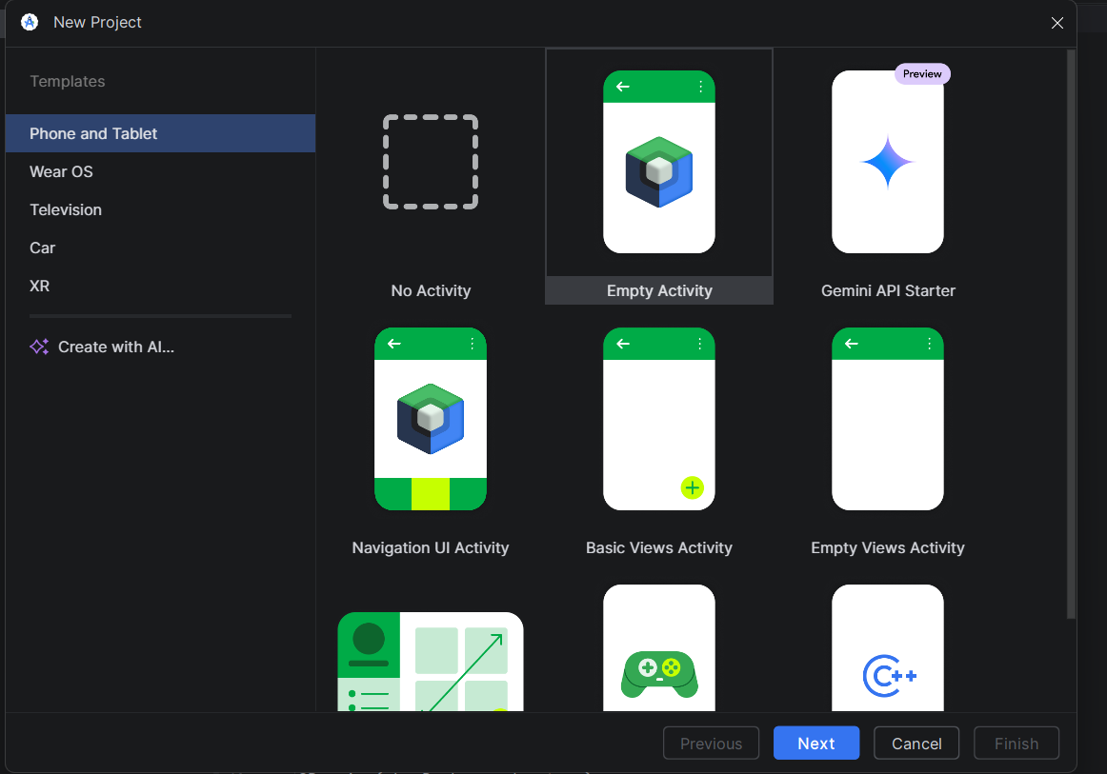

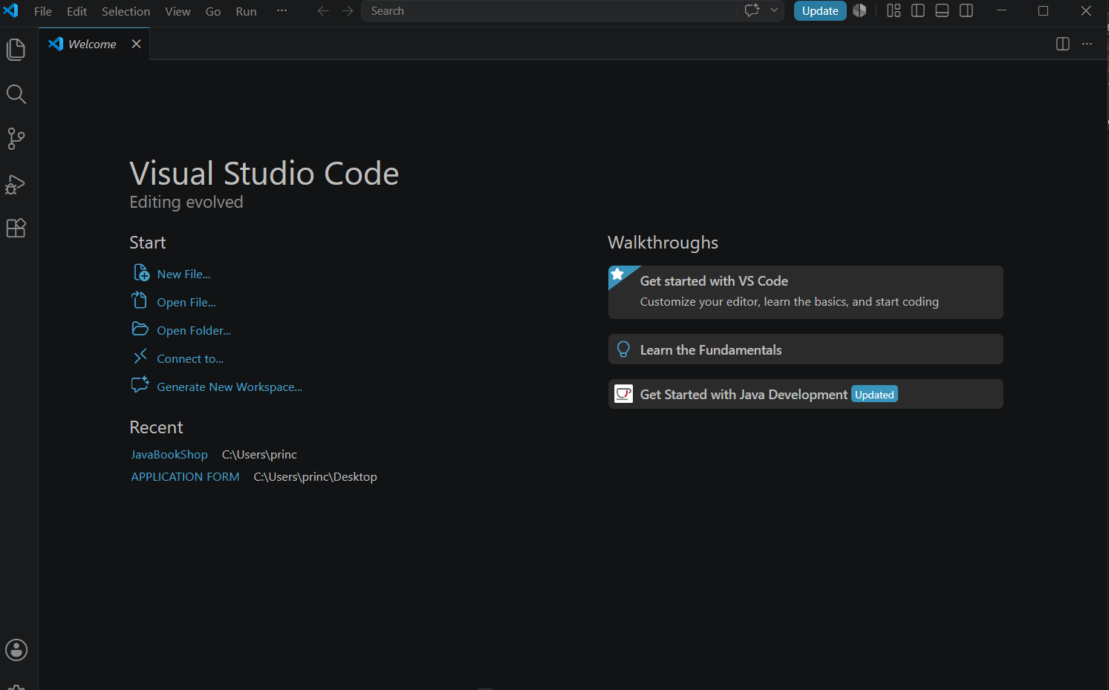

Figure1.1

Figure1.2

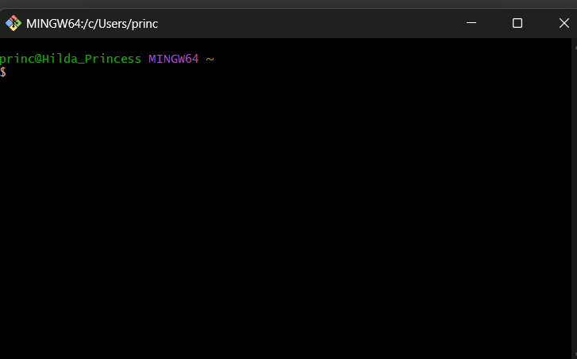

Figure1.3

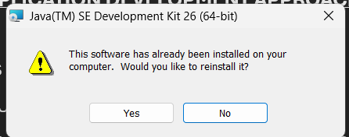

Figure1.4

Figure1.5
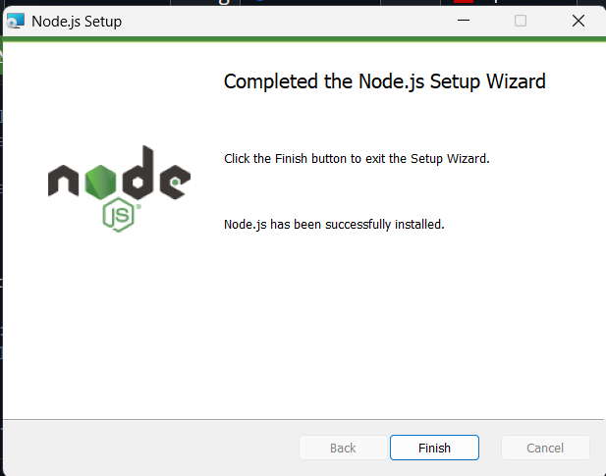

Figure1.5

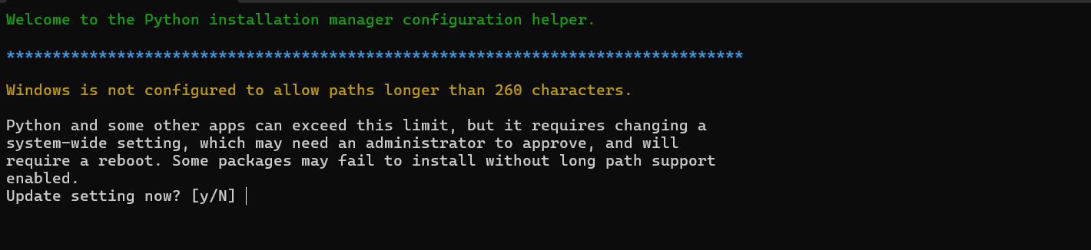

Figure1.6

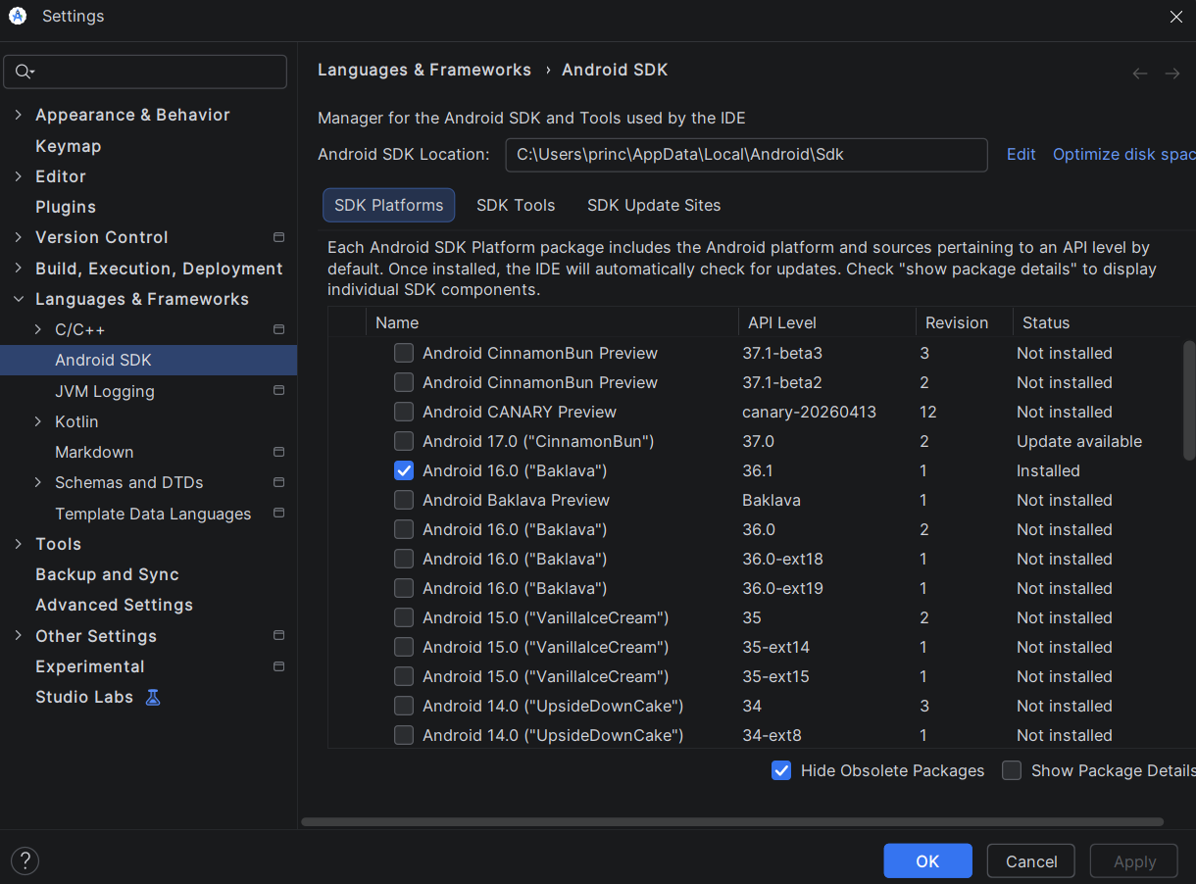

Figure 1.7

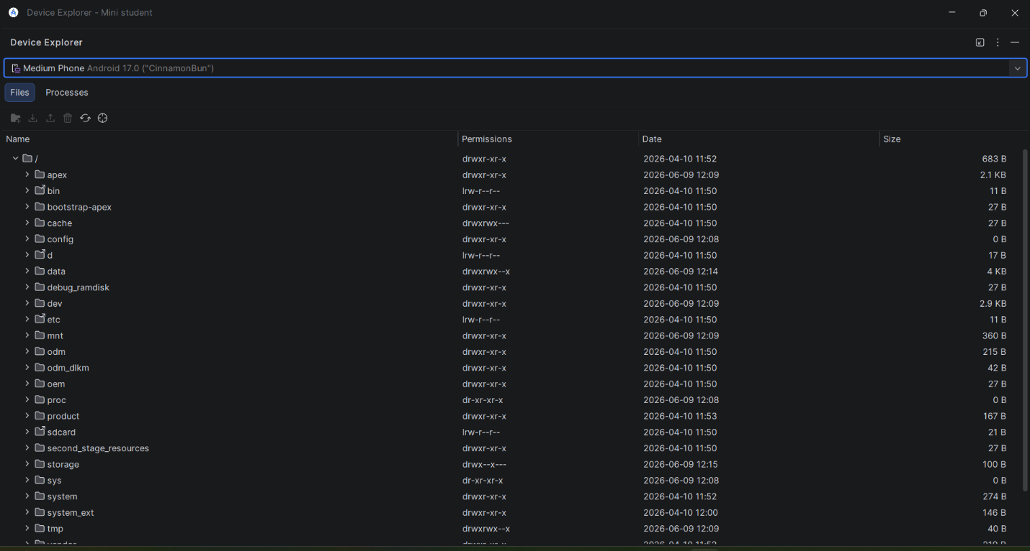

Figure 1.8

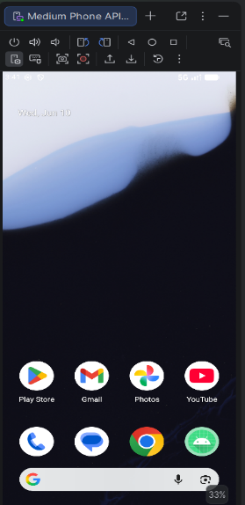

Figure 1.9

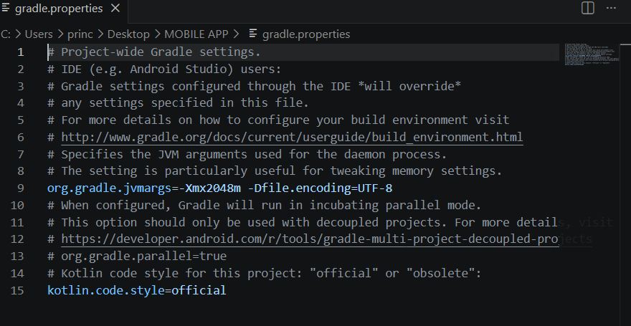Figure 2.0

TASK 2: HELLO WORLD

Figure 2.1
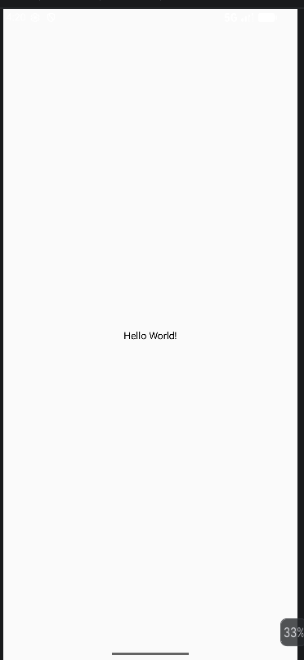

Figure 2.2
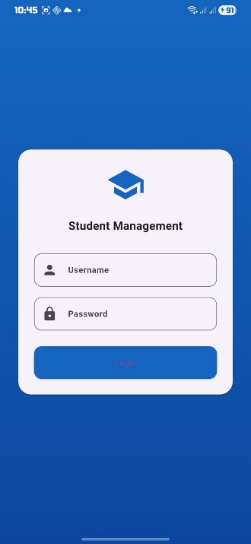

Figure 2.3
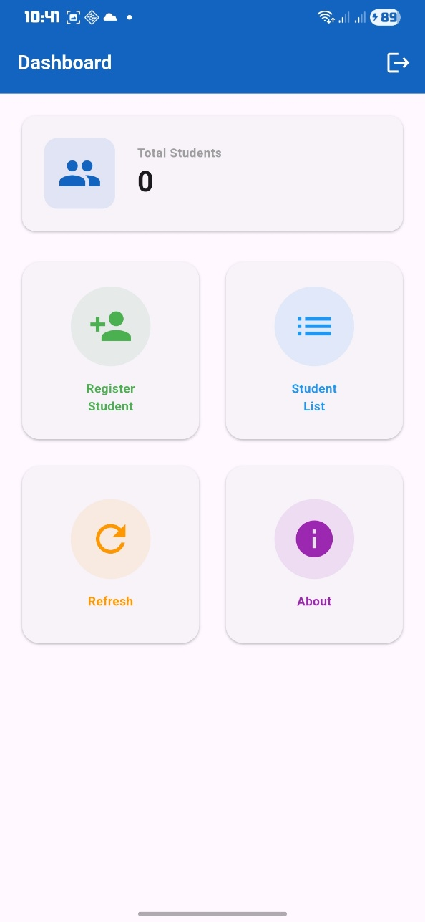

Figure 2.4
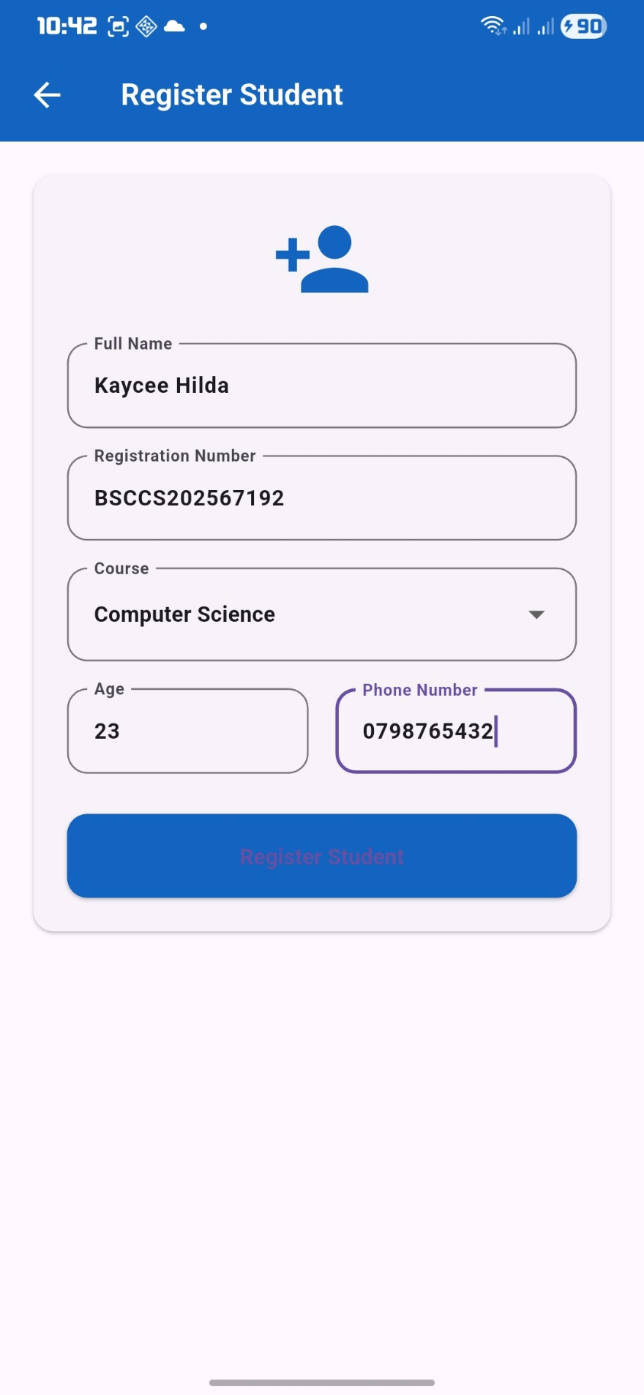

Figure 2.5
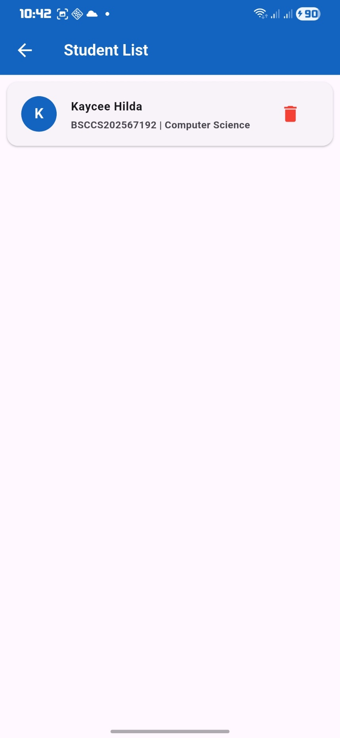

Figure 2.6
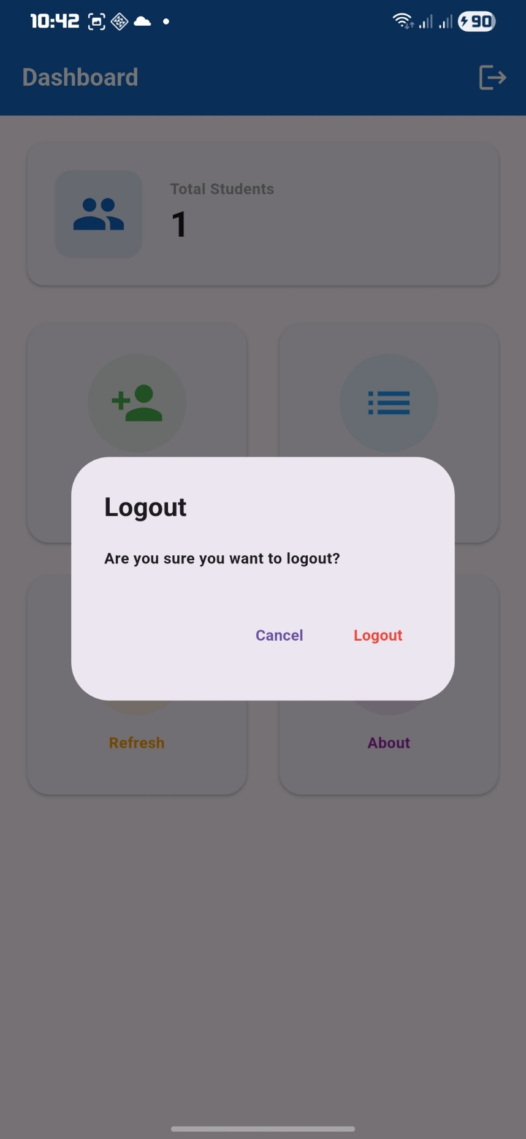

TASK 3: SMART STATIONERY INVENTORY APPLICATION DEVELOPMENT

Figure 3.0: Splash Screen
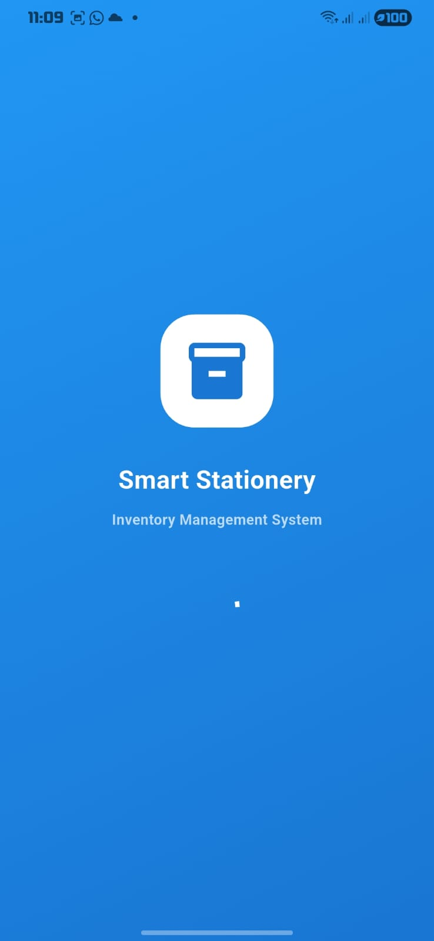

Figure 3.1: Login screen
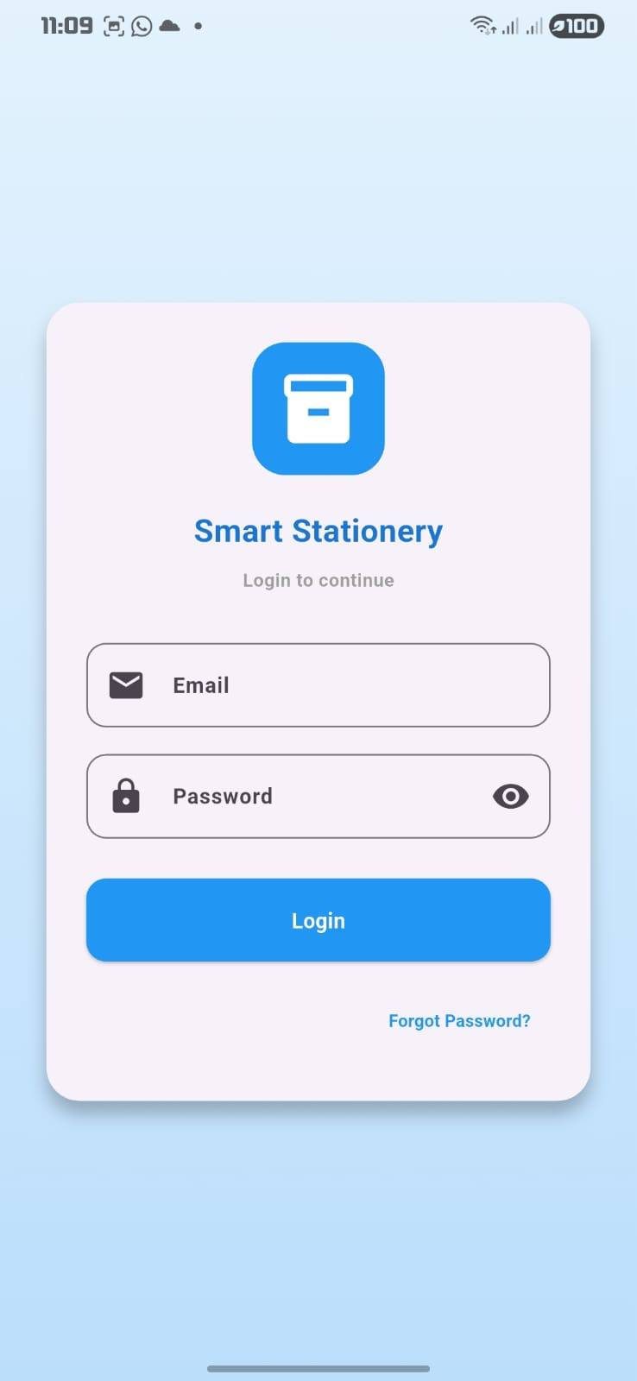

Figure 3.2: Forgot Password Dialog
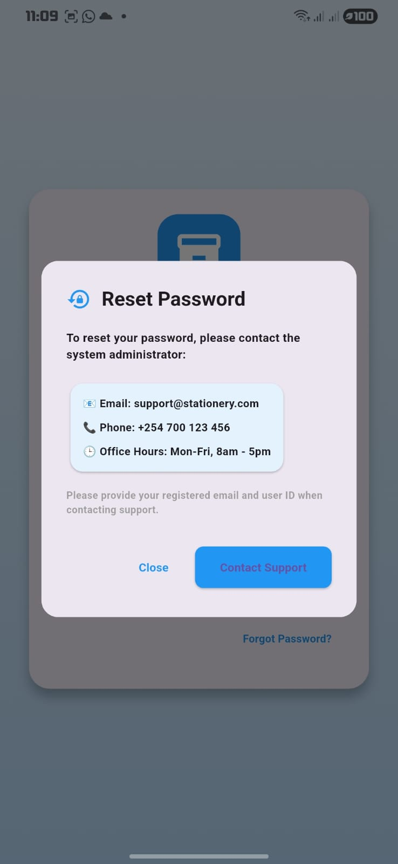

Figure 3.3: Invalid Password Dialog
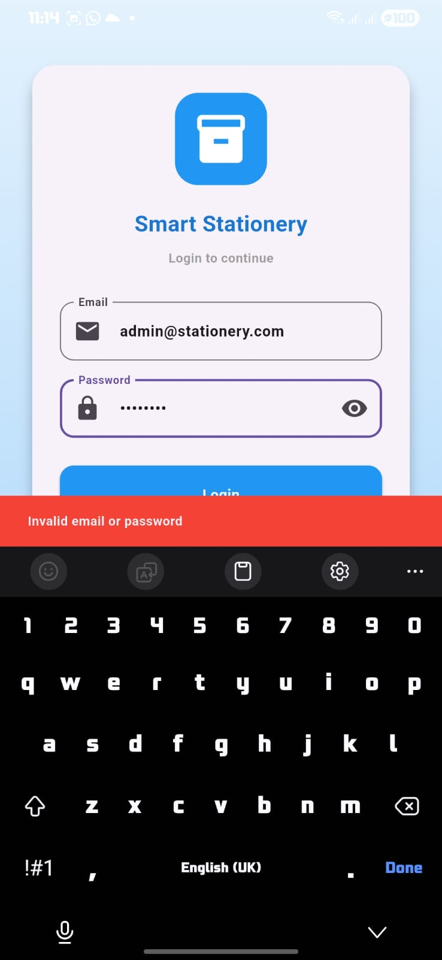

Figure 3.4: Home Screen Empty
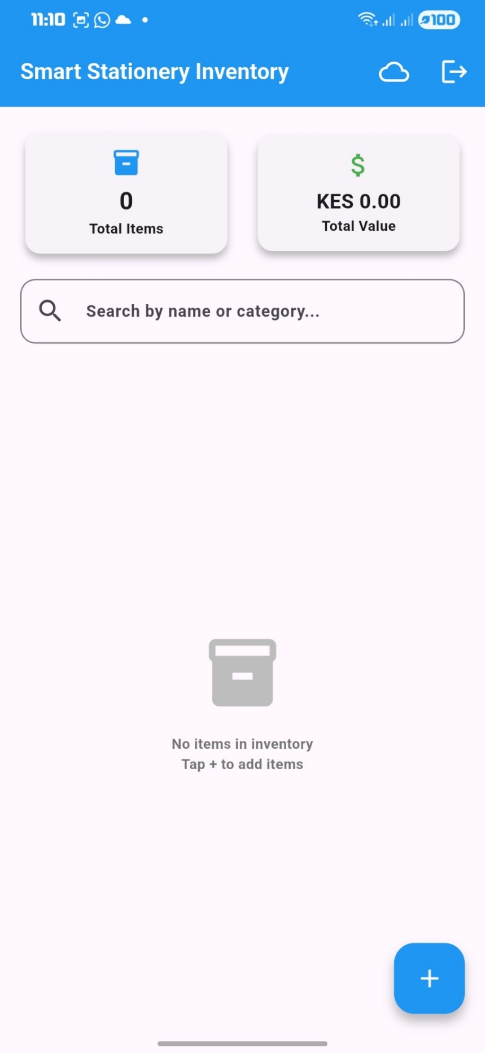

Figure 3.5: Add Item Form
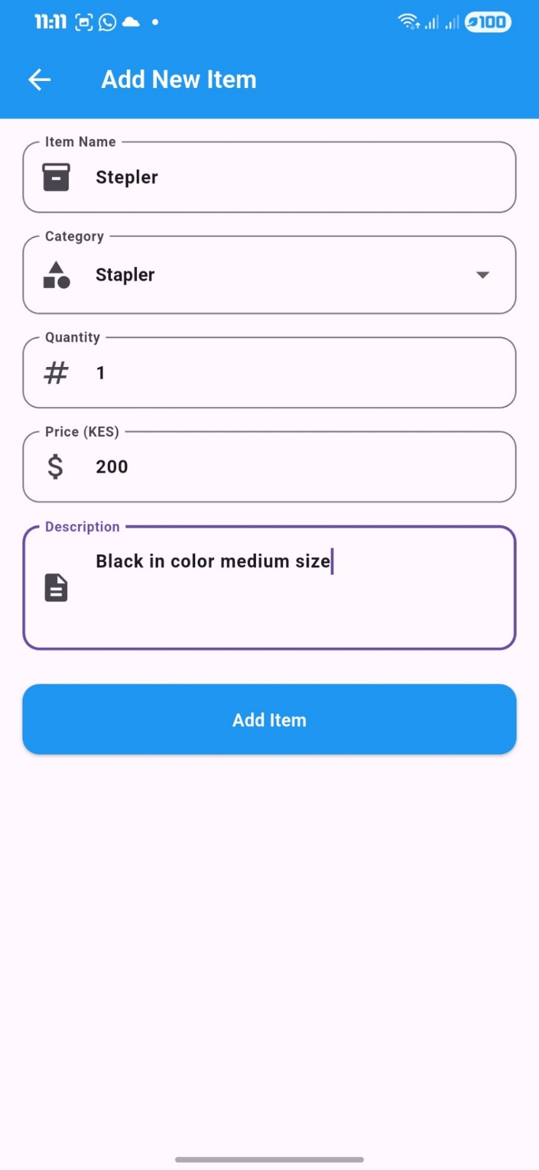

Figure 3.6: Home Screen With Item Form
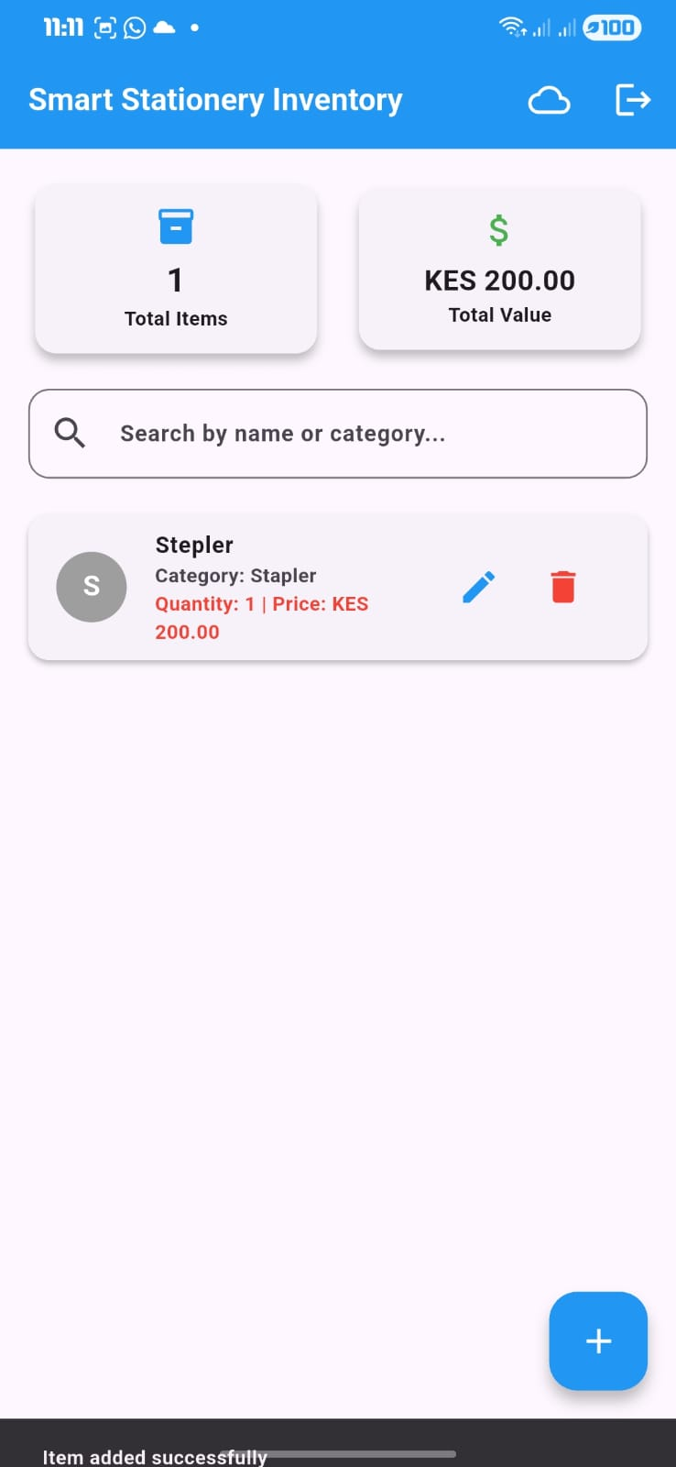

Figure 3.7: Search Function
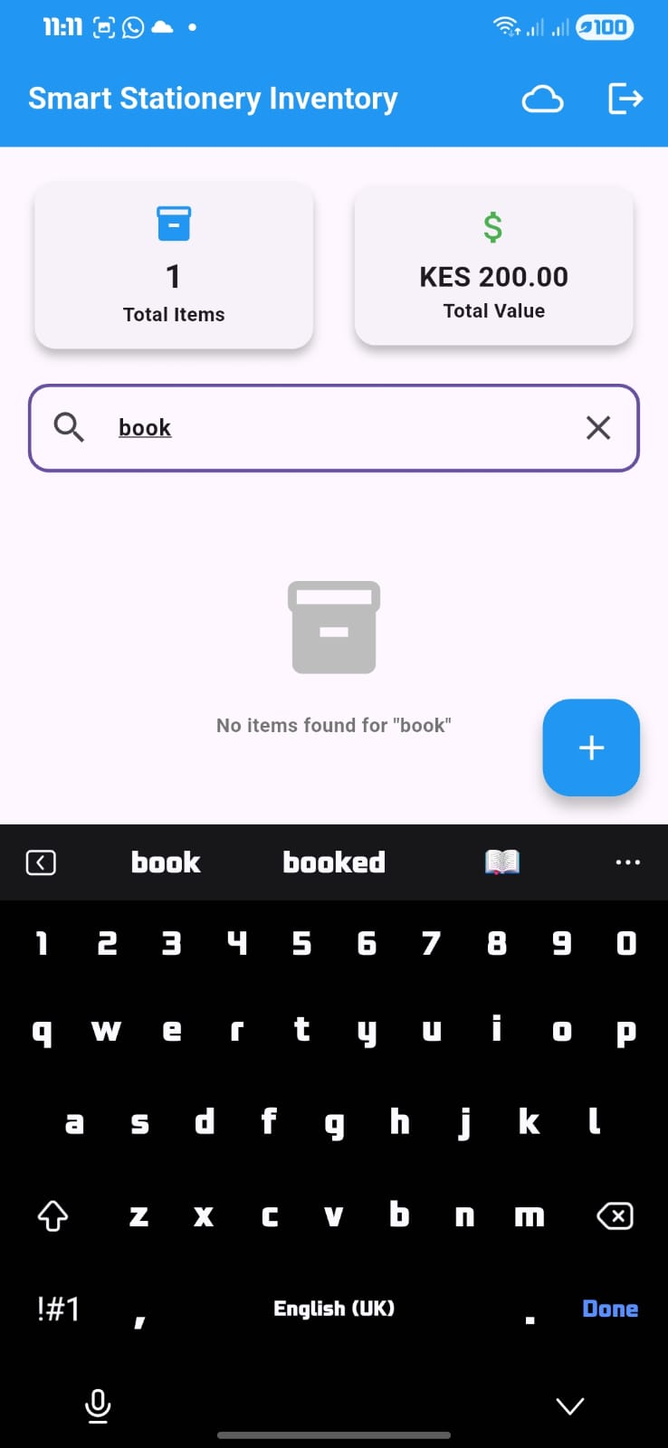

Figure 3.8:Edit Item Screen
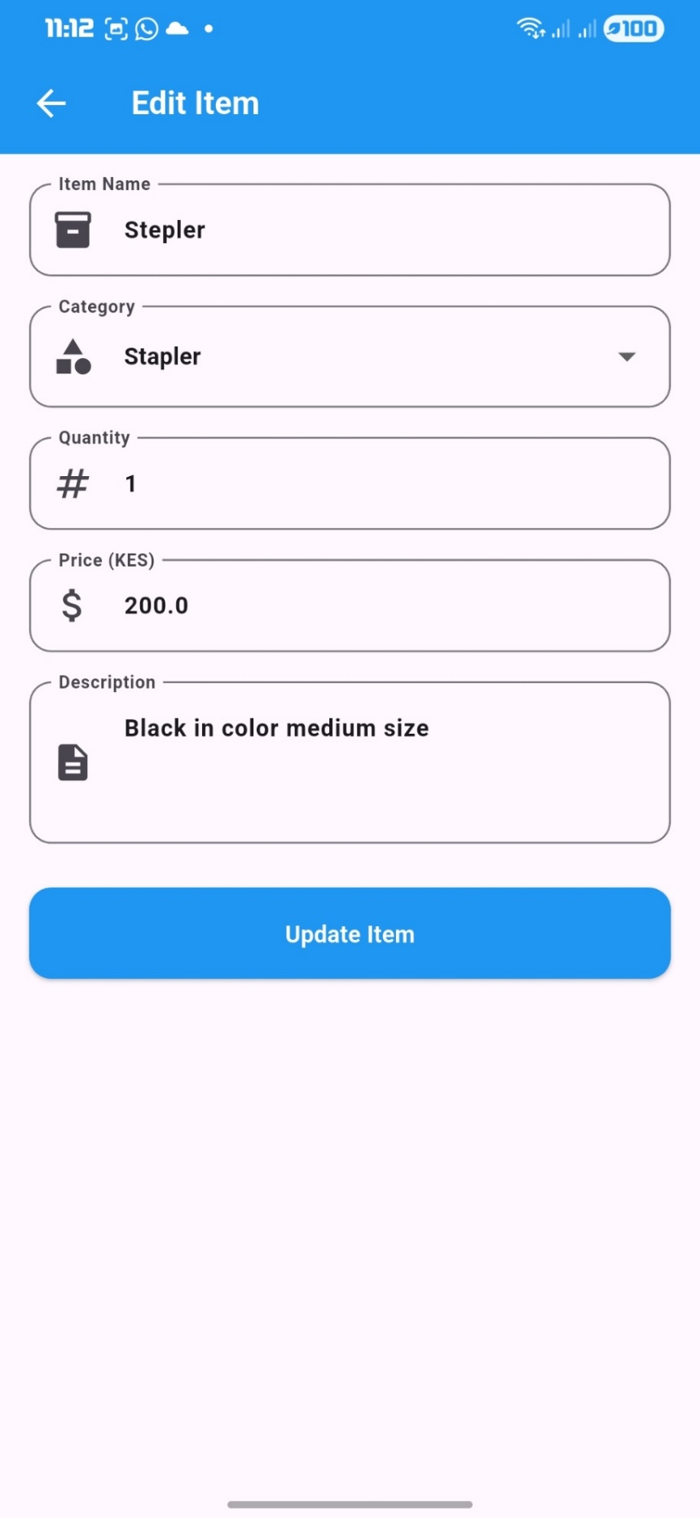

Figure 3.9: Delete Confirmation
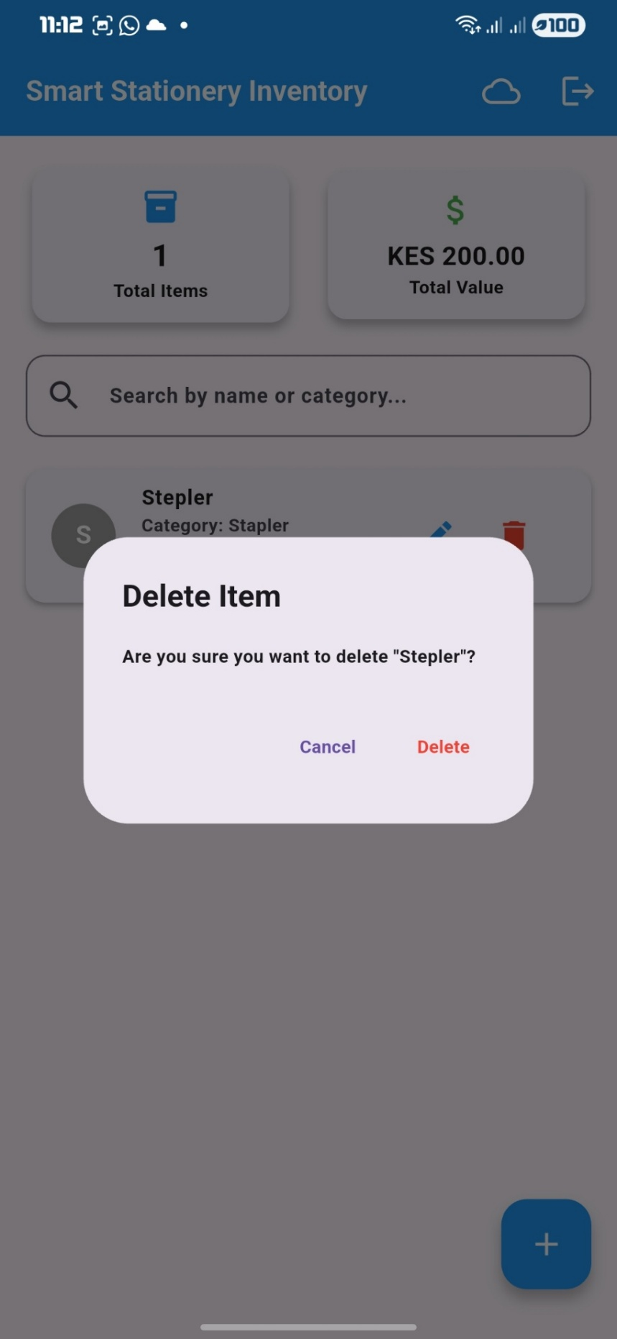

Figure 4.0: Item Detail Screen
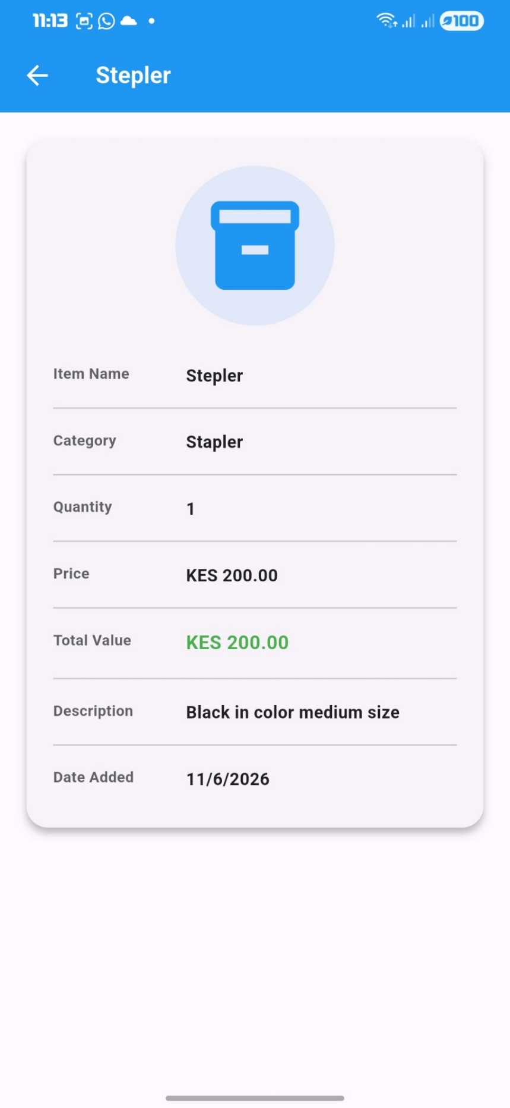

4.1: Logout Screen
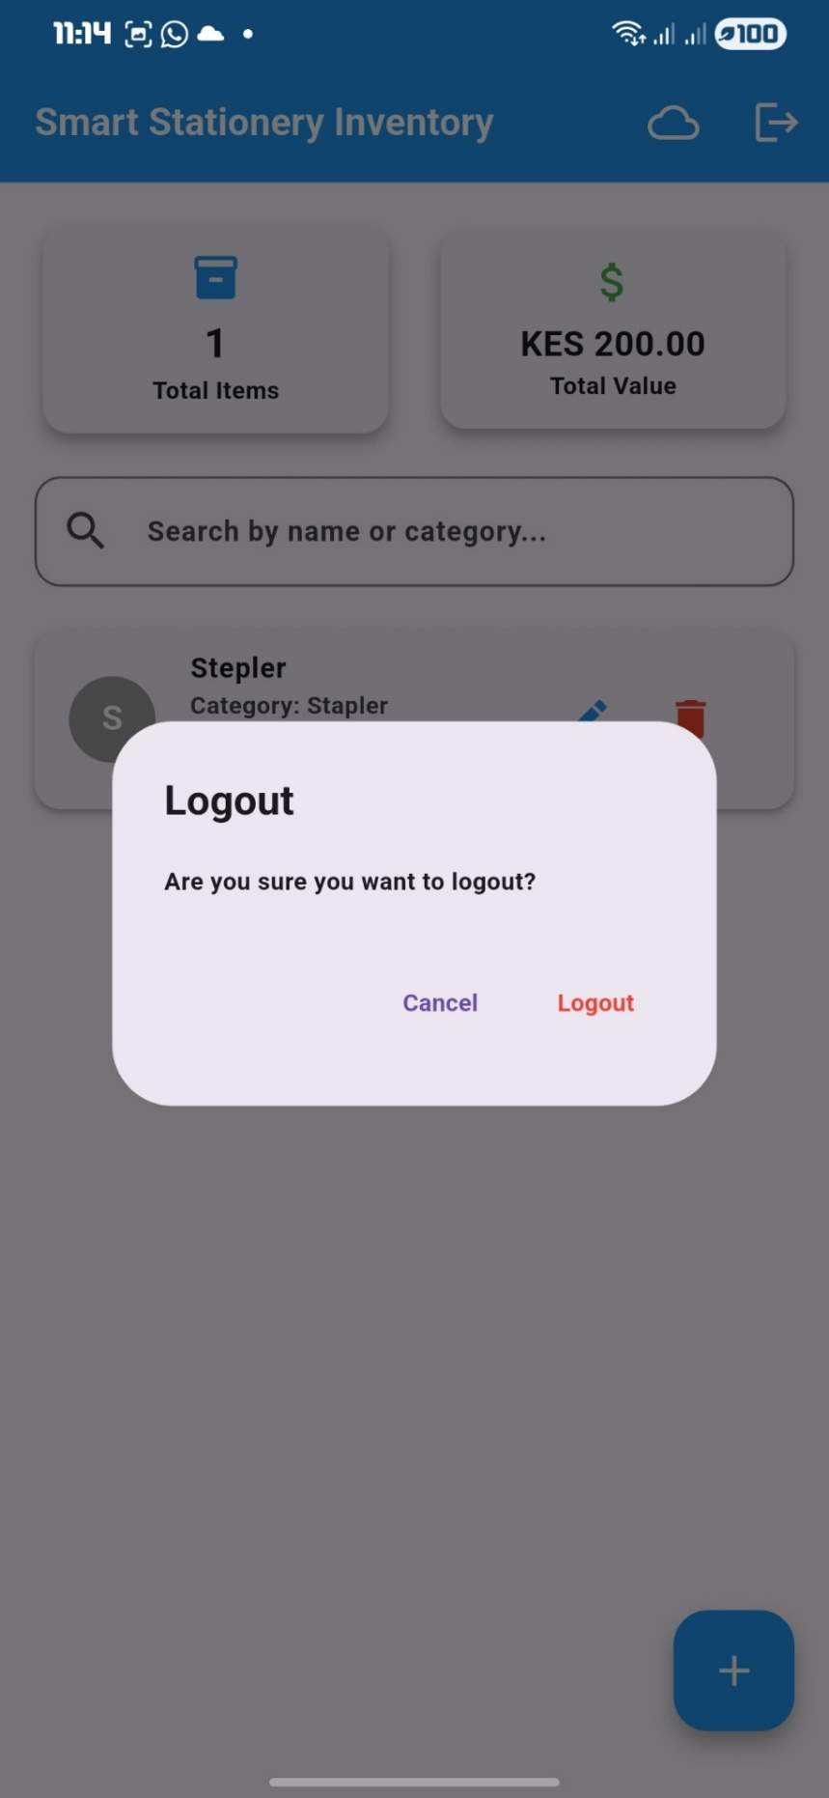

Figure 4.1 : SQLite Database
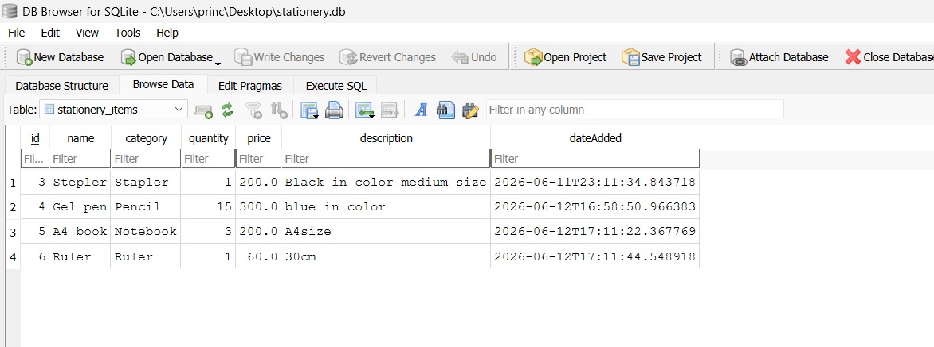

Figure 4.2: CREATE Operation
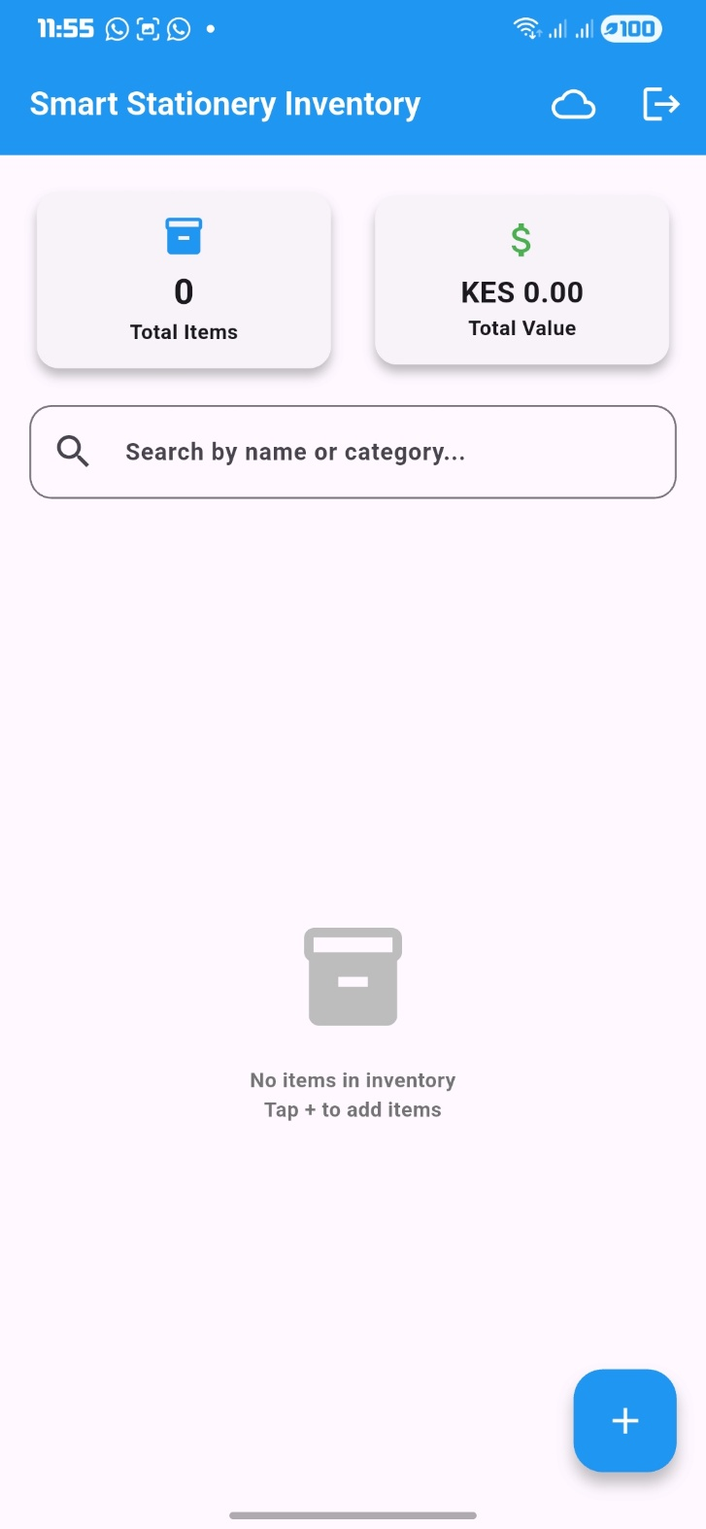
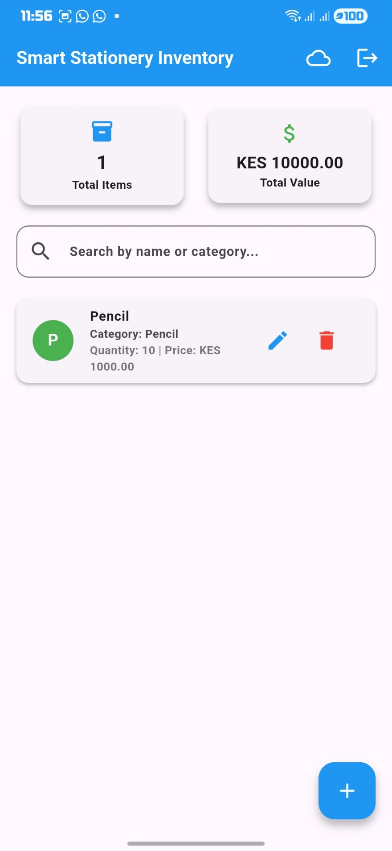

Figure 4.3: READ Operation
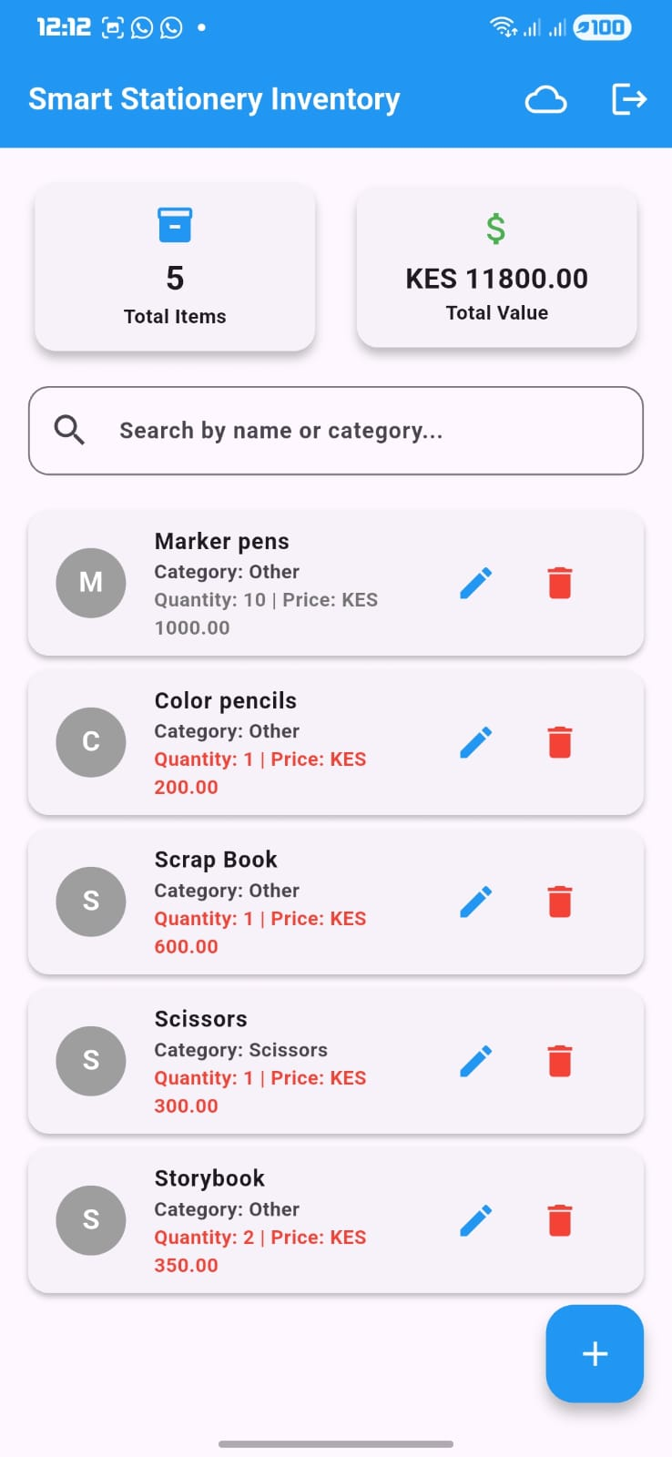

Figure 4.4: UPDATE Operation
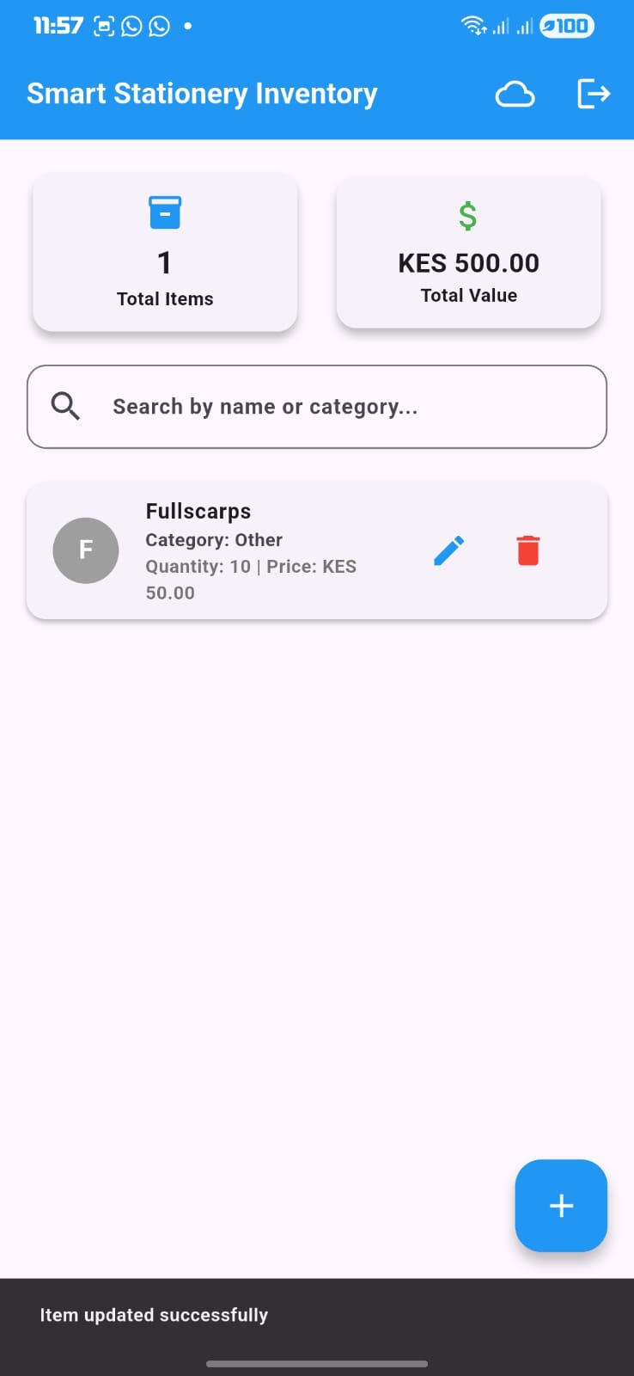

Figure 4.5: DELETE Operation
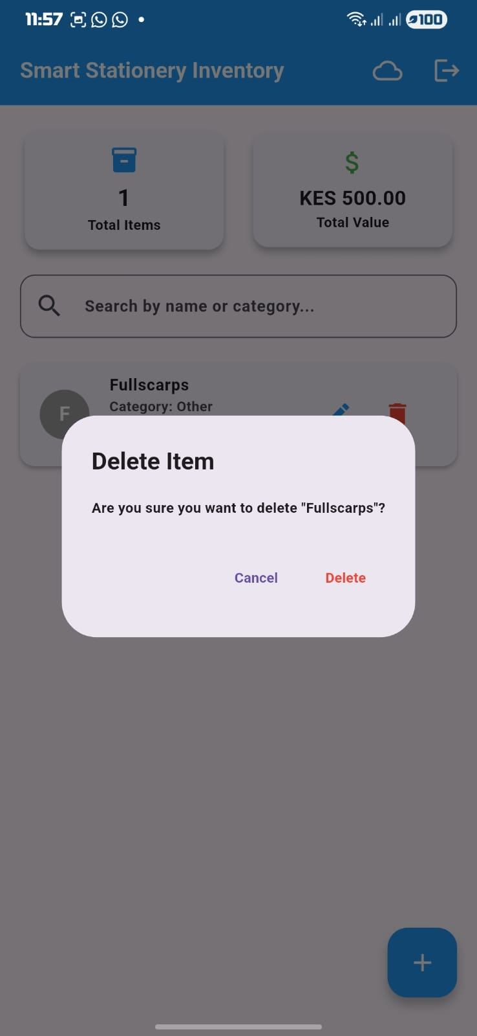

Figure 4.6: SEARCH Operation
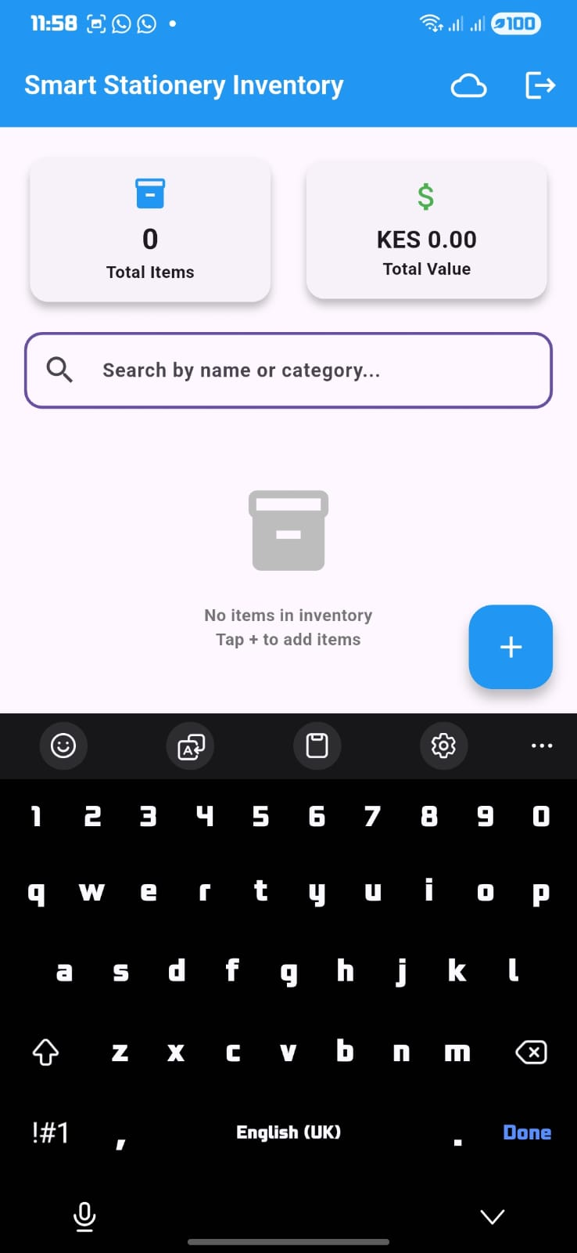

Figure 4.7: Connected to internet
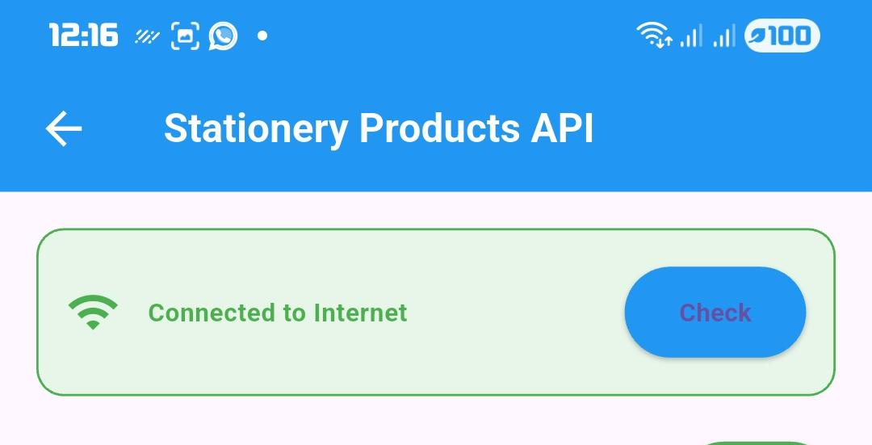

Figure 4.8: No internet connection
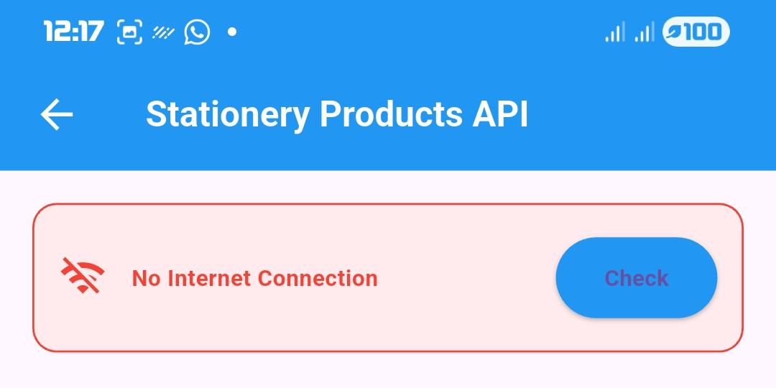

Figure 4.9: GET Method
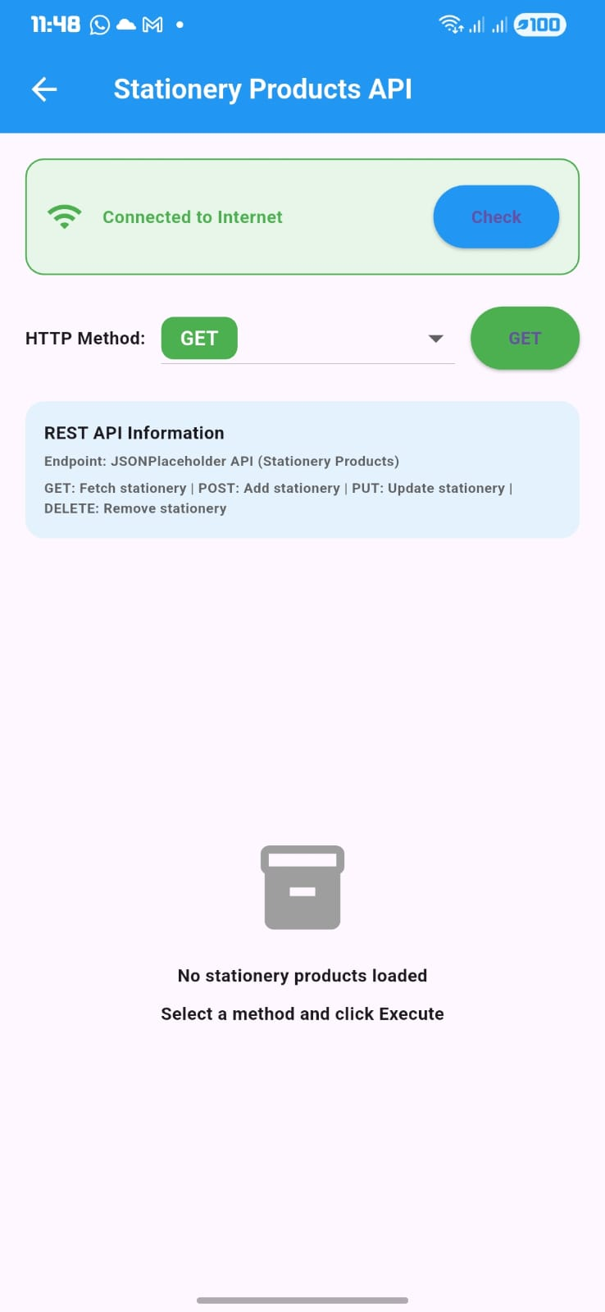

Figure 5.0: POST Method
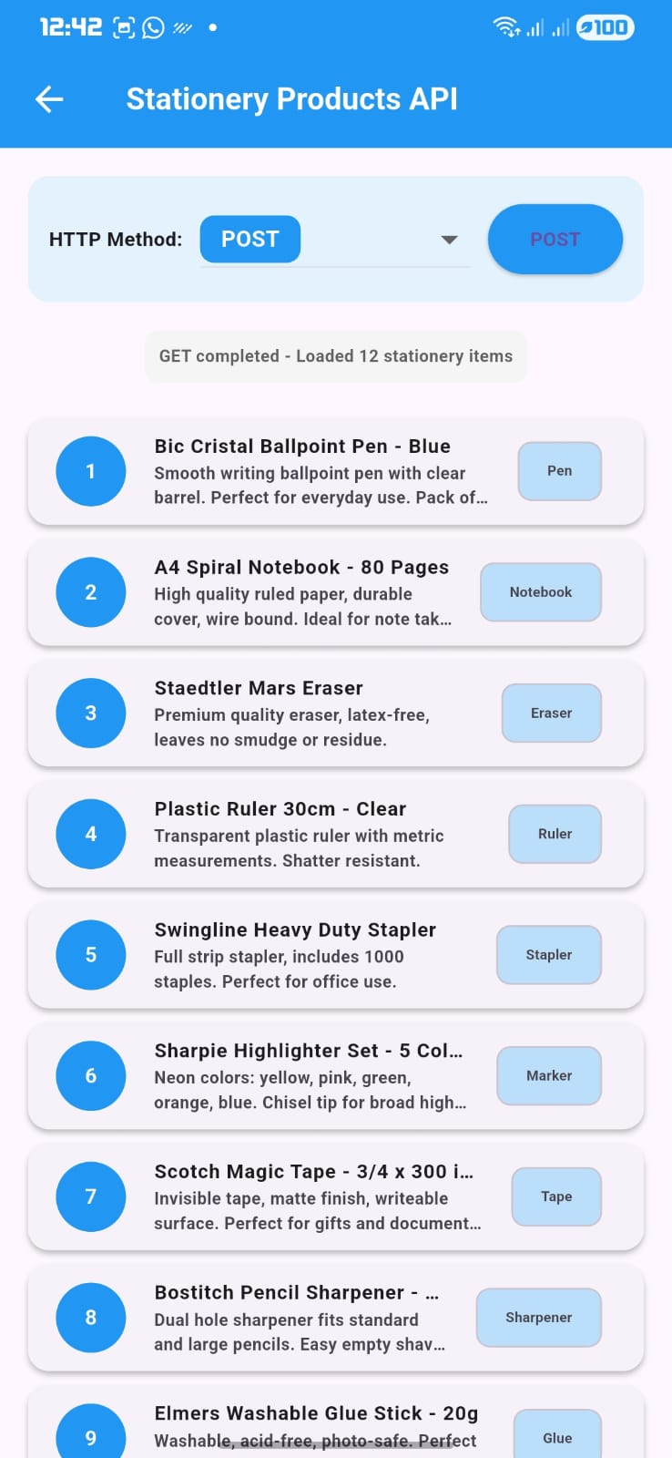

Figure 5.1: PUT Method
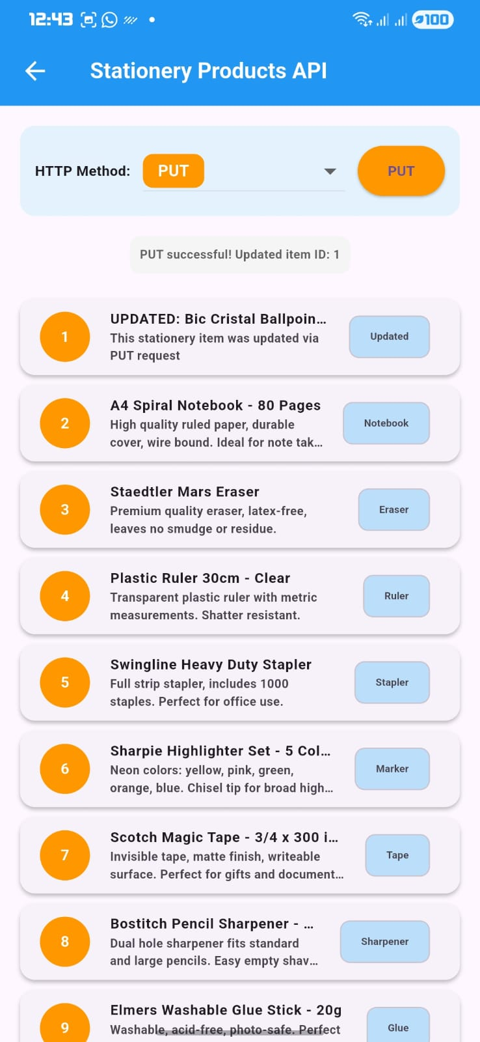

Figure 5.2: DELETE Method
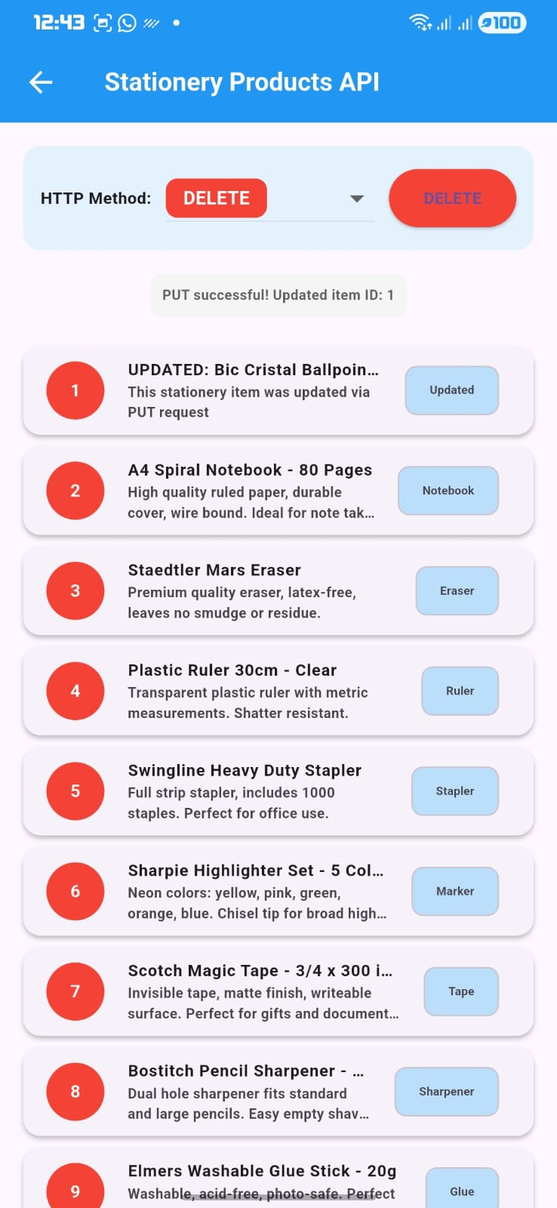

Figure 5.3: Error Handling

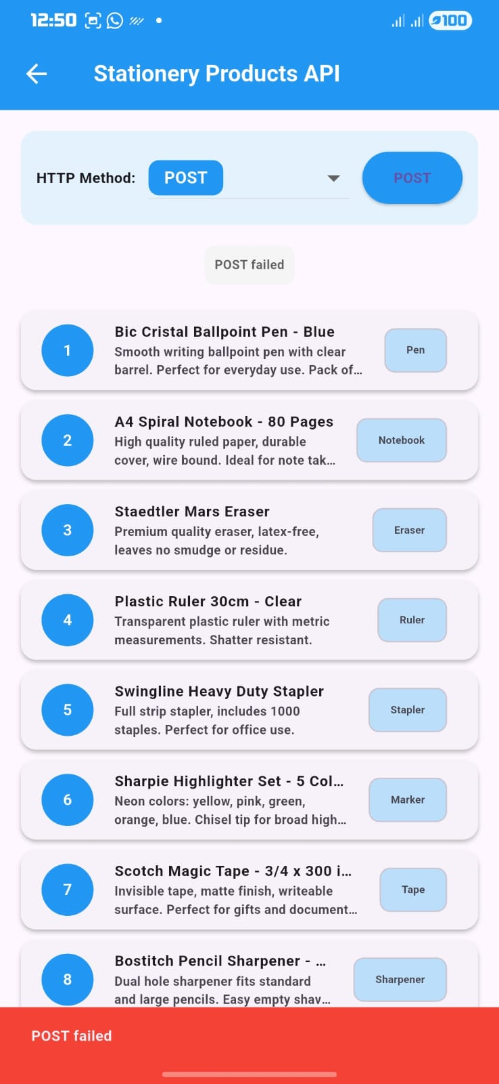

MOBILE APPLICATION DEVELOPMENT LOGBOOK
Student Name: PRINCESS HILDA MUNYI
Admission Number: BIT/2025/67192
Course: BACHELOR OF SCIENCE IN INFORMATION TECHNOLOGY
Project: Android Applications Development

PROJECT 1: HELLO WORLD APP (FLUTTER)

Flutter SDK Download and Installation
Objective
To download and install Flutter SDK for cross-platform mobile development.
Activities Performed
- Visited Flutter official website (https://docs.flutter.dev/get-started/install/windows)
- Downloaded Flutter SDK version 3.44.1 (flutter_windows_3.44.1-stable.zip)
- Extracted Flutter SDK to C:\src\flutter
- Added Flutter to system PATH environment variable
- Verified Flutter installation using command line
Commands Executed
cmd
cd C:\Users\princ\Downloads
# Extract flutter_windows_3.44.1-stable.zip to C:\src\flutter
flutter --version
Tools Used
- Windows 11 Operating System
- Flutter SDK 3.44.1
- Command Prompt
- File Explorer
Outcome
Flutter SDK was successfully downloaded, extracted, and added to system PATH.
Supervisor Signature

Android Studio and Plugin Installation
Objective
To install Android Studio and configure Flutter and Dart plugins.
Activities Performed
- Downloaded Android Studio from official website
- Installed Android Studio with default settings
- Opened Android Studio and navigated to Plugins section
- Searched for and installed Flutter plugin (Dart installed automatically)
- Restarted Android Studio after plugin installation
- Configured Flutter SDK path in Android Studio
Steps Performed
- File → Settings → Plugins
- Search "Flutter" → Click Install
- Restart Android Studio
- Set Flutter SDK path to C:\src\flutter
Tools Used
- Android Studio
- Flutter Plugin
- Dart Plugin
Outcome
Android Studio was successfully installed with Flutter and Dart plugins configured.
Supervisor Signature

Creating First Flutter Project (Hello World)
Objective
To create the first Flutter project and display "Hello World".
Activities Performed
- Opened Command Prompt and navigated to Desktop
- Created new Flutter project named hello_world_app
- Opened project in Android Studio
- Modified lib/main.dart to display "Hello World"
- Ran application on Medium phone on machine
- Ran application on Android emulator
Commands Executed
cmd
cd C:\Users\princ\Desktop
C:\src\flutter\bin\flutter create hello_world_app
cd hello_world_app
C:\src\flutter\bin\flutter run
Code Created - lib/main.dart
dart
Outcome
First Flutter application successfully displayed "Hello World" on both Chrome and Android emulator.
Supervisor Signature

Hello World App Testing and Documentation
Objective
To test the Hello World application and prepare documentation.
Activities Performed
- Tested application on multiple devices (Chrome, Edge, Android Emulator)
- Verified text display and app functionality
- Fixed minor formatting issues
- Documented all steps in logbook
- Captured screenshots for evidence
Outcome
Hello World application tested successfully on all platforms without errors.
Supervisor Signature

PROJECT 2: MINI STUDENT MANAGEMENT APP

Project Planning and Setup
Objective
To plan and set up the Mini Student Management application.
Activities Performed
- Identified system requirements for student management
- Planned application screens (Login, Register, Dashboard, Student List)
- Created new Flutter project named student_management_app
- Updated pubspec.yaml with required dependencies
- Created folder structure (models, database, screens)
System Requirements
Requirement
Login
Registration
Dashboard
Student List
Local Storage
Outcome
Student Management project was successfully created with proper structure.
Supervisor Signature

Creating Student Data Model and Database
Objective
To create the Student data model and database helper for local storage.
Activities Performed
- Created models folder in lib directory
- Created student.dart with Student class
- Created database folder in lib directory
- Created database_helper.dart with SQLite operations
- Implemented CRUD methods for student records
Student Model Code - lib/models/student.dart
Database Schema
sql
CREATE TABLE students(
id INTEGER PRIMARY KEY AUTOINCREMENT,
name TEXT NOT NULL,
regNumber TEXT NOT NULL UNIQUE,
course TEXT NOT NULL,
age INTEGER NOT NULL,
phone TEXT NOT NULL,
dateRegistered TEXT NOT NULL
)
Outcome
Student data model and database helper were successfully created with full CRUD operations.
Supervisor Signature

Creating Login Screen
Objective
To create the login screen for user authentication.
Activities Performed
- Created screens folder in lib directory
- Created login_screen.dart with username and password fields
- Implemented simple authentication logic
- Added navigation to home screen on successful login
- Added error message for invalid credentials
Login Credentials
Field | Value
Username | admin
Password | admin123
Login Screen Code Highlights
- TextField for username input
- TextField for password input (obscure text)
- Login button with validation
Outcome
Login screen was successfully created with authentication functionality.
Supervisor Signature

Creating Registration Screen
Objective
To create the student registration screen with form validation.
Activities Performed
- Created register_screen.dart with student registration form
- Implemented form validation for all fields
- Added dropdown for course selection
- Integrated with database to save student records
- Added success and error messages
Form Fields and Validations
Field | Type
Full Name | Text
Registration Number | Text
Course | Dropdown
Age | Number
Phone Number | Text
Available Courses
- Computer Science
- Information Technology
- Business Administration
- Engineering
- Medicine
- Law
- Education
Outcome
Student registration screen was successfully created with validation and database integration.
Supervisor Signature

Creating Home Screen (Dashboard)
Objective
To create the home screen with dashboard and navigation menu.
Activities Performed
- Created home_screen.dart with dashboard layout
- Implemented student count statistics card
- Created grid menu with four options:
  - Register Student
  - Student List
  - Refresh Data
  - About App
- Added logout button in app bar
Menu Items
 | Title | Navigation
 | Register Student | Navigate to Register Screen
 | Student List | Navigate to Student List
 | Refresh | Refresh dashboard data
 | About | Show about dialog
Outcome
Home screen dashboard was successfully created with navigation to all features.
Supervisor Signature

Creating Student List Screen
Objective
To create the student list screen displaying all registered students.
Activities Performed
- Created student_list_screen.dart with ListView
- Implemented loading of all students from database
- Added delete functionality for each student
- Added refresh button to reload data
- Implemented on-tap to view student details
Features Implemented
- Display all registered students in cards
- Show student name, registration number, course
- Delete button to remove student
- Tap on student to view full details
- Empty state message when no students
Outcome
Student list screen was successfully created with display and delete functionality.
Supervisor Signature

Main App Integration
Objective
To integrate all screens and configure app navigation.
Activities Performed
- Created main.dart as app entry point
- Configured named routes for navigation
- Set LoginScreen as initial route
- Added theme configuration
Outcome
All screens were successfully integrated and navigation works correctly.
Supervisor Signature

Mini Student App Testing and Debugging
Objective
To test the Mini Student Management application and fix errors.
Activities Performed
- Tested login with valid and invalid credentials
- Tested student registration with all fields
- Tested form validation
- Tested student list display
- Tested delete functionality
- Tested data persistence
- Fixed minor UI alignment issues
Test Results
Test Case | Expected Result
Login with admin/admin123 | Navigate to Home
Login with wrong password | Show error
Register new student | Save to database
Duplicate registration number | Show error
View student list | Display all students
Delete student | Remove from list
Data persistence | Survive app restart
Outcome
Mini Student Management application tested successfully on all features.
Supervisor Signature

PROJECT 3: SMART STATIONERY INVENTORY APP
Technologies Learned
- Flutter Framework
- Dart Programming
- SQLite Database
- REST API Integration
- Git/GitHub
Key Skills Acquired
- Cross-platform mobile development
- Local database management (SQLite)
- CRUD operations implementation
- REST API consumption (GET, POST, PUT, DELETE)
- Asynchronous programming (async/await)
- Error handling and validation
- UI/UX design principles
- Navigation between screens
- State management

SUPERVISOR SIGNATURES SUMMARY
Project |  | Activity |  | Supervisor Signature
Hello World |  | Flutter SDK Installation |  | _________________
Hello World |  | Android Studio Setup |  | _________________
Hello World |  | Create Hello World App |  | _________________
Hello World |  | Testing & Documentation |  | _________________
Mini Student |  | Project Planning & Setup |  | _________________
Mini Student |  | Data Model & Database |  | _________________
Mini Student |  | Login Screen |  | _________________
Mini Student |  | Registration Screen |  | _________________
Mini Student |  | Home Screen Dashboard |  | _________________
Mini Student |  | Student List Screen |  | _________________
Mini Student |  | Main App Integration |  | _________________
Mini Student | Testing & Debugging |  | _________________
Smart Stationery | (Refer to previous 12 days) |  | _________________

DECLARATION
I hereby declare that this logbook and the accompanying mobile applications (Hello World App, Mini Student Management App, and Smart Stationery Inventory App) are my original work and have not been submitted for any other assessment.
Student Name: PRINCESS HILDA MUNYI
Admission Number: BIT/2025/67192
Signature: _________________
Date: ______13/6/2026___________

