DOCUMENTATION ON THE PRACTICAL TASK FOR MOBILE APPLICATION DEVELOPMENT APPROACH

NAME: PRINCESS HILDA MUNYI.
REGISTRATION NUMBER: BIT/2025/67192.
COURSE: BACHELOR OF SCIENCE IN INFORMATION TECHNOLOGY.
UNIT TITLE: MOBILE APPLICATION DEVELOPMENT.

TASK 1: DEVELOPMENT TOOLS ASSESSMENT
Below are the screenshots of the software that I downloaded. Some software where there before.

Screenshot 1
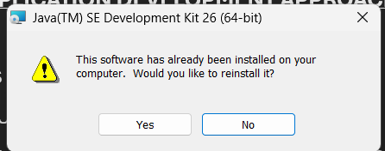
This is a screenshot of JDK that I installed earlier.

Screenshot 2
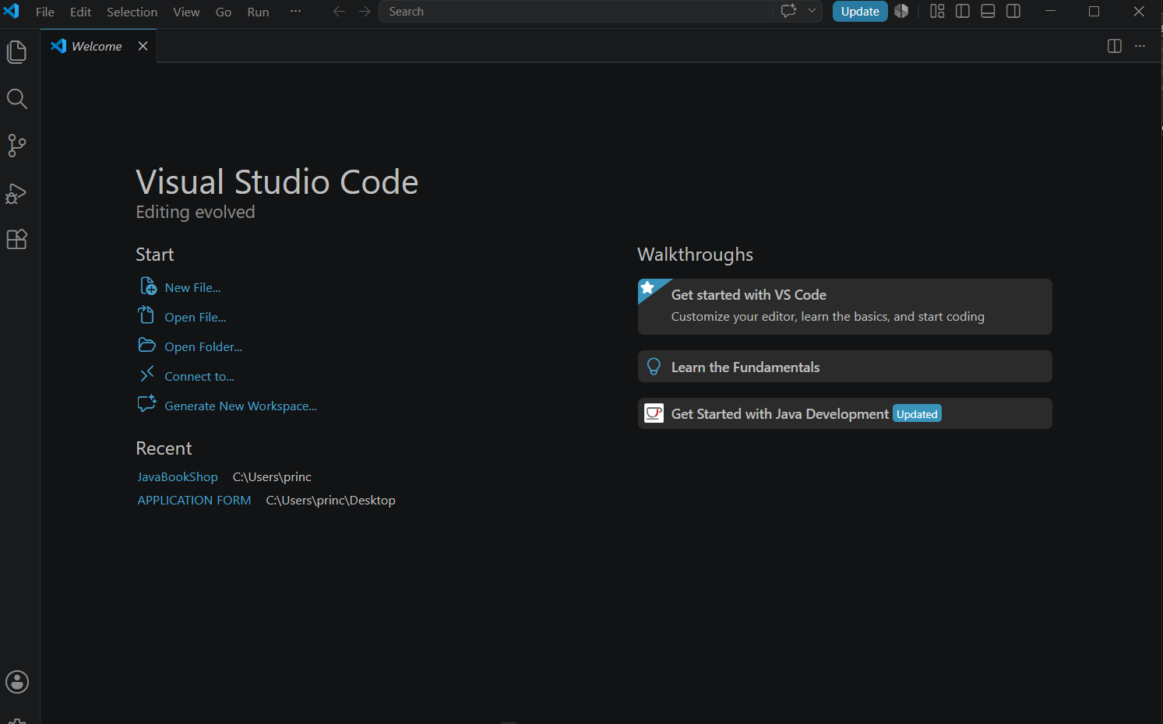
Visual Studio code successfully installed.

SCREENSHOTS 3
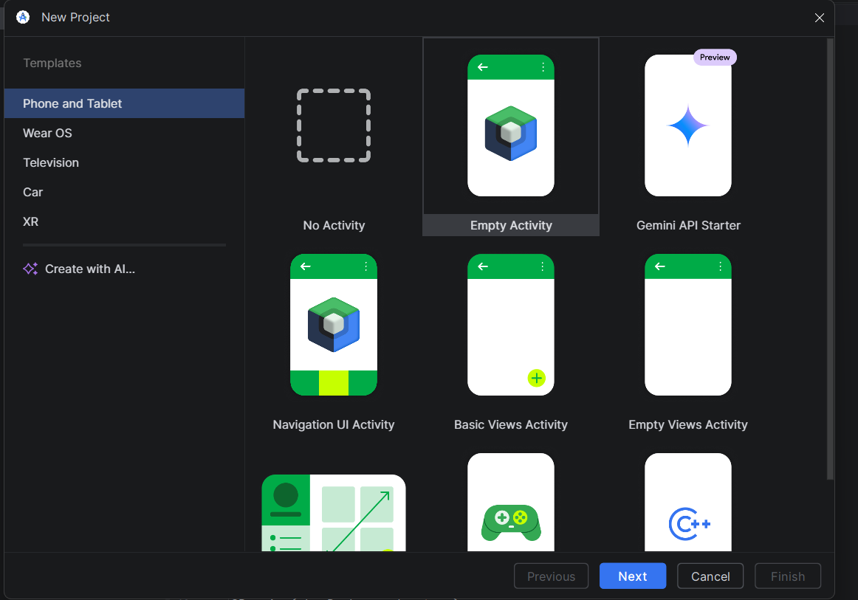
Above is a screenshot that’s shows inside android studio.
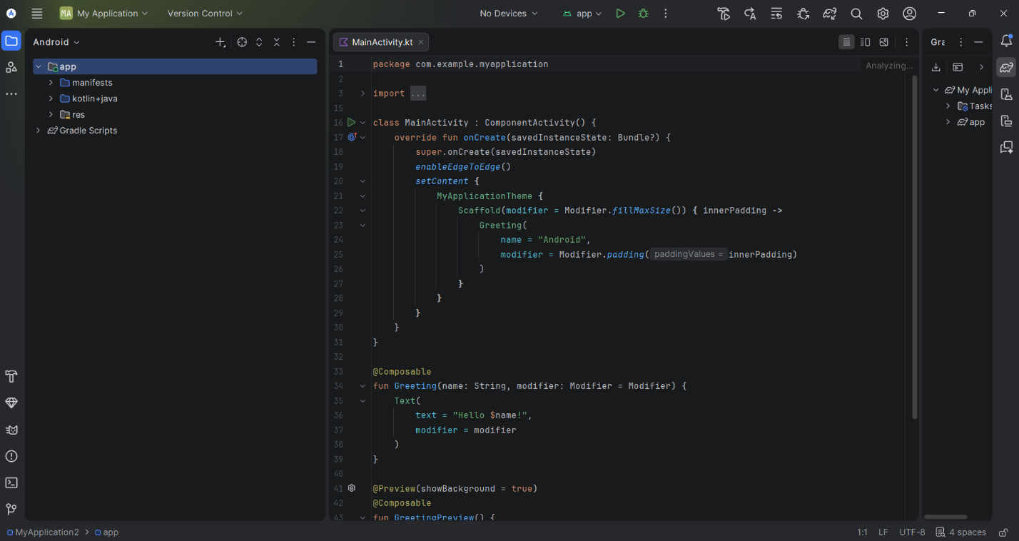
Succesful installation of android studio.

SCREENSHOT 4: Main ACTIVITY
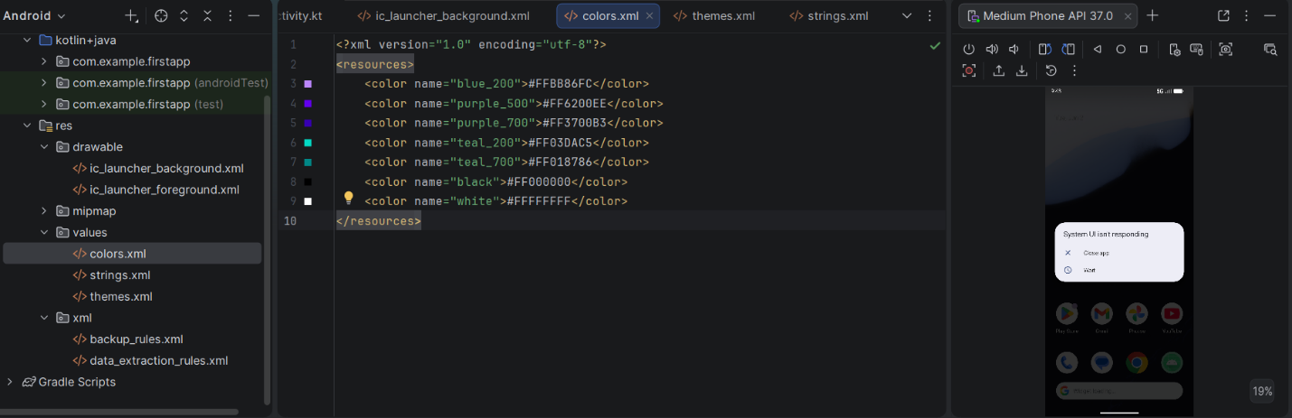

SCREENSHOT 5
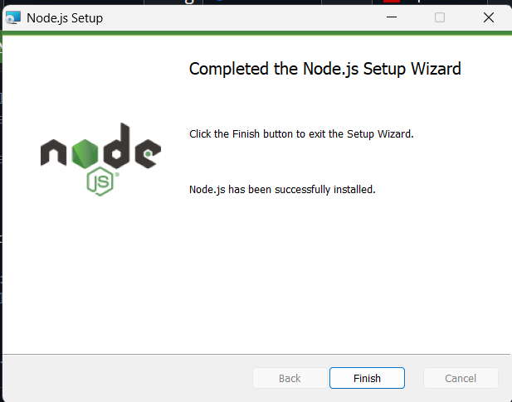
Node js successfully installed.

SCREENSHOT 6 : EMULATOR
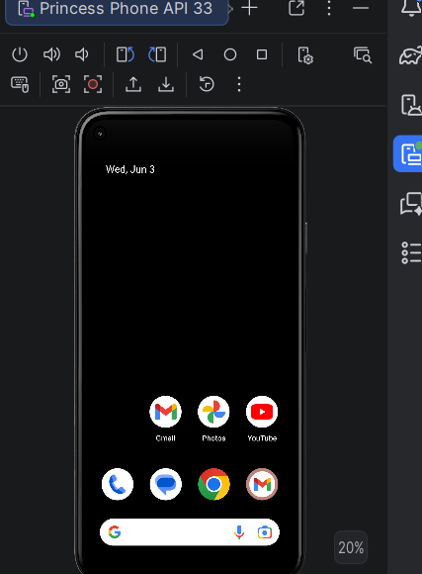
Screenshot of the emulator.

SCREENSHOT 7
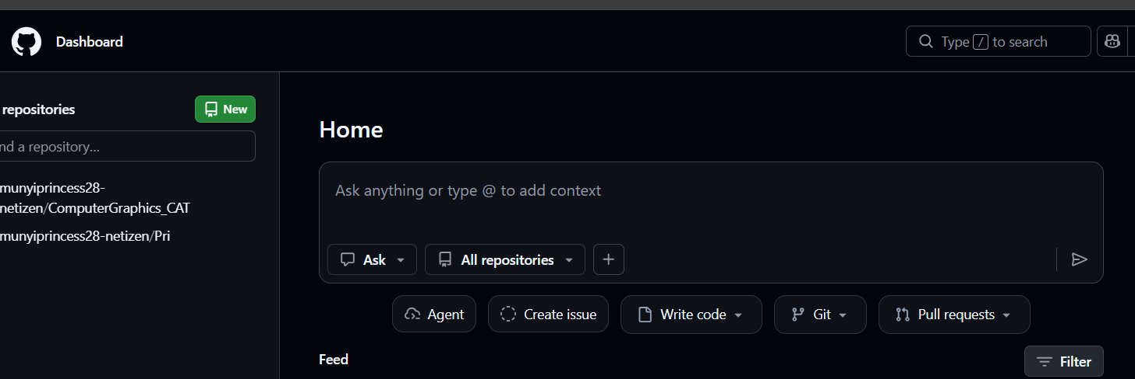
Screenshot of the github account in use.

SCREENSHOT : GRADLE
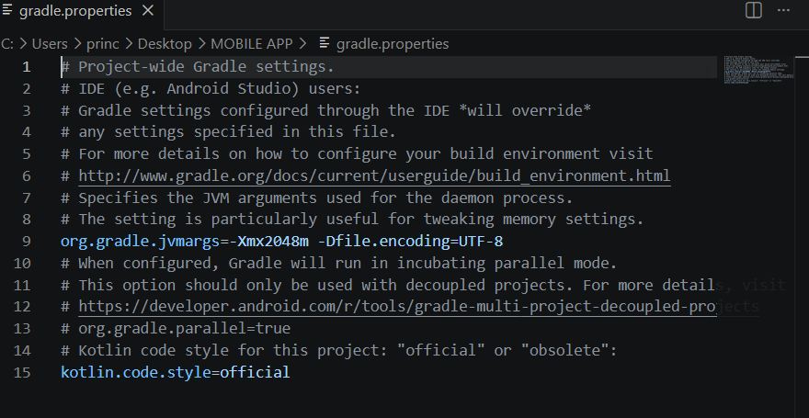
SCREENSHOT : FIREBASE
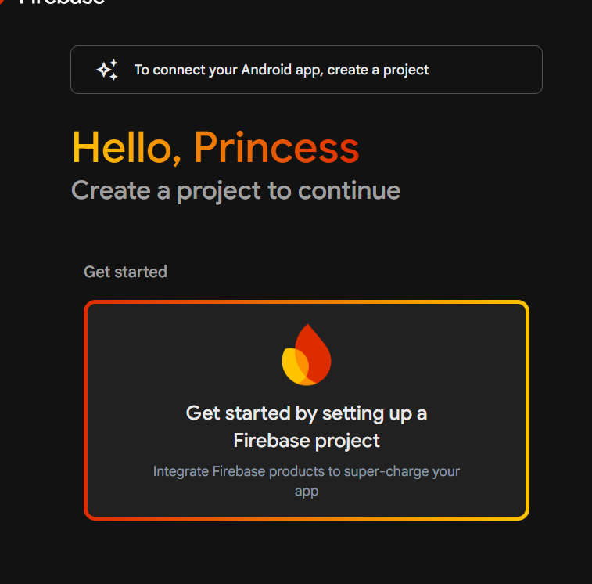

TASK 2 HELLO WORLD CREATION
My app title hello world
SCREENSHOT
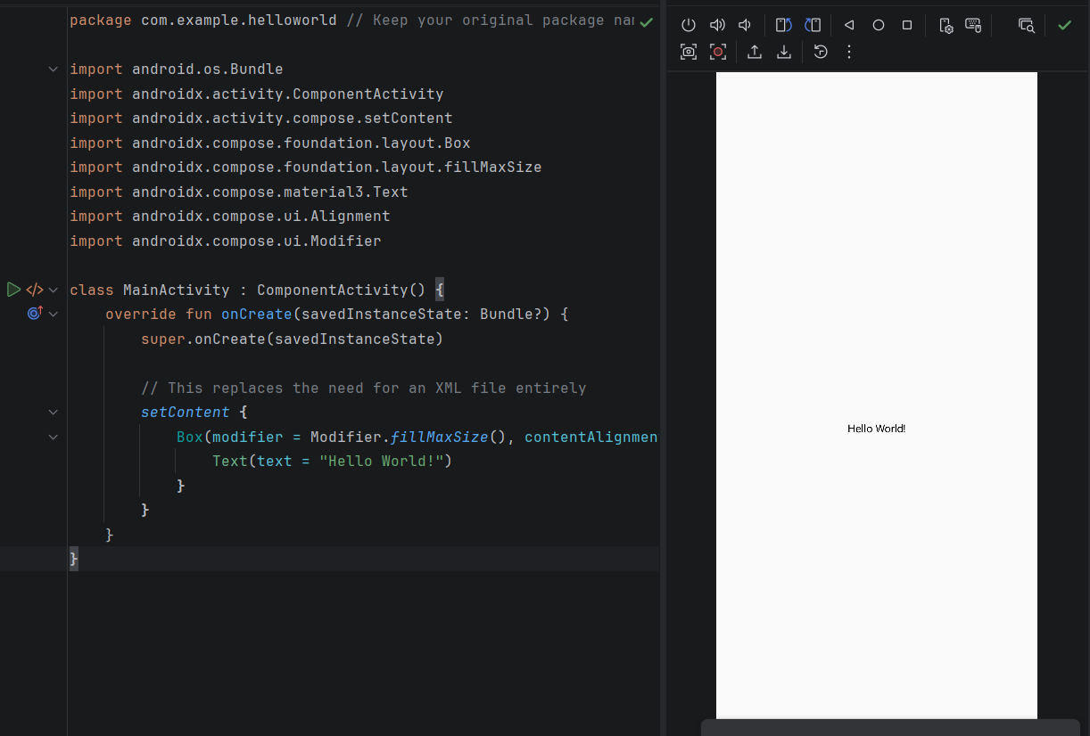

Week 2: Mini Student Management
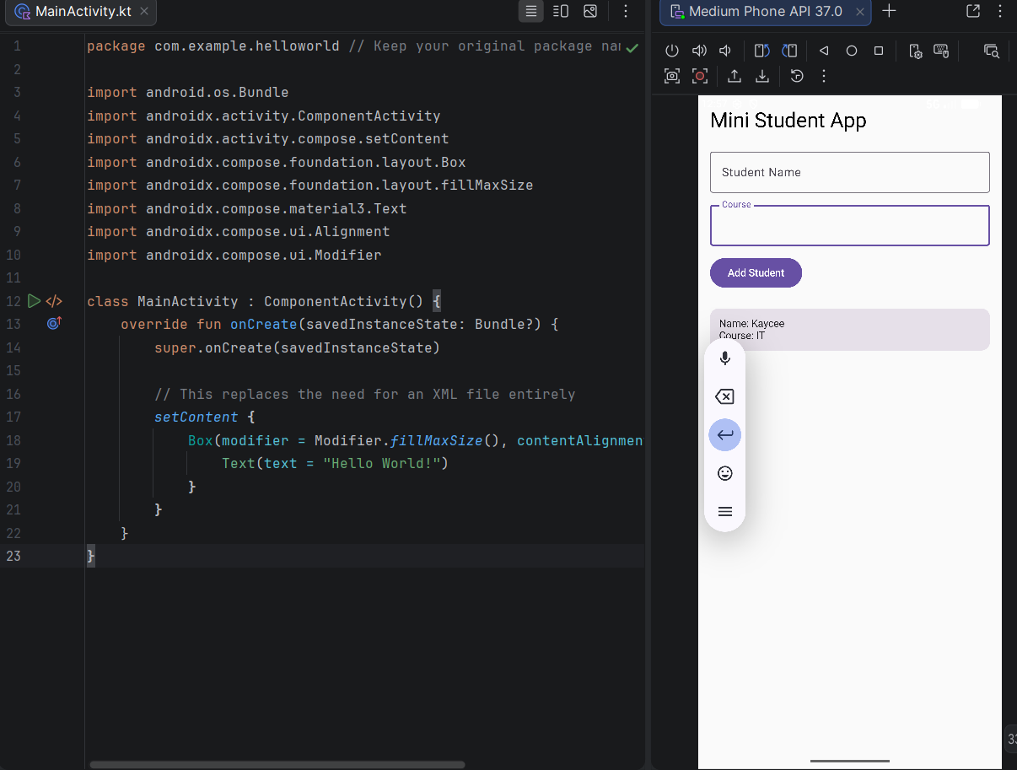

Screenshot of Kotlin
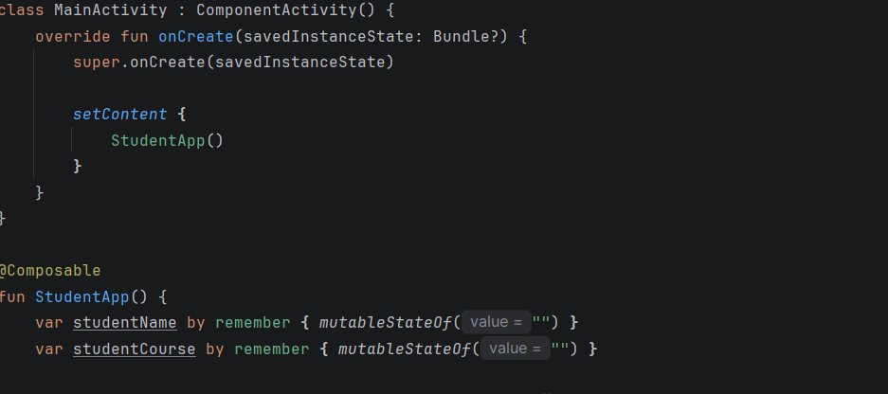
MOBILE APPLICATION DEVELOPMENT LOGBOOK
Student Name: PRINCESS HILDA MUNYI
Admission Number: BIT/2025/67192
Course: BIT
Project: Android Applications Development
Period: MAY- AUGUST

PROJECT 1: HELLO WORLD APP
Day 1: Environment Setup
Objective
To install and configure Android development tools.
Activities Performed
- Installed Android Studio.
- Installed Android SDK.
- Configured emulator.
- Created first Android project.
Tools Used
- Android Studio
- Kotlin
- Android Emulator
Outcome
Android Studio was successfully installed and configured.
Supervisor Signature

Day 2: Creating Hello World Application
Objective
To create a simple Android application.
Activities Performed
- Created a new Android project.
- Selected Empty Activity template.
- Wrote code to display "Hello World".
- Ran application on emulator.
Code Snippet
MOBILE APPLICATION DEVELOPMENT LOG BOOK
Student Name: _______________________
Admission Number: ___________________
Course: _____________________________
Project: Android Applications Development
Period: _____________________________

PROJECT 1: HELLO WORLD APP
Day 1: Environment Setup
Objective
To install and configure Android development tools.
Activities Performed
- Installed Android Studio.
- Installed Android SDK.
- Configured emulator.
- Created first Android project.
Tools Used
- Android Studio
- Kotlin
- Android Emulator
Outcome
Android Studio was successfully installed and configured.
Supervisor Signature

Day 2: Creating Hello World Application
Objective
To create a simple Android application.
Activities Performed
- Created a new Android project.
- Selected Empty Activity template.
- Wrote code to display "Hello World".
- Ran application on emulator.
Code Snippet
package com.example.helloworld
import android.os.Bundle
import androidx.activity.ComponentActivity
import androidx.activity.compose.setContent
import androidx.compose.material3.Text
class MainActivity : ComponentActivity() {
override fun onCreate(savedInstanceState: Bundle?) {
super.onCreate(savedInstanceState)
setContent {
Text("Hello World")
}
}
}
Outcome
Application displayed "Hello World" successfully.
Supervisor Signature

Day 3: Testing and Documentation
Objective
To test the application and prepare documentation.
Activities Performed
- Tested application functionality.
- Fixed minor errors.
- Documented project.
Outcome
Application worked successfully without errors.
Supervisor Signature

PROJECT 2: MINI STUDENT APP
Day 4: Project Planning
Objective
To design a student management application.
Activities Performed
- Identified system requirements.
- Planned application screens:
  - Login Screen
  - Registration Screen
  - Dashboard Screen
Outcome
Project structure was successfully designed.
Supervisor Signature

Day 10: Testing and Debugging
Objective
To verify system functionality.
Activities Performed
- Tested login process.
- Tested registration process.
- Fixed navigation errors.
- Improved UI appearance.
Outcome
Application operates successfully.
Supervisor Signature
Outcome
Application displayed "Hello World" successfully.
Supervisor Signature

Day 3: Testing and Documentation
Objective
To test the application and prepare documentation.
Activities Performed
- Tested application functionality.
- Fixed minor errors.
- Documented project.
Outcome
Application worked successfully without errors.
Supervisor Signature

PROJECT 2: MINI STUDENT APP
Day 4: Project Planning
Objective
To design a student management application.
Activities Performed
- Identified system requirements.
- Planned application screens:
  - Registration Screen
Outcome
Project structure was successfully designed.
Supervisor Signature

Day 10: Testing and Debugging
Objective
To verify system functionality.
Activities Performed
- Tested registration process.
Outcome
Application operates successfully.
Supervisor Signature

