<Your Project Title>

Bui Vu Nhat Minh
23085491

<resources links (github/onedrive)>

UXCFXK-30-3
Digital Systems Project


Abstract
This project develops an LLM-based AI agent that helps users understand very large code repositories and long technical documents through question answering with evidence citations (file path + line range / document section). The system compares three strategies for long-context understanding: (1) a single-pass long-context baseline (stuffing or summarise-then-answer), (2) a standard Retrieval-Augmented Generation (RAG) pipeline that retrieves top-k relevant chunks before answering, and (3) a recursive reading strategy that decomposes a query, selectively reads relevant snippets via tools, and synthesises a final response across multiple steps. The key research focus is “context rot”: performance degradation as input length grows and distractor content increases. The evaluation reports answer correctness, citation correctness, cost (tokens and number of model calls), and latency across controlled settings where corpus size and distractors are varied. The intended outcome is a working, demonstrable prototype (ingestion, indexing, QA with citations, and traceable tool actions) plus an empirical comparison that clarifies when recursive reading is beneficial relative to common baselines.

Acknowledgements
I would like to thank my project supervisor, Mai Xuan Trang, for her guidance, feedback, and support throughout the project. I also thank the module teaching team for providing the structure, milestones, and assessment guidance that shaped my planning and deliverables. Finally, I am grateful to my classmates and peers who discussed ideas, tested early prototypes, and provided useful perspectives on usability and evaluation.

Table of Contents
Abstract 1
Acknowledgements 2
Table of Contents 3
Table of Figures 4
Introduction 5
Literature Review 6
Methodology 7
Results and Analysis 8
Project Evaluation 9
Further Work and Conclusion 10
Glossary 11
Table of Abbreviations 12
References / Bibliography 13
Appendix A: First Appendix 14

Table of Figures

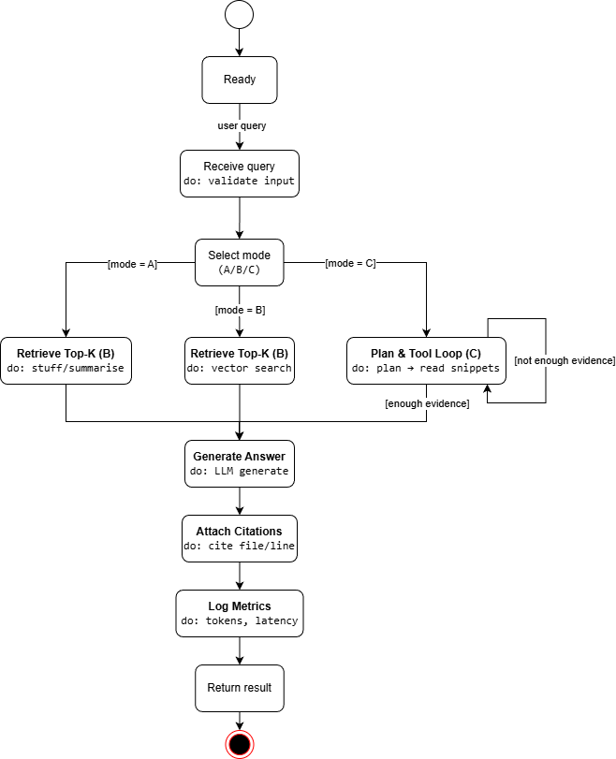
Figure 1: System architecture and data flow (ingestion → indexing → QA modes

Figure 2: State diagram of the agent interaction loop
Figure 3: Context-rot evaluation protocol and example plots

Introduction

Modern software repositories and technical documentation have become too large for a user to read end-to-end when they need quick understanding. A developer joining a new codebase may ask questions such as “Where is authentication enforced?”, “Which modules implement rate limiting?”, or “How does the system handle failures and retries?”. Similarly, long technical documents (standards, design documents, internal manuals) require time-consuming navigation to locate the exact sections that support an answer. Large Language Models (LLMs) appear promising because they can translate natural-language questions into coherent explanations, but they are limited by context windows, and their performance often degrades when inputs become long, noisy, or full of distractors.

This project addresses that gap by building an AI agent that performs question answering over large repositories and long documents with explicit evidence citations, so that users can verify claims. The key research problem is not only producing a fluent answer, but producing an answer that is grounded in the source artefacts and remains reliable as the corpus grows. To study this, the project focuses on “context rot”: the tendency for LLM-based systems to become less accurate and less grounded as more text is included, especially when irrelevant material is added.

To make this problem measurable and engineering-relevant, the project implements and compares three approaches for long-corpus understanding:
- Single-pass long-context baseline (stuffing / summarise-then-answer): The system either directly concatenates large portions of the corpus into one prompt or compresses the corpus into a summary, then answers the question in a single call. This baseline is simple and serves as a reference point for how far a “minimal engineering” approach can go.
- Standard RAG baseline (retrieve top-k chunks then answer): The corpus is chunked and indexed; at query time, the system retrieves the most relevant chunks and uses them as evidence in the LLM prompt. This approach is widely used because it reduces the need to include the entire corpus in context and encourages grounded outputs.
- Recursive reading (proposed method): Instead of depending on one prompt or one retrieval step, the system decomposes a question into smaller sub-questions, selectively reads relevant snippets using tools (e.g., search, open file sections), and synthesises a final answer over multiple steps. This method aims to reduce context rot by keeping each step focused and by building an explicit trace of actions and evidence.
The primary aim is to deliver a working prototype that can ingest repositories/documents, build an index with metadata, and answer user queries with citations. Beyond the prototype, the project evaluates whether recursive reading can reduce context rot relative to the baselines. The evaluation dataset targets both single-hop questions (where evidence is located in one place) and multi-hop questions (where evidence is spread across multiple files/sections). For each method, evaluation reports: (i) answer correctness, (ii) citation correctness, (iii) cost (tokens and number of model calls), and (iv) latency. A controlled protocol scales corpus length and adds distractors to isolate how each method behaves under increasing context pressure.
The project scope is intentionally practical. The system is designed as a read-only assistant over provided corpora, avoiding destructive operations. The output format prioritises traceability: the final answer should be accompanied by citations that point to exact locations. This makes the system useful for real users and also enables rigorous evaluation: a correct-looking answer is not sufficient if it cannot be justified by the cited evidence.
The remainder of this report is structured as follows. The Literature Review summarises the key research ideas motivating the project: limitations of long-context prompting, the strengths and weaknesses of RAG, and the promise and risks of tool-using and recursive reading agents. Later chapters (not included in this section) will describe the methodology and implementation, present experimental results and analysis, evaluate the overall system against requirements, and discuss further work and conclusions.

Literature Review

Long-Context Prompting and Context Degradation

Large language models (LLMs) have made it plausible to ask natural-language questions about complex artefacts such as large code repositories and long technical documents. A naive solution is to paste large portions of a corpus into a single prompt and ask the model to summarise or answer questions. In practice, this “single-shot” strategy often breaks down as input grows: the model may overlook key evidence, become inconsistent, or hallucinate details. Long inputs also increase the chance of irrelevant information dominating the model’s attention, especially when a repository contains many similar files (e.g., repeated configurations, multiple versions of documentation, or boilerplate code). These limitations motivate approaches that reduce the amount of text shown to the model at once, or that guide the model to read selectively and iteratively.

Single-pass long-context prompting provides a useful baseline against which to judge retrieval and agentic methods. This baseline usually takes one of two forms: stuffing (concatenating many chunks into one prompt) or summarise-then-answer (compressing the corpus first, then answering). Its appeal is simplicity - no embeddings, no index, and fewer moving parts. Yet long-context strategies inherit known failure modes. As context grows, attention can become uneven and important details may be overlooked. The “lost in the middle” phenomenon shows that models may underuse information that appears in the middle of long inputs, which directly threatens reliability when the corpus is large and answers depend on a few crucial sentences (Liu, et al., 2024). Summarisation can reduce length, but it introduces its own risk: the summary might omit the exact detail needed for a later question, and once omitted, the system has no way to recover it without rereading the original text.

Retrieval-Augmented Generation for Grounded QA

Retrieval-Augmented Generation (RAG) is a widely adopted approach for grounding LLM outputs in external sources. In a typical RAG pipeline, the corpus is split into chunks, each chunk is embedded, and the embeddings are stored in a vector index; at query time the system retrieves the most relevant chunks and conditions the LLM on those passages to generate an answer (Lewis, et al., 2020). For repository and document understanding, RAG is attractive because it supports evidence citations (e.g., file path and line range) and can reduce hallucination risk by anchoring the model’s response to retrieved text. RAG also improves scalability: rather than feeding the full corpus, the system only includes a small top-k set of chunks per query.

However, RAG performance depends heavily on retrieval coverage and representation choices. Chunking is not neutral: small chunks can fragment a concept across boundaries, while large chunks can dilute relevance and reduce retrieval precision. Code repositories add further difficulty because evidence is distributed across files (configuration, interface, implementation, and tests) and because developer questions often refer to behaviours (“where is authentication enforced?”) rather than the literal tokens that appear in source code. Multi-hop questions - requiring evidence from multiple locations - are especially challenging: top-k retrieval can miss one key piece of evidence, leading to an incomplete or incorrect synthesis even if some relevant chunks were retrieved. This motivates evaluation that separates (i) retrieval failures (missing evidence) from (ii) reasoning failures (misinterpreting evidence) and (iii) grounding failures (claim not supported by cited text).

Tool-Using Agents and Multi-Step Reasoning

Tool-using agent frameworks offer a third perspective. Instead of conditioning on one fixed prompt, an agent alternates between internal reasoning and external actions such as searching, opening files, and extracting targeted snippets. ReAct is a representative approach that interleaves reasoning with actions, enabling the model to gather evidence step-by-step and revise its plan based on observations (Yao, et al., 2023).This is appealing for repository QA because “reading everything” is unnecessary: a good agent can search for likely entry points (e.g., authentication middleware, configuration flags), open only relevant files, and then build an answer grounded in the extracted snippets. Tool traces also provide transparency: if an answer is wrong, one can inspect whether the agent looked in the wrong place, retrieved irrelevant sections, or misinterpreted the evidence.

Agentic methods introduce trade-offs that must be evaluated rather than assumed away. Multi-step pipelines can amplify errors: an early mistaken search query can lead to irrelevant evidence, which then biases later steps and compounds into an incorrect final answer. Tool use increases cost and latency because each loop iteration can require additional model calls and I/O. Without stopping criteria, agents may over-retrieve or wander. Longer tool traces can also become difficult to manage: if too much intermediate text is accumulated, the agent can recreate the same long-context pressure it tried to avoid. Tool former highlights both the promise and the complexity of tool use: models can be taught to call tools, but the quality of tool usage and the correctness of the final synthesis still require careful evaluation (Schick, et al., 2023).

Recursive Reading for Large Corpora

Recent “recursive reading” ideas further formalise the iterative approach. Instead of retrieving a fixed top-k set once, a recursive system decomposes a query into sub-questions, selectively reads evidence for each sub-question, and then calls back into the model to integrate partial results into a final answer. Zhang et al. (2025) describe this as a recursive pattern where repeated, smaller calls with targeted context may mitigate degradation from overly long prompts while keeping the reasoning process more structured. For repository/document QA, recursive reading is conceptually similar to how a human navigates: start at high-level documentation or entry modules, then drill down into specific components, then cross-check against tests or configuration. Importantly, recursive reading aims to keep each decision local and evidence-driven.

At the same time, the evidence base for recursive reading in realistic settings is still developing, so strong “replacement” claims should be treated cautiously. Many recursive systems still rely on retrieval-like primitives (keyword search, embeddings, file navigation), so the advantage may come from orchestration - deciding what to read next and how to synthesise it - rather than eliminating retrieval entirely. Decomposition quality is a major bottleneck: if the agent forms unhelpful sub-questions, recursion can increase cost without improving correctness. Therefore, a practical project should compare recursive reading against strong baselines under controlled conditions and report trade-offs, not only best-case wins.

Evaluation methodology is therefore central for repository/document QA. A strong evaluation should include both single-hop questions (evidence localised to one file/section) and multi-hop questions (evidence distributed across files/sections). It should measure not only answer correctness but also citation correctness - whether cited locations genuinely support the claims - because grounded systems can still produce plausible but unsupported answers. To study context rot, evaluation can scale corpus size and add distractors while holding the underlying questions constant, then plot metrics versus size to reveal degradation curves. This supports actionable conclusions: a method is preferable not only if it is accurate on small corpora, but if it degrades gracefully under realistic growth.

Synthesis and Research Gap

In summary, the literature motivates three competing strategies for long-corpus understanding. Single-pass long-context prompting is simple but can degrade with length and noise and can lose details through summarisation (Liu, et al., 2024). RAG improves grounded answering but is bottlenecked by retrieval coverage and chunking choices, especially on multi-hop questions (Lewis, et al., 2020). Tool-using and recursive reading approaches offer more human-like navigation and may reduce context rot by focusing each step, but they introduce compounding-error and cost risks that must be measured (Yao, et al., 2023) (Schick, et al., 2023) (Zhang, et al., 2025). These trade-offs motivate this project’s design: implement all three approaches and evaluate them systematically on repository/document QA tasks with controlled context-rot stress tests.

Methodology

Results and Analysis

Project Evaluation

Further Work and Conclusion

Glossary

Table of Abbreviations

References/ Bibliography
Lewis, P., Perez, E., Piktus, A. et al. (2020) ‘Retrieval-Augmented Generation for Knowledge-Intensive NLP Tasks’. Advances in Neural Information Processing Systems.
Liu, N.F., Lin, K., Hewitt, J. et al. (2024) ‘Lost in the Middle: How Language Models Use Long Contexts’. Transactions of the Association for Computational Linguistics, 12, pp. 157–173.
Schick, T., Dwivedi-Yu, J., Dessì, R. et al. (2023) ‘Toolformer: Language Models Can Teach Themselves to Use Tools’. arXiv preprint.
Yao, S., Zhao, J., Yu, D., et al. (2023) ‘ReAct: Synergizing Reasoning and Acting in Language Models’. arXiv preprint arXiv:2210.03629.
Zhang, A.L., Kraska, T. and Khattab, O. (2025) ‘Recursive Language Models’. arXiv preprint.

Appendix A: First Appendix

