
SUNU ASSURANCES VIE BURKINA FASO
Mobile Premium Collection Solution on POS Terminals
DOCUMENT 1
Solution Architecture
Subject | Solution Architecture
Version | 2.0
Date | 17 September 2026
Prepared for | SUNU Assurances Vie Burkina Faso — Central Operations Department
Prepared by | DBS SA — Digital Business Services
Classification | Confidential — SUNU Assurances Vie and DBS SA

Contents
1. Business Context
2. Architecture Overview (Level 1)
3. Component Architecture (Level 2)
3.1 POS terminal
3.2 Back office
4. Technology Stack
5. POS Application
6. Back-Office Application
7. API
7.1 Endpoints
7.2 New subscription
7.3 Premium payment
7.4 Errors
7.5 Conventions

1. Business Context
SUNU sells micro-insurance to people who rarely come to a branch. Its agents meet them in markets, villages and workplaces, sign them up on paper and collect premiums in cash. Today those collections reach SUNULIFE, the core insurance system, late and by hand.
The solution puts a payment terminal in each agent's hands and connects it to a web back office. The agent registers new customers and collects premiums on the terminal, prints a receipt on the spot, and the back office sees the operation as soon as it is sent.
Need | What it means in practice
Subscription in the field | The agent picks the product, enters the customer's details, photographs the signed proposal and both sides of the CNIB, and records the GPS position. The first premium and the policy cost are collected with a receipt for each
Premium collection by card | The agent reads the customer's card, sees the customer's active policies, picks one, collects the premium and prints a receipt
Collector cap and pay-in | Each agent can hold only a set amount of uncollected cash. At the limit the terminal blocks further collections until the agent pays the money into a SUNU bank account or cash office and the back office confirms it
Back office | All payments visible in one place and exportable for SUNULIFE; user profiles and permissions; 15 terminals; 5 000 cards and a personalisation station
SUNULIFE link | Existing customers and policies loaded from SUNULIFE, and collections sent back to it
Other payment and card options | Mobile Money (Orange Money, Moov Money) and a virtual card shown as a QR code

2. Architecture Overview (Level 1)
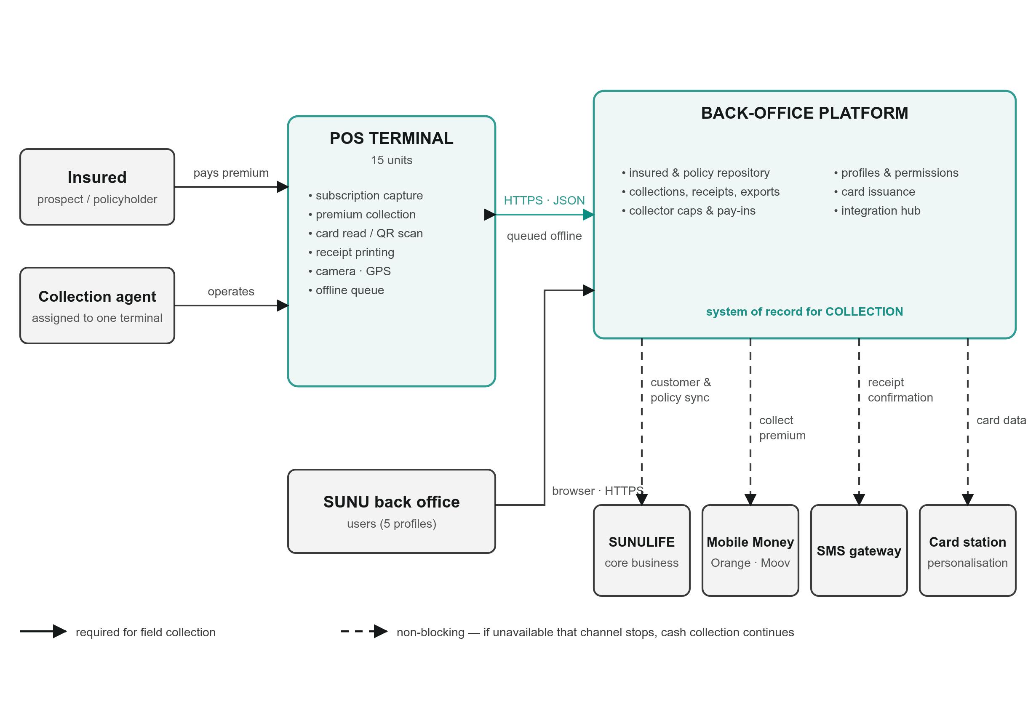
Figure 1 — System context. Solid lines are needed for field collection. Dashed lines are optional channels: if one is down, only that channel stops and cash collection carries on.
There are two parts to the system, the terminals and the back office, and everything else connects to the back office.
The insured deals only with the agent. They sign the proposal, pay, and present their card.
The collection agent is assigned to one terminal. The terminal knows who is using it, so every subscription and payment carries the agent's name, the terminal and the time.
The POS terminal is where the work happens. It captures subscriptions, collects premiums, reads cards, prints receipts and takes photos. When the network drops, the agent can keep an operation on the terminal and send it later.
The back-office platform is the reference for everything collected: customers, policies, payments, receipts, agent caps and pay-ins. SUNU staff use it from a web browser, with access set by profile.
External systems sit behind the back office, never behind the terminal. SUNULIFE stays the reference for the insurance contract; the back office is the reference for collection. Mobile Money, the SMS gateway and the card personalisation station are each connected separately, so a problem with one of them does not stop an agent from collecting cash.

3. Component Architecture (Level 2)
The tables below list the building blocks and whether each one is already live or still planned.

3.1 POS terminal
Component | What it does | Pilot
Login and session | Agent signs in with their own account; session closes after inactivity | Live
Product list | Downloads the active products and keeps a copy for offline use | Live
Subscription | Step-by-step form: product, identity, beneficiary, then three photos and GPS | Live
Photo capture | Proposal form, CNIB front, CNIB back; each photo compressed on the terminal | Live
Premium collection | Policy cost, first premium or recurring premium, each with a unique reference | Live
Card reading | Reads the NFC card and asks the back office for the customer's active policies | Live
Receipt printing | Prints a receipt on the built-in thermal printer for every payment | Live
Collector cap | Shows the agent's uncollected amount and blocks collection at the limit | Live
Pay-in | Agent declares a bank deposit or cash office payment | Live
Offline save | Keeps an operation on the terminal when it cannot be sent | Live
QR virtual card | Scans and checks a customer's QR card | Planned
Mobile Money | Starts a payment on the customer's phone and waits for confirmation | Planned

3.2 Back office
Component | What it does | Pilot
Users, profiles, permissions | Web login; five back-office profiles (back-office agent, supervisor, card officer, administrator, IT) plus the field agent profile | Live
Agents and terminals | Agent register, terminal register, which agent uses which terminal | Live
Product catalogue | SUNU products with DGTCP visa, category, guarantees and default premiums; products are switched off, never deleted | Live
Proposals | List of subscriptions sent from the field with their photos and GPS; review and acceptance | Live
Policies | Policies created from accepted proposals or imported from SUNULIFE | Live
Premium collections | Every payment with agent, terminal, reference and receipt; CSV export for SUNULIFE | Live
Caps and pay-ins | Cap per agent, running uncollected amount, pay-in confirmation or rejection | Live
Customer import | Loads existing customers and policies from a CSV file (Document 5) | Live
Cards | Card register and status (active, blocked, replaced…), link between a card and several policies | Live
Audit trail | Records who changed users, agents, terminals, customers and cards, and when | Live
SUNULIFE connector | Automatic exchange of customers, policies and collections with SUNULIFE | Planned, waiting for SUNULIFE API access
Mobile Money connector | Orange Money and Moov Money, directly or through an aggregator | Planned
QR card issuing | Signed QR credential for a customer | Planned

4. Technology Stack
Layer | Technology
Terminal hardware | Telpo F20 Android POS: touch screen, NFC reader, thermal printer, camera, GPS, 4G
Terminal application | Android, written in Java; minimum Android API level 21
Terminal local storage | SQLite
Back-office application | PHP 8 with the Laravel 9 framework; server-rendered web pages
Database | MySQL
Web server | Apache HTTP Server in the pilot; Nginx with PHP-FPM planned for production
File storage | Server file system for proposal and CNIB photos
API | REST with JSON; photos sent as multipart/form-data
Exports and imports | CSV, UTF-8
Languages | French and English in both the terminal and the back office
Hosting | Linux virtual server

5. POS Application
The terminal application is the agent's whole working tool. After login the home screen offers four things: subscribe a customer, collect a premium, declare a pay-in, and view the day's activity.
Subscribing a customer. The agent chooses a product from the list downloaded at login. The form then walks through the customer's identity, other details and beneficiary. Next come three photos, taken with the terminal's camera: the signed proposal, and the front and back of the CNIB. Each photo is reduced to 900 KB or less before sending, which keeps uploads short on a weak mobile connection. The terminal adds its GPS position and sends everything in a single request. If the back office refuses the request, the agent sees the reason field by field. If there is no network, the agent can save the subscription and send it later.
Collecting a premium. The agent reads the customer's card. The terminal asks the back office for the policies linked to that card and shows them. The agent picks the policy, confirms the amount, and the terminal sends the payment with a reference it generated itself. If the same payment is sent twice, for example after a timeout, the back office recognises the reference and does not record it again. A receipt is printed for each payment.
Staying within the cap. Every collection is added to the agent's uncollected amount. The terminal shows how close the agent is to the limit. Once it is reached, the back office refuses further collections until the agent declares a pay-in and a supervisor confirms it.
Device identity. Each terminal is registered in the back office under its Android device identifier. The terminal sends this identifier with every request, and the back office uses it to find the agent. A terminal that is not registered is refused.
Installation. The application is about 15 MB and is installed directly on the terminal. The current pilot version is 1.1.2.

6. Back-Office Application
The back office is a web application used by SUNU staff and the DBS support team. It also serves the API used by the terminals, so both share one database and one set of rules.
Main screens. Under the Premium collection menu: Proposals, Policies, Premium collections, Pay-ins, Products and Customer import. Around these are the standard administration screens for users, profiles, agents, terminals and cards.
From proposal to policy. A subscription sent from a terminal arrives as a proposal with its three photos and GPS position. A back-office user checks the photos against the data and accepts it. Acceptance creates the policy, numbered POL- followed by the proposal number.
Payments. Every payment is stored once, with its amount, type (policy cost, first premium, recurring premium), payment method, agent, terminal, reference, receipt number and time. The collections screen can export them as a CSV file for recording in SUNULIFE until the direct connection is in place.
Caps and pay-ins. Each agent has a cap and a running balance of cash not yet paid in. A pay-in declared on the terminal appears in the back office, where a supervisor confirms the amount received or rejects it. Confirmation reduces the balance and unblocks the terminal.
Existing customers. SUNU's current customers and policies are loaded from a CSV extract of SUNULIFE. Document 5 describes the file.
Main data.
business unit (SUNU Vie Burkina Faso)
├── users ── profiles ── permissions
├── agents ── terminals
│ └── cap and uncollected balance ── pay-ins
├── products
├── customers
│ ├── proposals (with photos and GPS)
│ ├── policies
│ └── cards ── card-to-policy links
├── premium collections ── financial transactions
└── audit trail
Traceability. Changes to users, profiles, agents, terminals, customers and cards are written to an audit trail with the user, the time and the values before and after. Proposals, policies and payments carry their own agent, terminal and timestamps.

7. API
The terminals talk to the back office through a REST API. Requests and responses are JSON in UTF-8. Subscriptions with photos are sent as multipart/form-data.

7.1 Endpoints
Method | Path | Used for
POST | /api/v1/agent/login | Agent login
GET | /api/v1/sunu/products | Active products
POST | /api/v1/sunu/proposals | New subscription with photos
GET | /api/v1/sunu/proposals/{id} | One proposal
POST | /api/v1/sunu/premiums | Record a premium payment
GET | /api/v1/sunu/policies/by-card/{uid} | Active policies for a card
GET | /api/v1/sunu/collector/status | Agent's cap and uncollected amount
POST | /api/v1/sunu/pay-ins | Declare a pay-in

Every call includes business_unit_id. Calls made on behalf of an agent also include device_serial, the terminal's identifier.

7.2 New subscription
POST /api/v1/sunu/proposals
Field | Required | Notes
business_unit_id | Yes | SUNU's business unit
device_serial | Yes | Terminal identifier (agent_id is accepted instead)
insurance_product_id | Yes | From the product list
last_name, first_names | Yes | Customer name
phone | No
proposal_number | No | Number printed on the paper form; generated if missing
latitude, longitude | No | Decimal degrees
client_reference | No | Unique ID set by the terminal; a resend with the same value returns the first result
form_data | No | Remaining form answers as JSON
proposal_image | No | Photo of the signed proposal; JPEG, PNG or WebP
id_document_front, id_document_back | No | CNIB photos; JPEG, PNG or WebP

A successful call returns HTTP 201 and the new proposal.

7.3 Premium payment
POST /api/v1/sunu/premiums
Field | Required | Notes
business_unit_id | Yes
device_serial | Yes
policy_id or proposal_id | One of them | Proposal for a first premium, policy otherwise
amount | Yes | XOF
collection_kind | Yes | policy_cost, first_premium or recurring_premium
reference | Recommended | Unique ID set by the terminal; stops double recording
payment_instrument | No | cash, momo or bank; cash in the pilot
reference_period, payment_frequency | No | For example 2026-09, monthly
receipt_number, latitude, longitude | No

The response contains the payment and the agent's updated cap status, so the terminal can warn the agent straight away.
Example response to GET /api/v1/sunu/collector/status (figures are illustrative):
{
"success": true,
"data": {
"agent_id": 12,
"cap_amount": 500000,
"warning_threshold_pct": 80,
"currency": "XOF",
"uncollected_amount": 415000,
"utilisation_pct": 83,
"is_blocked": false,
"blocked_at": null,
"last_pay_in_at": "2026-09-15T16:40:12+00:00"
}
}

7.4 Errors
HTTP code | Meaning
201 | Created
404 | Business unit, proposal or card not found
422 | Invalid data. The body has a message and an errors object listing each field and the problem with it; also returned for an unregistered terminal
423 | Agent blocked: a pay-in is needed before collecting again
500 | Server error; the operation was not recorded and can be sent again

7.5 Conventions
Item | Format
Amounts | Number in XOF
Dates | YYYY-MM-DD; date-times in ISO 8601
GPS | Decimal degrees
Photos | JPEG, PNG or WebP; the terminal sends 900 KB or less per photo

In the pilot the terminal is identified by its registered device identifier. Encrypted transport (HTTPS) and a per-terminal access token will be in place before production; Document 2 covers this.

End of Document 1.

