ReactJs

Date:30/07/24

Project-1

npm create-react-app react1-app

create-react1-app

npm start

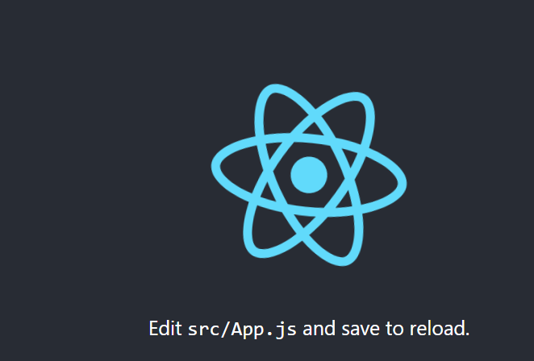

Server stop…(ctrl+c)

Project-2

npm create-react-app react2-app

create-react1-app

npm start

we add one line in app.js ..i.e is welcome to reactjs:sandy

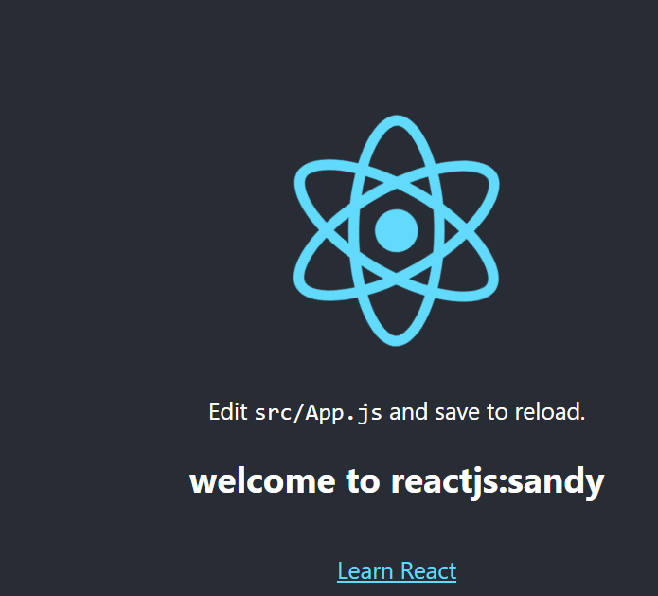

then server stop… (ctrl+c)

project-3

project-4

project-5

npm create-react-app react5-personalinfo

create-react5-app

npm start

