Scientia et Lux

B.P. 155

Ruhengeri

Rwanda

**T**

: +250

788 90

30 30

: +250

32

30

788 90

**E**

:

inesruhengeri@yahoo.fr

**W**

[:](http://www.ines.rw/)

[www.ines.ac.r](http://www.ines.rw/)

[w](http://www.ines.rw/)



**INSTITUT D’ENSEIGNEMENT SUPÉRIEUR DE RUHENGERI**

**Accredited by Ministerial Order N° 005/2010/Mineduc of 16 June 2010**

**FACULTY OF APPLIED**

**FUNDAMENTAL**

**SCIENCES**

**DEPARTMENT OF COMPUTER SCIENCE**

**OPTION OF**

**SOFTWARE ENGINEERING**

A

d

issertation presented in partial fulfillment of requirements for

the award of a Bachelor’s Degree of Science in Computer Science,

Option of Software

Engineering.

**By:**

**Happy Norbert**

**HORA NDIHANO**

**Reg. N**

**o**

**2**

**:**

**0**

**/**

**14551**

**Supervisor:**

**Eraste RUKUNDO**

**Musanze**

**,**

**October**

**2021**



**FREELANCE ATTORNEY GROUP**

**SYSTEM**

**CASE STUDY: RBA (Rwanda Bar Association**

**)**

# DECLARATION

I do hereby declare that the work presented in this dissertation is my contribution to the best of my knowledge. The same work has never been submitted to any other University or institution. I, therefore, declare that this work is my own for the partial fulfillment of the award of a

Bachelor’s degree of Science in Computer Science, with honors in Software Engineering at INES-Ruhengeri.

The candidate’s name: Happy Norbert HORA NDIHANO

Signature of the candidate: .........................................

Date of submission: ....................................................

# APPROVAL

This is to certify that this dissertation work entitled **“FREELANCE LAWYER GROUP SYSTEM”** is an original study conducted by Happy Norbert HORA NDIHANO under supervision and guidance.

The supervisor’s name: Eraste RUKUNDO

Signature of the supervisor: ..........................................

Date of submission: .....................................................

# DEDICATION

This is dedicated to:

The Almighty God,

My Parents and my Family,

My Brothers and Sisters,

My Supervisor, My Colleagues,

My fellow Students.

# ACKNOWLEDGMENTS

This work is conducted through the contribution and effort of several people who have spent their precious time helping me to carry out this study.

For that, I give all the praise and glory to the Almighty heavenly father for he has provided me the strength, courage, and health to accomplish my studies at INES-RUHENGERI.

I would like to acknowledge my supervisor Mr Eraste RUKUNDO for his enormous help, advice, and contributions of his supervision and contribution, also acknowledge my classmate for their support.

Special thanks to my parents, and family who do not hesitate to help me with all they have to pursue my career without complications in my education to carry out this work.

# ABSTRACT

Legal Group is a world wide network of experienced freelance/contract lawyers, who are all examined and carefully selected with checking their educational and personal information documents out of thousands of applicants by admin.  
This project helps to registered user to find out the appropriate lawyer for their case and send their request to that lawyer for solution. Approved Lawyers also able to see the various cases available and can show their interest for fighting case by sending request to that User. Registered user can add different cases with details. Lawyer can able to see the case details of user once user accepted the lawyer request. Admin manages both lawyer details as well as user details. Online payment option available to user once the case is finaliased.

This system developed an interactive and user-friendly system that is accessible to all clients and attorney (lawyer) and after a long and productive study of all the approval levels that the clients makes more process for finding the lawyer, Cases usually pass through from the clients to the lawyer based on the old system taking long distance and much time to find them, the wired system is built according to that approval level as the previous system. the advantage of the wired system it is easy to use, fast finding the lawyer and sent your case. The system is accessible on web and mobile platforms, the web platform is built using HTML, CSS, and JavaScript for the frontend while PHP and MYSQL for the backend and the mobile platform the front-end are built using react-native which is a JavaScript framework while PHP APIs and MYSQL were used for the backend.

Table of Contents

DECLARATION 2

APPROVAL 3

DEDICATION 4

ACKNOWLEDGMENTS 5

ABSTRACT 6

CHAPTER 1: GENERAL INTRODUCTION 11

1.1 Background of the study 11

1.2 Problem statement 12

1.3 Research objectives 12

1.3.1 General objective 12

1.3.2 Specific objectives 12

1.4 Research questions 13

1.5 Research hypotheses 13

1.6 Choice of the study 13

1.7 Significance of the study 14

1.7.1 Personal interests: 14

1.7.2. INES RUHENGERI interests: 14

1.7.3 REB interests: 14

1.8 Delimitation of the study 14

1.9 Research methodology/Materials and Methods 15

1.9.1. Data collection techniques 15

1.9.1.1. Sampling 15

1.9.1.2. Observation 15

1.9.1.3. Documentation 15

1.9.2. Software Methodology 15

1.10 Organization of the study 15

CHAPTER 2: LITERATURE REVIEW 17

2.1 GENERAL I INTRODUCTION 17

2.2 DEFINITION OF KEY TERMS 17

2.2.1 Web Application 17

2.2.2 Native Application 17

2.2.3 Database 18

2.2.4 Bootstrap 18

2.2.5 Data 18

2.2.6 CSS 18

2.2.7 JavaScript 18

2.2.8 React Native 19

2.2.9 Front End 19

2.2.10 Back End 19

2.2.11 XAMPP 19

2.2.12 JSON (JavaScript Object Notation) 19

2.2.13 MYSQL DATABASE 20

2.2.14 Normalization 20

2.2.14.1 1NF (First Normal Form) 20

2.2.14.2 2NF (Second Normal form) Rules Rule 20

2.2.14.3 3NF (Third Normal Form) 20

2.2.14.4 BCNF (Boyce-Codd Normal Form) 20

2.2.14.5 4NF (Fourth Normal Form) 20

2.2.14.6 5NF (Fifth Normal Form) 20

2.2.14.7 6NF (Sixth Normal Form) 20

2.2.15 API 21

2.2.16. Webserver 21

2.2.17 Web browser 21

2.2.18 server 21

2.2.19 DOM (Document Object Model) 21

2.2.20 VIRTUAL DOM 21

2.2.21 HTML 22

2.2.22 CODE EDITOR 22

2.3 Other Research Related To File and stock management system 22

2.3.1 IREMBO 22

2.3.2 E-Mboni 22

CHAPTER 3: RESEARCH METHODOLOGY 23

3.1General Introduction 23

3.2Data collection Methods 23

3.2.2 Interview 23

3.2.3 Observation 23

3.2.4 Documentation 23

3.3 Data processing and Analysis 23

3.4 System development methodology 24

3.4.1 Introduction 25

3.4.2 Risk Handling in Spiral Model 27

3.4.3 Languages and Technology 27

CHAPTER FOUR: SYSTEM ANALYSIS, DESIGN, AND IMPLEMENTATION 28

4.1 Introduction 28

4.2 Analysis of the current system 28

4.3 Solution of the Proposed system 28

4.4 Advantage of the Proposed solution 28

4.5 Use Case Diagram 29

4.5.1 Importance of use case Diagram 29

4.6 Flow Chart Diagram 30

4.7 Data Flow Diagram 32

4.7 Entity-Relationship (ER) Diagram 33

4.8 Web Interface 34

4.8.1 Welcome Page 35

4.8.2Login Page 35

4.9 Dashboard 36

4.9.1 Mission Order File Template 36

4.9.2 Report File Template 37

4.9.3 Stock Requisition File template 38

4.9.4 Incoming File Template 40

4.9.5 Adding New Item page 40

4.9.6 Stock Status page 41

4.9.7 Received Requests Page 42

4.9.8 User Registration page 43

CHAPTER FIVE: CONCLUSION AND RECOMMENDATION 44

5.1Conclusion 44

5.2 Recommendations 44

5.2.1To REB 44

5.2.3To REB workers 44

5.2.4To Ines 44

5.2.5 To next researchers 44

References 44

**LIST OF ABBREVIARIONS**

INES: Institut d’Enseignement Supérieur de Ruhengeri.

RBA: Rwanda Bar Association

RISA: Rwanda Information Society Authority

PHP: Hypertext Preprocessor

API: Application Programming Interface

HTML: HyperText Mark-up Language

CSS: Cascading Style Sheet

DFD: Data Flow Diagram

ERD: Entity Relationship Diagram

JS: JavaScript

SQL: Structured Query Language

# CHAPTER 1: GENERAL INTRODUCTION

## Background of the study

The system I made is definitely something unique. Because you can consider this an open platform for all the lawyers. Different lawyers from different locations will be able to join this system by providing some information. This system can also be known as a freelancing platform for the lawyers. Users will be able to search their suitable lawyers & hire them for an individual case. The primary goal of this system is to help finding suitable lawyers. So here a question can arise how we can ensure that the lawyer will suitable? In answer to that I can say, in this system I am using filtering option to find lawyer. This lawyer finding system won’t be a typical one. The system will give the user an option to filter their finding. Initially I am using three different filtering option in my system. Those are, 1. Seniority / Experience 2. Expertise 3. Location. By using these three options filtering I can assume that the user will definitely able to find the suitable lawyer for them. Moreover, he can also visit the lawyer’s profile to know about the lawyer in details. The user will be also able to send the lawyers a booking request for appointment by selecting date. If the lawyer accepts his request the user will be notified. In other hand, the lawyer will also be able to see the user’s details. When they get any booking request. Because only the registered users will be able send booking request. So basically, three user panel in my system. Those are 1. Admin 2. Lawyer 3.

Rwanda Basic Education Board (REB) is a Government institution established in 2020 by the presidential order No: 122/01 of 15/10/2020 published in Official Gazette No 32 bis of 19/10/2020. It was established under the Ministry of Education to promote the quality of education in basic, specialized, and adult schools.

In REB the file and stock management system is built according to the level of authority and the stages of approval rely on those different levels where the file comes from a technician and goes directly to the unit director when approved the file goes to the head of the department in which the technician is in when approved the file goes to the general director and when approved all the stages below can see that the file has been approved and in case of being rejected the authority which rejects the letter provides feedback on what’s wrong with the file and the file comes back to the sender and the same goes with stock. This system follows all the stages as well as those in the current system

## 1.2 Problem statement

Before starting develop this project, I have tried to find some similar system. But I was not satisfied with any of them. Because those were not exactly what I was looking for. I found many informative sites where people are able to see some lawyer’s details. I also found some websites which are dedicated to one lawyers’ firm or association. But I wanted to build an open platform for lawyers. Where any lawyer from any location with any specialty will be able to register themselves. In other hand, public will be able to find their lawyers by filtering them in just few clicks on computer screen. So, here through my system both side problem will be solved. In this documentation I have discussed many aspects in details below. I have added some diagrams to justify my system & some test cases to show the ability of my system..

The manual file and stock management system could increase the spreading of the coronavirus pandemic due to paper file movement from one person to another therefore the automated file and stock management system could act as a preventive measure against the spreading of the coronavirus pandemic that the world is facing nowadays.

Many organizations need file and stock management systems to be well built and done electronically as a way of making the work easier for their workers, keeping track of all the transactions that took place in the organization during a certain period, and helping their workers to not spend much time waiting for the feedback and this file and stock management system provides a solution to all those problems.

## 1.3 Research objectives

##### 1.3.1 General objective

##### 

##### I have built a web-based online lawyer group system where lawyers can be registered and found easily with filtering option.

##### 1.3.2 Specific objectives

1. To build a system allowing users to access file templates
2. To build a system allowing the user to view, download, approve, reject and send files according to the user permission levels
3. Building a system facilitating the controlling of stock items
4. A system facilitating the tracking of files
5. A system that is compatible and accessible by web and mobile devices
6. A system that fastens the request and approval of files
7. A system notifying the user of the status of the file through pop up and SMS
8. A system that facilitates reporting and reports printing in a given period

## 1.4 Research questions

1. What are the different types of cases
2. How will workers be able to have access to those different files according to their functions in REB (Rwanda Basic Education Board)
3. What path will the files be following to reach the final approval level

## 1.5 Research hypotheses

1. There are different types of files used in REB (Rwanda Basic Education Board) they are categorized into two types internal and external files
2. The workers will have a user-friendly platform that will be helping them to interact with different types of files based on their functionality
3. The file and stock management system is built according to the usual administrative architecture of REB (Rwanda Basic Education Board) making the path of files similar to the ones that the current system used

## 1.6 Choice of the study

After a long observation during my internship of how the current system of managing files and stock and made they came a though of a system of file and stock management but in a computerized way, then there was proposed the idea after some presentations the idea was accepted and the staff in charge provided all the detailed information needed about the working of the current system.

The current system had many challenges associated with its operation status some of those challenges are time-consuming for both workers and higher individuals to receive files, file tracking was difficult since it required the sender to move from office to office trying to know the status of the file, some files were lost during the process, keeping records in case of stock was difficult and the way of storing was not dependable

The solution to all those problems is no other than using a computerized file and stock management system to correct all those issues that are detected from the current system.

## 1.7 Significance of the study

##### 1.7.1 Personal interests:

1. This study will help me implement my knowledge acquired for the past three years into the application.
2. This study will help me with gaining experience in solving some of the problems that society is facing.

##### 1.7.2. INES RUHENGERI interests:

I. This study will help my fellow students who are concerned with computerized file and stock management system

##### 1.7.3 REB interests:

1. The system will benefit REB workers in saving time, keeping track of their files easily, and being able to make reports of all the transactions that took place in a certain period
2. The system will help REB in general to keep all the records of the transactions that take place inside the institution and might be useful for future use.

## 1.8 Delimitation of the study

This study is bordered to the observation of how the current system was being performed, collection of secondary data related to the current system and the administrative structure of REB (Rwanda Basic Education Board), and interviewing all the workers and different administrative levels of approvals in REB. This study covered two months until its completion time.

The study was limited to time and resources, the system is built using PHP programming language due to the presence of PHP servers used while hosting other systems in REB on the part of web application and React Native for mobile application since it is a cross-platform for building mobile apps that run on both android and IOS devices.

## 1.9 Research methodology/Materials and Methods

### 1.9.1. Data collection techniques

###### 1.9.1.1. Sampling

The research methodology that was used is random sampling. clients working under a certain unity in a department and some of the approving authorities were chosen without putting in place any consideration and were asked about the current system and explained about the system to be introduced.

###### 1.9.1.2. Observation

Some data were collected through the process of visiting some attorney in their cabinets and taking notes of how the current system was being performed and how the file passes through all the approval levels and where all approved files are stored

###### 1.9.1.3. Documentation

Other data were be collected by referring to a secondary source of information through the information that was given by REB.

### 1.9.2. Software Methodology

The software methodology used in this study is Spiral Software Methodology. The spiral model is one of the most important Software Development Life Cycle models, which provides support for Risk Handling (Alshamrani & Bahattab, 2015). In its diagrammatic representation, it looks like a spiral with many loops. The exact number of loops of the spiral is unknown and can vary from project to project. Each loop of the spiral is called a Phase of the software development process. The exact number of phases needed to develop the product can be varied by the project manager depending upon the project risks. As the project manager dynamically determines the number of phases, so the project manager has an important role to develop a product using the spiral model.

The Radius of the spiral at any point represents the expenses(cost) of the project so far, and the angular dimension represents the progress made so far in the current phase.

There will be the use of other software programs such as google chrome, visual studio code,

Microsoft word, and so on…

## 1.10 Organization of the study

The project will be organized into five chapters

1. Chapter I. General Introduction will be focused on the Objectives of the project, Problem statement, and Interest of the project, Hypothesis, and Methodology of the project.
2. Chapter II. The literature review will offer theoretical concepts, fundamental tools, and languages that support the project and will be used during the development of the Project.
3. Chapter III. Research Methodology will focus on the software development methodology that will be used on the project and the data gathering techniques that will be made.
4. Chapter IV. Results and Discussions will be formed by analysis and the development of the project.
5. Chapter V. Conclusion and Recommendations will be made up of the conclusion and recommendation for further improvements of the design software.

# CHAPTER 2: LITERATURE REVIEW

## 2.1 GENERAL I INTRODUCTION

File and stock management is one of the key assets resulting in the knowledge of what are the daily operational activities performed by businesses, companies, and different organizations. So, the greater the operating period and services inside the organizations the greater the number of files and records will be available, and the bigger the number of files present the harder it gets to keep track of them while using a manual system of managing files and stock.

In Rwanda Basic Education Board (REB) the manual system of managing files and stock is done by the use of paper application where a worker writes down a paper file with his bare hands and the file is sent to his/her unit director where it is reviewed for mistakes and inconveniences when they are found the file is returned to the sender and when there are none the files pass to the head of the department of the sender and then directly to the General director.

The files pass through approval levels following the mechanism of the administrative organization of the institution shown below

The file and stock management system developed also follows all these levels of approvals as shown in the diagram above and the system also is computerized making it a lot easier for all workers in Rwanda Basic Education Board (REB).

## 2.2 DEFINITION OF KEY TERMS

##### 2.2.1 Web Application

A web application is application software that runs on a web server, unlike computer-based software programs that are run locally on the operating system of the device. (Chen *et al*, 2016) Web applications are accessed by the user through a web browser with an active internet

##### 2.2.2 Database

A Database is an organized, structured set of data stored in a computer, especially accessible in various ways.

##### 2.2.3 Bootstrap

Bootstrap is a free and open-source CSS framework directed at responsive, mobile-first front-end web development. It contains CSS- and JavaScript-based design templates for typography, forms, buttons, navigation, and other interface components.

##### 2.2.4 Data

Data are units of information, often numeric, that are collected through observation. In a more technical sense, data are a set of values of qualitative or quantitative variables about one or more persons or objects, while a datum is a single value of a single variable.

##### 2.2.5 CSS

Cascading Style Sheets is a style sheet language used for describing the presentation of a document written in a markup language such as HTML. CSS is a cornerstone technology of the World Wide Web, alongside HTML and JavaScript.

##### 2.2.6 JavaScript

JavaScript is a scripting or programming language that allows you to implement complex features on web pages, every time a web page does more than just sit there and display static information for you to look at, displaying timely content updates, interactive maps, animated 2D/3D graphics, scrolling video jukeboxes, etc.

New and Faster JavaScript VMs and platforms built upon them (notably Node.Js, Vuejs, etc...) have also increased the popularity of JavaScript for server-side web applications and also is used for game development and the creation of desktop and mobile applications. JavaScript is a prototype-based scripting language with dynamic typing and has first-class functions. Its syntax was influenced by C.

JavaScript copies many names and naming conventions from Java, but the two languages are otherwise unrelated and have very different semantics. The key design principles with JavaScript are taken from the self and schema programming languages.

##### 2.2.7 Front End

The front-end is the interface of a system. Front-end web development, also known as client-side development is the practice of producing HTML and CSS, and JavaScript for a website or web application so that a user can see and interact with them directly. The challenge associated with front-end development is the tools and techniques used to create the front-end of a website change constantly. They are two categories of font-end design: Graphical design tools

##### 2.2.8 Back End

In the computer world, the “back-end” refers to parts of a computer application or a program’s code that allow it to operate and that can not be accessed by a user. Most data and operating syntax are stored and accessed in the back-end of a computer system. Typically the code is comprised of one or more programming languages. The back-end usually consists of three parts: Server, Application, and Database. Back-end developers will write code that makes it all work.

##### 2.2.9 XAMPP

XAMPP is a free and open-source cross-platform web server solution stack package developed by Apache Friends, consisting mainly of the Apache HTTP Server, MariaDB database, and interpreters for scripts written in the PHP and Perl programming languages.

##### 2.2.10 JSON (JavaScript Object Notation)

JSON is a lightweight data-interchange format. It is easy for humans to read and write. It is easy for machines to parse and generate. It is based on a subset of the JavaScript Programming Language Standard ECMA-262 3rd Edition - December 1999. JSON is a text format that is completely language-independent but uses conventions that are familiar to programmers of the C-family of languages, including C, C++, C#, Java, JavaScript, Perl, Python, and many others. These properties make JSON an ideal data-interchange language.

##### 2.2.11 MYSQL DATABASE

MySQL is an open-source relational database management system. Its name is a combination of "My", the name of co-founder Michael Widenius's daughter, and "SQL", the abbreviation for Structured Query Language

##### 2.2.12 Normalization

Database normalization is the process of restructuring a relational database by a series of so-called normal forms to reduce data redundancy and improve data integrity, Normalization is a database design technique that organizes tables in a manner that reduces redundancy and dependency of data (Nayembil, 2021).

Steps of normalization



###### 2.2.12.1 1NF (First Normal Form)

Rules Each table cell should contain a single value. Each record needs to be unique.

###### 2.2.12.2 2NF (Second Normal form) Rules Rule

1- Be in 1NF Rule 2- Single Column Primary Key

###### 2.2.12.3 3NF (Third Normal Form)

Rules Rule 1- Be in 2NF Rule 2- Has no transitive functional dependencies 16

###### 2.2.12.4 BCNF (Boyce-Codd Normal Form)

Even when a database is in 3rd Normal Form, still there would be anomalies resulting if it has more than one Candidate Key. Sometimes BCNF is also referred to as the 3.5 Normal Form.

###### 2.2.12.5 4NF (Fourth Normal Form)

Rules If no database table instance contains two or more, independent and multivalued data describing the relevant entity, then it is in the 4th Normal Form.

###### 2.2.12.6 5NF (Fifth Normal Form)

Rules A table is in the 5th Normal Form only if it is in 4NF and cannot be decomposed into any number of smaller tables without loss of data.

###### 2.2.12.7 6NF (Sixth Normal Form)

Proposed 6th Normal Form is not standardized, yet however, it is being discussed by database experts for some time

##### 2.2.13 API

An application programming interface is a connection between computers or between computer programs. It is a type of software interface, offering a service to other pieces of software. A document or standard that describes how to build or use such a connection or interface is called an API specification

##### 2.2.14 Webserver

A web server is software and hardware that uses HTTP “Hypertext Transfer Protocol” and other protocols to respond to client requests made over the WWW “World Wide Web”, The main job of a web server is to display website content through storing, processing, and delivering web-pages to users

##### 2.2.15 Web browser

A web browser is a software application for accessing the information on the World Wide Web. When a user requests a web page from a particular website, the web browser retrieves the necessary content from a web server and then displays the page on the user’s device

##### 2.2.16 server

In computing, a server is a piece of computer hardware or software (computer program) that provides functionality for other programs or devices, called clients. This architecture is called the client-server model. Servers can provide various functionalities, often called services, such as sharing data or resources among multiple clients or performing computation for a client

##### 2.2.17 DOM (Document Object Model)

The Document Object Model (DOM) is a programming interface for HTML and XML documents. It represents the page so that programs can change the document structure, style, and content. The DOM represents the document as nodes and objects. That way, programming languages can connect to the page.

##### 2.2.18 VIRTUAL DOM

A virtual DOM is a lightweight JavaScript representation of the DOM used in declarative web frameworks such as React, Vue.js, and Elm. Updating the virtual DOM is comparatively faster than updating the actual DOM. Thus, the framework is free to make unnecessary changes to the virtual DOM relatively cheaply

##### 2.2.19 HTML

The HyperText Markup Language or HTML is the standard markup language for documents designed to be displayed in a web browser. It can be assisted by technologies such as Cascading Style Sheets and scripting languages such as JavaScript. (Khare & Rifkin, 1997)

##### 2.2.22 CODE EDITOR

A source code editor is a text editor program designed specifically for editing the source code of computer programs. It may be a standalone application or it may be built into an integrated development environment or web browser.

## 2.3 Other Research Related To freelance lawyer system

##### 2.3.1 IREMBO

Irembo is a system developed for facilitating Rwandan citizens in their application of various documents and assisting with payment where necessary.

Irembo deals with government-related documents whereas my system which is a file and stock management system will help REB workers to ease their document composing and tracking way and also help in stock management of the institution.

##### 2.3.2 E-Mboni

Document Tracking Management System enables users to send and work on documents by eliminating the paper-based approach in institutions.

Rwanda has launched a document tracking system aimed at improving overall efficiency, accountability, and transparency in government through the use of electronic documents and records lifecycle management.

The Document Tracking and Workflow Management System (DTWMS) named E-Mboni, will promote government organizational efficiency.

The Minister of Youth and ICT Jean Philbert Nsengimana said; “The system will improve inter and intragovernmental efficiencies ultimately geared to serving (...) (Bakunzibake, Klein, & Islam, 2019)

# CHAPTER 3: RESEARCH METHODOLOGY

## 3.1General Introduction

Research methodology simply refers to the practical “how” of any given piece of research. More specifically, it’s about how a researcher systematically designs a study to ensure valid and reliable results that address the research aims and objectives.

## 3.2Data collection Methods

##### 3.2.2 Interview

An interview is essentially a structured conversation where one participant asks questions, and the other provides answers. For a better understanding, an interview was conducted among REB workers according to their functionality in the institution.

##### 3.2.3 Observation

an act or instance of regarding attentively or watching something or someone. By conducting this research observation method was used. The purpose of using this research method is together more reliable insights. In other words, observation was implemented by going into the office of workers of REB according to their functionality and taking notes on how they deal with the current system.

##### 3.2.4 Documentation

This technique of collecting data had permit the researchers to consult scientific books, newspapers, memoirs, class notes, web pages, and papers related to the subject of the project. I gathered all the information related to the current system and how it operated to build a new system but with the same architecture as the old system.

## 3.3 Data processing and Analysis

Data Analysis involves actions and methods performed on data that help describe facts, detect patterns, develop explanations, and test hypotheses (Abowitz & Toole, 2010). This includes data quality assurance, statistical data analysis, modeling, and interpretation of results.

While, Data processing is a series of actions or steps performed on data to verify, organize, transform, integrate, and extract data in an appropriate output form for subsequent use. Methods of processing must be rigorously documented to ensure the utility and integrity of the data.

## 3.4 System development methodology

Software development life cycle (SDLC) is a series of [phases](http://melsatar.blog/2017/06/13/what-do-you-need-to-know-about-the-eight-software-development-phases/) that provide a common understanding of the software building process. How the software will be realized and developed from the business understanding and requirements elicitation phase to convert these business ideas and requirements into functions and features until its usage and operation to achieve the business needs. A good software engineer should have enough knowledge on how to choose the SDLC model based on the project context and the business requirements.

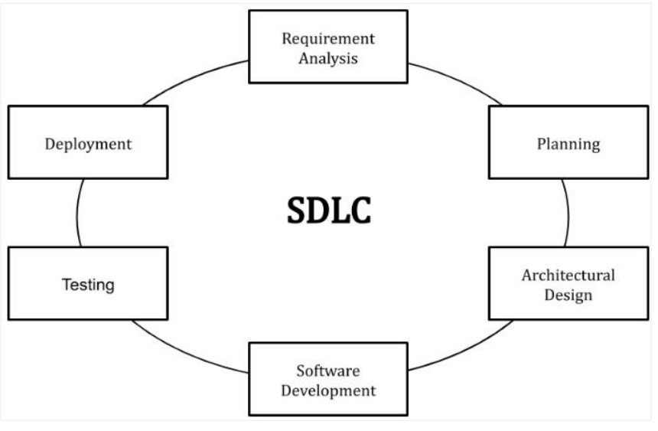

* **Requirement analysis:** This stage of the SDLC means getting input from all stakeholders, including customers, salespeople, industry experts, and programmers. Learn the strengths and weaknesses of the current system with improvement as the goal.

* **Planning**: This stage of the SDLC, it’s for determining the cost and resources required for implementing the analyzed requirements. It also details the risks involved and provides subplans for softening those risks.
* **Software design such as architectural design**: This phase of the SDLC starts by turning the software specifications into a design plan called the Design Specification.
* **Software development**: At this stage, the actual development starts. The developer must stick to the blueprint.
* **Testing Deployment**: In this stage, it is for testing defects and deficiencies. In short, is to verify if the code meets the defined requirements.
* **Software Deployment:** At this stage, the goal is to deploy the software to the production environment so users can start using the prod.

The most common SDLC are the Waterfall model, Spiral model, and Agile model. In this study I will be using the Spiral model since it is the most flexible of the SDLC models, the spiral model is similar to the iterative model in its emphasis on repetition. The spiral model goes through the planning, design, build and test phases over and over, with gradual improvements at each pass

### 3.4.1 Introduction

The spiral model is one of the most important Software Development Life Cycle models, which provides support for Risk Handling. In its diagrammatic representation, it looks like a spiral with many loops. The exact number of loops of the spiral is unknown and can vary from project to project. Each loop of the spiral is called a Phase of the software development process. The exact number of phases needed to develop the product can be varied by the project manager depending upon the project risks. As the project manager dynamically determines the number of phases, so the project manager has an important role to develop a product using the spiral model.

The Radius of the spiral at any point represents the expenses(cost) of the project so far, and the angular dimension represents the progress made so far in the current phase.

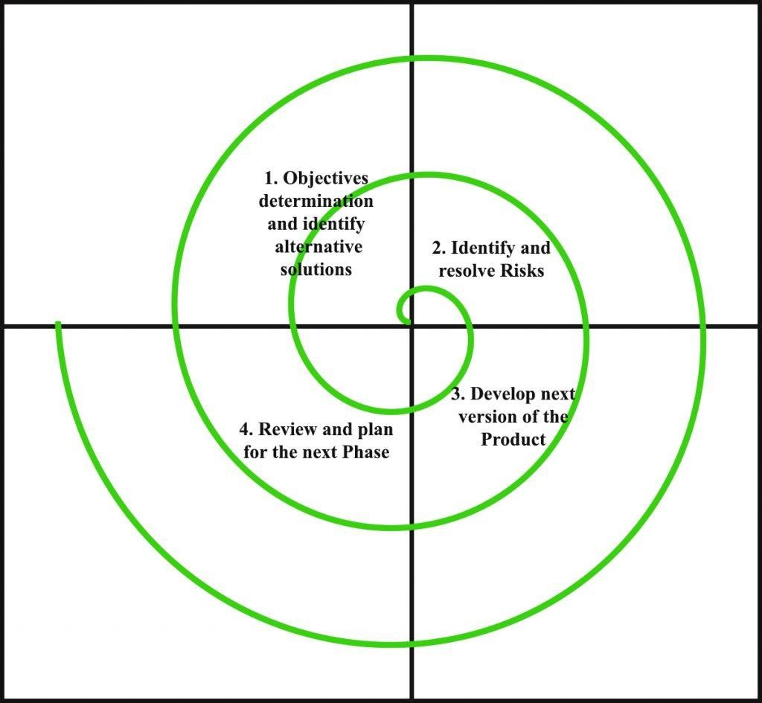

Each phase of the Spiral Model is divided into four quadrants as shown in the above figure.

The functions of these four quadrants are discussed below-

1. **Objectives determination and identify alternative solutions:** Requirements are gathered from the customers and the objectives are identified, elaborated, and analyzed at the start of every phase. Then alternative solutions possible for the phase are proposed in this quadrant.
2. **Identify and resolve Risks:** During the second quadrant, all the possible solutions are evaluated to select the best possible solution. Then the risks associated with that solution are identified and the risks are resolved using the best possible strategy. At the end of this quadrant, the Prototype is built for the best possible solution.
3. **Develop the next version of the Product:** During the third quadrant, the identified features are developed and verified through testing. At the end of the third quadrant, the next version of the software is available.
4. **Review and plan for the next Phase:** In the fourth quadrant, the Customers evaluate the so far developed version of the software. In the end, planning for the next phase is started.

##### 3.4.2 Risk Handling in Spiral Model

A risk is any adverse situation that might affect the successful completion of a software project. The most important feature of the spiral model is handling these unknown risks after the project has started. Such risk resolutions are easier done by developing a prototype. The spiral model supports copying up with risks by providing the scope to build a prototype at every phase of the software development.

##### 3.4.3 Languages and Technology

***3.4.3.1 Front end***

Front-end web development is the development of the graphical user interface of a website, through the use of HTML, CSS, and JavaScript, so that users can view and interact with that website. The client-side of the system is designed using HTML, JavaScript, and bootstrap for the web application and React Native which is a JavaScript framework for building mobile application interfaces.

***3.4.3.1 Back end***

In the computer world, the "backend" refers to any part of a website or software program that users do not see. It contrasts with the frontend, which refers to a program's or website's user interface. In programming terminology, the backend is the "data access layer,". The PHP programming language was used to connect the front end with the backend(database) of the system for web application and PHP-based API for connecting the front end of the mobile application to the same back end of the system.

***3.4.3.1 Software Used***

* Visual studio code
* Google chrome
* Microsoft word
* Terminal
* Android studio
* XAMPP
* StarUML

# CHAPTER FOUR: SYSTEM ANALYSIS, DESIGN, AND IMPLEMENTATION

## 4.1 Introduction

File and stock management system is an important feature when it comes to keeping track of the daily activities of an organization (Pentland, 1995). So as long as the organization continues to deal with its daily activities there will always be the presence of files and the interaction in the stock inside the organization, therefore files are essential for the clarification and justification of what happened in the organization for a certain period.

## 4.2 Analysis of the current system

In REB the files and stock management system is currently not using modern technology as a way of making the exchange of files within the organization easier and quicker.

The current system faces these challenges:

The lack of a suitable way of tracking a file to its final approval level The lack of favorable and dependable storage for files.

The hardship in accessing file templates

The hardship in knowing the problem that files face during passing through different approval levels

## 4.3 Solution of the Proposed system

As a way of eradicating all of these challenges faced by the old system, there has to be developed a platform combining all the workers of REB, all the files used in the organization, and each file accessed by the appropriate workers according to their functionality. That platform is both web and mobile-based applications to ease the accessibility of the system regardless of the device a worker is having

## 4.4 Advantage of the Proposed solution

The new platform of file and stock management system will be having a lot of benefits including:

1. The ease of tracking the status of the file
2. The provision of secured storage for files
3. The quick access to stock items
4. The easy and safe management of stock

## 4.5 Use Case Diagram

A use case diagram is a graphical depiction of a user's possible interactions with a system. A use case diagram shows various use cases and different types of users the system has and will often be accompanied by other types of diagrams as well. The use cases are represented by either circles or ellipses. In UML, use-case diagrams model the behavior of a system and help to capture the requirements of the system.

Use-case diagrams describe the high-level functions and scope of a system. These diagrams also identify the interactions between the system and its actors (Hause, 2004). The use cases and actors in use-case diagrams describe what the system does and how the actors use it, but not how the system operates internally.

##### 4.5.1 Importance of use case Diagram

1. Before starting a project, you can create use-case diagrams to model a business so that all participants in the project share an understanding of the workers, customers, and activities of the business.
2. While gathering requirements, you can create use-case diagrams to capture the system requirements and to present to others what the system should do. iii. During the analysis and design phases, you can use the use cases and actors from your usecase diagrams to identify the classes that the system requires. iv. During the testing phase, you can use use-case diagrams to identify tests for the system.

The following topics describe model elements in use-case diagrams:

* [**Use cases**](https://www.ibm.com/docs/en/SS8PJ7_9.6.1/com.ibm.xtools.modeler.doc/topics/cuc.html)

A use case describes a function that a system performs to achieve the user’s goal. A use case must yield an observable result that is of value to the user of the system.

* [**Actors**](https://www.ibm.com/docs/en/SS8PJ7_9.6.1/com.ibm.xtools.modeler.doc/topics/cactor.html)

An actor represents a role of a user that interacts with the system that you are modeling. The user can be a human, an organization, a machine, or another external system.

* [**Subsystems**](https://www.ibm.com/docs/en/SS8PJ7_9.6.1/com.ibm.xtools.modeler.doc/topics/csubsys.html)

In UML models, subsystems are a type of stereotyped component that represents independent, behavioral units in a system. Subsystems are used in class, component, and use-case diagrams to represent large-scale components in the system that you are modeling.

* [**Relationships in use-case diagrams**](https://www.ibm.com/docs/en/SS8PJ7_9.6.1/com.ibm.xtools.modeler.doc/topics/crelsme_ucd.html)

In UML, a relationship is a connection between model elements. A UML relationship is a type of model element that adds semantics to a model by defining the structure and behavior between the model elements.

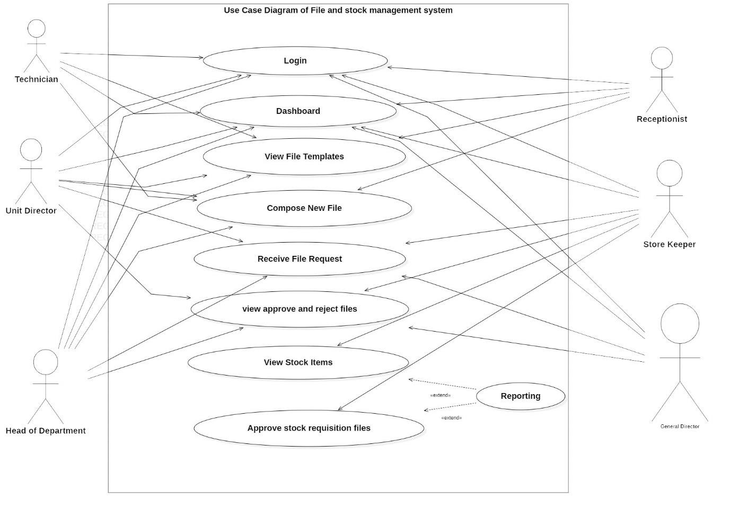

## 4.6 Flow Chart Diagram

A flowchart is a type of diagram that represents a workflow or process. A flowchart can also be defined as a diagrammatic representation of an algorithm, a step-by-step approach to solving a task. The flowchart shows the steps as boxes of various kinds, and their order by connecting the boxes with arrows.

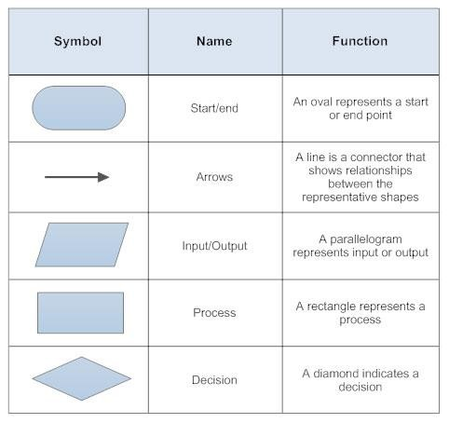

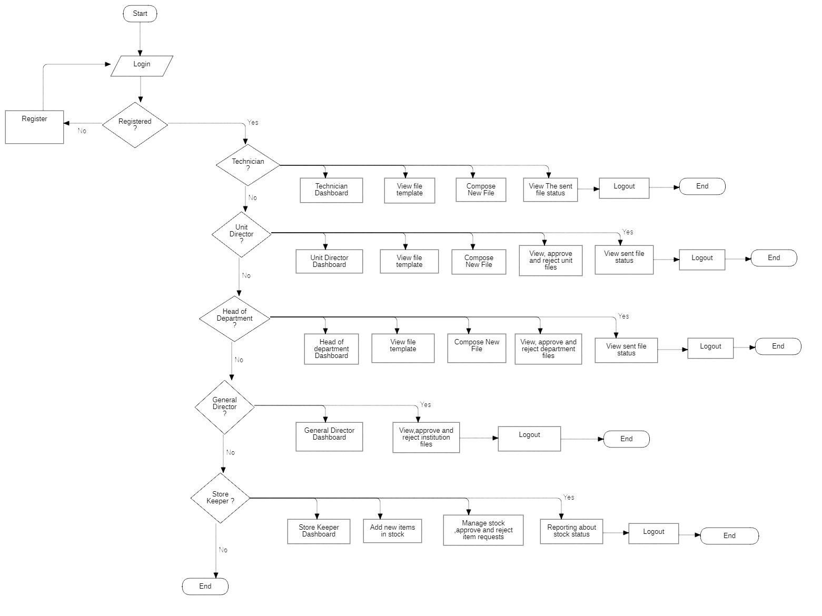

## 4.7 Data Flow Diagram

A data-flow diagram is a way of representing a flow of data through a process or a system. The DFD also provides information about the outputs and inputs of each entity and the process itself. A data-flow diagram has no control flow — there are no decision rules and no loops

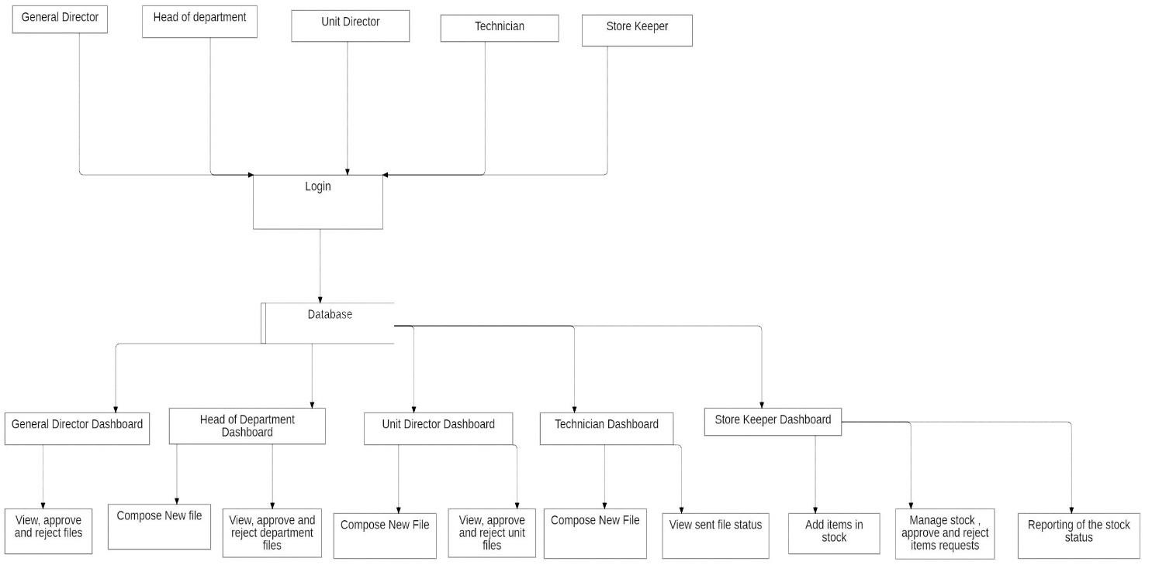

## 4.7 Entity-Relationship (ER) Diagram

An entity-relationship model describes interrelated things of interest in a specific domain of knowledge. A basic ER model is composed of entity types and specifies relationships that can exist between entities

Entity Relationship Diagram (ERD) is composed by:

1. Entities: This is a concept about which you want to store information
2. Relationship: This shows how two entities share information in the database
3. Attribute: This is the unique characteristics of the entity.

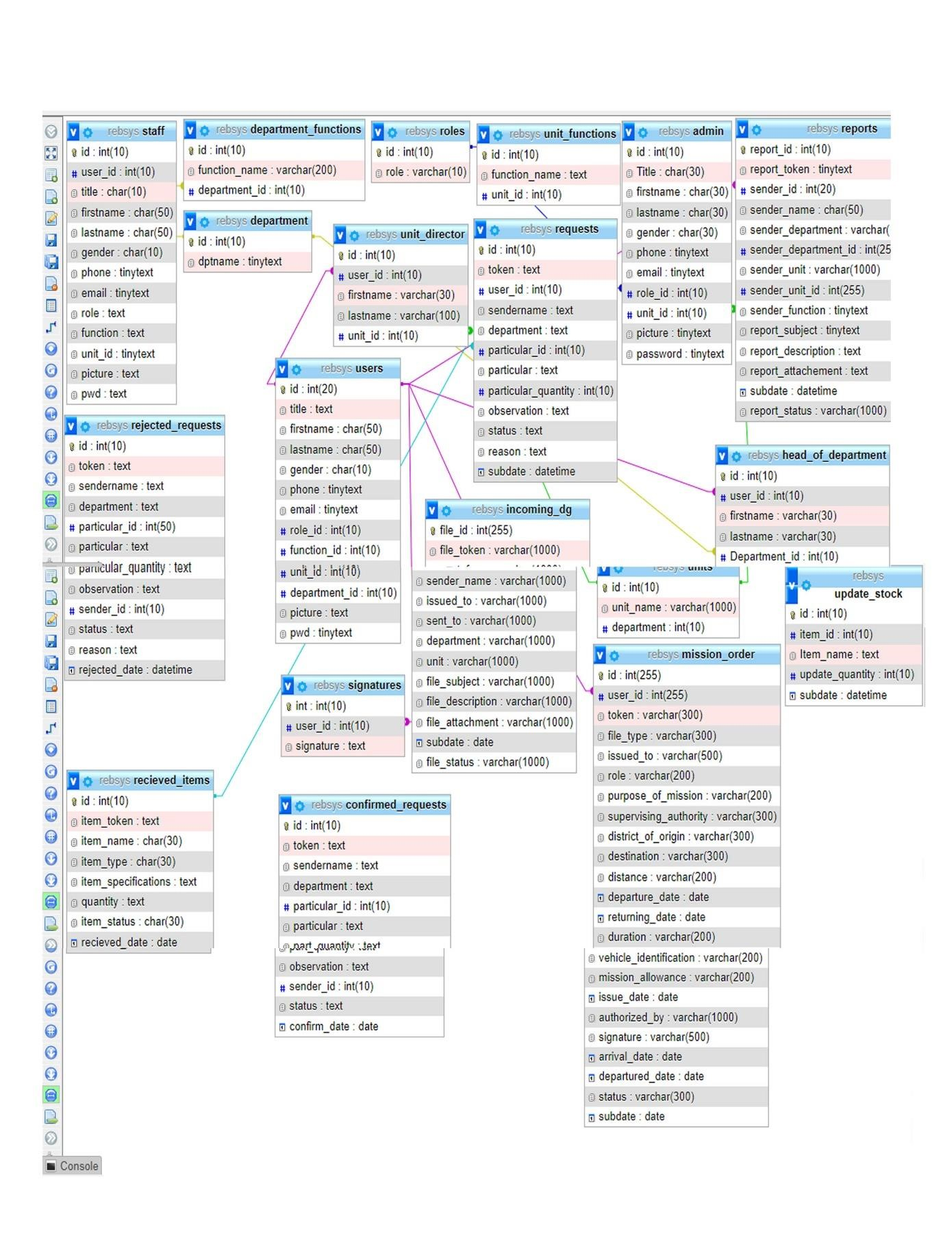

## 4.8 Web Interface

##### 4.8.1 Welcome Page

This is the welcome page where users redirect for the first time, here users can have a clue about what the system does.

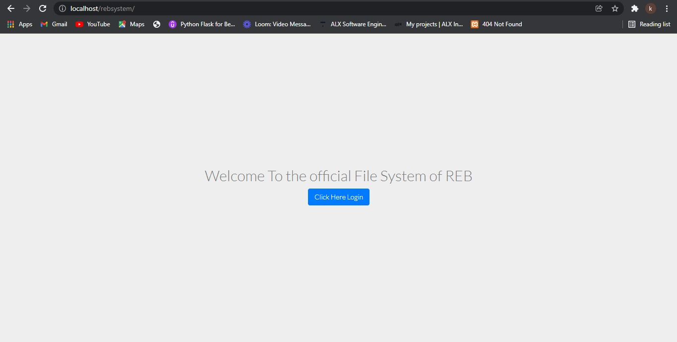

#### 4.8.2Login Page

On this page, the users are authenticated and if approved they are redirected to the dashboard corresponding to their role in the institution

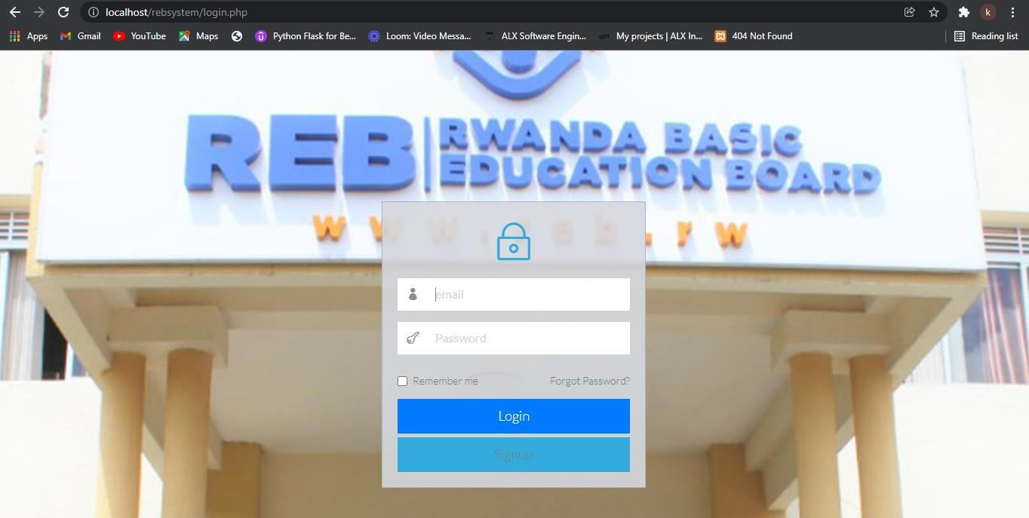

## 4.9 Dashboard

##### 4.9.1 Mission Order File Template

A mission order file is a file that requests the authority to carry out the work but not in the office but the field. This file explains clearly the purpose of the mission, the location where the mission will be carried out, and the duration of the mission as well as the requirements needed to carry out the mission.

The file is prepared by a technician, unit director, and head of the department and the file has to be approved or rejected following the organization authority level, the final approval level is done by the Director-General.

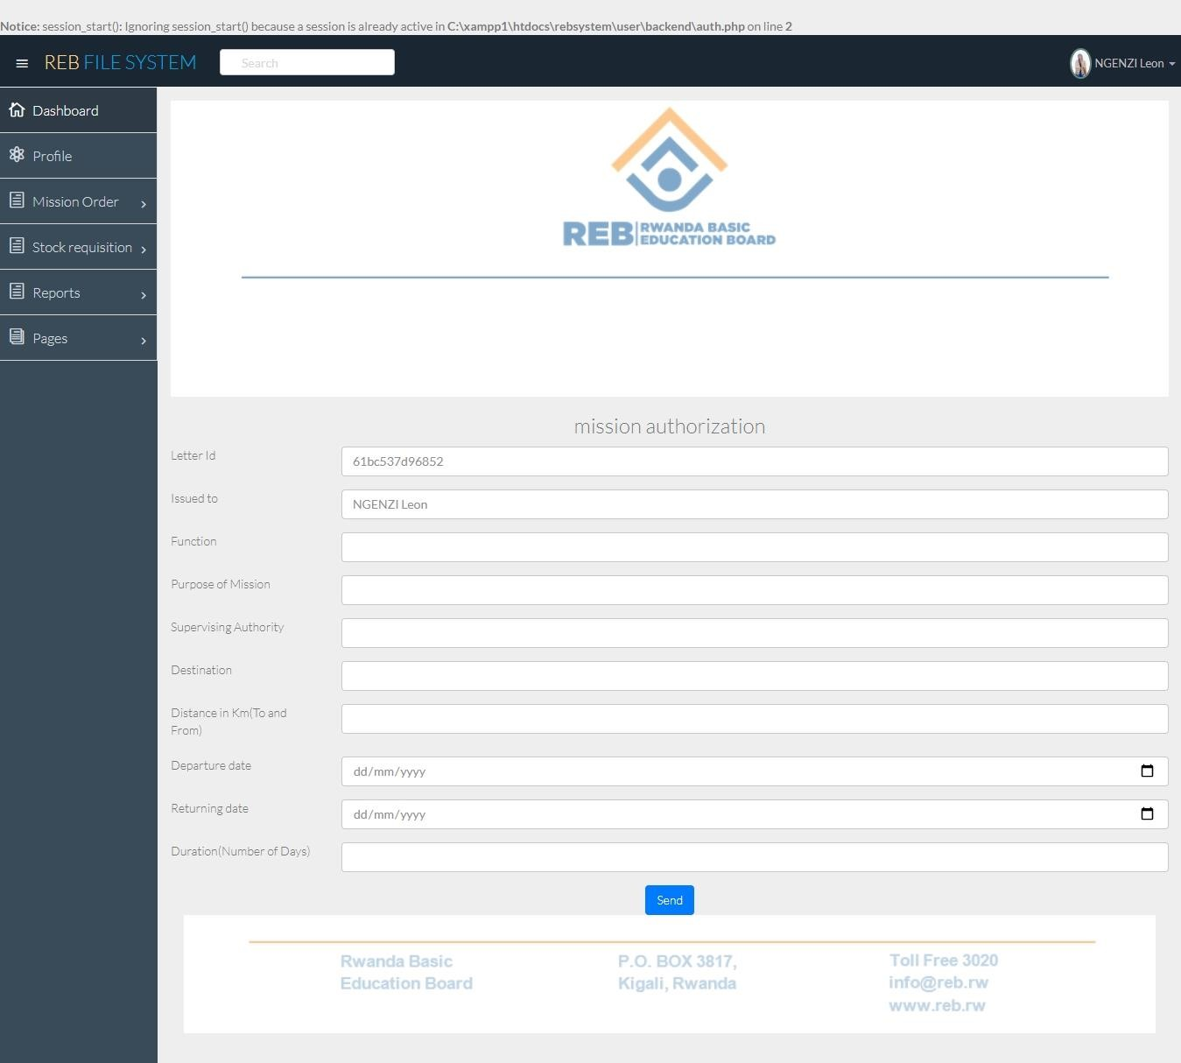

##### 4.9.2 Report File Template

A report is a file used to provide information of actions performed within a certain period and provide an overview of how the actions were carried out during a given amount of time. The reports also follow the same approval levels as the mission order from the sender to the organization authority level until the General Director of REB.

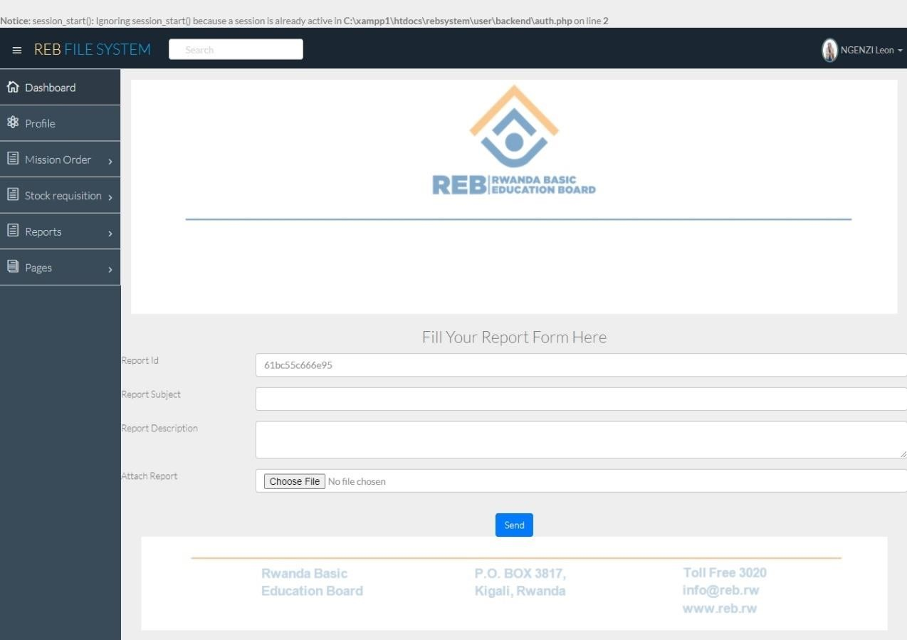

##### 4.9.3 Stock Requisition File template

Stock requisition is a file used to request items in stock. The file passes from the unit members to the unit director, from the unit director to the head of the department and from the head of the department to the logistic officer, and then to the storekeeper when approved the items are granted to the requesters.

The figure below is the page where the user will have to input several items they need.

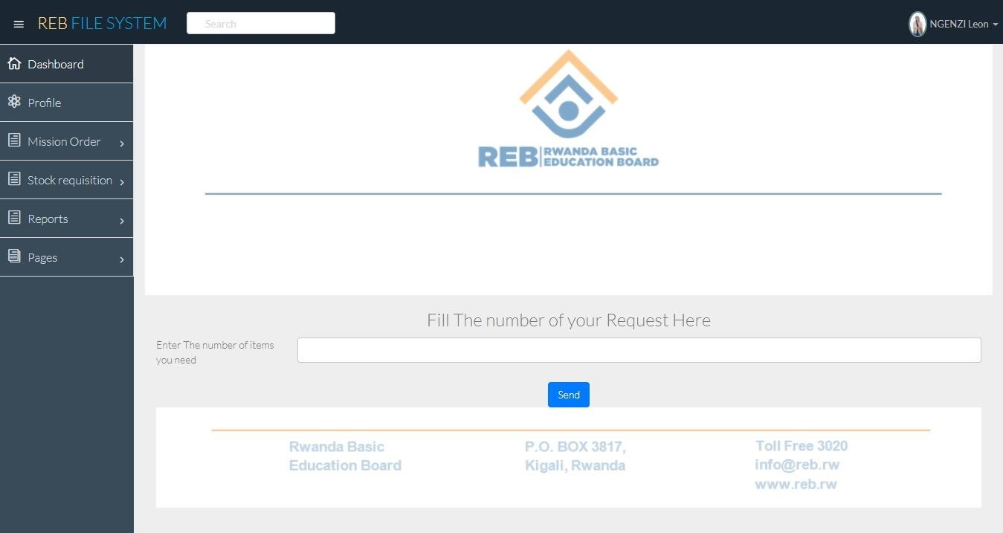

And after entering the number (suppose the number entered is three) then the user is redirected directly to the next page with the equivalence of the number of items entered from the previous page (in our case three).

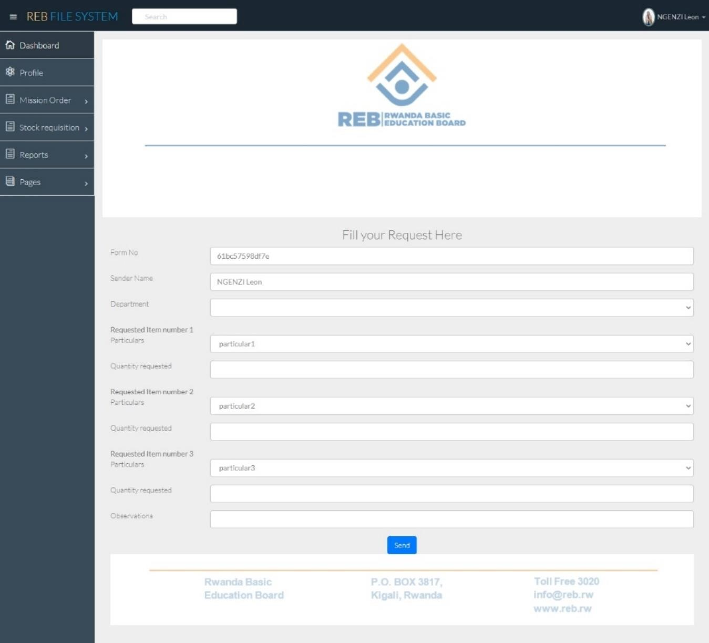

##### 4.9.4 Incoming File Template

The incoming file template is used for files coming out of the institution and needs attention within the institution. The incoming file passes from the receptionist directly to the General director where he sends the file via the concerned head of department and the head of the department might send the file to the unit director and the movement of the file stops there.

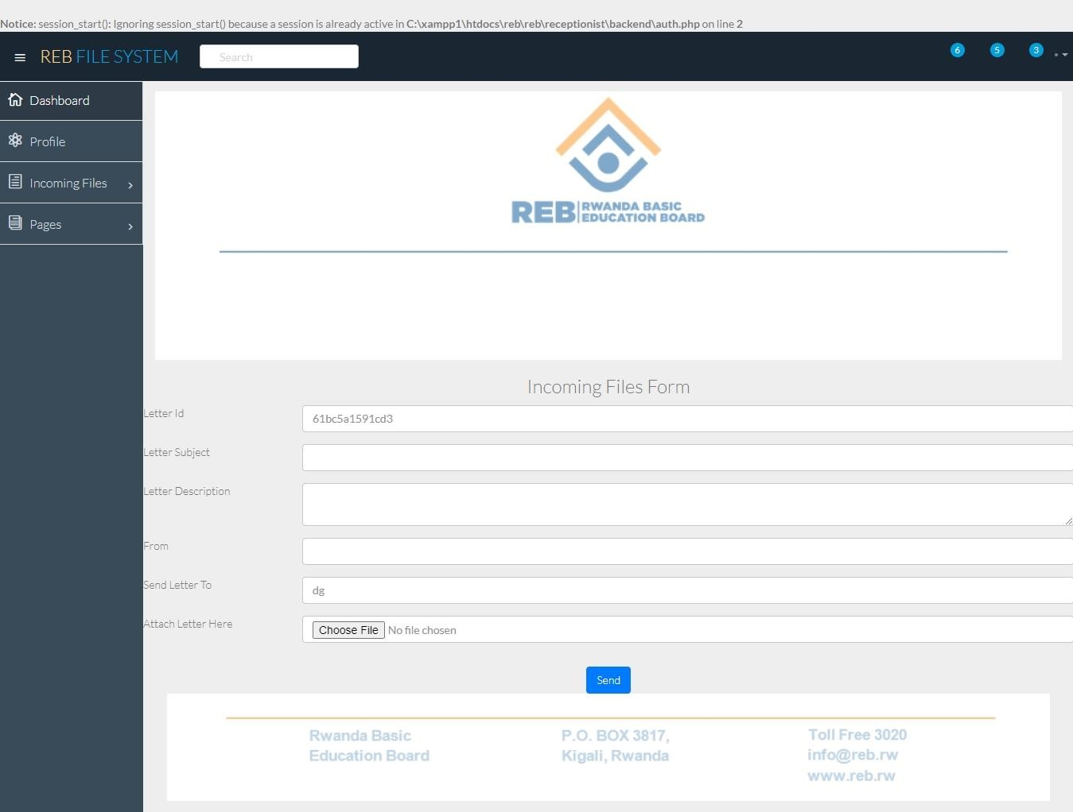

##### 4.9.5 Adding New Item page

This page helps the storekeeper to record all the new items and keep track of the date that the items were brought and the quantity of the items brought.

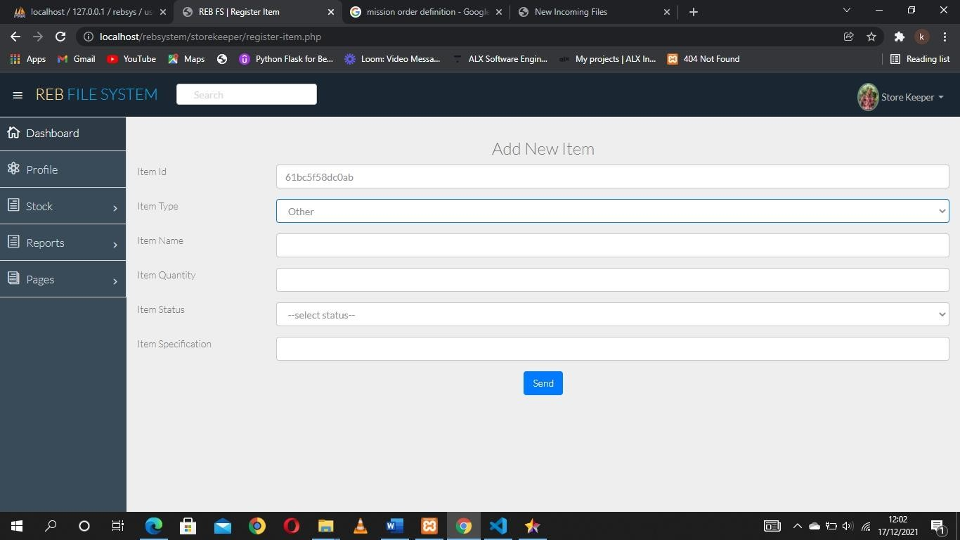

##### 4.9.6 Stock Status page

This page is to show items remaining in stock and their quantity along with other information related to the items all these are viewed by the storekeeper and logistics officer and they can edit and remove items whenever necessary.

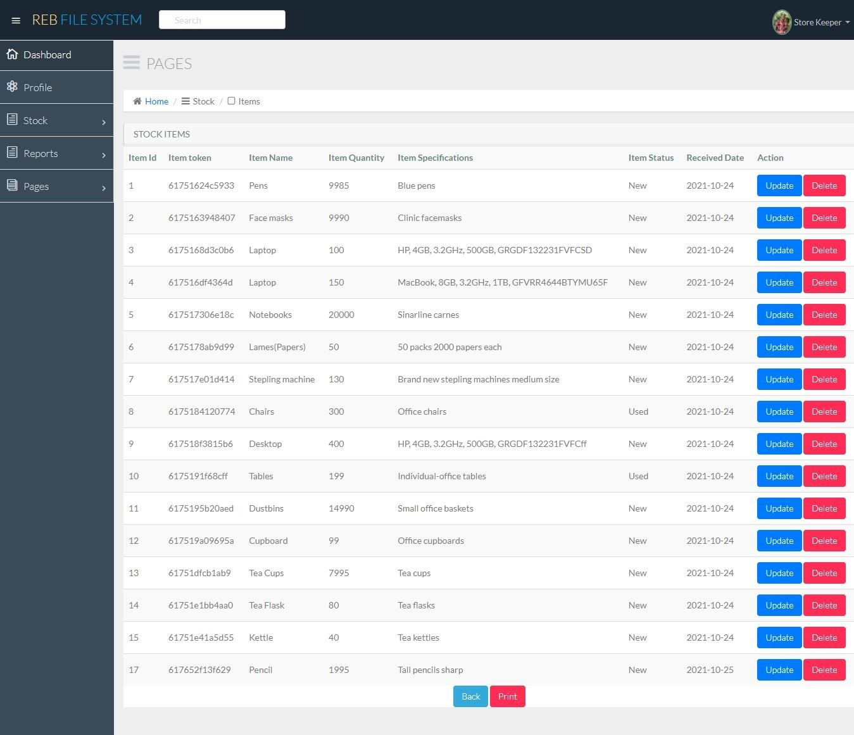

##### 4.9.7 Received Requests Page

On this page, all the files with the pending status are displayed here but according to the level of approval and also according to the type of file and according to the functionality, the user is granted permissions to modify, approve and reject files.

The figure below shows an example of a page of received files (in our case it is a page of reports received by the unit director) the unit director has the permission to read, download, modify, approve and reject files related only to his unit.

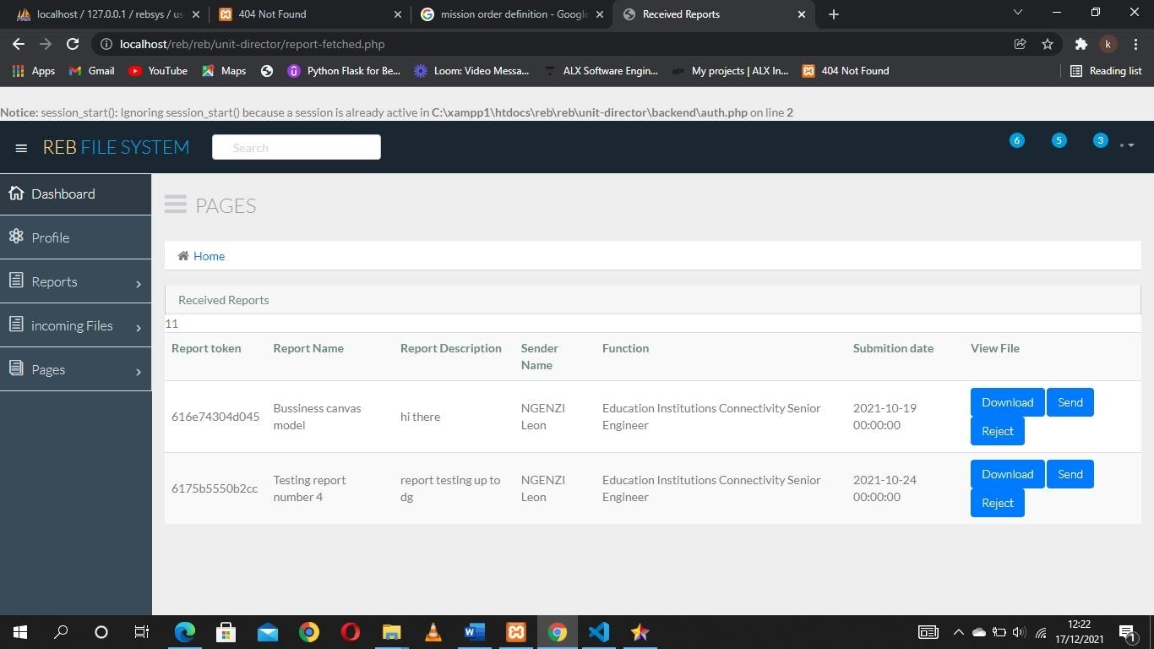

##### 4.9.8 User Registration page

This page is used to register a new user to have access to the system based on the department, unit, and functionality of the user being registered and provide credentials that help in the login of the system.

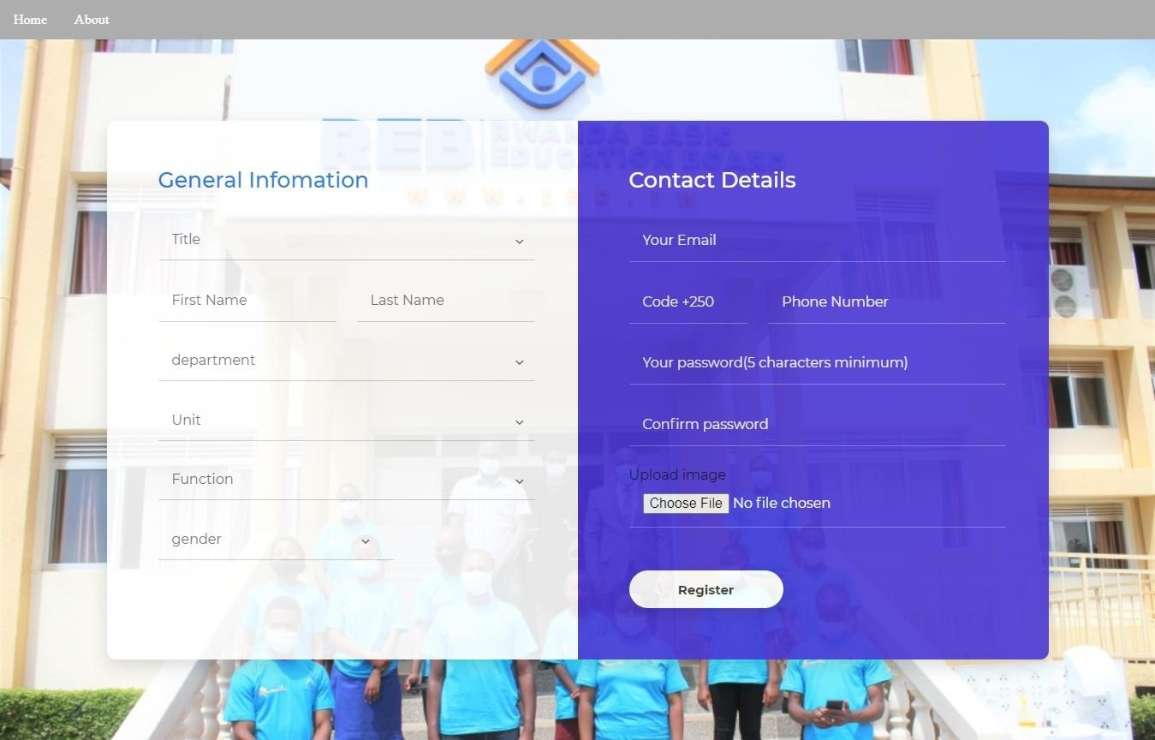

4.1

# CHAPTER FIVE: CONCLUSION AND RECOMMENDATION

## 5.1Conclusion

Based on the information shown in the previous chapters and also based on the general objective of the study was to build a paperless working environment in REB institutions by abolishing the movement of paper files inside the institution and building a platform for electronic files movement.

There are still some of the workers who have doubts about using this platform showing a few insecurities with the system but the institution is preparing some training for its workers to have a better and clear understanding of the usage of the system.

The system will act as a linkage between files and workers in REB making it an easy and quick way of moving and storing files in the institution

## 5.2 Recommendations

#### 5.2.1To REB

Embracing the use of technology and its features in all their daily activities

#### 5.2.3To REB workers

To benefit and make use of the platform designed to ease their daily activities and to be flexible with the technologies that are being introduced by the institution

#### 5.2.4To Ines

1. The researcher recommends INES to adopt and use the system with students as well, all the application files that students get to write should all be done electronically to ease the job for INES workers and help students in tracking their different requests

1. The researcher recommends INES to facilitate students in the computer science department with testing servers to help students evaluate the performance of their products

##### 5.2.5 To next researchers

1. The researcher recommends the next researchers to build an ios application with a similar performance to the system built.
2. To emphasize innovating within the system and the security of the system as well

# References

Abowitz, A. D., & Toole, M. T. (2010). Mixed method research: Fundamental issues of design, validity, and reliability in construction research. *Journal of construction engineering and management, 136*(1), 108-116.

Alshamrani, A., & Bahattab, A. (2015). A comparison between three SDLC models waterfalls model, spiral model, and Incremental/Iterative model. *International Journal of Computer Science Issues (IJCSI), 12*(1), 106.

Bakunzibake, P., Klein, O. G., & Islam, M. S. (2019). E-government implementation process in Rwanda: Exploring changes in a sociotechnical perspective. *Business Systems Research: International journal of the Society for Advancing Innovation and Research in Economy, 10*(1), 53-73.

Chen , D. L., Schonger , M., & Wickens , C. (2016). oTree—An open-source platform for laboratory, online, and field experiments. *Journal of Behavioral and Experimental Finance, 9*, 88-97.

Hause, M. (2004). Use-cases to aid safe design. *Electronics Systems and Software, 2*(2), 3841.

Khare, R., & Rifkin, A. (1997). XML: A door to automated Web applications. *IEEE Internet Computing, 1*(4), 78-87.

Nayembil, M. L. (2021). Data Management Considerations. *Applied Multidimensional Geological Modeling: Informing sustainable human interactions with the shallow subsurface*, 183-210.

Pentland, B. T. (1995). Information systems and organizational learning: the social epistemology of organizational knowledge systems. *Accounting, Management and Information Technologies, 5*(1), 1-21.