

NAME: MUQADAS
Sap id=65314

TASK 1

Infix to prefix:
K + L - M * N + (O^P) * W/U/V * T + Q

Reverse expression would be:
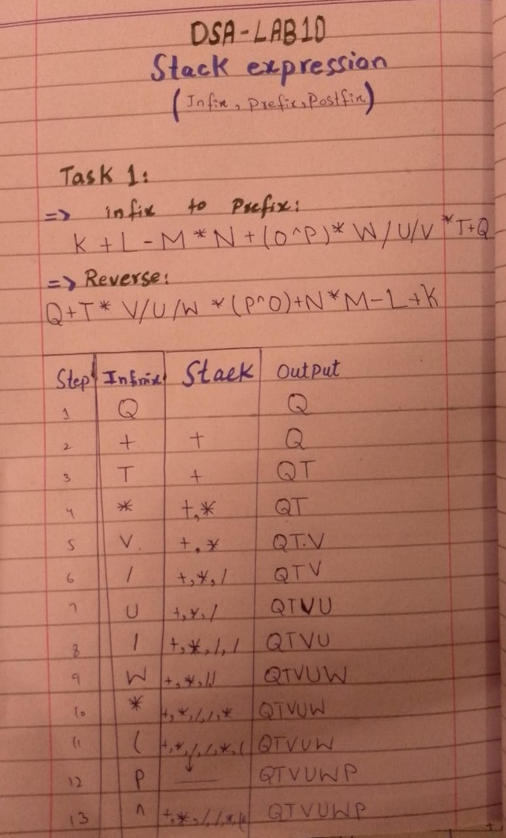
Q + T * V/U/W * (P^O) + N*M - L + K
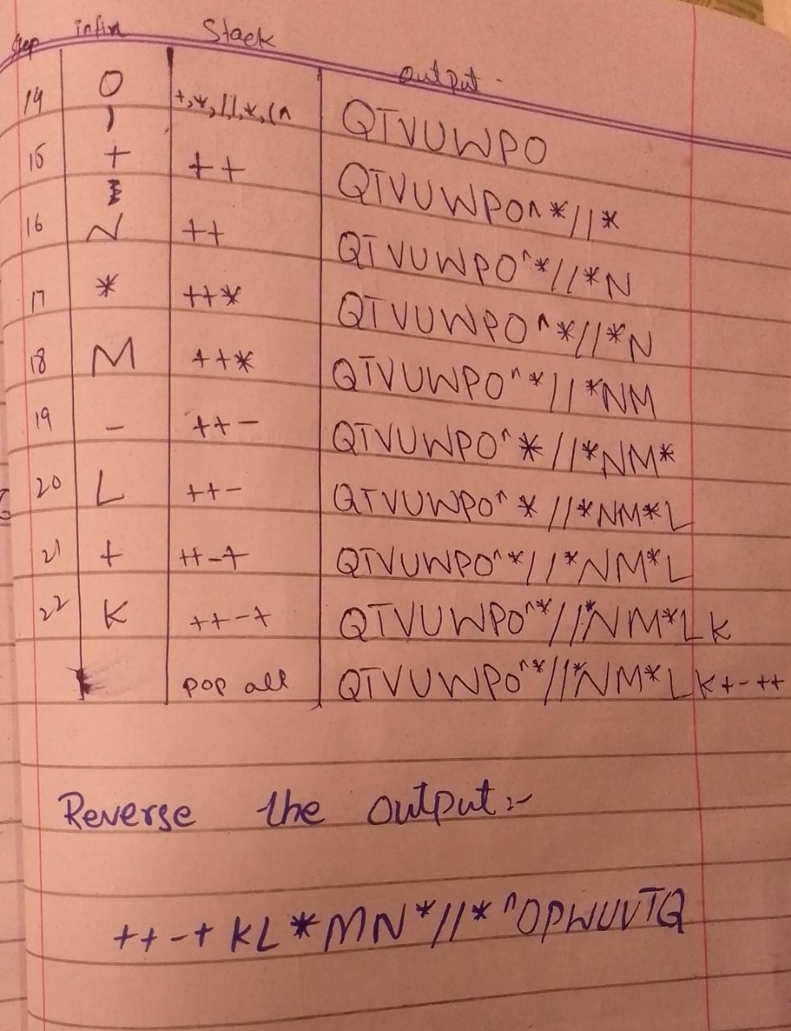TASK 2
Infix to Postfix
K + L - M*N + (O^P) * W/U/V * T + Q

Step | Symbol | Action / Stack | Output (Postfix)
1 | K | Operand → output | K
2 | + | Push '+'
3 | L | Operand → output | K L
4 | - | Pop +  push - | K L +,
5 | M | Operand → output | K L + M
6 | * | Push '*’ (-*)
7 | N | Operand → output | K L + M N
8 | ( | Push '(' | Stack: - * (
9 | O | Operand → output | K L + M N O
10 | ^ | Push '^' | Stack: - * (^
11 | P | Operand → output | K L + M N O P
12 | ) | Pop until '(' → Pop ^ | Output: K L + M N O P ^, Stack: - *
13 | * | '' and '' same precedence, left-associative → pop previous '*' | Output: K L + M N * O P ^ *, Stack: - *
14 | W | Operand → output | K L + M N * O P ^ * W
15 | / | Pop '*' (same precedence) → push '/' | Output: K L + M N * O P ^ * W *, Stack: - /
16 | U | Operand → output | K L + M N * O P ^ * W * U
17 | / | Pop '/' (same precedence) → push '/' | Output: K L + M N * O P ^ * W * U /, Stack: - /
18 | V | Operand → output | K L + M N * O P ^ * W * U / V
19 | * | '*' and '/' same precedence → pop '/' first | Output: K L + M N * O P ^ * W * U / V /, Stack: - *
20 | T | Operand → output | K L + M N * O P ^ * W * U / V / T
21 | + | '+' lower precedence → pop '*' and '-' → push '+' | Output: K L + M N * O P ^ * W * U / V / T * - +, Stack: +
22 | Q | Operand → output | K L + M N * O P ^ * W * U / V / T * - + Q
23 | End | Pop remaining '+' | K L+MN*OP^*W*U/V/T*-+Q+

