DecodeLabs Bio-informatics Internship Program
OFFICIAL INTERNSHIP REPORT —Task 02
═════════════════════════════════════════════════
TOPIC
FRAUD DETECTION PIPELINE
═════════════════════════════════════════════════
Submitted By: | Muqaddas Mukhtar  BS Bio-informatics (5th Semester)
Submitted To: | DecodeLabs

1.Introduction:
Fraud detection is an important application of data science and machine learning. E-commerce platforms generate large amounts of transaction data, and machine learning models can be used to identify transactions that may have suspicious characteristics. This project presents a complete fraud detection pipeline using an e-commerce transaction data-set. The workflow includes data loading, preprocessing, feature engineering, target generation, model training, evaluation, and visualization.

2. Project Objective:
The main objectives of this project are to:
- Load and explore an e-commerce transaction dataset.
- Clean and preprocess numerical and categorical features.
- Create a fraud-related target variable for supervised learning.
- Train Logistic Regression and Random Forest classification models.
- Handle class imbalance using SMOTE.
- Evaluate the models using classification and ROC-based metrics.
- Compare model performance and identify the better-performing model.

3. Dataset Description:
The dataset contains e-commerce order and transaction-related information, including numerical, categorical, and date-related attributes. The dataset contains 1,200 records. Important attributes include quantity, total price, payment method, and transaction date.
The preparation steps included checking data types, handling missing values through preprocessing pipelines, removing identifier-like columns, and extracting Year, Month, Day, and Day of Week from the date column.

4. Fraud Label Generation:
The original dataset did not contain a verified fraud-label column. Therefore, a synthetic target variable named IsFraud was generated using transaction-based rules. A transaction was labelled as fraudulent if it met one or more of the following conditions:
- Total Price was greater than the 95th percentile of TotalPrice.
- Quantity was greater than the 95th percentile of Quantity.
- Payment Method was Cash on Delivery.
After target generation, the dataset contained 1,140 non-fraud records and 60 fraud records, creating an imbalanced classification problem.

5. Data Preprocessing:
Numerical features were processed using missing-value imputation and standard scaling. Categorical features were processed using missing-value imputation and one-hot encoding. The dataset was divided into training and testing sets using an 80:20 stratified split.
SMOTE (Synthetic Minority Over-sampling Technique) was applied to the training data to address class imbalance and help the models learn minority-class patterns.

6. Machine Learning Models:

6.1 Logistic Regression;
Logistic Regression was used as a baseline classification model to estimate the probability that a transaction belonged to the fraud or non-fraud class.

6.2 Random Forest;
Random Forest is an ensemble learning algorithm that combines multiple decision trees. It was selected because it can capture non-linear relationships and provide feature-importance values.

7. Model Evaluation Metrics:
- Accuracy: proportion of all correctly classified transactions.
- Precision: proportion of predicted fraud cases that were actually fraud cases.
- Recall: proportion of actual fraud cases correctly identified.
- F1-Score: harmonic mean of precision and recall.
- ROC-AUC: ability of the model to distinguish between the two classes.

8. Results and Model Comparison:
The performance of both models on the test dataset is shown below.
Model | Accuracy | Precision | Recall | F1-Score | ROC-AUC
Logistic Regression | 99.17% | 91.67% | 91.67% | 91.67% | 99.71%
Random Forest | 99.58% | 100.00% | 91.67% | 95.65% | 100.00%
Random Forest performed better overall because it achieved the highest accuracy, precision, F1-score, and ROC-AUC.

9. Confusion Matrix:
A confusion matrix was used to examine correct and incorrect predictions made by the Random Forest model.
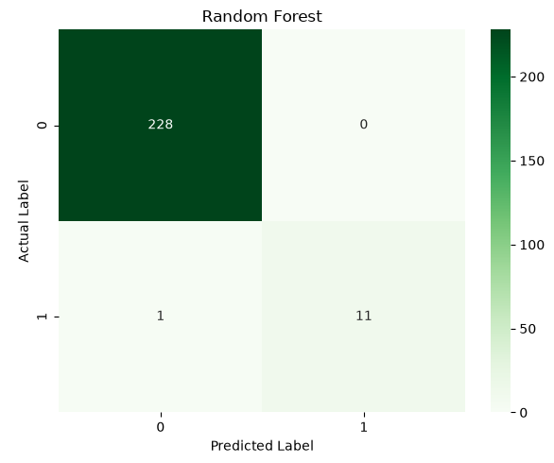
Figure 1: Confusion Matrix of the Random Forest Model.

10. ROC Curve:
The ROC curve shows the relationship between the true-positive rate and false-positive rate at different classification thresholds. Random Forest achieved an ROC-AUC of 1.00, while Logistic Regression achieved approximately 0.997.
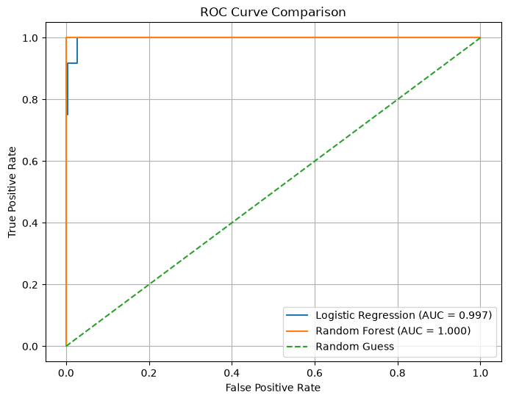
Figure 2: ROC Curve Comparison of Both Models.

11. Feature Importance:
Feature importance was extracted from the Random Forest model to identify the transaction features that contributed most to its predictions.
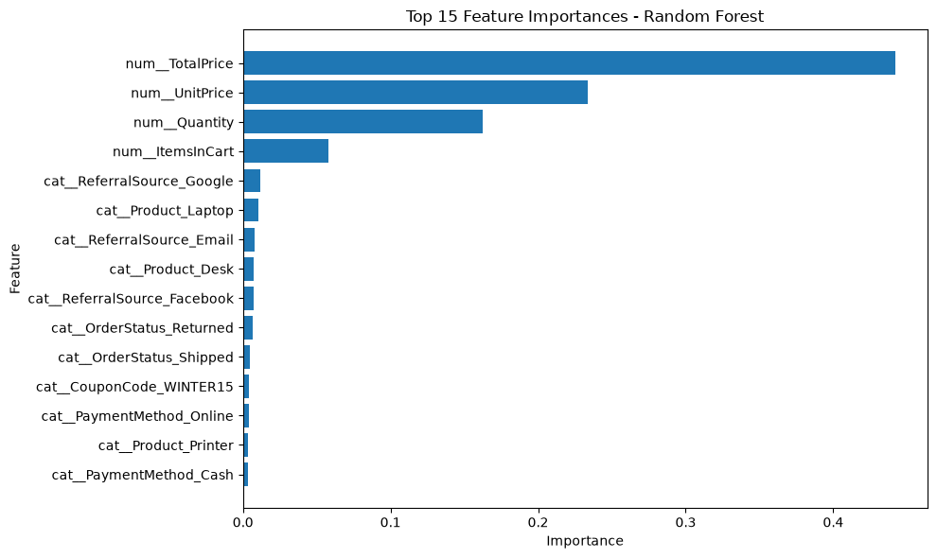
Figure 3: Top Feature Importances from the Random Forest Model.

12. Discussion:
Both models achieved high performance on the test data. Random Forest was selected as the best model, with an F1-score of 95.65% and an ROC-AUC of 100%. Its precision of 100% indicates that all transactions predicted as fraud were labelled as fraud according to the synthetic target rules.
The use of SMOTE helped address the imbalance between fraud and non-fraud classes. Pipelines ensured that preprocessing was applied consistently during training and testing.

13. Limitations:
The main limitation is that fraud labels were synthetically generated because the original dataset did not contain verified fraud outcomes. The labels were based on Total Price, Quantity, and Payment Method. Since the target was created from features already present in the dataset, the high performance may partly reflect the rules used to generate the labels.
Therefore, the results demonstrate successful implementation of the pipeline but should not be interpreted as real-world fraud detection performance. A real-world system would require verified historical fraud labels and validation on unseen production transactions.

14. Conclusion:
This project successfully implemented a machine learning-based fraud detection pipeline for e-commerce transaction data. The workflow included preprocessing, feature engineering, synthetic target generation, class balancing with SMOTE, model training, evaluation, and visualization. Logistic Regression and Random Forest were trained and compared. Random Forest was the better-performing model, achieving 99.58% accuracy, 95.65% F1-score, and 1.00 ROC-AUC on the test set. The synthetic nature of the fraud labels must be considered when interpreting these findings.

15. Tools and Technologies Used:
- Python
- Jupyter Notebook
- Pandas
- NumPy
- Scikit-learn
- Imbalanced-learn
- Matplotlib
- Seaborn

16. Appendix: Screenshot Checklist:
- Dataset preview
- Class distribution
- Confusion Matrix
- ROC Curve
- Feature Importance
- Model evaluation results

