


PROJECT REPORT:
EMPLOYEE ATTENDANCE SYSTEM
COURSE:
Object Oriented Programming
SUBMITTED BY:
- MUQADDAS ZAHEER AHMAD
Department:
ARTIFICIAL INTELLIGENCE (M)

TABLE OF CONTENTS
- Introduction
- Objectives
- Problem Statement
- System Features
- System Design
- OOP Concepts Used
- Menu Functionalities
- System Working
- Algorithm Overview
- Data Storage Logic
- Limitations
- Future Improvements
- Output Screenshots
- Conclusion
- Introduction
The Employee Attendance System is a console-based application developed in C++ using Object-Oriented Programming (OOP) concepts. It helps manage employee records and attendance in an easy and organized way.
It allows users to:
- Add employees (Permanent and Contract)
- Mark and update attendance
- Search employee records
- Display employee information
- Generate attendance reports
- Delete employee records
This project demonstrates important OOP concepts such as:
• Inheritance
• Runtime Polymorphism
• Encapsulation
• Dynamic Memory Allocation

2. Objectives
The main objectives of this project are:
- To manage employee records efficiently.
- To track employee attendance for 30 days.
- To implement OOP concepts in a practical application.
- To practice dynamic memory allocation and pointers.
- To understand runtime polymorphism using virtual functions.
3.Problem Statement
Managing employee attendance manually can be difficult and time-consuming. Maintaining employee records on paper may lead to errors, data loss, and inefficient record management.
This project provides a simple computerized solution to store employee information, manage attendance records, and generate attendance reports efficiently using Object-Oriented Programming concepts.
4. System Features

4.1 Employee Management
- Add new employees.
- Store Employee ID and Name.
- Support two employee types:
  - Permanent Employee
  - Contract Employee

4.2 Attendance Management
- Mark daily attendance.
- Store attendance for 30 days.
- Update attendance records.
- View attendance history

4.3 Search and Display
- Search employees by ID.
- Display employee details.
- View attendance reports.

4.4 Delete Functionality
- Delete employee records safely.
- Free allocated memory safely.

5. System Design

Data Members
- employee_name
- employee_ID
- attendance[30]
- days

Member Functions
- input()
- DisplayInfo()
- markAttendance()
- getID()
- displayAttendance()
- setAttendance()

5.2 Derived Class: PermanentEmployee

Additional Data Member
- department

Member Functions
- input()
- DisplayInfo()

5.3 Derived Class: ContractEmployee

Additional Data Member
- contractDuration

Member Functions
- input()
- DisplayInfo()

5.4 Class Diagram

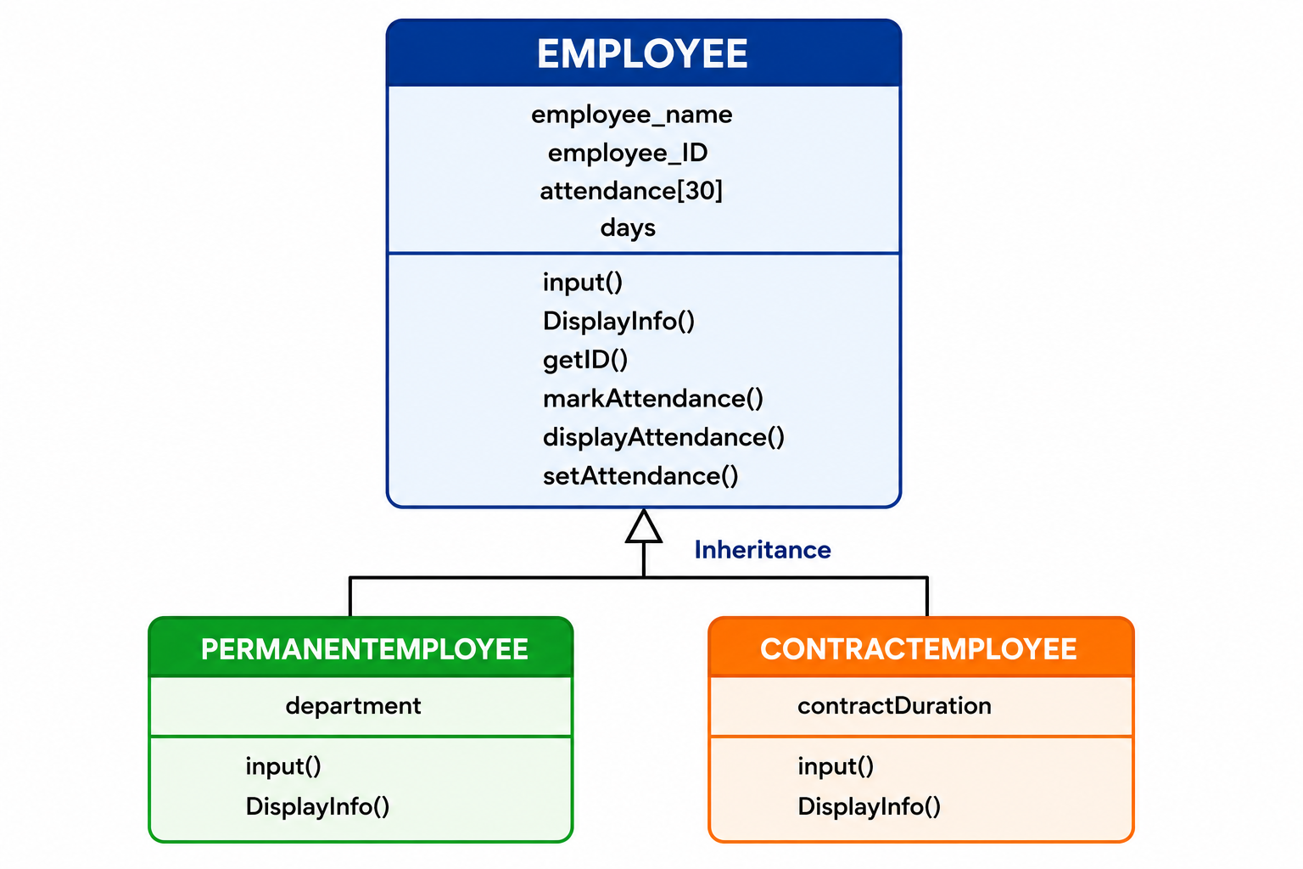
Figure 1: Class Diagram of Employee Attendance System

6. OOP Concepts Used

6.1 Inheritance
PermanentEmployee and ContractEmployee inherit from the Employee class.

6.2 Runtime Polymorphism
The virtual function DisplayInfo() is used to implement runtime polymorphism.

6.3 Encapsulation
Employee data is stored inside classes and accessed through member functions.

6.4 Dynamic Memory Allocation
Employee objects are created using the new keyword and managed using pointers.

7. Menu Functionalities
- Add Employee
- View All Employees
- Search Employee
- Mark Attendance
- Update Attendance
- View Employee Record
- Delete Employee
- Mark Attendance for All Employees
- Attendance Report
- Exit

8. System Working
• The program starts.
• The menu is displayed.
• The user selects an option.
• The system performs the selected operation.
• Employee data is managed using dynamic memory allocation and pointers.
• The program continues until the user selects Exit.

9. Algorithm Overview

Step 1
Initialize the employee array and set count = 0.

Step 2
Display the menu repeatedly.

Step 3
Perform the selected operation:
- Add → Create a new employee object.
- Search → Find an employee by ID.
- Attendance → Update attendance records.
- Delete → Remove an employee and free allocated memory.

Step 4
Exit the program and release allocated memory.

10. Data Storage Logic
Employees are stored using an array of pointers:
Employee* emp[100]
Attendance is stored as:
- 0 = Absent
- 1 = Present
Each employee has a separate attendance record.

11. Limitations

Although the system performs its required functions effectively, it has some limitations:
• Console-based application.
• Data is not saved permanently.
• Attendance is limited to 30 days.

• No login or authentication system.

12. Future Improvements
The following enhancements can be added in future versions:
- Add file handling for permanent data storage.
- Develop a GUI version.
- Add login functionality.
- Generate monthly and yearly attendance reports.
- Add salary calculation based on attendance.

13.Output Screenshots

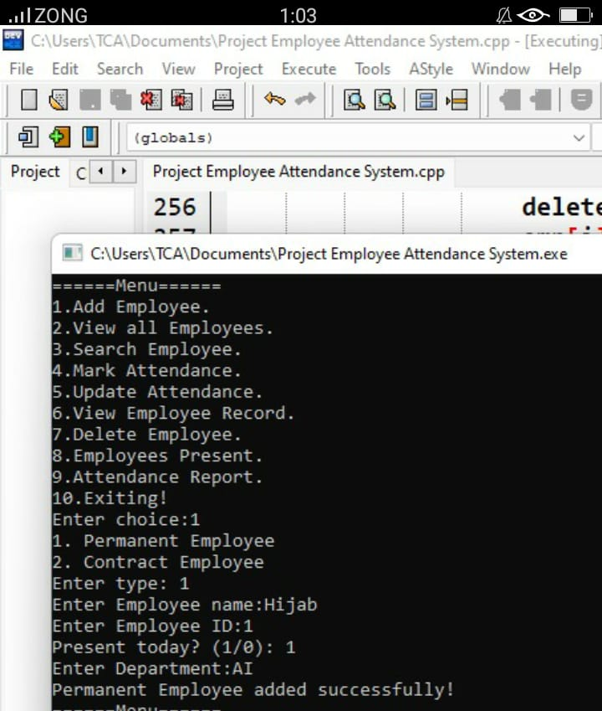

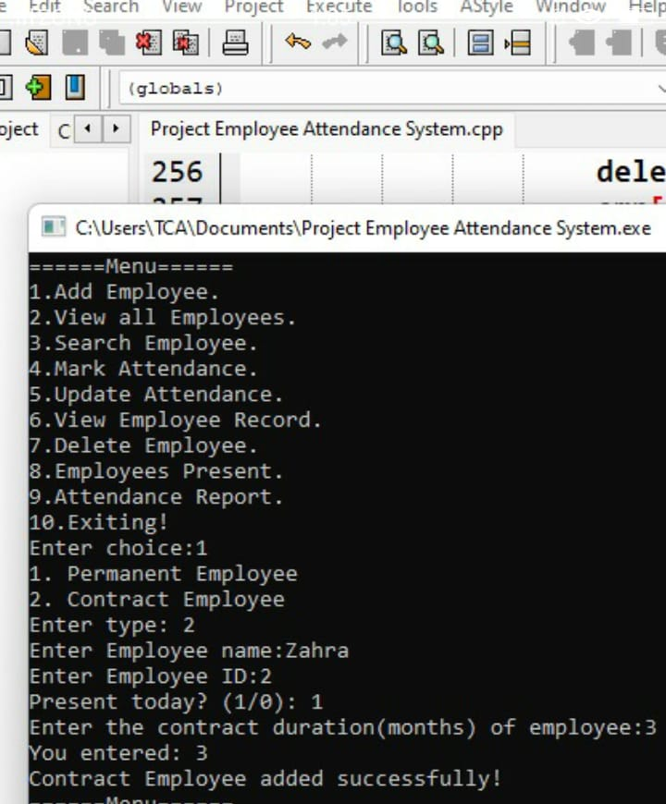

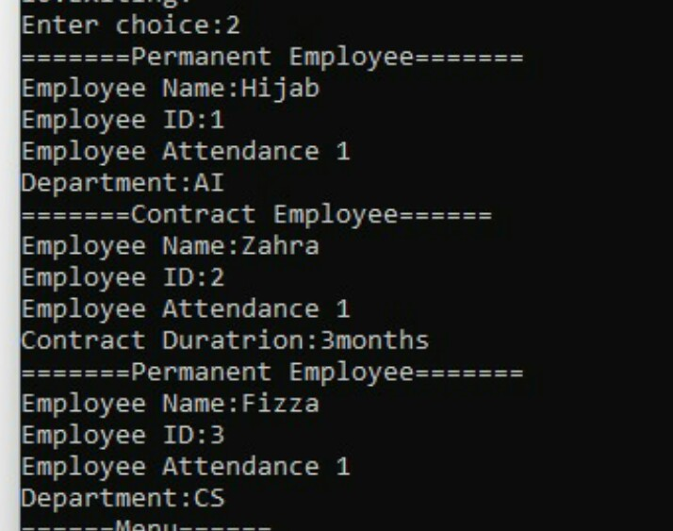

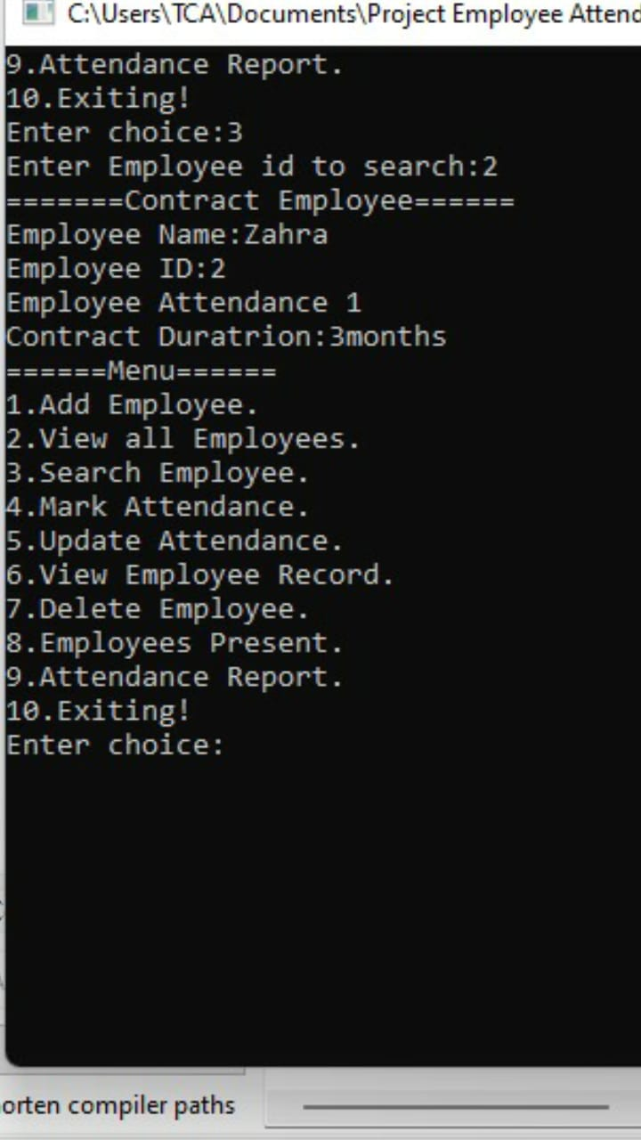

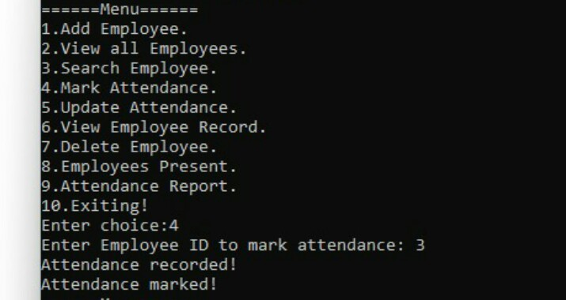

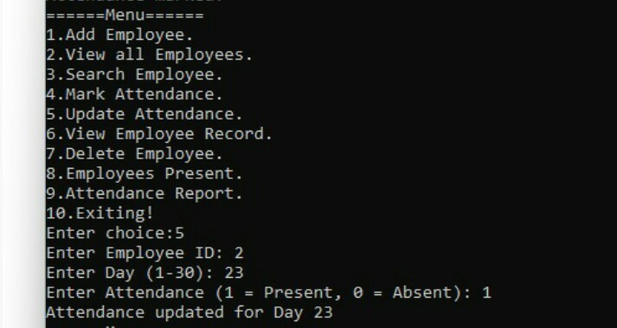

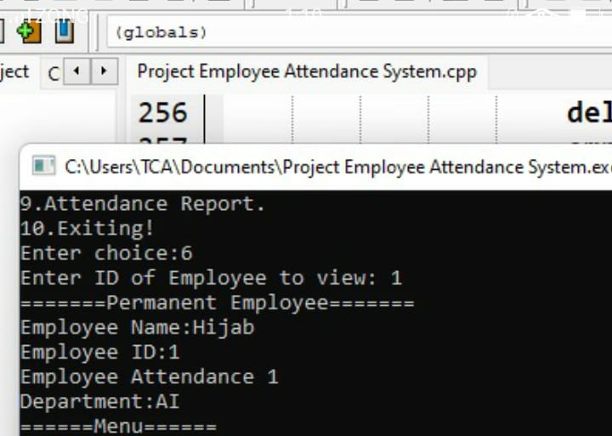

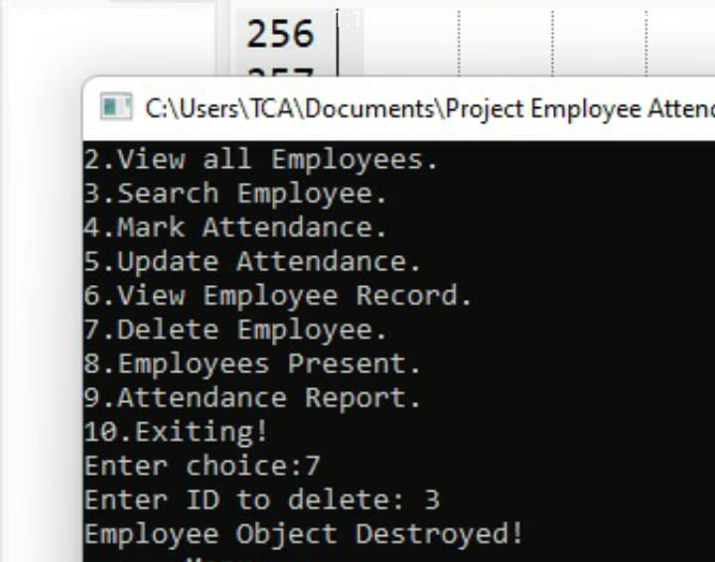

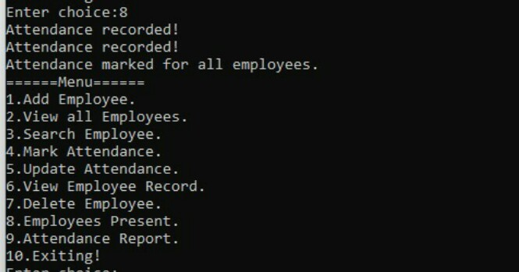

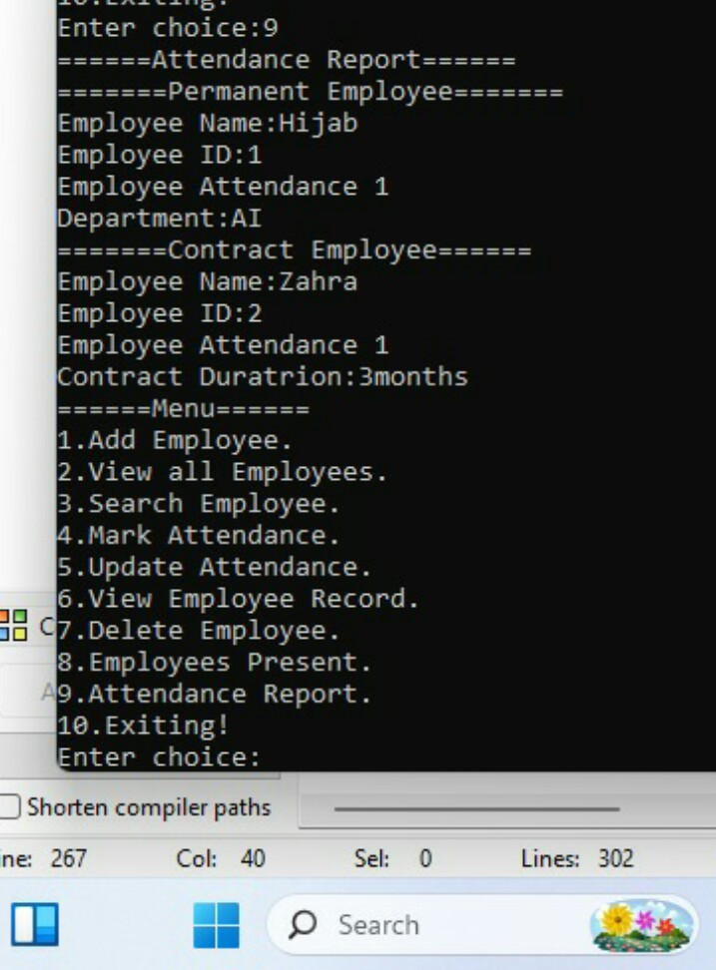

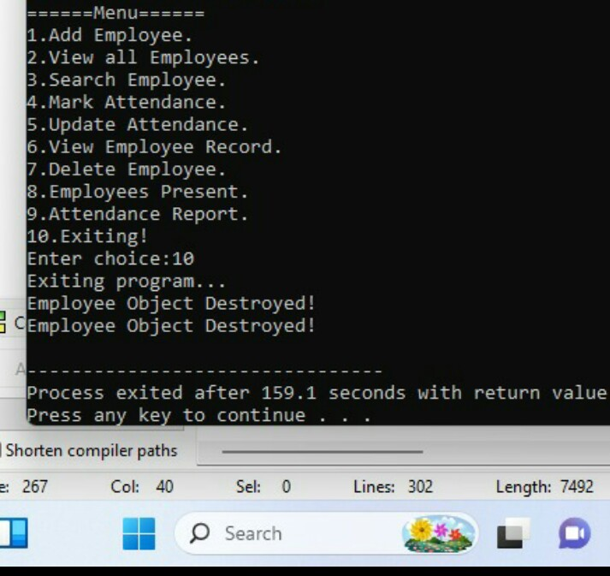

14. Conclusion
The Employee Attendance System is a simple application developed using C++ and OOP concepts. It helps manage employee records and attendance efficiently. The project demonstrates important OOP concepts such as inheritance, encapsulation, runtime polymorphism, and dynamic memory allocation through a practical application.

