**Dockerfiles**

**Front-end**

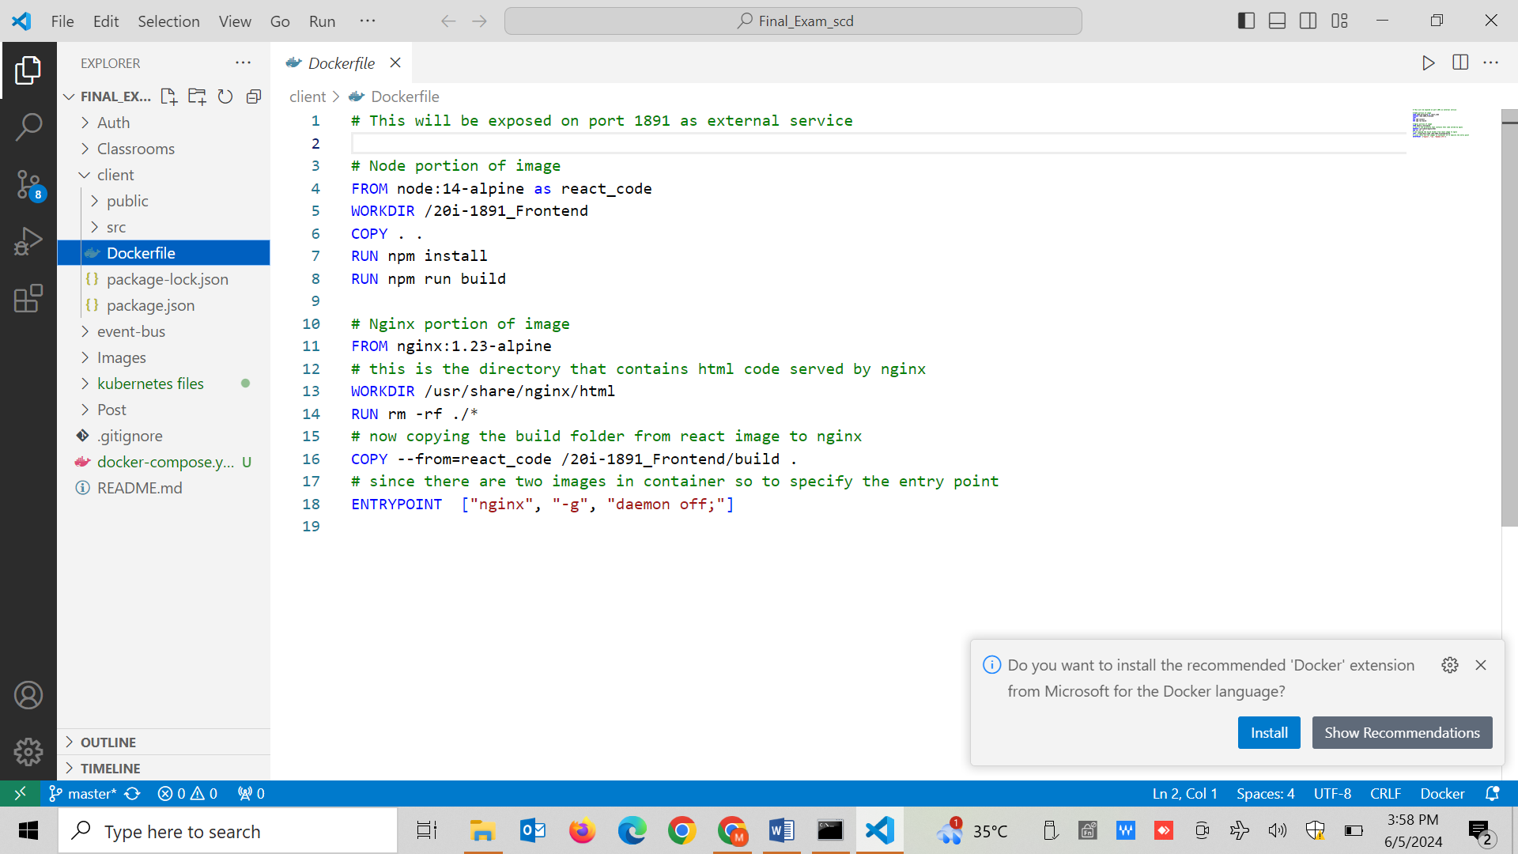

I am deploying front end using nginx in static production mode. For this reason I am building and then moving files to nginx root folder. The port mappings for this image will be 80:1891. I have also changed the internal variables that are specifying the backend service and I have used the domains of services of kubernetes cluster for the respective backend microservices.

**Backen Microservices:**

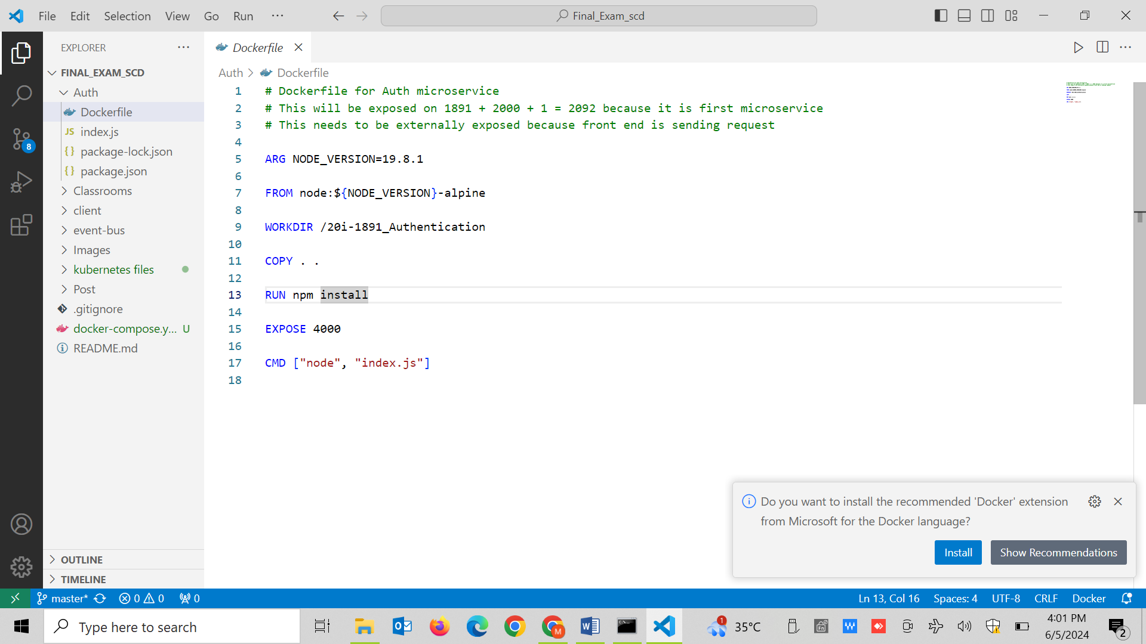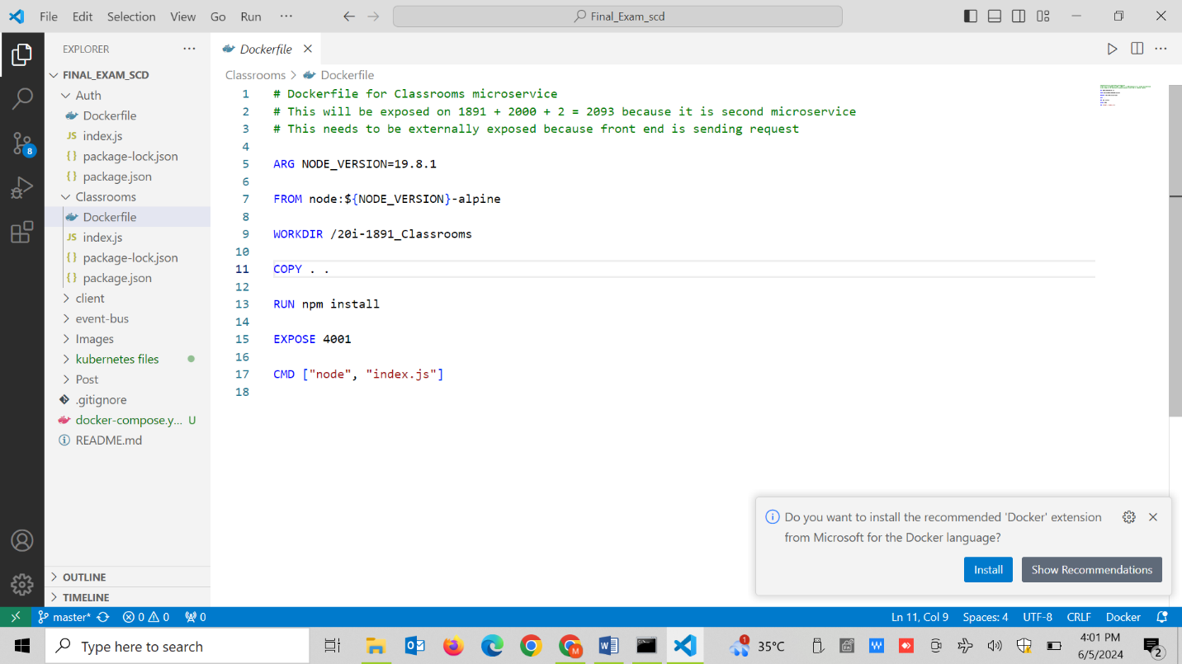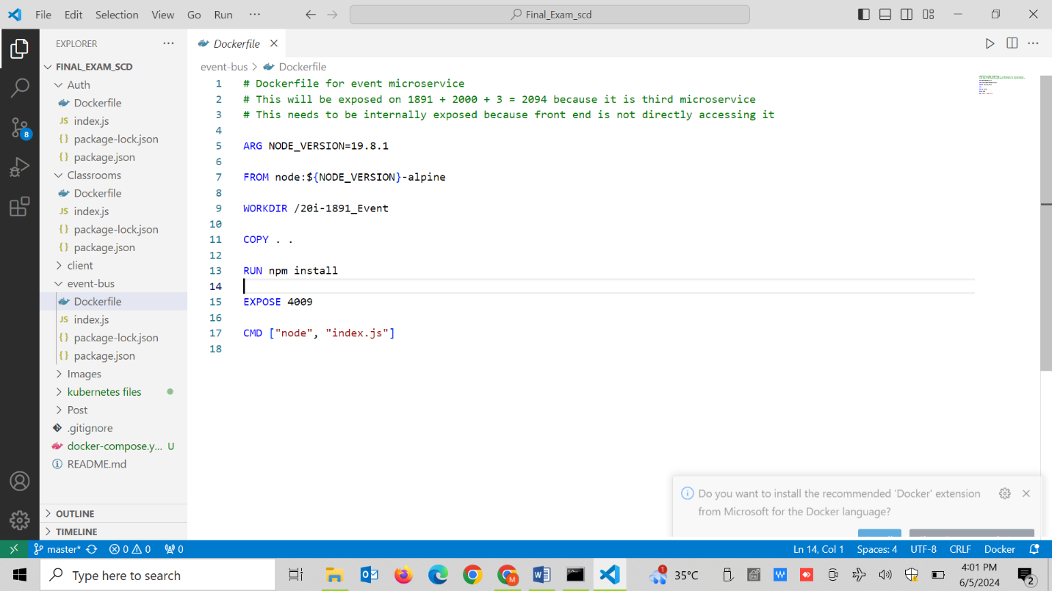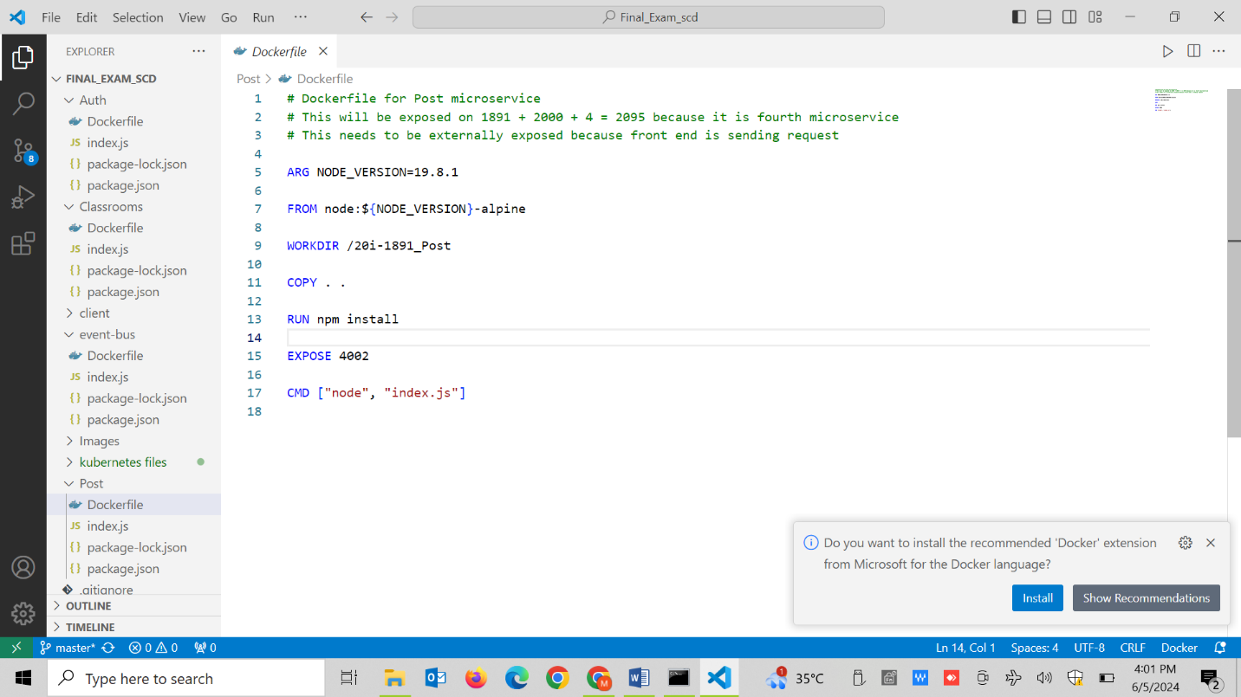

These are the respective docker files for backend microservices and I also have used the env variables for container communications and changed the code as well.

**Docker-compose:**

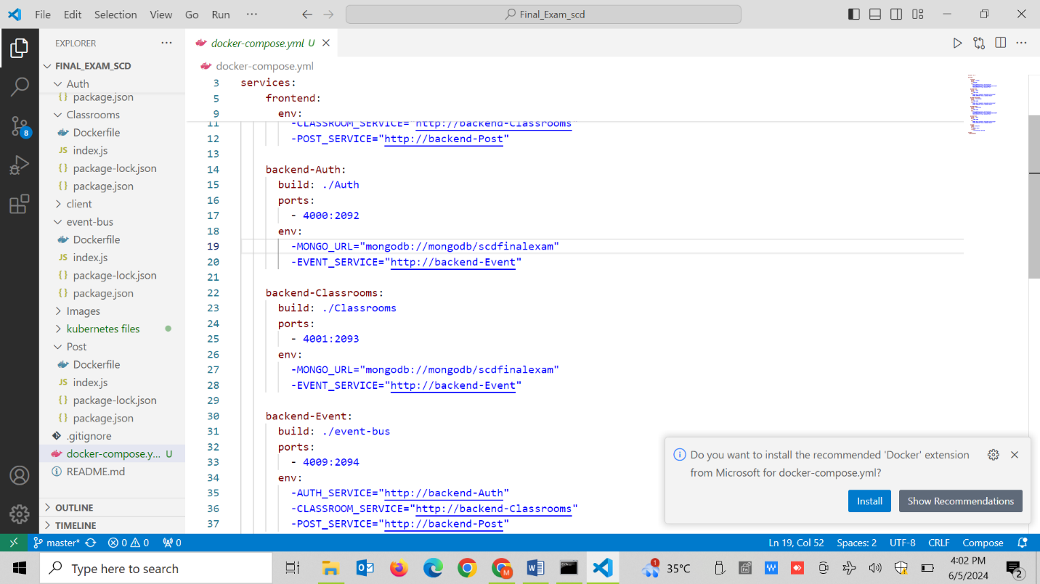

In this docker compose file, I have made all the services for front end , all microservices and mongo db and I have also attached the volumes. All the services have their envs as well that are used for internal communication.

**Kubernetes:**

I have made all the yaml files for making the services and deployments for frontend, backend microservices and mongodb. All these deployments are given the service domain names in environment variables and with the help of this the pods can communicate with each other.

**Auth microservice:**

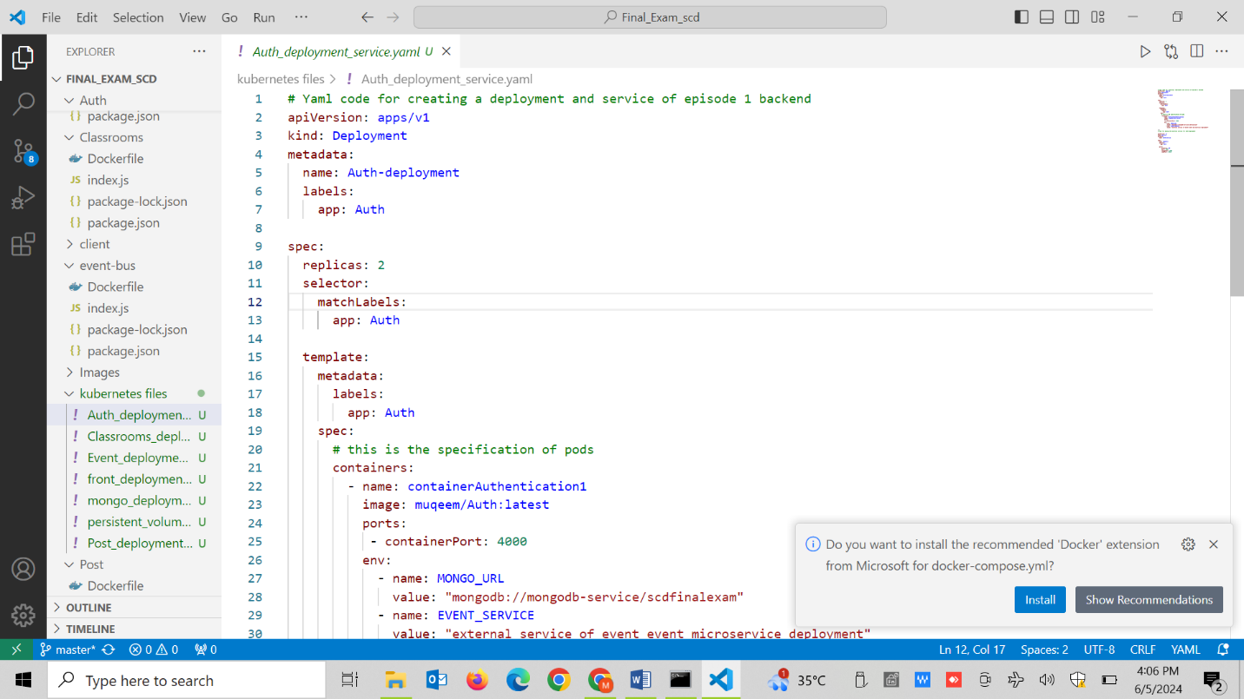

**Classrooms:**

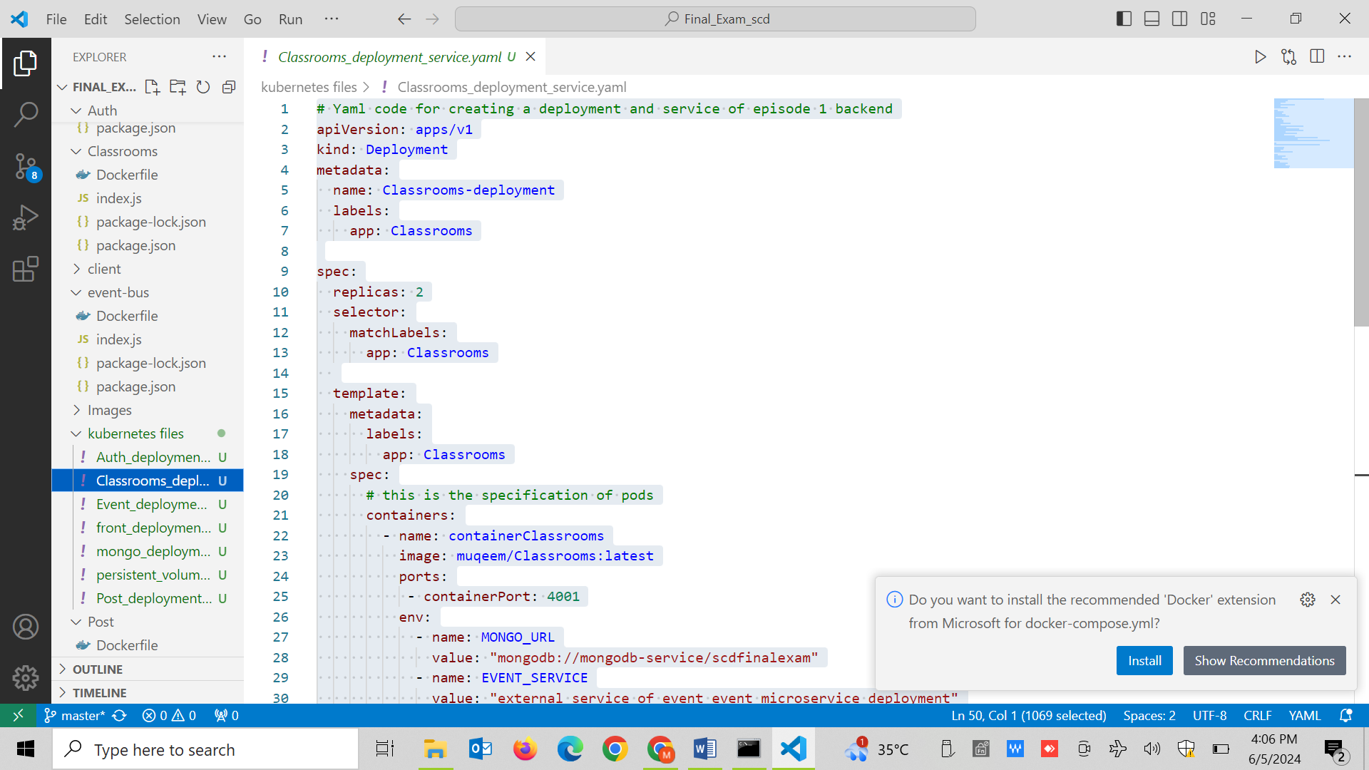

**Events:**

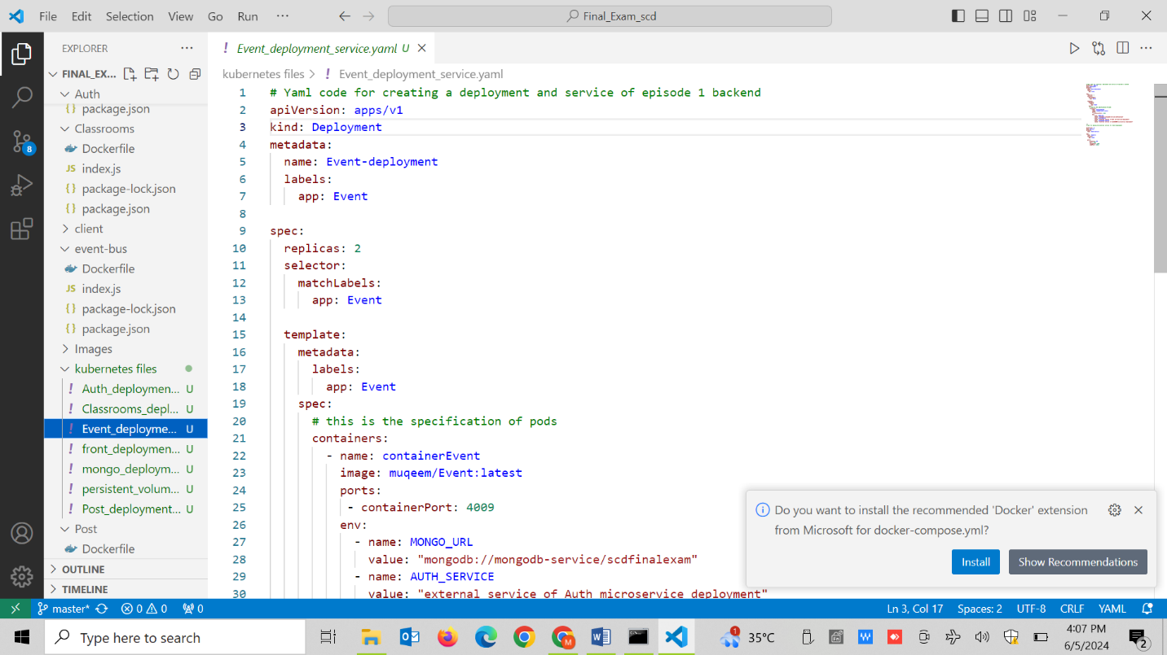

**Post-service:**

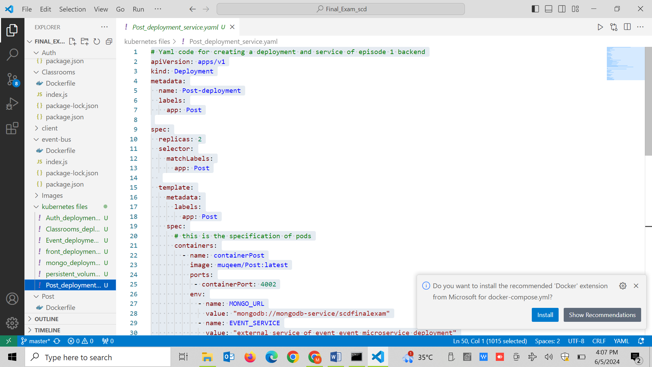

**Front-end:**

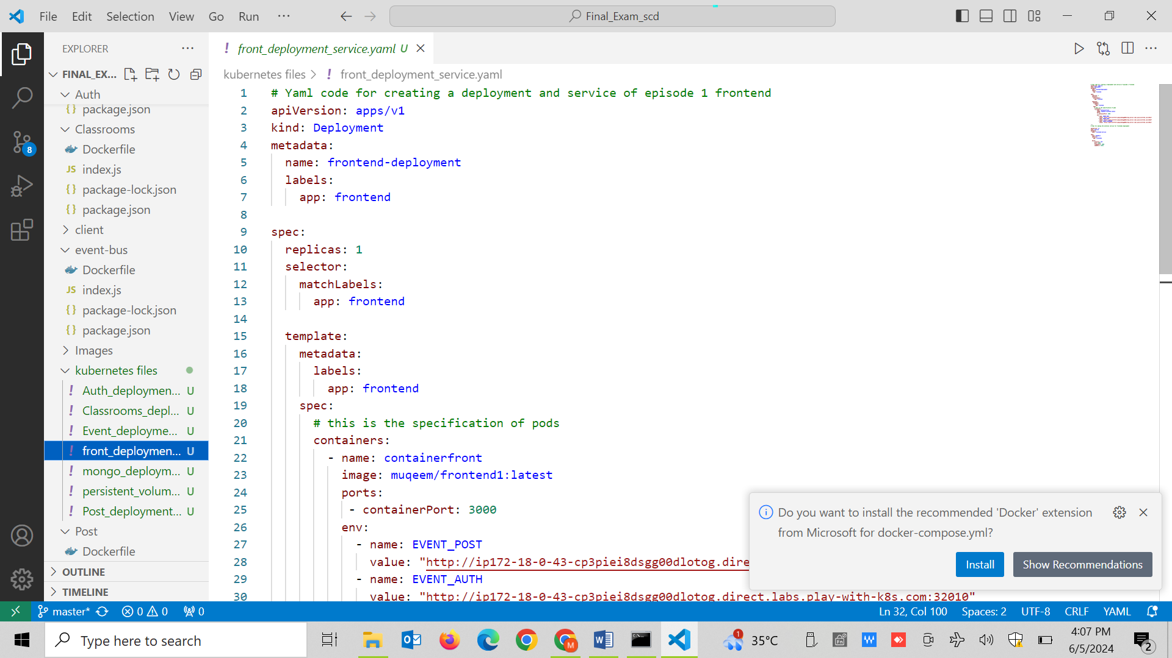

**MongoDb:**

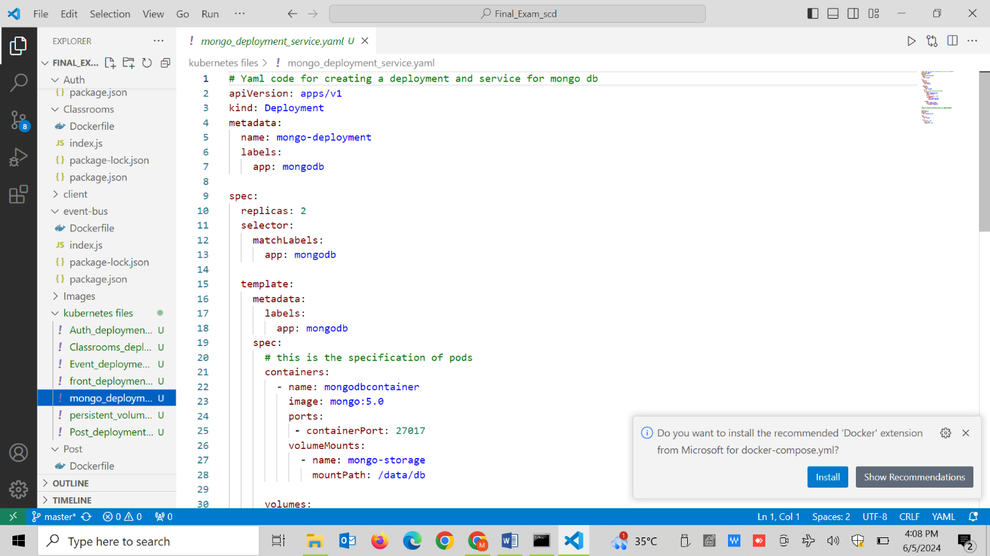

**Volume:**

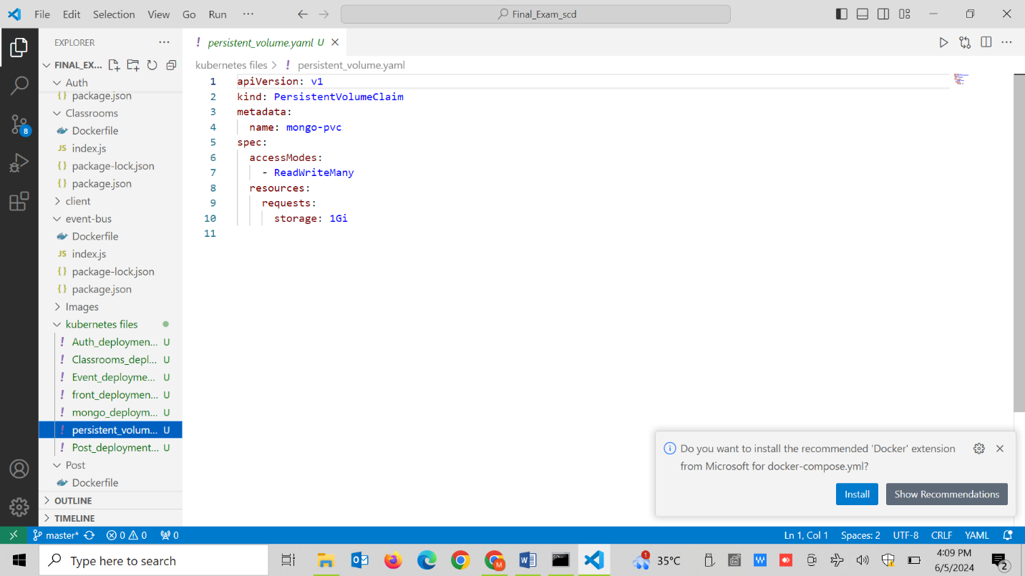

**Repository on github:**

