Bash-Scripting assignment-01.
Notes: Create a Jira ticket for this assignment, work on the tasks listed below, and submit the task completion document by EOD with clear steps and required evidence (outputs/screenshots)
- Watch the video and write down notes.
- Execute all scripts shown in video and capture the screenshots.
- Execute all the scripts share in #devops-cloud-documents-14 channel.

.Created directory and file
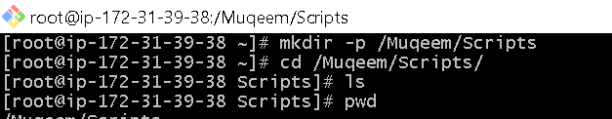
.edited file with
Ø Vi Helloworld
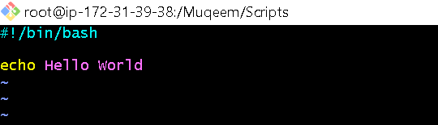

. chmod 777 Helloworld
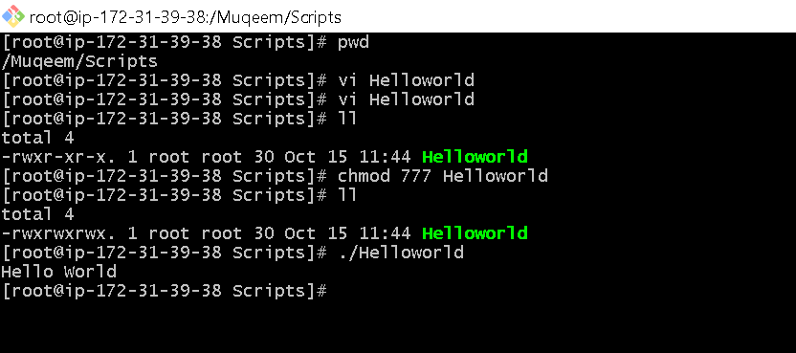

.we must give propper naming conventions for our scripts like below.
. and change the permissions using chmod 755 Filename
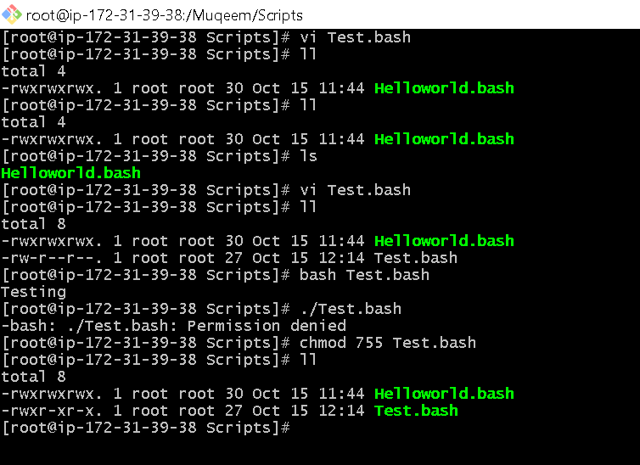

. we add comments after#
eg. #Purpose, #Date,#Modification
.And we add Variables/Containers in the script
Eg. a=’write what you want to store in the container or variable’

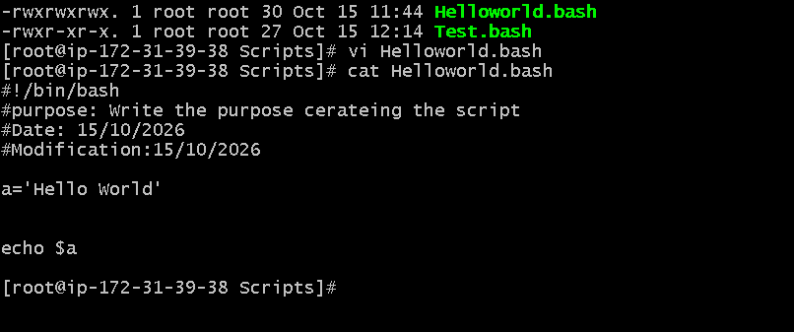

.To delete all the script file we have created we use the cmd .> rm -rf *
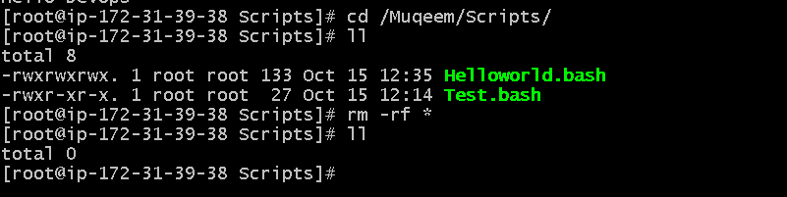
.to edit the script we use vi Filename
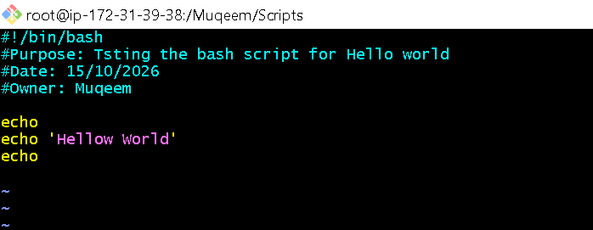
.create new script and change the permission
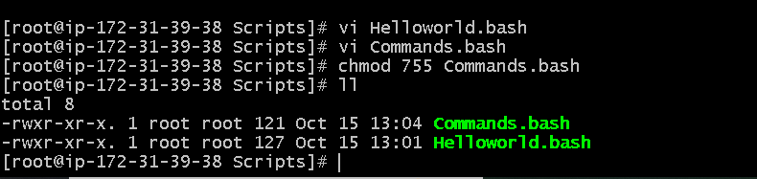
.To run and check the script we have created use the command
> ./Filename and enter
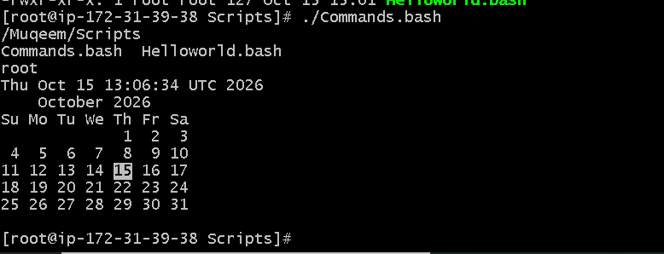

Created new script for sanity test
And changed the permissions
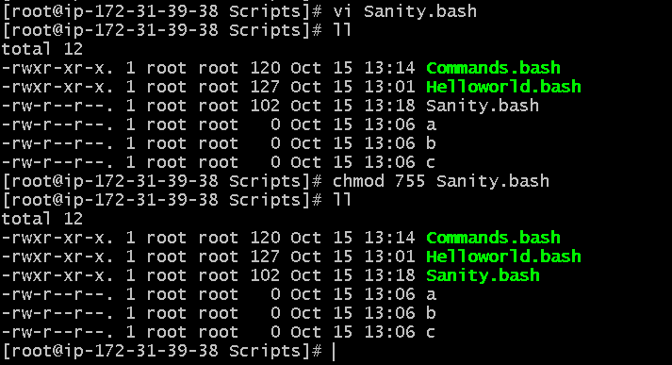
Now to run the script we use command
> ./Filename ex: ./Sanity.bash and enter
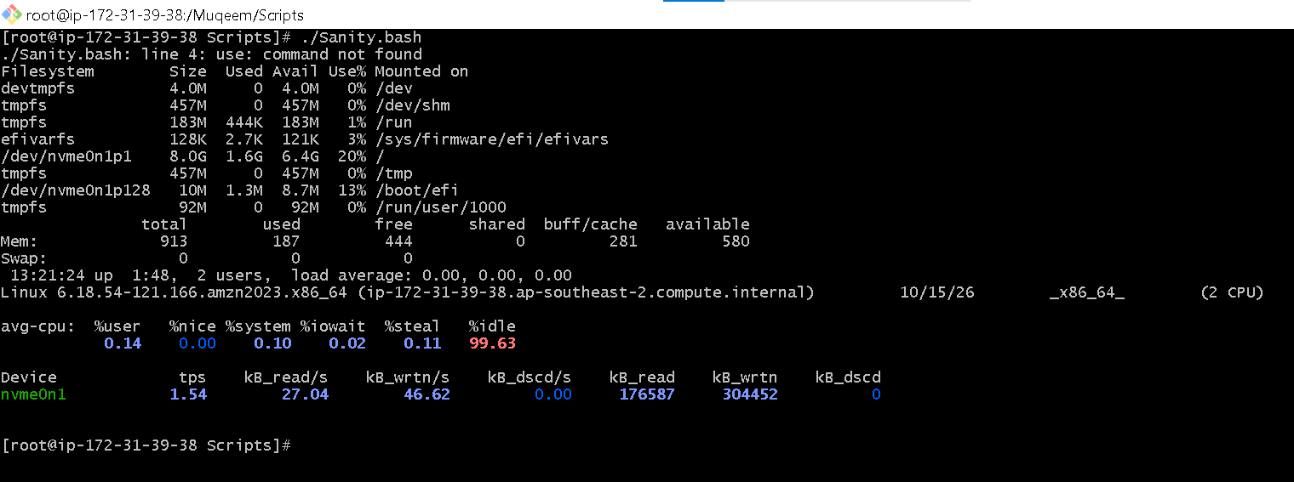
.Created a new script by name Variable.bash
.And changed permissions
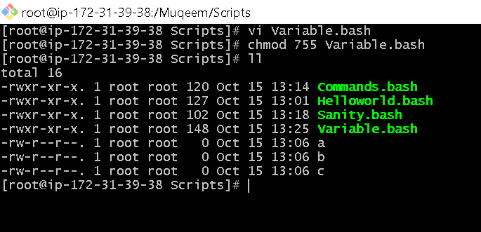

.Now to Run the Variable.bash script use the below cmd.
> ./Variable.bash
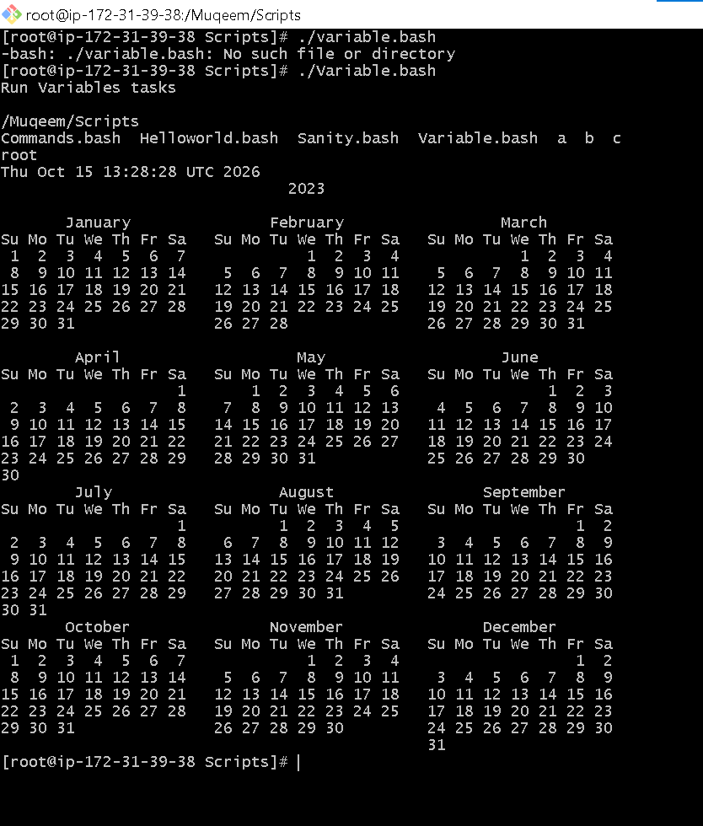

.Created one scrip with name Input.bash for “Hello my name is Muqeem”
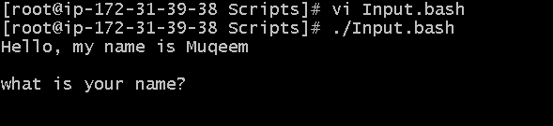

.Created a new script with name Output and added file permissions
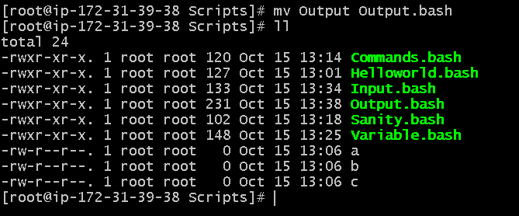

.Run script Output.bash using th command ./Output.bash

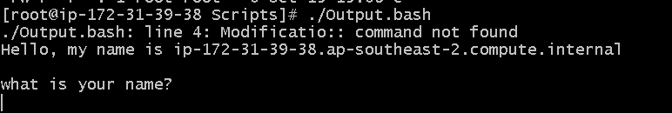

Created a new script with name Condition1.bash

And changed permissions to file
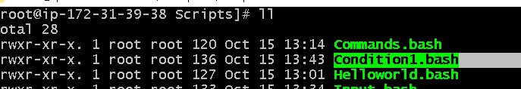

.Executed the script of Condition1.bash

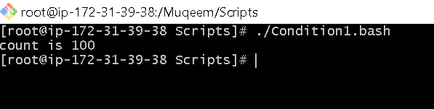

.Created a new script for the name Condition2.bash
And added execution permission to the file of script
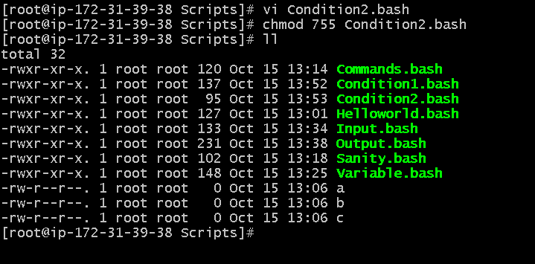

Condition:
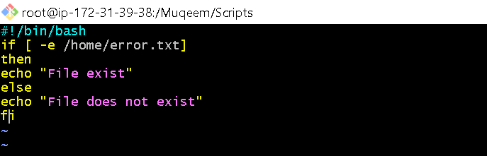

.Executed the script
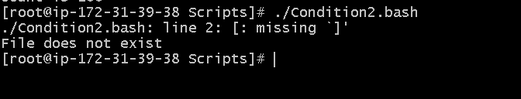

.Created a new script for Case Statement
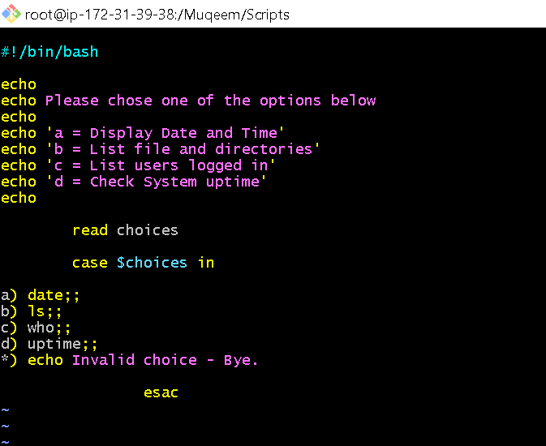

.Executed the script
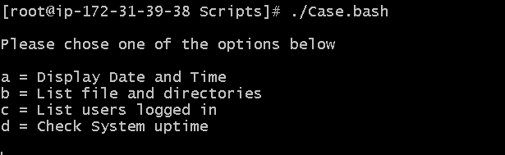

.Created a script of For loop

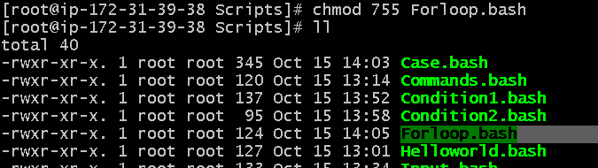

Script in vi looks like
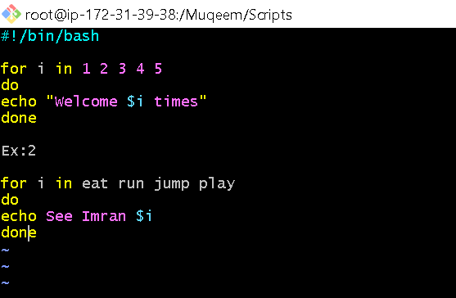
.Executed the script

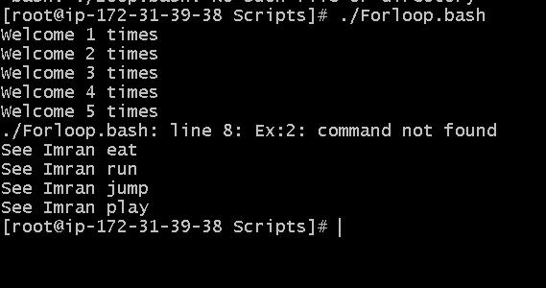

.Created a script for Do-while

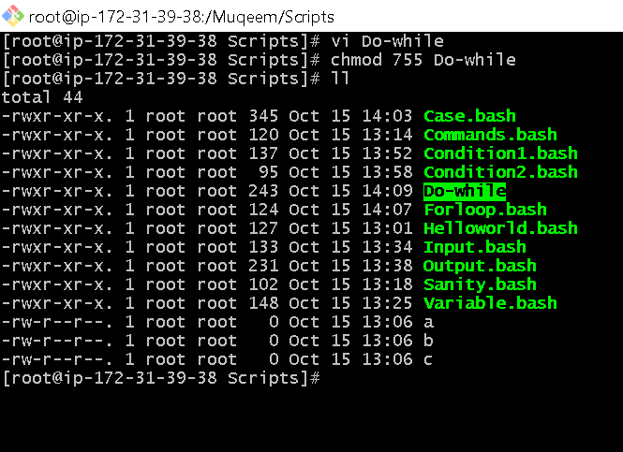
Do-while script in vi editor
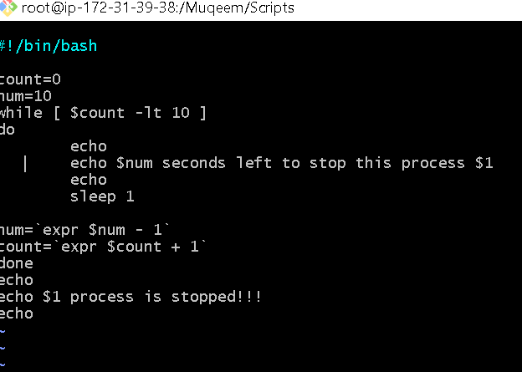

Executed the Do-while script with the result.

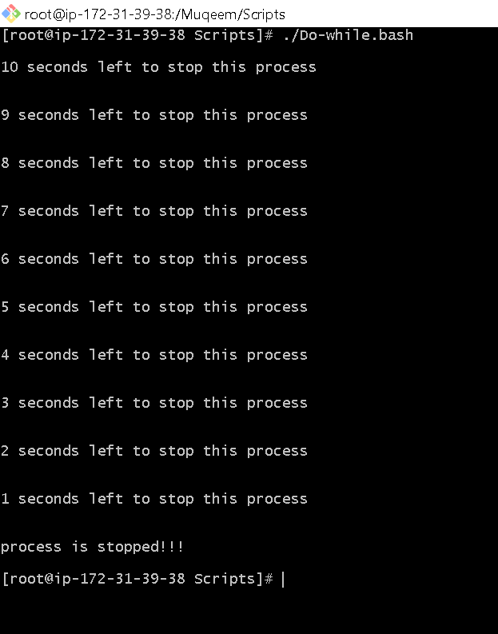

Created script for exit status
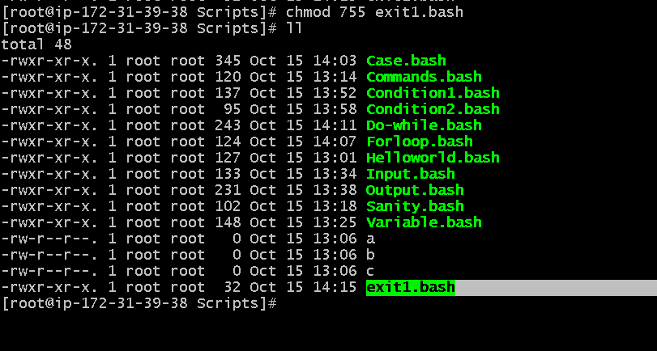

script:

.Executed the script with result.


