Task on Application and Web Servers
server app5 3.26.61.170:80 check
server app6 13.54.233.181:80 check

Notes: Create a Jira ticket for this assignment, work on the tasks listed below, and submit the task completion document by EOD with clear steps and required evidence (outputs/screenshots)
- Install nginx and run nginx on port number 81. (3.25.170.31)
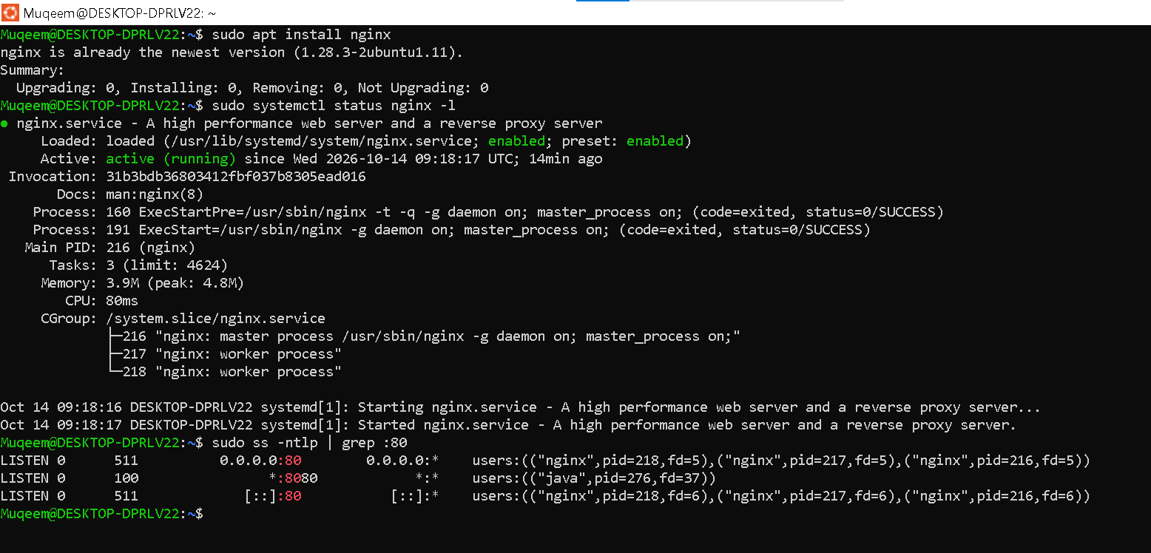

.Configured the port number from 80 to 81
.Using the command in wsl : > sudo nano /etc/nginx/sites-available/default
.And checked the syntax error using the command in wsl : > sudo nginx -t
.restarted nginx using command: > sudo systemctl restart nginx
.checked status using : > sudo systemctl status nginx
.and checked what service actually running on port 81 with
: >sudo ss -ntlp | grep :81
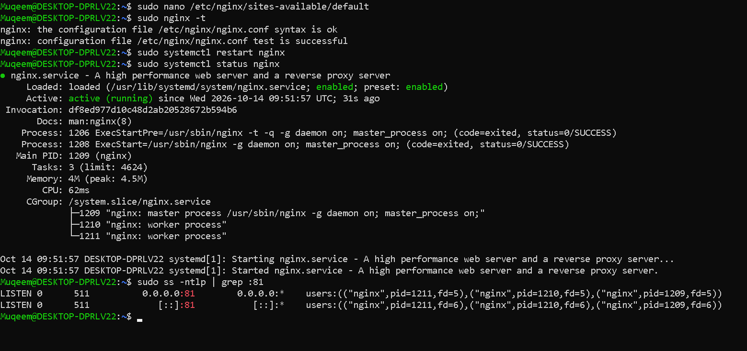
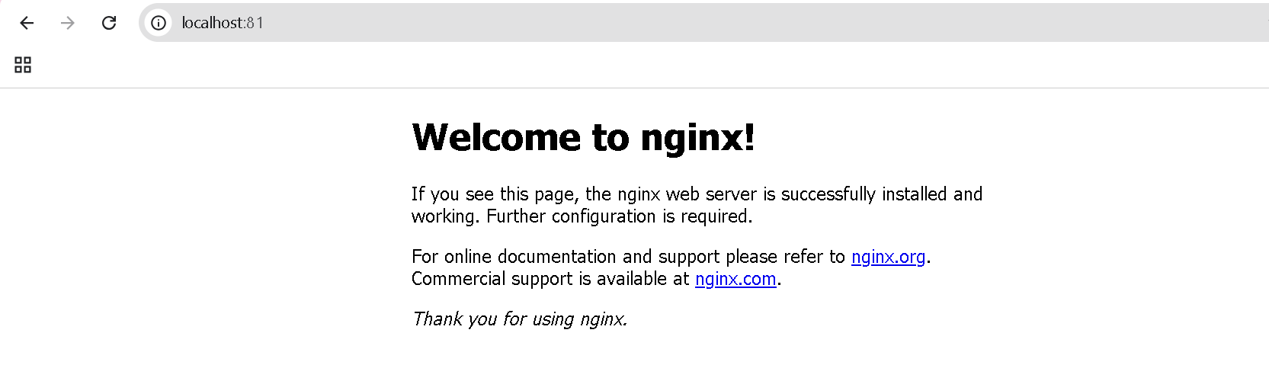
- Deploy a sample index.html file on nginx.
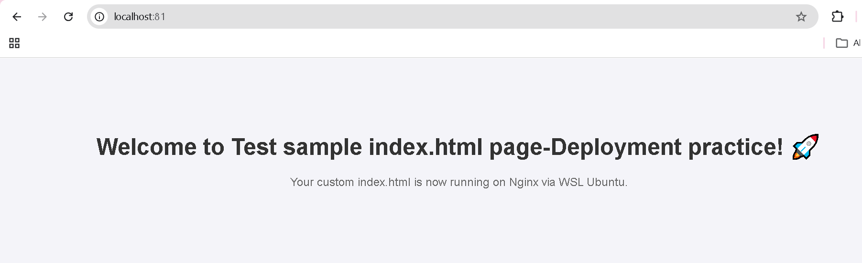

- Install Apache and run Apache on port number 82
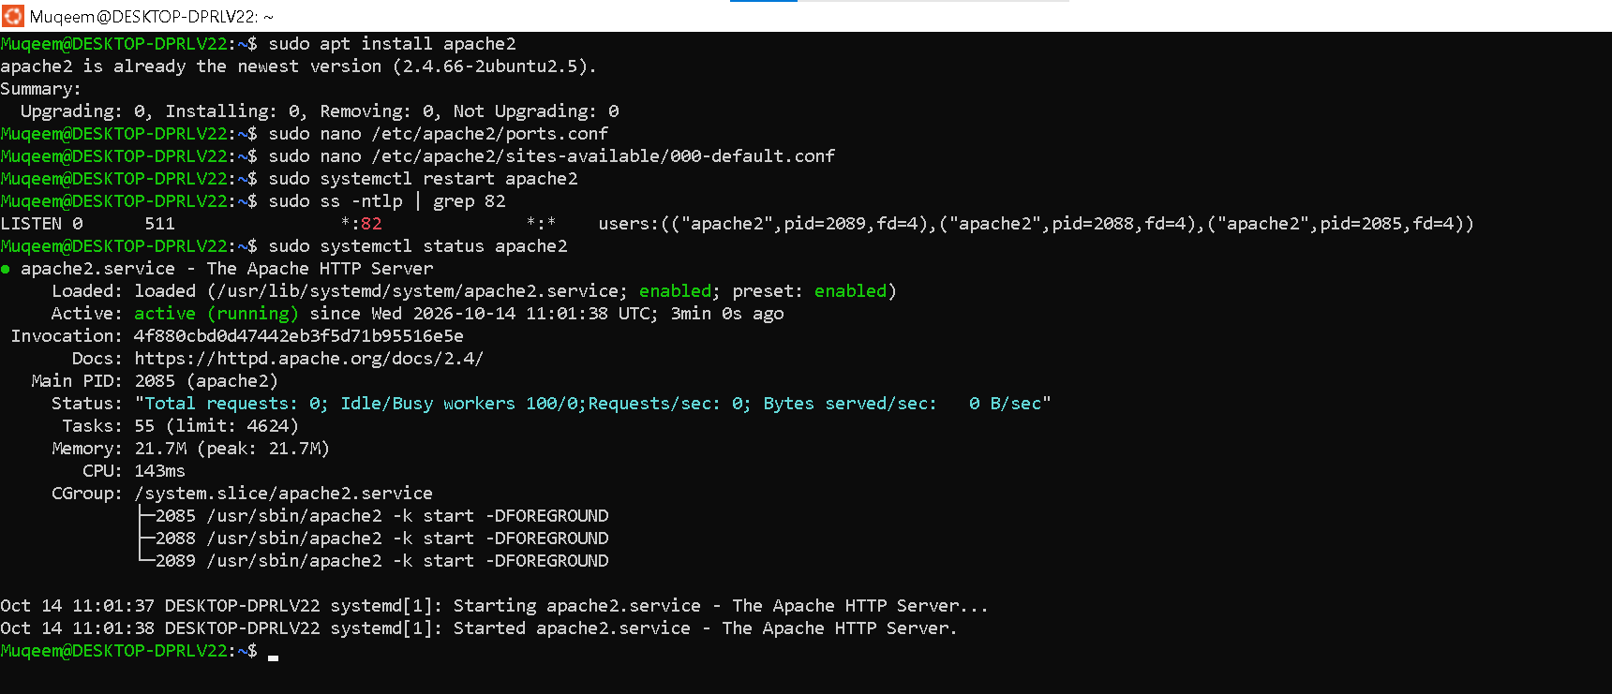

- Deploy a sample index.html file on Apache.
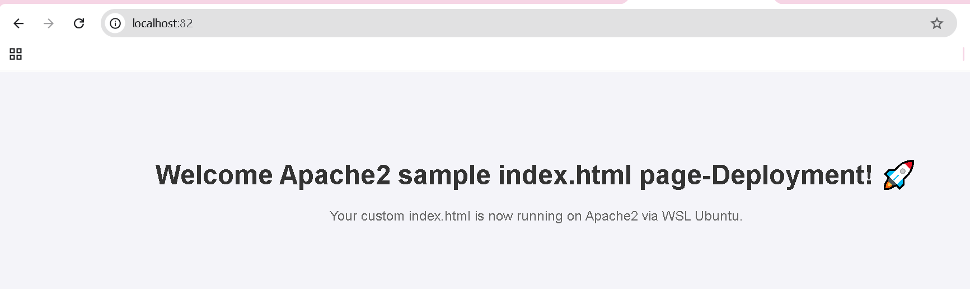

- Install Apache tomcat and run on port number 8082
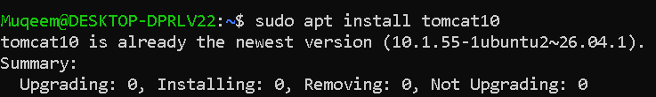
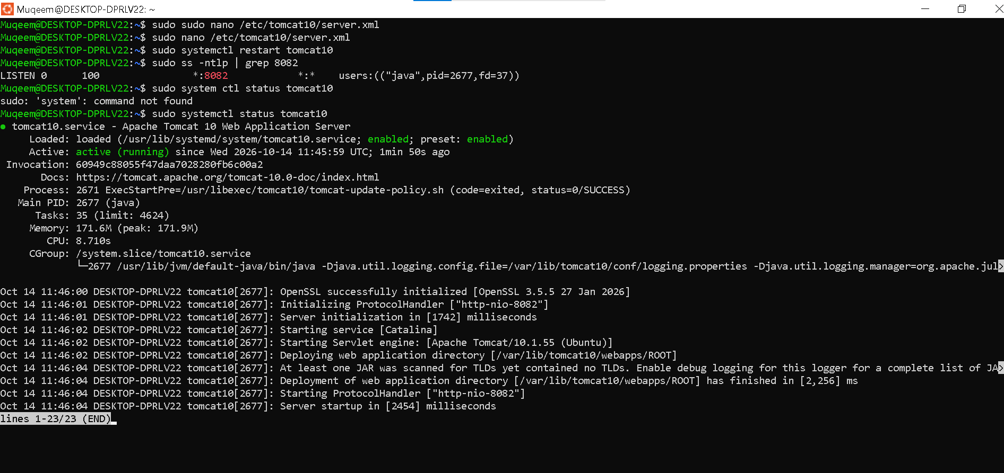

- Deploy a sample app on webapps
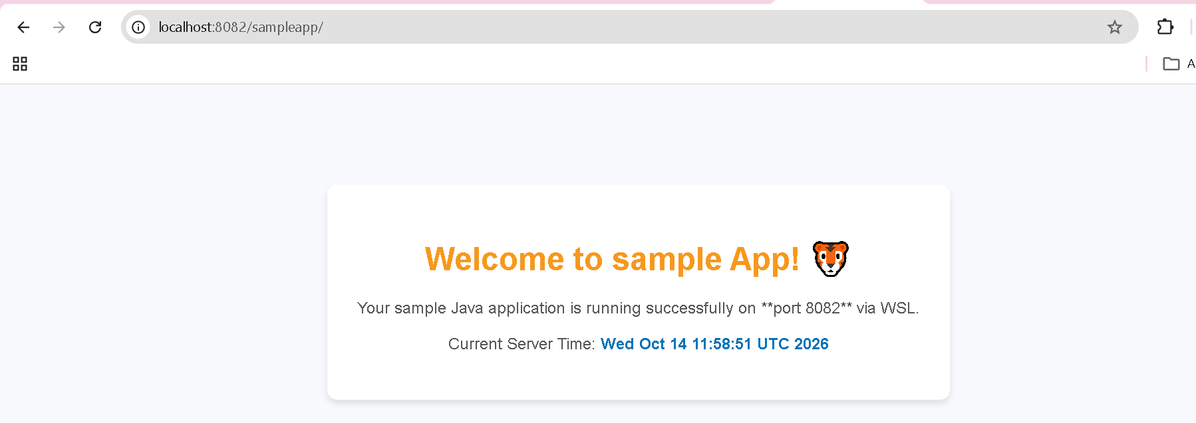

- Create a tomcat.service file for tomcat.

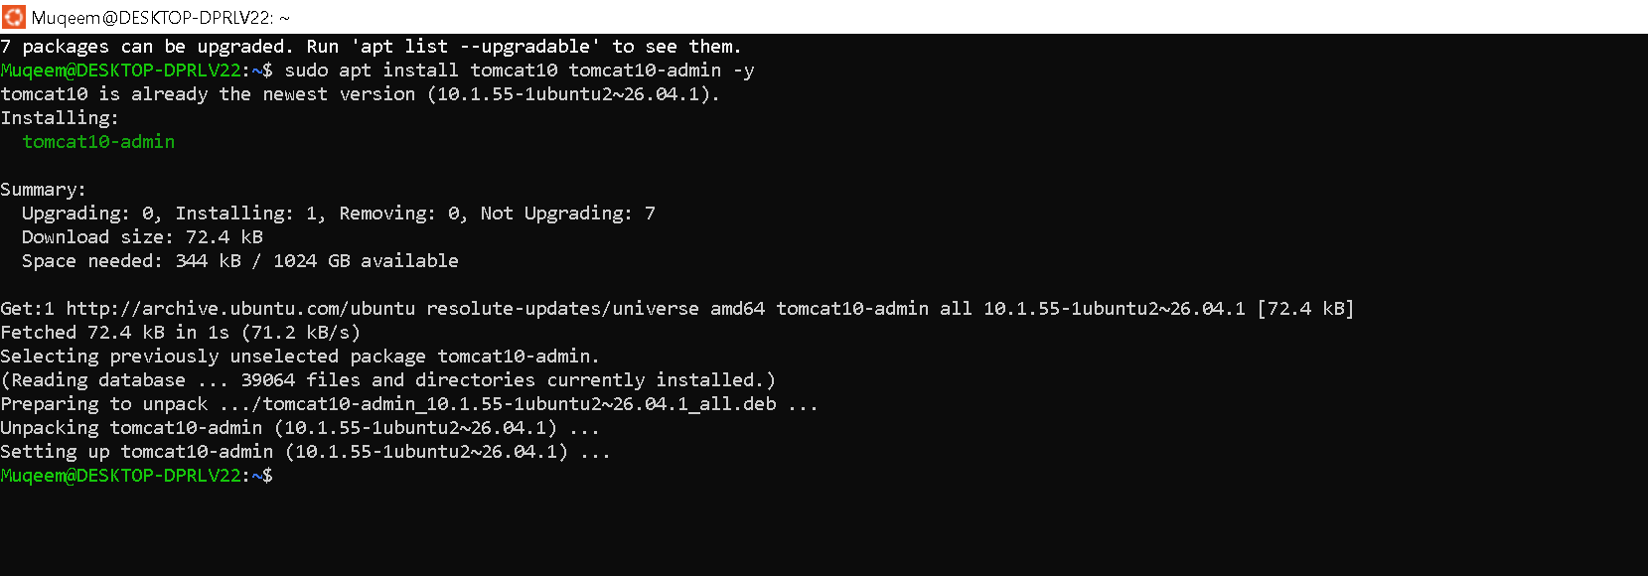
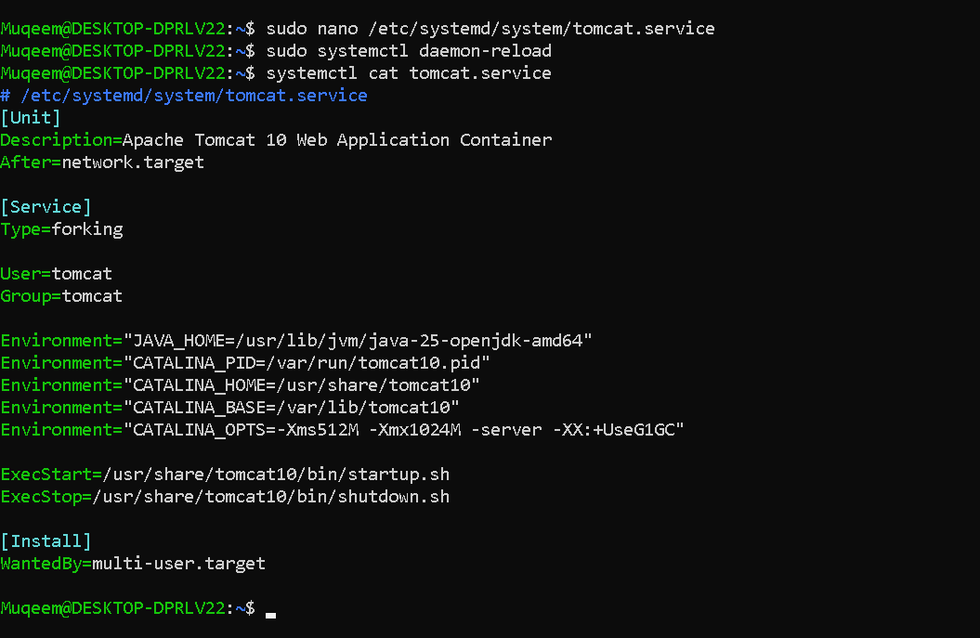

- Configure HA Proxy server
Launch 3 ec2 instances name as Server1, Server-2, HA-Proxy-Server.

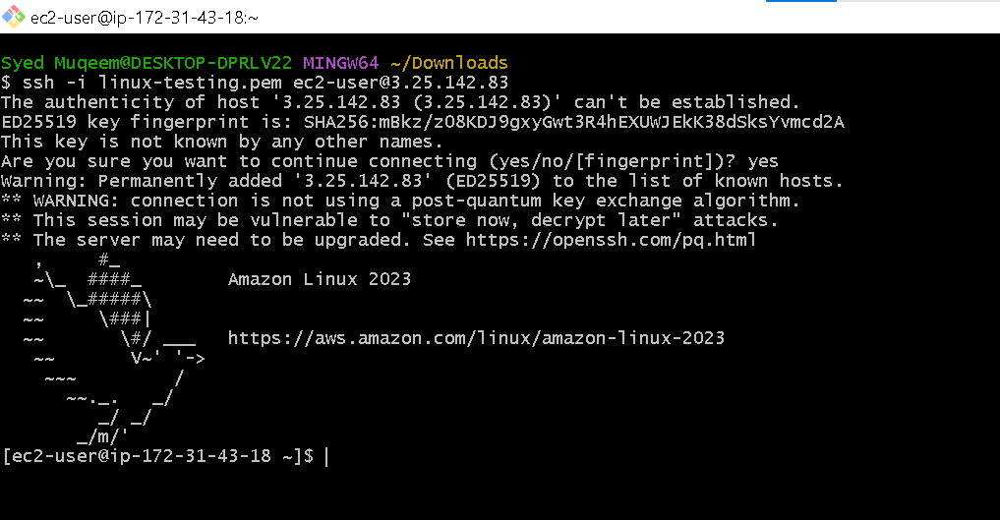
.sudo -i 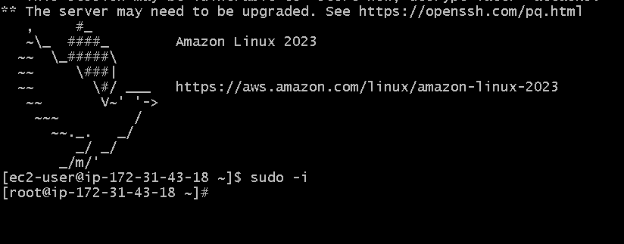
.yum update -y
.yum install httpd -y
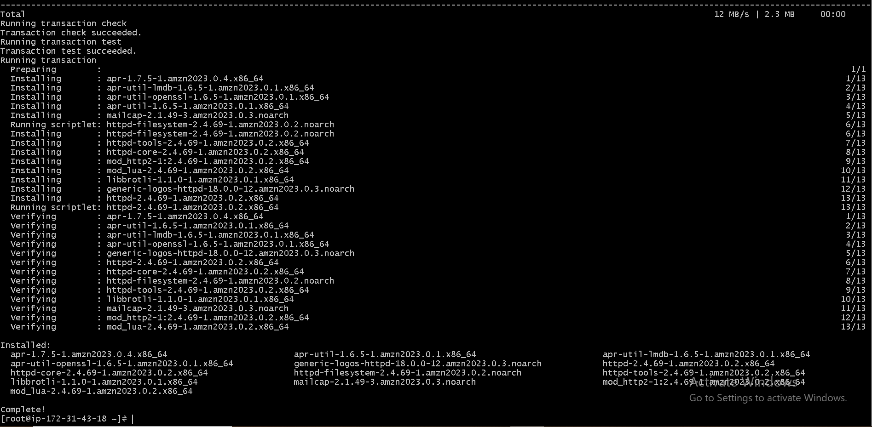
.vi /etc/hosts
.Add public IP of the Server1-Instance

.Run command > ping load_balancer -c4
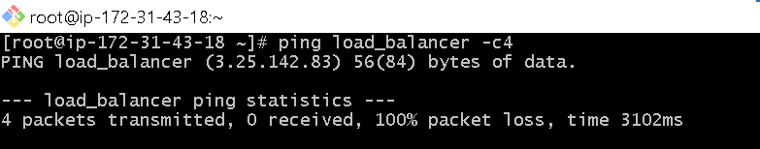

.> systemctl start httpd
.> systemctl status httpd

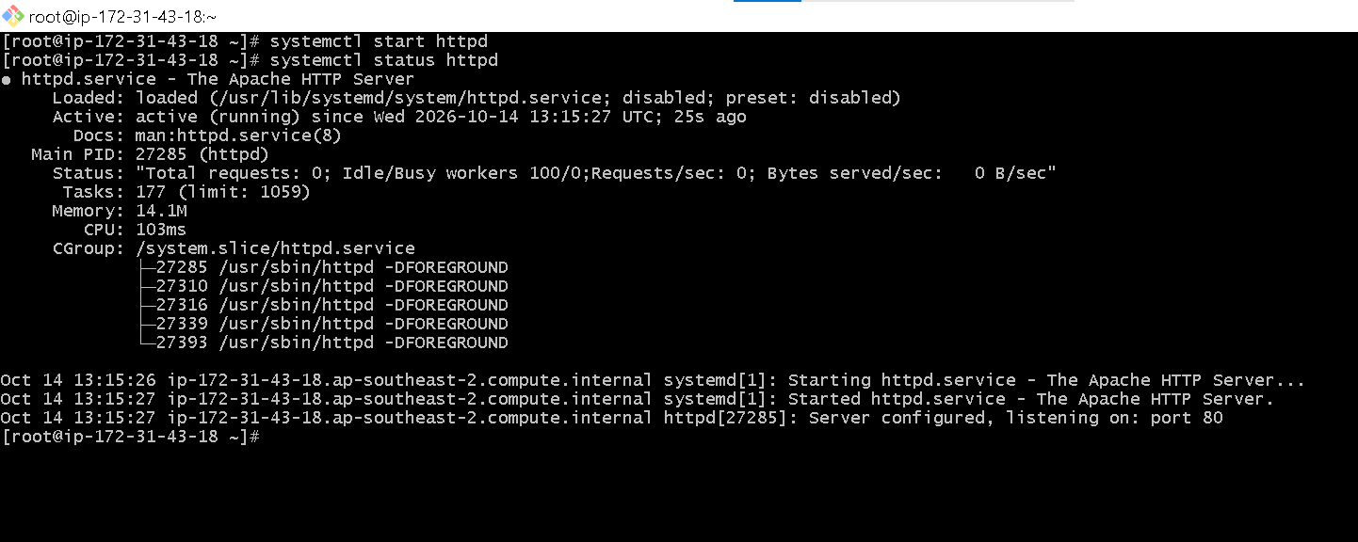
.Server2
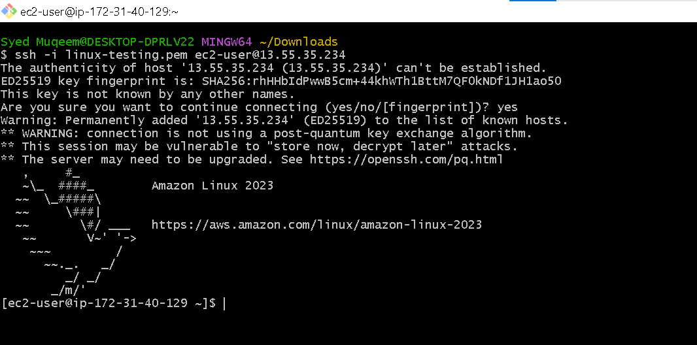
.sudo -i
.yum update -y

.yum install nginx -y
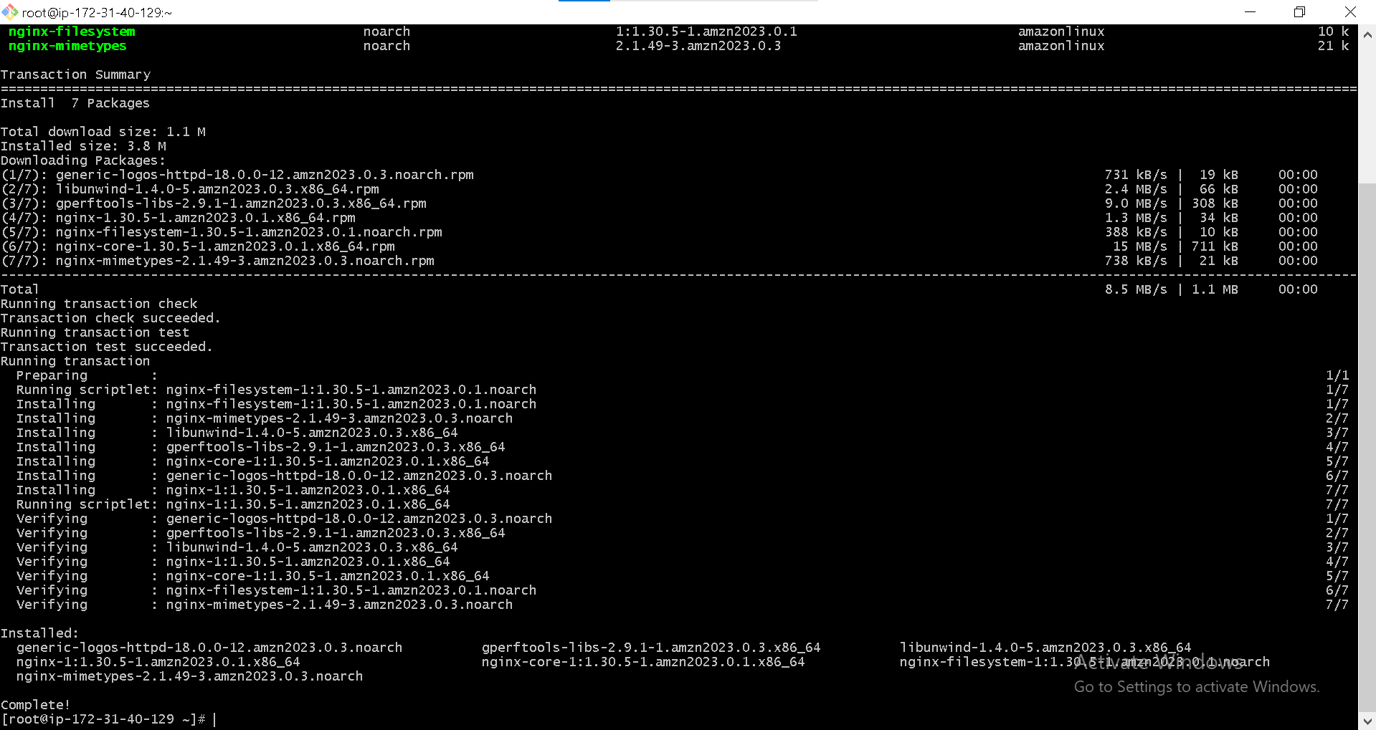
.vi /etc/hosts
.Add Server2-instance public IP
.cat /etc/hosts
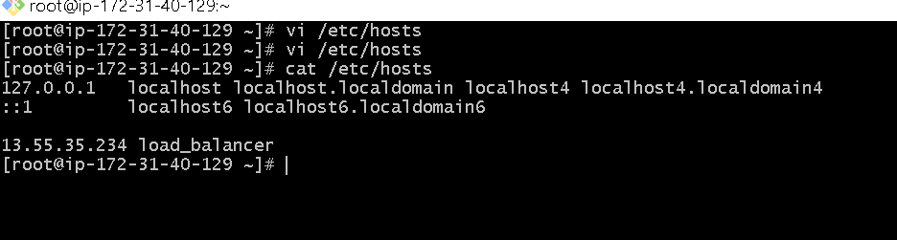
.ping load_balancer -c4
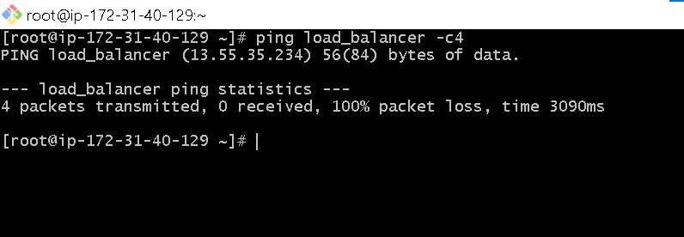

.systemctl start nginx
.systemctl status nginx
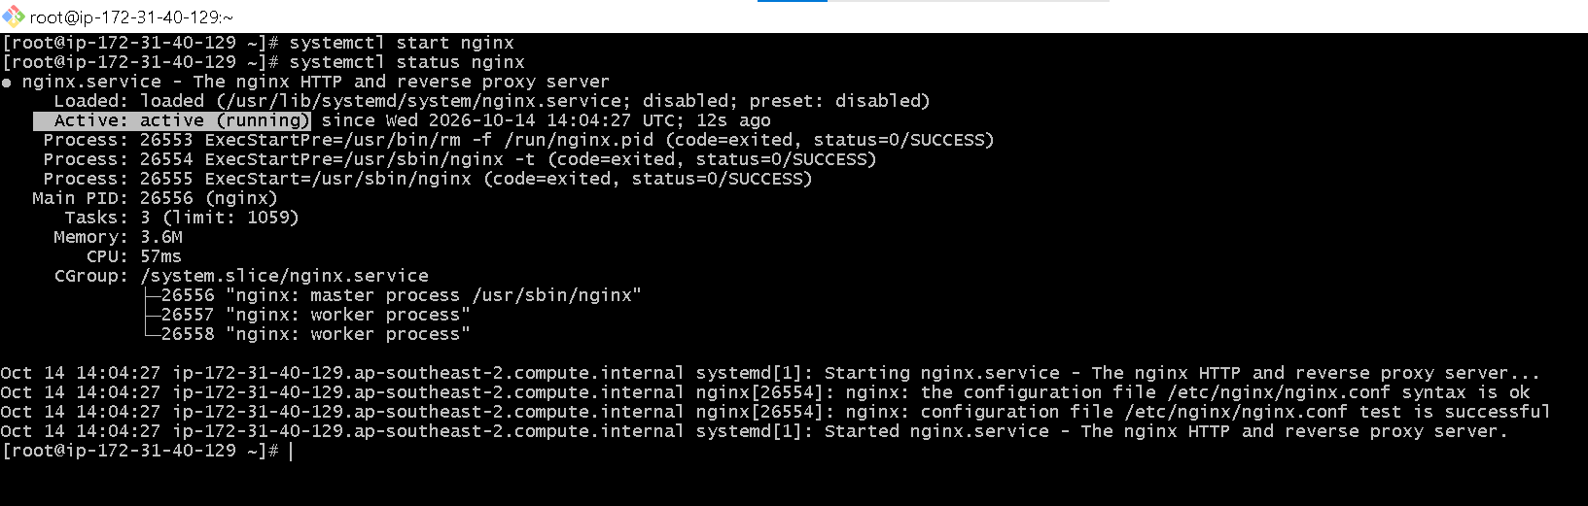

. HA-Proxy-Server. Instance
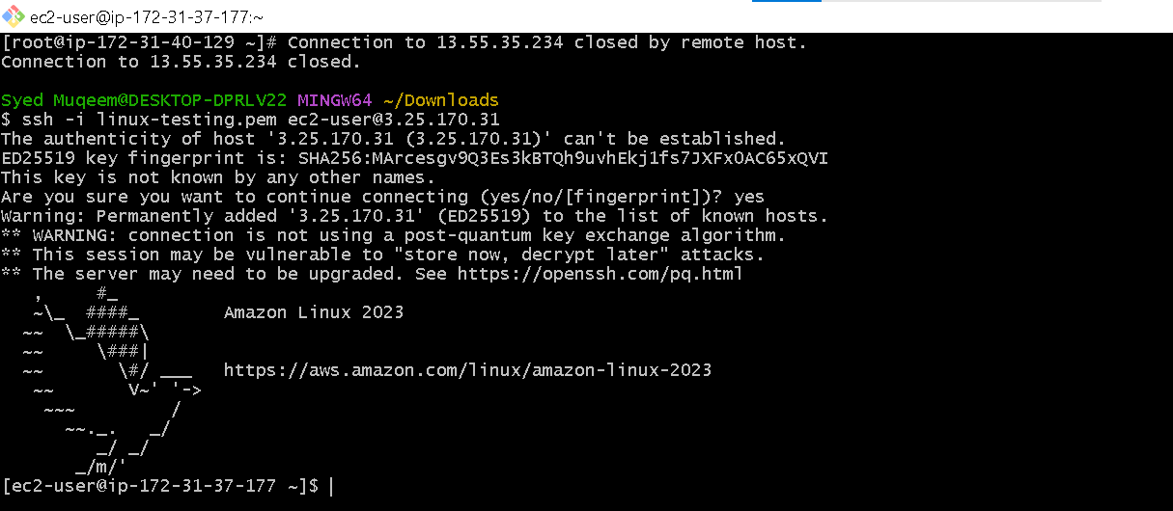
.sudo -i
.yum update -y


. yum install haproxy
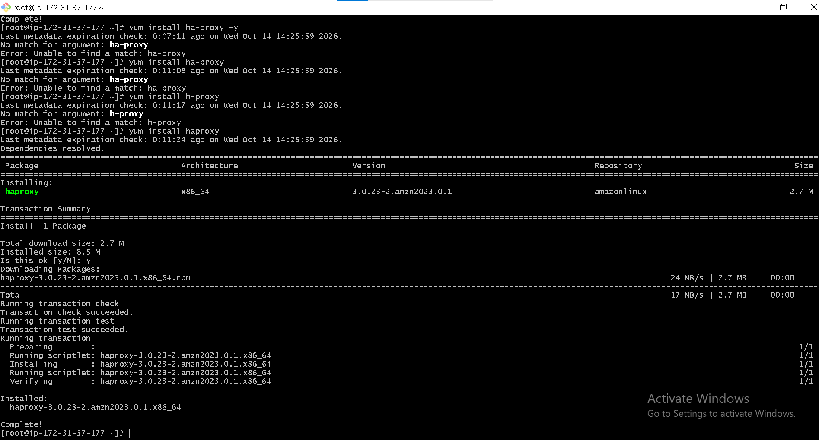
.vi /etc/hosts
Add Server1 public IP
Servr2- Public IP
.cat /etc/hosts



