Challenge-1
Notes: Create a Jira ticket for this assignment, Provide detailed step-by-step instructions for the installation process along with proper evidence (Outputs, and screenshots). You may refer to YouTube tutorials or Google resources for guidance, and submit the challenge completion document by EOD.
- Launch one aws ec2 and install jenkins.
- Setup Apache Tomcat on Ubuntu Virtual Machine
- Setup Docker Desktop on your local windows.

- Launch and aws ec2 and install Jenkins.

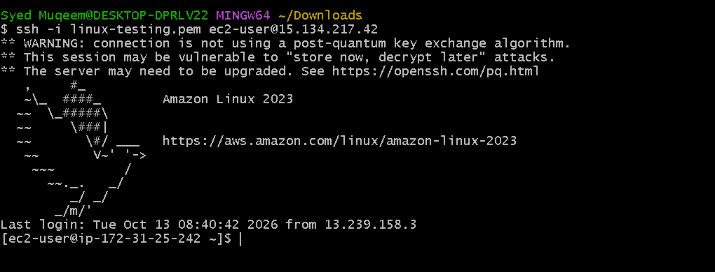
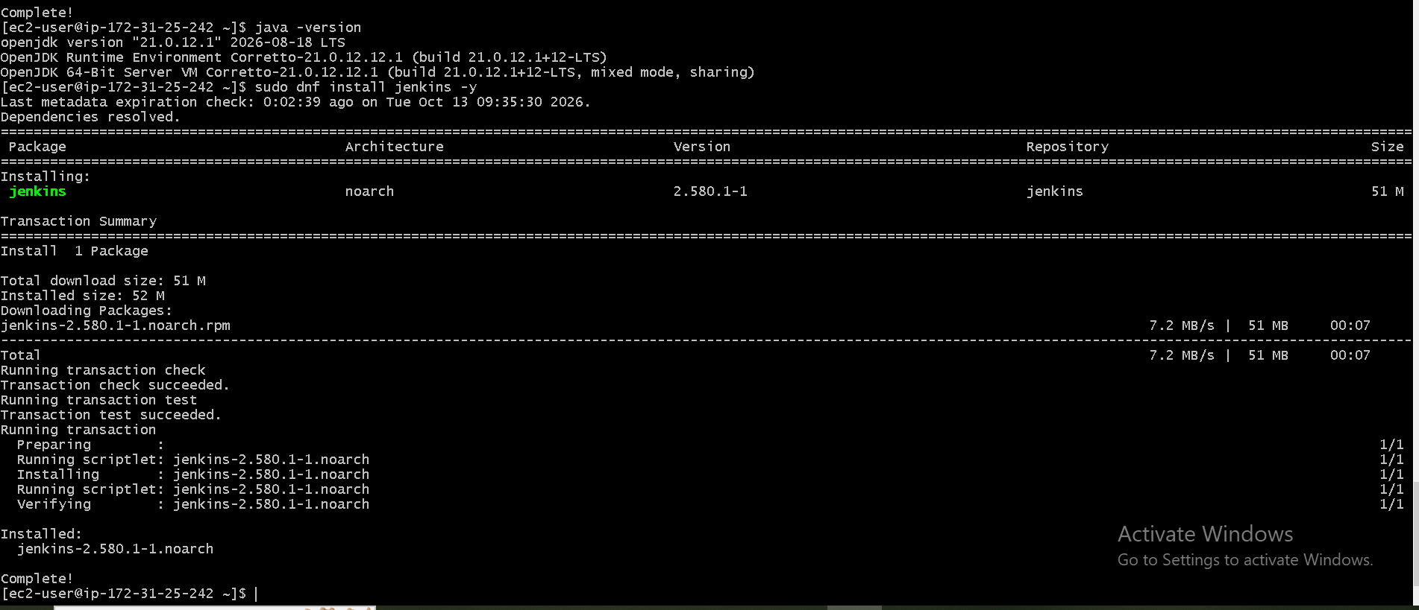
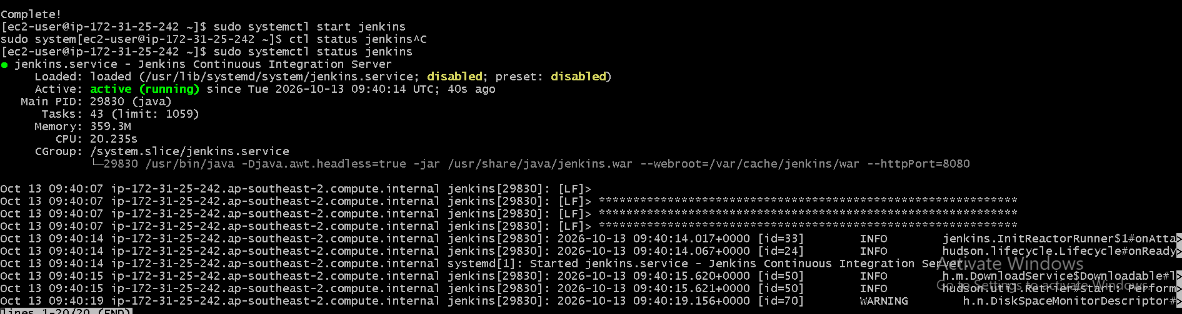

Checked in the browser.

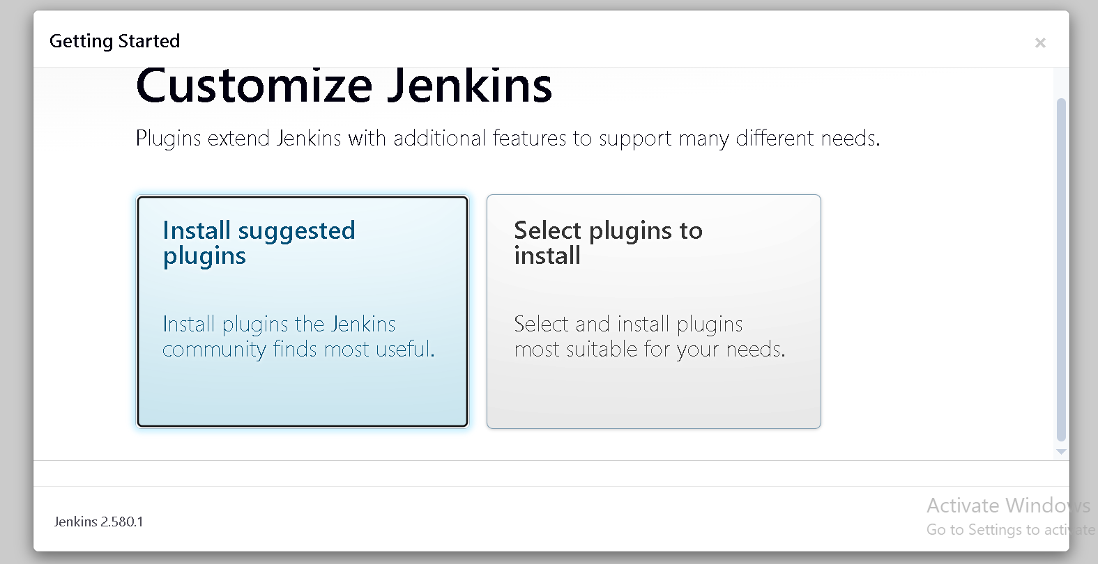

- Set up Apache Tomcat Ubuntu Virtual Machine.

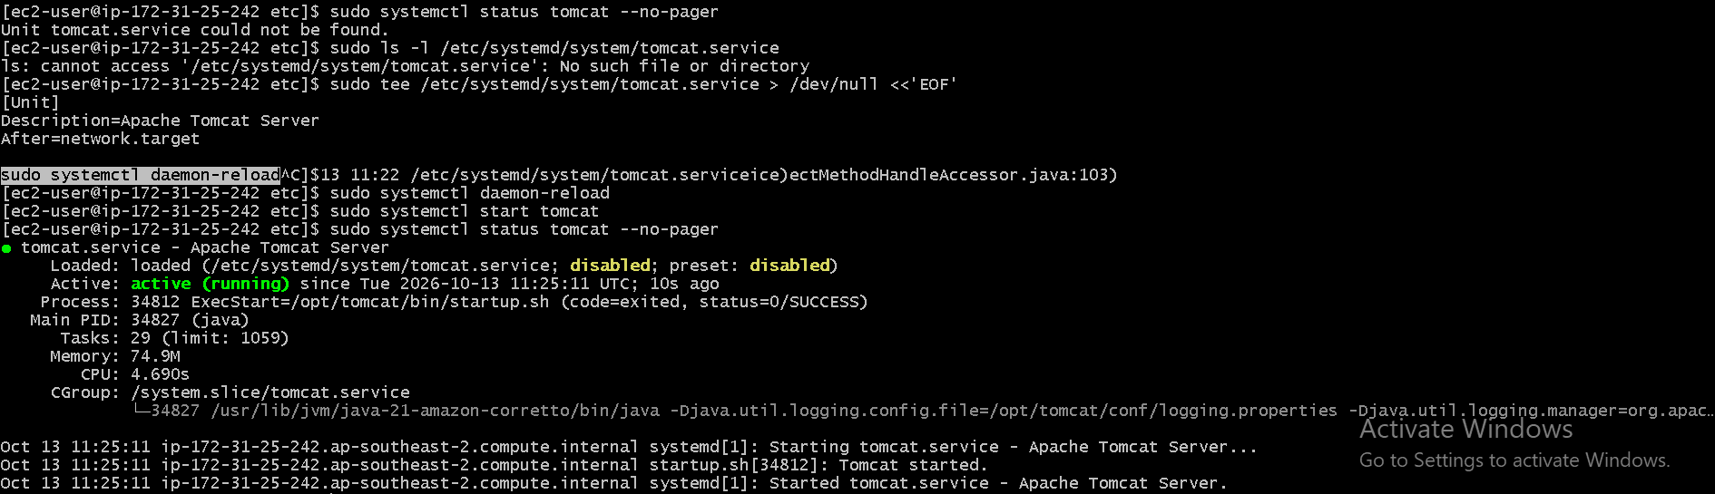

And checked on browser as well.

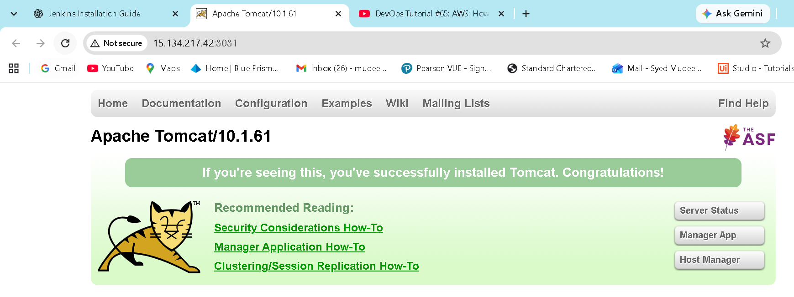

- Setup Docker Desktop on your local windows.
Successfully downloaded and installed in the local windows.s
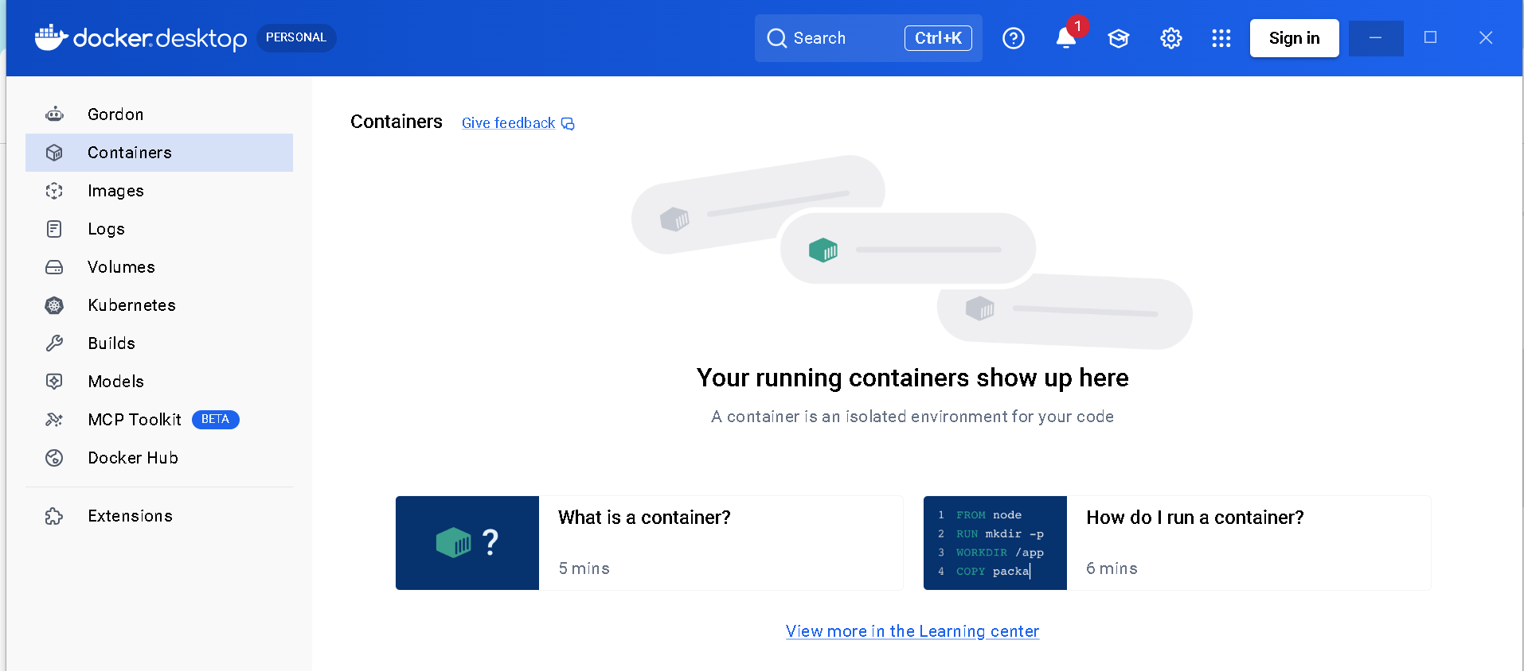

Note: Closed jira ticket for the challenge-1
Completed the challenge

- Launched aws ec2 and installed jekins in it,
And attached screenshots of the process.

- Set up the apache tomcat on ubuntu virtual machine, and attached screenshots.

- Set up Docker in the local windows.

