BTReport Classification Results: Accuracy, F1, and Weighted F1
Molecular and grade classification performance across six LLMs (GPT-OSS-120B, GPT-5.5, Gemini 2.5 Pro, Llama-4 Maverick, DeepSeek-R1, and OpenBioLLM-70B), comparing the BTReport and BTReport++ feature sets. Each block reports accuracy, F1 (binary positive-class for IDH and 1p/19q, macro-averaged for grade), and weighted F1 (support-weighted across classes).

Summary
Across the whole cohort of 646 subjects, IDH-status prediction was the strongest of the three tasks, and GPT-5.5 was the clear overall leader (accuracy 0.788, F1 0.764, weighted F1 0.784 under BTReport features), ahead of GPT-OSS-120B, Gemini 2.5 Pro, Llama-4 Maverick, DeepSeek-R1, and the domain-specialised OpenBioLLM-70B, which cluster together at a lower level. Because IDH classes are relatively balanced, the F1 and weighted-F1 columns track closely for this task. Moving to the expanded BTReport++ feature set improved IDH performance for several models, chiefly by raising sensitivity: GPT-5.5 climbed to 0.822 accuracy and 0.822 weighted F1, Gemini improved from 0.662 to 0.736 weighted F1, and Llama-4 Maverick rose from 0.647 to 0.716 weighted F1, whereas GPT-OSS-120B and DeepSeek-R1 regressed on IDH (weighted F1 0.736 to 0.652 and 0.672 to 0.614 respectively) as their specificity fell. OpenBioLLM-70B showed the sharpest degradation under BTReport++, with IDH accuracy dropping from 0.678 to 0.512 (weighted F1 0.678 to 0.437), suggesting the larger feature set overwhelmed rather than helped this smaller biomedical model. The 1p/19q codeletion task shows the largest gap between the two F1 variants for every model: binary (positive-class) F1 is very low (from 0.00 for DeepSeek-R1 up to 0.44 for GPT-5.5 and 0.43 for OpenBioLLM-70B) because the codeleted minority is rarely recovered, yet weighted F1 is high (roughly 0.70 to 0.78) since the dominant non-codeleted class is classified well. This contrast is the clearest signal of class imbalance in the data, and it means weighted F1 alone can overstate codeletion competence. Tumor grading was intermediate; GPT-5.5 was again best (accuracy 0.690, macro F1 0.557, weighted F1 0.669 under BTReport++), with DeepSeek-R1, Llama-4 Maverick, and OpenBioLLM-70B mid-pack (weighted F1 around 0.52 to 0.59), and in every case the weighted score sits above the macro F1 because grade 4, the majority class, is identified most reliably while errors concentrate between grades 2 and 3.
The per-dataset breakdown shows performance is uneven across sources for all six models. Results are strongest on the larger, class-balanced cohorts (UCSF-PDGM and EGD) and weakest on TCGA-LGG, where grade accuracy collapses to roughly 0.13 to 0.27. On the small glioblastoma-only cohorts (TCGA-GBM, UPENN-GBM, IvyGAP) the labels are highly skewed, so accuracy and weighted F1 are inflated while binary/macro F1 stays near zero because the rare minority class is essentially never recovered — the divergence between the F1 and weighted-F1 columns is the most reliable indicator of these degenerate cases. Overall, BTReport++ tends to trade specificity for sensitivity, helping the harder IDH calls for GPT-5.5, Gemini, and Llama-4 Maverick while hurting GPT-OSS-120B, DeepSeek-R1, and especially OpenBioLLM-70B; across tasks, datasets, and both F1 definitions, GPT-5.5 remains the most consistent performer, and the remaining five models — including the medically fine-tuned OpenBioLLM-70B, which does not outperform the general-purpose models here — are broadly comparable to one another.

Overall (whole cohort)
Whole-cohort results (IDH n=646, 1p/19q codeletion n=541, grade n=646). Acc. = accuracy; F1 = positive-class (binary) / macro (grade) F1; W-F1 = weighted F1.
Model | Task | BTReport Features |  |  | BTReport++ Features
 |  | Acc. | F1 | W-F1 | Acc. | F1 | W-F1
GPT-OSS-120B | IDH | 0.737 | 0.729 | 0.736 | 0.652 | 0.671 | 0.652
 | 1p/19q codel. | 0.780 | 0.168 | 0.727 | 0.784 | 0.245 | 0.744
 | Grade | 0.588 | 0.500 | 0.599 | 0.554 | 0.461 | 0.566
GPT-5.5 | IDH | 0.788 | 0.764 | 0.784 | 0.822 | 0.827 | 0.822
 | 1p/19q codel. | 0.793 | 0.440 | 0.783 | 0.782 | 0.410 | 0.772
 | Grade | 0.675 | 0.514 | 0.638 | 0.690 | 0.557 | 0.669
Gemini 2.5 Pro | IDH | 0.686 | 0.588 | 0.662 | 0.742 | 0.708 | 0.736
 | 1p/19q codel. | 0.789 | 0.081 | 0.715 | 0.756 | 0.298 | 0.738
 | Grade | 0.661 | 0.490 | 0.602 | 0.650 | 0.490 | 0.598
Llama-4 Maverick | IDH | 0.673 | 0.569 | 0.647 | 0.718 | 0.702 | 0.716
 | 1p/19q codel. | 0.675 | 0.207 | 0.674 | 0.756 | 0.143 | 0.710
 | Grade | 0.622 | 0.443 | 0.549 | 0.598 | 0.413 | 0.522
DeepSeek-R1 | IDH | 0.672 | 0.677 | 0.672 | 0.636 | 0.715 | 0.614
 | 1p/19q codel. | 0.795 | 0.018 | 0.706 | 0.793 | 0.000 | 0.701
 | Grade | 0.638 | 0.472 | 0.591 | 0.594 | 0.462 | 0.568
OpenBioLLM-70B | IDH | 0.678 | 0.699 | 0.678 | 0.512 | 0.262 | 0.437
 | 1p/19q codel. | 0.739 | 0.434 | 0.749 | 0.763 | 0.200 | 0.724
 | Grade | 0.574 | 0.475 | 0.565 | 0.567 | 0.407 | 0.531

Per-dataset breakdown
Accuracy, F1, and weighted F1 by source dataset. Acc. = accuracy; W-F1 = weighted F1.
Dataset | Model | Task | BTReport Features |  |  | BTReport++ Features
 |  |  | Acc. | F1 | W-F1 | Acc. | F1 | W-F1
UCSF-PDGM | GPT-OSS-120B | IDH | 0.822 | 0.832 | 0.822 | 0.733 | 0.763 | 0.731
 |  | 1p/19q codel. | 0.892 | 0.250 | 0.879 | 0.861 | 0.207 | 0.859
 |  | Grade | 0.686 | 0.578 | 0.704 | 0.696 | 0.611 | 0.718
 | GPT-5.5 | IDH | 0.806 | 0.793 | 0.805 | 0.848 | 0.859 | 0.848
 |  | 1p/19q codel. | 0.837 | 0.372 | 0.858 | 0.819 | 0.375 | 0.847
 |  | Grade | 0.822 | 0.645 | 0.791 | 0.801 | 0.668 | 0.795
 | Gemini 2.5 Pro | IDH | 0.791 | 0.765 | 0.786 | 0.811 | 0.808 | 0.811
 |  | 1p/19q codel. | 0.879 | 0.000 | 0.851 | 0.795 | 0.261 | 0.825
 |  | Grade | 0.838 | 0.698 | 0.815 | 0.822 | 0.711 | 0.817
 | Llama-4 Maverick | IDH | 0.775 | 0.736 | 0.767 | 0.791 | 0.794 | 0.791
 |  | 1p/19q codel. | 0.723 | 0.303 | 0.780 | 0.825 | 0.171 | 0.836
 |  | Grade | 0.791 | 0.671 | 0.781 | 0.744 | 0.619 | 0.740
 | DeepSeek-R1 | IDH | 0.660 | 0.663 | 0.660 | 0.654 | 0.725 | 0.638
 |  | 1p/19q codel. | 0.910 | 0.000 | 0.867 | 0.910 | 0.000 | 0.867
 |  | Grade | 0.764 | 0.604 | 0.738 | 0.696 | 0.564 | 0.687
 | OpenBioLLM-70B | IDH | 0.691 | 0.718 | 0.691 | 0.508 | 0.266 | 0.433
 |  | 1p/19q codel. | 0.729 | 0.348 | 0.785 | 0.831 | 0.176 | 0.840
 |  | Grade | 0.586 | 0.439 | 0.570 | 0.492 | 0.355 | 0.473
TCGA-GBM | GPT-OSS-120B | IDH | 0.680 | 0.000 | 0.648 | 0.640 | 0.400 | 0.674
 |  | 1p/19q codel. | 1.000 | 0.000 | 1.000 | 1.000 | 0.000 | 1.000
 |  | Grade | 0.880 | 0.312 | 0.936 | 0.840 | 0.304 | 0.913
 | GPT-5.5 | IDH | 0.760 | 0.000 | 0.691 | 0.840 | 0.667 | 0.849
 |  | 1p/19q codel. | 1.000 | 0.000 | 1.000 | 1.000 | 0.000 | 1.000
 |  | Grade | 1.000 | 0.333 | 1.000 | 0.960 | 0.327 | 0.980
 | Gemini 2.5 Pro | IDH | 0.800 | 0.000 | 0.711 | 0.760 | 0.400 | 0.760
 |  | 1p/19q codel. | 1.000 | 0.000 | 1.000 | 1.000 | 0.000 | 1.000
 |  | Grade | 1.000 | 0.333 | 1.000 | 1.000 | 0.333 | 1.000
 | Llama-4 Maverick | IDH | 0.720 | 0.000 | 0.670 | 0.800 | 0.545 | 0.806
 |  | 1p/19q codel. | 0.957 | 0.000 | 0.978 | 1.000 | 0.000 | 1.000
 |  | Grade | 1.000 | 0.333 | 1.000 | 0.960 | 0.327 | 0.980
 | DeepSeek-R1 | IDH | 0.400 | 0.210 | 0.455 | 0.320 | 0.370 | 0.283
 |  | 1p/19q codel. | 1.000 | 0.000 | 1.000 | 1.000 | 0.000 | 1.000
 |  | Grade | 0.920 | 0.319 | 0.958 | 0.800 | 0.296 | 0.889
 | OpenBioLLM-70B | IDH | 0.720 | 0.533 | 0.747 | 0.800 | 0.444 | 0.791
 |  | 1p/19q codel. | 0.652 | 0.000 | 0.789 | 0.957 | 0.000 | 0.978
 |  | Grade | 0.720 | 0.279 | 0.837 | 0.520 | 0.228 | 0.684
UPENN-GBM | GPT-OSS-120B | IDH | 0.709 | 0.167 | 0.760 | 0.767 | 0.143 | 0.795
 |  | 1p/19q codel. | 0.971 | 0.000 | 0.985 | 0.952 | 0.000 | 0.975
 |  | Grade | 0.689 | 0.272 | 0.816 | 0.786 | 0.293 | 0.880
 | GPT-5.5 | IDH | 0.874 | 0.133 | 0.854 | 0.835 | 0.191 | 0.838
 |  | 1p/19q codel. | 0.981 | 0.000 | 0.990 | 0.981 | 0.000 | 0.990
 |  | Grade | 0.961 | 0.327 | 0.980 | 0.971 | 0.328 | 0.985
 | Gemini 2.5 Pro | IDH | 0.903 | 0.000 | 0.857 | 0.893 | 0.267 | 0.877
 |  | 1p/19q codel. | 1.000 | 0.000 | 1.000 | 0.981 | 0.000 | 0.990
 |  | Grade | 1.000 | 0.333 | 1.000 | 0.981 | 0.330 | 0.990
 | Llama-4 Maverick | IDH | 0.874 | 0.000 | 0.842 | 0.883 | 0.333 | 0.878
 |  | 1p/19q codel. | 0.990 | 0.000 | 0.995 | 0.981 | 0.000 | 0.990
 |  | Grade | 0.981 | 0.330 | 0.990 | 0.961 | 0.327 | 0.980
 | DeepSeek-R1 | IDH | 0.641 | 0.178 | 0.713 | 0.524 | 0.246 | 0.613
 |  | 1p/19q codel. | 1.000 | 0.000 | 1.000 | 1.000 | 0.000 | 1.000
 |  | Grade | 0.942 | 0.323 | 0.970 | 0.903 | 0.316 | 0.949
 | OpenBioLLM-70B | IDH | 0.699 | 0.311 | 0.759 | 0.864 | 0.125 | 0.849
 |  | 1p/19q codel. | 0.883 | 0.000 | 0.938 | 0.971 | 0.000 | 0.985
 |  | Grade | 0.748 | 0.285 | 0.856 | 0.583 | 0.245 | 0.736
IvyGAP | GPT-OSS-120B | IDH | 0.889 | 0.800 | 0.882 | 0.333 | 0.250 | 0.350
 |  | 1p/19q codel. | 0.857 | 0.000 | 0.791 | 0.857 | 0.000 | 0.791
 |  | Grade | 0.889 | 0.533 | 0.904 | 0.556 | 0.238 | 0.635
 | GPT-5.5 | IDH | 0.778 | 0.500 | 0.738 | 0.889 | 0.800 | 0.882
 |  | 1p/19q codel. | 0.857 | 0.000 | 0.791 | 0.857 | 0.000 | 0.791
 |  | Grade | 0.889 | 0.314 | 0.837 | 1.000 | 0.667 | 1.000
 | Gemini 2.5 Pro | IDH | 0.667 | 0.000 | 0.533 | 0.667 | 0.000 | 0.533
 |  | 1p/19q codel. | 0.857 | 0.000 | 0.791 | 0.857 | 0.000 | 0.791
 |  | Grade | 0.889 | 0.314 | 0.837 | 0.889 | 0.314 | 0.837
 | Llama-4 Maverick | IDH | 0.778 | 0.500 | 0.738 | 0.778 | 0.500 | 0.738
 |  | 1p/19q codel. | 0.857 | 0.000 | 0.791 | 0.857 | 0.000 | 0.791
 |  | Grade | 0.889 | 0.314 | 0.837 | 0.889 | 0.314 | 0.837
 | DeepSeek-R1 | IDH | 0.667 | 0.571 | 0.675 | 0.333 | 0.500 | 0.167
 |  | 1p/19q codel. | 0.857 | 0.000 | 0.791 | 0.857 | 0.000 | 0.791
 |  | Grade | 0.778 | 0.311 | 0.830 | 0.667 | 0.267 | 0.711
 | OpenBioLLM-70B | IDH | 0.778 | 0.750 | 0.783 | 0.667 | 0.000 | 0.533
 |  | 1p/19q codel. | 1.000 | 1.000 | 1.000 | 0.857 | 0.000 | 0.791
 |  | Grade | 0.667 | 0.267 | 0.711 | 0.444 | 0.222 | 0.593
TCGA-LGG | GPT-OSS-120B | IDH | 0.554 | 0.713 | 0.713 | 0.554 | 0.713 | 0.713
 |  | 1p/19q codel. | 0.639 | 0.063 | 0.544 | 0.663 | 0.125 | 0.574
 |  | Grade | 0.253 | 0.227 | 0.339 | 0.133 | 0.141 | 0.212
 | GPT-5.5 | IDH | 0.651 | 0.788 | 0.788 | 0.771 | 0.871 | 0.871
 |  | 1p/19q codel. | 0.735 | 0.476 | 0.710 | 0.699 | 0.324 | 0.649
 |  | Grade | 0.181 | 0.180 | 0.271 | 0.265 | 0.248 | 0.373
 | Gemini 2.5 Pro | IDH | 0.337 | 0.504 | 0.504 | 0.542 | 0.703 | 0.703
 |  | 1p/19q codel. | 0.675 | 0.069 | 0.564 | 0.651 | 0.216 | 0.593
 |  | Grade | 0.133 | 0.144 | 0.215 | 0.133 | 0.140 | 0.209
 | Llama-4 Maverick | IDH | 0.313 | 0.477 | 0.477 | 0.542 | 0.703 | 0.703
 |  | 1p/19q codel. | 0.578 | 0.186 | 0.543 | 0.663 | 0.125 | 0.574
 |  | Grade | 0.048 | 0.059 | 0.088 | 0.036 | 0.042 | 0.062
 | DeepSeek-R1 | IDH | 0.759 | 0.863 | 0.863 | 0.904 | 0.949 | 0.949
 |  | 1p/19q codel. | 0.675 | 0.000 | 0.544 | 0.675 | 0.000 | 0.544
 |  | Grade | 0.157 | 0.164 | 0.248 | 0.145 | 0.155 | 0.233
 | OpenBioLLM-70B | IDH | 0.626 | 0.770 | 0.770 | 0.169 | 0.289 | 0.289
 |  | 1p/19q codel. | 0.735 | 0.450 | 0.703 | 0.723 | 0.343 | 0.668
 |  | Grade | 0.277 | 0.242 | 0.364 | 0.410 | 0.224 | 0.341
EGD | GPT-OSS-120B | IDH | 0.745 | 0.758 | 0.747 | 0.583 | 0.662 | 0.579
 |  | 1p/19q codel. | 0.579 | 0.193 | 0.488 | 0.623 | 0.318 | 0.556
 |  | Grade | 0.540 | 0.458 | 0.543 | 0.455 | 0.396 | 0.473
 | GPT-5.5 | IDH | 0.787 | 0.792 | 0.788 | 0.808 | 0.836 | 0.809
 |  | 1p/19q codel. | 0.623 | 0.464 | 0.603 | 0.623 | 0.464 | 0.603
 |  | Grade | 0.562 | 0.438 | 0.522 | 0.587 | 0.484 | 0.567
 | Gemini 2.5 Pro | IDH | 0.617 | 0.536 | 0.592 | 0.689 | 0.678 | 0.687
 |  | 1p/19q codel. | 0.585 | 0.108 | 0.460 | 0.585 | 0.353 | 0.546
 |  | Grade | 0.511 | 0.338 | 0.424 | 0.502 | 0.350 | 0.415
 | Llama-4 Maverick | IDH | 0.621 | 0.539 | 0.595 | 0.638 | 0.667 | 0.642
 |  | 1p/19q codel. | 0.421 | 0.164 | 0.387 | 0.547 | 0.143 | 0.454
 |  | Grade | 0.481 | 0.322 | 0.377 | 0.468 | 0.318 | 0.347
 | DeepSeek-R1 | IDH | 0.694 | 0.707 | 0.696 | 0.621 | 0.723 | 0.593
 |  | 1p/19q codel. | 0.572 | 0.029 | 0.423 | 0.566 | 0.000 | 0.409
 |  | Grade | 0.536 | 0.407 | 0.480 | 0.511 | 0.416 | 0.482
 | OpenBioLLM-70B | IDH | 0.668 | 0.721 | 0.668 | 0.447 | 0.253 | 0.377
 |  | 1p/19q codel. | 0.660 | 0.542 | 0.649 | 0.547 | 0.163 | 0.461
 |  | Grade | 0.575 | 0.504 | 0.571 | 0.685 | 0.483 | 0.647

Performance Bar Charts (whole cohort)
Whole-cohort accuracy and F1 for all six models, grouped by classification task. Charts are shown separately for the BTReport and BTReport++ feature sets.

Accuracy
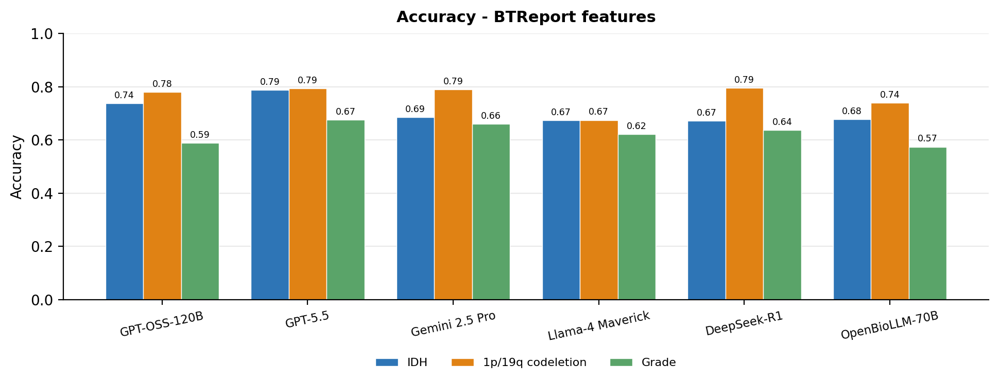
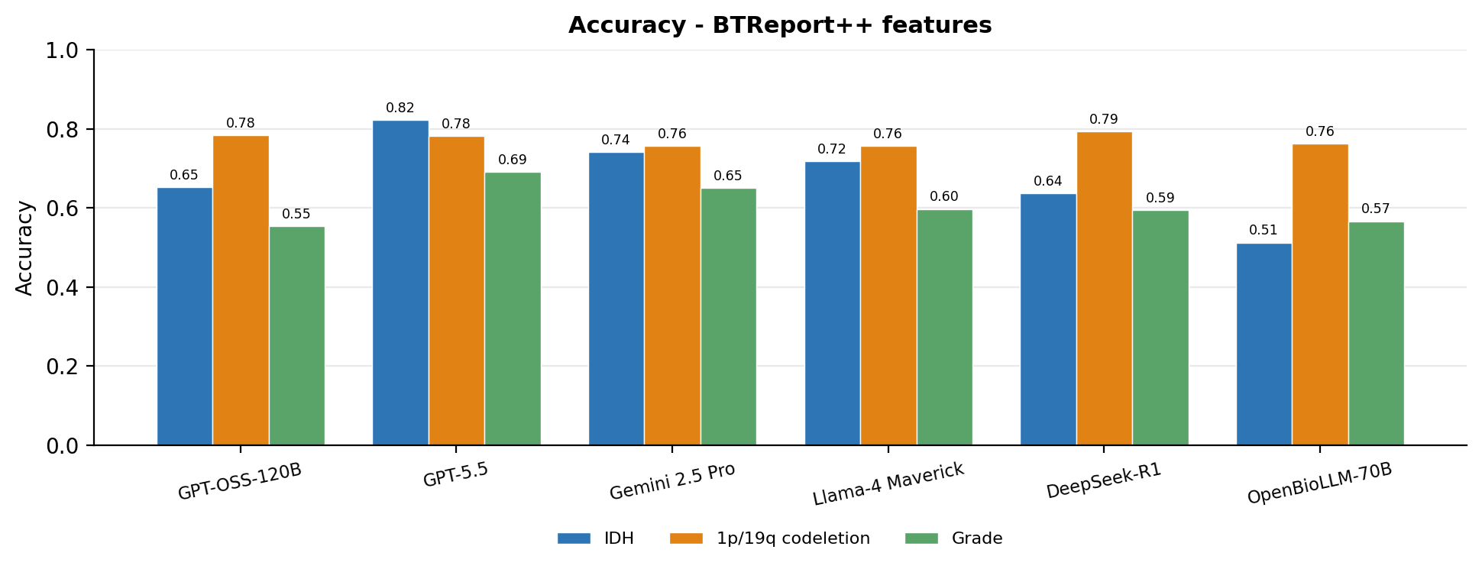

F1
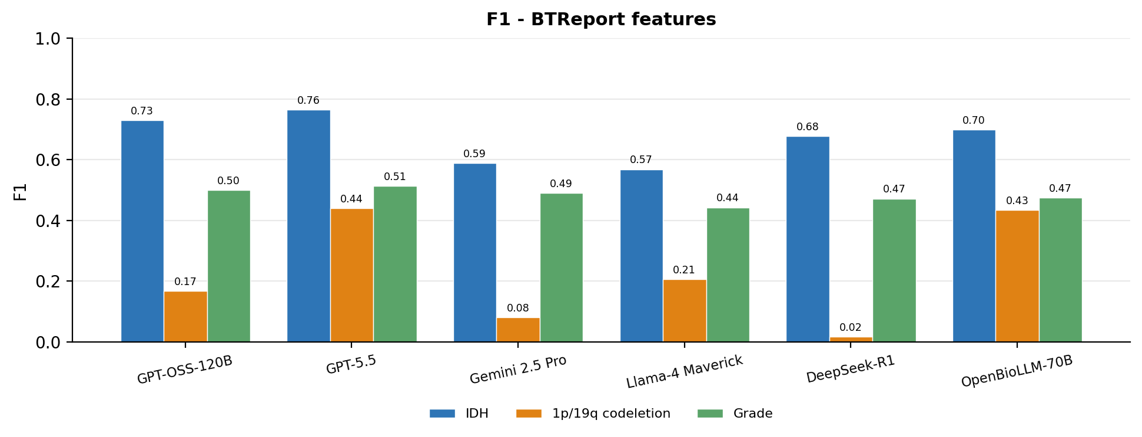
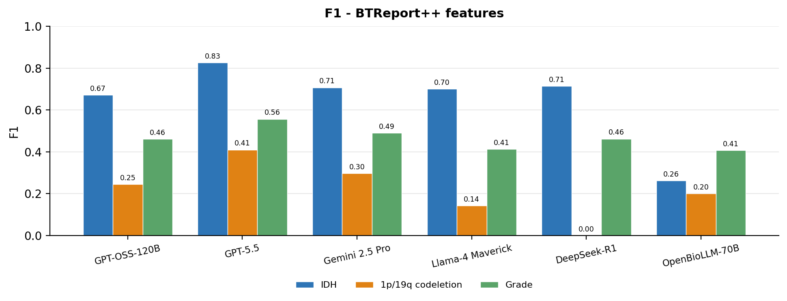

Confusion Matrices (whole cohort)
Rows = ground-truth class, columns = predicted class. Diagonal (highlighted) cells are correct predictions. One matrix per model, task, and feature set.

GPT-OSS-120B
IDH
BTReport features (n=646)
True \ Pred | mutant | wildtype
mutant | 229 | 115
wildtype | 55 | 247

BTReport++ features (n=646)
True \ Pred | mutant | wildtype
mutant | 230 | 114
wildtype | 111 | 191

1p/19q codeletion
BTReport features (n=541)
True \ Pred | codeleted | non-codeleted
codeleted | 12 | 100
non-codeleted | 19 | 410

BTReport++ features (n=541)
True \ Pred | codeleted | non-codeleted
codeleted | 19 | 93
non-codeleted | 24 | 405

Grade
BTReport features (n=646)
True \ Pred | 2 | 3 | 4
2 | 85 | 52 | 61
3 | 22 | 29 | 45
4 | 13 | 73 | 266

BTReport++ features (n=646)
True \ Pred | 2 | 3 | 4
2 | 80 | 48 | 70
3 | 22 | 20 | 54
4 | 9 | 85 | 258

GPT-5.5
IDH
BTReport features (n=646)
True \ Pred | mutant | wildtype
mutant | 222 | 122
wildtype | 15 | 287

BTReport++ features (n=646)
True \ Pred | mutant | wildtype
mutant | 275 | 69
wildtype | 46 | 256

1p/19q codeletion
BTReport features (n=541)
True \ Pred | codeleted | non-codeleted
codeleted | 44 | 68
non-codeleted | 44 | 385

BTReport++ features (n=541)
True \ Pred | codeleted | non-codeleted
codeleted | 41 | 71
non-codeleted | 47 | 382

Grade
BTReport features (n=646)
True \ Pred | 2 | 3 | 4
2 | 81 | 38 | 79
3 | 23 | 15 | 58
4 | 2 | 10 | 340

BTReport++ features (n=646)
True \ Pred | 2 | 3 | 4
2 | 98 | 30 | 70
3 | 27 | 21 | 48
4 | 2 | 23 | 327

Gemini 2.5 Pro
IDH
BTReport features (n=646)
True \ Pred | mutant | wildtype
mutant | 145 | 199
wildtype | 4 | 298

BTReport++ features (n=646)
True \ Pred | mutant | wildtype
mutant | 202 | 142
wildtype | 25 | 277

1p/19q codeletion
BTReport features (n=541)
True \ Pred | codeleted | non-codeleted
codeleted | 5 | 107
non-codeleted | 7 | 422

BTReport++ features (n=541)
True \ Pred | codeleted | non-codeleted
codeleted | 28 | 84
non-codeleted | 48 | 381

Grade
BTReport features (n=646)
True \ Pred | 2 | 3 | 4
2 | 61 | 19 | 118
3 | 11 | 15 | 70
4 | 0 | 1 | 351

BTReport++ features (n=646)
True \ Pred | 2 | 3 | 4
2 | 55 | 35 | 108
3 | 12 | 21 | 63
4 | 1 | 7 | 344

Llama-4 Maverick
IDH
BTReport features (n=646)
True \ Pred | mutant | wildtype
mutant | 139 | 205
wildtype | 6 | 296

BTReport++ features (n=646)
True \ Pred | mutant | wildtype
mutant | 214 | 130
wildtype | 52 | 250

1p/19q codeletion
BTReport features (n=541)
True \ Pred | codeleted | non-codeleted
codeleted | 23 | 89
non-codeleted | 87 | 342

BTReport++ features (n=541)
True \ Pred | codeleted | non-codeleted
codeleted | 11 | 101
non-codeleted | 31 | 398

Grade
BTReport features (n=646)
True \ Pred | 2 | 3 | 4
2 | 33 | 38 | 127
3 | 3 | 22 | 71
4 | 0 | 5 | 347

BTReport++ features (n=646)
True \ Pred | 2 | 3 | 4
2 | 26 | 42 | 130
3 | 6 | 22 | 68
4 | 0 | 14 | 338

DeepSeek-R1
IDH
BTReport features (n=646)
True \ Pred | mutant | wildtype
mutant | 222 | 122
wildtype | 90 | 212

BTReport++ features (n=646)
True \ Pred | mutant | wildtype
mutant | 294 | 50
wildtype | 185 | 117

1p/19q codeletion
BTReport features (n=541)
True \ Pred | codeleted | non-codeleted
codeleted | 1 | 111
non-codeleted | 0 | 429

BTReport++ features (n=541)
True \ Pred | codeleted | non-codeleted
codeleted | 0 | 112
non-codeleted | 0 | 429

Grade
BTReport features (n=646)
True \ Pred | 2 | 3 | 4
2 | 67 | 23 | 108
3 | 19 | 13 | 64
4 | 6 | 14 | 332

BTReport++ features (n=646)
True \ Pred | 2 | 3 | 4
2 | 70 | 23 | 105
3 | 19 | 17 | 60
4 | 15 | 40 | 297

OpenBioLLM-70B
IDH
BTReport features (n=646)
True \ Pred | mutant | wildtype
mutant | 242 | 102
wildtype | 106 | 196

BTReport++ features (n=646)
True \ Pred | mutant | wildtype
mutant | 56 | 288
wildtype | 27 | 275

1p/19q codeletion
BTReport features (n=541)
True \ Pred | codeleted | non-codeleted
codeleted | 54 | 58
non-codeleted | 83 | 346

BTReport++ features (n=541)
True \ Pred | codeleted | non-codeleted
codeleted | 16 | 96
non-codeleted | 32 | 397

Grade
BTReport features (n=646)
True \ Pred | 2 | 3 | 4
2 | 127 | 15 | 56
3 | 41 | 15 | 40
4 | 104 | 19 | 229

BTReport++ features (n=646)
True \ Pred | 2 | 3 | 4
2 | 165 | 0 | 33
3 | 71 | 0 | 25
4 | 151 | 0 | 201

