The Islamia University of Bahawalpur
Department of Information Technology

SOFTWARE REQUIREMENTS SPECIFICATION

(SRS DOCUMENT)

for
DeepDrive: A Deep Learning Approach to Car Model Recognition

Version 1.0

By

Muqit ur Rehman
Roll No: F22BINFT1M01001
&
Saad Hassan
Roll No: F22BINFT1M01026
Session Fall 2022 – 2026

1

Supervisor

Prof. Dr. Dost Muhammad Khan

Bachelor of Science in Information Technology

Table of Contents
Revision History 1
Application Evaluation History 2
Introduction 3
Purpose 3
Scope 3
Overall description 3
Product perspective 3
Operating environment 3
Design and implementation constraints 3
Requirement identifying technique 4
Use case diagram 4
Use case description 4
Functional Requirements 6
Functional Requirement X 6
Non Functional Requirements 7
Usability 7
Performance 8
References 8

2

Revision History

Name | Date | Reason for Change | Version

1

Application Evaluation History

Comments (by committee)  *include the ones given at scope time both in doc and presentation | Action Taken

Supervised by Prof. Dr. Dost Muhammad Khan

Signature

2

Introduction
The introduction presents an overview to understand how the SRS is organized and how to use it.

Purpose

The purpose of this Software Requirements Specification (SRS) document is to outline the requirements for the development and deployment of a car classifier system. The car classifier is designed to identify and categorize different types of cars based on input images. This document serves as a comprehensive guide for stakeholders involved in the development, testing, and deployment of the system, providing a clear understanding of the project's objectives, functionalities, and constraints.

Scope

The car classifier system is intended to be a versatile tool for accurately identifying and categorizing cars within images. The primary features of the system include:

Model Training:
The ability to train the car classification model using labelled datasets.

Model Deployment:
The capability to deploy the trained model for real-time classification.

API Development (Django):
Implementation of APIs using the Django framework to expose the classification model.

API Consumption (Next.js):
Utilization of APIs by a Next.js frontend to enable seamless integration into web applications.

The scope of this project encompasses the end-to-end process, from training the model to consuming the classification results through a web interface. However, this document does not cover hardware specifications, detailed design specifications, or the intricacies of the machine learning algorithm employed for classification.

Definitions, Acronyms, and Abbreviations

SRS:
Software Requirements Specification

API:
Application Programming Interface

Django:
A high-level Python web framework

Next.js:
A React-based web framework

3.3.4. ML:
Machine Learning.

Overall description

The Car classifier will classify cars into their respective classes

Product perspective

The car classifier system represents a novel addition to our product portfolio, introducing
a cutting-edge solution for image-based car classification. It stands as an independent application within our product line, leveraging advancements in machine learning to offer accurate and efficient car identification capabilities. While it is not directly replacing any existing applications, it aligns with our commitment to delivering innovative solutions that cater to emerging technological needs.

Operating environment

The car classifier system is designed to operate in a diverse range of environments, accommodating various hardware platforms and operating systems. The key components of the operating environment include:

Hardware Platform:
The system should be compatible with standard computing hardware, ensuring flexibility for users with different configurations.

Operating Systems:
The car classifier system is platform-agnostic and compatible with major operating systems, including but not limited to
      - Windows (versions 7 and above)
      - macOS (versions 10.12 and above)
      - Linux distributions (Ubuntu, CentOS, etc.)

Geographical Locations:
The system is intended for use globally, without geographical restrictions. It should perform consistently regardless of the geographical location of users or servers.

Web Browsers:
The web-based interfaces, including the Django server and Next.js frontend, should be compatible with popular web browsers. Example compatibility includes:
3.6.4.5 Google Chrome (all versions)
3.6.4.5 Mozilla Firefox (latest versions)
3.6.5.4.5 Microsoft Edge (latest versions)Apple Safari (latest versions)

3.6.5. Server Environment:
The backend system, developed using Django, should be deployable on standard web servers. It is expected to operate seamlessly on server environments such as Apache or Nginx.

3.6.6.Databases:
The system is designed to work with common relational databases, including but not limited to PostgreSQL, and MySQL.

3.6.5. Machine Learning Frameworks:
The underlying machine learning model uses frameworks compatible with diverse environments, such as TensorFlow or PyTorch.
This comprehensive compatibility ensures that the car classifier system can seamlessly integrate into various user setups, promoting widespread accessibility and usability. Any deviations from these specified environments may require additional testing and configuration adjustments.OE-1: The System shall operate correctly with the following web browsers: Windows Internet Explorer versions 7, 8, and 9; Firefox versions 12 through 26; Google Chrome (all versions); and Apple Safari versions 4.0 through 8.0.

Design and Implementation Constraints

Technology Stack

      - Programming Language:
The system shall be implemented using Python for its versatility in machine learning and web development. This constraint is driven by the availability of robust machine learning libraries (e.g., TensorFlow, PyTorch) and the use of Django for web application development.

      - Machine Learning Framework:
The development and deployment of the car classification model will be based on established machine learning frameworks such as TensorFlow or PyTorch. This constraint is in place to ensure compatibility, maintainability, and community support.

      - Web Framework:
Django will be used as the web framework for building APIs. This choice is based on its simplicity, scalability, and the ability to seamlessly integrate with machine learning components.

Database System

      - Database Engine:
The system shall use PostgreSQL or MySQL as the preferred relational database management system. This constraint is established to maintain consistency across database interactions and to leverage the strengths of these well-established systems.

Deployment Environment
Server Environment: The system is constrained to deploy on widely used web servers, such as Apache or Nginx. This constraint ensures compatibility with common server configurations and facilitates deployment in various hosting environments.

External Services
Machine Learning Service: The car classification model may use external machine learning services for certain functionalities. The integration of such services will be constrained by their compatibility with the chosen machine learning frameworks and adherence to security standards.

Rationale
These constraints are essential for maintaining a cohesive and efficient development process. The development team can benefit from established best practices, community support, and well-documented solutions by standardising on specific technologies and frameworks. The constraints also ensure a more straightforward integration of different system components and contribute to the overall reliability and stability of the car classifier system.

Requirement identifying technique
The primary technique for identifying requirements will be the use case analysis. Use cases provide a clear and effective way to capture and document user interactions, system behaviours, and functional requirements in an interactive end-user application like the car classifier. Use cases will be used to model various scenarios, ensuring that the system fulfils user needs and expectations.
This technique allows for a structured approach to understanding system requirements, interactions, and potential challenges. Each identified use case will be documented, specifying the actors involved, preconditions, main flow, alternative flows, and post-conditions. The use case approach facilitates effective communication between stakeholders and developers, promoting a shared understanding of the system's functionality.

Use case diagram

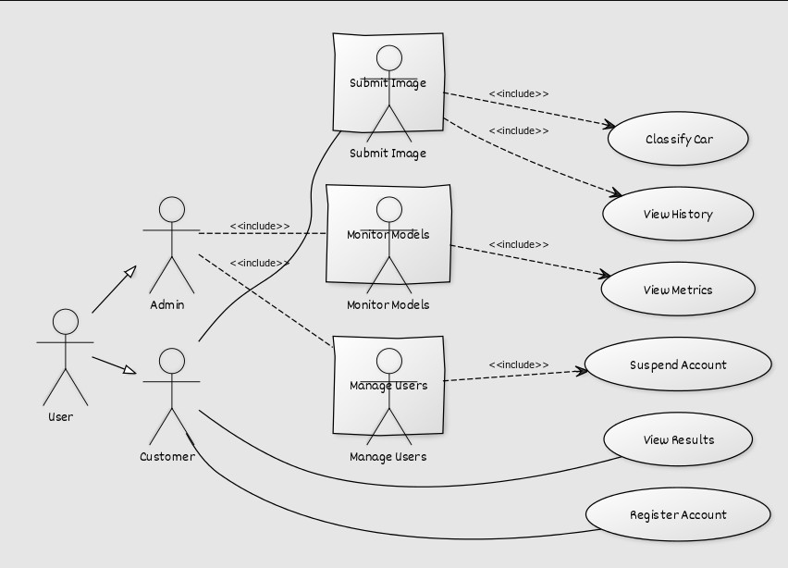
- Functional Requirements
This section describes the functional requirements of the system expressed in natural language style. This section is typically organized by feature as system feature name and specific functional requirements associated with this feature. It is just one possible way to arrange them. Other organizational options include arranging functional requirements by use case, process flow, mode of operation, user class, stimulus, and response depending on what kind of technique has been used to understand functional requirements. Hierarchical combinations of these elements are also possible, such as use cases within user classes. For further detail see Chapter 10 “Documenting the requirements”. Let's consider a feature scheme as an example.

Table 6 Shows the functional requirement template

Identifier | Title | Requirement | Source | Rationale | Business Rule | Dependenc ies | Priority
REQ-001 | Data Ingestion | The system shall allow users to upload labelled datasets for model training. | User | To enable users to train the car classification model using their datasets. |  |  | High
REQ-002 | Model Training | The system shall utilize a machine learning framework (e.g.,  TensorFlow, PyTorch) to train a car classification model. | System | To implement the core functionality of training the model using established  machine learning frameworks. |  | REQ-001 | High
REQ-003 | Model Serialization | The system shall serialize the trained car classification model for deployment. | System | To prepare the trained model for deployment in a production environment. |  | REQ-002 | Medium
REQ-004 | API  Development | The system shall expose RESTful APIs using the Django framework to provide access to the deployed model. | System | To facilitate interaction with the trained model through a standardized API. |  | REQ-003 | High
REQ-005 | Frontend Integration | The Next.js frontend shall  integrate with the Django backend to consume the car classification APIs. | System | To provide users with a seamless interface for interacting with the car classifier system. |  | REQ-004 | High
REQ-006 | User Registration | The system shall allow users to register accounts with unique  usernames and passwords. | User | To enable users to access personalized features and track their usage. |  |  | Medium
REQ-007 | Model Monitoring | Administrators shall have access to a dashboard for monitoring the performance and health of deployed models. | User / System | To provide administrators with insights into the status and performance of deployed models. |  | REQ-005, REQ-005 | Medium
REQ-008 | Error Handling for Model Training | The system shall handle errors during data ingestion by providing clear error messages indicating the nature of the issue. | System | To guide users in resolving data ingestion issues and  ensure the integrity of training data. |  | REQ-001 | Medium

Non-Functional Requirements
  - Usability

USE-1:
The car classifier system shall provide a user-friendly interface that allows users to submit images for

classification with a single interaction.

USE-2:
The system shall include clear and intuitive navigation to facilitate ease of learning and use for users with varying levels of technical expertise.

USE-3:
The system shall support accessibility standards to ensure usability for users with disabilities, including but not limited to screen reader compatibility and keyboard navigation.

Performance

PER-1:
The car classification API response time shall not exceed 500 milliseconds for 95% of requests when serving images of average size (2 MB) and complexity.

PER-2:
The system shall support concurrent requests from at least 100 users without degradation of response time or system performance.

PER-3:
The Next.js frontend shall load within 3 seconds on commonly used web browsers, such as Google Chrome, Mozilla Firefox, and Microsoft Edge, over a standard broadband connection.

Reliability
REL-1: The system shall achieve a minimum uptime of 99.9% over a calendar month, excluding planned maintenance periods.
REL-2: In the event of a server or API failure, the system shall provide appropriate error messages to users and log detailed error information for system administrators.

Security
SEC-1: User authentication shall be implemented securely using industry-standard encryption protocols to protect user credentials during transmission.
SEC-2: The system shall employ role-based access control to ensure that users have access only to functionalities relevant to their roles.
SEC-3: The car classifier API shall implement secure communication protocols (e.g., HTTPS) to protect data integrity during API interactions.

Scalability
SCL-1: The system architecture shall support scaling horizontally to accommodate an increase in the number of concurrently deployed models and API requests.
SCL-2: The database infrastructure shall be designed to scale vertically to handle growing datasets and user accounts.

