In terms of the tone and emotional framing, the Glassdoor reviews have more stronger emotions. This can be seen in the word cloud in Figure 1 where strong words like ‘miserable’, ‘easy’, ‘long’, ‘decent’ are used to describe the working conditions and opportunities at Amazon Warehouses. In contrast, the word cloud generated by YouTube reviews in Figure 2 has more filler words like ‘got’, ‘come’, and ‘time’ and less emotional words like ‘good’ which is not a strong nor emotional word. The YouTube reviews also seem to be reactive compared to the Glassdoor reviews which are constructive. This can also be explained by the strong emotional words and lower quantity of filler words used in Glassdoor reviews which provided feedback to management compared to YouTube reviews which seemed more natural and unfiltered.

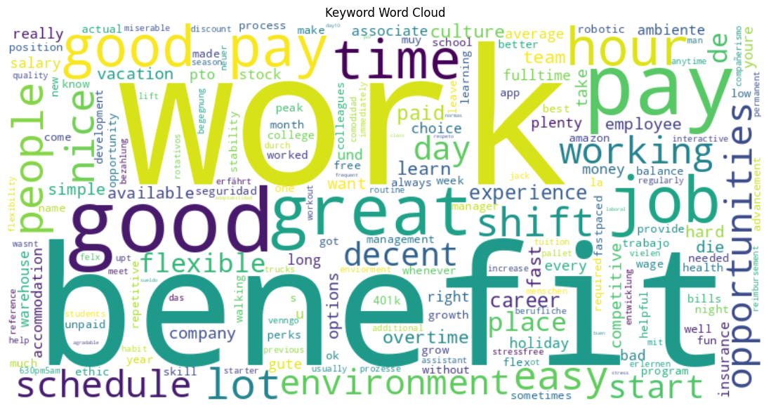
Figure 1: Word Cloud of Glassdoor Reviews

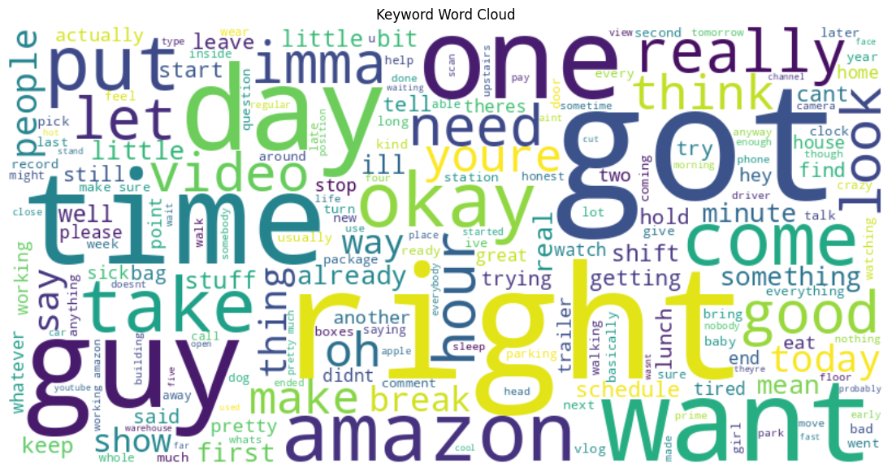
Figure 2: Word Cloud of YouTube Reviews

In terms of content depth and structure, the Glassdoor reviews also provided more details regarding the timing, pay, and responsibilities of the job as well as the management. They also provided more details on opportunities for improvement for the management and business. This can be seen in Figure 3 where the top 10 bigrams for Glassdoor reviews include words like ‘good pay’, ‘good benefits’, and ‘easy work’. In contrast Figure 4 shows that the YouTube reviews include lots of filler words that provide no meaning such as “going to”, “don’t know”, and ‘im going’ which reduces the depth of the content and its structure.

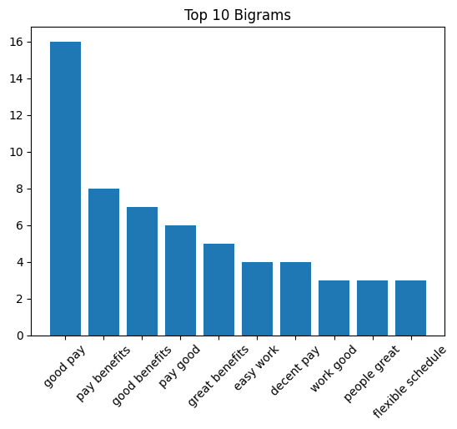
Figure 3: Top 10 Bigrams for Glassdoor Reviews

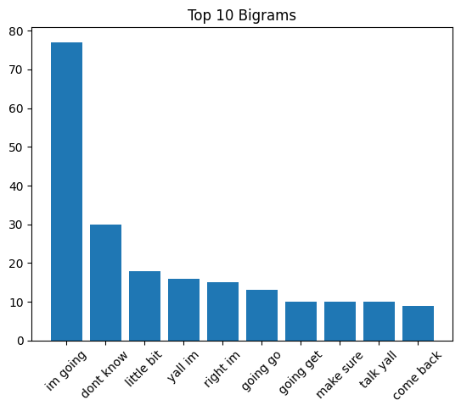
Figure 4: Top 10 Bigrams for YouTube Reviews

In terms of platform and audience context, employees tend to focus on the pay and timing of the job and share their feedback when they are able to anonymize themselves on a platform like Glassdoor. This can be seen in Figure 1 from the word cloud of Glassdoor reviews where words like ‘benefit’, ‘pay’, and ‘time’ are more common. In contrast, the YouTube reviews tend to focus on describing the work procedures and responsibilities rather than describing the management’s actions or behaviour due to the fear of consequences as the videos are public and not anonymous. This is seen by the use of the words ‘want’, ‘got’, ‘day’, ‘put’ which are mostly action verbs rather than adjectives or descriptions.

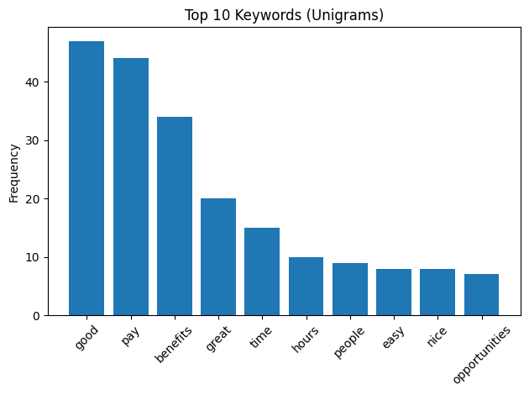
Figure 5: Top 10 Keywords for Glassdoor Reviews

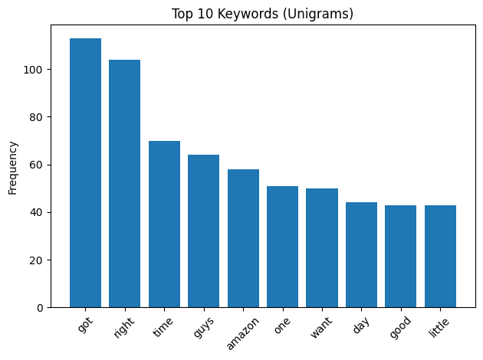
Figure 6: Top 10 Keywords for YouTube Reviews

All in all, both platforms share reviews of employees and their experiences working at an Amazon warehouse. However, YouTube reviews seem to be focused on casual descriptions of an employee’s experience working at Amazon whereas Glassdoor reviews are more emotional reviews of the management and procedures due to the ability to anonymize oneself.

