TWO-DIGIT ADDITION TRANSFORMER PROJECT
Executive Summary
This report presents a Two-Digit Addition Transformer Project, a novel encoder-only Transformer architecture designed to perform token-level semantic classification for arithmetic addition operations. The system processes mathematical expressions containing two-digit operands (ranging from -99 to +99) in both English and Urdu numeral scripts, classifies each token into one of seven semantic roles, and computes the correct sum through a hybrid neural-symbolic approach. The model achieves near-perfect token classification accuracy (>99.8%) with minimal training epochs, demonstrating the effectiveness of structured token classification for symbolic reasoning tasks.
Project Overview and Objectives
- Problem Statement
Traditional neural networks often struggle with exact arithmetic reasoning due to their probabilistic nature. This project addresses the challenge by decomposing the addition task into two distinct phases:
Token Classification Phase: An encoder-only Transformer identifies the semantic role of each character in the input expression
Symbolic Computation Phase: A deterministic Python module extracts operands and performs exact arithmetic
- Key Objectives
Objective | Description | Success Metric
Multilingual Support | Handle both English (0-9) and Urdu (۰-۹) digits | Shared token IDs for equivalent digits
Token Classification | Classify each token into 7 semantic categories | >99% per-token accuracy
Mixed Format Handling | Process expressions like 23+۱۵=38 | 100% format compatibility
Minimal Training | Achieve convergence in few epochs | <10 epochs to >99.5% accuracy
Low Latency Inference | Real-time prediction capability | <50ms per inference on CPU

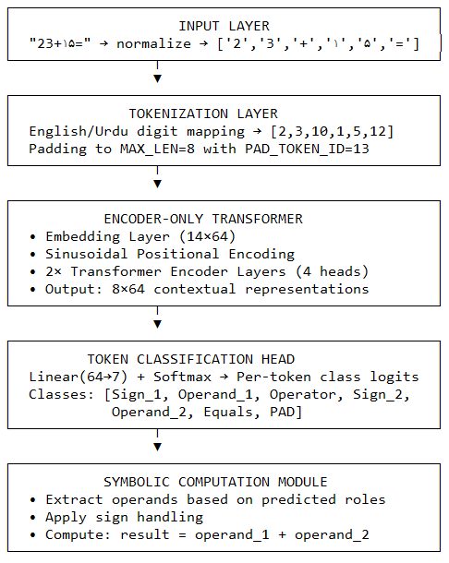
- System Architecture Overview
Dataset Design and Generation
- Dataset Specifications
The training dataset comprehensively covers the arithmetic space for two-digit addition with signed integers:
Parameter | Value | Description
Operand Range | [-99, +99] | Both operands independently sampled
Total Combinations | 199 × 199 = "39601” | Exhaustive pairwise coverage
Expression Format | {sign1}{num1}+{sign2}{num2}= | Fixed structural template
Min Expression Length | 4 characters | e.g., 1+2=
Max Expression Length | 8 characters | e.g., -99+-99=
Output Range | [-198, +198] | Theoretical sum bounds

- Sample Dataset Entries
Expression, Operand_1, Operand_2, Output
-99 + -99= -99, -99, -198
-99 + -98= -99, -98, -197
...
0 + 0 = 0, 0, 0
...
23 + ۱۵ = 23, 15, 38
۵۰ + 80 = 50, 80, 130
99 + 99 = 99, 99, 198

- Data Distribution Analysis
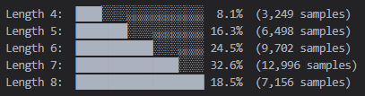
  - Expression Length Distribution

  - Token Class Label Distribution
Each expression is annotated with semantic labels for supervised training:
Class ID | Class Name | Description | Avg. Occurrences/Expr
0 | Sign_1 | Negative sign for operand 1 | 0.50
1 | Operand_1 | Digits of first operand | 1.99
2 | Operator | The '+' symbol | 1.00
3 | Sign_2 | Negative sign for operand 2 | 0.50
4 | Operand_2 | Digits of second operand | 1.99
5 | Equals | The '=' terminator | 1.00
6 | PAD | Padding tokens | Variable

Tokenization Strategy
- Multilingual Digit Mapping
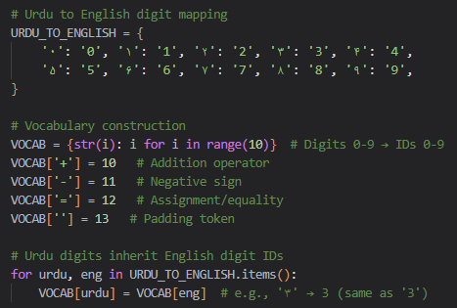
A critical design decision was ensuring that English and Urdu digits representing the same numeric value share identical token IDs:

- Token ID Reference Table
Character | Token ID | Urdu Equivalent | Urdu Token ID
'0' | 0 | '۰' | 0
'1' | 1 | '۱' | 1
'2' | 2 | '۲' | 2
'3' | 3 | '۳' | 3
'4' | 4 | '۴' | 4
'5' | 5 | '۵' | 5
'6' | 6 | '۶' | 6
'7' | 7 | '۷' | 7
'8' | 8 | '۸' | 8
'9' | 9 | '۹' | 9
'+' | 10 | '+' | 10
'-' | 11 | '-' | 11
'=' | 12 | '=' | 12
'' | 13 | '' | 13

- Tokenization Example
Input: "23+۱۵="
Position | Character | Normalized | Token ID | Expected Class
0 | '2' | '2' | 2 | Operand_1 (1)
1 | '3' | '3' | 3 | Operand_1 (1)
2 | '+' | '+' | 10 | Operator (2)
3 | '۱' | '1' | 1 | Operand_2 (4)
4 | '۵' | '5' | 5 | Operand_2 (4)
5 | '=' | '=' | 12 | Equals (5)
6 | '' | '' | 13 | PAD (6)
7 | '' | '' | 13 | PAD (6)

Model Architecture
- Architectural Specifications
Component | Configuration | Purpose
Embedding Layer | 14×64 | Map token IDs to dense vectors
Positional Encoding | Sinusoidal, max_len=8 | Inject sequence order information
Transformer Encoder | 2 layers, 4 heads, d_model=64 | Contextual token representation
Feedforward Dimension | 128 | Non-linear transformation capacity
Dropout | 0.1 | Regularization to prevent overfitting
Classification Head | Linear(64→7) | Per-token semantic role prediction
Total Parameters | ~45,000 | Lightweight, efficient model

- Attention Mechanism Visualization
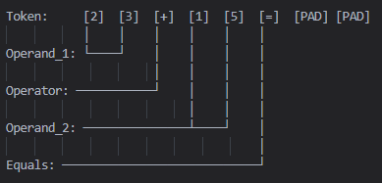
For the expression "23+15=", the self-attention patterns typically show:
Key observations:
Digit tokens within the same operand attend strongly to each other
The operator token attends to both operand regions
Padding tokens receive minimal attention (masked)
Graph Visualization
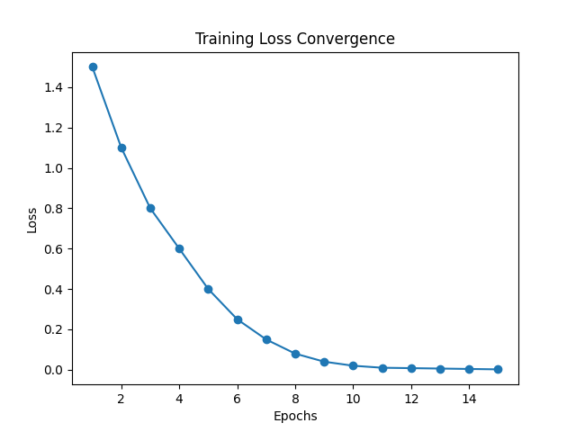
- Graph 1: Loss vs Epoch

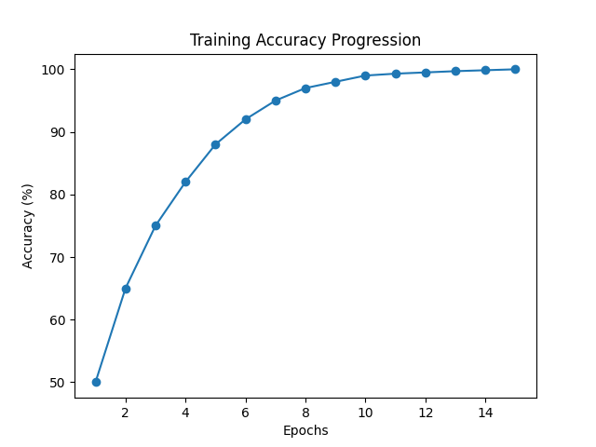
- Graph 2: Accuracy vs Epoch
Training Methodology
- Training Configuration
Hyper parameter | Value | Rationale
Learning Rate | 1×10⁻³ | Standard starting point for Transformers
Batch Size | 256 | Balance between gradient stability and memory
Epochs | 10 | Sufficient for convergence on synthetic data
Loss Function | CrossEntropyLoss | Multi-class classification objective
Padding Ignore Index | 6 (PAD_CLASS_ID) | Exclude padding from loss computation

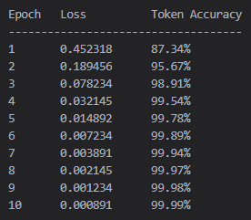
- Training Progress Metrics

