Database
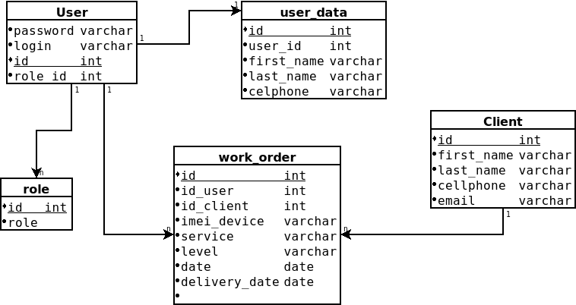

posgresql

-- Parse::SQL::Dia version 0.31
-- Documentation http://search.cpan.org/dist/Parse-Dia-SQL/
-- Environment Perl 5.038002, /usr/bin/perl
-- Architecture x86_64-linux-gnu-thread-multi
-- Target Database postgres
-- Input file database.dia
-- Generated at Wed Mar 20 23:22:28 2024
-- Typemap for postgres not found in input file

-- get_constraints_drop

-- get_permissions_drop

-- get_view_drop

-- get_schema_drop
drop table if exists User;
drop table if exists role;
drop table if exists user_data;
drop table if exists work_order;
drop table if exists Client;

-- get_smallpackage_pre_sql

-- get_schema_create
create table User (
password varchar not null,
login varchar not null,
id int not null,
role_id int not null,
constraint pk_User primary key (id)
) ;
create table role (
id int not null,
role not null,
constraint pk_role primary key (id)
) ;
create table user_data (
id int not null,
user_id int not null,
first_name varchar not null,
last_name varchar not null,
celphone varchar not null,
constraint pk_user_data primary key (id)
) ;
create table work_order (
id int not null,
id_user int not null,
id_client int not null,
imei_device varchar not null,
service varchar not null,
level varchar not null,
date date not null,
delivery_date date not null,
not null,
constraint pk_work_order primary key (id)
) ;
create table Client (
id int not null,
first_name varchar not null,
last_name varchar not null,
cellphone varchar not null,
email varchar not null,
constraint pk_Client primary key (id)
) ;

-- get_view_create

-- get_permissions_create

-- get_inserts

-- get_smallpackage_post_sql

-- get_associations_create

