Bayesian and benchmark models for landslide susceptibility in Chattogram with spatial validation and conditional uncertainty

Abstract
Reliable landslide susceptibility assessment requires discrimination, spatial validation and explicit limits on probability interpretation. We compare Bayesian logistic regression (BLR), a Gaussian process classifier (GPC), L2-regularized logistic regression and Random Forest (RF) using 369 locations in Chattogram, Bangladesh, including 155 landslides and 214 sampled negatives with 14 predictors. The workflow combines repeated stratified cross-validation, spatial cluster validation and a 74-location random holdout. RF achieved the highest holdout area under the receiver operating characteristic curve (ROC-AUC; 0.866) and Matthews correlation coefficient (MCC; 0.611); GPC achieved ROC-AUC 0.821 and MCC 0.481. GPC had the lowest 10-bin expected calibration error (ECE; 0.084), but paired bootstrap intervals and alternative bin counts did not establish superior calibration. Spatial MCC decreased to 0.323 for RF and 0.259 for GPC. Three negative-subset sensitivity runs retained RF’s ROC-AUC lead but changed threshold-dependent rankings. A code audit identified a probability-derived ambiguity score in the previous uncertainty export; we replace it with directly computed latent variance and distinguish probability-scale posterior variance from expected Bernoulli variance. Corrected bivariate displays are restricted to observed locations because predictor rasters and a reproducible study-area mask are unavailable in the analytical archive. Sampling provenance, fractional categorical codes and missing event metadata constrain interpretation. The contribution is a transparent comparison of validation, calibration and conditional uncertainty within a static susceptibility analysis, rather than evidence of general Bayesian superiority or a temporally defined hazard forecast.
Keywords: Landslide susceptibility; Gaussian process classification; Spatial validation; Calibration; Pseudo-absence sensitivity; Conditional uncertainty.

1 Introduction
Landslide susceptibility describes where slope failures may occur given terrain and environmental conditions. It differs from hazard, which requires a temporal component, and from risk, which also requires exposure and consequences. Urban hills in Chattogram combine monsoon rainfall, weathered materials and slope modification, making spatial screening useful while also placing strong demands on the reliability of predictions.
Model choice is only one source of uncertainty. Inventory completeness, positional accuracy, the definition of negative samples and the mapping unit can influence both fitted relationships and apparent predictive performance (Reichenbach et al. 2018). Comparisons among machine-learning algorithms therefore require attention to the data and validation design as well as the algorithm; tree ensembles are strong benchmarks in this setting (Merghadi et al. 2020). Bayesian inference represents uncertainty conditional on a model and its data, but does not automatically correct biased inventories, inappropriate predictors or sampling design.
Regional studies illustrate complementary objectives. Ahmed (2015) used multi-criteria evaluation and 30 m layers in CMA. Chowdhury et al. (2024; published online in 2023) compared logistic regression, RF and decision/regression trees using 30 m conditioning layers, 255 inventory locations and a random 80/20 training/test split. Biswas et al. (2026) evaluated CNN, DNN and LSTM models and an ensemble, with stratified 10-fold validation for tuning. These designs address susceptibility discrimination but do not provide the same evaluation as the geographically grouped test used here. They should not be described collectively as lacking all uncertainty analysis, and accuracy values from different inventories and extents are not directly comparable.
Bivariate susceptibility–uncertainty mapping is also established. Schlögl et al. (2025) combined susceptibility and sampling uncertainty using an RF ensemble, so neither bivariate display nor uncertainty communication is exclusive to Bayesian models. The present contribution is an application-level audit and comparison: we make the split assignments explicit, examine calibration sampling variability and binning, assess sensitivity to the retained negatives and coarse predictors, and separate alternative definitions of uncertainty. We do not introduce a new Bayesian algorithm or claim that combining established procedures is itself a new statistical method.
The data limitation is specific: the archive contains multiple static predictors but lacks an event-linked time series and complete inventory provenance. Accordingly, we study static susceptibility conditional on the sampled dataset. BLR and GPC are the Bayesian candidates under the archived deployment policy; RF and regularized logistic regression remain performance benchmarks. The question is whether GPC offers useful conditional uncertainty alongside adequate predictive performance, not whether it dominates RF on every criterion.

2 Study area and data

2.1 Physical setting and anthropogenic processes
The sampled corridor lies in the Chattogram metropolitan hill system of southeastern Bangladesh (Figure 1). The analytical point extent is approximately 22.327–22.491° N and 91.759–91.843° E. This sampled extent should not be equated with the approximately 775 km² metropolitan area discussed in regional literature. Hills, narrow valleys and urban development occur in close proximity. Regional accounts describe weathered hill soils over shale and sandstone and shallow failures during or following rainfall (Ahmed 2015). No site-specific measurements of shear strength, regolith thickness or bedding orientation are available in this analysis.
Road excavation can remove toe support and alter runoff routing; hill cutting can steepen slopes; vegetation removal can change root reinforcement and surface drainage. Distance to roads, land use/land cover (LULC) and NDVI are indirect proxies for these processes. They do not measure excavation geometry, building loads, blocked drains or illegal hill cutting. A low NDVI value alone cannot distinguish cutting from seasonal vegetation variation or other land-cover differences. Engineering geology and disturbance are therefore used to motivate predictors, without treating model associations as measurements of physical mechanisms.

2.2 Inventory provenance and negative samples
The source compilation describes records from NASA’s Global Landslide Catalog, CEGIS, the Bangladesh Army and published inventories, with a reported span of 2001–2022. The archived modeling table contains labels, coordinates and predictors, but no event identifier, date, source record, failure-type field, size, trigger, positional accuracy or field-verification flag. The reported temporal span cannot therefore be checked record by record from this table. Rabby and Li (2020) provide a regional inventory for 2001–2017; their inventory attributes cannot be assumed to have been retained for every point used here.
The reproducible processing step removes seven exactly duplicated rows from 376 records, leaving 369 unique records: 155 positives and 214 negatives. Coordinates are complete, and the retained table contains no exactly duplicated coordinate pairs. Exact-row deduplication is not the same as identifying duplicate events within a positional tolerance. Neither 10 m event consolidation, systematic imagery verification, date reconciliation nor a quantitative completeness assessment can be demonstrated from the retained records. We therefore withdraw those assertions. Missing failure types preclude mechanism-specific stratification; the positive class may combine different slope-failure processes, which limits physical interpretation.
The 214 zero-labeled records are treated as sampled pseudo-absences, not verified permanently stable sites. Their original sampling seed, candidate mask and field checks were not archived. A new audit finds that 71 negatives are within 500 m of a known positive and 27 have recorded slopes of at least 10°. Thus the previously stated 500 m exclusion and slope below 10° rules were not universally enforced in the table analyzed. Only 115 negatives demonstrably satisfy both criteria using their recorded values. Unmapped failures may remain among negatives; the sensitivity experiment in Section 3.6 tests the composition of the available negative pool but cannot establish its geomorphic validity.

2.3 Predictors and spatial support
Table 1 summarizes the predictor sources described in the compilation. The analysis uses the archived point values; the original aligned predictor rasters, resampling commands, acquisition dates, categorical codebook and study-area vector mask were not retained with the supplied modeling archive. Nominal grid resolution is distinct from effective information resolution. Interpolating approximately 5 km CHIRPS or 250 m soil information onto a 30 m grid cannot create independent 30 m rainfall or soil observations. Continuous variables may be interpolated for alignment, while discrete classes require class-preserving resampling; the particular operations applied to each source cannot be reconstructed from the point table.
The archived implementation median-imputes and standardizes all 14 numeric columns. It does not one-hot encode LULC or soil texture, and aspect is treated as a numeric angle rather than a circular predictor. In addition, 31 observed LULC values and 19 soil-texture values are fractional. Their origin cannot be inferred safely or repaired by arbitrary rounding. This creates an encoding limitation, particularly for distance-based kernels and linear models. The numerical reproduction retains these values to avoid silently changing the dataset; source-raster re-extraction and appropriate categorical/circular encoding are required before operational use.
Precipitation has eight distinct observed values and is described in the source manuscript as a mean annual CHIRPS layer. Its exact aggregation years and product version are absent from the analytical archive. CHIRPS itself provides time-series rainfall at 0.05° resolution (Climate Hazards Center); the restriction here is the lack of a documented, event-linked extraction for these samples, not the global nonexistence of daily rainfall data. We therefore cannot estimate antecedent rainfall, intensity–duration thresholds or event probability from this table.
SPI denotes stream power index, TWI topographic wetness index, TRI terrain ruggedness index and NDVI normalized difference vegetation index. SRTM denotes the Shuttle Radar Topography Mission and CHIRPS Climate Hazards Group InfraRed Precipitation with Station data.

3 Methods

3.1 Preprocessing and model specification
We reproduce the archived split with seed 42: 295 training samples (124 positives, 171 negatives) and 74 holdout samples (31 positives, 43 negatives). Median imputation and standard scaling are fitted within each training fold. Variance inflation factor (VIF) screening was performed on the initial training subset before repeated validation, and retained all predictors. This screening was not fully nested within each validation fold, although it did not change the predictor set. The archived VIF values range from 1.140 to 3.342; this does not establish independence among predictors or validate categorical coding.
BLR uses zero-mean Gaussian priors on slopes with precision 1.5, an unpenalized intercept and a Laplace approximation at the maximum a posteriori estimate. The implementation uses L-BFGS-B with a 500-iteration limit and tolerance 10⁻⁶. Its probability approximation is sigmoid{μ / √(1 + πv/8)}, where μ and v are posterior latent mean and variance. GPC uses a scaled Matérn kernel with smoothness ν = 1.5 plus a white-noise kernel, a logistic likelihood, a Laplace approximation and five optimizer restarts. The kernel acts on standardized environmental predictors, not directly on geographic coordinates. Hyperparameters are optimized rather than integrated out, so the uncertainty is conditional and approximate (Rasmussen and Williams 2006).
The logistic benchmark uses L2 regularization with C = 1, balanced class weights and an iteration limit of 3,000. RF uses 300 trees, a minimum leaf size of two and balanced-subsample class weights; other estimator settings follow the archived defaults. All stochastic estimator seeds are 42. Software versions and individual predictions accompany the revision. No post-hoc calibration of RF was performed, and Bayesian status is not treated as evidence of calibration superiority.

3.2 Validation and spatial clusters
Repeated stratified five-fold validation with three repeats uses the 295 training samples. The separate spatial validation also uses those 295 samples. The actual rule is k = min(10, max(4, floor(n/30))); therefore n = 295 gives nine KMeans clusters, not ten. KMeans is fitted to longitude and latitude in degrees with n_init = 10 and seed 42. Five-fold GroupKFold holds out complete clusters. Grouping in geographic coordinates produces irregular groups without a fixed block width or buffer, and does not guarantee complete spatial independence across adjacent group boundaries.
Figure S1a shows the nine training clusters and the 74 holdout locations. Figure S1b additionally provides the requested ten-cluster display of all 369 points, explicitly separated from the design used to calculate the reported validation metrics. Tables S1 and S2 report fold counts and cluster extents. Training clusters contain 20–56 samples; maximum within-cluster sample separation ranges from 2.58 to 5.25 km. These separations describe sampled points, not polygon diameters or a prescribed block size.
The holdout is a random stratified split, not a geographically independent or external sample. Its minimum distance to a training point is 4.52 m, median nearest-training distance is 339.65 m, and 51 of 74 holdout points lie within 500 m of a training point. Holdout scores primarily evaluate interpolation within the sampled region. Spatial validation provides a more demanding complementary check, but spatial buffers, an independently mapped region and a temporal test remain absent.

3.3 Discrimination and calibration
At probability threshold 0.5 we compute accuracy, precision, recall, F1, MCC and false-negative rate FNR = FN/(TP + FN). ROC-AUC measures ranking over thresholds. The reported PR-AUC is average precision, following the archived implementation, rather than trapezoidal integration. Brier score and log loss assess probability error. For ten equal-width probability bins, ECE = Σb (nb/n)|yb − pb|, where yb is the mean binary label and pb the mean predicted positive-class probability within bin b. Empty bins contribute zero. This is positive-class calibration, not accuracy-versus-confidence calibration.
We resample the 74 holdout label–prediction pairs with replacement 2,000 times using seed 42 and identical row samples for every model. The 2.5th and 97.5th percentiles form descriptive 95% bootstrap intervals. Models are not refitted, so these intervals concern finite evaluation-sample variability conditional on the fitted models; they omit training, spatial-dependence and inventory uncertainty. We also compute a paired GPC-minus-RF ECE interval and repeat ECE with five and fifteen equal-width bins. Reliability diagrams show unsmoothed empirical bin means and counts. Absolute-value bin statistics can have appreciable small-sample bootstrap bias; percentile intervals should not be read as proof of precise population calibration (see also Guo et al. 2017 for calibration assessment).

3.4 Model eligibility and selection
The archived policy restricts final Bayesian uncertainty analysis to BLR and GPC while retaining RF and logistic regression as benchmarks. Eligibility is an objective of the study, not a reward assigned after observing RF performance. The original composite uses ranks of repeated-CV MCC (20%), holdout MCC (35%), spatial MCC (30%), holdout Brier score (10%) and holdout ECE (5%); lower scores are preferred. These are ordinary ranks, not normalized ranks. RF ranks first overall and GPC first among eligible candidates.
Because the original score uses holdout outcomes, that holdout is not an untouched final selection-independent assessment. We disclose this rather than retroactively describing it as external validation. As a revision sensitivity check, we remove holdout criteria and use training-only ranks: 40% repeated-CV MCC, 40% spatial MCC, 10% repeated-CV Brier and 10% repeated-CV ECE. This post-hoc rule again favors GPC among Bayesian candidates. It does not create a new independent test or demonstrate GPC superiority over RF. The archived Friedman test is reported descriptively because repeated folds share observations and their scores are not independent experimental replicates.

3.5 Definitions and calculation of uncertainty
Let f* have approximate posterior mean μ* and variance v* under the fitted GPC, and let q* = sigmoid(f*). Latent variance v* is measured on the logit-function scale. Probability-scale posterior variance Var(q*|D) describes uncertainty in the conditional probability under the fitted model. Expected Bernoulli variance E[q*(1 − q*)|D] describes the residual outcome variation under that likelihood. Their sum is Var(Y*|D) = p*(1 − p*), where p* = E(q*|D). Thus latent variance, probability variance and total outcome variance are different quantities.
We call the first component a conditional epistemic measure and the second a conditional aleatory component, while recognizing that neither propagates all inventory, predictor or model-structure errors. Optimized kernel parameters are held fixed. The white-noise kernel contributes to the reported latent variance, so the result is not a pure, comprehensive epistemic map. We obtain latent moments directly through the binary GPC latent_mean_and_variance API (Scikit-learn developers 2026), and calculate probability moments using 64-point Gauss–Hermite quadrature. Numerical checks verify the variance decomposition; the largest difference between quadrature and the classifier’s probability approximation is 0.000118.
For display we use U = √v*/maxj√vj over the same 369 sample locations. The fixed normalizer is 2.415011. This maps relative latent standard deviation to [0,1] and is not an absolute confidence probability. The previous saved uncertainty column equals 1 − 2|p − 0.5| to floating-point precision. That score reflects proximity to the decision boundary, not posterior variance. It is replaced throughout the revised uncertainty analysis, and the previous posterior-confidence interpretation is withdrawn.
The revised bivariate display uses susceptibility tertiles at 0.251145 and 0.595974 and normalized latent-standard-deviation tertiles at 0.452066 and 0.535307. The classes summarize the sampled distribution, not safety limits, event frequencies or management triggers. We compare them with three-class Jenks breaks and fixed thirds (Table S7). Equal marginal sample counts do not imply equal joint-class counts or equal spatial areas. Independent calibration or decision costs would be needed to justify management thresholds.

3.6 Sensitivity analyses and SHAP
Negative-sample sensitivity holds the 124 positive training records and all 74 holdout records fixed. For seeds 7, 21 and 84, 136 of the 171 training negatives are selected without replacement (floor of 80%). Models are refitted with the same settings. We report holdout metrics and prediction changes at all 369 sampled locations. This tests sensitivity to negative-pool composition and the changed training class ratio; it is not fresh pseudo-absence generation from an independently surveyed candidate domain. The available records do not support that broader experiment.
A paired predictor ablation separately excludes precipitation, soil texture, and both, while retaining the original split and estimator settings. These tests quantify model dependence on the recorded coarse predictors. They do not recover fine-scale rainfall or soil information, nor do they validate the original resampling method. They are exploratory comparisons on a reused holdout and are not used to select a newly optimized model.
We regenerate Kernel SHAP for the GPC trained on the 295 training records, explaining all 74 holdout records on the positive-class log-odds scale. The background consists of 30 training rows sampled with seed 42; each explanation uses nsamples = 150, with the random generator seeded at 42. The background, explained rows and attribution array are exported. Kernel SHAP explains model behavior (Lundberg and Lee 2017). No conditional dependence-aware explainer is implemented, so correlated predictors and potentially unrealistic feature combinations can redistribute attributions. VIF screening does not resolve these concerns, and SHAP values are not causal effects.

3.7 Spatial products and SCAI
An audit shows that the legacy maps interpolate model predictions at the 369 sampled points onto a 500 × 500 longitude–latitude grid using linear interpolation and nearest-neighbor filling. This does not evaluate the classifier against complete predictor values in each nominal 30 m cell. A small output pixel size is not evidence of equivalent prediction support. A reproducible study-area polygon and aligned predictor rasters are absent, so we restrict the corrected uncertainty displays to point locations and do not release the legacy continuous surfaces as validated 30 m susceptibility products.
The archived five-class susceptibility scheme uses Jenks breaks (with a quantile fallback), which differs from the three-class bivariate scheme. SCAI for class c is (Ac/A)/(Lc/L), using class area Ac and landslide count Lc. The previous 78.71% landslide concentration in 9.47% of mapped area is a descriptive statistic of the full-data fit and interpolated grid, not independent validation. Its denominator is not established here as the study-area polygon. We retain the legacy table only as an explicitly identified audit record in Table S8 and withdraw the operational area and validation claims from the results and conclusion.

4 Results

4.1 Predictive performance and missed positives
The rerun reproduces the archived holdout metrics to numerical precision (Table 2; Figure 2). RF achieves the highest ROC-AUC (0.866), average precision (0.865) and MCC (0.611), as well as the lowest Brier score (0.153) and log loss (0.471). GPC is stronger than BLR on these metrics but does not outperform RF. At threshold 0.5, GPC misses 8/31 positives (FNR 25.8%), compared with BLR’s 11/31 (35.5%). RF and regularized logistic regression each miss 7/31 (22.6%). The GPC-versus-BLR sensitivity advantage therefore does not justify a claim of the lowest missed-landslide rate across all models.

4.2 Spatial generalization and calibration
Repeated stratified and spatial CV retain RF’s advantage, while spatial testing reduces MCC (Table 3; Figure S2). RF decreases from 0.498 to 0.323 and GPC from 0.450 to 0.259. These decreases are consistent with a harder geographic prediction task but do not by themselves isolate spatial autocorrelation as the sole cause; fold composition and environmental coverage also change. RF and GPC remain the leading models, while the two linear models exchange MCC order.

GPC has the lowest point estimate of ten-bin ECE (0.084), followed by regularized logistic regression (0.110), BLR (0.112) and RF (0.120). However, the paired GPC-minus-RF difference is −0.036, with a descriptive bootstrap interval of −0.078 to 0.071. Five bins favor BLR (0.057), while fifteen bins also favor BLR (0.111) over GPC (0.143). Reliability diagrams reveal sparse bins (Figure 3; Table S3). These results do not establish a robust calibration advantage for GPC. Ten bins do not automatically reduce variance, and an unsmoothed diagram is preferable to implying unsupported precision through a smooth curve.
The original weighted rank scores are 1.15 for RF, 1.95 for GPC, 3.35 for regularized logistic regression and 3.55 for BLR. The training-only sensitivity scores are 1.00, 2.00, 3.60 and 3.40, respectively. GPC remains the preferred Bayesian candidate under both rules, while RF remains the strongest overall benchmark. The archived Friedman statistic is 17.727 with p = 0.000501; overlapping repeated folds limit its interpretation as confirmatory significance evidence.

4.3 Negative sampling and coarse predictors
Across the three negative-subset runs, RF ROC-AUC ranges from 0.848 to 0.864 and GPC from 0.805 to 0.820 (Table S5). RF retains the ROC-AUC lead; MCC is not uniformly ordered. At seed 21 GPC MCC (0.530) exceeds RF (0.520), and at seed 84 they tie at 0.544. GPC ECE ranges from 0.113 to 0.147, exceeding its original value. GPC predictions across the 369 locations correlate strongly with the baseline training-fit predictions (Spearman 0.986–0.990), with mean absolute changes of 0.035–0.039. This indicates limited changes in relative point predictions within the available pool, not proof of geographically stable raster patterns or immunity to pseudo-absence bias.
Excluding precipitation increases GPC holdout ROC-AUC from 0.821 to 0.848 and reduces Brier score from 0.172 to 0.162, while ECE increases to 0.118. Excluding soil yields ROC-AUC 0.807 and ECE 0.152; excluding both yields ROC-AUC 0.839 and ECE 0.133 (Table S6). RF ROC-AUC remains 0.858–0.872 across these ablations. Thus the coarse predictors affect probability behavior and thresholded performance, but the data do not show that the rainfall layer consistently improves GPC discrimination. Attribution to precipitation should be interpreted in light of this sensitivity.

4.4 Conditional uncertainty and model interpretation
Figures 4 and 5 display corrected GPC uncertainty at observed locations after refitting on all 369 records. The fitted covariance is 3.44² × Matérn(length scale 5.09, ν = 1.5) + WhiteKernel(noise level 10⁻⁵). The noise term reaches its lower optimization bound, a recorded limitation of the fitted configuration. Separate latent and probability-scale summaries are provided so their meanings are not conflated. Low conditional variance does not certify slope stability, and full-data fitted displays do not provide independent prediction validation.
Tertile and Jenks classifications agree at 93.2% of points for susceptibility but only 74.3% for latent uncertainty. Fixed thirds agree with tertiles at 82.4% and 48.2%, respectively (Table S7). This sensitivity is particularly relevant to the uncertainty axis: class names summarize a choice of display thresholds rather than universal uncertainty levels. Continuous values and explicit cut points are supplied alongside the bivariate display.
Regenerated SHAP attributions rank elevation, precipitation and LULC highest by mean absolute contribution (Figure S3). These are contributions to the fitted log-odds relative to a training background. They are not independent confirmation that elevation, rainfall or urbanization causes a particular failure. Correlation, spatial sampling and fractional LULC coding limit process-specific interpretation; no claim of consistent feature importance across all validation folds is made.

5 Discussion
The central practical distinction is between predictive discrimination, calibration evidence and conditional model uncertainty. RF provides the strongest overall discrimination and probability scores in the original holdout. GPC provides an explicit approximate latent posterior and is the better of the two Bayesian candidates. Its selection serves that declared analytical objective; it does not establish general superiority, nor does a lower ECE point estimate compensate automatically for weaker MCC or a higher false-negative rate. A future comparison with RF recalibrated exclusively within training folds would test a broader deployment choice.
Spatial validation changes the apparent strength of every model. The random holdout includes close neighbors of training observations, whereas grouped validation holds out clusters. Both are useful, but neither estimates temporal transfer to future storms or external transfer to a new region. Bootstrap intervals based on individual holdout records also ignore spatial dependence; they should be understood as a conditional small-sample diagnostic. With only five spatial folds, strong claims about statistical superiority are premature.
Rainfall is both a physically important trigger and a poorly resolved predictor in this archive. Ahmed et al. (2018) explicitly combined local susceptibility information with rainfall thresholds for Chattogram. That objective requires dates, antecedent rainfall histories and event-specific validation. The current mean-annual variable cannot identify which storm initiates failure, its lead time or its duration. Public availability of CHIRPS daily data alone does not supply the missing event linkage or recover local rain-gauge variability. This analysis therefore supports spatial susceptibility research, not an early-warning threshold or event-frequency estimate.
Inventory and predictor uncertainties remain upstream of the posterior calculation. Mixed failure mechanisms, unmeasured excavation and drainage changes, unverified negatives and unknown positional errors can all bias fitted relationships. The negative-subset experiment addresses only one restricted aspect of sampling uncertainty. Fractional categorical values and numeric aspect treatment are additional model-input limitations that cannot be corrected by more elaborate uncertainty plots. Restoring source provenance and class-preserving extraction is a higher priority than interpreting small differences among classifiers.
The mapping unit is equally consequential. Point-sampled learning and interpolation of point predictions do not reproduce wall-to-wall raster inference. Area-based SCAI values require a documented mask and prediction domain, and full-inventory concentration cannot validate a model fitted to that inventory. Corrected point displays expose the uncertainty calculation without implying information at unsampled terrain cells. The next mapping step must apply the fitted preprocessing and classifier to complete aligned predictor cells, preserve no-data masks, quantify applicability and test the outputs against independent observations.

6 Conclusions
For the archived Chattogram sample, RF is the strongest discrimination benchmark and GPC the stronger Bayesian candidate. Spatial validation lowers performance substantially. The lowest ten-bin ECE for GPC is not a robust demonstration of superior calibration, and negative-sample sensitivity changes MCC rankings. Correctly computed latent and probability-scale uncertainty provide distinct conditional summaries, but neither incorporates all inventory, sampling or predictor uncertainty. The revision replaces a mislabeled ambiguity measure, makes validation assignments and numerical sensitivity results explicit, and limits spatial displays to their supported point locations. The analysis is a reproducible static susceptibility comparison; verified raster inputs, inventory provenance and event-linked observations remain necessary for an operational map or hazard forecast.

Data and code availability
Revision scripts, input-table snapshot, sample assignments, predictions, metric tables and uncertainty calculations accompany the reproducibility supplement. Author-identifying repository details are supplied separately on the title page for double-blind review. The archive does not include original predictor rasters, event-level source records or a verified study-area vector mask.

References
Ahmed B (2015) Landslide susceptibility mapping using multi-criteria evaluation techniques in Chittagong Metropolitan Area, Bangladesh. Landslides 12:1077–1095. https://doi.org/10.1007/s10346-014-0521-x
Ahmed B, Rahman MS, Islam R, Sammonds P, Zhou C, Uddin K, Al-Hussaini TM (2018) Developing a Dynamic Web-GIS Based Landslide Early Warning System for the Chittagong Metropolitan Area, Bangladesh. ISPRS International Journal of Geo-Information 7:485. https://doi.org/10.3390/ijgi7120485
Biswas N, Islam KS, Efty EA, Das S, Pathan AM, Ferdaus MR (2026) Ensemble deep learning framework for landslide susceptibility mapping and road vulnerability index development in the Chittagong Hill Tracts, Bangladesh. Geomatics, Natural Hazards and Risk 17:2634207. https://doi.org/10.1080/19475705.2026.2634207
Chowdhury MS, Rahman MN, Sheikh MS, Sayeid MA, Mahmud KH, Hafsa B (2024) GIS-based landslide susceptibility mapping using logistic regression, random forest and decision and regression tree models in Chattogram District, Bangladesh. Heliyon 10:e23424. https://doi.org/10.1016/j.heliyon.2023.e23424
Climate Hazards Center (accessed 13 October 2026) CHIRPS Rainfall Estimates from Rain Gauge and Satellite Observations. University of California Santa Barbara. https://chc.ucsb.edu/data/chirps
Guo C, Pleiss G, Sun Y, Weinberger KQ (2017) On Calibration of Modern Neural Networks. Proceedings of Machine Learning Research 70:1321–1330. https://proceedings.mlr.press/v70/guo17a.html
Lundberg SM, Lee SI (2017) A Unified Approach to Interpreting Model Predictions. Advances in Neural Information Processing Systems 30. https://proceedings.neurips.cc/paper_files/paper/2017/hash/8a20a8621978632d76c43dfd28b67767-Abstract.html
Merghadi A, Yunus AP, Dou J, Whiteley J, Pham BT, Bui DT, Avtar R, Abderrahmane B (2020) Machine learning methods for landslide susceptibility studies: A comparative overview of algorithm performance. Earth-Science Reviews 207:103225. https://doi.org/10.1016/j.earscirev.2020.103225
Rabby YW, Li Y (2020) Landslide Inventory (2001–2017) of Chittagong Hilly Areas, Bangladesh. Data 5:4. https://doi.org/10.3390/data5010004
Rasmussen CE, Williams CKI (2006) Gaussian Processes for Machine Learning. MIT Press, Cambridge, Massachusetts. https://gaussianprocess.org/gpml/
Reichenbach P, Rossi M, Malamud BD, Mihir M, Guzzetti F (2018) A review of statistically-based landslide susceptibility models. Earth-Science Reviews 180:60–91. https://doi.org/10.1016/j.earscirev.2018.03.001
Schlögl M, Graser A, Spiekermann R, Lampert J, Steger S (2025) Brief communication: Visualizing uncertainties in landslide susceptibility modelling using bivariate mapping. Natural Hazards and Earth System Sciences 25:1425–1437. https://doi.org/10.5194/nhess-25-1425-2025
Scikit-learn developers (accessed 13 October 2026) GaussianProcessClassifier API documentation. https://scikit-learn.org/stable/modules/generated/sklearn.gaussian_process.GaussianProcessClassifier.html

Figures
Figure 1. Study-area and landslide-location illustration retained from the supplied manuscript assets. This contextual map does not supply a reproducible vector mask for area calculations.

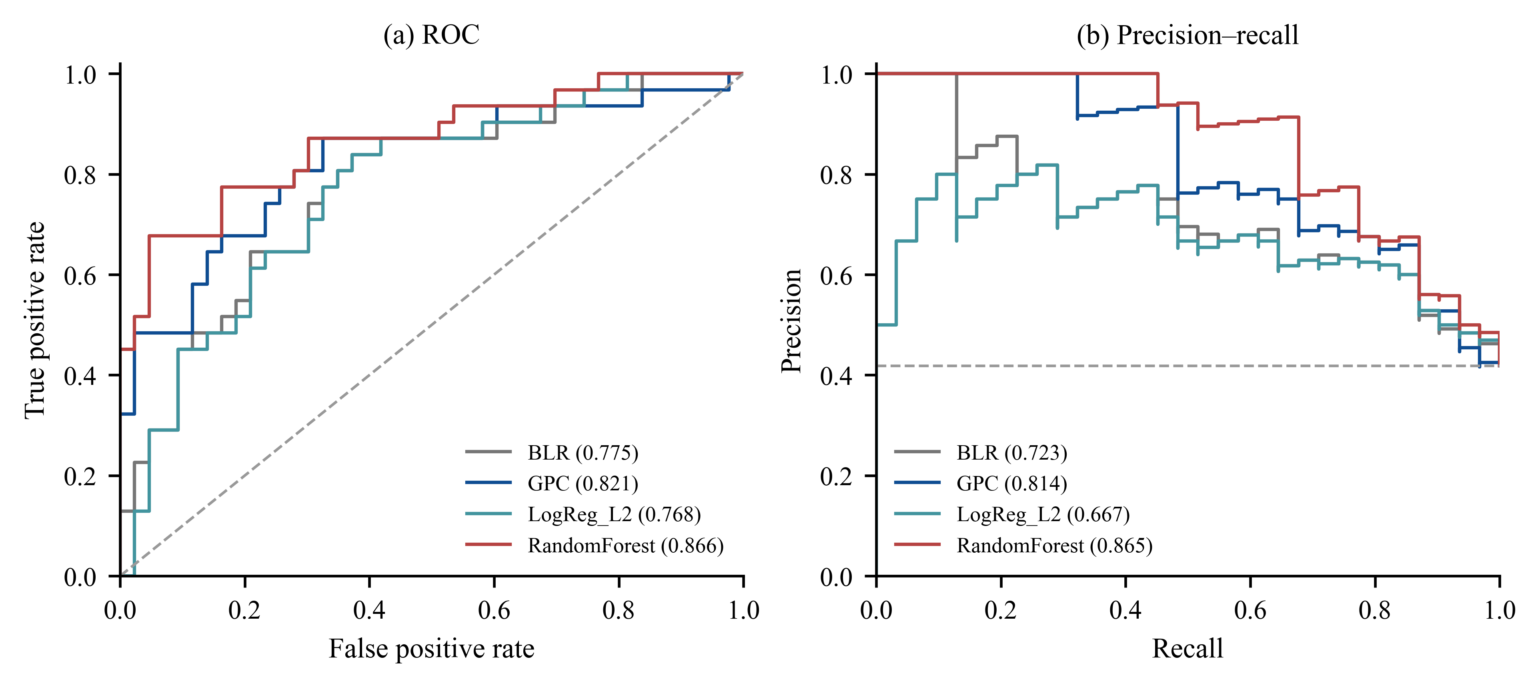
Figure 2. Reproduced holdout discrimination for the four classifiers on the same 74 samples. Legend values are ROC-AUC in panel a and average precision in panel b. The dashed precision baseline is the sampled positive fraction.
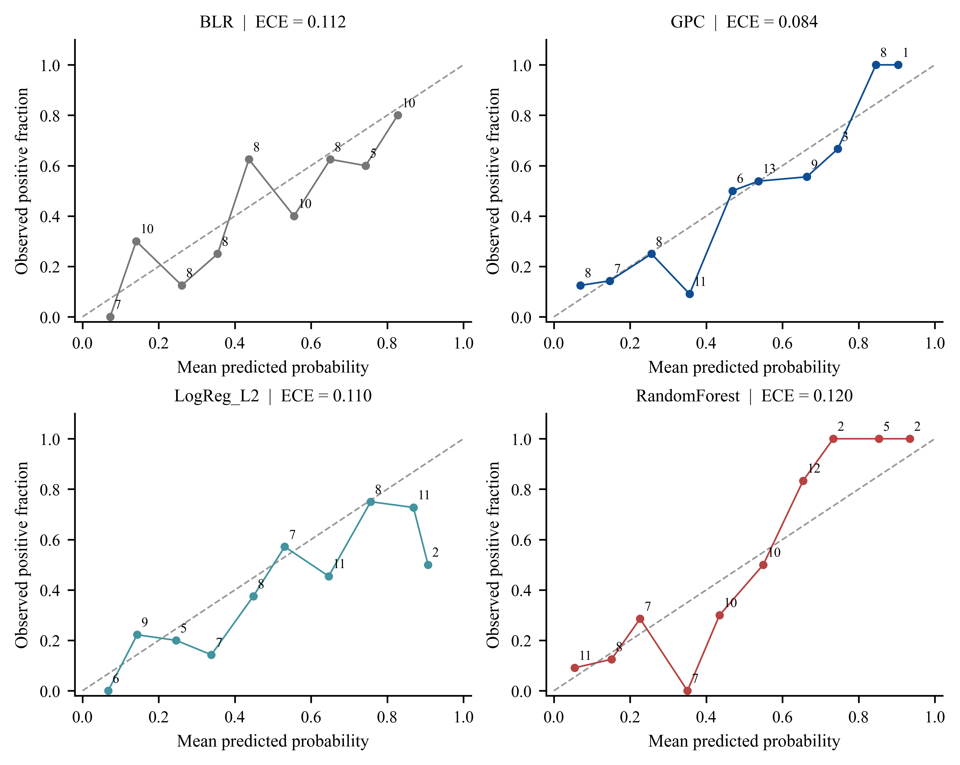
Figure 3. Unsmoothed reliability diagrams using ten equal-width bins. Labels are bin sample counts; empty bins are omitted. The dashed diagonal is perfect calibration. Sparse bin estimates and a small holdout limit inference.

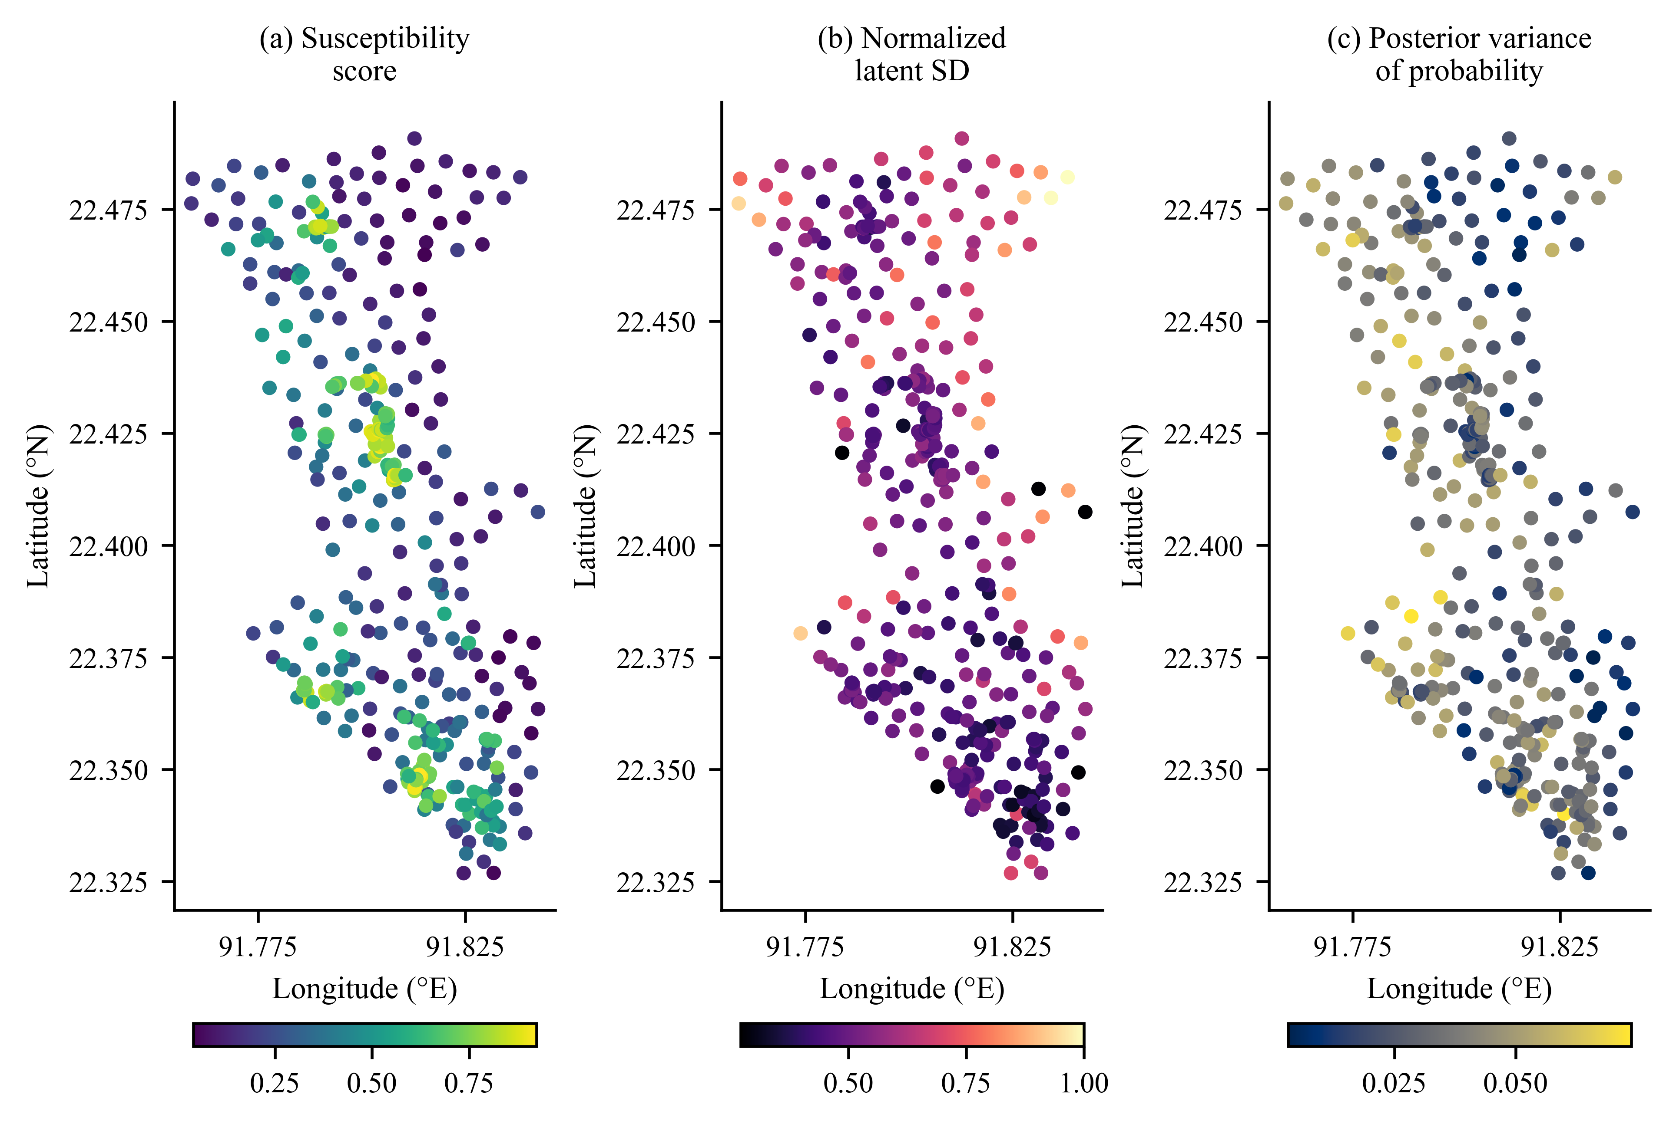
Figure 4. Full-data GPC susceptibility, normalized latent standard deviation and probability-scale posterior variance at the 369 observed locations. These are point displays, not wall-to-wall raster predictions or independent validation.
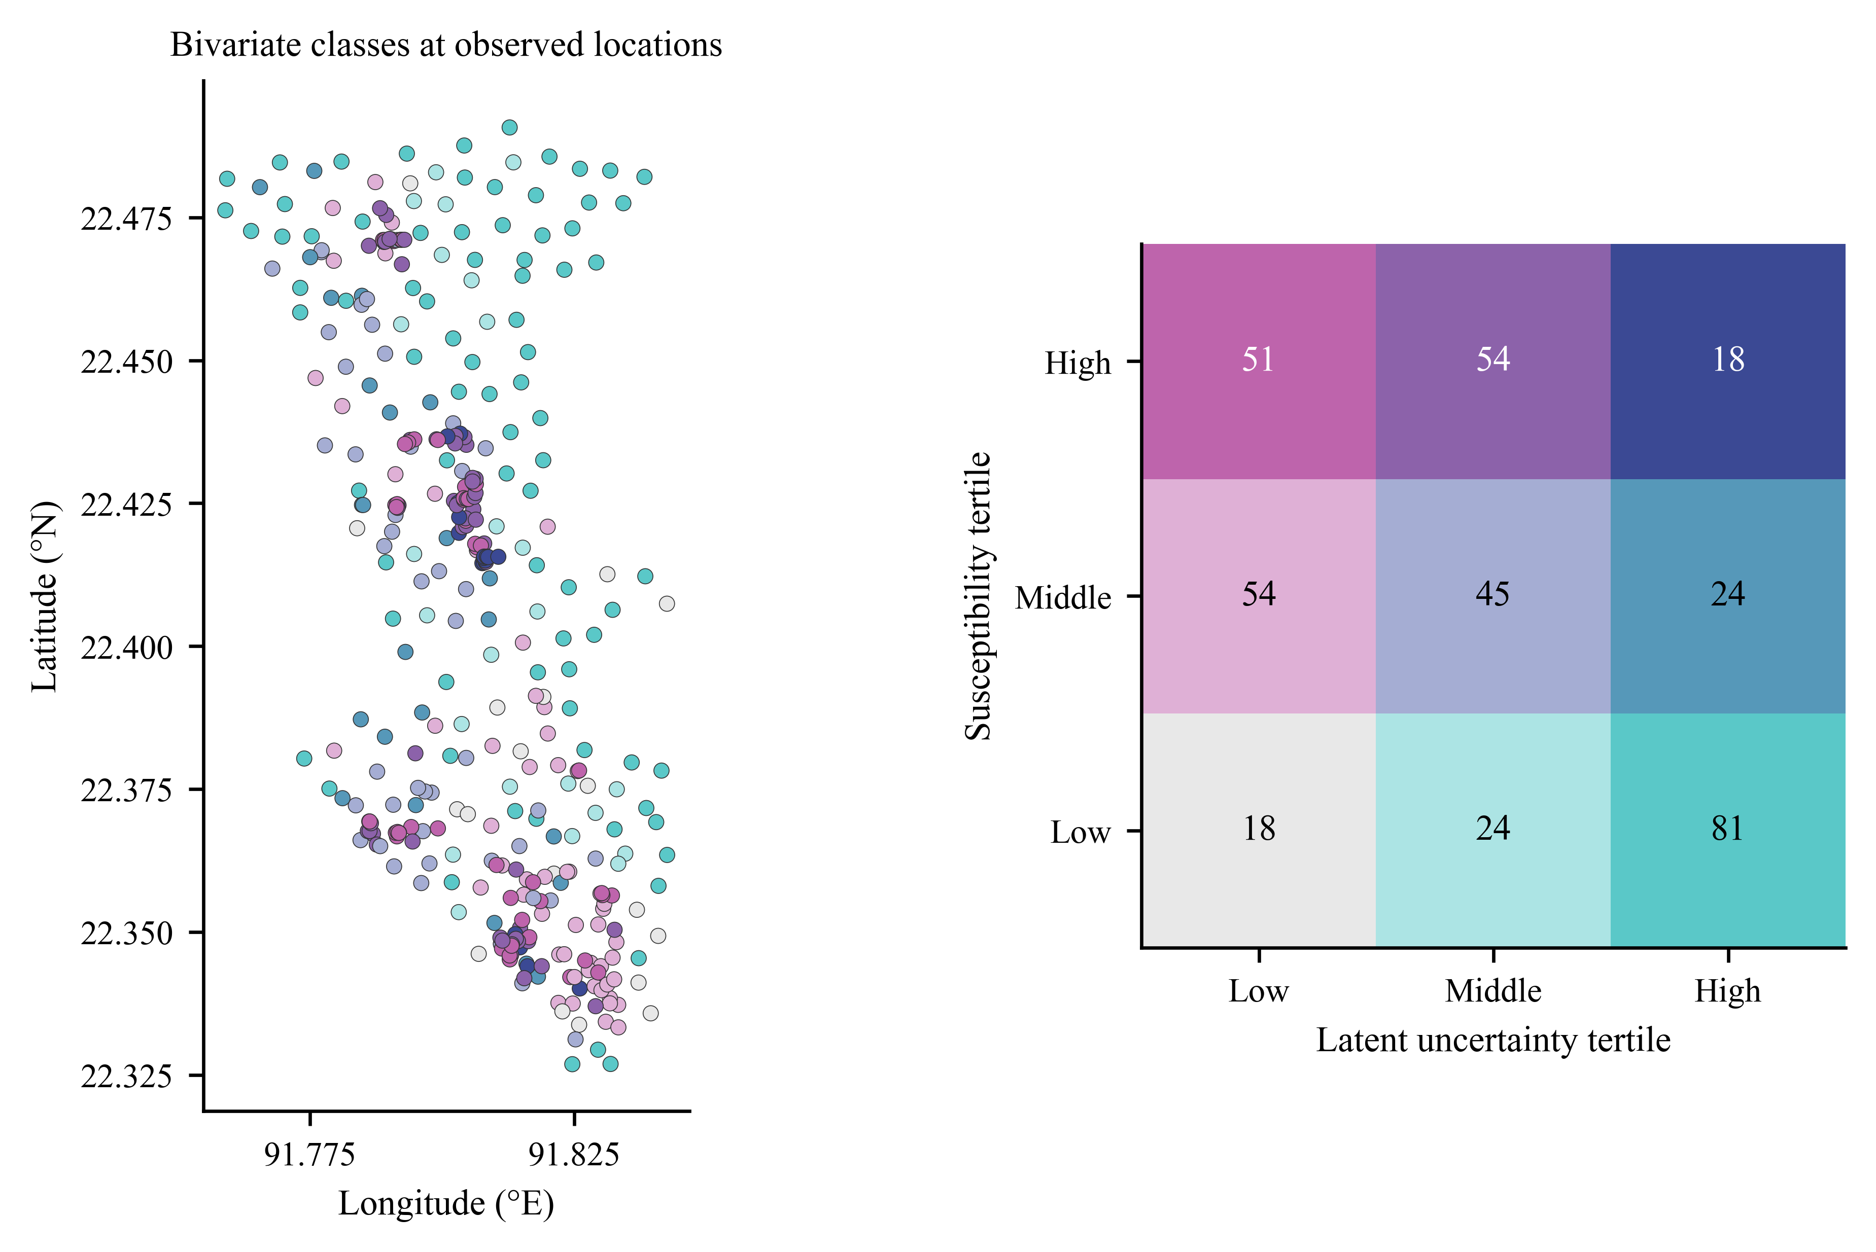
Figure 5. Corrected bivariate point display using the explicitly reported susceptibility and latent-standard-deviation tertiles. Numbers in the legend give point counts in each joint class. The classes are relative to the observed sample distribution and do not represent area percentages.

Tables
Table 1. Predictor provenance reported in the source compilation. Resolutions are native or nominal source resolutions, not independently verified resolutions of the point extraction.
Predictor group | Reported source | Native or nominal support
Elevation, slope, aspect, curvature, SPI, TWI, TRI | SRTM DEM and terrain derivatives | 30 m
NDVI | Landsat 8 Level-2 surface reflectance | 30 m
LULC | Esri Sentinel-2 land cover | 10 m
Precipitation | CHIRPS mean annual layer; years unrecorded | 0.05° (approximately 5 km)
Drainage density and distance to river | DEM-derived drainage network | 30 m terrain basis
Distance to road | OpenStreetMap road network | Vector source; rasterization unrecorded
Soil texture | ISRIC SoilGrids-derived layer | 250 m
Table 2. Holdout performance on 74 locations. PR is average precision; ECE uses ten equal-width bins. Parentheses give descriptive 95% percentile bootstrap intervals for ECE from 2,000 paired resamples. The GPC point ECE lies below its percentile interval because of upward bootstrap bias in this small-sample binned statistic.
Model | ROC-AUC | PR | MCC | Brier | ECE and 95% interval | FN and FNR
RandomForest | 0.866 | 0.865 | 0.611 | 0.153 | 0.120  (0.098–0.224) | 7/31  22.6%
GPC | 0.821 | 0.814 | 0.481 | 0.172 | 0.084  (0.097–0.223) | 8/31  25.8%
LogReg_L2 | 0.768 | 0.667 | 0.420 | 0.203 | 0.110  (0.090–0.239) | 7/31  22.6%
BLR | 0.775 | 0.723 | 0.340 | 0.193 | 0.112  (0.087–0.233) | 11/31  35.5%
Table 3. Validation means from the archived repeated CV and independently reproduced spatial CV. Spatial folds use nine training clusters, not the ten-cluster all-sample illustration.
Model | Repeated MCC | Repeated ROC-AUC | Spatial MCC | Spatial ROC-AUC
RandomForest | 0.498 | 0.849 | 0.323 | 0.805
GPC | 0.450 | 0.836 | 0.259 | 0.769
LogReg_L2 | 0.433 | 0.756 | 0.214 | 0.709
BLR | 0.388 | 0.757 | 0.226 | 0.709

