Supplementary methods and results for the Chattogram susceptibility revision
This supplement documents the actual spatial splits, calibration resampling, negative-subset experiments, coarse-predictor ablations and corrected uncertainty calculation. The underlying CSV files retain full precision and sample identifiers. Legacy area statistics are isolated as an audit record and are not presented as validation of the corrected uncertainty displays.

S1 Spatial validation design
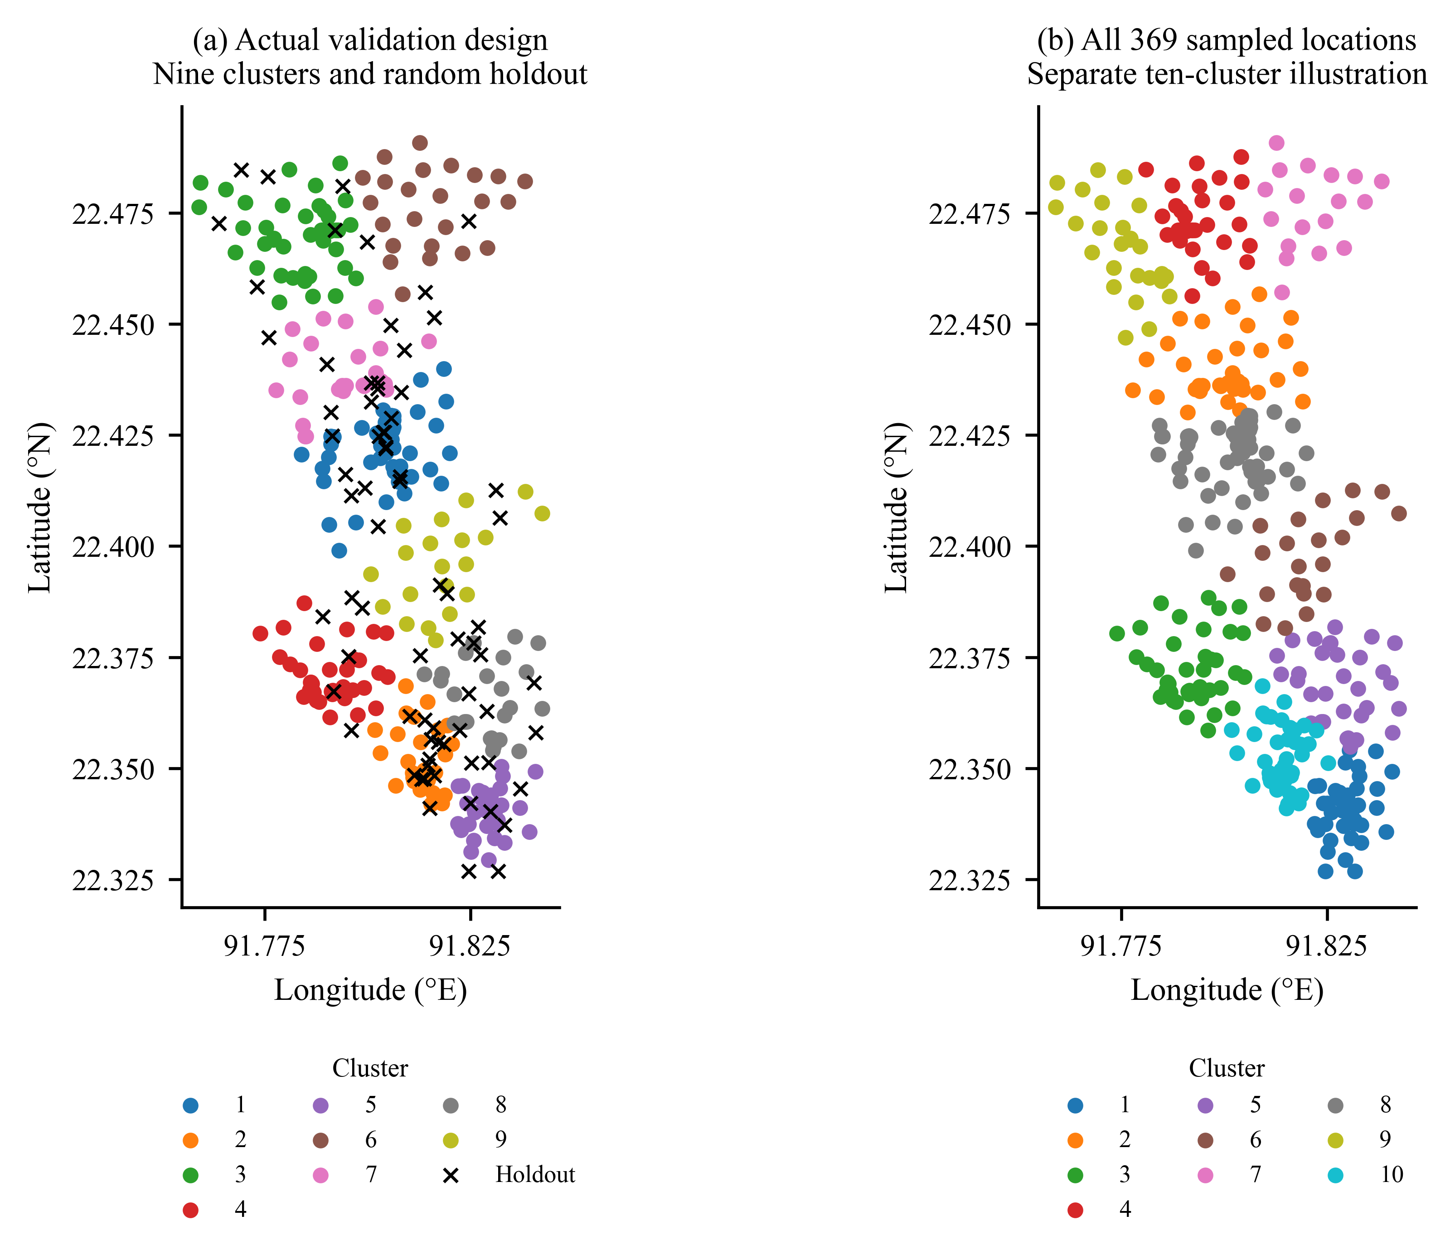
Figure S1. Panel a shows the nine KMeans training clusters actually used for spatial CV, together with the 74 random holdout locations. Panel b shows a separate ten-cluster partition of all 369 records to address the requested all-sample display. Clustering uses geographic coordinates, n_init = 10 and seed 42. No vector study boundary was available for a reproducible overlay.
Table S1. GroupKFold assignments and class counts. The held-out training clusters do not include the 74-location random holdout.
Fold | Clusters | Train + | Train − | Test + | Test − | Test total
1 | 1 | 90 | 149 | 34 | 22 | 56
2 | 3,9 | 104 | 125 | 20 | 46 | 66
3 | 4,6 | 109 | 126 | 15 | 45 | 60
4 | 2,7 | 94 | 144 | 30 | 27 | 57
5 | 5,8 | 99 | 140 | 25 | 31 | 56

Table S2. Cluster composition and maximum separation among member points. Separations are great-circle distances using Earth radius 6,371,008.8 m, and do not define polygon widths.
Cluster | Total | Positive | Negative | Maximum separation km
1 | 56 | 34 | 22 | 5.25
2 | 32 | 19 | 13 | 3.07
3 | 46 | 20 | 26 | 4.56
4 | 36 | 15 | 21 | 3.45
5 | 30 | 17 | 13 | 2.58
6 | 24 | 0 | 24 | 4.16
7 | 25 | 11 | 14 | 4.01
8 | 26 | 8 | 18 | 3.08
9 | 20 | 0 | 20 | 4.63

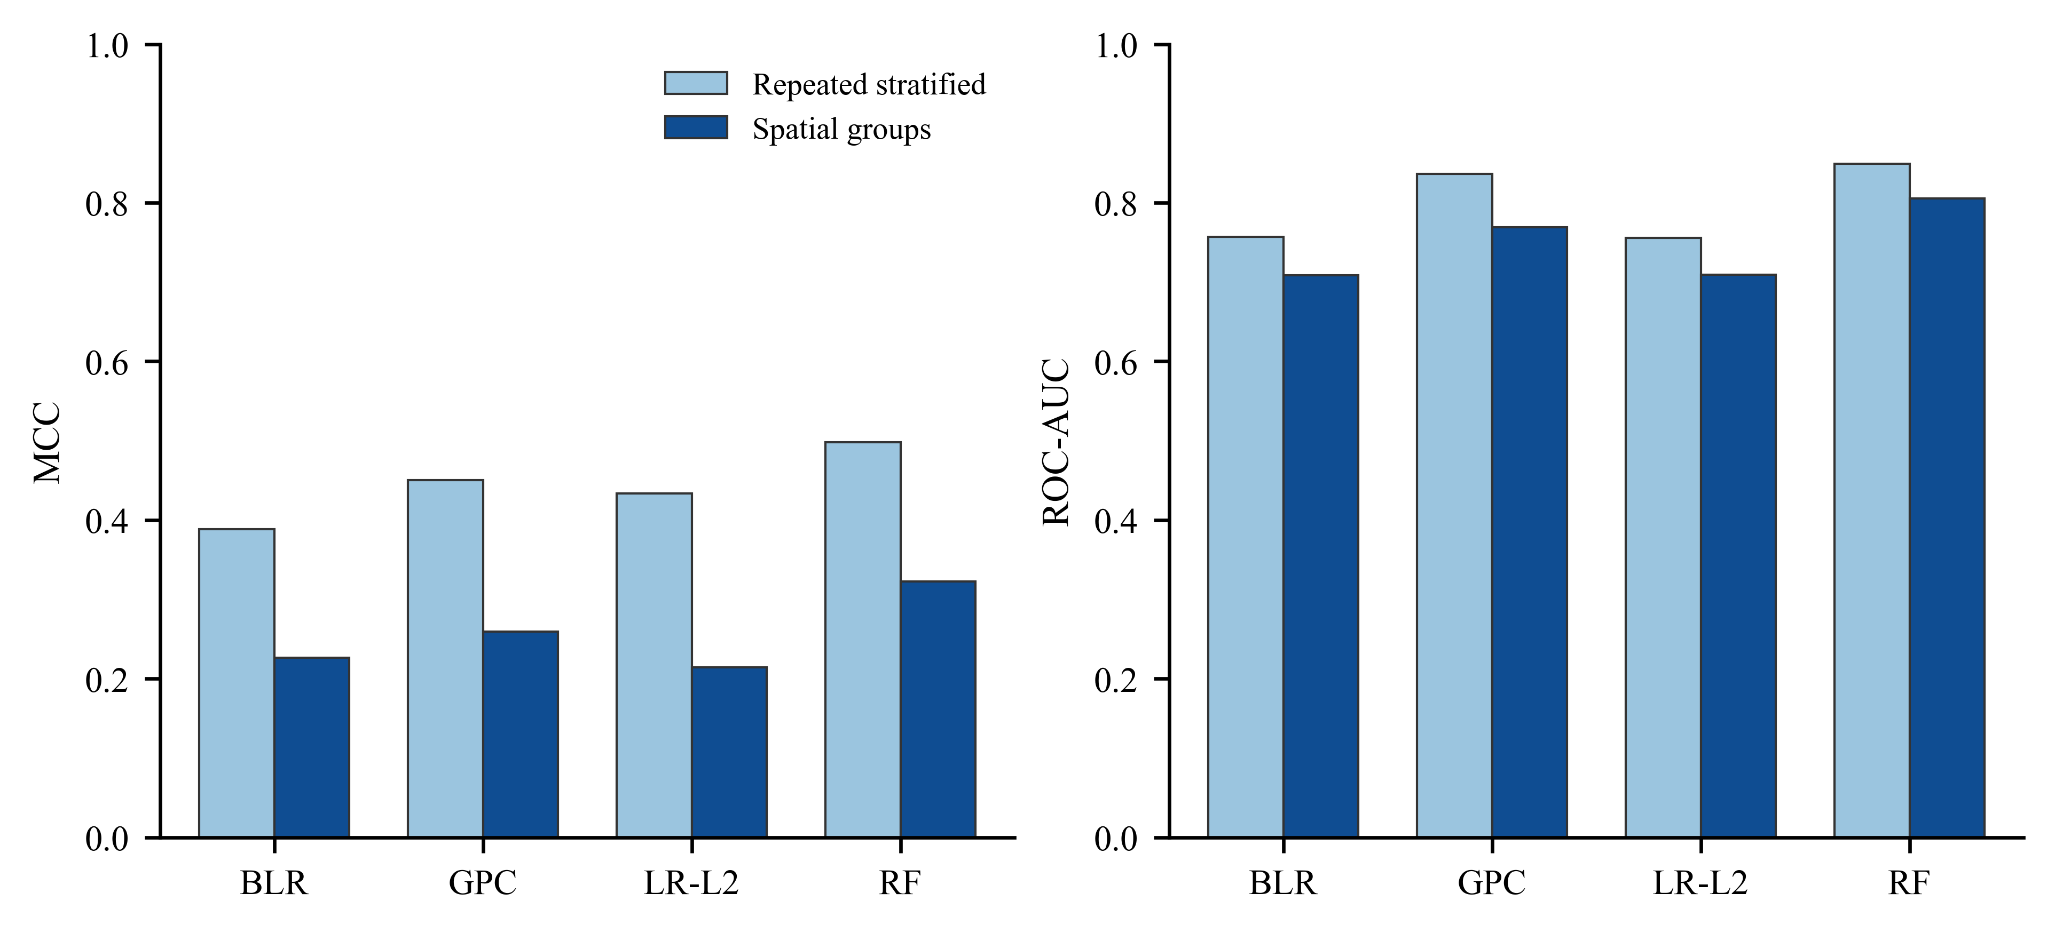
Figure S2. Comparison of repeated stratified CV means and reproduced spatial CV means. Repeated folds overlap and are not independent experimental replicates.

S2 Calibration resampling
Each of 2,000 bootstrap replicates resamples 74 label–prediction pairs with replacement. Identical resampled indices are used for all models (NumPy default_rng seed 42). Models are not refitted. ECE uses positive-class empirical frequency, equal-width bins and zero contribution from empty bins. The GPC 10-bin interval excludes its point estimate because resampling increases the absolute bin discrepancies on average; it is a descriptive percentile interval, not a bias-corrected or spatial confidence guarantee. The paired GPC-minus-RF interval includes zero (−0.078 to 0.071).
Table S3. Holdout calibration bin occupancy. Entries are counts in probability bins [0,0.1], (0.1,0.2], …, (0.9,1]. Exact means and observed fractions are in calibration_bins.csv.
Model | 1 | 2 | 3 | 4 | 5 | 6 | 7 | 8 | 9 | 10
BLR | 7 | 10 | 8 | 8 | 8 | 10 | 8 | 5 | 10 | 0
GPC | 8 | 7 | 8 | 11 | 6 | 13 | 9 | 3 | 8 | 1
LogReg_L2 | 6 | 9 | 5 | 7 | 8 | 7 | 11 | 8 | 11 | 2
RandomForest | 11 | 8 | 7 | 7 | 10 | 10 | 12 | 2 | 5 | 2

Table S4. ECE binning sensitivity and percentile bootstrap intervals. Bootstrap medians are distinct from original point estimates.
Model | Bins | Point ECE | Bootstrap median | 95% interval
BLR | 5 | 0.057 | 0.105 | 0.043–0.183
BLR | 10 | 0.112 | 0.152 | 0.087–0.233
BLR | 15 | 0.111 | 0.176 | 0.112–0.249
GPC | 5 | 0.083 | 0.119 | 0.060–0.191
GPC | 10 | 0.084 | 0.152 | 0.097–0.223
GPC | 15 | 0.143 | 0.188 | 0.128–0.258
LogReg_L2 | 5 | 0.091 | 0.126 | 0.056–0.214
LogReg_L2 | 10 | 0.110 | 0.160 | 0.090–0.239
LogReg_L2 | 15 | 0.136 | 0.192 | 0.125–0.271
RandomForest | 5 | 0.103 | 0.125 | 0.061–0.193
RandomForest | 10 | 0.120 | 0.159 | 0.098–0.224
RandomForest | 15 | 0.147 | 0.186 | 0.127–0.248

S3 Negative subset sensitivity
For each seed we retain 136 of 171 original training negatives without replacement and all 124 training positives. The 74 holdout records remain fixed and are excluded from every training fit. Estimator seed 42 is held constant so the designated sensitivity seed changes the retained negative records. The experiment also changes the training prevalence. It does not create new negative locations, demonstrate stability of an unsampled domain or measure independent raster-map changes.
Table S5. Negative-subset sensitivity. The correlation and mean absolute error (MAE) compare predictions from each sensitivity fit with the corresponding baseline training fit at all 369 observed locations; this is a descriptive point-pattern comparison.
Seed | Model | AUC | MCC | ECE | Point ρ | Point MAE
7 | BLR | 0.761 | 0.411 | 0.099 | 0.991 | 0.046
7 | GPC | 0.805 | 0.443 | 0.113 | 0.986 | 0.039
7 | LogReg_L2 | 0.764 | 0.431 | 0.121 | 0.988 | 0.029
7 | RandomForest | 0.864 | 0.598 | 0.093 | 0.979 | 0.042
21 | BLR | 0.764 | 0.379 | 0.126 | 0.992 | 0.045
21 | GPC | 0.813 | 0.530 | 0.129 | 0.990 | 0.035
21 | LogReg_L2 | 0.757 | 0.398 | 0.126 | 0.993 | 0.023
21 | RandomForest | 0.848 | 0.520 | 0.113 | 0.979 | 0.048
84 | BLR | 0.771 | 0.411 | 0.118 | 0.992 | 0.043
84 | GPC | 0.820 | 0.544 | 0.147 | 0.987 | 0.038
84 | LogReg_L2 | 0.770 | 0.420 | 0.138 | 0.993 | 0.024
84 | RandomForest | 0.863 | 0.544 | 0.106 | 0.982 | 0.041

S4 Coarse predictor ablations
Table S6. Excluding rainfall, soil, or both using the original split. No spatial detail is created by this analysis. The soil ablation also removes the questionable numeric soil-texture codes, so its effect is not solely a resolution effect.
Excluded | Model | AUC | MCC | Brier | ECE
rainfall | BLR | 0.779 | 0.434 | 0.189 | 0.051
rainfall | GPC | 0.848 | 0.556 | 0.162 | 0.118
rainfall | LogReg_L2 | 0.773 | 0.376 | 0.198 | 0.119
rainfall | RandomForest | 0.866 | 0.470 | 0.150 | 0.130
soil | BLR | 0.771 | 0.340 | 0.193 | 0.107
soil | GPC | 0.807 | 0.506 | 0.177 | 0.152
soil | LogReg_L2 | 0.770 | 0.388 | 0.202 | 0.099
soil | RandomForest | 0.858 | 0.497 | 0.153 | 0.114
both | BLR | 0.780 | 0.434 | 0.189 | 0.062
both | GPC | 0.839 | 0.553 | 0.165 | 0.133
both | LogReg_L2 | 0.771 | 0.376 | 0.198 | 0.119
both | RandomForest | 0.872 | 0.553 | 0.147 | 0.146

S5 Conditional uncertainty and classification
The archived ambiguity score is reproduced by Uold = 1 − 2|p − 0.5| with a maximum absolute discrepancy of 2.78 × 10⁻¹⁶. It is not used as latent variance. The corrected output provides latent mean, latent variance, normalized latent standard deviation, probability-scale posterior variance and expected Bernoulli variance separately. Numerical quadrature verifies Var(q) + E[q(1 − q)] = E[q](1 − E[q]) to tolerance 10⁻¹². The kernel and normalization are conditional on the full-data fitted model and the 369-location display domain.
Table S7. Classification sensitivity at the observed locations. Fixed thirds are arbitrary comparison breaks, not calibrated decision thresholds. Agreement is the fraction of points assigned the same ordinal class as under tertiles.
Variable and method | Cuts | Low | Middle | High | Agreement
Probability / Tertiles | 0.251145  0.595974 | 123 | 123 | 123 | 100.0%
Probability / Jenks | 0.298405  0.584422 | 146 | 98 | 125 | 93.2%
Probability / Fixed thirds | 0.333333  0.666667 | 159 | 116 | 94 | 82.4%
Latent uncertainty / Tertiles | 0.452066  0.535307 | 123 | 123 | 123 | 100.0%
Latent uncertainty / Jenks | 0.469716  0.644965 | 144 | 176 | 49 | 74.3%
Latent uncertainty / Fixed thirds | 0.333333  0.666667 | 11 | 314 | 44 | 48.2%

S6 SHAP specification
Kernel SHAP explains the positive-class logit of the GPC trained on the original 295 training records. The reference is 30 sampled training rows; all 74 holdout rows are explained, with 150 coalition evaluations per explanation, random seed 42 and SHAP 0.46.0. Background rows, explained rows and attribution arrays are archived. No conditional correction for feature dependence is applied. The input coding limitations documented in the manuscript remain relevant to the attributions.
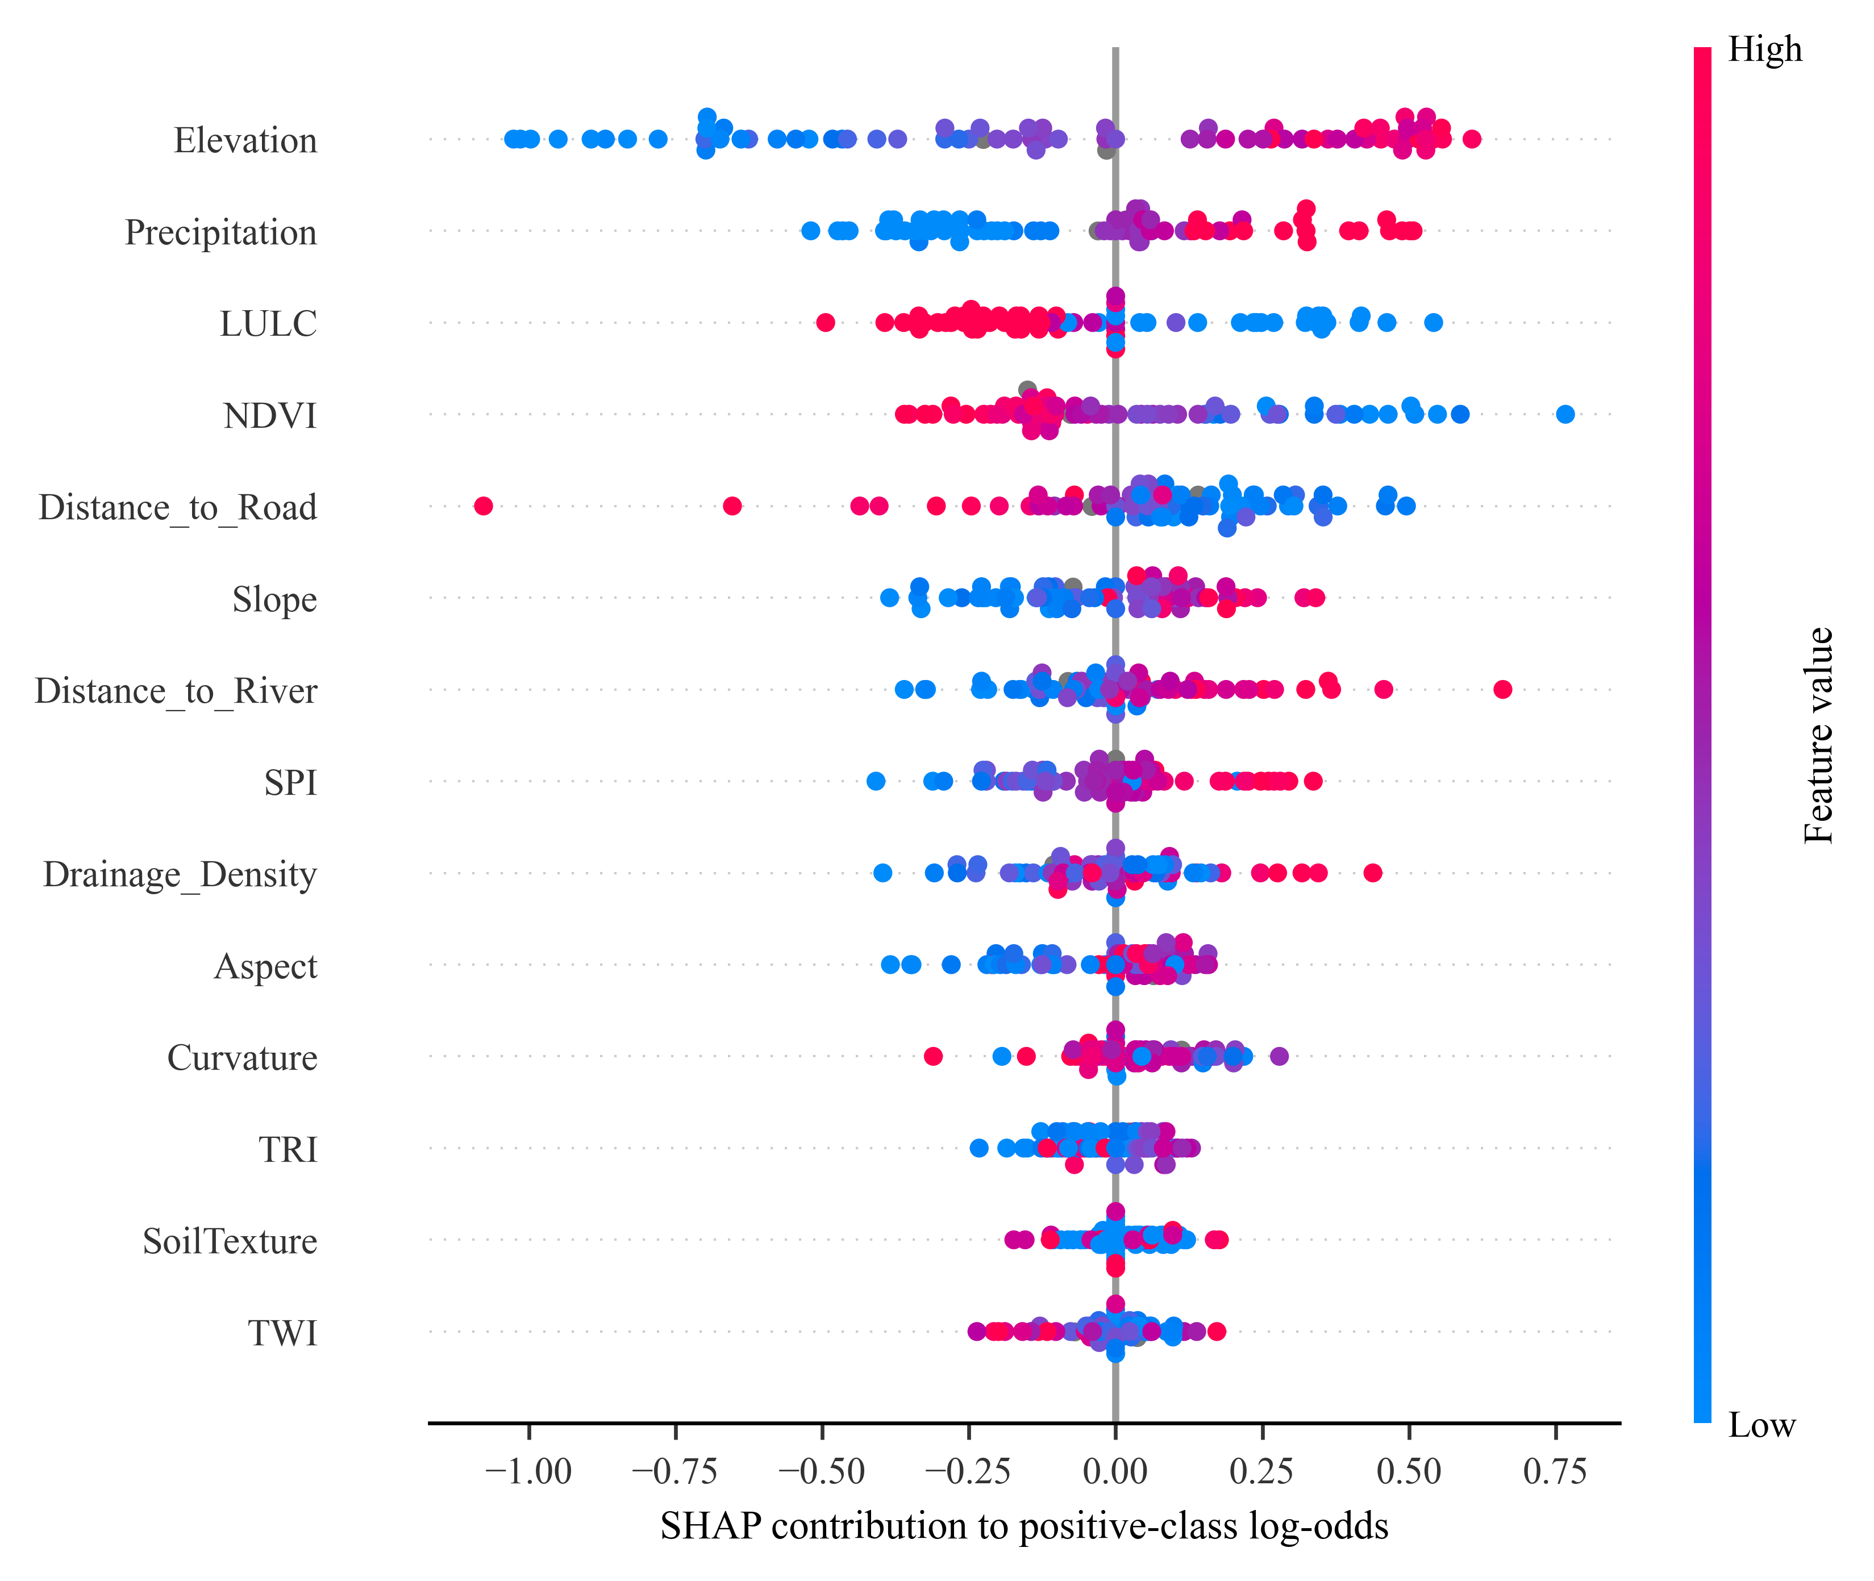
Figure S3. Regenerated GPC Kernel SHAP summary on the positive-class log-odds scale. Color indicates the recorded predictor value, including numeric categorical codes. Attributions describe the fitted model and are not causal evidence.

S7 Legacy SCAI audit record
Table S8. Preserved legacy SCAI values, included only to explain the withdrawn area claim. These values came from the full-data model and an interpolated 500 × 500 grid. They do not evaluate the corrected latent uncertainty, and their area denominator cannot be verified against a source polygon. The rows must not be cited as independent validation or percentages of the metropolitan area. The script selects five Jenks classes with a quantile fallback; the original numerical breakpoints were not saved in the CSV.
Tier | Area_Pixels | Landslide_Count | Area_Pct | Landslide_Pct | SCAI | SCAI_Smoothed
Very Low | 39523 | 1 | 29.372 | 0.645 | 45.527 | 30.841
Low | 31167 | 1 | 23.163 | 0.645 | 35.902 | 24.321
Moderate | 32343 | 9 | 24.036 | 5.806 | 4.140 | 3.985
High | 18788 | 22 | 13.963 | 14.194 | 0.984 | 0.977
Very High | 12737 | 122 | 9.466 | 78.710 | 0.120 | 0.122

S8 Data and reproducibility audit
Check | Observed result
Raw rows / retained rows | 376 / 369 after exact-row deduplication
Positive / negative records | 155 / 214
Negative points within 500 m of a positive | 71 of 214
Negative points with recorded slope ≥ 10° | 27 of 214
Fractional LULC / soil-texture values | 31 / 19
Actual spatial clusters / all-sample illustration | 9 / 10
Holdout points within 500 m of training | 51 of 74
Source table SHA-256 | 405d76c05777b089e4e2d0bd1743f2b6304e9c38092c2a7f6c912168b3c4ecb1
Holdout reproduction | MCC, AUC and average precision reproduced exactly; ECE and Brier differences < 2 × 10⁻¹⁴
Spatial reproduction | Maximum absolute MCC mean difference < 10⁻¹⁵

The archived repeated-CV summary was reused rather than recomputed; holdout models and every spatial fold were independently refitted. All new negative-subset and predictor-ablation results were computed from the source table. Input files and legacy outputs remain unchanged. Run revision/run_revision_analysis.py followed by revision/run_revision_checks.py from the repository root. The manuscript and tables are built by revision/build_submission.py. Environment versions and model warnings accompany the analysis.

