Stochastic Physics-Informed Neural Network with MC Dropout for Estimating Consolidation Parameters
Golam Murad¹, Shotabdy Chowdhury Srabony², Debajit Das Gupta³ and Md. Aftabur Rahman^{4*}
¹Graduate, Department of Civil Engineering, Chittagong University of Engineering & Technology, Chattogram-4349, Bangladesh, e-mail: u1901087@student.cuet.ac.bd
²Research Assistant, Department of Civil Engineering, Chittagong University of Engineering & Technology, Chattogram-4349, Bangladesh, e-mail: u1901052@student.cuet.ac.bd
³Undergraduate Student, Department of Civil Engineering, Chittagong University of Engineering & Technology, Chattogram-4349, Bangladesh, e-mail: u2101101@student.cuet.ac.bd
⁴Professor, Department of Civil Engineering, Chittagong University of Engineering & Technology, Chattogram-4349, Bangladesh, e-mail: maftabur@cuet.ac.bd
*Md. Aftabur Rahman
ABSTRACT
Reliable estimation of the coefficient of consolidation is essential for settlement prediction, pore-pressure dissipation analysis, and staged construction planning in soft ground engineering. Conventionally, this parameter is obtained from laboratory oedometer tests and back-analysis, which are costly, time-consuming, and difficult to scale for rapidly developing infrastructure systems. This study presents an uncertainty-aware physics-informed neural network (PINN) that infers the consolidation coefficient directly from sparse, noisy spatiotemporal sensor data, reducing reliance on traditional workflows. The framework incorporates Terzaghi’s one-dimensional consolidation equation into the loss function and integrates Monte Carlo dropout to provide both point estimates and confidence bounds. The model was trained on only 50 synthetic sensor readings with added noise to mimic field conditions. Even with this limited data, it estimated the coefficient very accurately, giving $c_{v}=1.209335$compared with the true value of $1.2$, which corresponds to a relative error of only 0.7779%. When tested on a dense grid, it also performed well, with an MSE of 0.008802, an RMSE of 0.093818, and 95% interval coverage of 94.67%. Overall, the results show that physics-informed machine learning can produce reliable inverse estimates and provide a useful measure of uncertainty, making it promising for future GeoAI-based monitoring and digital twin applications in geotechnical engineering.
Keywords: PINN; PDE, coefficient of consolidation (cᵥ); Monte Carlo dropout, Geo-Ai
Introduction
Globally, urban centres near the coast and major ports are facing increasing geotechnical and engineering stresses. Because of port expansion, corridor improvements for transport modes, industrial land development, reclamation practices, or creeping urban encroachment into the hillside. The above projects frequently face soft, compressible soils, where the consolidation response is a key factor in serviceability, construction sequencing, and long-term settlement risk. Rapid and robust estimation of the coefficient of consolidation (cᵥ) is not an academic exercise in such scenarios. But before we can deliver safe and economical infrastructure (C et al., 2026). Yet geotechnical practice, i.e., oedometer tests and back-analysis, relies on a lengthy, heuristic lab process and limited data collection. Again, those processes are difficult to upgrade. A contemporary GeoAI should thus do much more than just curve fitting: it needs to assimilate limited sensor data, stay in concert with governing mechanics, quantify uncertainty, and update efficiently as information arrives (Murad et al., 2026; Singh et al., 2024). While traditional finite element methods (FEM) remain irreplaceable for high-fidelity forward simulation, they are constrained as an end-to-end inference engine for repeated parameter back-analysis across applications (Sun et al., 2025). Although inverse FEM workflows usually require iterative calibration, mesh generation, constitutive model selection, and repeated solver calls. Therefore, this can be difficult when fast operational decision-making is necessary. At the other extreme, typical black-box deep learning models readily interpolate observations but violate boundary conditions, conservation laws, or diffusion physics when extrapolating beyond the training cloud (Slater et al., 2023). Thus, uncertainty quantification (UQ) is an important aspect of this work (Gal & Ghahramani, 2015). Safety, constructability, and lifecycle cost are affected by pore-pressure dissipation, foundation settlement, and embankment performance. Considering a purely deterministic model, especially given the sparsity and noise inherent in measurements, is an insufficient basis for decision-making. The hybrid method of physics-informed neural networks (PINNs) embeds the governing partial differential equation (PDE) directly into the training process, providing a temperate balance between data and prior knowledge, while Monte Carlo (MC) dropout provides a simple and scalable means to approximate epistemic uncertainty for deep models. Thus, this study proposes a mesh-free stochastic inverse PINN for 1D consolidation and examines its capacity to infer (cᵥ) from volatile, limited observations.

methodology
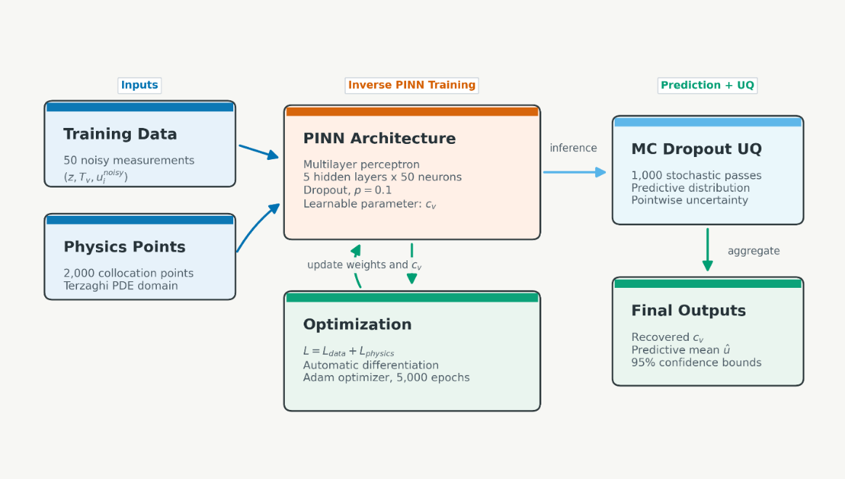
Figure 1: Inverse Physics-Informed Neural Network Framework for Parameter Estimation and Uncertainty Quantification
Governing Equations
The governing physics is Terzaghi’s one-dimensional consolidation equation (Terzaghi, 1943):
$\frac{∂u}{∂t}=c_{v}\left(\frac{∂^{2}u}{∂z^{2}}\right), 0<z<H, 0<t$ (1)
where u (z, t) is excess pore pressure, (z) is depth, (t) is the normalised time coordinate reported as (Tᵥ) in the figures, and (cᵥ) is the coefficient of consolidation to be inferred. In the present study, the depth domain was fixed at (H = 2.0) m, the dimensionless time-factor range was (0 < Tᵥ < 1), and the initial excess pore pressure amplitude was (u₀ = 1.0). The synthetic reference field was generated from the analytical series solution for a double-drainage-type setting with zero excess pore pressure at the drainage boundaries:
$u\left(0,t\right)=0, u\left(H,t\right)=0, u\left(z,0\right)=u_{0}$ (2)
The analytical truth used throughout the study was adopted (cᵥ = 1.2).
Synthetic data generation under sparse field-like conditions
To simulate real-world instrumentation constraints, the dense analytical field was not used directly for training. You only sampled 50 spatiotemporal sensors. Sensor depths followed the same uniform density across the soil layer, and time points were drawn from a beta distribution with a small left-hand limit to favour early stages, following earlier statements, reflecting that data points from the early-time consolidation data appear more informative relative to later time points. Orthogonal Gaussian noise with standard deviation 0.05 was introduced to mimic field conditions (Cao et al., 2018). We obtained a dataset that poses a very difficult inverse problem, with observations that are sparse, irregular, and noisy. The realised perturbations shown in Figure 1 had a mean of +0.003 and a standard deviation of 0.047, which closely matched the specified noise level.
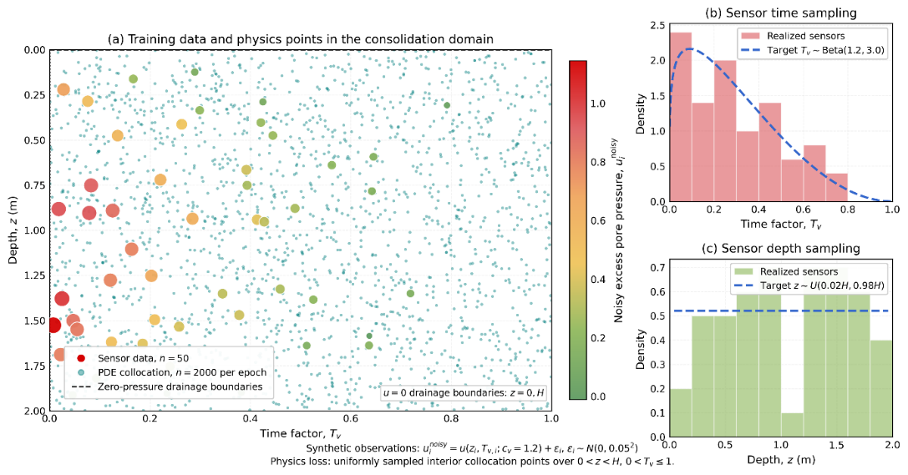
Figure 2: Sparse spatiotemporal sensor and Collocation Sampling in the Consolidation Domain.
Uncertainty-aware PINN architecture
In this case, the inverse model is implemented in PyTorch in the form of a fully connected multilayer perceptron with five hidden layers (50 neurons each) and hyperbolic tangent activations, along with dropout (p = 0.1) (Wu et al., 2023). The inputs (z,t) are scaled to the range of $\left[-1,1\right]$, and $u(z,t)$ is excess pore pressure. Then, the coefficient of consolidation is trained as a positive, regularised parameter (initial value set to 0.5), so that both the state field and the physics laws are learned simultaneously from incomplete data. Monte Carlo dropout is also applied during inference, performing 1,000 stochastic forward passes to build an empirical predictive distribution (Zhu et al., 2019). The mean gives the final estimate and standard deviation $\left(σ_{u}\right)$ defines approximate 95% confidence bounds. This turns a deterministic PINN into a stochastic inference framework that can identify both regions with strong constraints and those where caution is warranted.
$\hat{u}\left(z,t\right)±1.96σ_{u}\left(z,t\right)$ (3)
2.4 Inverse physics-informed loss and optimisation
The network was trained by minimising a composite objective made of a data-misfit term and a physics-residual term:
$L=L_{data}+L_{phys}$ (4)
The data component was the mean squared error between predictions and the 50 noisy sensor values:
$L_{data}=\left(\frac{1}{N_{s}}\right)\sum_{i=1}^{N_{s}}{{\left(u_{i}-\hat{u_{i}}\right)}^{2}}$ (5)
The physics term enforced consistency with the governing PDE through the residual
$r\left(z,t\right)=\frac{∂u}{∂t}-c_{v}\frac{∂u^{2}}{∂z^{2}}$ (6)
evaluated at 2,000 randomly sampled interior collocation points per epoch:
$L_{phys}=\left(\frac{1}{N_{r}}\right)\sum_{j=1}^{N_{r}}{r{\left(Z_{j},t_{j}\right)}^{2}}$ (7)
Automatic differentiation provided exact first- and second-order derivatives via the computational graph, eliminating the need for manual PDE discretisation. Optimisation was performed with Adam for 5,000 epochs, starting from a learning rate of (10⁻³) with stepwise decay. To contextualise the value of the physics prior, a degree-8 polynomial regression model trained only on the noisy sensor data was also evaluated as a non-physics baseline (Rao et al., 2023).
results and discussion
Convergence and inverse parameter discovery
The inverse PINN estimated $c_{v}=1.2093$, with a small absolute error of 0.0093 and a relative error of 0.78% compared to the true value (1.2). Training remained stable over the 5,000 epochs we trained for, with data loss consistently decreasing from 0.299 to 0.020, while physics loss stayed near that value at ≤ 0.010. The PDE residual initially dropped rapidly, before levelling out at around${10}^{-2}$ demonstrating that the model learned from noisy data, returning the underlying physics. The estimated $c_{v}$ rose non-linearly from 0.5 and approached the true value by the last time point. With just 50 noisy samples, the model still predicted accurately thanks to the helpful smearing provided by physics-based regularisation, an example of it working well. The model focused on the full domain yielded (MSE = 0.0088, RMSE = 0.0938 and MAE = 0.0679). The training sensor error (MSE = 0.0165) suggests the model generalizes well and balanced data fitting with physical fidelity without overfitting.
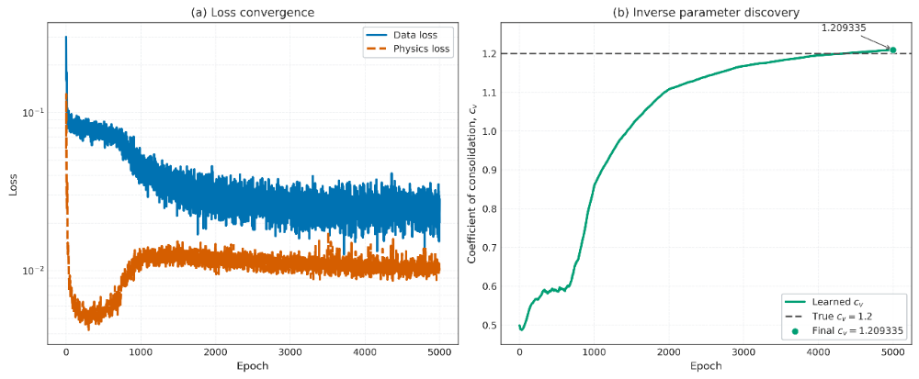
Figure 3: Training history for data loss, physics loss, and learned $c_{v}$, showing stable convergence toward the true value of 1.2.
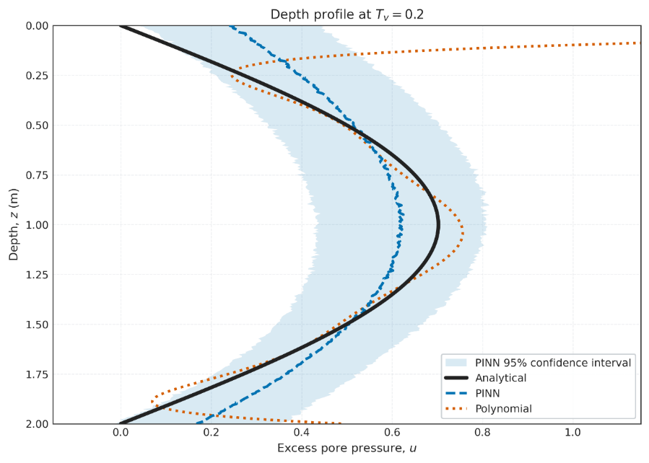
Figure 4: Depth profile at $T_{v}=0.2$comparing analytical solution, PINN mean, polynomial baseline, and PINN 95% confidence interval, showing the PINN stays close to the physics-based reference while the baseline deviates outside well-constrained regions.
Uncertainty structure and confidence calibration
The average prediction uncertainty (standard deviation with MC dropout) was 0.085. The maximum uncertainty of 0.118 occurred at depth z = 0.667 m, which was the initial time (Tᵥ = 0). Even with the limited data available, the model's uncertainty estimates are fairly trustworthy, as approximately 94.67% of true values fell within the 95% confidence intervals. The uncertainty is not isotropic: it is lowest in the interior zone, where data and the PDE are informative for the model, while it grows near boundaries and in early-time zones, where less information is available. This pattern can also assist engineers in determining whether they need to install additional sensors (piezometers) at a few specific locations.

3.3 Error localisation and engineering interpretation
The stochastic PINN is useful in practice as it yields low predictive error in the main region of interest (i.e., where most engineering decisions are performed). Yet it also very much reveals its own limitations in fast-changing areas. It is important to understand the distinction between uncertainty and error: uncertainty provides a conservative overall indication of risk, while error indicates a mistake at a local scale. The two work in tandem to help engineers make better choices about where to locate sensors and how to observe the system. Moreover, it is a mesh-free method that runs quickly on a CPU and thus provides an efficient implementation for real-time applications critical to large infrastructure systems.

3.4 Scope and limitations
We demonstrate a proof of concept that the stochastic PINN can indeed faithfully recover consolidation parameters from sparse, noisy data whilst adhering to the governing physics. The results reaffirm that the core method is validated, with simplified assumptions limiting its field applications. This study is limited to a simplified one-dimensional consolidation problem and validated with synthetic data. The methodology assumes homogeneous soil conditions and ideal boundary conditions. That may not describe field complexity. For uncertainty quantification, we use approximate Bayesian inference. Future research will be conducted with complete probabilistic methods. Additionally, validation will be with real field data.
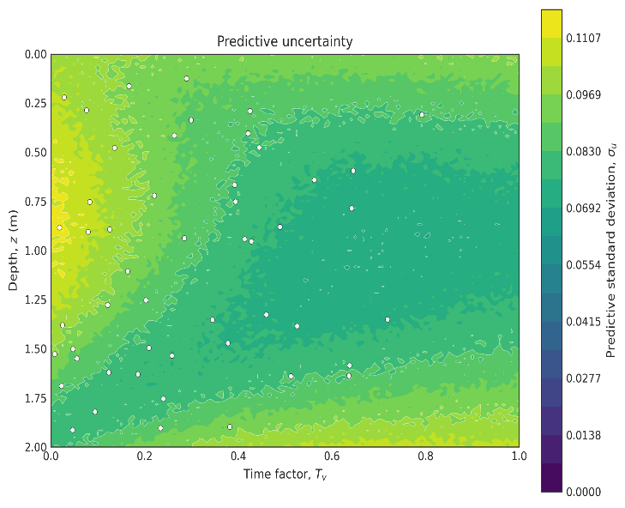  Figure 5: MC-dropout uncertainty map over depth and time, highlighting regions where more data is needed to improve confidence. | 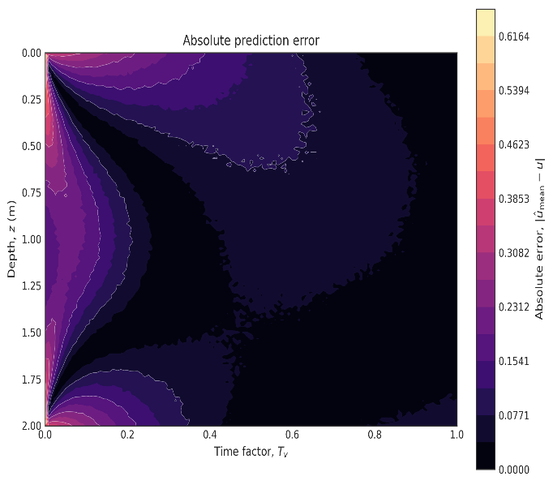  Figure 6: Absolute error map of the PINN compared to the analytical solution, showing higher errors near early-time and boundary regions, and lower error across most of the interior.

- Conclusion
In this research, we have shown that an uncertainty-aware PINN can effectively extract consolidation parameters from only a few noisy sensor readings while remaining consistent with the underlying governing physics. Despite limited data, the model recovered the crucial parameter almost exactly at the true value and generated excellent predictive power throughout (most of) its range. More importantly, it not only provided a single answer but also indicated where the predictions are more or less reliable. Together, these results indicate that this type of physics-informed machine learning may be a feasible and pragmatic tool for geotechnical interpretation when full-field testing is out of reach. This framework could enable systems for monitoring and digital twins in working locations like Chittagong, where smart, high-speed yet low-data decision-making is of supreme importance. That would be the next step: to test it first under complex soil conditions and, ideally, with field data as well. This application is a significant first demonstration of the approach to the paradigm.

REFERENCES
C, Y. U., Prasanna, H. S., & Anil, U. (2026). A physics-informed neural network framework for consolidation parameter prediction using controlled clay-sand mixtures. Results in Engineering, 29, 109255–109255. https://doi.org/10.1016/j.rineng.2026.109255
Cao, Z.-J., Zheng, S., Li, D., & Phoon, K.-K. (2018). Bayesian identification of soil stratigraphy based on soil behaviour type index. Canadian Geotechnical Journal, 56(4), 570–586. https://doi.org/10.1139/cgj-2017-0714
Gal, Y., & Ghahramani, Z. (2015). Dropout as a Bayesian Approximation: Representing Model Uncertainty in Deep Learning. arXiv (Cornell University). https://doi.org/10.48550/arxiv.1506.02142
Murad, G., Rahman, M. A., Srabony, S., & Mahmud, S. (2026). Uncertainty-Aware Bayesian Machine Learning for Landslide Susceptibility Mapping: In the Chattogram Metropolitan Hill System, Bangladesh. https://doi.org/10.31223/x55j40
Rao, C., Ren, P., Wang, Q., Büyüköztürk, O., Sun, H., & Liu, Y. (2023). Encoding physics to learn reaction–diffusion processes. Nature Machine Intelligence, 5(7), 765–779. https://doi.org/10.1038/s42256-023-00685-7
Singh, G., Moncrieff, G. R., Venter, Z. S., Cawse‐Nicholson, K., Slingsby, J. A., & Robinson, T. B. (2024). Uncertainty quantification for probabilistic machine learning in earth observation using conformal prediction. Scientific Reports, 14(1). https://doi.org/10.1038/s41598-024-65954-w
Slater, L., Arnal, L., Boucher, M.-A., Chang, A. Y.-Y., Moulds, S., Murphy, C., Nearing, G., Shalev, G., Shen, C., Speight, L., Villarini, G., Wilby, R. L., Wood, A. W., & Zappa, M. (2023). Hybrid forecasting: Blending climate predictions with AI models. Hydrology and Earth System Sciences, 27(9), 1865–1889. https://doi.org/10.5194/hess-27-1865-2023
Sun, L., Hu, Z., & Todd, M. D. (2025). Normalizing Flow Enhanced Global and Local Sampler for Bayesian Parameter Updating and State Estimation in Finite Element Models. Journal of Mechanical Design, 148(2). https://doi.org/10.1115/1.4070208
Terzaghi, K. (1943). Theoretical Soil Mechanics. https://doi.org/10.1002/9780470172766
Wu, W., Daneker, M., Jolley, M. A., Turner, K. T., & Lu, L. (2023). Effective data sampling strategies and boundary condition constraints of physics-informed neural networks for identifying material properties in solid mechanics. Applied Mathematics and Mechanics, 44(7), 1039–1068. https://doi.org/10.1007/s10483-023-2995-8
Zhu, Y., Zabaras, N., Koutsourelakis, P.-S., & Perdikaris, P. (2019). Physics-constrained deep learning for high-dimensional surrogate modeling and uncertainty quantification without labeled data. Journal of Computational Physics, 394, 56–81. https://doi.org/10.1016/j.jcp.2019.05.024

