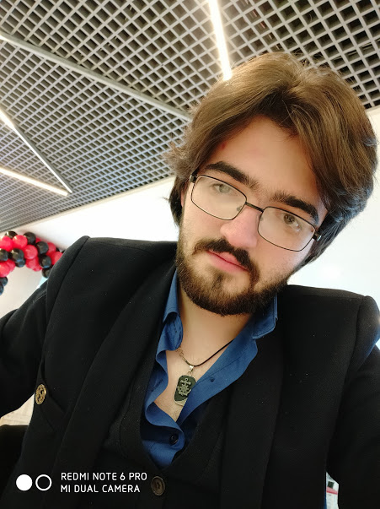

**About me**

**FRONT-END DEVELOPER**

2020 **©** Murad Narimanlı

Nərimanlı Murad

**Hi. I am Murad Narimanli, I am 21 years old and I have been engaged in web technologies for more than 1 year (1 year 6 months). My purpose in contacting you is to look for a new company to further develop myself.**

**\*** **For more information, please visit** <https://muradn.netlify.app/> **This is my own webpage about me my works, portolio and certfiactes..**

**Thansk a lot**

**Portfolio**

**SITES**

<https://gilan.whm.az/>

<https://lareine.az/>

https://eurowin.az/

<https://dosttech.az/>

<https://goldensky.az/>

<https://lezzetaa.az/>

<https://steelline.az/>

<https://mirashotel.az/>

<https://www.dijitalsebet.az/>

<https://rmk.az/>

**HOBBY REACT TİC TAC TOE GAME**

<https://tictactoe11.netlify.app/>

**ECOMMERCE SCRIPT WITH REACT**

<https://m-beershop.netlify.app/>

**Education**

**2016-2020 (Bachelor's degree)**

**AZERBAIJAN STATE OIL AND INDUSTRIAL UNIVERSITY**

**FACULTY OF INFORMATION TECHNOLOGIES**

**Department of Control and Systems Engineering, specialty Electronics Telecommunications and Radio Engineering**

C:\Users\Murad\AppData\Local\Microsoft\Windows\INetCache\Content.Word\github-11-32.png

**At “Upwork və Freelancer.com” From 01-03-2019 to 05-08-2019**

**At “Okmedia LLC” From 05-08-2019 to 05-05-2020 – Front-end developer**

**At “Avanti LLC” From 05-05-2020 to now – Front end developer**

**Knowledge and skills**

**HTML5 , CSS3 , SASS , BOOTSTRAPP MATERIALIZECSS MATERIAL-UI, JAVASCRİPT , JQUERY,**

**BEGINNING LEVEL**

**-> REACT.JS, REDUX, HOOKS CONTEXTS API,**

**GRAPHQL NODE.JS EXPRESS.JS <-**

**GİT , GİTHUB , BITBUCKET ,WEBPACK , NPM**

**PHP , MVC (understanding) , MYSQL , MONQODB POSTGRESS**

**ABILITY TO WORK WITH DIFFERENT CMS AND PLUGINS**

**MAKING CHANGES ON CURRENT CODE AND NEW DESIGN INTEGRATION..**

**English-pre intermediate level (Ability to read documentation)**

**Russian- a1**

**Experience**

**Language skills**

https://github.com/murad-narimanli

<https://muradn.netlify.app/>

Murad.narimanli@mail.ru

**Contact**

0556230599

M.nerimanli@gmail.com

**Interests and hobbies**

**Writing code and fixing bugs :)**

Music (Playing guitar)

Swimming (when pools open ☹)

**Coffee from brands**

**2018-2019**

**DIGITAL ACADEMY**

**WEB PROGRAMMING COURSE**

**HTML CSS JAVASCRİPT JQUERY MYsql PHP LARAVEL..**

**2020-2022 (Master's degree)**

**AZERBAIJAN STATE OIL AND INDUSTRIAL UNIVERSITY**

**FACULTY OF INFORMATION TECHNOLOGIES**

**Automation and programming**