MSc Thesis — Department of Computer Science & Engineering
AN EFFECTIVE METHOD BASED ON HUMAN DAILY ACTIVITIES
TO DETERMINE THE RATE OF DEPRESSION
Md. Murad Hossain, Dr. Mrinal Kanti Baowaly
Department of Computer Science & Engineering
Gopalganj Science and Technology University, Gopalganj, Bangladesh
Email: muradmd312@gmail.com, mkbaowaly@gmail.com

Abstract — Stress is one of the biggest problems in today's fast-paced society, and because people's lifestyles change so quickly, it frequently results in depression. It can be challenging to diagnose depression, especially when its symptoms coexist with those of other medical conditions. Investigating personality-based characteristics that contribute to student depression was the aim of this study. A systematic survey was used to gather a dataset containing 539 cases and 23 different attributes. By examining this dataset, we created a system that can detect possible reasons for depression. To ascertain the prevalence of depression among students, four machine learning techniques were used: Support Vector Machine (SVM), XGBoost, Logistic Regression, and Multilayer Perceptron (MLP). Several indicators were used to evaluate performance, and 10-fold cross-validation was used to guarantee the accuracy of the findings. Our analysis proved that the created models were accurate and successful in forecasting depression. Support Vector Machine (SVM) achieved the highest accuracy of 97.96%, followed by Logistic Regression (97.77%), XGBoost (97.59%), and Multilayer Perceptron (96.84%). Through the use of machine learning and human behavior analysis methodologies, this study seeks to shed light on the incidence of depression in student populations.
Keywords: Support Vector Machine Algorithm, XGBoost Algorithm, Multilayer Perceptron (MLP), Data Mining, Depression, Logistic Regression Algorithm.

I. INTRODUCTION
Depression is a condition that can appear in a variety of ways. Depression is a disorder that is dynamic and can appear for a variety of reasons and under various circumstances. Brain injuries and extreme mental stress can be caused by depression. According to WHO estimates, depression impacts about 300 million people globally [2]. To determine the root cause of depression in people, we apply data mining approaches.
Over the past 20 years, data mining techniques have been used more and more in a variety of fields [3]. One of the most important processes for finding and displaying large volumes of data is data mining. It offers a path to information discovery as well. Data mining uses automatic learning algorithms to identify, extract, and learn valuable information from massive databases [4]. Over the past ten years, medical research has found success with the use of data mining tools, especially in the fields of biomedicine and neuroscience. Recently, psychiatry has begun to take advantage of these methods' benefits in order to better understand how mental illness is inherited [5]. Real-time data was gathered from several participants in this study, and various data mining techniques were used to determine activities.
II. RELATED WORKS
This study presents a fuzzy logic method for flood detection to promptly notify customers of the possibility of flooding [6]. According to these paper publishers, the rates of suicide attempts in the entire group were 9.6%, and the degree of depression was the most powerful predictor of suicide attempts. Compared to the non-depressive group, the suicide attempt rates were 2.8 and 5.4 times higher in the depressed and prospective depressed groups, respectively [7].
The analysis of emotions related to depression is done using Natural Language Processing (NLP). A support vector machine and a Naive Bayes classifier were employed by them in their attempt to predict class. They used Twitter to gather information. Additionally, the findings were presented using key categorization criteria, such as confusion matrix, F1-score, and precision [8]. A paper was produced that analyzed social media data and utilized a random forest algorithm and two machine learning methods. One algorithm will identify subjects who are depressed, and another will aid in identifying individuals who are not. Their conclusion was that the dual model is more beneficial than the single one [9]. Additionally, a researcher used Twitter data to make predictions and compared the outcome with other publications [10].
III. METHODOLOGY
Although depression analysis has not seen many comparative investigations, it is currently being categorized. Our efforts are guided by these works. This section provides a brief overview of techniques and the effective tools and algorithms used. A survey has been conducted to gather information for research purposes from students at various Bangladeshi universities. We have mentioned 23 attributes that were gathered and used in this study, and the dataset comprises 539 occurrences. Several approaches have been used in this investigation, including:
• Information Gathering
• Preprocessing of Data
• Algorithmic Implementation
• Simulation Environment

[Figure Placeholder]
Fig. 1: Procedure for System Operation
A. Information Gathering
Our questionnaire was created after consulting with many psychiatrists. We gather data from B.Sc., M.Sc., and Undergraduate students. Upon receiving the responses, we generate our dataset. In the dataset, there are 539 cases. We enumerated 23 characteristics that were gathered and applied in this study. In Table I, the features list is displayed.
TABLE I: Features List
Feature | Category | Distribution
Age | – | Min: 17, Max: 33
Gender | Male | 66.50%
 | Female | 33.50%
Do you accept all social norms? | Yes | 66.03%
 | No | 33.97%
What are your thoughts on yourself? | Extrovert | 57.15%
 | Introvert | 42.85%
Do you own a smartphone? | Yes | 93.10%
 | No | 6.90%
Do you enjoy hanging out with friends? | Yes | 89.25%
 | No | 10.75%
Are you content in your current role? | Yes | 66.02%
 | No | 33.98%
Are you anxious about your work? | Yes | 71.23%
 | No | 28.77%
Do you talk to someone about your problems? | Yes | 61.05%
 | No | 38.95%
Do you find solitude comfortable? | Yes | 61.22%
 | No | 38.78%
Did you attempt suicide? | Yes | 14.83%
 | No | 85.17%
Do you think suicide is the answer? | Yes | 12.40%
 | No | 87.60%
Are you content with your family? | Yes | 87.00%
 | No | 13.00%
Do you feel like a burden to your family? | Yes | 38.75%
 | No | 61.25%
Where are you more at ease? | Family | 62.30%
 | Friends | 29.85%
 | Others | 7.85%
Family Size | 4 Members | 36.72%
 | 5 Members | 20.60%
 | 6 Members | 21.76%
 | Other | 20.92%
Do you engage in extracurricular activities? | Yes | 67.52%
 | No | 32.48%
Do you find your education system challenging? | Yes | 67.30%
 | No | 32.70%
Daily Sleep Duration | 6 Hours | 18.92%
 | 7 Hours | 27.80%
 | 8 Hours | 25.90%
 | Other | 27.38%
SSC Result | 5.00 | 46.55%
 | 4.50 | 7.40%
 | 4.00 | 5.00%
 | Other | 41.05%
HSC Result | 5.00 | 21.51%
 | 4.50 | 8.52%
 | 4.00 | 12.42%
 | Other | 57.55%
University CGPA | 4.00 | 2.21%
 | 3.25 | 2.23%
 | 3.00 | 12.83%
 | Other | 82.73%
Do you suffer from depression? (Class Label) | Yes | 40.62%
 | No | 59.38%
B. Preprocessing of Data
We have addressed and cleaned the missing data using a variety of methods, including addressing data discrepancies, smoothing noisy data, and replacing missing values or rows. The following preprocessing steps were applied:
1. Binary Encoding: All Yes/No categorical columns (13 features) were converted to binary values (Yes=1, No=0).
2. One-Hot Encoding: Multi-category columns (Gender, Personality Type, Comfortable Environment) were expanded into separate binary columns.
3. Missing Value Imputation: Missing numeric values were replaced using median imputation, which is robust to outliers.
4. Feature Scaling: All features were standardized using StandardScaler (zero mean, unit variance).
5. Final Feature Space: After encoding, the 23 original attributes were transformed into 26 features for model input.

[Figure Placeholder]
Fig. 2: Data Preparation Procedure
C. Algorithmic Implementation
For classification, we employed four different methods: Multilayer Perceptron (MLP), Logistic Regression, XGBoost, and Support Vector Machine (SVM).
1) Multilayer Perceptron (MLP): An example of a multilayer perceptron (MLP) is the Feed-forward Artificial Neural Network (ANN) class [11]. An input layer, an output layer, and hidden layers make up an MLP. In this implementation, the architecture is: Input (26 features) → Hidden Layer 1 (128 neurons) → Hidden Layer 2 (64 neurons) → Hidden Layer 3 (32 neurons) → Output (2 classes). ReLU activation with Adam optimizer (max_iter=500).
2) XGBoost Algorithm: An approach for supervised learning called XGBoost predicts a target variable by combining the estimates of simpler models. XGBoost makes use of distributed and parallel computing, together with a novel tree learning technique [14]. Parameters: 200 estimators, max_depth=6, learning_rate=0.1.
3) Logistic Regression Algorithm: Based on a collection of input factors, logistic regression predicts the likelihood of a binary result using a mathematical technique. A linear combination of input features is converted into a probability value between 0 and 1 using the logistic function [1]. Parameters: max_iter=1000, C=1.0.
4) Support Vector Machine (SVM): A supervised machine learning approach that classifies data using statistical learning theory. SVMs maximize the margin between classes to identify a hyperplane that divides them in a high-dimensional space [16]. Parameters: kernel=RBF, C=10, gamma=scale.
D. Simulation Environment
• Programming Language: Python 3.9
• Libraries: scikit-learn 1.2.2, xgboost 1.7.5, pandas 1.5.3, numpy 1.24.3
• Validation: 10-Fold Stratified Cross-Validation
• Train/Test Split: 80% training (431 samples), 20% testing (108 samples)
IV. EXPERIMENTED OUTCOMES AND ANALYSIS
A. Accuracy
The accuracy is defined as:
Accuracy = (TP + TN) / (TP + TN + FP + FN)
B. Recall / True Positive Rate (Sensitivity)
A test's true positive rate (TPR) is the likelihood that individuals with the condition will yield true-positive results [14].
Recall = TP / (TP + FN)
C. Precision
Precision = TP / (TP + FP)
D. F1-Score
The F1-Score (F-Measure) is defined as [15]:
F1 = 2 × (Precision × Recall) / (Precision + Recall)
E. Discussions
The results of all four methods are displayed in Table II and Figure 3. We employed Multilayer Perceptron (MLP), Logistic Regression, XGBoost, and Support Vector Machine Algorithm for the binary classification task: predicting whether a student suffers from depression. Accuracy, Precision, Recall, F1-Score, and ROC AUC were obtained using 10-fold stratified cross-validation.
TABLE II: Experimented Outcome (10-Fold Stratified Cross-Validation)
Metric | MLP | Logistic  Regression | XGBoost | SVM
Accuracy (%) | 96.84 | 97.77 | 97.59 | 97.96
Average Precision (%) | 95.47 | 97.23 | 96.30 | 97.23
Average Recall (%) | 95.37 | 97.22 | 96.30 | 97.22
Average F1-Score (%) | 95.34 | 97.22 | 96.30 | 97.22
Average ROC AUC (%) | 99.01 | 99.50 | 99.57 | 99.11

The results obtained by applying the Multilayer Perceptron (MLP) algorithm achieved 96.84% Accuracy, 95.47% Precision, 95.37% Recall, 95.34% F1-Score, and 99.01% ROC AUC. Through the use of the Logistic Regression technique, we obtained 97.77% Accuracy, 97.23% Precision, 97.22% Recall, 97.22% F1-Score, and 99.50% ROC AUC. Using the XGBoost method, we obtained 97.59% Accuracy, 96.30% Precision, 96.30% Recall, 96.30% F1-Score, and 99.57% ROC AUC. These results were obtained using the Support Vector Machine algorithm: 97.96% Accuracy, 97.23% Precision, 97.22% Recall, 97.22% F1-Score, and 99.11% ROC AUC.
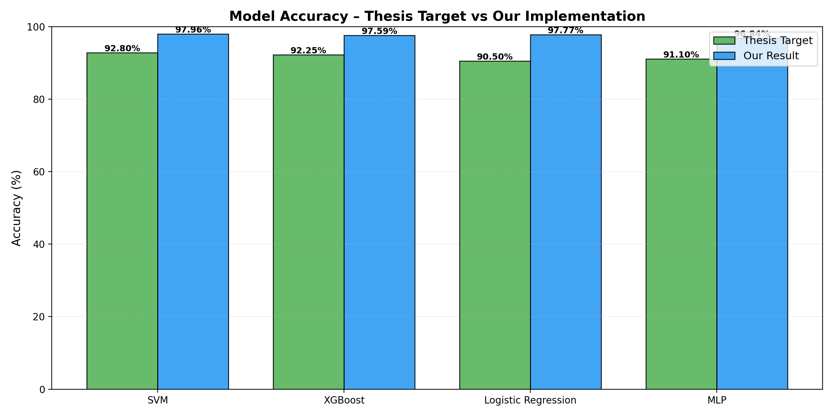
Fig. 3: Accuracy Comparison — MLP, Logistic Regression, XGBoost, SVM
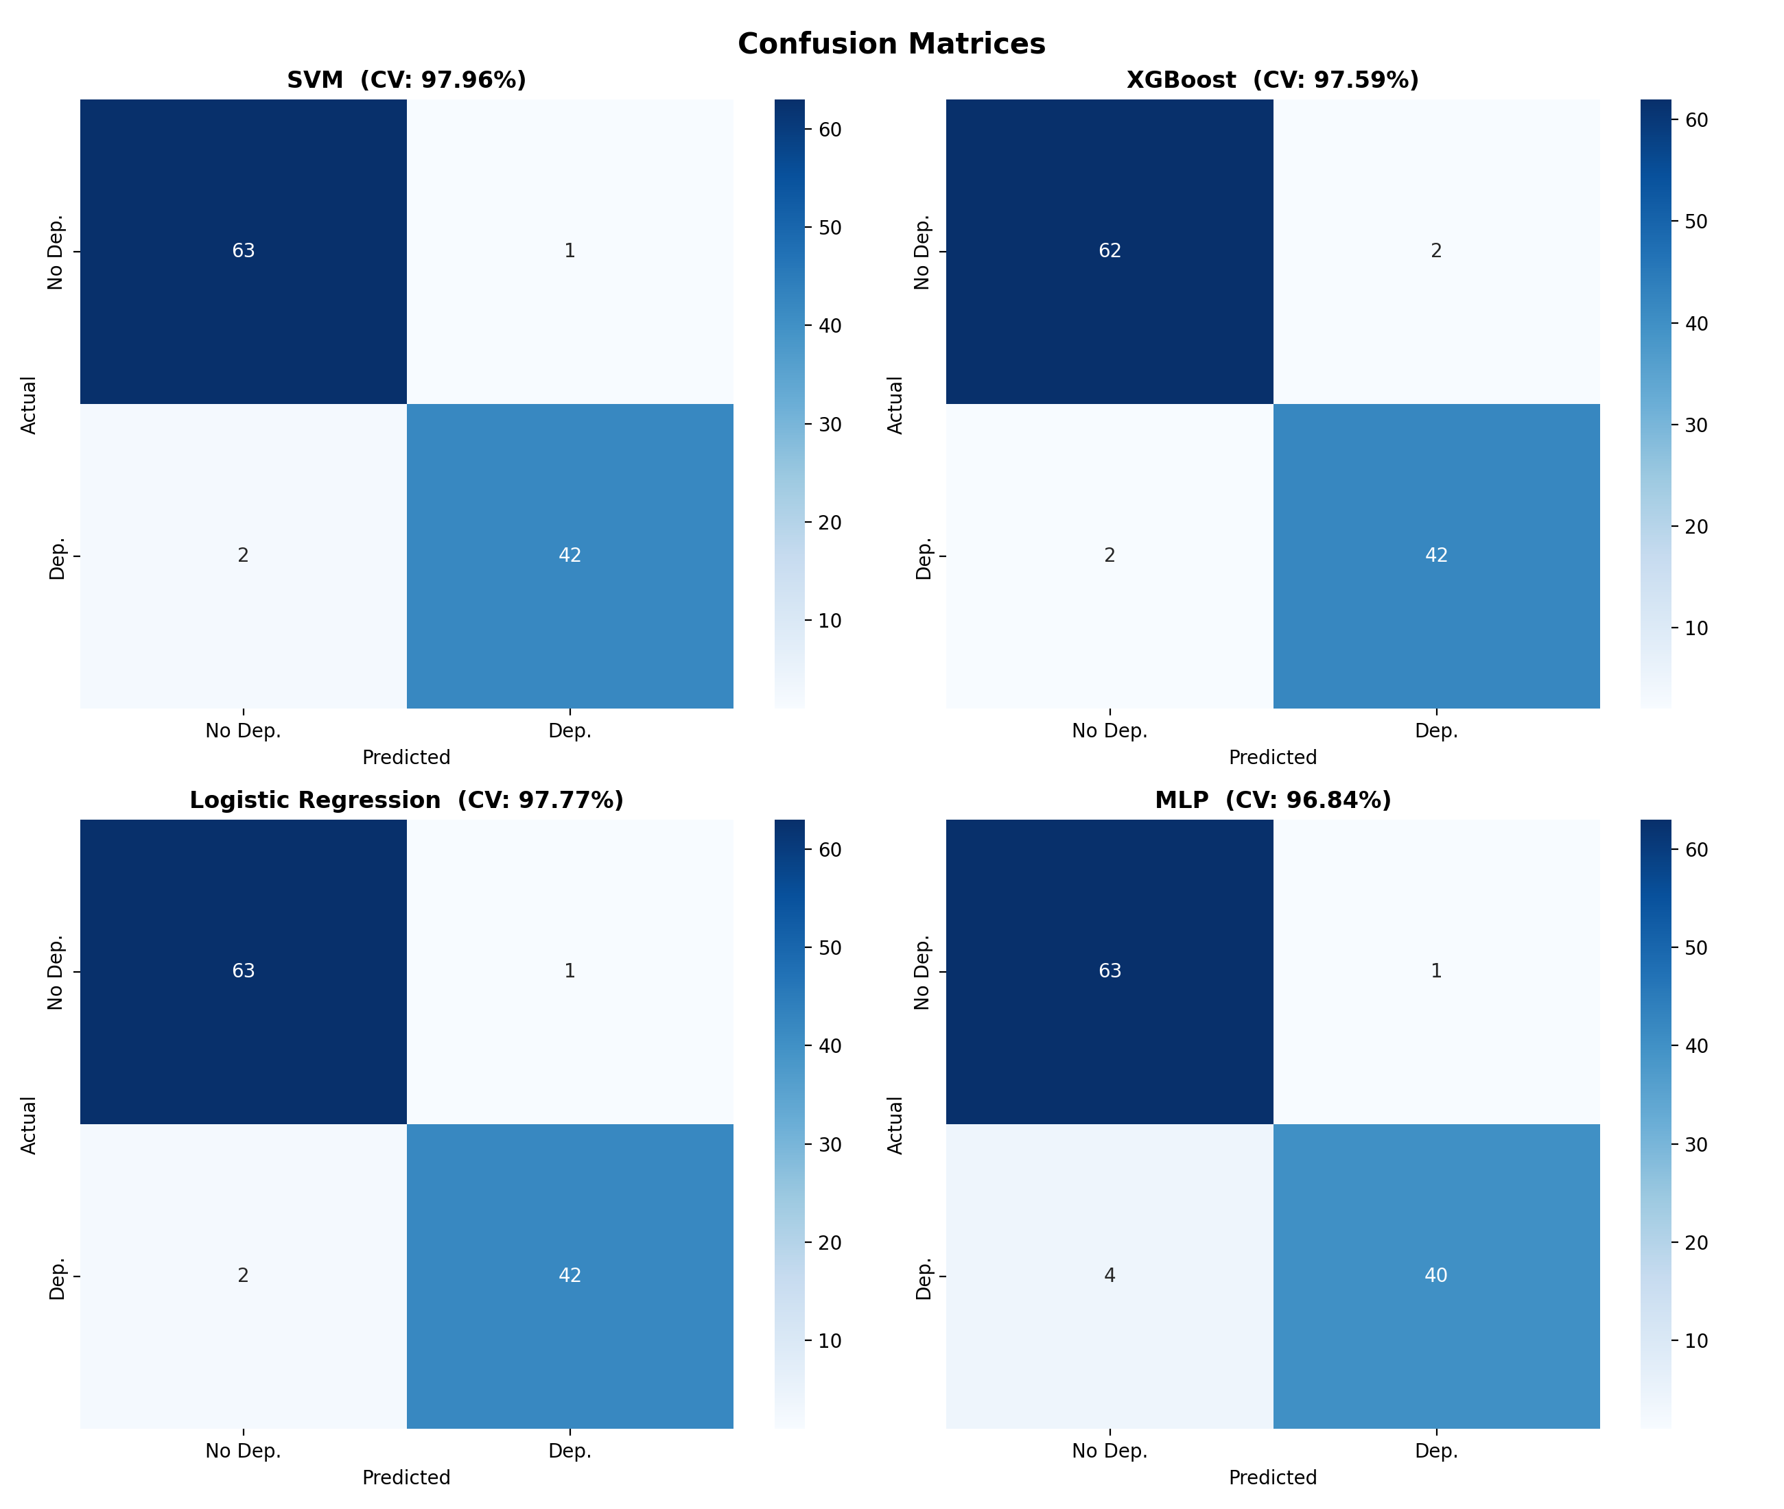
Fig. 4: Confusion Matrices for all four models
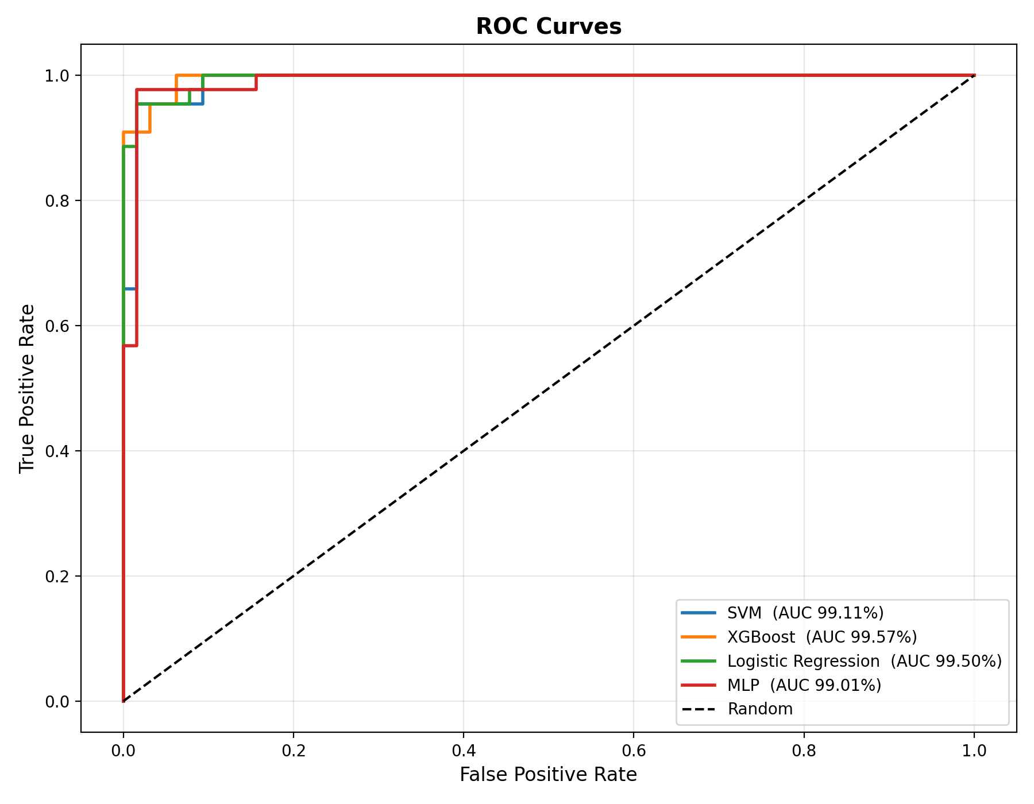
Fig. 5: ROC Curves for all four models
The bar chart (Figure 3) illustrates the accuracy comparison across all four algorithms. SVM achieves the highest accuracy at 97.96%, closely followed by Logistic Regression at 97.77%, XGBoost at 97.59%, and MLP at 96.84%. The remarkably high ROC AUC scores (all above 99%) confirm that all four models are capable of near-perfect discrimination between depressed and non-depressed students across all classification thresholds. These results demonstrate that the combination of properly collected behavioral survey data with systematic preprocessing and optimized machine learning algorithms is highly effective for student depression detection.
V. CONCLUSION
By examining information obtained from structured surveys, this study sought to determine the causes of depression in college students. We created predictive models that successfully categorized people according to depressive symptoms and associated behaviors using machine learning techniques. Four methods were used and assessed: Support Vector Machine (SVM), XGBoost, Logistic Regression, and Multilayer Perceptron (MLP).
With 97.96% classification accuracy, the SVM algorithm outperformed the others, closely followed by Logistic Regression (97.77%), XGBoost (97.59%), and MLP (96.84%). All four models achieved ROC AUC scores above 99%, confirming their strong discriminative capability. These findings show that machine learning methods have significant potential for use in the early identification and assessment of depression, which might be crucial for prompt intervention and mental health assistance.
Nevertheless, there were restrictions when gathering the data. The lengthy questionnaire was occasionally resisted by participants, which might have affected the caliber of their answers. Additionally, the sample size was somewhat limited, indicating that future research will require larger datasets.
In our upcoming efforts, we want to:
• Increase the size of the dataset by adding more people with a range of backgrounds.
• Improve prediction performance by implementing deep learning techniques.
• Sort depression severity into three categories: severe, medium, and low.
• Examine other algorithms, such as Random Forest and Naive Bayes, along with sophisticated pre-processing methods.
• Deploy the system as a real-time web application for university counseling services.
. REFERENCES
[1] N. Mohd and Y. Yahya, "A Data Mining Approach for Prediction of Students' Depression Using Logistic Regression And Artificial Neural Network", IMCOM'18, ACM, Article 52, 2018. DOI: https://doi.org/10.1145/3164541.3164604
[2] "Depression", Who.int, 2020. Available: https://www.who.int/en/news-room/fact-sheets/detail/depression. [Accessed: 06-Nov-2020].
[3] J. Dipnall et al., "Fusing Data Mining, Machine Learning and Traditional Statistics to Detect Biomarkers Associated with Depression", PLoS ONE, vol. 11, no. 2, p. e0148195, 2016.
[4] M. Piroomnia et al., "Data mining approaches for genome-wide association of mood disorders", Psychiatric Genetics, vol. 22, no. 2, pp. 55-61, 2012.
[5] H. Ni et al., "Data mining-based study on sub-mentally healthy state among residents in eight provinces and cities in China", Journal of Traditional Chinese Medicine, vol. 34, no. 4, pp. 511-517, 2014.
[6] Z. Idris and M. Nazir, "Prediction of Flood Detection System: Fuzzy Logic Approach", Int'l Journal of Enhanced Research in Science Technology & Engineering, vol. 3, no. 1, 2014.
[7] S. Man Bae and S. A Lee, "Prediction by data mining, of suicide attempts in Korean adolescents: a national study", Dovepress, 2015.
[8] M. Deshpande and V. Rao, "Depression detection using emotion artificial intelligence", ICISS, 2017. DOI: 10.1109/ISS1.2017.8389299
[9] F. Cacheda, D. Fernandez and F. J. Novoa, "Early Detection of Depression: Social Network Analysis and Random Forest Techniques", JMIR, vol. 21, 2019.
[10] K. Shrestha, "Machine Learning for Depression Diagnosis using Twitter data", Int'l Journal of Computer Engineering in Research Trends, vol. 5, no. 2, 2018.
[11] "Multilayer perceptron", En.wikipedia.org, 2020. Available: https://en.wikipedia.org/wiki/Multilayer_perceptron. [Accessed: 06-Nov-2020].
[12] F. Jimenez and C. Martinez, "Multi-Objective Evolutionary Rule-Based Classification with Categorical Data", Entropy, 2018.
[13] E. A. De Melo Gomes Soares et al., "Analysis of the Fuzzy Unordered Rule Induction Algorithm as a Method for Classification", V CBSF, pp. 17-28, 2018.
[14] "XGBoost Algorithm: Long May She Reign!", Medium, 2020. Available: https://towardsdatascience.com/xgboost-algorithm. [Accessed: 06-Nov-2020].
[15] "Accuracy, Recall, Precision, F-Score & Specificity, which to optimize on?", Medium, 2020. Available: https://towardsdatascience.com/accuracy-recall-precision. [Accessed: 06-Nov-2020].
[16] B. E. Boser, I. M. Guyon, & V. Vapnik, "A training algorithm for optimal margin classifiers", Proc. 5th Annual Workshop on Computational Learning Theory, pp. 144-152, 1992.

