Move any element one line done : alt+ down arrow

] speed up [ speed down

6 elements to specify an element in css:

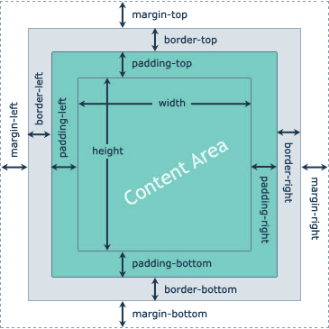

Text decoration:underline,overline,dotted,dashed

Text-transform:uppercase,lowercase,capitalize;

Letter spacing,word spacing,line height

Border: 1px solid/dashed color

**Unordered list** List List style type:none/circle/..

**Link** text-decoration:none :visted,:hover:…

**Button** style:border radius,border:none,outline:none,courser;pointer,padding: 8 16

**Button disabled**:cursor not allowed,opacity:0~1

Display :none//dekhao jina or kono jiga o thakena

Visibility :hidden //jiga thake kintu visible hoina

Overflow

**Float** dite hole parent element er display block kore nite hoi /height width fix kore dite hoi nahole overlapping hote pare

.div{

            width:100%;

            height: 400px;

            background-color: red;

           /* display: block;*/

            margin-bottom:5px;

        }

section{

            width:100%;

            height: 400px;

            background-color: red;

           /* display: block;*/

            margin-bottom:5px;

        }

**Display inline block** diye column pupropuri akta jiga niye nei ata thik korte hole

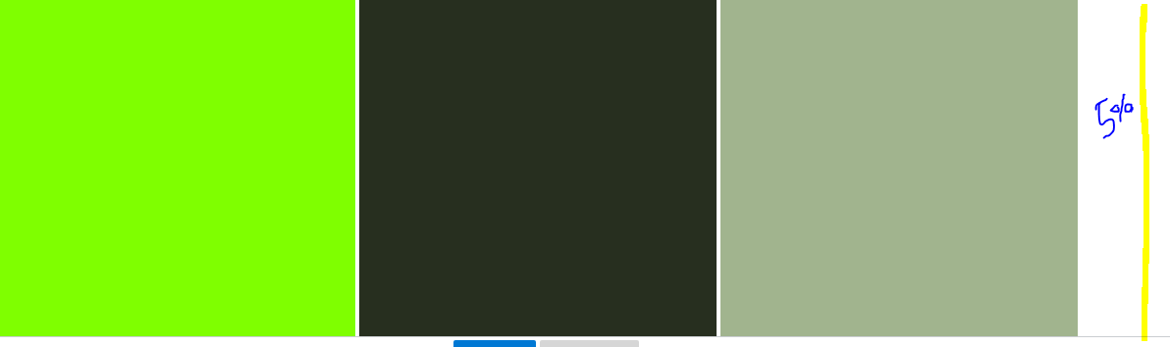

 .main{

        padding:10px 5%;//10%

        }

        .sidebarwidth{

            height:400px; width:30%;//33% p

           display: inline-block;

        }

**Positon** dite hole height width diye dite hoi nahole kaj korbena(position:fixed)

Selector: .class a, .class>a, .class+a(immediate sibling ) .class~a all matched sibling

Color(red,green,blue,transparent(0~1 deepness komiye dei)

Required aivabeo dewa ji jgula focus thakbe segula required a:focus:required

Input field eo **cursor not allowed** diye not allow kora ji

To select first of type

.div p:first of type, .div :nth-first-of-type(n)here n=1,2,3… last child nth-last-of-child(n)

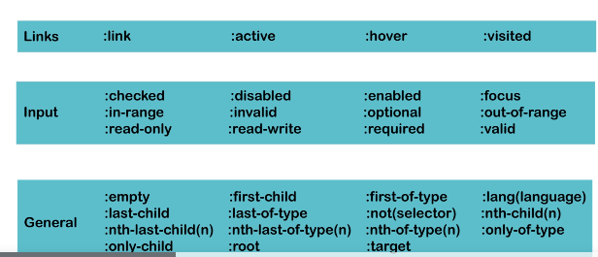

:: first letter, : : first line

P:: selection{

Background color…..

}

: :before,: :after{

Content:”text”

Content:” ’ ”

We can use image content:url(’image link’)

Backgroudimage:url(‘ ’)

}

Background repeat:no-repeat;

Background-size:we can specifiy the image size,**cover**

Background postion:left,right,top,centre, left bottom, right top

**Flexbox**

**Parent** eliment k **display:flex** dite hobe

Flex direction,