Theme 2
Mathematical Models of Systems
_______________________________________________________
2.1 Differential Equations of Physical Systems
2.2 Linear Approximations of Physical Systems
2.3 Transfer Function
2.4 Block Diagram Models
_______________________________________________________

2.1 Differential Equations of Physical Systems
Mathematical models of physical systems are key elements in the design and analysis of control systems. To understand and control complex systems, one must obtain quantitative mathematical models of these systems. It is necessary therefore to analyze the relationships between the system variables and to obtain a mathematical model. Because the systems under consideration are dynamic in nature, the descriptive equations are usually differential equations.
The differential equations describing the dynamic performance of a physical system are obtained by utilizing the physical laws of the process. This approach applies equally well to mechanical, electrical, fluid, and thermodynamic systems.
For mechanical systems, one uses Newton's laws. For example, the simple spring-mass-damper mechanical system shown in Figure 2.1(a) is described by Newton's second law of motion. (This system could represent, for example, an automobile shock absorber.) The free-body diagram of the mass M is shown in Figure 2.1(b). In this spring-mass-damper example, we model the wall friction as a viscous damper, that is, the friction force is linearly proportional to the velocity of the mass. In reality the friction force may behave in a more complicated fashion. For example, the wall friction may behave as a Coulomb damper. Coulomb friction, also known as dry friction, is a nonlinear function of the mass velocity and possesses a discontinuity around zero velocity. For a well-lubricated, sliding surface, the viscous friction is appropriate and will be used here and in subsequent spring-mass-damper examples.
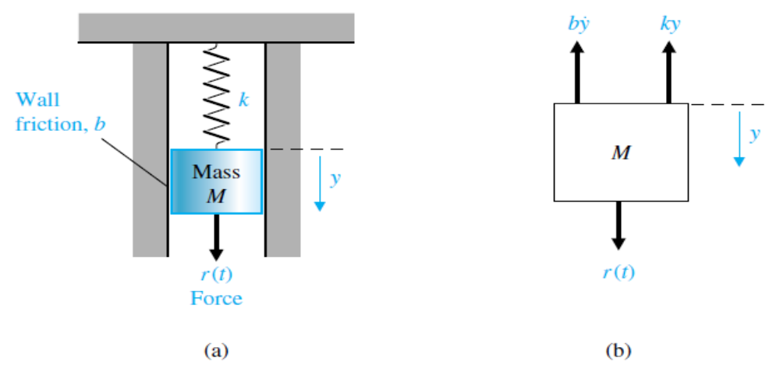
(a) (b)
FIGURE 2.1 (a) Spring-mass-damper system.
(b) Free-body diagram.
Summing the forces acting on M and utilizing Newton's second law yields
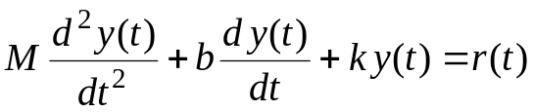, (2.1)
where k is the spring constant of the ideal spring and b is the friction constant. Equation (2.1) is a second-order linear constant-coefficient differential equation.
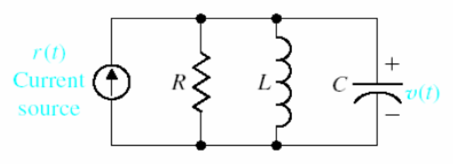
FIGURE 2.2 RLC circuit.
Alternatively, one may describe the electrical RLC circuit of Figure 2.2 by utilizing Kirchhoff’s current law. Then we obtain the following integro-differential equation:
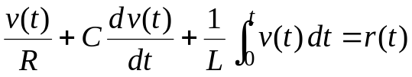. (2.2)
The solution of the differential equation describing the process may be obtained by classical methods such as the use of integrating factors and the method of undetermined coefficients.
For example, when the mass is initially displaced a distance 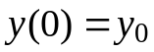 and released, the dynamic response of the system can be represented by an equation of the form
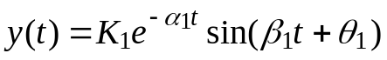. (2.3)
A similar solution is obtained for the voltage of the electrical RLC circuit when the circuit is subjected to a constant current 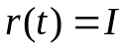. Then the voltage is
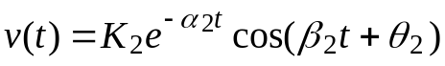. (2.4)
A voltage curve typical of an RLC circuit is shown in Figure 2.3.
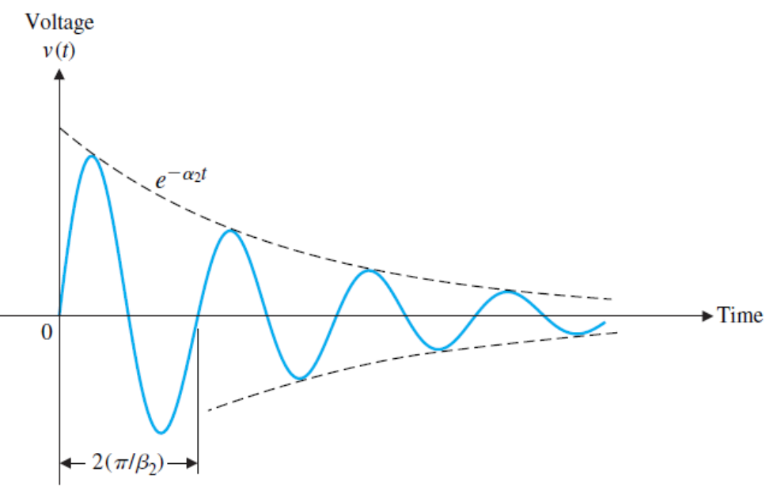
FIGURE 2.3 Typical voltage response for an RLC circuit.
To reveal further the close similarity between the differential equations for the mechanical and electrical systems, we shall rewrite Equation (2.1) in terms of velocity:
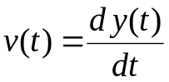.
Then we have
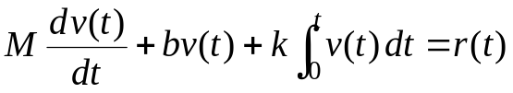. (2.5)
One immediately notes the equivalence of Equations (2.5) and (2.2) where velocity 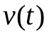 and voltage are equivalent variables, usually called analogous variables, and the systems are analogous systems. Therefore the solution for velocity is similar to Equation (2.4), and the response for an underdamped system is shown in Figure 2.3. The concept of analogous systems is a very useful and powerful technique for system modeling.
Analogous systems with similar solutions exist for electrical, mechanical, thermal, and fluid systems. The existence of analogous systems and solutions provides the analyst with the ability to extend the solution of one system to all analogous systems with the same describing differential equations. Therefore what one learns about the analysis and design of electrical systems is immediately extended to an understanding of fluid, thermal, and mechanical systems.
2.2 Linear Approximations of Physical Systems
A great majority of physical systems are linear within some range of the variables. In general, systems ultimately become nonlinear as the variables are increased without limit. For example, the spring-mass-damper system of Figure 2.1 is linear and described by Equation (2.1) as long as the mass is subjected to small deflections 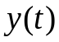. However, if were continually increased, eventually the spring would be overextended and break. Therefore the question of linearity and the range of applicability must be considered for each system.
A system is defined as linear in terms of the system excitation and response. In the case of the electrical network, the excitation is the input current 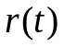 and the response is the voltage . In general, a necessary condition for a linear system can be determined in terms of an excitation 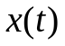 and a response .
When the system at rest is subjected to an excitation 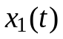, it provides a response 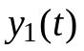. Furthermore, when the system is subjected to an excitation 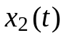, it provides a corresponding response 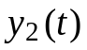. For a linear system, it is necessary that the excitation 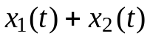 result in a response 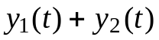. This is usually called the principle of superposition.
Furthermore, the magnitude scale factor must be preserved in a linear system. Again, consider a system with an input that results in an output . Then the response of a linear system to a constant multiple 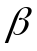 of an input x must be equal to the response to the input multiplied by the same constant so that the output is equal to 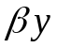. This is called the property of homogeneity.
A linear system satisfies the properties of superposition and homogeneity.
A system characterized by the relation 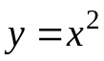 is not linear, because the superposition property is not satisfied.
A system represented by the relation 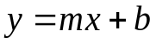 is also not linear, because it does not satisfy the homogeneity property. However, this second system may be considered linear about an operating point 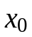, 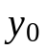 for small changes 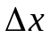 and 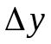. When 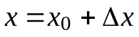 and 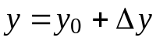, we have
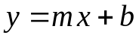
or
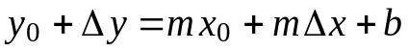.
Therefore,
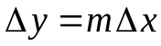,
which satisfies the necessary conditions.
The linearity of many mechanical and electrical elements can be assumed over a reasonably large range of the variables. This is not usually the case for thermal and fluid elements, which are more frequently nonlinear in character.
Fortunately, however, one can often linearize nonlinear elements assuming small-signal conditions.
Consider a general element with an excitation variable and a response variable . The relationship of the two variables is written as
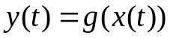, (2.6)
where 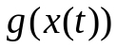 indicates is a function of . The normal operating point is designated by . Because the curve (function) is continuous over the range of interest, a Taylor series expansion about the operating point may be utilized. Then we have
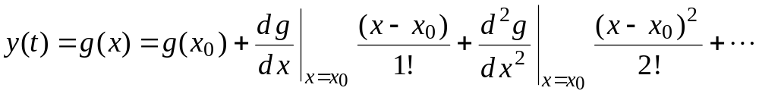. (2.7)
The slope at the operating point,
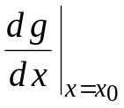,
is a good approximation to the curve over a small range of 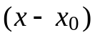, the deviation from the operating point. Then, as a reasonable approximation, Equation (2.7) becomes
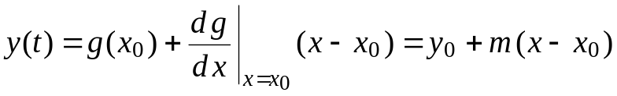, (2.8)
where m is the slope at the operating point. Finally, Equation (2.8) can be rewritten as the linear equation
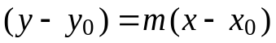
or
. (2.9)
EXAMPLE 2.1 Nonlinear spring
Consider the case of a mass, M, sitting on a nonlinear spring, as shown in Figure 2.4(a). The normal operating point is the equilibrium position that occurs when the spring force balances the gravitational force Mg, where g is the gravitational constant. Thus, we obtain 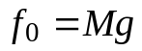, as shown. For the nonlinear spring with 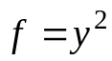, the equilibrium position is 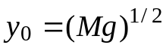. The linear model for small deviation is
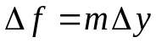,
where
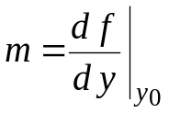,
as shown in Figure 2.4(b). Thus, 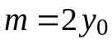. A linear approximation is as accurate as the assumption of small signals is applicable to the specific problem.
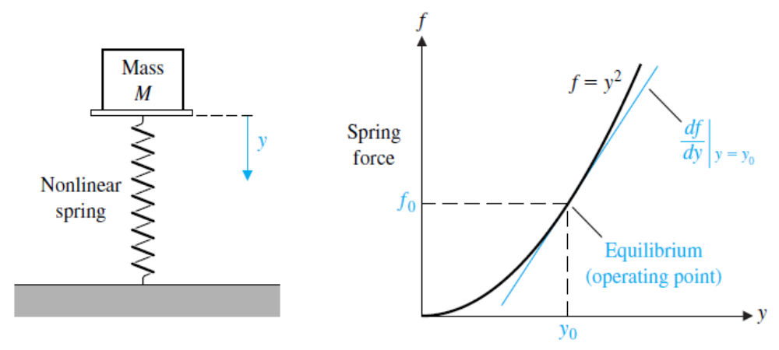
(a) (b)
FIGURE 2.4 (a) A mass sitting on a nonlinear spring.
(b) The spring force versus y.
If the dependent variable y depends upon several excitation variables, 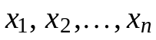, then the functional relationship is written as
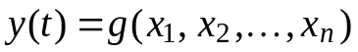. (2.10)
The Taylor series expansion about the operating point 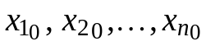 is useful for a linear approximation to the nonlinear function. When the higher-order terms are neglected, the linear approximation is written as
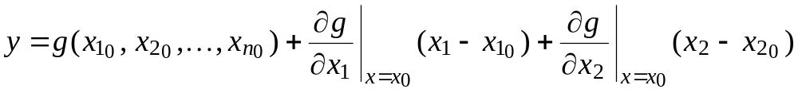
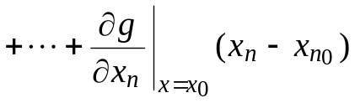, (2.11)
where is the operating point. Example 2.2 will clearly illustrate the utility of this method.
EXAMPLE 2.2 Pendulum oscillator model
Consider the pendulum oscillator shown in Figure 2.5(a). The torque on the mass is
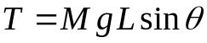, (2.12)
where g is the gravity constant. The equilibrium condition for the mass is 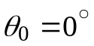. The nonlinear relation between T and 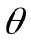 is shown graphically in Figure 2.5(b).
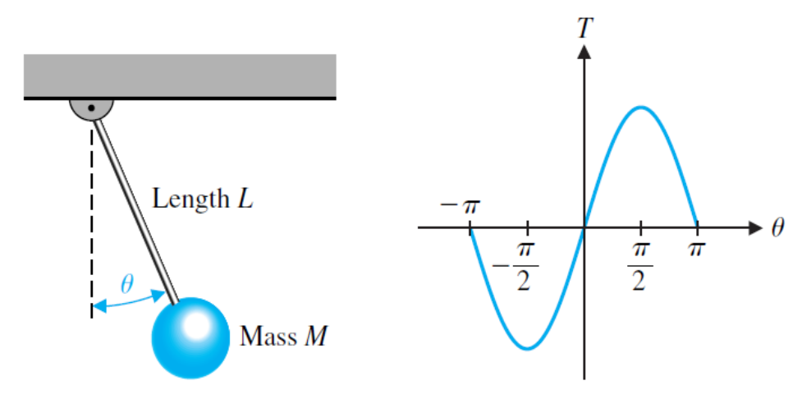
(a) (b)
FIGURE 2.5 Pendulum oscillator.
The first derivative evaluated at equilibrium provides the linear approximation, which is
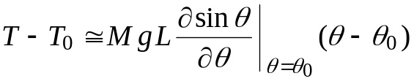,
where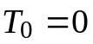. Then, we have
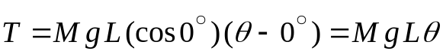. (2.13)
This approximation is reasonably accurate for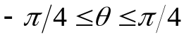. For example, the response of the linear model for the swing through 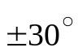 is within 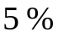 of the actual nonlinear pendulum response.
2.3 Transfer Function
The transfer function of a linear system is defined as the ratio of the Laplace transform of the output variable to the Laplace transform of the input variable, with all initial conditions assumed to be zero. The transfer function of a system (or element) represents the relationship describing the dynamics of the system under consideration.
A transfer function may be defined only for a linear, stationary (constant parameter) system. A nonstationary system, often called a time-varying system, has one or more time-varying parameters, and the Laplace transformation may not be utilized.
Furthermore, a transfer function is an input-output description of the behavior of a system. Thus, the transfer function description does not include any information concerning the internal structure of the system and its behavior.
The transfer function of the spring-mass-damper system is obtained from the original Equation (2.1). The Laplace transform of Equation (2.1) with zero initial conditions is:
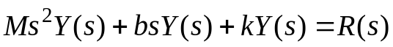. (2.14)
Then the transfer function 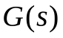 is
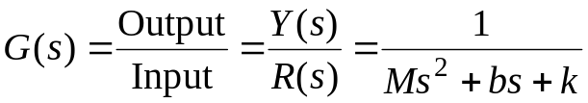. (2.15)
The transfer function of the RC network is obtained by writing the Kirchhoff voltage equation, yielding
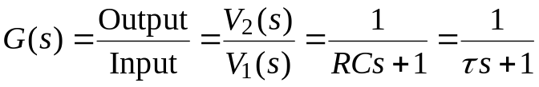, (2.16)
where 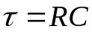, the time constant of the network.
Consider the dynamic system represented by the differential equation
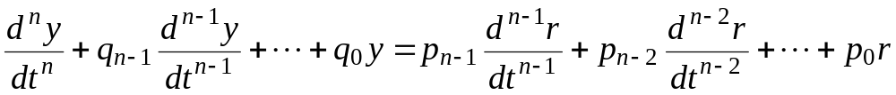, (2.17)
where is the output or response, and is the input or forcing function. Then the transfer function of the dynamic system is
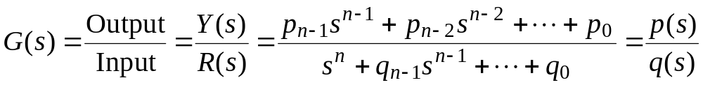. (2.18)
The denominator polynomial 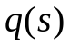, when set equal to zero, is called the characteristic equation because the roots of this equation determine the character of the time response. The roots of this characteristic equation are also called the poles of the system. The roots of the numerator polynomial 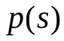 are called the zeros of the system.
As an example, let us obtain the transfer function of an important electrical control component, the DC motor. A DC motor is used to move loads and is called an actuator. An actuator is a device that provides the motive power to the process.
EXAMPLE 2.3 Transfer function of the DC motor
The DC motor is a power actuator device that delivers energy to a load, as shown in Figure 2.6(a); a sketch of a DC motor is shown in Figure 2.6(b).
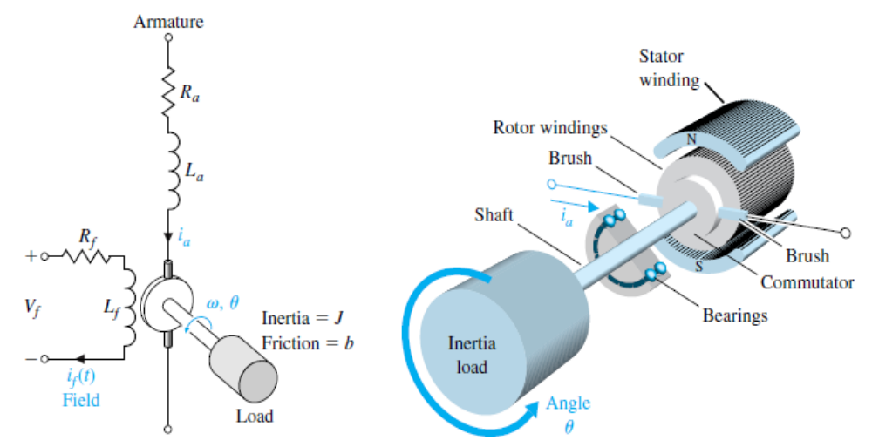
(a) (b)
FIGURE 2.6 A DC motor (a) electrical diagram and (b) sketch.
The DC motor converts direct current (DC) electrical energy into rotational mechanical energy. A major fraction of the torque generated in the rotor (armature) of the motor is available to drive an external load. Because of features such as high torque, speed controllability over a wide range, portability, well-behaved speed-torque characteristics, and adaptability to various types of control methods, DC motors are widely used in numerous control applications, including robotic manipulators, tape transport mechanisms, disk drives, machine tools, and servo valve actuators.
The transfer function of the DC motor will be developed for a linear approximation to an actual motor, and second-order effects, such as hysteresis and the voltage drop across the brushes, will be neglected. The input voltage may be applied to the field or armature terminals. The air-gap flux of the motor is proportional to the field current, provided the field is unsaturated, so that
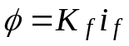. (2.19)
The torque developed by the motor is assumed to be related linearly to and the armature current as follows:
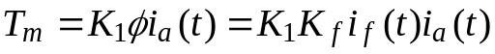. (2.20)
It is clear from Equation (2.20) that, to have a linear system, one current must be maintained constant while the other current becomes the input current.
First, we shall consider the field current controlled motor, which provides a substantial power amplification. Then we have, in Laplace transform notation,
, (2.21)
where 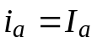 is a constant armature current, and 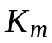 is defined as the motor constant. The field current is related to the field voltage as
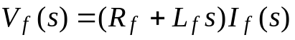. (2.22)
The motor torque 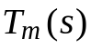 is equal to the torque delivered to the load. This relation may be expressed as
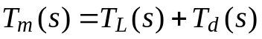, (2.23)
where 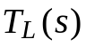 is the load torque and 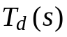 is the disturbance torque, which is often negligible. However, the disturbance torque often must be considered in systems subjected to external forces such as antenna wind-gust forces. The load torque for rotating inertia, as shown in Figure 2.6, is written as
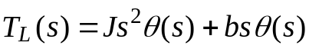. (2.24)
Rearranging Equations (2.21) – (2.23), we have
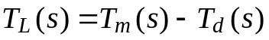, (2.25)
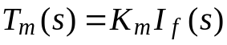, (2.26)
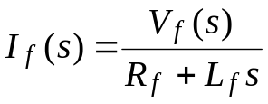. (2.27)
Therefore, the transfer function of the motor-load combination, with 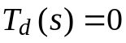, is
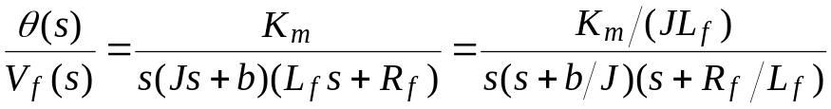. (2.28)
Alternatively, the transfer function may be written in terms of the time constants of the motor as
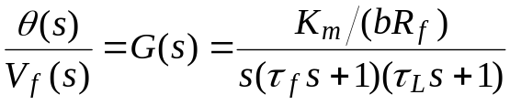, (2.29)
where 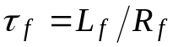 and 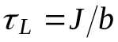. Typically, one finds that 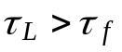 and often the field time constant may be neglected.
The armature-controlled DC motor uses the armature current 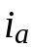 as the control variable. The stator field can be established by a field coil and current or a permanent magnet. When a constant field current is established in a field coil, the motor torque is
. (2.30)
When a permanent magnet is used, we have
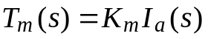,
where is a function of the permeability of the magnetic material.
The armature current is related to the input voltage applied to the armature by
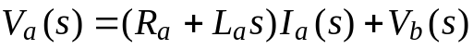, (2.31)
where 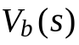 is the back electromotive-force voltage proportional to the motor speed. Therefore, we have
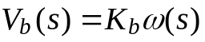, (2.32)
where 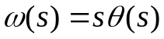 is the transform of the angular speed and the armature current is
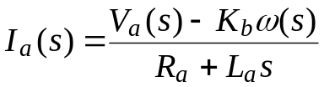. (2.33)
Equations (2.24) and (2.25) represent the load torque, so that
. (2.34)
Using Equations (2.30), (2.33), and (2.34) and letting , we solve to obtain the transfer function
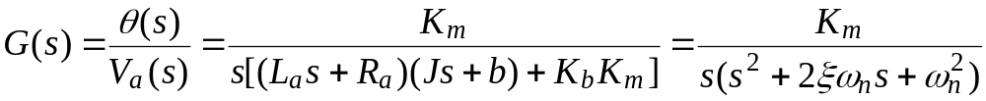. (2.35)
However, for many DC motors, the time constant of the armature, 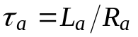, is negligible; therefore,
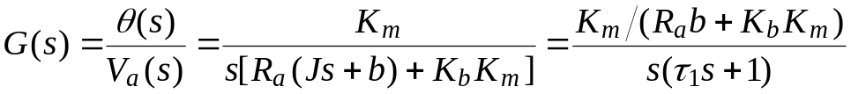. (2.36)
where the equivalent time constant 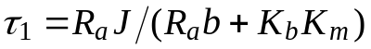.
Note that is equal to 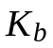. This equality may be shown by considering the steady-state motor operation and the power balance when the rotor resistance is neglected. The power input to the rotor is 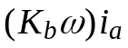, and the power delivered to the shaft is 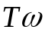. In the steady-state condition, the power input is equal to the power delivered to the shaft so that 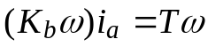; since 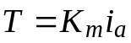 (Equation 2.30), we find that 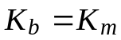.
The transfer function concept and approach is very important because it provides the analyst and designer with a useful mathematical model of the system elements. We shall find the transfer function to be a continually valuable aid in the attempt to model dynamic systems.
2.4 Block Diagram Models
The dynamic systems that comprise automatic control systems are represented mathematically by a set of simultaneous differential equations. As we have noted in the previous section, the Laplace transformation reduces the problem to the solution of a set of linear algebraic equations. Since control systems are concerned with the control of specific variables, the controlled variables must relate to the controlling variables. This relationship is typically represented by the transfer function of the subsystem relating the input and output variables. Therefore, one can correctly assume that the transfer function is an important relation for control engineering.
The importance of this cause-and-effect relationship is evidenced by the facility to represent the relationship of system variables by diagrammatic means. The block diagram representation of the system relationships is prevalent in control system engineering. Block diagrams consist of unidirectional, operational blocks that represent the transfer function of the variables of interest.
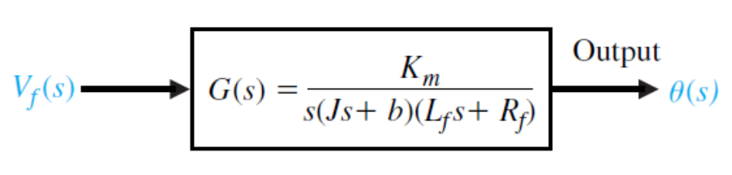
FIGURE 2.7 Block diagram of a DC motor.
A block diagram of a field-controlled DC motor and load is shown in Figure 2.7. The relationship between the displacement 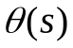 and the input voltage 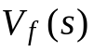 is clearly portrayed by the block diagram.
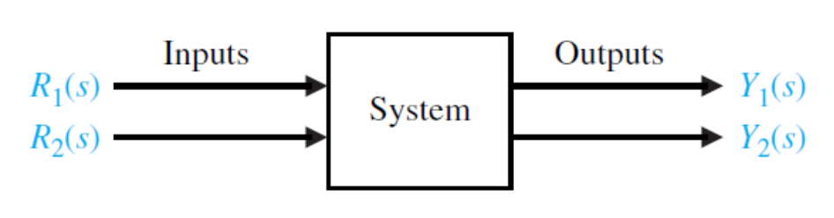
FIGURE 2.8 General block representation of
two-input, two-output system.
To represent a system with several variables under control, an inter-connection of blocks is utilized. For example, the system shown in Figure 2.8 has two input variables and two output variables. Using transfer function relations, we can write the simultaneous equations for the output variables as
, (2.37)
and
, (2.38)
where 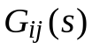 is the transfer function relating the ith output variable to the jth input variable. The block diagram representing this set of equations is shown in Figure 2.9.
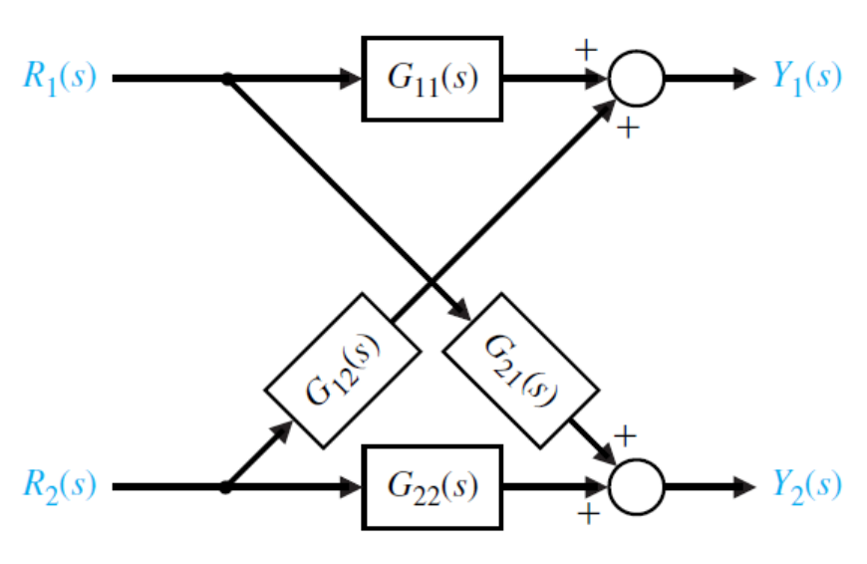
FIGURE 2.9 Block diagram of interconnected system.
In general, for J inputs and I outputs, we write the simultaneous equation in matrix form as
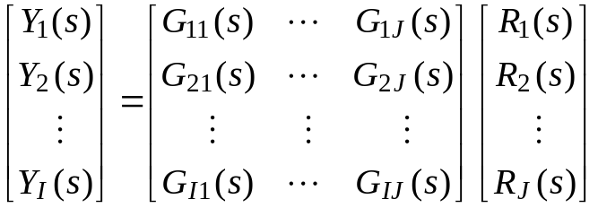 (2.39)
or simply
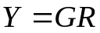. (2.40)
Here the Y and R matrices are column matrices containing the I output and the J input variables, respectively, and G is an I by J transfer function matrix. The matrix representation of the interrelationship of many variables is particularly valuable for complex multivariable control systems.
The block diagram representation of a given system often can be reduced to a simplified block diagram with fewer blocks than the original diagram. Several useful diagram transformations are given in Table 2.1. All the transformations in Table 2.1 can be derived by simple algebraic manipulation of the equations representing the blocks.
Table 2.1 Block Diagram Transformations
Transformation | Original Diagram | Equivalent Diagram
1. Combining blocks in  cascade | 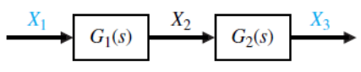 | 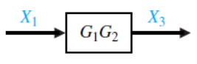  or  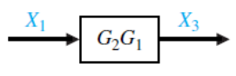
2. Moving a summing  point behind a block | 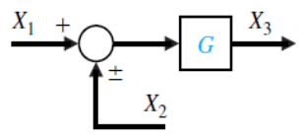 | 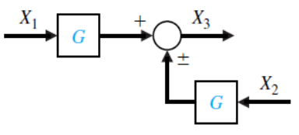
3. Moving a pickoff point  ahead of a block | 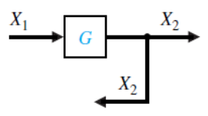 | 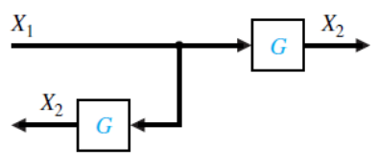
4. Moving a pickoff point  behind a block | 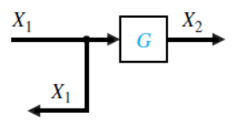 | 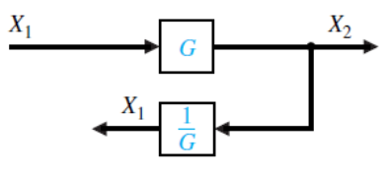
5. Moving a summing  point ahead of a block | 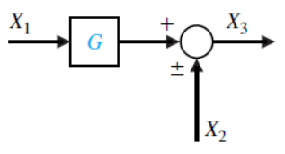 | 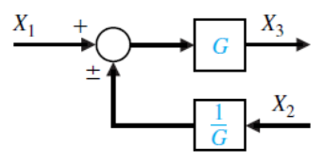
6. Eliminating a feedback  loop | 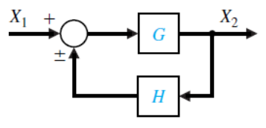 | 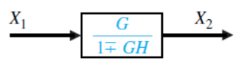
Since the transfer functions represent linear systems, the multiplication is commutative. Thus, in Table 2.1, item 1, we have
.
When two blocks are connected in cascade, as in Table 2.1, item 1, we assume that
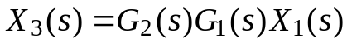
holds true. This assumes that when the first block is connected to the second block, the effect of loading of the first block is negligible. Loading and interaction between interconnected components or systems may occur. If the loading of interconnected devices does occur, the engineer must account for this change in the transfer function and use the corrected transfer function in subsequent calculations.
System analysis by the method of block diagram reduction affords a better understanding of the contribution of each component element than possible by the manipulation of equations. The utility of the block diagram transformations will be illustrated by an example using block diagram reduction.
EXAMPLE 2.4 Block diagram reduction
The block diagram of a multiple-loop feedback control system is shown in Figure 2.10. It is interesting to note that the feedback signal 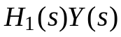 is a positive feedback signal, and the loop 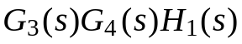 is a positive feedback loop.
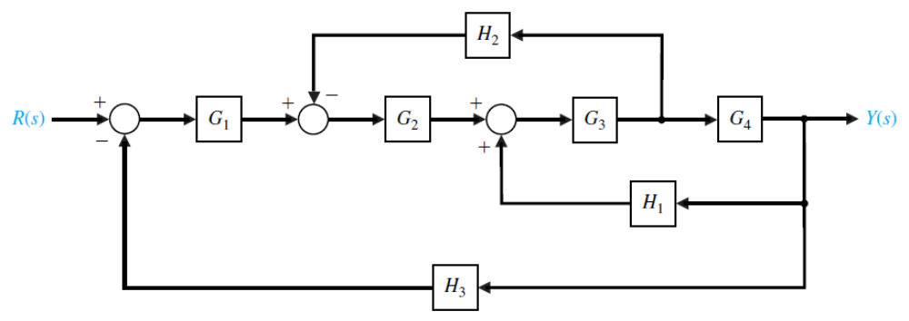
FIGURE 2.10 Multiple-loop feedback control system.
The block diagram reduction procedure is based on the use of Table 2.1, transformation 6, which eliminates feedback loops. Therefore the other transformations are used to transform the diagram to a form ready for eliminating feedback loops. First, to eliminate the loop 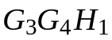, we move 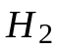 behind block 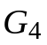 by using transformation 4, and obtain Figure 2.11(a). Eliminating the loop by using transformation 6, we obtain Figure 2.11(b). Then, eliminating the inner loop containing 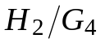, we obtain Figure 2.11(c). Finally, by reducing the loop containing 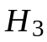, we obtain the closed-loop system transfer function as shown in Figure 2.11(d).
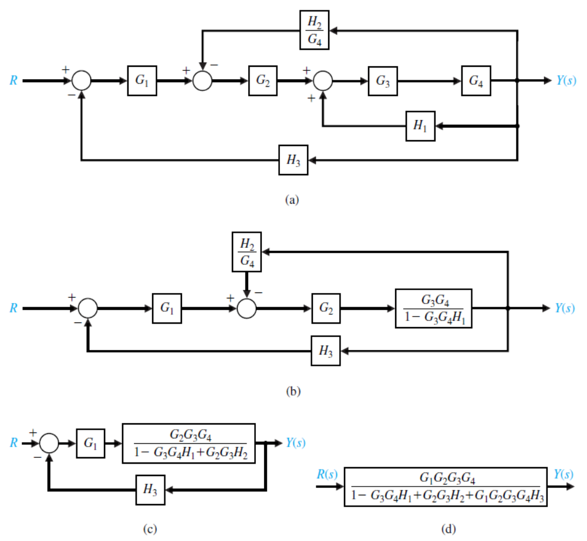
FIGURE 2.11 Block diagram reduction of the system of Figure 2.10.
The block diagram representation of feedback control systems is a valuable and widely used approach. The block diagram provides the analyst with a graphical representation of the interrelationships of controlled and input variables. Furthermore, the designer can readily visualize the possibilities for adding blocks to the existing system block diagram to alter and improve the system performance.
EXAMPLE 2.5 Disk drive system
In Example 1.2 (Section 1.4), we developed an initial goal for the disk drive system: to position the reader head accurately at the desired track and to move from one track to another within 10 ms, if possible. We need to identify the plant, the sensor, and the controller. We will obtain a model of the plant and the sensor. The disk drive reader uses a permanent magnet DC motor to rotate the reader arm (see Figure 1.15). The DC motor is called a voice coil motor in the disk drive industry. The read head is mounted on a slider device, which is connected to the arm as shown in Figure 2.12.
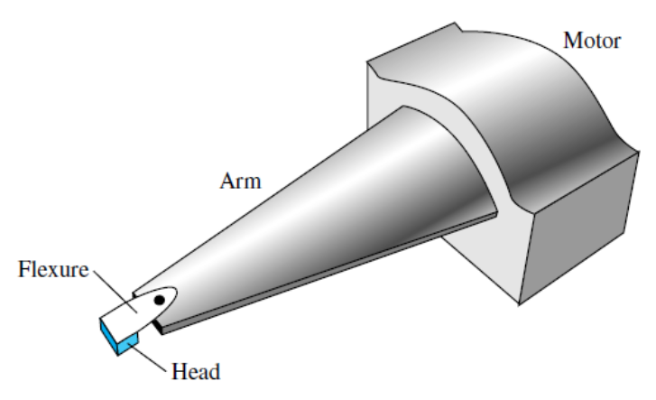
FIGURE 2.12 Head mount for reader, showing flexure.
A flexure (spring metal) is used to enable the head to float above the disk at a gap of less than 100 nm. The thin-film head reads the magnetic flux and provides a signal to an amplifier. The error signal of Figure 2.13(a) is provided by reading the error from a prerecorded index track. Assuming an accurate read head, the sensor has a transfer function 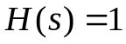, as shown in Figure 2.13(b). The model of the permanent magnet DC motor and a linear amplifier is shown in Figure 2.13(b). As a good approximation, we use the model of the armature-controlled DC motor with 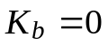. The model shown in Figure 2.13(b) assumes that the flexure is entirely rigid and does not significantly flex.
Typical parameters for the disk drive system are given in Table 2.20. Thus, we have
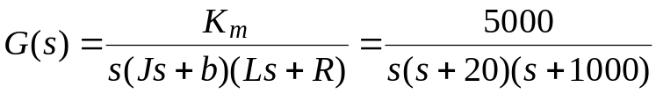. (2.41)
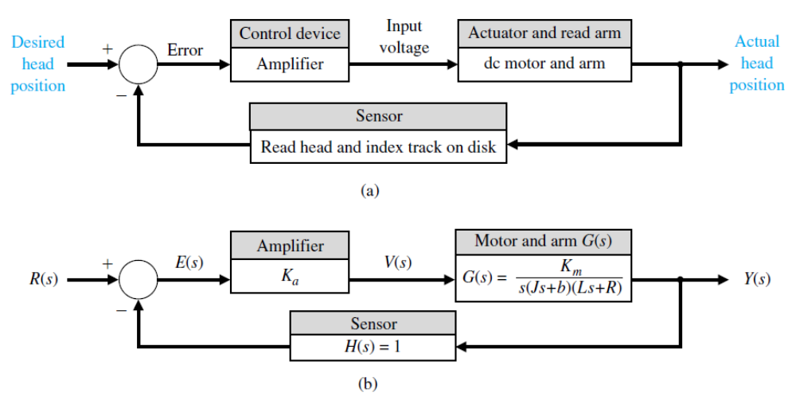
FIGURE 2.13 Block diagram model of disk drive system.
Table 2.2 Typical Parameters for Disk Drive System
Parameter | Symbol | Typical Value
Inertia of arm and read head | 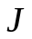 | 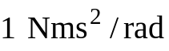
Friction |  | 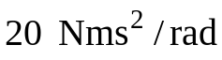
Amplifier | 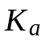 | 10 – 1000
Armature resistance | 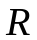 | 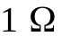
Motor constant |  | 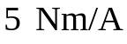
Armature inductance | 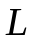 | 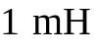
We can also write
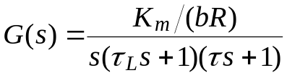, (2.42)
where 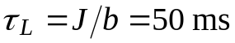 and 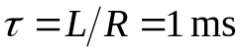. Since 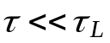, we often neglect . Then, we would have
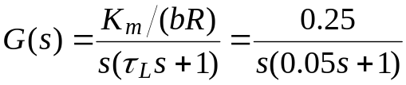,
or
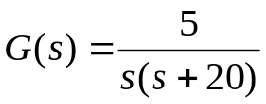.
The block diagram of the closed-loop system is shown in Figure 2.14.
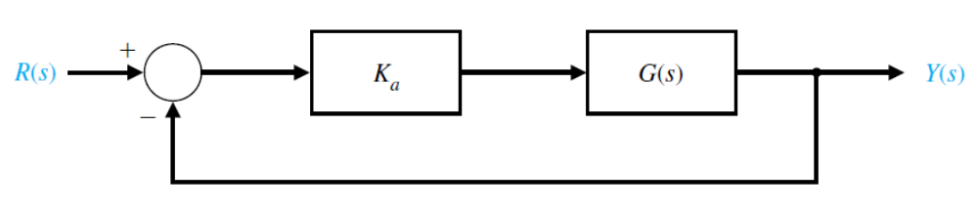
FIGURE 2.14 Block diagram of closed-loop system.
Using the block diagram transformation of Table 2.1, we have
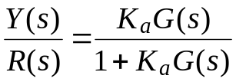. (2.43)
Using the approximate second-order model for , we obtain
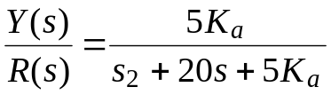.
When 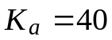, we have
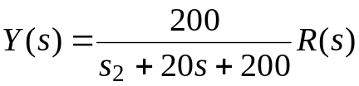
and for 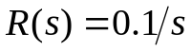 rad we obtain the step response, as shown in Figure 2.15.
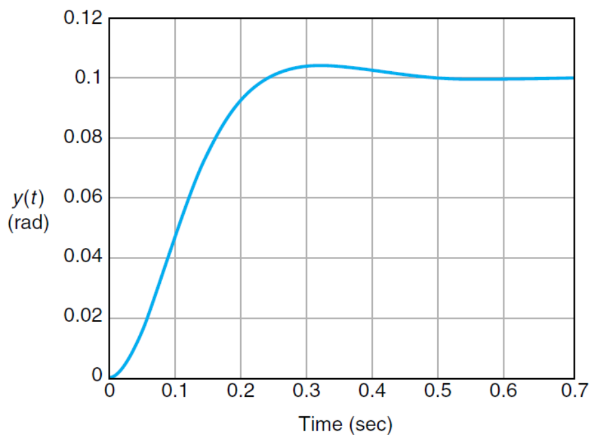
FIGURE 2.15 The system response of the system
shown in Figure 2.14 for .
Text:
Dorf, R. C., R. H. Bishop. Modern Control Systems, 12th Ed., Prentice Hall, Upper Saddle River, N.J., 2011.

