Lab 6
Stability Analysis using
the Routh-Hurwitz Criterion
Objective
This lab aims to teach the students to analyze stability of closed-loop control systems using the Routh-Hurwitz criterion.
Background Materials
Lecture notes for the course Control Theory 1, Theme 5. Stability of Linear Control Systems, pp. 1 – 18.
Tasks
Task 1
A unity negative feedback system has a loop transfer function
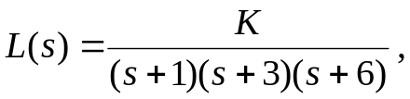
where K = 20. Using the MATLAB command roots, determine if the closed-loop system is stable.
Task 2
A closed-loop system has a characteristic equation
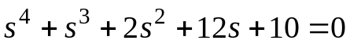.
Check the stability of the system by applying the Routh-Hurwitz criterion. Determine the number of roots, if any, in the right half-plane.
Task 3
Consider the position control system shown in Figure 1. The values of the parameters 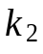 and 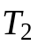 are 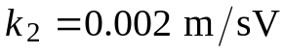 and 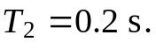
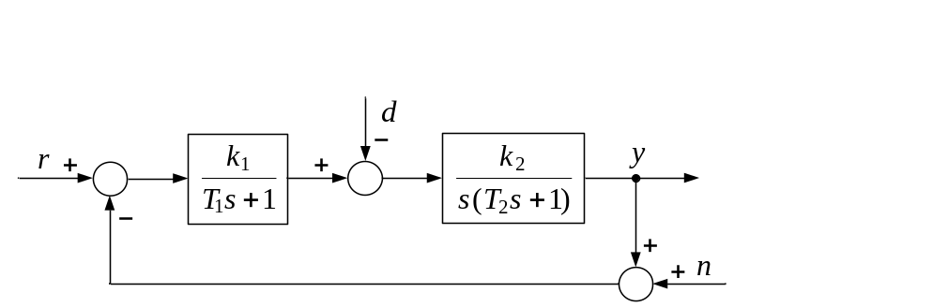
Figure 1 Block diagram of position control system.
- Using the Routh-Hurwitz criterion, determine the range of the gain 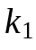 for which the control system is stable when 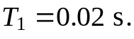
- Determine and plot with MATLAB the region of stability for the control system for the parameters and 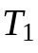 (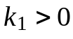, >0).
- Use Simulink to plot the response of 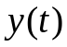 to a step input 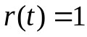 for 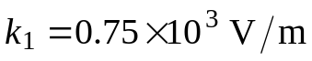, 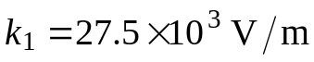, and 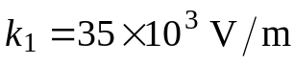. The time constant 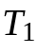 is assumed to be 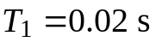. Explain the obtained results.
Task 4
Consider the position control system in Figure 2. The values of the parameters , , and are as in the Task 4: , 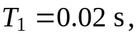 and Using the Routh-Hurwitz criterion, determine the range of the time constant 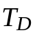 for which the control system is stable when 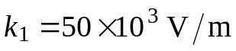 (Note that for this values of the parameters , , , and the control system shown in Figure 1 is unstable.)
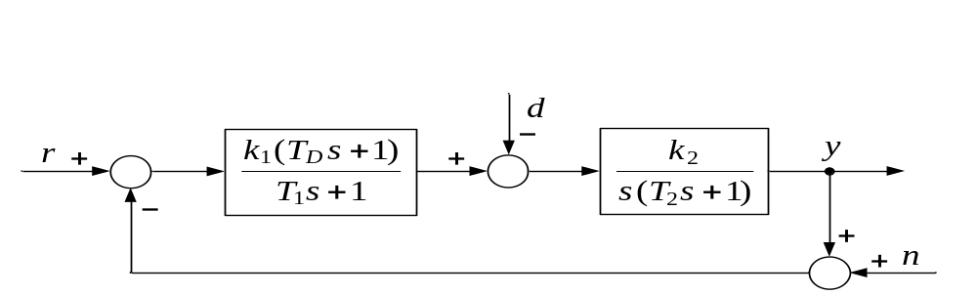
Figure 2 Block diagram for Task 4.
Task 5
A unity negative feedback system has a loop transfer function
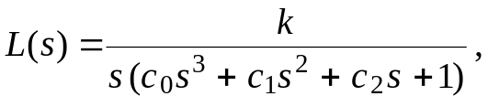
where the parameters 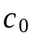, 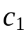, and 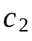 are positive. Using the Routh-Hurwitz criterion, determine the range of the gain k resulting in closed-loop stability.
Report Content
The lab report should contain the following:
- The objective of the lab.
- Formulation of the tasks.
- Obtained results, including MATLAB script-file, Simulink model and plots.
- Discussion of obtained results.
- Conclusion.

